

Postgraduate/Distance Learning
Assignment coversheet & feedback form

THIS SHEET MUST BE THE FIRST PAGE OF THE ASSIGNMENT YOU ARE SUBMITTING (DO NOT SEND AS A SEPARATE FILE)

For completion by the student:
Student Name: SARAH PAGE

Student University Email: 1704966@student@uwtsd.ac.uk
Module code: AHAN7036  Module title: Engaging with Anthropological Theory | Student ID number:  1704966 |  |  | Educational support needs:  Yes/No
Assignment title: Review of Benjamin Coles’ Ingesting Places: Embodied Geographies of Coffee, 2013

Assignment due date: 31.5.19
This assignment is for the 1st 2nd 3rd 4th 5th 6th module of the degree
I confirm that this is my original work and that I have adhered to the University policy on plagiarism.
Signed …………S PAGE………………………
Email submission:if you are submitting this form via email, please tick this box
(as a substitute for your signature) to confirm that you agree to the above declaration.
Assignment Mark
1st Marker’s Provisional mark
2nd Marker’s/Moderator’s provisional mark
External Examiner’s mark (if relevant)
Final Mark

NB. All marks are provisional until confirmed by the Final Examination Board.

For completion by Marker 1 :
Comments:

Marker’s signature: |  |  | Date:
For completion by Marker 2/Moderator:

Comments:

Marker’s Signature: |  | Date:
External Examiner’s comments (if relevant)

External Examiner’s Signature: |  | Date:

Introduction

A Review of Benjamin Coles, Ingesting Places: Embodied Geographies of Coffee, 2013
In Why We Eat, How We Eat, Contemporary Encounters between Foods and Bodies

The ethnography on Monmouth Coffee Company by Benjamin Coles (Coles, 2013) uses the language of Actor-Network theory (ANT) “particularly as it has been reclaimed by Latour’s recent (2005) reflections.” (Coles, 2013). The material culture of coffee in this ethnography is identified as being in a number of people, things and places, although it is the places in which Coles has particular interest. As a Geographer, his focus is on how the country of origin is somehow embodied into the coffee, and thus into the human body when consumed. Coles describes Monmouth Coffee’s attempts to translate place into coffee and concludes that “to eat a food is to eat its geography” (p.268). He attests that all the participants involved, from the farmer growing the bean to the barista serving it, are part of a network that translates place into the coffee cup. Not only does the origin of the coffee bean translate, but significantly for the Actor-Network approach, Coles also suggests that other non-human actants and practices form part of the network of producing coffee.

By tracing the relations and following paths that are connections between and with actors, human or non-human, Coles’ ethnography aligns with the Actor-Network Theory (ANT) which can make visible the range of actors and associations working together. ANT states that everything (and everyone) can only exist as part of a network of relations. “It assumes that nothing has reality or form outside the enactment of those relations.”(Law, 2007) Monmouth’s business is translated as the network, consisting of numerous actors that together perform to create the coffee. The network functions to produce coffee and the balance of power in the network appears stable. An equilibrium is necessary for a successful actor-network, as detailed in Callon’s study of scallop production in St Brieuc Bay (Callon, 1999). This demonstrated the translation, or establishment of a network, and how equivalencies within the network were vital to its stability. When one actant performed independently, differently to the expected, the network collapsed.

ANT & Bruno Latour

Actor-Network Theory (ANT) is a methodological approach to social theory, conceived in the early 1980’s initially to understand processes undertaken during science experiments and highlighted the significance of social relations in scientific studies. It was developed by Bruno Latour, Michel Callon and John Law (Latour, 1987). The ANT had a central notion that a thing can only exist because of its interconnectedness or relationship with everything it encounters, and those relationships form a network. Each network of relations is connected to other networks, and any network may alter according to the actors in the network as they perform acts and respond to others doing so. Latour specifies the use of the word actant over actor, as this obviates the distinction between a human or non-human participant (Latour, 2005. p.54). The creation of an actor-network is known as ‘translation’.

ANT is not a theory per se. It influences the way objects are understood, with regard to their agency, their relationships and how knowledge is embodied in them. Latour explains that ANT is not a framework to be applied to data analysis. The network is not a network, just as a pencil is not the shape of something drawn by the pencil. (Latour, 2005, p.143) ANT is a Material-Semiotic method of understanding social relations. It is a way of describing what is. It does not explain why a network exists, but rather how it exists and possibly how it might become stable, durable or fall apart because of the enactments of the actants in the network.

There are numerous critiques of Latour’s work on the ANT. Assigning equal importance to the way in which a non-human can affect others is for some scholars, incomprehensible. The fundamental difference between humans and things or objects is their intentionality (Winner, 2017), although to counter this, an object can have agency, but not necessarily be intentional (Gell, 1998). Critiques of the ANT because it does not allow for power imbalances or individual forces that might attempt to control the network can be addressed. Translation is the process during which “the identity of the actors, the possibility of interaction and the margins of manoeuvre are negotiated and delimited.” (Callon, 1986). The result is a situation in which certain entities control others, opening the network to the realms of power and manipulation. That said, Kien states “Power is the illusion that people get when they are obeyed - it’s a consequence, not an origin.” (Kien, 2016) Latour’s overarching view is that the notion of power in ANT should be abandoned (Latour, 2005, p.64) and attention turned to the other types of actants who are coming into play in the network. These two points are explored later in this review.

Identifying themes in the ethnography
This ethnography cites Coles embarking on a journey, discovering the actants involved in the production of coffee, diverting and responding to them as they interact with him; he immerses himself in the network where one element connects to another. He leaves some tails hanging that will no doubt form a connection with another network of research yet he does not explain this. In true fashion, ANT only requires a description and “Only bad descriptions need an explanation.” (Latour, 2005).

This review identifies three themes used in Coles’ study that support the Actor-Network approach and the relevance and accuracy of each are identified and discussed in turn. Whilst not exhaustive of ANT methodology, nor explicit and sometimes appearing as synonyms, these are: The Actor-Network Relations, Human and Non-human Actants, and Performance, Power and Stability.

The Actor-Network - Relations

There is no doubt that in order to manufacture a commodity such as Monmouth Coffee, people are involved and when people are involved, there has to be a relationship between them. Whether as an employer, a supplier, or a consumer, communication takes place that constitutes a relationship, a connection or an interaction. ANT’s primary theme is this relational aspect of everything in a network. Following a short introduction in which Coles writes as a customer of Monmouth Coffee, he explains that his focus of interest is on the relationships that create the Monmouth brand. “This chapter explores the ways in which place and food (or drink) are interrelated and how this interrelatedness becomes ingested by the body.” (Coles, 2013, p.255)

Latour recommends viewing the network on the inside, as an actant itself (Latour, 2005, p.151). Coles describes his participant observer experience and reveals the complex actions that occur before the coffee even reaches the Monmouth shop, as well as noting and describing each of the actions taken once an order has been placed for a cup of Monmouth coffee. Human interfaces are plentiful: in person, with Monmouth’s staff at the shop in Borough Market and also where the roasting takes place; in written text, with the newsletter (produced by humans); in visual clues, with the branding and images displayed around the shop, including “the requisite photograph of happy coffee plantation workers” (Coles, 2013, p.265). As a result of conversations with AJ and Angela, Coles identifies other interactions or relations between AJ and the profile group, between AJ and the farmers, between AJ and the baristas. By describing these relations, Coles is using the ANT methodology efficiently and effectively, although he does not explicitly refer to a Monmouth actor-network.

In ANT, the network is a flow, a constant movement of interactions as actants affect each other. Monmouth ‘invites’ Coles to undertake a journey, to follow this theoretical flow, and the topology of food and drink that he studies “destabilizes linear conceptions of connectivity” (Coles, 2013, p.266). This supports Latour’s discomfort with the word network in the ANT because the word network does not accurately portray what network actually is. Before ANT, Deleuze and Guattari developed a Rhizome Theory to enable non-hierarchical interpretations of data, with no beginnings or endings (Deleuze and Guattari, 1987). Latour says he “would have no objection to renaming ANT ‘actant-rhizome ontology’ if it only had sounded better.” (Latour, 1999) Other scholars have applied, adapted and developed ANT since its first publication in the 1980s and suggested alternative names and definitions. Ingold posits Meshwork or even web-work as a development and extension on ANT (Ingold, 2011, p.63). This implies no linear paths or singular flows and suggests blurred boundaries that may intertwine more readily with other meshes or webs but not as a joining of other networks or an overlay of objects per se. The consumption of Monmouth coffee is described as a network, but Ingold’s ‘meshwork’ may fit better, with consumers in and out of the shop, sitting, walking along the street, interplaying with other actants, mobile devices, other people etc. all concurrently.

Human and Non-human Actants
- Humans and Non-humans are actants in the network and neither one is more privileged than the other. This is the principle of generalised symmetry. The focus is on their relations or interactions, not on the subjects or objects in the network, nor on whether they are in fact subjects or objects.

Coles posits that whilst a foodstuff is created by biophysical aspects, soil, water and climate, it also embodies the place or places through which it has lived and travelled. Coles explains that with topology, places connect with other places so that soil and water, nutrients and climate are biophysical elements that can be ingested. With regard to ANT, these non-human actants are in the Monmouth coffee actor-network and impact on the coffee’s being. The place in which they are grown eg. Huila, Columbia, is another actant in the network. Without Huila, this particular coffee would not exist ie. the network would break. Therefore, the place, forming part of the network, is embodied in the coffee because it is the coffee. “…place is materialised as coffee beans” (Coles, p.262). Coles explores other actants in the network and relays his interview with Angela, the chief roaster, who explains the role of the new roasting machines and the methods used to prepare the beans. Coles also observes other machinery and tools that act on the coffee in the shop. Again, these are all actants in the network.

Performance, Power and Stability
- Relations need to be repeatedly performed in order to maintain the network. This means a network may become fragile or even collapse if the actants do not continuously re-enact their performances. Influences or power imbalances affect the performances and the actants.

The performance and the uniqueness of Monmouth’s coffee is the way in which the actor-network is constituted. Coffee performs ie. according to Monmouth’s marketing, because of the way it is grown, harvested, dried, roasted, filtered and served to fit their branding. The case study presented by Coles epitomises the actor-network approach where everything, actants (human and non-human), practices, performances, places and relations all affect the taste, the experience, the consumption, the existence of Monmouth coffee. Coffee consumption thus, is black-boxed or punctualised (Latour, 1999). The business continues without question or upset and consumers remain oblivious to the hidden relationships and workings of the network in which they are part. Their place in the network is revealed only when an imbalance occurs, the black box is opened (depunctualisation) (Latour, 1999). In this example, consumers would then examine the other actants in the network and question how their acting affects them. If a particular coffee was out-of-stock, a customer might draw in knowledge or question the climate in Indonesia, whereas previously they may have given no conscious thought to the place (as an actant) in this network.

Monmouth controls the Network

Human actors have no hierarchy nor control over the ANT. Yet, Coles describes how Monmouth exerts influence over the network to produce its commodity. It dictates how actants should behave: to the farmer, when to harvest, whether to apply potassium to the soil, how to dry the beans, the method of transport; to staff, the equipment chosen to roast the beans, the duration, heat applied. Latour visited the possibility of a controlling force in the actor-network (2005, p.147) and suggested that those who do not respond of their own will are dopes, puppets, and should not be described in the network at all because they are not actants performing. Coles recognises and hints at the power relations in the coffee network. Consumers are subjected to a “biased tour guide” and they may be “allowed” to undertake the journey (Coles, 2013, p.257). If the ANT is real, this power imbalance might suggest that the network is not as stable or durable as originally thought.

Tastes
Another example of Monmouth exerting control is in their creation of a story for each of their coffees. Whilst visual semiotics of the coffee’s origin are displayed as pictures of farmers working to grow coffee beans in country, Coles states that the taste is crafted - an imagined taste. It is the taste sought or required by AJ, the buyer. Her imagining and that of the profilers, determines the coffee’s characteristics (Coles, 2013, p.261). These descriptions are translated to the consumer in subjective language. How each individual consumer understands a ‘heavy body’, or a ‘demanding flavour’ is not clear. The imposition of taste based on an individual or group’s imagining does not translate a genuine sense of place to the coffee ie. AJ’s idea of a Columbian taste may not be anyone else’s! This suggests that the human actant in ‘AJ-representing-Monmouth’, exerts more force in this network.

Commodification
The ethnography evidences cultural constructivism, although the imaginings of Monmouth do not translate place into coffee, but only translate the imaginings of place. Coffee is simply a commodity. Within a network of so many actants, Monmouth attempt to achieve their goal of producing or reproducing their coffee as standard, just like McDonald’s globalisation. The coffee actually represents corporate culture, and not its indigenous culture at all (Crowther, 2013, p.xxv). Crowther further states that “culture is commodified through ethnically marked ingredients, flavour and dishes that hide the reality of the lives of the people who produce (it).” (Crowther, 2013, p.205) Coffee is not consumed in Columbia, nor Ethiopia, nor Indonesia in the same way it is in the Global North. Therefore, the idea that place is embodied in coffee at Monmouth’s is a conundrum. The imagined place of origin is perceived by Monmouth to be embodied in the coffee. For consumers who have never been to Columbia, Columbia as a place may well be translated, but consumers are hoodwinked into believing that they are experiencing the South American culture when in fact they are experiencing Monmouth culture.

Coles describes the commodification of the coffee, the introduction of new machines to roast the beans, the necessity to standardise the tastes. He raises questions about the network and which actants appear to have more influence. “Concerns have shifted from … which places I am ingesting when I drink my Monmouth coffee, to whose places I am drinking and, finally, to whose palate I am experiencing.” (Coles, 2013. p.267).

Coles depunctualises Monmouth Coffee’s actor-network when he visits the roasting warehouse. Volatile chemicals impact on the individuality of a bean (Coles, 2013, p.264). The beans are subject to a group of profilers categorising them and crafting them into their own imaginings about the geography of the place from which they came (Coles, 2013, p.261). This, however, could be interpreted in two ways. Either it shatters the illusion of genuine place-making that Coles may have had. Or, drawing on Barad’s research, it posits a different understanding of how the actor-network is working. One could argue that the Monmouth actor-network was translated to be a commodity enterprise, and the actants in this actor-network ‘subscribed’ to the production of coffee in this way. (Barad, 2007) might postulate that Monmouth’s role is one of diffraction, interfering in relations but not necessarily dominating. If other actants e.g. climate performed differently and destabilised the network, then in order to re-establish the equilibrium, the farmer (actant) will act and provide extra water for the crops. The question of how and if the network will destabilise or rebalance remains unanswered but that is precisely what the ethnography requires if it indeed employs ANT methodology, because explanations are not part of the ‘theory’.

Coles’ ethnography cannot cover an exhaustive list of all the elements constituting the Monmouth Coffee actor-network, and neither can he relay the number of different interactions or relationships. The complexity and size of the network is too great. It is indicative of the interrelatedness of other networks and highlights the difficulties of knowing where the network ends and another joins. The question of how effectively Coles has used the ANT methodology in his ethnography relies on Latour’s base premise: Has he described the social relations?.

Anthropological studies historically produce ethnographies as texts (writing) based on fieldwork. However, Science and Technology studies, where Latour first revealed the ANT, display graphic representations of networks in abundance these days (Figure 1).

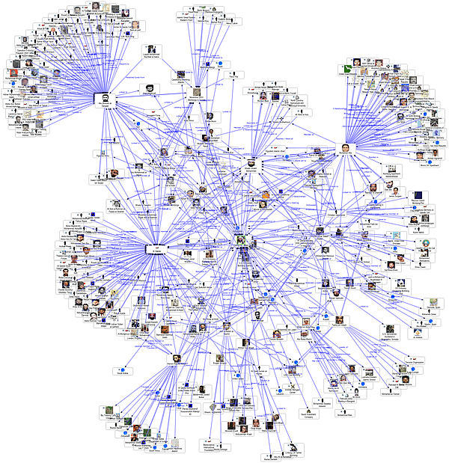
Figure 1 Social Network Diagram. fmsasg.com

An actor-network therefore could be offered in visual form, ie. not in a written report, but as an ethnographic drawing (Ingold, 2011) (see figure 2)
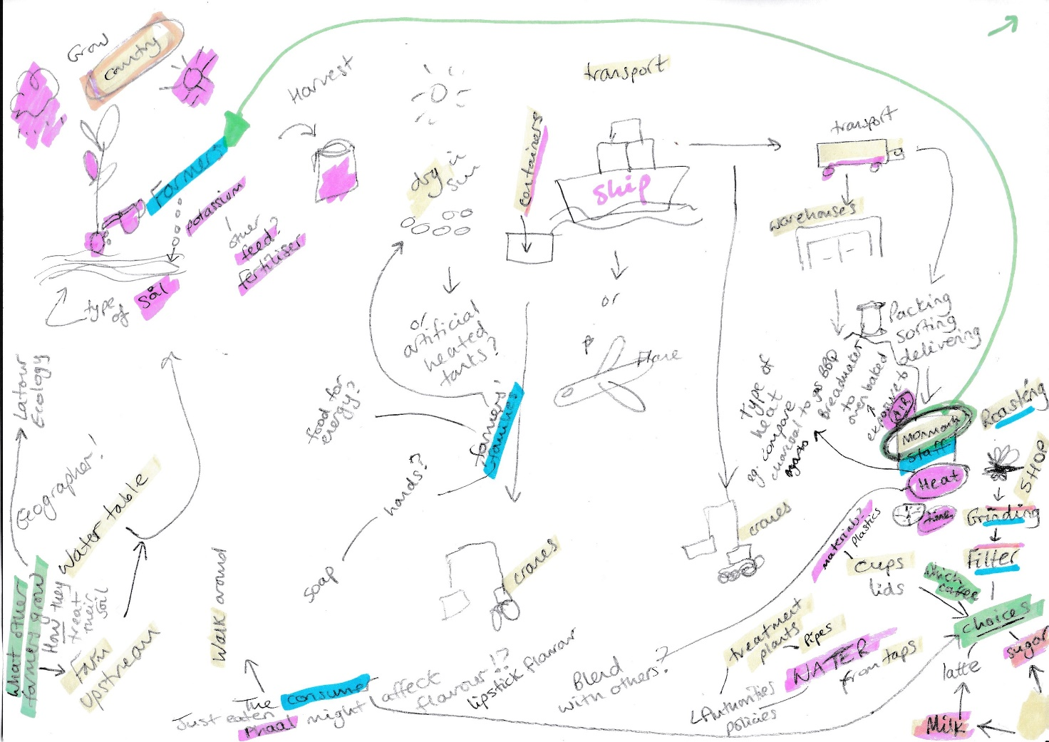
Figure 2 Ethnographic drawing of Monmouth Coffee's Actor-Network. Origin: Sarah Page 2019, on Ben Coles’ Ingesting Places

The concept of place being embodied into coffee is a subjective call that involves phenomenology in fieldwork which is extremely difficult to convey to others. Latour says everything is social, there are no facts, just relations (Latour, 2009). A quick and easy way to assess whether Coles’ ethnography has identified the relations in the Monmouth actor-network is to draw them
(figure 3)

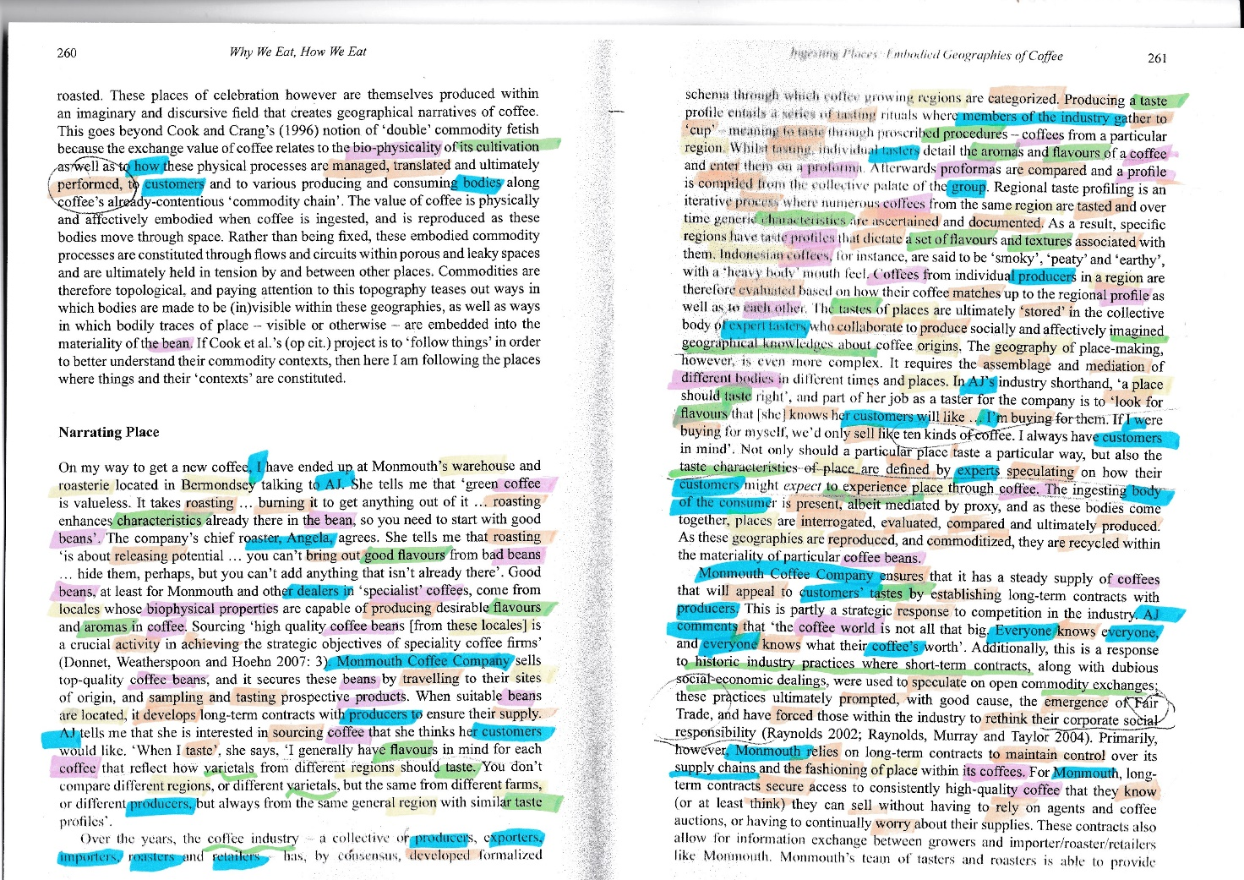
Figure 3 Highlighted Ethnographic Text, showing actants in the Actor-Network of Monmouth Coffee – Original Text Coles, 2013
Human actants performances Non-human actants intangible actants

Conclusion

The ethnography that Coles has crafted is itself part of a vast network of research into relationships and consequences in the production and consumption of coffee. The Actor-Network Theory (ANT) runs through the ethnography, considering all actants, whether human or non-human and includes the geographies or place-making that Coles set out to study. This review has identified three themes from the ANT and considered their application to the ethnography. These themes were, The Actor-Network Relations, The Human and Non-human Actants and the Performance, Power and Stability of the network. With the first theme, the relations are described with Coles as a participant observer. He interviews, discovers and observes the range of relations in the network, between the farmers, the employees, the roaster, the profilers and the consumers. The second theme identifies the actants in the network, paying attention to the equipment, machinery and methods of roasting, grinding, filtering and serving coffee, thus identifying both human and non-human actants. In the third theme, Coles’ summary of the translation of place into coffee is analysed as being the Monmouth imagined place, rather than the actual place of origin. The power imbalances are discussed and the conclusion drawn that the commodification of coffee is the actor-network for the Monmouth Coffee Company, and the actants in the network perform to meet the needs of the business and produce the coffee. Under the concept of power and stability, the ANT methodology of (de-)punctualisation and black-boxing is identified, and Coles investigates the roasting and categorisation of coffee. This does not break the network but alters the illusion for Coles of the black box, the actor-network operating to create the place-making that he intended to study.

Some illustrative networks are included as figures at the end of this review, to demonstrate how a visual representation of a network and an ethnography can be combined to show an actor-network’s actants and relations. Whilst these figures have not been produced by Coles, they evidence the relations in his ethnography and visually confirm the presence of his descriptions. alternative way of reviewing his work.

References

Barad, K. (2007) Meeting the Universe Halfway. Quantum Physics and the Entanglement of Matter and Meaning. Durham: Duke University Press.
Callon, M. (1999) ‘Some elements of a sociology of translation: Domestication of the scallops and the fishermen of St. Brieuc Bay BT - The science studies reader’, The science studies reader, pp. 67–83.
Coles, B. (2013) ‘Ingesting Places: The Embodied Geographies of Place-making’, in Why We Eat, How We Eat. Contemporary Encounters between Foods and Bodies. Routledge.
Deleuze, G. and Guattari, F. (1987) ‘A Thousand Plateaus’, SubStance, 20, p. 117. doi: 10.2307/3684887.
Gell, A. (1998) Art and Agency:An Anthropological Theory. Oxford: Oxford University Press.
Ingold, T. (2011) Being Alive. Essays on Movement, Knowledge and Description. Abingdon: Routledge.
Kien, G. (2016) Actor-Network Theory.
Latour, B. (1987) Science in Action. Cambridge: Harvard University Press.
Latour, B. (1999) Pandora’s Hope: Essays on the Reality of Science Studies. Cambridge: Harvard University Press.
Latour, B. (2005) Reassembling the Social An Introduction to Actor-Network-Theory. Oxford: Oxford University Press.
Latour, B. (2009) ‘Will non-humans be saved? An argument in ecotheology’, Journal of the Royal Anthropological Institute, 15(3), pp. 459–475.
Law, J. (2007) ‘Actor Network Theory and Material Semiotics’, The New Blackwell Companion to Social Theory, (April), pp. 141–158. doi: 10.1002/9781444304992.ch7.
Winner, L. (2017) ‘Upon Opening the Black Box and Finding It Empty : Social Constructivism and the Philosophy of Technology Author ( s ): Langdon Winner Published by : Sage Publications , Inc . Stable URL : http://www.jstor.org/stable/689726 Upon Opening the Black Box and F’, Science, Technology, & Human Values, 18(3), pp. 362–378. doi: 10.1007/s00535-006-1966-z.
Social Network Diagram. Sentinel Visualizer http://www.fmsasg.com/SocialNetworkAnalysis/

