section 1: Front page



Name | Faeryn Matthew Kenneth-Troy LaVerick
Student Number | 2007555
Module Name | Developing Relationships and Workplace Achievement
Module Number | BMSW5102_BIRM
Lecturer | Sujeewa Herath

Section 2: Task



Section 3: Contents

Table of Contents
Front page 1
task 2
contents page…………………………………………………………………………….2 INTRO 2
Answer 1 4,5,6
Answer2………………………………………………………………………………....6,7
Answer 3 8,9
SWOT, PDP…………………………………………………………………………9,10,11
Conclusion…….………………………………………………………………………..11
References……………………………………………………………………………12,13

In today’s forever changing society with new technology being developed and delivered every day, as a business it is important that your staff and yourself are working in synchronisation to develop and grow with the times.
In the body of this work, I will be using critical discussion and evaluation to discuss:
- The importance of employee motivation
- evaluate how reward makes an impact on organisational performance
- the importance of training and development
I will also be delivering a more up to date Swot and PDP for myself, followed with a conclusion.

Section 4: Big Local Who and what are we?

Hill Top & Caldwell Big Local (HTC) is a project that covers Old Hill Top, Chilvers Coton, New Hill Top & Caldwell.
Together these neighbourhoods were awarded £1 Million from the Big Lottery Fund to make a lasting positive difference to the area over 10 years.
The project is resident led, what we do is driven by what the people who live here tell us what their priorities are – so we would love to hear from you.
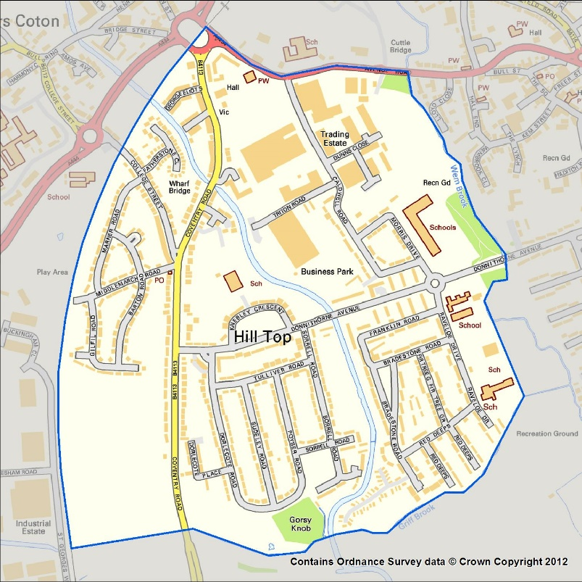
The local trust (http://localtrust.org.uk/) Supports large local projects (there are 150 of us across England).
In our area, it was started in 2012 to bring people together to make their communities a better place to live.
Large-Scale Local Effects:
- Communities will be better able to recognise local needs and respond accordingly.
- People will have more skills and confidence in the future, allowing them to continue to identify and respond to needs.
- The community will have an impact on the issues it prioritises.
- People will believe that their neighbourhood is a better place to live.

Section 5: Answer 1

In this section I will be giving a Critical evaluation on the role and importance of employee motivation in performance enhancement using Hilltop and Caldwell Big Local, I will supply a critical discussion on the various motivation factors that the organisation should use to develop employees for the future.
I would like to supply some examples and explanations for the two main types of motivational factors, Intrinsic motivation, and extrinsic motivation.

Intrinsic  Intrinsic motivation is doing something because you find it rewarding.  Intrinsic motivation is performing an activity for its own sake rather than a reward or to prevent punishment with the behaviour itself being the reward. | Extrinsic  Extrinsic is being motivated to perform a behaviour or activity because a person either wants to avoid punishment or earn a reward.  Extrinsic motivation enables you to engage in a behaviour not because it brings satisfaction or that you enjoy what you are doing but simply because you expect to receive a reward or avoid something unpleasant.
Examples of intrinsic motivation within HTC Big Local:  - Delivering a service to the users because staff are receiving awards.  - Delivering a service in a way to avoid punishment.  - Delivering a service to win a chance to go to the Annual big local get together.  - Training up to get a good performance review.  - Doing things for money/wealth  - Doing something to climb the ladder or rise in the ranks of the business | Examples of Extrinsic motivation within HTC Big Local:  - Delivering a service because the service itself is rewarding.  - Delivering a service because you find it challenging and rewarding.  - Delivering a service simply for the fun and excitement of what the service will provide to the service user.  - Learning from the experience because you find it fascinating.  - Doing things for personal wellbeing

With neither form of motivation being right nor wrong, it is a force that is driven to achieve a goal-oriented behaviour.
As you can see from the examples above and what Hilltop and Caldwell Big Local have done, motivation is critical to the success of leaving a legacy. Without motivated employees, HTC Big Local will be unable to continue its work after 2023 because the remaining lottery funds will have to be returned. In order for HTC Big Local to continue operating, sustainability must be achieved before that date, and it must become a legal entity in its own right. As a result, it requires a dedicated, motivated team on board to ensure success and the ability to move forward in all that it does in the future.
In order to keep the company afloat, the hope to continue is key when using both motivational in properties: not only to be successful, but also to enable a better outcome not just for HTC Big Local but also for HTC Big Local residents.
There fore when it comes to motivational theory whether it be one going against the other or working side by side I have chosen comparisons: (Maslow, 1943, 1962, 1987) Herzberg’s dual-factor theory (1959) Maslow’s because it goes in to how when a persons needs are met from a hierarchy perception that not only will people tend to work better but will feel better bringing the outcome that they are more fulfilled/Motivated in the workplace and will want to give 110%. Alongside Herzberg’s dual factor theory with it being both intrinsic and extrinsic in the way of rewards/returns for the members of staff, both models show that when put in to practice that the success rate is higher and the people/staff feel better within themselves.

According to Akianbi, (2011) from his research in to intrinsic motivation, extrinsic motivation, and reward that out of 100 people that took part in the research led to the findings showing that the best form of reward for members of staff below the managerial level is extrinsic reward, whereas further findings stated that those wealthy, at managerial level and up were happy with the intrinsic kind of reward.

Performance
Role
perceptions
Perceived value
of reward
Expectation that effort
will produce reward
Ability
Source: Porter and Lawler (1968)
Effort

Heading 6: Answer 2

In this second section, I will Critically evaluate how reward makes an impact on organisational performance using HTC Big Local.
When talking about rewards we are opening many doors as the spectrum of types of reward is beyond compare, again they fall under the same named two Categories, Intrinsic reward, and extrinsic reward Here are some examples:
Examples of Intrinsic reward within the HTC Big Local: | Examples of Extrinsic reward within the HTC Big Local:
- Appreciation of hard work  - Having a sense of achievement  - A sense of challenge and enjoyment  - Good work/life balance  - Opportunities of advancement  - A sense of pride  - Family atmosphere  - Acknowledgement | - Training opportunities  - Cake and coffee  - A weekend away all inclusive with other Big Locals  - A chance to network  - Meals with colleagues  - Equal opportunities

As you can see, these are just a few examples; working with the people I do, I'd say there's at least a 60-40% split, with intrinsic motivation being both the primary motivator and the primary source of reward, though training is given and offered when and where gaps are identified that need to be filled (and not just with coffee and cake ha-ha).
According to Armstrong (2007, p1), the development of a reward system comprises of interrelated procedures and practises that work together to ensure that reward management is carried out to the benefit of the organisation and its employees.
The 'total reward' approach Tyson, (2015, p277) to reward management emphasizes the significance of evaluating all components of compensation as a cohesive whole that is linked to other HR initiatives aimed at increasing employee motivation, commitment, engagement, and development. "Reward programmes must be integrated with other HRM initiatives, such as talent management and human resource development," says the report. Reward management is an important component of an HRM approach to people management" (Armstrong,2007, p.3).
Here Tyson, (2015) and Armstrong, (2007) explain that the “total reward” system raises employee motivation keeps employees engaged and committed to the organisation and also enables the employees to develop their own sets of skills. With all this in play in all areas throughout the organisation will only enable the organisation to grow and prosper within itself.
With all of this in mind, I'd like to emphasise the importance of the reward system to not only HTC Big Local, but all workplaces and organisations, as it shows employees that they are all valued, that they are all part of the team, similar to how, say, your body or an old pocket watch, if one of the components is lost or broken, it affects the entire machine, and I'm afraid the cogs will not turn correctly, the belt wont drive and the heart will cease to beat until the “total reward” system is fully implemented throughout.

Heading 7: answer 3

Here I will be Critically assessing the importance of training and development in Hilltop and Caldwell Big Local and how it supports employee satisfaction and business performance.
It is very important to Hilltop and Caldwell big local and its employees that the opportunity to train in all areas are given, a huge percentage of the employees are voluntary and possibly join the committee with hardly any qualifications at all being from the areas that Hilltop and Caldwell big local are reaching out to help, at hilltop and Caldwell big local it is primary that the training be given in the best possible ways some examples are:
- Bitesize training which is smaller and more manageable
- Just-in-time training which is training that needs to be straight away
- Transfer training which is training given that can be taken with you to all positions gained within the organisation
Effective training uses a systematic approach with an emphasis on skills analysis.

Reynolds five stage training process (2004)

Identify learning needs

Plan training programs

Techniques, Facilities, Locations, Trainers

Implement training

Evaluate training

The design was created in the 1960s for industrial training boards and is based on a simple Five-stage paradigm, as can be seen in the above diagram.

- Determine your training requirements.
- Determine what kind of training is required to meet these requirements.
- Implement training with the help of professional and well-trained trainers.
- To guarantee that training is effective, follow up and review it.

Training not only helps the employee better themselves but enables them to become a benefit/asset to the business/organisation bringing better productivity, better quality and reliability, Reynolds (2004: 45) stated that traditional training tends to "emphasise subject-specific information rather than attempting to enhance core learning capacities.
Training, as Reynolds (2004: 45) points out, has a complementary function to play in accelerating learning: 'Rather than considering it as a comprehensive and all-pervasive people development solution, it should be reserved for situations that require a more directed, expert-led approach.'

According to Lambert, Vero, Zimmermann (2012) the continuous development of learning and development to enable career paths to become more secure at European policy level. Though there are questions surrounding how the implementation and hoe it should be shared amongst employees, employers, and public institutions. studies were based on quantitative and qualitative surveys given to employers and employees provides a model for professional growth that is based on capability.

Heading 8: PDP

SWOT

The four categories of the SWOT analysis are strengths, weaknesses, opportunities, and threats. Each region can help bring out elements that are crucial for success in a business, throughout life, and on decision implementation, according to Doctor Doug Leigh Ph.D., Doctorate, (2009). Here's an S, W, O, T analysis of myself from my own perspective, along with suggestions for how I might improve my work with Hilltop and Caldwell Big Local.

Strengths  I am a person who is driven by a strong desire to succeed.  I am courageous.  I am a powerful individual.  I have overcome adversity.  I adore with all of my heart.  I am a fantastic friend and colleague.  I enjoy learning new things.  I am truthful. | Weakness  My heart is on my sleeve.  Others may find my enthusiasm for life to be too much for them.  I live with numerous hidden ailments on a daily basis.  Because I am half deaf in both ears, I may misunderstand.
Opportunities  To reach out and seize the bull by the horns of life.  to broaden my understanding  To improve myself in order to be a fantastic role model for my son  To show others that no matter what happens to you, you can do anything if you set your mind to it.  to realise my ambitions | Threats  Occasionally, a smidgeon of self-doubt  A concern that once I get to a certain point, there will be nothing left to do.  That my health would deteriorate, and that I might be exploited

PDP (personal development plan):

Beausaert, Segers, and Gieselers (2011) claim that A personal development plan (PDP) is needed to plan, enable, and show a person's path of action/growth in both personal and professional settings; it is a plan that grows and moves with you on every step forward you take, setting the next goal as soon as one is achieved, and constantly looking at what/where you need to go next to keep that path of self-growth moving forward. My three-year personal development strategy is as follows:

PERSONAL DEVELOPMENT PLAN
Name: Faeryn LaVerick Year: 2001-2004
Reviewed on: 22/11/2021 Quarterly Reviews: [ 1]
Long-Term Goal:
• To be taught in all areas to assist Hilltop and Caldwell Big Local in becoming its own legal body by passing my BA, HONS in Leadership abilities
• Both Level 5 and Level 6
• To aid with the long-term viability and heritage of the Hilltop and Caldwell large locals.
• Complete a first-aid course
• Complete my food hygiene
• Identify a need in the business and help fill it with solutions
• Create and execute effective activities
• Earn my master's degree

Development Goals for This Year:

• Public speaking
• Problem-solving
• Self-confidence
• Food safety
• First-aid
• Plan and execute a successful activity

Delivery Goals for This Year:

• To improve my public speaking skills and control my anxieties.
• To be able to control my internal feelings when it comes to problem-solving.
• To be more organised when it comes to deadlines than I was at the start of last year.
• Strengthen my self-belief and STOP being so hard on myself.
• Finishing my first aid course
• Finishing my food hygiene course
• Finishing my level 5 BA Hons

Progress Report & Notes
Date | Notes
25/12/21
25/03/22
25/06/22

As I was doing a swot and personal development plan on myself the above swot and personal development plan have been taken from a piece of work that I wrote last year I have developed and adapted items to suit my situation and needs.

Heading 9: conclusion

When it comes to critical thinking and organisational commitment, it is widely accepted that the impact of human resource management (HRM) practises can generate a competitive edge for the organization's success. On the contrary, in today's workplace, turnover has become a trend and is on the rise. The major goal of this research is to show a link between HRM practises and organisational commitment, as well as their impact on turnover intentions, its about good practice and the importance of not only the employer but also the employee as shown in this piece of work on how motivation, reward, continual training, and development, are a key factor to gain a successful business with happy employees.

Heading 10: References
Website title:
URL: |  | https://www.simplypsychology.org/maslow.html
Akanbi, P.A., 2011. Influence of extrinsic and intrinsic motivation on employees’ performance. Retrieved September 18, p.2016.

ARMSTRONG, M., 2007. PART 01: THE FUNDAMENTALS OF REWARD MANAGEMENT; Chapter 01: Reward management: an overview. 2nd ed. edn. London: Kogan Page Ltd.

Beausaert, S.A.J., Segers, M.S.R. & Gijselaers, W.H. Using a Personal Development Plan for Different Purposes: Its Influence on Undertaking Learning Activities and Job Performance. Vocations and Learning 4, 231–252 (2011). https://doi.org/10.1007/s12186-011-9060-y
Cottrell, Stella. Skills for Success: Personal Development and Employability, Macmillan Education UK, 2015. ProQuest Ebook Central, https://ebookcentral.proquest.com/lib/trinity/detail.action?docID=4762723.
Hoffman, E. (1988). The right to be human: A biography of Abraham Maslow. Los Angeles, CA: Jeremy P. Tarcher.
Kenrick, D. T., Neuberg, S. L., Griskevicius, V., Becker, D. V., & Schaller, M. (2010). Goal-driven cognition and functional behavior: The fundamental-motives framework. Current Directions in Psychological Science, 19(1), 63-67.
Leigh, D., 2021. SWOT Analysis. [online] Wiley online library. Available at: <https://onlinelibrary.wiley.com/> [Accessed 18 November 2009]
Lambert, M., Vero, J., & Zimmermann, B. (2012). Vocational training and professional development: A capability perspective. International Journal of Training and Development, 16, 164-182. http://dx.doi.org/10.1111/j.1468-2419.2012.00402.x
Maslow, A. H. (1943). A theory of human motivation. Psychological Review, 50(4), 370-96. Maslow, A. H. (1954). Motivation and personality. New York: Harper and Row.
Maslow, A. H. (1962). Toward a psychology of being. Princeton: D. Van Nostrand Company. Maslow, A. H. (1970a). Motivation and personality. New York: Harper & Row.
Maslow, A. H. (1970b). Religions, values, and peak experiences. New York: Penguin. (Original work published 1966)
Maslow, A. H. (1987). Motivation and personality (3rd ed.). Delhi, India: Pearson Ed
Miller, J. D., Reynolds, S. K., & Pilkonis, P. A. (2004). The Validity of the Five-Factor Model Prototypes for Personality Disorders in Two Clinical Samples. Psychological Assessment, 16(3), 310–322. https://doi.org/10.1037/1040-3590.16.3.310ucation.
Tay, L., & Diener, E. (2011). Needs and subjective well-being around the world. Journal of Personality and Social Psychology, 101(2), 354-356. doi:10.1037/a00
Tyson, s. (2015) Essentials of Human Resource Management, London, routledge
Wulff, D. M., & Maslow, A. H. (1965). Religions, values, and peak experiences. The Journal of Higher Education, 36(4), 235.

