Student Name: Charlotte Clark
Personal Number: 1702364
Programme of Study: Photography in the Arts
Task: Creating an Exhibition
Module: M4X01559
Tutor: Rob Jones

EXHIBTION TITLE: Love Thy Neighbour
We find ourselves at a point where history is looking to repeat itself due to ignorance and our refusal to learn from prior mistakes. The decisions being made today reflect those of events that have already happened as, we find ourselves on the brink of war, discrimination taking lives and displays of cruelty around the world; it’s these acts that made me think of Bible’s commandment ‘Love thy neighbour’ (Goodman, 2008: 1). This commandment tells us to love everyone and accept those around us. However, the more you look into the news the clearer it is to see this commandment is ignored. It is read in many texts about man’s cruelty; how acts of hate affect the world and why we fight one-another. With the threat of the past repeating itself it’s more important than ever to look into our history to see the acts that lead us to destroy one-another, so we’ll learn from them rather than repeat them. The exhibition will look into horrifying aspects of our nature and how they have been documented, from the past to the present, to emphasise our need to learn from them.
It is said by Peirce ‘nothing is a sign unless it is interpreted as a sign’ (Pierce, 1931:58), meaning we interpret things in the way we want to, explaining why human nature is flawed and why no-one will interpret things the same way as one-another causing conflict. It’s this misunderstanding that leads to our mistakes and cruel acts; as historically, misunderstandings can produce fear which can lead onto violence.
The theme of ‘Love Thy Neighbour’ is one of irony, the exhibition shows this irony to highlight how much we have done to one-another; meaning that when the viewer enters the exhibition it would have a larger impactful as the contents would be unexpected with the misleading title. To highlight mankind’s destruction, the art displayed documents the low-points in humanity, showing on its dark-sides such as wars, discrimination, violence and other hateful acts.
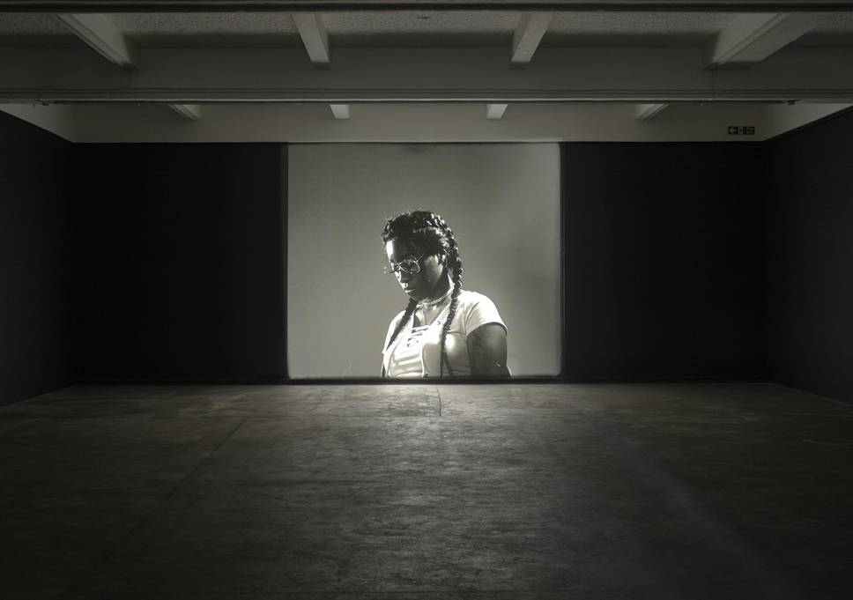
The exhibition looks at events from the past and present to find art that would truly express the situation and impact the viewer rather than imitations made just for profit.
Luke Willis Thompson, Auto-Portrait of Diamond Reynolds (2017)
The first artist chosen was Luke Willis Thompson, his Auto-Portrait of Diamond Reynolds is an inspiration, giving dignity and power to the victim of racism. It shows a modern example of how man treats one-another; as the shooting of Philando Castile demonstrates the racism and police brutality that occurs today. It shows the effect of violence on the victims and helps to enforce the message that’s being created; of how hateful actions are destructive.
The imagined space is based off the Mission Gallery in Swansea, as having a separate room worked with displaying Luke Willis Thompson’s Auto-Portrait, as it’s intended to be shown alone for a bigger impact on the viewer, however, since the back room in the mission gallery is curved the projection would be obscured. The changes made were to the shape of the backroom with the entrance to the side, so the projector can sit undisturbed, with the viewer being isolated from the main exhibition. This artists work, whilst standing-out on its own merit, works well with older pieces of art due to its subtlety and black-and-white format allowing unity with older, black-and-white, photography.

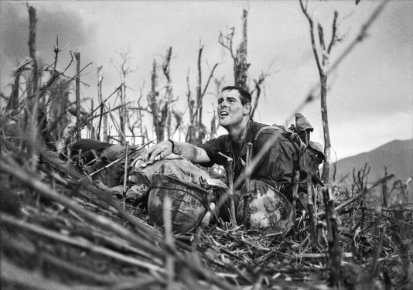
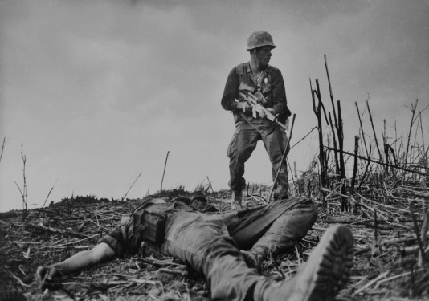
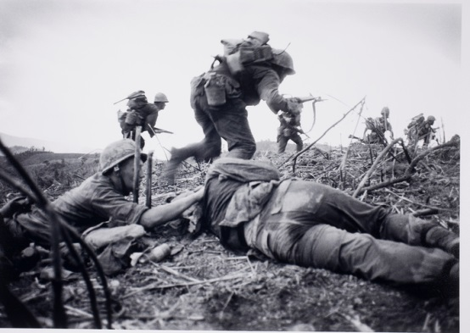
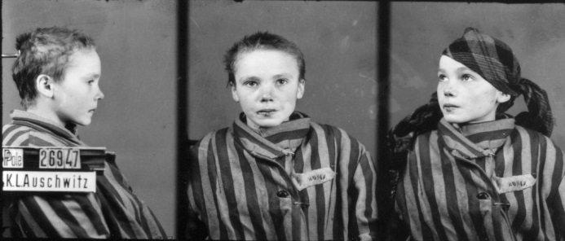
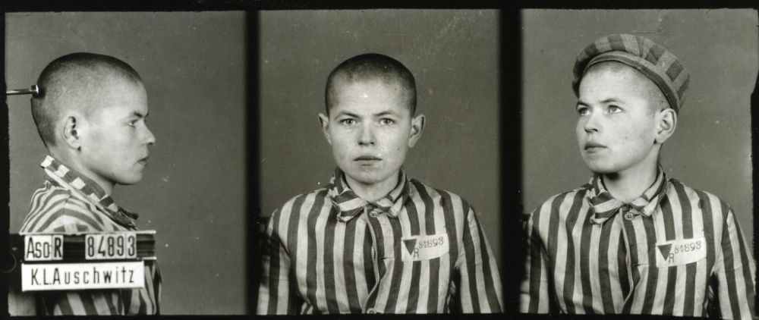
Catherine Leroy, American Soldiers in Battle (1955-1975)
An example of this is Catherine Leroy, whose war photography is well-known due to its hard-hitting nature showing war through the anguish the soldiers sent to fight and kill, or be killed, like pawns in a game. It’s this reason that these images were chosen, showing death surrounding the soldiers, as a testament to the kill or be killed nature of war. These acts in war align with Pinker’s views mankind’s cruelty as he points out how ‘nothing can force me to believe that anyone except me is conscious. This power to deny that other people have feelings is not just an academic exercise then all-too-common vice, as we see in the long history of human cruelty,’ (Pinker, 2007) this explains how we forget people feel and instead view them as tools that can be manipulated to our advantage without consequence; such as how the deaths of people we send to war effect those who knew and loved them, not only those killed. It portrays a larger scale of cruelty around 43 years ago; whilst this is still recent history it explores beyond the Auto-Portrait.

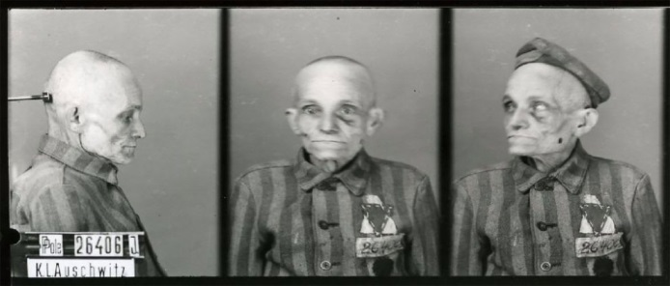

Wilhelm Brasse, ID images from concentration camps from World War II (1939-1945)
Leroy’s images tie into Wilhelm Brasse’s work of ID images from concentration camps from World War II. These images are powerful as, whilst they are portraits of those going into Nazi concentration camps, the images chosen show the range of people who were discriminated against because of the religion they were born into. The fact that this piece isn’t made out of free-will but by force, as Wilhelm Brasse was another Jew taken into the concentration camps and forced into work, makes the pieces all that more hard-hitting in highlighting the tragic nature of this period. For Leroy’s series of work, American Soldiers in Battle from the Vietnam war, the piece will be placed on one of the longer stretches of wall in the room due to having found three images that were powerful from this series to display the message of the exhibition. Alongside this, as the pieces from this series could mirror the pieces from the ID Images from the Concentration Camps; as there are also three images from this collection displayed it would leave symmetry to the exhibition making it easier to navigate because of how they tie into one-another, both being photographs of war, though showing a different perspective of suffering; those captured and those fighting and the pain both sides are put through.
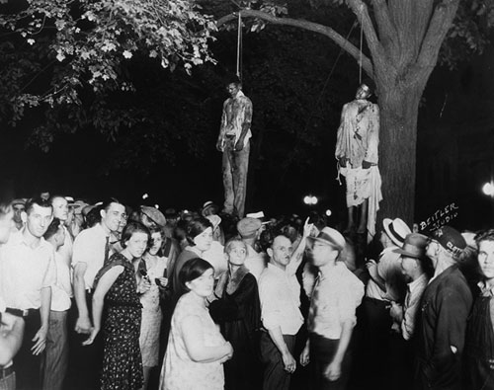
It’s the discrimination seen in Brasse’s work that ties into the next chosen piece of work to display.
Unknown (In the Collection of James Allen), Lynching, Georgia (1930)
The creator of this last image is unknown though has been collected into the works of James Allen and featured the book Without Sanctuary: Lynching Photography in America that he created with John Lewis and Leon F. Litwack. This book was a testament to the cameras ability to make us remember events that we choose to forget, from this fact this piece ties in with the theme of irony. The image depicts the lynching of two men in Georgia, 1930. This is the oldest piece displayed; it represents the results of racial hatred as even though we’re all made up the same parts and hold the same needs we treat people with cruelty and different standards because of their skin-colour. It rounds off the exhibition as even though it is the oldest piece it represents the same issues as the 2017 Auto-Portrait.
This piece would be displayed on the back-wall, making it the first image seen when people enter. Being the only singular image from a series to be displayed, it seemed fitting to use the smaller wall to display the image. This allows the image to be blown-up allowing the detail within the photograph to be seen, showing the actions of those in the photograph towards this sight; empathizing how hateful mankind can be to one-another. This links with what Martin Luther King Jr famously said “the ultimate tragedy is not the oppression and cruelty by the bad people but the silence over that by the good people,” (King Jr, 2016) describing how man’s hateful actions are destructive, but our inaction is a larger tragedy, as refusal to stand-up and fight for what is right means those in the wrong will never learn, causing repetition of our history of destruction towards one-another.

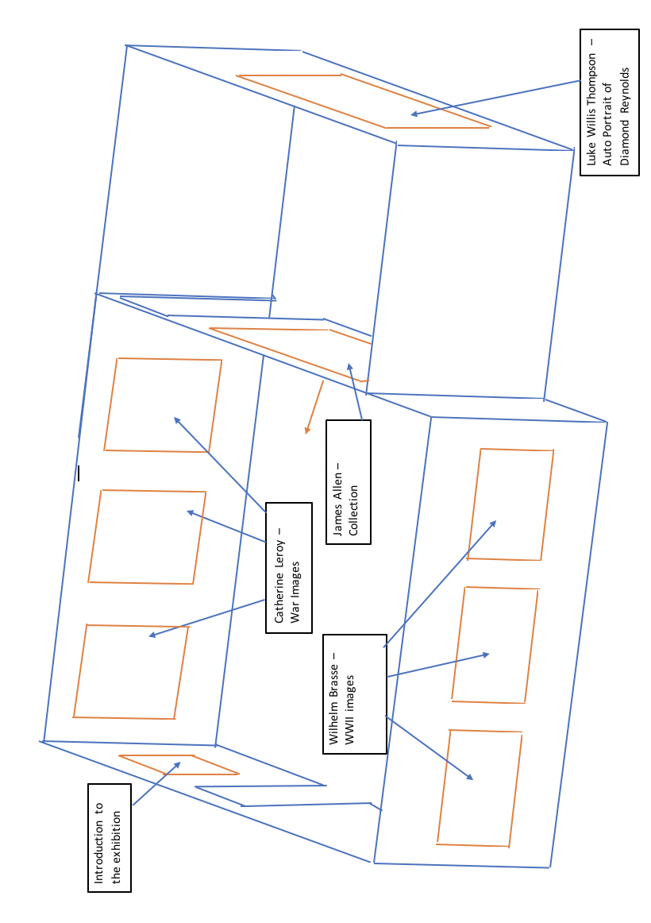

Word count: 1300

Reference:

Davidson, J. (2016). White Silence Is Not An Option. [online] HuffPost. Available at: https://www.huffingtonpost.com/jess-davidson-/white-silence-is-not-an-o_b_10927210.html [Accessed 29 Apr. 2018].
Goodman, L. (2008). Love thy neighbour as thyself. Oxford: Oxford University Press.
Peirce, Charles Sanders (1931): Collected Writings (8 Vols.). (Ed. Charles Hartshorne, Paul Weiss & Arthur W Burks). Cambridge, MA: Harvard University Press.
Pinker, S. (2007). The Brain: The Mystery of Consciousness. [online] TIME.com. Available at: http://content.time.com/time/magazine/article/0,9171,1580394-7,00.html [Accessed 29 Apr. 2018].

Bibliography:

Allen, J., Lewis, J. and Litwack, L. (2000). Without Sanctuary: Lynching Photography in America. Santa Fe: Twin Palms Publishers.
Allen, J., Lewis, J., Litwack, L. and Als, H. (n.d.). Without Sanctuary. [online] Goodreads.com. Available at: https://www.goodreads.com/book/show/135012.Without_Sanctuary [Accessed 29 Apr. 2018].
Auschwitz.org. (n.d.). Prisoners photos / About the available data / Museum / Auschwitz-Birkenau. [online] Available at: http://auschwitz.org/en/museum/about-the-available-data/prisoners-photos [Accessed 29 Apr. 2018].
Burns, R. (1826). The Poetical Works of Robert Burns. University of Lausanne: J.F. Dove.
Herman, E. (2017). Opinion | The Greatest War Photographer You’ve Never Heard Of. [online] Nytimes.com. Available at: https://www.nytimes.com/interactive/2017/03/28/opinion/vietnam-leroy-photoessay.html [Accessed 29 Apr. 2018].
The Photographers' Gallery. (2018). Artist Talk: Luke Willis Thompson. [online] Available at: https://thephotographersgallery.org.uk/whats-on/artist-talk-luke-willis-thompson [Accessed 29 Apr. 2018].
Vintag.es. (2017). Wilhelm Brasse’ Mugshots: Photographer Took Up to 50,000 Chilling Photos in Auschwitz for the Nazis During World War II. [online] Available at: http://www.vintag.es/2017/01/wilhelm-brasse-mugshots-photographer.html [Accessed 29 Apr. 2018].

