Task -2
- Sine wave (Channel A): measure time period $T$using oscilloscope cursors
In Proteus, connect a Signal Generator to an Oscilloscope (Channel A). Set the generator to Sine, 1 kHz, 10 Vpp. Display the waveform and use the time cursors to measure one full cycle and determine the time period $T$. Calculate the frequency.
Time Period (s) | Frequency (Hz)
1mS | 1000
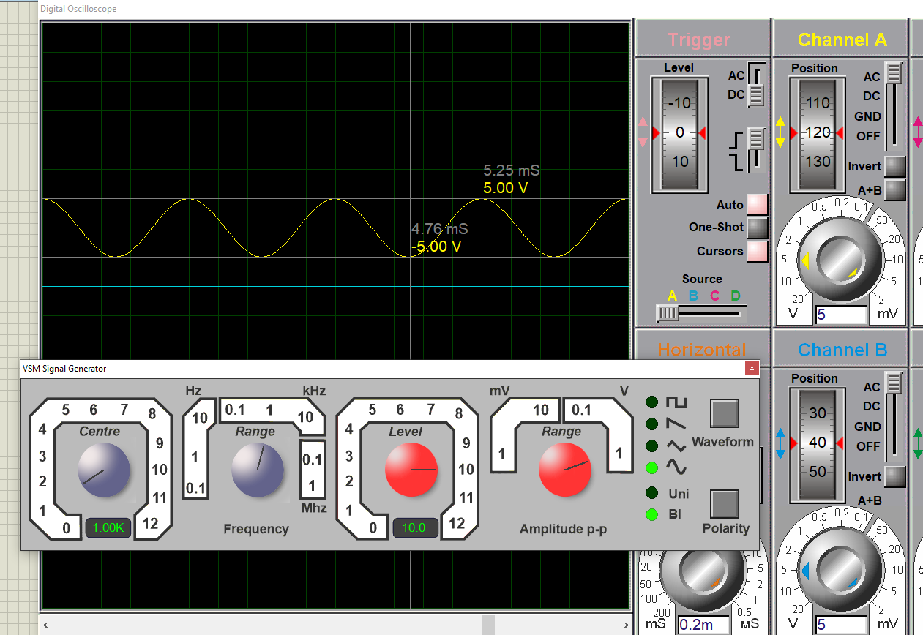
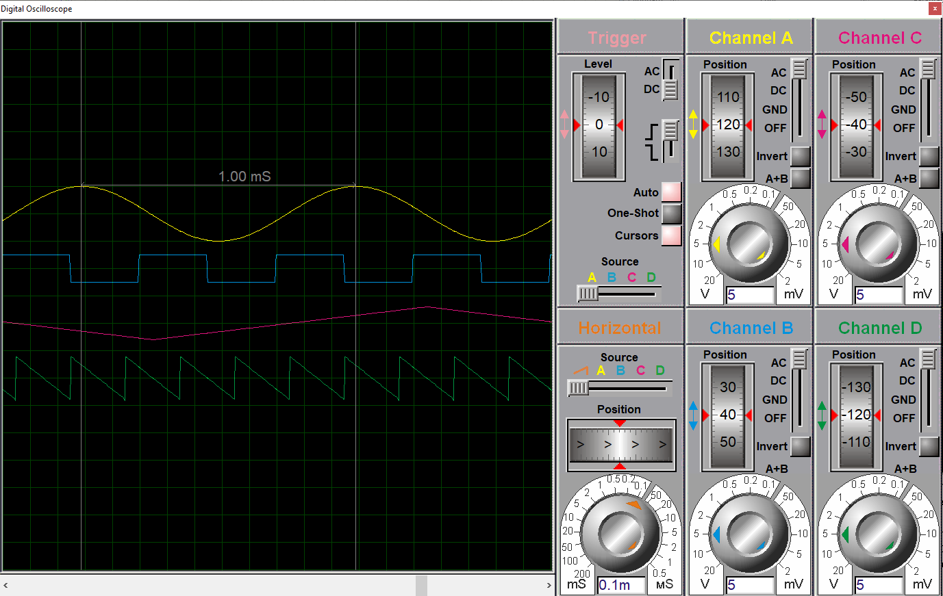

- Square wave (Channel B): measure $T$, frequency, $T_{ON}$, $T_{OFF}$, and $V_{pp}$using oscilloscope cursors
In Proteus, connect a Signal Generator to an Oscilloscope (Channel B). Set the generator to Square, 2 kHz, 5 Vpp. Display the waveform and use the time cursors to measure the time period $T$. Then use the cursors to measure $T_{ON}$(high time) and $T_{OFF}$(low time). Calculate the frequency and use the voltage cursors to measure $V_{pp}$.
Time Period (s) | $T_{ON}$ (s) | $T_{OFF}$ (s) | Frequency (Hz) | Peak-Peak Voltge (V)
500uS | 250uS | 250uS | 2000 | 5Vpp
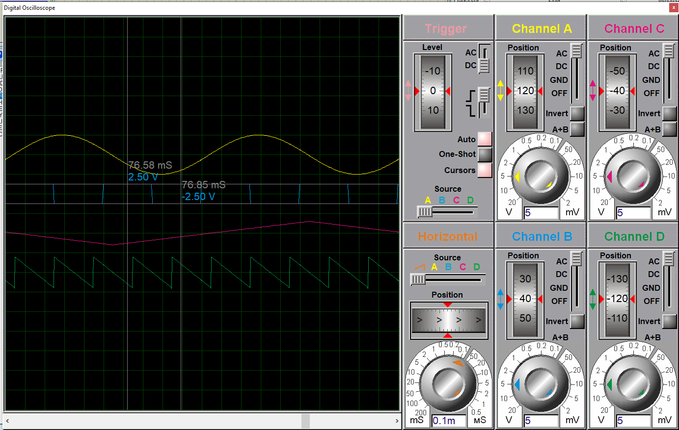
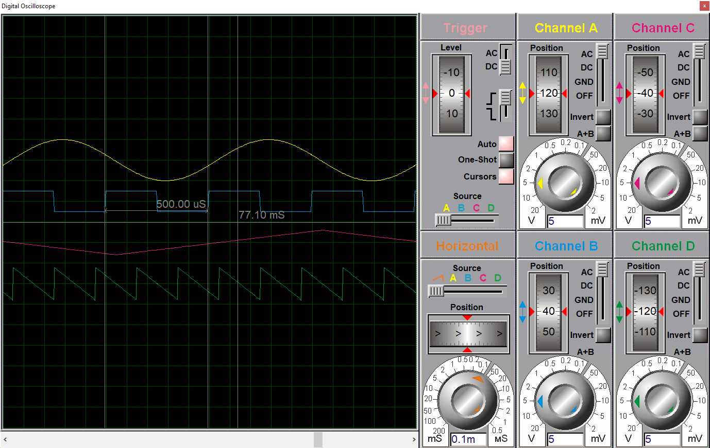
- Triangle wave (Channel C): measure time period $T$using oscilloscope cursors
In Proteus, connect a Signal Generator to an Oscilloscope (Channel C). Set the generator to Triangle, 500 Hz, 6 Vpp. Display the waveform and use the time cursors to measure the time period $T$between two identical points (peak-to-peak or zero-crossing to zero-crossing). Calculate the frequency and the amplitude.
Time Period (s) | Frequency (Hz) | Amplitude (V)
2mS | 500Hz | 3
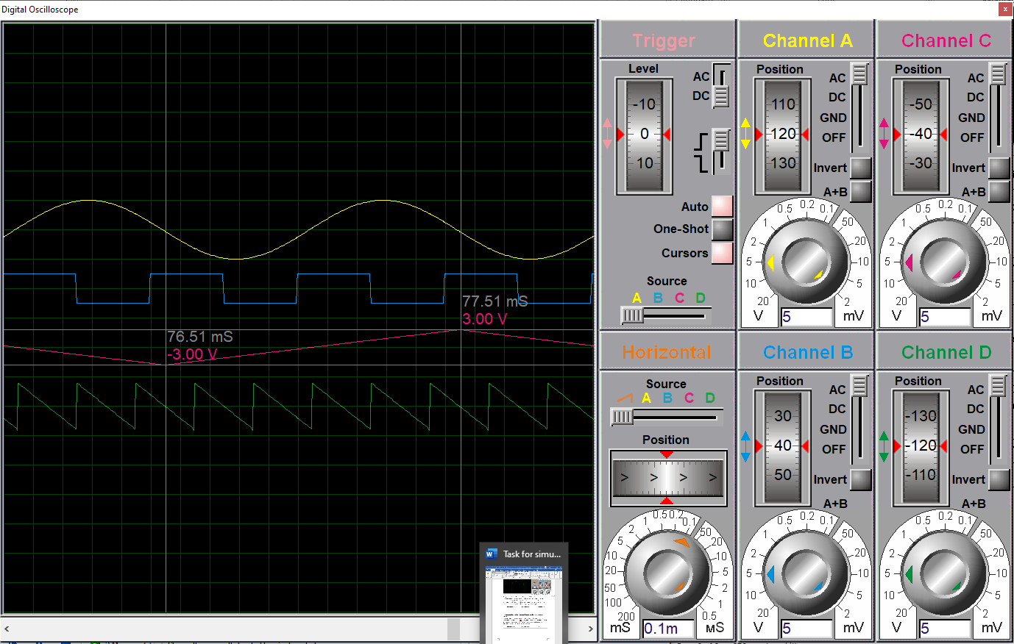
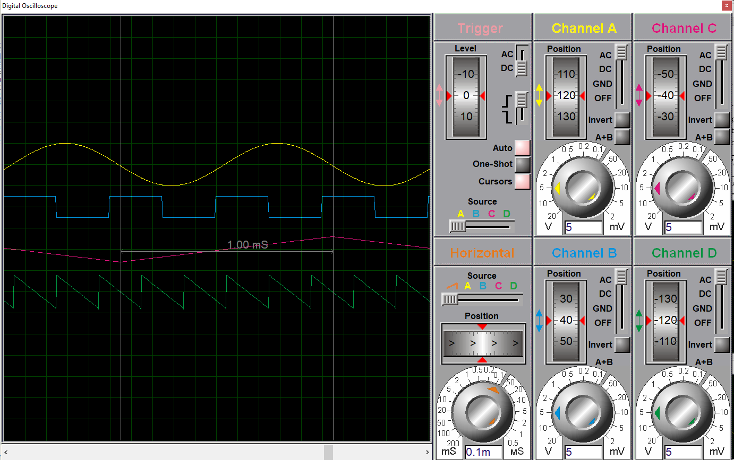
- Sawtooth wave (Channel D): measure $T$, frequency, and $V_{pp}$using oscilloscope cursors
In Proteus, connect a Signal Generator to an Oscilloscope (Channel D). Set the generator to Sawtooth, 5 kHz, 8 Vpp. Display the waveform and use the time cursors to measure the time period $T$(between two successive resets). Calculate the frequency and use the voltage cursors to measure $V_{pp}$
Time Period (s) | Frequency (Hz) | $V_{pp}$ (V)
200uS | 5000 | 8



