MBA MARKETING MANAGEMENT LCMB7001

75 % Assignment

Submission date: 11.01.2022
Word count: 6380
Submission ID: 2115546
Student Name: Viorica Bivol
Lecturer: Tushara Balendran
Table of Contents
Introduction…………………………………………………………………….... 3
- Company background …………………………………………………. .5
- Communication and IMC………………………………………………. 7
- Promotional strategies for Samsung Galaxy brand……………………. 10
- Keller’s Brand Equity Model………………………………………….. 13
- Customer Journey & Customer Touchpoints……….…………………. 18
- The Total Engagement Model…………………………………………..26
Conclusion…...……………………………………………………………….…. 28
Recommendation.……………….………………………………………….……28
Bibliography 30

INTRODUCTION
Marketing can be defined as a pursuit of research and the establishment and fulfillment of human and social needs. Philip Kotler (2009), states that, "marketing needs profitably", which means that marketing in addition to establishing and satisfying consumers also means fulfilling the function of generating profit for any business, in order to maintain a high level of profit to create a longer performance for company.
Marketing is not only a management process, but it is also a good strategic business element that stimulates, facilitates, and replenishes consumer demand. However, marketing also has the function of building the brand image, stimulating innovation, developing relationships, and creating effective channels of communication between consumers of goods and services and companies (Lancaster & Massingham, 2018).
In a modern company that focuses on maintaining the performance relationship between business and consumers, consumers will be positioned at the center, and marketing will be seen as a function that surrounds consumers along with other major functions in a business, as represented in Figure 1.1. This figure shows that the consumer and the satisfaction of his needs must be the basic element on which to focus all the functions of a business.

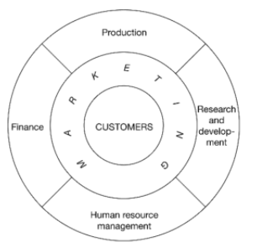

Figure 1.1 The structure of a modern company
Source: (Lancaster & Massingham, 2018)
Marketing management focuses on improving the consumer experience which has been positioned by 72% of companies as a major one. The determination of the touch points of the consumers in their purchase journey must be analyzed and established by any company, in order to ensure a high performance of the customers' experience (Peeter W. J. Verlegh , et al., 2019).
The key aspect of this report will be to determine the communication channels used by Samsung, as well as to establish and describe the Shannon and Weaver communication model. We will also present and detail new ways of promotion both online and offline that will create awareness for our company, and more precisely for the Samsung Galaxy smartphone brand.
The Keller's Brand Equity model will be directed to our company and a critical analysis will be performed, which will describe the advantages and disadvantages of the model.
This report will present the company's customer journey map, which will be explained and critically analyzed, as well as touch points from all three phases of purchasing the product: before purchasing, during and after purchasing a phone. Samsung Galaxy mobile.
The Total Engagement Model will be presented and reported to Samsung.
To summarize the report at the end, a conclusion will be presented with the recommendations of new touch points that could be used by the company in order to create awareness.

- Company background
Samsung Electronics Company LTD, was founded in January 1969 in order to participate in the development of the performance of the Samsung Group, being one of the most famous companies in the field of sales of electronics and computer products, with headquarters in Suwon, South Korea (Chun, 2015).
SEC (Samsung Electronics Company), produces a wide variety of electronic products some of them being, smartphones, tablet PCs, televisions, home appliances, telecommunication equipment, semiconductors solid etc.
Due to the fact that SEC covers 17 percent of South Korea's GDP, this company not only influences the economic situation of the country, but also the lives of people in general. Samsung includes and is affiliated with other businesses, most of which operate under the Samsung brand. One of these examples is the Samsung Medical Center, which ensures the birth process of Korean people, and they are insured by the Samsung Life insurance company (Chun, 2015).
SEC consists of three departments as shown in figure 1.2, these being:
- component department.
- consumer electronics department and.
- IT/mobile department.
IT/mobile department is composed of three divisions including wireless divisions, network divisions and media solution divisions.

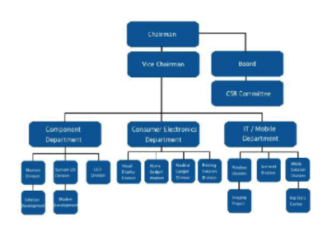

Figure 1.2 Organizational structure chart of Samsung Electronics
Source: (Ying, 2015)
Samsung Electronics Co first entered the English market in 1987 (SamsungNewsroom.Uk, 2012). The SEC currently has several stores located in the UK, where it sells its products, these stores are called:
- Samsung Experience Store.
- Samsung Brand store.
Figura 1.3 below shows some of the locations of the Samsung Experience Store in London.
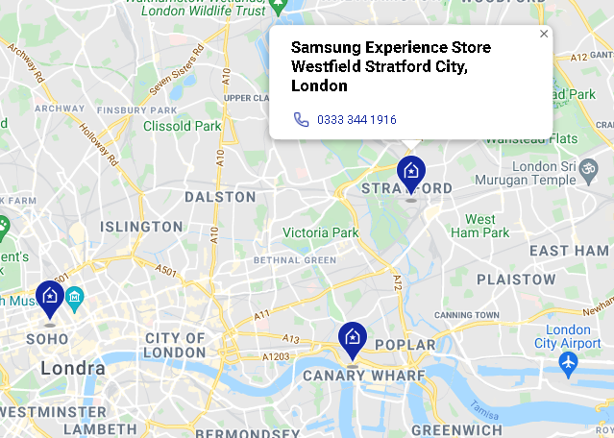

Figure 1.3 Samsung Experience Store London Location
Source: https://www.samsung.com/uk/samsung-experience-store/locations/
- Communication and Integrated Marketing Communications
Nowadays, the emphasis is on establishing the most stable and efficient relations between the seller and the buyer. Due to a vast competitive market and the existence of various products, with different design, performance, but which ultimately meet the same requirements, there is a need to implement new promotional tools. Therefore, these promotional tools are used to inform the buyer or user about the benefits and opportunities that a product can offer and what differentiates it from other products.
Communication, therefore, is a promotional tool, as it is defined as a process of capturing the attention of consumers through various promotional channels and sharing information to the audience about the product, its design, benefits, and possibilities that it offers during use (Kayode, 2014). Also marketing communication is an essential element of the marketing mix, because before positioning a product in the mind of the consumer, first the awareness must be created, through promotional communication which is also part of the promotional mix.
That being said, a basic communication model, which is also considered the '' Mathematical Theory of Communication '' (Al-Fedaghi, 2012), is the Shannon & Weaver communication model.
Shannon & Weaver is a linear communication model frequently used at the technical level representing a framework for analyzing the way a message is transmitted and received (Al-Fedaghi, 2012). However, David Foulger (2004), states that the model shows that communication takes place in an environment that is often direct and unidirectional, but in fact applied to the real-world media, communication is almost never unidirectional, on the contrary being an indirect one.
To support those, (Foulger, 2004) also listed some weaknesses of this model:
- it does not talk much about human communication.
- too formal to explain content.
- static & linear.

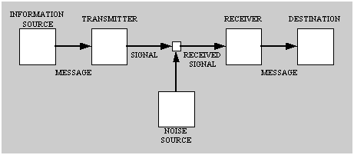

Figure 2.1 Shannon and Weaver Model of Communication
Source: (Foulger, 2004)
Figure 2.1 represented above shows through a diagram the model of Shannon& Weaver, with the seven component parts that will be detailed below.
- Source of information - represents the person who formed the message to be transmitted.
- The message - represents the object of the communication that is sent and received.
- Transmitter is the way this message is transmitted, either directly or indirectly. Direct being from seller to consumer, the indirect being the use of TV broadcasts, newspapers, social media, etc.
- The signal is the one that passes through the channel, in a communication process there can be several parallel signals, just as it exists in face-to-face communication, and on which it depends how we further perceive the information received.
- Receiver - in Shannon's view, this is a tool that receives information, such as a telephone, a TV antenna, and in face-to-face communication the receiver would be the ears or eyes or both.
- Destination - is the one who received the message sent by the sender.
- Noise - represents the other noisy signals in the communication channel that divert and block the main message, creating the error of the information that could be diverted and misinterpreted by the recipient.

Integrated Marketing Communication
Integrated Marketing Communication, which can also be interpreted as relationship marketing, is an effective tool for attracting a certain individual, with a unique message through a certain media element (Blakeman, 2018).
The main objective of IMC is to build long-term relationships between buyer and seller, attracting an individual through an interactive way of informing. Nowadays, experts have not only recreated the concept of IMC, but also redirected it to an environment focused on consumer communication efforts. Therefore, they believe that media efforts and the development of computer programs generate databases ensuring that the message will reach the target consumers intact and correct.
As media channel are seen as a component part of IMC, Figure 2.2 below lists the advantages and disadvantages of using media channels
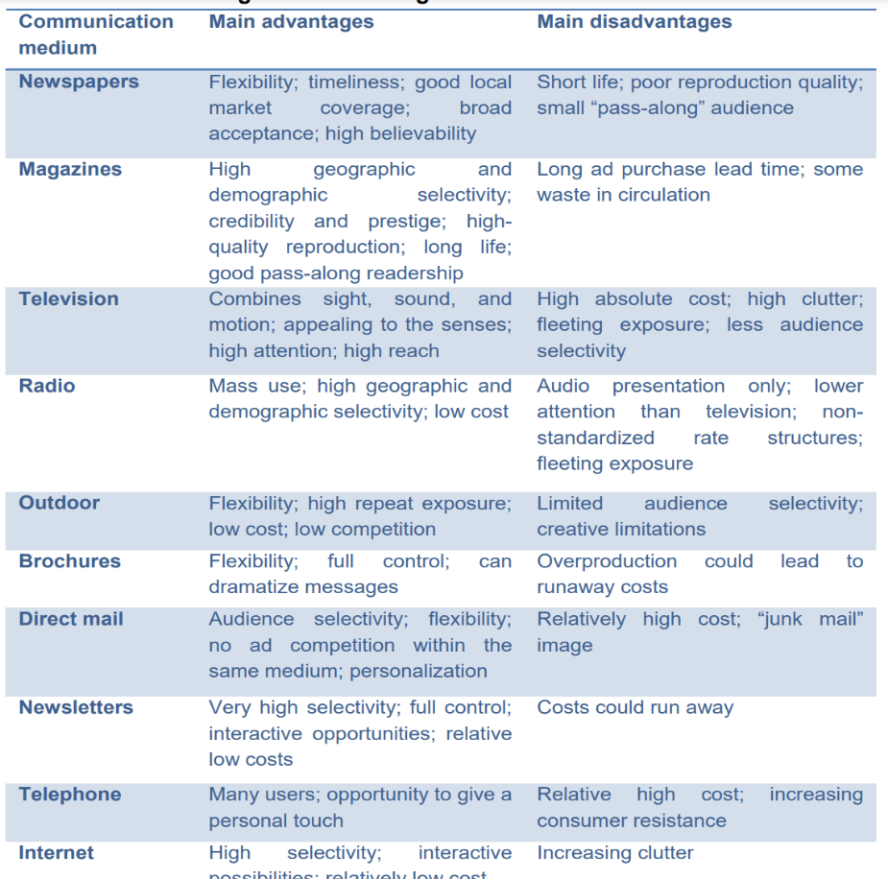

Figure 2.2 Advantages/Disadvantages of Media Channels
Source: (Oana, 2018)
- Promotional Strategies for Samsung Galaxy smartphone brand
NEW ONLINE PROMOTION | - The “Tik Tok” application is a social media platform that allows the user to record a video for fifteen seconds. This App was launched in 2016, and in November 2017 the number of Android and iOS users reached 700 million (Xu, 2019). Samsung could use this platform by introducing the hashtag # let'sgotouniversity, which could be used by students with a Galaxy smartphone and if they would shoot an informative video about the university they go to, and the video description would indicate this hashtag they will automatically be registered at the raffle. Thus, at the end of the year, the company could randomly select three students through selection programs, giving them the opportunity to make a free claim for any product in the Samsung Galaxy series.  - Samsung could use television as a promotional tool by implementing the principle “first come -first served”, so if they broadcast an ad during the evening show, after dinner on Channel 4, one of the most popular TV channels in the UK, according to (YouGov, 2021) Channel 4 was appreciated by over 68 % of people in the UK, and would promote Samsung products, indicating a promo code below, the person who would first send the promo code to the address indicated on TV would benefit from a discount on the purchase of a smartphone Samsung Galaxy.  - Social media influencers are a new type of celebrity endorsement, being an independent third party that motivates and moderately or intensely changes the attitudes of the public towards certain aspects through blogs, tweets and media tools (Freberga, et al., 2011). SE company could enter into partnerships with one of the UK's most famous fashion influencers, Chole Smis, who has a community of 1.2 million followers on Instagram, through which she would film reels about makeup and the latest trends in fashion with the help of the Samsung Galaxy smartphone, thus the quality of the videos would demonstrate the high performance of the device's camera, motivating its followers to adopt the use of a smartphone from this brand.
NEW OFFLINE PROMOTIONS | - Samsung could tailor a funding program for UK university students as an annual scholarship, which would not only support higher education and student performance, but also increase the company's fame and recognition, building consumer confidence in the minds of consumers and its brands.  - International students make up 50% of the total number of students enrolled in the education system. However, in 2014 only 5,639 of them received a Visa - a tool by which companies sponsor students from outside the EU (Cambridge University Press, 2019). As a result, Brexit has prevented EU students who do not have settled or pre-settled status from being able to enroll in employment. Therefore, Samsung could come up with a Visa sponsorship program for high-performance students in innovation, IT and computer science, not only to give it access to high-performing studies, but also to provide the company with qualified employees. That being said, the company, by implementing this program would increase the confidence of EU countries in its products.

- Keller’s Brand Equity Model
Brand represents and can be defined as a set of tangible and intangible attributes associated to create the recognition and identification of the good / service, in order to build a high-performance reputation of this good or service (Sammut-Bonnici, 2016). In fact, the American Marketing Association (AMA) defines a brand as a name, term, symbol, or sign or the contrast of these elements, so that consumers can identify and differentiate the goods and services of a seller or group of sellers. of those made available by their competition (Keller, 2003).
Branding is a strategic tool for modeling and creating a brand in the minds of consumers, in order to imprint and build trust in an organization, a product or service, but also the benefits and satisfactions offered by them in use (Keller, 2003). However, the main goal of branding is to attract new consumers, as well as to maintain the loyalty of existing consumers and shareholders who interact with the product offered by maintaining brand promises (Kotler & Lane Keller, 2015).
Brand equity is made up of differences in consumer attitudes towards a brand and a standard product, and these differences are highlighted in the formation of brand awareness. Consumers' perceptions of a brand form its capital - a set of ideas about the characteristics of a brand that arise as a result of the formation of knowledge about it and affect the attitude of consumers towards marketing support for this product (VASILEVA & VASILEVA, 2017).
In the smartphone industry, the brand equity strategy is a key marketing tool, because due to which consumers differentiate the products from the same industry but which are recognized as different brands. The competition in the UK smartphone market is strong and rigorous, so that a wide variety of mobile phones are available to consumers, with different accessibility for consumers.
Keller’s Brand Equity Model, which is represented in Figure 4.1, it can also be called a CBBE model based on Customer based brand equity (Mind Tools Content Team, 2021). From a Marketing perspective, the consumer becomes the main goal of the company. Meeting the needs of a consumer, but also maintaining its loyalty must be the main focus to ensure the company's profit. Keller’s Brand Equity Model is a pyramid that is a strategic tool for determining the actions a company must take in order to understand and build strong equity and how to provide consumers with the desired experience. and to create the effect of loyalty to the brand.
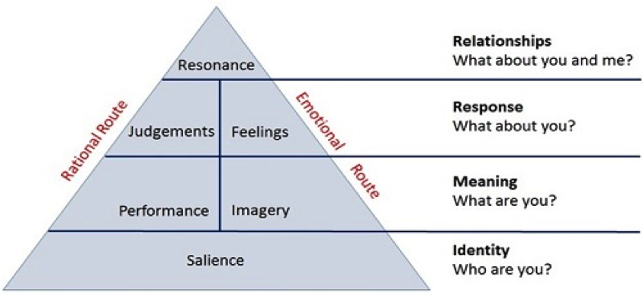

Figure 4.1 Keller’s Brand Equity Model
Source: (Mind Tools Content Team, 2021)
- Keller’s Brand Equity Model can still be reported in the case of Samsung Galaxy smartphones. Thus, Level 1 in the pyramid refers to Brand Identity. Samsung to create brand salience or awareness, ensures the creation of a brand that will be imprinted and aware by consumers regardless of the wide competition. The company has established market segments, which refer to different ages, classes and occupations of consumers and focuses on targeting them, positioning the product in the minds of consumers to create awareness for brand equity.
The company logo contains the English brand "Samsung". The current design of the logo is the result of performance in 2005 to improve the visibility of the logo, which is an evolution that has been based on the way the human eye perceives visual cues.
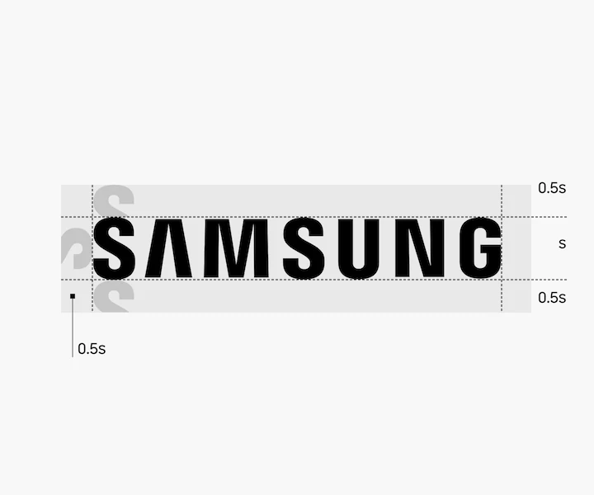
The distance and height of the marking has been rigorously designed, as can be seen in Figure 4.2, which aims to create visual harmony by evenly distributing the letters (SamsungUK, 2021).

Figure 4.2 Distance, height, and company log name
Source: (SamsungUK, 2021)
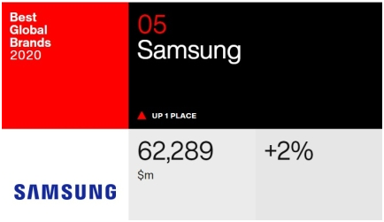
In October 2020, Interbrand, a global brand consulting firm, placed Samsung in fifth place in the list of the best global brands 2020, with a brand value of $ 62.3 billion (Min-hee, 2020). Figure 4.3 below shows the value of Samsung

Figure 4.3 Samsung brand value
Source: http://www.businesskorea.co.kr/news/articleView.html?idxno=53530
The positioning of the Samsung brand in the minds of consumers is based on the production of state-of-the-art, innovative smartphones, which allow the user to get the maximum experience. Mahmud (2015) states that Samsung's positioning strategy reflects the style and technology of the young professional, thanks to its modern design and high-performance connectivity features.
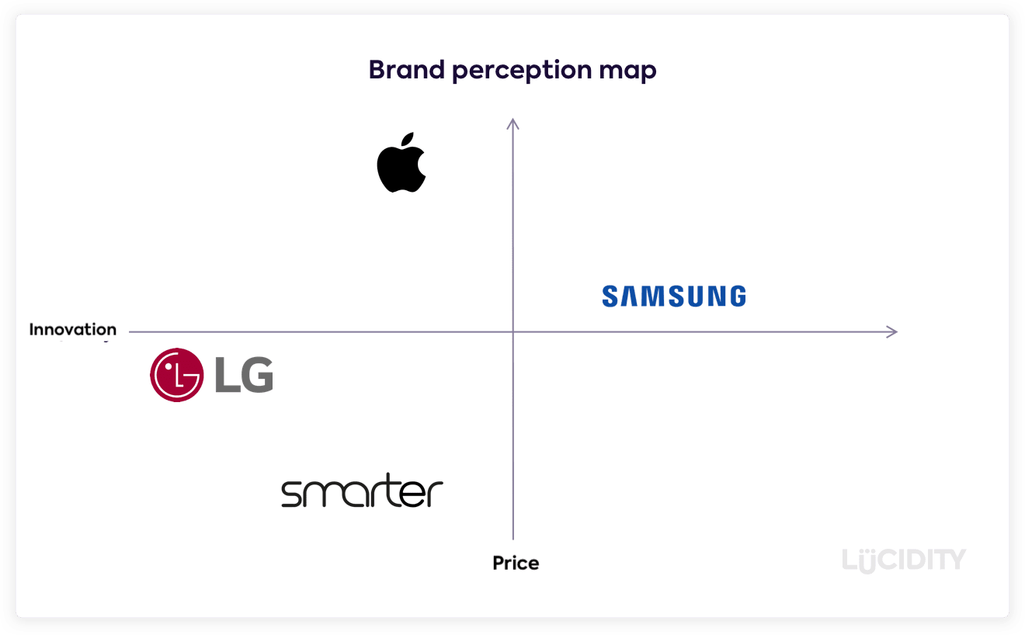
Figure 4.4 highlights Samsung's position in consumer perception.

Figure 4.4 Brand perception map
Source: https://getlucidity.com/strategy-resources/samsung-family-hub-strategy/

Samsung's positioning strategy for Galaxy smartphones is based on creating state-of-the-art devices that are comfortable and stylish. Thus, the launch of the Samsung Galaxy Z Flip 3, allowed to penetrate the market and attract new consumer segments.
One of the factors that refers to the positioning strategy of Samsung Galaxy Z Flip 3 (see Figure 4.5), is the strategy of differentiating this smartphone from all the others launched by the company. Galaxy Z Flip 3 is a smartphone that offers the user the approach of several possibilities in use, namely compact running, using the cover display as a camera monitor, taking hands-free selfies, rotating the start screen in the landscape, etc. (Word Press, 2019).
Samsung also uses the skimming price strategy, with the launch of Galaxy Z flip 4 the price for Z flip 3 has been reduced, making it affordable for a certain segment of customers.
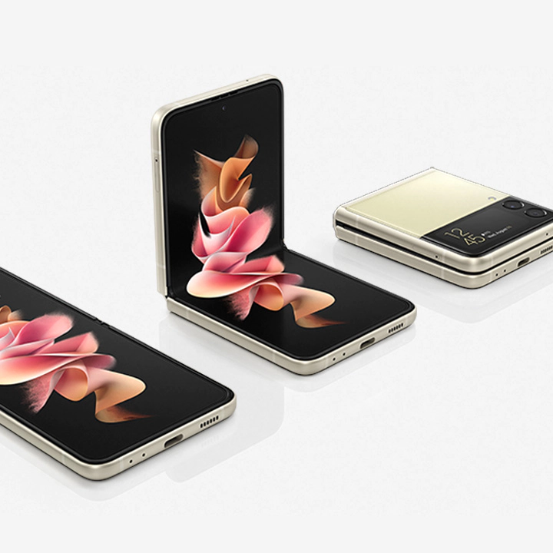

Figure 4.5 Samsung Galaxy Z Flip 3
Source: https://www.samsung.com/nz/smartphones/galaxy-z-flip3-5g/buy/

- Level 2 Brand Meaning - Samsung has managed to assert its market position of the Samsung Galaxy brand due to the high-performance possibilities offered by this product. Thus, it introduced in the features of the Galaxy series products, memory of different types: 64GB, 128GB, 256GB, 512GB, as well as different properties of the camera and posing, so consumers choose the products according to their needs and requirements (SamsungUK, 2021). Also, thanks to the software installed in the Samsung application, Android, which allows the user to download any application that has determined that the products are reliable in front of consumers.
- Level 3 Brand Response- At this level, the product must meet the consumer's expectations after making the purchase and keep the consumer loyal to the brand. After the product purchase stage, Samsung has ensured that the consumer is provided with a warranty period for the purchased product, which will receive a warranty certificate upon purchase. The warranty certificate is not only offered for the smartphone, but also for its components, such as the charging battery. Also, due to the high-performance settings of the mobile phone, the software updates itself by updating the phone data.
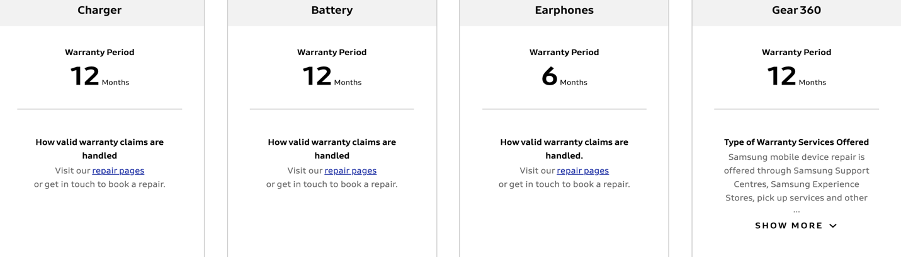
Figure 4.6 shows the warranty for various Samsung products.
Figure 4.6 Warranty for Samsung products
Source: https://www.samsung.com/uk/support/warranty/
- Level 4 Relationships - In order to raise awareness for this brand, Samsung relies on Customer Relationship Management, which is shown in Figure 4.7 Therefore, Samsung through CRM gathered a press release from consumers on social media, such as Instagram, Facebook, Twitter, where it posts the latest news about the Smasung Galaxy brand and more.

Keller’s Brand Equity Model
Advantages | Disadvantages
- The main purpose of this model is to provide the advantage of brand awareness and allow the consumer to differentiate brands by guiding the mind and feedback on marketing activities as a result of the knowledge gained from the first level of the pyramid (Kotler & Keller, 2016).  - Brands that manage to create resonance from consumers, not only enjoy their loyalty, but are also those that embrace greater price premium, or high-performance marketing programs.  - The CBBE model answers all six questions that are part of the brand building block, thanks to which any brand can excel in performance (Keller, 2001). | - A limitation of this model refers to the fact that Keller sees things in a higher order, the pyramid blocking judgments, ignoring the customer's relationship with the sales team due to the focus on consumer markets (L. Kuhn, et al., 2018).  - However, if in the second stage the meaning of the brand was not presented correctly, no response can appear, and brand awareness is not created (Keller, 2001).  - The model cannot be applied to B2B products, as after L. Kuhn (2018) states that the pyramid focuses on the individual brand, and B2B products are marketed under the manufacturer's label or under a hybrid brand, the company name being used with a certain product name.
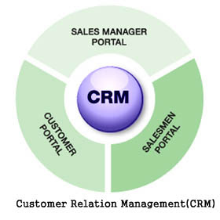

Figure 4.7 Customer Relation Management
Source: ResearchGate
Figure 4.8 Advantages & Disadvantages of Keller’s Brand Equity Model
Source: The author of this assignment based on the references included in the bibliography
- Customer Journey and Customer Touchpoints
These days, creating a positive consumer experience is the managerial goal that all companies focus on. The development of the consumer experience is manifested by the creation of the consumer journey map, as the company thus analyzes the stages of this journey, but also the touch points in each stage the consumer goes through when interacting with the company's products (Lemon & Verhoef, 2016). However, the concept of customer experience management (CRM), was developed by Bernd Schmitt, being characterized as a strategic process of managing the entire consumer experience with a market or company offer (Kotler, et al., 2009). By the way, Schmitt finds that a brand can help create five different types of experience: sense, feel, think, act and relate.
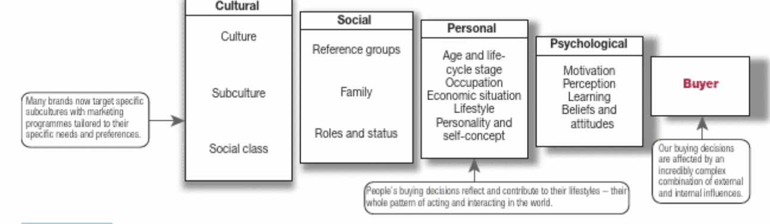
Consumer buying behavior is an essential responsibility of marketing management. Thus, the behavior of the purchasing consumer means the buying behavior of the final consumer, individual or collective, all those who buy goods or services for final consumption, are considered final consumers, and constitute the consumer market (Kotler, 2020). The consumer's buying behavior before, during and after the purchase can be influenced, figure 5.1 shows some factors that influence the buyer's behavior.
Figure 5.1Factors that influence consumer buying behavior
Source: (Kotler, 2020)

Customer journey management (CJM) refers to understanding and coordinating customer experiences during their shopping trip. The existence of a well-organized system integrated by CJM is an essential factor for every company. It is also important for manufacturers to understand customer experiences and travel, ensuring that they optimize both the placement of their products and services and their communications in online stores (Grewal & Roggeveen, 2020).
Figure 5.2 below shows the steps in the customer journey.

Figure 5.1 The Stages in a Costumer Journey
Source: Figure executed by the author of this assignment

According to Indeed website (2021), customer touchpoints can be categorized into three criteria. So, as you can see in Samsung's customer journey map, before, during and after the purchase, the consumer interacts with different types of touchpoints.
Samsung Galaxy Smartphone – costumer touchpoints
Pre-purchase | Pre-purchase customer touchpoints, represents marketing and advertising activity, which professional sales marketers aim to create brand awareness and help consumers by motivating them to buy product (Kotler, 2020).  - Online Advertisement – social media used by the Samsung as Instagram, Twitter, Facebook.  - Digital Marketing Content- Samsung uses branded film distribution as digital marketing. One of the brand's films was dedicated to Samsung smartphones, with the description: "The spot begins in the year 2007, as the first-gen release of iPhone. The hero, Erik, of course buys the product, while his future- girlfriend Lauren has a Samsung by 2013. Eric started having storage issues even in the old version of iOS. Then, in 2013, when they compare the screen sizes and the water resistance, the results are shameful.” (Asena, 2020).  - TV or broadcast advertisements – Chanell 4.  - Product launch events – Samsung organized for the launch of the Galaxy Z Flip3 smartphone an event, called Samsung Unpacked.
Purchase | Purchase customer touchpoint are determined by any point of contact that occurs during the purchase, including staff, marketing objects or sales activities that the customer faces during the purchase (Indeed Editorial Team, 2021).  - Product Catalogues- Samsung products can be analyzed on the website https://www.samsung.com/uk/.  - Product reviews- viewed on social media pages or even on the company's website.  - Product description  - Payment process- installments or full payment.  - Product packaging – Samsung is using only recyclable materials for packaging.
Post-Purchase | Customer touchpoint post-purchase helps marketers, customer service staff to capture important information about the customer experience and how to improve it.  - Purchase confirmation emails.  - Feedback surveys – social media Networks.  - Cross-selling emails  - Help centers (online or in-person)  - Subscription offerings and renewal options  - Billing documents

The consumer's experience while traveling on the consumer's shopping map is influenced by several types of touchpoints, which influence either positively or negatively (pain points) the consumer's experience. A custom touchpoint is any position in which a previous, current, or potential consumer interacts with a product, service, or business. Contact points may appear before performing the purchase, during the purchase, after the purchase (Indeed Editorial Team, 2021). Customer touchpoints are paramount, as they can influence various factors related to sales, customer satisfaction and brand identity. Thus, customer touchpoints are essential because:
- Encourages consumers to make initial purchases.
- Encourages repeat customers.
- Helps you enhance customer experience.
Therefore, Samsung Electronics aims to establish a high performance in terms of consumer experience. Thus, to establish which are the contact points, but also the stages that a consumer goes through before, during and after the purchase of a Samsung Galaxy smartphone, the consumers' travel map was made, being presented in Figure 5.4.
The profile of the person who wants to buy the Samsung Galaxy smartphone:
Peter is an office worker, who deals with the analysis of employee files, his goal is to spend as little time as possible on spending time in physical stores, so in most cases he makes online purchases.
Name: Peter Borough
Age: 30 years
Occupation: Office worker
Location: Central London
Status: Single

Figure 5.3 Example Persona Used by Samsung Company
Source: Figure executed by the author of this assignment
Stage | Awareness | Evaluation Consideration | Decision of buying | Retention | Advocacy
  Persona actions | - Peter wants to replace the old smartphone, he asks colleagues, friends.  - Conduct online research | - visit Samsung's online store, comparing it to Apple's iPhone smartphone  - analyzes the properties of smartphones, prices  - evaluates the methods of purchase, payment in installments or full payment | - Peter chooses the Samsung Galaxy Flip Z 256 GB smartphone  - Add the product to cart  - Choose the payment method  - Enter the card details  - Select the collection point  - Make the payment  - Receive payment confirmation | - Peter signed up for the Samsung page.  - He agreed to the terms of confidentiality and agreed to receive emails about products and services.  - He took the warranty certificate for his smartphone. | - Peter came up with a positive review about smartphones on the company's social networks
Touchpoints | e-commerce website  Social Media  Online Advertisement  Digital marketing content  Peer Referral |  | Website  Product catalogue  Point of sale  Product reviews  Log-in/sign-in page  Checkout page  Payment page  Shipping page  Order confirmation  E-mail confirmation of order | warranty certificate  Upselling/Cross-selling emails  Subscription Renewals
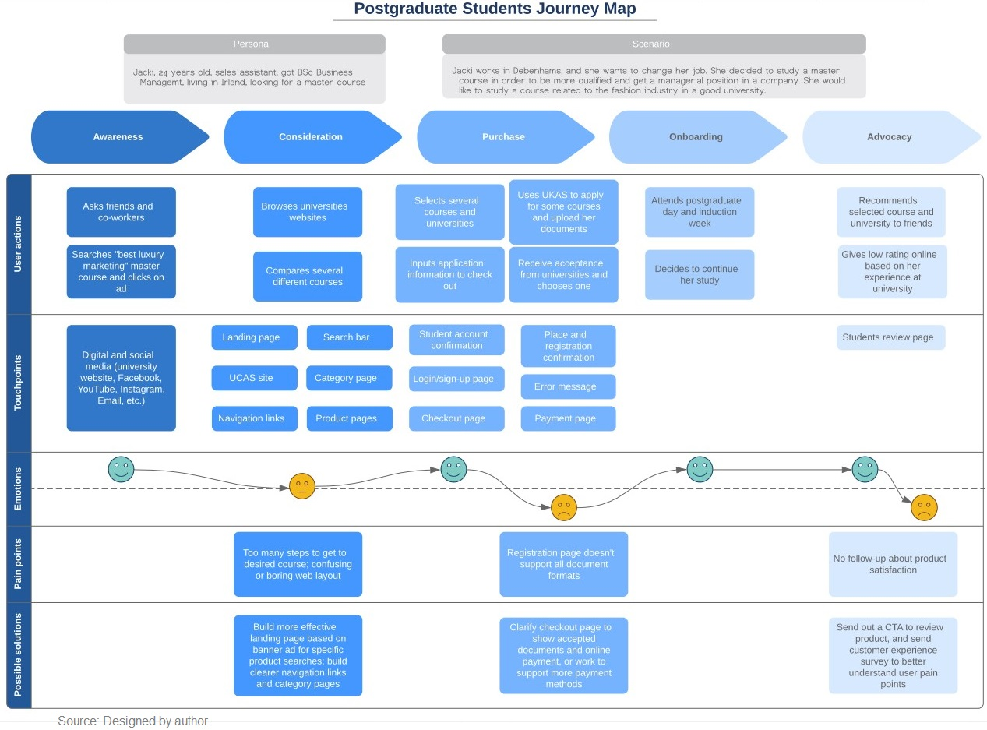
Emotions
Pain Points | Too many steps to get to desired product, confusing or boring web layout  Too many products and you cannot choose to view from start your product |  | Checkout page doesn't support all credit cards  The smartphone is not available in every store for collection  Too long date to wait for availability of the smartphone
Positive solutions | Built more effective landing page based on banner ad for specific product searches, build web site page just for smartphones, build clearer navigation links and category pages |  | Create a website with a checkout page payment that will accept all times of cards and to support more payment methods.
Figure 5.2 Samsung Galaxy Costumer Journey Map
Source: Figure executed by the author of this assignment

Samsung Galaxy smartphone Costumer Journey Map
Strengths  - Samsung costumer journey map presents the process of emotional satisfaction and user experience and evaluates step by step the identification of the flow between the general service and the interaction from the customers perspective.  - Consumer travel map for Samsung smartphone, determines the company to improve the online product viewing system, as well as to improve the provision of services. According to Grewal, Dhruv & Roggeveen, Anne L. (2020), the use of these maps increases the company's profit, registering revenues 3.5 times. | Weaknesses  - The Samsung customer map is created from the point of view of only one consumer, but each user behaves differently during the purchase and is influenced by different touchpoints.  - Samsung map focus on the journey but not the customer’s expectations or emotions.  - The given map can only be used for a certain period, but the costumer journey process never ends.  - One of the pain points of the map offered by Samsung is the difficulty it sometimes presents when paying online with the card, which may or may not be accepted. However, online payment by credit, debit or e-cash card creates the disadvantage of consumer insecurity. F. Sudweeks & C. T. Romm (2012) states that online payment and data security are the major disadvantage that consumers perceive. Thus, Samsung needs to create a secure online payment model, accessible and with as valid data as possible.
Analyzing the customer journey map, we highlighted the main strengths and weaknesses in Figure 5.4 of the Samsung company map.
Figure 5.4 Strenghts&Weaknesse of Samsung costumer journey map
Source: Figure executed by the author of this assignment

- The Total Engagement Model
In the marketing literature, consumers and customers are interpreted as subjects of customer engagement, while brands, products, services, or organization are the objects. Customer Engagement describes the varying level of "presence" of the consumer in his relationship with the company or its product. Presence is determined by emotional, physical, and cognitive presence. Costumer engagement is perceived as a higher-order construct, which consists of four elements: dedication, vigor, absorption, and interaction (Żyminkowska, 2019). According to the complicated situations and changes that a brand encounters today, every action of communication and interaction with consumers must be based on full capitalization, optimization and be treated as an opportunity to create customers involved and loyal to the brand (Roberts, et al., 2016). All these elements are reflected in the Total Engagement Model, which focuses on contrasting the four key elements of the value proposition for customers, brand advertising, culture and customer experience.
Here are the steps that each company should take in order to create the customers involved:
1. Develop a unique value proposition based on strong customer insight and competitor positioning.
2. It should then communicate this value proposition to customers consistently in its brand advertising.
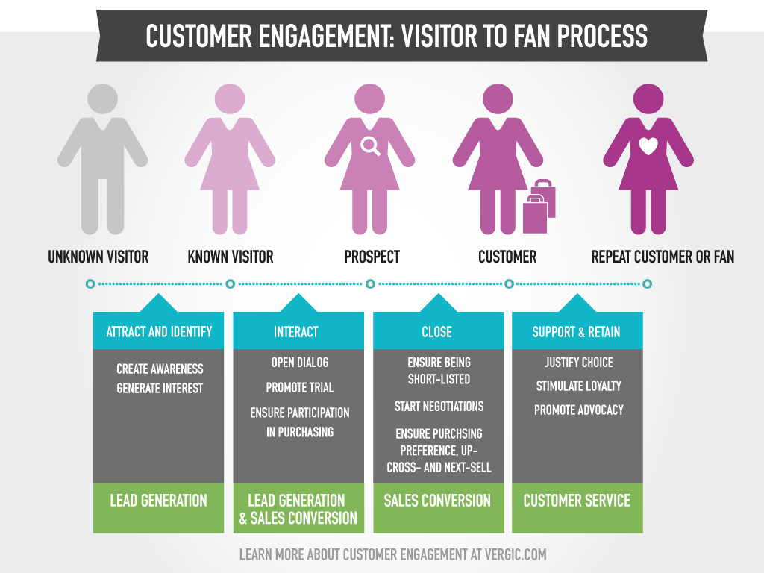
3. This promise is then ideally delivered by engaged staff that support and understand the strategy and importantly, understand their individual role in making it a success.

Figure 6.1 Costumer engagement model
Source: https://www.vergic.com/wpsitefiles_de3fxs/wp-content/uploads/2014/08/Customer-engagement-visitor-to-fan-process1.png
The Total Engagement Model for Samsung Galaxy
Brand | Loyal users of this brand have long been acquainted with the multifunction of these smartphones. The latest models of Galaxy phones, you can see the launch of two applications on the split screen being as easy as swiping to the left to open the Edge menu and select a pair of applications. Pairs of applications are combinations of applications that the user frequently uses in tandem, such as email and Office or Spotify and Samsung Health. These are multitasking shortcuts.  Samsung Galaxy uses Android software, so more than 2.5 billion Android devices are actively used and have an 85% market share, very few quality app developers currently leave Android out of the way (Schick, 2021).
Customer Value Proposition  Customer Experience | - Samsung is constantly working on the stages of the device manufacturing process to make it more and more easy for its customers. Thanks to this approach, the customers of this company become more connected with their devices; as a result, they become more and more connected to this brand.  - Samsung has been expanding its chatbot ability through using bots for efficiently directing the customers to a real person, who could answer their questions.  - Rewards - VOC (Voice of Customer) management for its customers providing ranking & rating, interviews or surveys, periodic quality-review meetings, and many others.
Culture | Samsung’s mission statement is “We will devote our human resources and technology to create superior products and services, thereby contributing to a better global society.” (Samsung, 2020).

Conclusion
Increasing brand awareness is one of the main factors that any company now interacts with, given today's challenges. Ensuring a consumer-conscious brand is not only based on various strategic brand promotion tools, but also on the methods used by the company to ensure effective communication with its customers.
The communication model used by the company, as well as the elements of Integrated Market Communication model must be well defined and analyzed with certainty which is the best model to communicate about the brand, making sure that the message is clear and unobtrusive to other competitors who want to reach the target consumer.
The consumer experience must be paramount when conducting an external analysis by the company, whether they analyze the review or database, because only then can the company see what is wrong and what could be improved to create brand awareness and loyal consumers.
Marketing as a subject of study certainly improves the aspects related to communication and the growth of a better consumer experience, when he wants to interact with a product, because each marketing department with the establishment of consumer experience, promotional strategies, come with remedies negative situations that influenced the retention of the consumer in the company. Marketing professionals not only access the communication and communication channels, but also the consumer's experience in the entire process of purchasing a product. In this context, each company, by determining the target segment of consumers, makes the travel map of the consumer, so they determine which touch points are used, what else innovative could include, but also which are pain points and what should remedy to provide the customer with the maximum experience during the purchase.
Therefore, a marketing department with well-defined goals within a company, can lead the company to reach its maximum potential, through the brand and its products.

Recommendation
The recommendations section includes new customer touchpoints that could be implemented by Samsung to increase awareness for the Samsung Galaxy brand. Therefore, Samsung could use promotional leaflets, which could be mailed, in this sense it could enter into a partnership with the fashion company Asos, and when the consumer places an order, he/she would also receive a promotional flier, with the latest smartphone promotions. Also, in terms of marketing relationships, Samsung should consider offering loyalty cards to consumers, after the purchase, to ensure the maintenance and loyalty of the customer.
Also, to create brand awareness, a new touch point that could be introduced in the term of attracting consumers could be considered sending by email a letter of participation of the most loyal consumers, registered at each purchase in a database, which by accumulating a certain number of points could be registered in a lottery, with a draw, with the possibility of winning other Samsung products in order to benefit from the experience and to attract different consumer segments for other products of the brand.

Bibliography

Philip Kotler, M. B., Malcom Goodman & Torben Hansen, 2009. Marketing Management. 13th ed. s.l.:Pearson Eudacation Limited.
Lancaster, G. & Massingham, L., 2018. Essentials of Marketing Management. 2nd ed. New York: Routledge.
A.-M. K., M. H. P. K. & Peeter W. J. Verlegh , 2019. Outsourcing the pain, keeping the pleasure: effects of outsourced touchpoints in the customer journey. Journal of the Academy of Marketing Science , Volume 47, pp. 308-327.
Chun, J., 2015. STUDYLIB. [Online]
Available at: https://studylib.net/doc/8218255/how-samsung-electronics--organizational-structure-and-cul...
[Accessed 02 December 2021].
Ying, F., 2015. Samsung's international strategy. An Analysis. s.l.:GRIN Verlag.
SamsungNewsroom.Uk, 2012. SamsungUk. [Online]
Available at: https://news.samsung.com/global/history-of-samsung-6-entering-the-global-marketplace-19811983
[Accessed 2 December 2021].
Kayode, O., 2014. Marketing Communications. 1 ed. s.l.:eBook.
Al-Fedaghi, S., 2012. A Conceptual Foundation for the Shannon-Weaver Model of Communication, Kuwait: Computer Engineering Department Kuwait University,.
Foulger, D., 2004. Models of the Communication Process. [Online]
Available at: https://davis.foulger.info/research/unifiedModelOfCommunication.htm
[Accessed 05 December 2021].
Blakeman, R., 2018. Integrated Marketing Communication. Creative Strategy- from idea to implementation. 3 ed. Knoxville: Rowman&Littlefield.
Oana, D., 2018. Sciendo. [Online]
Available at: https://sciendo.com/pdf/10.2478/sbe-2018-0022
[Accessed 05 December 2021].
Xu, L., 2019. Research on the Causes of the “Tik Tok” App Becoming Popular and the Existing Problems. Journal of Advanced Management Science , 7(2), pp. 59-63.
YouGov, 2021. YouGov. [Online]
Available at: https://yougov.co.uk/topics/media/explore/tv_channel/Channel_4?content=all
[Accessed 05 December 2021].
Freberga, K., Graham, K., McGaugheyc, K. & Freberg, L., 2011. Who are the social media influencers? A study of public perceptions of personality. Public Relations Review, 37(1), pp. 90-92.
Cambridge University Press, 2019. Is Employer Sponsorship a Good Way to Manage Labour Migration? Implications for Post-Brexit Migration Policies. National Institute Economic Review, Volume 248, pp. 28-39.
Sammut-Bonnici, T., 2016. University of Malta. [Online]
Available at: https://www.um.edu.mt/library/oar/bitstream/123456789/21686/1/brand%20and%20branding.pdf
[Accessed 05 December 2021].
Keller, K. L., 2003. Understanding brands, branding and brand equity. HENRY STEWART PUBLICATIONS , March, pp. 7-20.
Kotler, P. & Lane Keller, K., 2015. Marketing Mannagement, Dartmouth: Pearson.
VASILEVA , I. & VASILEVA, T., 2017. KELLER''S BRAND EQUITY MODEL. Russian State Academy of Intellectual Property, 6(1), pp. 93-98.
Mind Tools Content Team, 2021. Keller's Brand Equity Model. Building a Powerful Brand. [Online]
Available at: https://www.mindtools.com/pages/article/keller-brand-equity-model.htm
[Accessed 07 December 2021].
SamsungUK, 2021. SamsungUK. [Online]
Available at: https://www.samsung.com/uk/smartphones/?product1=sm-f926bzkdeua&product2=sm-f711bzebeua&product3=sm-g998bzsheua
[Accessed 07 December 2021].
L. Kuhn, K.-A., Alpert, F. & K.Ll.. Pope, N., 2018. An application of Keller's brand equity model in a B2B context., s.l.: ResearchGate.
Kotler, P. & Keller, K., 2016. Marketing Management. 12th ed. New Jersey: Pearson Prentice Hall.
Keller, K. L., 2001. Building Customer-Based Brand Equity. In: Marketing Management. s.l.:s.n., pp. 14-21.
Lemon, K. N. & Verhoef, P. C., 2016. Understanding Customer Experience Throughout the Customer Journey. Journal of Marketing, 1 November, Volume 80, pp. 69-86.
Grewal, D. & Roggeveen, A. L., 2020. Understanding Retail Experiences and Customer Journey Management. Journal of Retailing, 96(1), pp. 3-8.
Kotler, P., 2020. Principles of Marketing. 8th ed. Harlow, England: Pearson.
Kotler, P., Brady, M., Goodman, M. & Hansen, T., 2009. Marketing Management. [European ed.] ed. Harlow, England: Pearson Pretince Hall.
Indeed Editorial Team, 2021. What Is a Customer Touchpoint?. [Online]
Available at: https://www.indeed.com/career-advice/career-development/customer-touchpoint
[Accessed 07 December 2021].
Asena, A., 2020. Digital Agency Network. [Online]
Available at: https://digitalagencynetwork.com/take-notes-on-samsungs-most-clever-and-successful-digital-marketing-strategies/
[Accessed 07 December 2021].
Żyminkowska, K., 2019. Customer Engagement in Theory and Practice: A Marketing Management Perspective. Bielsko-Biala, Poland: Palgrave Macmillan.
Roberts, C., Alpert, F. & Carrisa, R., 2016. Strategic Drivers of Customer and Employee Engagement: Practical Applications. In: P. R. Brodie & L. Hollebeek, eds. “Strategic Drivers of Customer Engagement: Practical Applications”. New York: Routledge, pp. 171-192.
Schick, S., 2021. 20 reasons to switch to a Samsung smartphone. [Online]
[Accessed 07 December https://insights.samsung.com/2021/02/01/20-reasons-to-switch-to-a-samsung-smartphone/].
Samsung, 2020. Sustainability Report 2020, Suwon: Samsung.
Min-hee, J., 2020. Business Korea News Portal. [Online]
Available at: http://www.businesskorea.co.kr/news/articleView.html?idxno=53530
[Accessed 10 November 2021].
Word Press, 2019. Word Press. [Online]
Available at: http://mybrandsquad.com/what-is-positioning-of-samsung/
[Accessed 10 November 2021].
Mahmud, S., 2015. Brand Positioning of Samsung Mobile. [Online]
Available at: https://sumaiyamahmud.blogspot.com/
[Accessed 10 Novembber 2021].
Sudweeks, F. & Romm, C. T., 2012. Doing Business on the Internet: Opportunities and Pitfalls. 2nd ed. Rockhampton: Springer Science & Business Media.

