Yumita Hayashi
1900741
BSc Product Design and Technology
Tasks in order I received them:

Task One: Manifesto Writing (Julia’s task) “What do I believe in?” followed by 519 words and bibliography
Task Two: Reflective writing (Jon’s task) “Do you know what you think?” followed by 531 words and bibliography
Task Three: Observational writing (Ryan’s task) “Identify an image and write a semiotic analysis” followed by 536 words and bibliography

Tutor: Julia and Gwen

Task one: Manifesto writing (Julia’s task) “What do I believe in?”
- `Failing` is a part of the journey which you will face in life.
- Without the ambition of `trying` something `new`, there can be no development in this `modern` world.
- `Creativity` within the field of arts or design, always begins with a `simple drawing`.
- Any design must or should have `ecological` features.
- `Minimalism` is an example of an `environmentally friendly` feature of design.
- `Smart` aesthetic, `less detail` and a `simplicity of form` are one type of the `westernised` style.
- There is no meaning of existence in this world, if it is not `easy` or `well-functioning`.
- To `make` memorable object (products), it requires `accuracy`, `Aesthetic`, and `Application`.
Mind map
Keyword: Failing
Chosen Statements
Research
Manifesto Writing
Beginning of the writing
Keyword: Creativity
Keyword: Minimalism
How I would start design process
Statement 1
Statement 5
Statement 3
Keywords from three chosen statements
Keywords and image
Failing
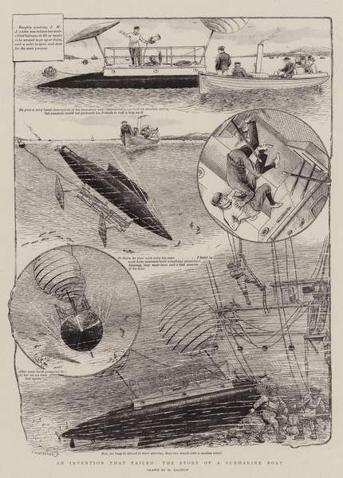
An Invention that failed, the Story of a Submarine Boat (Ralston, 1899)
- `Failing` is a part of the journey which you will face in life.

It feels frustrating and scared to fail during the design process. It is obvious that no one is perfect but in same time we can learn something from these failing. According to Read (2011, p. 64) “by failing gracefully when failure came, Larian was always ready to learn from the experience and do something better in the next round.” So that it is a good thing to reflect on failing and then try applying this on next time.

Keywords and image
Creativity

Looking for scents (Kyung Hwa, 2011)
- `Creativity` within the field of arts or design, always begins with a simple drawing.

In my own creative process, I always start with a simple line sketch, whether if it is a rough or simple drawing. From these drawings, we designers communicate with each other through the use of line for the visualization of our ideas. This refers to Nair’s article Creativity (2014, p.4) which states “People are creative in the process sense; few are creative in the product sense.” This viewpoint explains that the idea of the product can be developed from their sense in the process of creativity. In relation to simple drawing at the early stage of the development, this outlines the basic design but leaves it open to change and development. According to Tversky and Suwa (2009, p. 79) “The ambiguity of design sketches, rather than promoting confusion, promotes innovation. Because they support many interpretations, early sketches can be used for discovery and reinterpretation to further the design.” This viewpoint expresses the concept that simple drawings are the starting point of the design process.

Keyword and image
Minimalism

Chair, made 1998, designed 1984 (Judd, 1984)
- `Minimalism` is an example of an environmentally friendly feature of design.

I believe that the positive way of art or design is a minimalistic style that gives a different impact to complex arts such as traditional painting. Judd describes how minimalism gives impact upon the viewer through the use of simplicity of form conveying a huge world within those objects and emphasising its shape:
The one thing overpowers the earlier painting. It also establishes the rectangle as a definite form; it is no longer a fairly neutral limit. A form can be used only in so many ways. The rectangular plane is given a life span. The simplicity required to emphasize the rectangle limits the arrangements possible within it. The sense of singleness also has a duration, but it is only beginning and has a better future outside of painting.
(Judd, 1965, pp. 74-82)
This means that the relationship between the audience and the artwork is emphasised by the minimal object. Some minimal painting also creates life in a drawing itself, such as the Ensō the Japanese sacred symbol below (Shibata XX, 2000).


Modernzen.org explains that the Ensō has various meaning:
Ensō symbolizes many more things including: strength, elegance, the universe, single mindedness, the state of mind of the artist at the moment of creation and the acceptance of imperfection as perfect. It also represents the oneness of life and all things contained within it, the spirit of harmonious cooperation, personal development and refinement of character, the visible and the invisible, absolute fullness in emptiness, simplicity, completeness, endlessness, perfect harmony, the circle of infinity and the cyclical nature of existence.
(Modernzen.org, 2019,)
So that Ensō gives an impact on different aspect to the audience with a single painting.

Bibliography
Judd, D. (1984) Chair, made 1998, designed 1984 (copper). Available at: https://www-bridgemaneducation-com.ezproxy.uwtsd.ac.uk/en/asset/1072563/summary (Accessed: 15 November 2019)
Judd, D. (1965) ‘Specific Objects’ in Harrison, C. and Wood, P. (ed.) Art in Theory 1900 – 2000 An anthology of Changing Ideas. Oxford, UK; Cambridge, Mass, USA: Blackwell
Kyung Hwa, Y. (2011) Looking for Scents, 2011 [Chinese ink on sliding-screen paper, Colored ink]. Available at https://www-bridgemaneducation-com.ezproxy.uwtsd.ac.uk/en/asset/779562/summary (Accessed: 15th November 2019)
Modernzen.org (2019) Ensō. Available at: https://modernzen.org/enso-htm/ (Accessed: 15th November 2019)
Nair, D. (2014) ‘Creativity’, SCMS Journal of Indian Management, 11(1), p. 4. Available at https://search-proquest-com.ezproxy.uwtsd.ac.uk/docview/1537057342?accountid=130472&rfr_id=info%3Axri%2Fsid%3Aprimo (Accessed: 18th October 2019)
Ralston, W. (1899) An Invention that failed, the Story of a Submarine Boat [engraving]. Available at https://www-bridgemaneducation-com.ezproxy.uwtsd.ac.uk/en/asset/1042874/summary?context=%7B%22route%22%3A%22assets_search%22%2C%22routeParameters%22%3A%7B%22_format%22%3A%22html%22%2C%22_locale%22%3A%22en%22%2C%22filter_text%22%3A%22failing%22%7D%7D (Accessed: 23rd November 2019)
Read, S. (2011) Effectual entrepreneurship. London; New York: Routledge.
Shibata XX, K. (2000) Ensō [Japanese ink painting on washi]. Available at: https://en.wikipedia.org/wiki/Ensō#/media/File:Enso.jpg (Accessed: 15th November 2019)
Tversky, B. & Suwa, M. (2009) Chapter 4, ‘Thinking with Sketches’, In Markman, A. and Wood, K. (ed.) Tools for Innovation. Oxford University Press.

Task two: Reflective writing (Jon’s task) Do you know what you think?
Planning
- Big picture intro (Abstract Conceptualisation)
- Example piece, who do I admire (Concreate Experience)
- How and why I like this particular piece (Reflective Observation)
- Active Experimentation
My experience with design

My passion about designing

Active Experimentation
Reflective writing
Who am I admire?
Trying out some of their Ideas by sketching, making model
How am I admire?
Dieter Rams

Books, Journal, Article
Research
How is it influence my work?
As my view on design I tried to create products that are simple and easy for me to draw out onto paper and which are functional and that everyone can understand how they work.
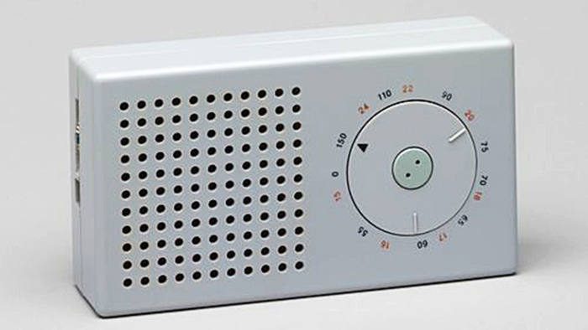
T3 Pocket Radio (Lorentz, 2016)
As I am reflecting on the example piece, I have an interest in the work of Dieter Rams and his view on design. I have chosen his T3 pocket Radio, which was designed in 1958, as my object/artwork of interest. Lorentz (2016) notes that this is an exceptional example of timeless design. This timelessness is a quality to which all designers aspire, but it is difficult to achieve, particularly with electronic goods. However, this radio was used as a perfect influence upon “Apple's first-generation iPod, as shown in the iPod’s all-white body and circular controls.” (Lorentz, 2016). This design influences me even more to further my interest in minimalism, because this design is so simple and uncomplicated, proving that functional design can be simple, beautiful and neat. Bradbury describes Rams’ view on design as follows:
Modern design such as the T3 radio was characterized by the pared-down aesthetic of functionalism and exemplified the attributes of Good Design. ….. Rams continued to promote a modern industrial dematerialised aesthetic through well-designed products, executed using state-of-the-art technology.
(Bradbury, 2014, pp. 591-592)
From this point I started to think about how smart aesthetics can be combined with advanced technology. Wilikes et al (2015, pp. 591-592) explains that Many manufacturers and designers copied many of Braun’s product designs, however they adapted their look without including Rams’ careful approach to design and detail, therefore, not many of their copies were as successful or as well produced. By understanding Rams’ ideas and opinion on design, we can create more efficient and functional products with a clean aesthetic as is reflected in Fiell and Fiell (2015, p. 309) statement that “The aesthetic quality of a product is ultimately a part of its utility”. Lovell (2017, p. 1) describe and states Rams’ 10 statements of design:
The fundamental thinking, the design philosophy, if you like, that has influenced me, and my fellow designers was summed up in the early 1980s in 10 simple statements. They are a helpful means of orientation and understanding. They are not binding; good design is in a constant state of redevelopment just like technology and culture.
1. Good design is innovative.
2. Good design makes a product useful.
3. Good design is aesthetic.
4. Good design helps a product to be understood.
5. Good design is unobtrusive.
6. Good design is honest.
7. Good design is durable.
8. Good design is consistent to the last detail.
9. Good design is concerned with the environment.
10. Good design is as little design as possible.
(Lovell, 2007, p. 1)
So that this statement has influenced upon the modern design and how minimal design can produce successful products.
By reflecting on Rams’ work and his view on design, I can understand how the simple design can be aesthetically pleasing. It means that products can function effectively as well as being environmentally friendly. As a result of looking at Rams’ work, I will now consider making products with minimal design and that use less material.

Bibliography
Bradbury, D. (2014) Mid-century modern complete. London: Thames & Hudson. P.
Fiell, C. and Fiell, P. (2015) Design of the 20th century. New edn. Köln: Taschen. P.
Lorentz, T. (2016) ‘Design Classic: Dieter Rams' T3 radio’, FT.com, 5th February Available at https://search-proquest-com.ezproxy.uwtsd.ac.uk/docview/1772065165/668A5A219D444FA3PQ/2?accountid=130472 (Accessed: 22nd November 2019)
Lorentz, T. (2016) Design Classic: Dieter Rams' T3 radio. Available at https://www.ft.com/content/65a9fc82-c515-11e5-808f-8231cd71622e (Accessed: 27th November 2019)
Lovell, S. (2007) 'Less but better', FT.com, p.1. Available at https://search-proquest-com.ezproxy.uwtsd.ac.uk/docview/229060022?accountid=130472&rfr_id=info%3Axri%2Fsid%3Aprimo (Accessed: 20th November 2019)
Wilkes, et al. (2015) Design : the definitive visual history. London: Dorling Kindersley Limited, A Penguin Random House Company.

Task three: Semiotic writing (Ryan’s task)
Planning
Step 1: Introducing three key aspects of semiotics:
- Denoted
- Connoted
- Signifier

Step 2: Introducing Products from 21st century e.g. iPhone
- Forward design: Bigger screen no need see it closer
- Face ID (recognition) No need to remember passcode (in case you do not remember)
- ‘Animoji’ (new technology) Can create their own animation
- Way of advertising: Under purple colour but different shades, attracts funky and modern, next to camera shows that it has better quality.
- Different gender, skin aiming at wide cultural market.
- Just a face no idea who they or what they do.
- Big bold statement gives impact in every section. Gives customer to think that it has many features in one product. Us those statement to emphasis the advertisement.
- Keep their brand new by improving small change (incremental improvement)

Step 3: Compare the product and advertisement in relation to the aspects of semiotic above

“Anyone can create symbols, but the genius creates symbols that others pay attention to time and again.” (Nair, 2014, p. 4) bearing this in mind, how do we see images or symbols, how do we understand them? Why do they make us look at them over and over again? In this task, I am analysing a product from the 21st century and also the way it’s advertised, by using denoted, connoted and signified aspects of semiotics.
The signified is the concept or object that is represented (Bradley, 2016) and expression of the signifier itself as described by Barthes and lavers (1993, p. 113) who states that “the signifier expresses signified”. However, Saussure has suggested that “the sign is fundamentally relational but the relationship between the signifier and signified is arbitrary” Emerling (2005, p. 36). Connoted is one ‘whose plane of expression is itself constituted by a signifying system.’ (Williamson, 2003, p. 100) she also states that “As for the signified of connotation, its character is at once global and diffuse; it is, if you like, a fragment of ideology”. Denoted is “the work of signification performed ‘within’ a sign as it were: it is the process whereby a signifier ‘means’ – denotes – a specific signified.” (Williamson, 2003, p. 99)
In 2017, Apple introduced and launched the iPhone X with “Meet iPhone X” (2017) advertisement through social media. It contains a big bold statement which gives an impact in every section. This makes the customer think that the iPhone has many features in one product. This particular statement is used to try make the advert more powerful and direct and this emphasised by the graphic imagery. The colours used are under the different variety of purple tone with different shades, this implies that it is funky and modern. The points in the next shot to the camera shows that it has better quality. This advert uses people of different gender, and variety of cultures which shows they are aiming at the worldwide market. It is also a depersonalised images we do not know who the faces are or what they do. The product itself has a sleek and simple design which signifies the concept of Apple. It also connotes the idea of simplicity and functionality. On the front of the phone, it has only face camera, microphone and the touch screen, which shows the incremental development of the product. On the back, it has just a camera, Apple logo and the name of the product itself, which directly signifies the image of the company. The technology inside the iPhone also denotes Apple’s product development such as the introduction of ‘Face ID’ which offers a more secure service and ‘Animoji’ technology that means that the consumer can create their own animation, this suggest that the company believes in the consumer’s own creativity. Through comparison of the product and the advert, it can be understood that product signifies the incremental development of its design over a period of time, and the advert echoes this progression and its fast-moving graphics suggest that the world is moving forward.
With this semiotic analysis I have learned how to deconstruct the product and its advert and look for the messages within the visual presentation.

Bibliography
Apple, (2017) YouTube, [video]. Available at https://www.youtube.com/watch?v=0S6pHex-KCo (Accessed: 13th November 2019)
Barthes, R. & Lavers, A. (1993) Mythologies. New edn. London: Vintage.
Bradley, S. (2016) Vanseo design. [blog] Available at: https://vanseodesign.com/web-design/semiotics-signifier-signified/ (Accessed 14th November 2019)
Emerling, J. (2005) Theory for art history. New York; London: Routledge.
Nair, D., (2014). ‘Creativity’, SCMS Journal of Indian Management, 11(1), pp. 4. Available at https://search-proquest-com.ezproxy.uwtsd.ac.uk/docview/1537057342?accountid=130472&rfr_id=info%3Axri%2Fsid%3Aprimo (Accessed: 18th October 2019)
Williamson, J. (2003) Decoding advertisements. London: Marion Boyars.

