RETROFITTING EXISTING GAMES: CREATING A GAME DESIGN DOCUMENT

IMPORTANT INFORMATION
STUDENT NAME: | Ffiôn Young
STUDENT NUMBER: | 2104015
PROGRAMME: | BA Computer Games Design
MODULE NAME: | Game Design & History
MODULE NUMBER: | ACCA4033
A Game Design Document on the game Party Hard [1], using Scott Rogers ‘Ten-Pager’ Template [2].
Contents
SECTION 1: TITLE PAGE 2
SECTION 2: GAME OUTLINE 4
SECTION 3: MAIN CHARACTER(S) & PLAYER CONTROLS 7
SECTION 4: GAMEPLAY 14
SECTION 5: GAME WORLD 16
SECTION 6: GAME EXPERIENCE 20
SECTION 7: GAMEPLAY MECHANICS 24
SECTION 8: ENEMIES 31
SECTION 9: CUTSCENES 34
SECTION 10: BONUS MATERIALS 36
BIBLIOGRAPHY 38

SECTION 1: TITLE PAGE

Party Hard

INTENDED PLATFORMS | Initial release planned to be on Windows OS via Steam [3], subsequent effort and development into console editions including Xbox [4] and PlayStation [5].

TARGET AGE / DEMOGRAPHIC OF PLAYERS
Late teens into young adults. People who enjoy action-based stealth, dark humour and a bit of silliness.

INTENDED PEGI / ESRB RATING
Due to the nature of the game being a killing game, which should feature violence, blood and gore (though not too graphic because of an 8-bit pixel style), references to drugs and alcohol, sexual content as well as strong language, the Pegi [6] and ESRB [7] ratings should be around 16-17+

CONTRIBUTING TEAM MEMBER: | Ffiôn Young

SECTION 2: GAME OUTLINE

GAME STORY SUMMARY
The game follows Darius the serial killer behind the ‘party hard killings’, a character who just wants to sleep but can’t due to constant party’s nearby, so at 3 am he decided enough is enough and takes matters into his own hands by killing everyone there.
Cut scenes between levels form the structure of the game by showing an interrogation turn conversation, between Darius and John West a Police officer as they recount the events which took place.
The beginning flashes back to Darius as he kills everyone at the neighbouring party, noticeably killing a girl who was latter said to be Katie – John Wests daughter, however they struggled to identify her due to the disfigurements.
From there this sets off his progressive killing spree traveling across America, from one party to another, gaining the public attention whilst keeping his identity hidden.
Meanwhile Katie turns out to be alive, having faked her death to escape her abusive father. She had become fixated on Darius and decided to massacre a Miami party to gain his attention.
They then travel together before Darius ultimately kills her, with John as a witness, John hesitated to kill him and he makes a getaway, continuing his killing.
The interrogation comes to an end as Darius finishes emotionally exhausting and manipulating John, with john starting to accept that Darius has been his alternate personality the whole time.

GAME FLOW
A top-down action based stealth game, that finds Darius the serial killer behind the ‘party hard killings’, travels across America from one party to another, wiping out all participants, to achieve the silence which follows after.

CONTRIBUTING TEAM MEMBER: | Ffiôn Young

SECTION 3: MAIN CHARACTER(S)
& PLAYER CONTROLS

CHARACTER APPEARANCE
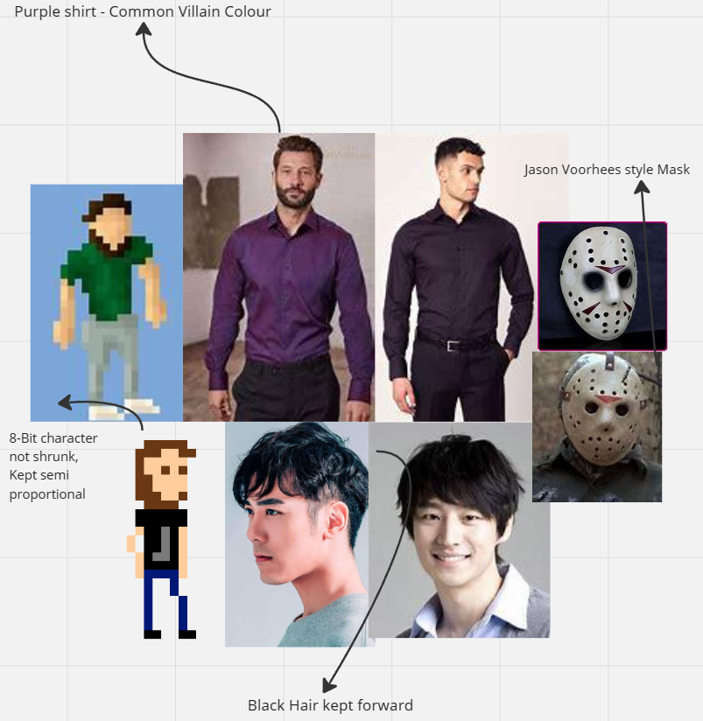[8]

CHARACTER DOSSIER / DETAILS
NAME: | Darius
GENDER: | Male
SPECIES: | Human
AGE: | Young adult
FACTION: | Heroes
Occupation: | None
WEAPON: | Knife

CHARACTER’S BACKSTORY
- Darius is the main protagonist he’s the “Party Hard Killer’’. The default player on all levels aside from Miami Party where Katie is the only playable character first time around.
- His journey of the murders is explained through cut scenes in between levels, with the final cut scene subtly revealing that the whole time he is merely a persona, that John West the Police officer has created.
- Motivation for killing was a desire for peace and quiet, which then develops into eradicating any and all parties.
- Clever, witty, calculated, ruthless, psychotic, cheeky.
- Kills with a single hit, quick stab.
- Has no special features.

CHARACTER APPEARANCE
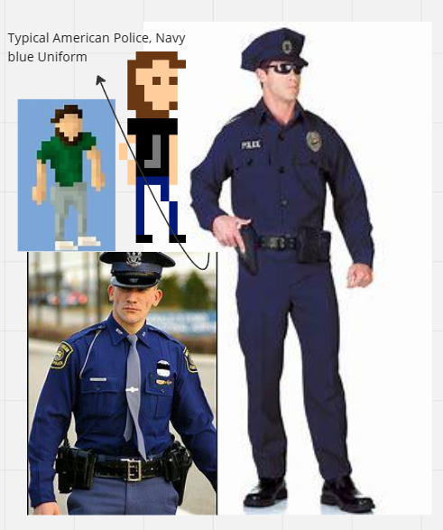[9]

CHARACTER DOSSIER / DETAILS
NAME: | John West
GENDER: | Male
SPECIES: | Human
AGE: | Adult
FACTION: | Heroes
Occupation: | Police officer, Inspector
WEAPON: | Knife + Wrench

CHARACTER’S BACKSTORY
- John West is a playable character which is unlocked after completing the game.
- He is seen throughout cutscenes talking to Darius. By the final cutscene he comes to accept the crimes he’s committing, this then allows the character to become playable and marks the end of the first playthrough.
- Darius is his persona he has created to separate himself from the killings. He has a daughter Katie who ends up getting involved.
- Kills with a single hit, quick stab.
- He cannot use any traps or bonus items found within levels.
- He can carry bodies without raising suspicion. Can transfer blame onto other partygoers.

CHARACTER APPEARANCE
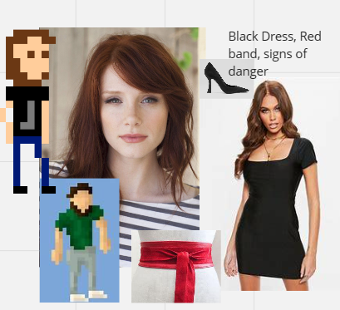

CHARACTER DOSSIER / DETAILS
NAME: | Katie West
GENDER: | Female
SPECIES: | Human
AGE: | Early-mid 20’s
FACTION: | Heroes
Occupation: | University Student
WEAPON: | Knife

CHARACTER’S BACKSTORY
- Katie is a character first playable on the Miami party level.
- She is the daughter of John West
- After the first level she is declared dead, after being found by her father John West. However, she faked her death to join Darius. The Miami killings is her display to prove her dedication. She travels with him until Darius kills her in Kansas, with John West seeing her dead in his arms.
- Troubled childhood, weaker killer, emotionally troubled, desperate.
- Kills by kicking and knocking out partygoers first, then quick stab to finish. Takes longer to kill.

ADDITIONAL CHARACTERS
There are 3 additional playable characters, these have varying special abilities but are all loosely inspired by stereotypical killers. These characters are further personas John west has developed over time.[10]
- Ninja – cannot be seen – comes with smoke grenades.
- Hinter – timed, gain time by killing.
- Butcher – slower – comes with chainsaw.

CHARACTER CONTROLS / PLAYER CONTROLS
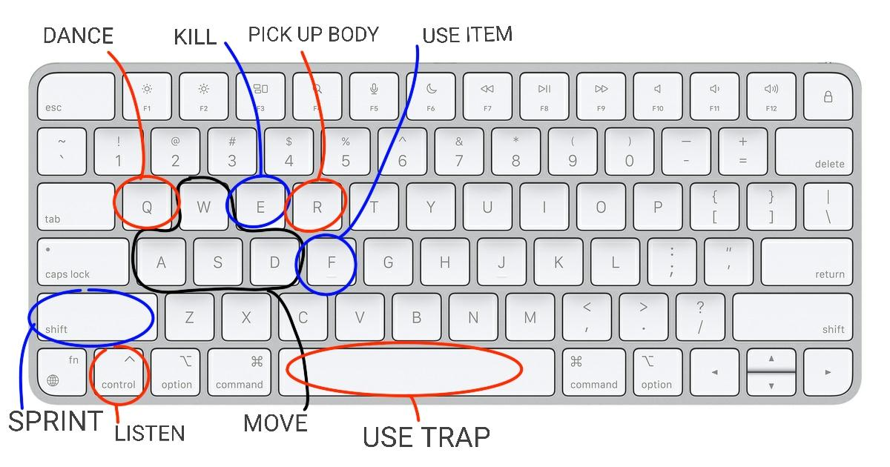
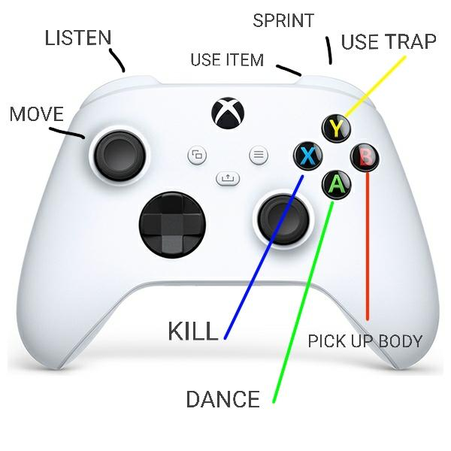
[11] [12]

SECTION 4: GAMEPLAY

SEQUENCE OF PLAY
There are 12 levels throughout the game, each requires the player to kill everyone there once that is completed the next level is unlocked.
In between levels there is a cutscene showing an interview between Darius and John West, the cutscene tends to reflect on the last party massacred (last level) and where the killer was heading next, setting the scene for the next level. With each cutscene more is explained.
Levels get more difficult with added elements and more challenging maps.

UNIQUE SELLING POINTS (USPs)
Every time you play will be a different experience, with randomised traps, people in different locations, the pure randomness of it will mean that no level can be played the same twice,
The different choices of heroes, changes game experience.
There will be a wide range of ways the game can be played, by taking it slow and picking off the stragglers of the party or going right into the centre, rapidly killing them all.

PLATFORM-SPECIFIC FEATURES
A local co-op multiplayer option only supported on PC.
PC enables supports for controllers/gamepads.

CONTRIBUTING TEAM MEMBER: | Ffion Young

SECTION 5: GAME WORLD

GAME WORLD
Top-down 2d game world in pixel style graphics. All locations are based in America.
- BBQ Party – California
- Biker Party – California
- Casino Party – Nevada
- Neon Top Party – Arizona
- Boat Party – Offshore Texas
- Miami Party – Florida
- Bus Party – Florida
- Open Air – Kansas
- Pool Party – Colorado
- Halloween Party – Wyoming
- Campus Party – Utah
- Underground Sick – California

LOCATION DETAILS
NAME: | BBQ Party
WHAT DOES IT LOOK LIKE? | Dark, Old house, wooden floor, dark walls, DJ set up, tables covered in drinks . Basic house lay out with porch leading into a large living room, from which the kitchen dining room, bathroom and toilet, a sitting room, office and bedroom all come off.
WHAT MOOD IS BEING INVOKED IN THIS LOCATION? | The dark setting to really push the whole idea of it being 3 in the morning, also with the whole house setting, drinks everywhere, shows how it’s a irresponsible party
WHAT KIND OF MUSIC WILL BE USED FOR THIS LOCATION? | Upbeat, electronic, dance, pop style music
HOW ARE THE LOCATIONS CONNECTED IN THE GAME WORLD? | Via the menu in game, next level only unlocked one previous is completed.

LOCATION DETAILS
NAME: | Neon Top Party
WHAT DOES IT LOOK LIKE? | Set on the top of a high rise building. Made of 3 parts, the main room featuring a large dance floor, a VIP area and a small balcony. The level is filled with bright white blue and pink neon lights. NPCS are mostly dressed in bright white too. Theres waiters running around serving the partygoers.
WHAT MOOD IS BEING INVOKED IN THIS LOCATION? | The bright white throughout to create a feeling that this is a party for the rich, with expensive clothes staff and venue.
WHAT KIND OF MUSIC WILL BE USED FOR THIS LOCATION? | Upbeat, electronic, dance, pop style music
HOW ARE THE LOCATIONS CONNECTED IN THE GAME WORLD? | Via the menu in game, next level only unlocked one previous is completed.

GAME FLOW
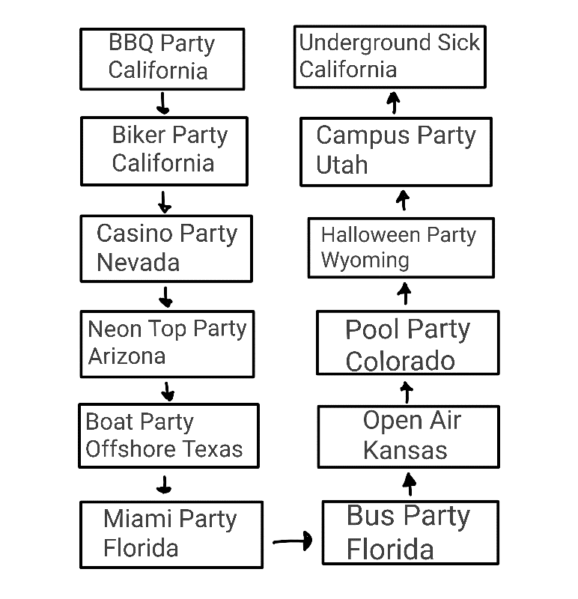

CONTRIBUTING TEAM MEMBER: | Ffion Young

SECTION 6: GAME EXPERIENCE

GAME EXPERIENCE
Action – Strategy – Stealth – Chaotic – Thrilling – Dark Humour – Retro – Comedy – Upbeat

HOW IS THIS FEELING GOING TO BE PRESENTED TO THE PLAYER?
Upbeat - Vivid colours and imagery accompanied by music, feels like a party.
Thrilling – unrestricted unwarranted violence, speed, completion of challenge.
Tension – avoiding suspicion, disposing bodies quickly running too slowly.
Chaotic – fast paced, explosions, special characters, bears fighting people.
Dark humour - people dying in illogical ways and everyone else then going back to dancing.

ARE THERE ANY SPECIAL MODES OR INTERFACES FOR GAMEPLAY?
A part of the game allows players to design their own levels using the games assets.
With the ability to play other levels people have created.

Addition to event specific characters which change the level gameplay.
- Zombies – Turn NPCs into zombies – can be killed without suspicion – can kill you.
- Aliens – steal NPCS – Normal otherwise.

WHAT DOES THE PLAYER FIRST SEE WHEN THEY START THE GAME?
Loading up the game brings up the main menu, set in the Killers bedroom mask on side, party lighting shining through the window, alarm clock highlighting its 3am.
The second menu with the level selection on, is set on a tabletop map of America, with evidence of his crimes sprawled across the surface. As the player unlocks more levels and travels to each red pins are added to the map with red thread connecting them.
When the player opens a level, it’ll open straight onto the map, often with some NPCs spawning in at the bottom with you and entering the venue.

WHAT EMOTIONS ARE MEANT TO BE INVOKED BY THE GAME?
Start of the game –Initial anticipation and challenge of working out the map, planning and identifying traps and enemies within the level.
Getting caught – feeling annoyed then channelling that back into perfecting what went wrong.
Mid way though – heightened tension of being caught and having to start over, having to problem solve with fewer traps and groups of people left.
End of level – feeling of achievement in being able to get everyone without being caught, being proud of the time completed or methods which worked out well.

HOW ARE MUSIC AND SOUND GOING TO BE USED?
Dance pop / electric style music to give to the feeling of an upbeat party with a strong beat, this will help to reinstall that party feeling throughout each level, as well as keeping the game upbeat and fun, maintaining the light-heartedness.

HOW DOES THE PLAYER NAVIGATE THE SHELL MENUS/ SCREENS OF THE GAME?
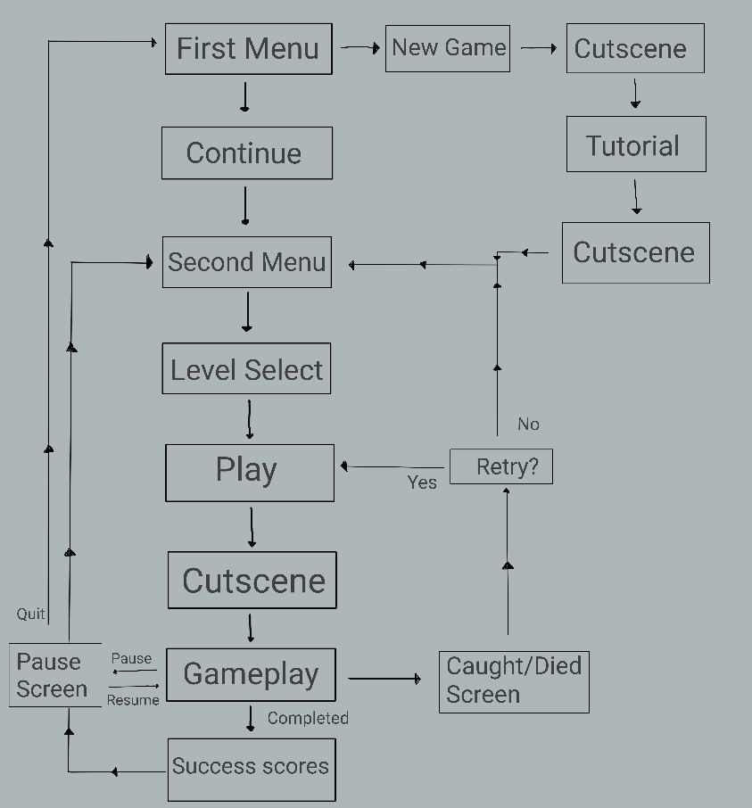

CONTRIBUTING TEAM MEMBER: | Ffion Young

SECTION 7: GAMEPLAY MECHANICS

GAMEPLAY MECHANICS
Mechanics
- Escape Routes - jump from one location to another
- Body hiding locations - such as sewers, dumpsters and ice machines.
- Phones - interact to make a call, different levels cause different results.

Hazards
All of the hazards are traps which the player sets up to kill partygoers, however a few of them can kill the player themselves if done incorrectly. Some of the hazards:
- Car/ Golf Buggy/ Bull
- Barbecue
- Trees
- Gumball Machine
- Speakers
- Electric Wire
- Vent Fans
- Keg/Punchbowl
- Porta-Potty
- Motorbike
- Horse
- Sawmill
- Bear Trap
- Advertising screens
- Steam Valve

Power-ups
Can be obtained either via a guy in a trench coat walking around dealing, or found in briefcases within the levels, only one powerup can be used at a time, power ups within the game are:

- Poison – party goer dies 30 seconds later.
- Bomb – set up, explodes, kills all nearby.
- Running Sneakers – Gives temporary speed boast.
- Stun bomb – set up, explodes, knocks out nearby.
- Smoke Grenade – creates cloud of smoke to kill in.
- Sword – kill multiple people in one swipe.
- Spare Clothes – change outfit to avoid police.

MECHANIC DETAILS
NAME: | Trapdoor (Escape Route)
WHAT DOES IT LOOK LIKE? | Will look different depending on the level. On the pool party level the trap doors are flat on the floor in a slightly different colour with a handle, coming out of a normal door positioned on the side of the boat
EFFECT ON PLAYER: | Can jump between locations, allowing for quick escapes, transporting bodies and overall quicker navigation of the map.
WHEN WILL IT FEATURE IN THE GAME? | Majority of levels have some form of escape route but not all do, a set part of the levels.

HAZARD DETAILS
NAME: | Car
WHAT DOES IT LOOK LIKE? | Level dependent, biker Party the car is a pickup truck, casino party the car is a prize display sports car.
EFFECT ON PLAYER: | The player can turn the car on, this will cause it to move off in the direction its facing, with the intention of running over groups of people. If standing in the wrong place it can also knock out or kill the player themselves.
WHEN WILL IT FEATURE IN THE GAME? | Car only appears on set levels

HAZARD DETAILS
NAME: | Poison Punchbowl
WHAT DOES IT LOOK LIKE? | A stereotypical American punchbowl, themed to match the level. On counters around levels.
EFFECT ON PLAYER: | The player can poison the punch, this will mean any partygoers which stand next to the punch for too long will get poisoned and eventually die. The player cannot get poisoned themselves.
WHEN WILL IT FEATURE IN THE GAME? | Randomly generated on levels.

HAZARD DETAILS
NAME: | Bear Trap
WHAT DOES IT LOOK LIKE? | A bear trap which sits vertically then open flat once activated, until someone walks into it then it will snap shut and stay vertical filled with body parts.
EFFECT ON PLAYER: | The player can set the bear trap up and can’t get caught in it. Can only be used once to kill one NPC.
WHEN WILL IT FEATURE IN THE GAME? | Randomly generated on levels.

POWER-UP DETAILS
NAME: | Smoke Grenade
WHAT DOES IT LOOK LIKE? | Small graphic icon to represent the smoke grenade
EFFECT ON PLAYER: | When deployed creates temporary cloud of smoke, allowing the player to kill anyone within in, without being seen. Doesn’t work on police.
WHEN WILL IT FEATURE IN THE GAME? | If found in briefcase or from dealer, player chooses when to use.

COLLECTIBLE ITEMS
No collectibles

COLLECTIBLE DETAILS
NAME: | N/A
WHAT DOES IT LOOK LIKE? | N/A
BENEFIT FOR PLAYER: | N/A
WHEN WILL IT FEATURE IN THE GAME? | N/A
CAN IT BE USED AS CURRENCY? | N/A
WILL IT EARN PLAYERS AN ACHIEVEMENT? | N/A

(NOTE: Copy-paste the tables in this section as necessary for each gameplay mechanic you wish to feature.)

GAME ECONOMY
No economy.

CONTRIBUTING TEAM MEMBER: | Ffion Young

SECTION 8: ENEMIES

LIST OF ENEMIES
- Police
- Bouncers
- S.W.A.T
- Special Agents
- Mario (comes out of plumbing, blocks off passageways used when escaping police)

ENEMY DETAILS
NAME: | Police
WHAT DOES IT LOOK LIKE? | Stereotypical police man, navy blue police uniform and hat
ATTACKS: | The police will chase the player if they have been seen killing, carrying or near a dead body. If the police catch the player they will be arrested, ending the level.  Within a level the first police are the slowest and weakest, but as it goes on, the more the player escapes them the faster they get.  The police will also arrest partygoers if they are seen near a body instead.
WHEN WILL IT FEATURE IN THE GAME? | Police will appear when a partygoer has called the phone after seeing a dead body
HOW DOES THE PLAYER DEFEAT IT? | The player can escape the police by outrunning them or changing clothes or killing them. The player cannot kill the police directly, however they can kill them through traps.
ENEMY DETAILS
NAME: | Bouncer
WHAT DOES IT LOOK LIKE? | Wearing all black, identification on t-shirt, muscular
ATTACKS: | Will block the player from entrances/exits, if player gets close they will chase and attack them, ending the level.
WHEN WILL IT FEATURE IN THE GAME? | On multiple levels where there is an official venue, when the difficulty of the maps increase.
HOW DOES THE PLAYER DEFEAT IT? | The player can escape the Bouncers by outrunning them or killing them, bouncers can be killed normally but only when their back is turned. As well as traps.

LIST OF BOSS CHARACTERS
In party hard there is no boss character, however the levels vary in difficulty to create challenges throughout.

BOSS CHARACTER DETAILS
NAME: | N/A
WHAT DOES IT LOOK LIKE? | N/A
ATTACKS: | N/A
WHEN WILL IT FEATURE IN THE GAME? | N/A
HOW DOES THE PLAYER DEFEAT IT? | N/A
WHAT DOES THE PLAYER EARN FOR DEFEATING THEM? | N/A

(NOTE: Copy-paste the tables in this section as necessary for each enemy / boss you wish to feature.)

CONTRIBUTING TEAM MEMBER: | Ffion Young

SECTION 9: CUTSCENES

CUTSCENES
There is 14 cut scenes within the game, these cutscenes explain the story of the “Party Hard”killings
Through Darius and John West talking and breaking it down together.

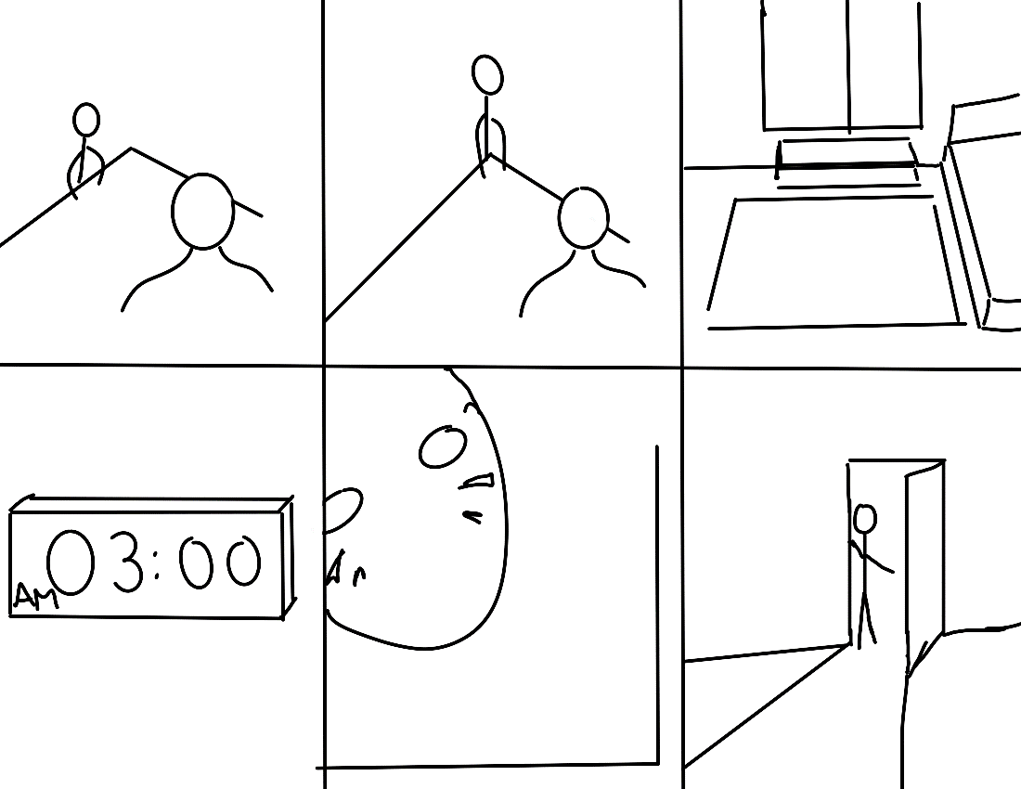

CUTSCENE DETAILS (use this table for each unique cutscene you include)
VISUAL STYLE: | 2D pre-rendered cutscenes, in pixel style but higher quality then gameplay, dark dramatic shadows.
BRIEF DESCRIPTION OF SCENE: | The first cutscene, introducing the characters to us leaving to kill at 3am
WHEN WILL IT FEATURE IN THE GAME? | Before the first level loads in
PURPOSE: | Introducing us to the characters and setting the scene for the rest of the game

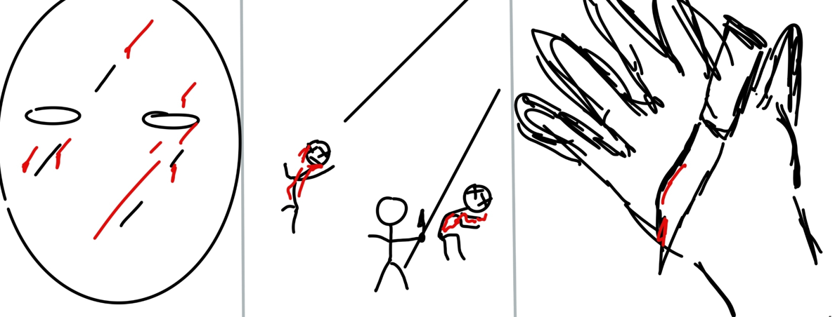

CUTSCENE DETAILS (use this table for each unique cutscene you include)
VISUAL STYLE: | 2D pre-rendered cutscenes, in pixel style but higher quality then gameplay dark dramatic shadows police lights in distance
BRIEF DESCRIPTION OF SCENE: | The first time Darius murders.
WHEN WILL IT FEATURE IN THE GAME? | After the first level takes place.
PURPOSE: | Showing moment of hesitation but then dismissing it.

CONTRIBUTING TEAM MEMBER: | Ffion Young

SECTION 10: BONUS MATERIALS

BONUS MATERIALS
- Custom world creation, the ability to create new levels using the games assets. As well as being able to play other peoples levels they’ve created.
- Local co-op multiplayer on PC.
- There are two DLCs “Dark Castle” and “High Crimes” adding more levels and challenges.
- Theres’s achievements which can be unlocked based on completing difficult combos or tricks.

REPLAY VALUE
Unique experience every time due to randomly generated traps and NPCs.

Theres the chance to unlock all the characters however the player must complete challenges like escaping the police 5 times to unlock them, these characters then offer different gameplay.
With all the different characters, one level can be repeated multiple times, with each to get a completely different experience.

The maps themselves have different content, for example the first level BBQ Party one room could be a bedroom, an office or a meth lab allowing for the same level to have different contents.

Due to there being a time completed and points gained screen at the end of the level, this allows players to compete against themselves for a better score/time.

CONTRIBUTING TEAM MEMBER: | Ffion Young

BIBLIOGRAPHY

[1] Party Hard: [Software], United States of America: Pinokl Games, 2016
[2]S. Rogers, Level Up! John Wiley & Sons, 2010.
[3]Steam, “Steam,” Steampowered.com, 2019. https://store.steampowered.com/
[4]“Xbox consoles | Xbox,” Xbox.com. https://www.xbox.com/en-GB/consoles
[5]“Home,” Playstation, 2023. https://www.playstation.com/en-gb/
[6]Pegi, “Home | Pegi Public Site,” Pegi.info, 2017. https://pegi.info/
[7]Entertainment Software Rating Board, “Ratings Guide - ESRB Ratings,” ESRB Ratings, 2019. https://www.esrb.org/ratings-guide/
[8]Friday the 13th, (Aug. 05, 1980).
[9]F. Young, “Sign up | Miro | The Visual Workspace for Innovation,” https://miro.com/. https://miro.com/app/board/uXjVNDiDSPs=/ (accessed Dec. 12, 2023).
[10]“Characters,” Party Hard Wikia. https://party-hard.fandom.com/wiki/Characters#Alien (accessed Dec. 1, 2023).
[11]Smyths Toys, “Xbox Controller ,” www.smythstoys.com. https://www.smythstoys.com/uk/en-gb/gaming-and-tech/gaming-accessories/xbox-series-x-s-accessories/xbox-wireless-controller-robot-white/p/192245 (accessed Dec. 05, 2023).

[12]Apple, “Magic Keyboard - US English,” Apple (UK). https://www.apple.com/uk/shop/product/MK2A3LB/A/magic-keyboard-us-english (accessed Dec. 05, 2023).

