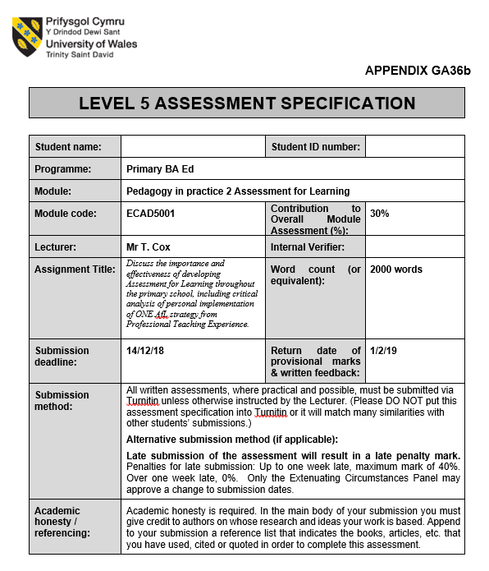
1701843
Caitlin Ford
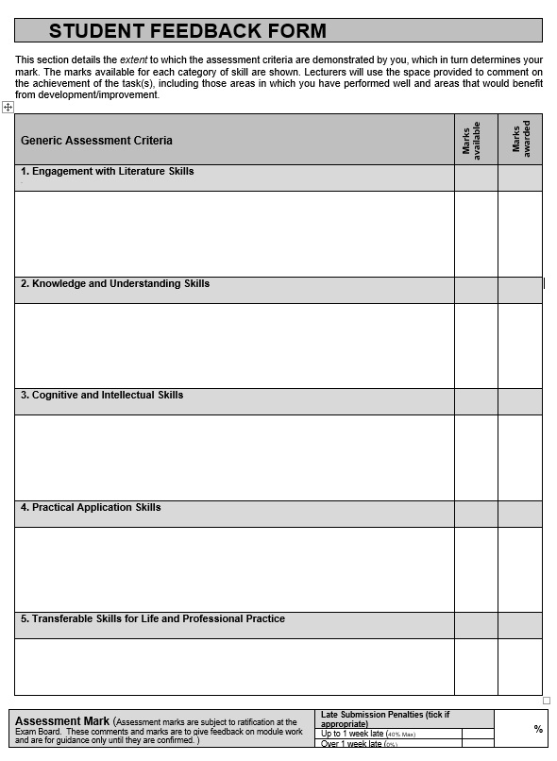
This assignment will discuss the importance and effectiveness of developing Assessment for Learning (AFL) throughout the primary school, including critical analysis of a personal implementation of one strategy from Professional Teaching Experience (PTE).

Assessment itself has been used in primary schools for many years with the historic association causing uninspiring ideas within education. In reality, assessment is a “key responsibility in the life of a teacher and has a direct bearing on the quality of pupil’s experiences” (Grigg 2015, pg.390). In addition, Black and Wiliam (1998) suggest when implementing assessment it is important not to adopt an educator-led instruction with lack of effective pupil engagement. They advise that teachers need to be aware of pupil’s progress; to identify difficulties in order to adapt their teaching and meet individual needs, such assessment becomes formative. Formative assessment is often referred to synonymously with AFL.

What is AFL?
Research from Wiliam (2009), Black (1998) and Hattie (2009) highlight a general consensus about AFL suggesting that it is an ongoing process which helps an educator and learner identify where they are at, where they need to be and how they can get there. It provides immediate, short term feedback that is ongoing and adaptable for further teaching and learning. Concept about implementation of AFL have progressed through-out the years, initial old style of assessment would involve educators teaching first and assessing after. Nevertheless, it has since developed in to a much more effective new style, proposed by Fautley and Savage (2008) they suggest that assessment and teaching should not be seen as two separate activities but considered as an integral approach that takes place alongside the learning. To support, Weeden, Winter and Broadfoot (2012) highlight how AFL should not be seen as something extra but purely as part of everyday teaching to help reflect on the learning. In order to develop greater understanding for educators, Black and Wiliam (1998) developed four key elements of AFL for educators to engage with including, sharing criteria with learners, quality of questions/quality of talk, use and quality feedback and peer and self-assessment.

Should we be using AFL in Primary schools?
There are many sources to support the use of AFL in the primary school due to its effectiveness. Harris and Bell (1990) and Black et al (2003) both emphasise how AFL has a pivotal role in improving communication links, suggesting it allows a main form of discussion between the learner and their educator, a central part the learning process. Black and Wiliam (1998) research clearly highlights the importance of AFL in a primary school and its ability to raise standards within the classroom, especially for lower attaining children. In addition, their study also emphasizes how AFL raises overall attainment, reducing the gap from the lowest to the highest attainders. Taking this point into consideration, raising standard’s matters for everyone, Wiliam (2006) highlights that we need to prepare our children for higher education, for jobs that haven’t been invented yet and for an overall good quality of life. By raising individual standards to the highest they can be gives each child the best chance at life. However, he emphasises for this to be the case it is essential that there is investment into good teachers with sound understanding of the concept of AFL. Estyn (2018) highlight how many educationalists regard AFL as a fundamental aspect of teaching in order to raise standards for their learners, stating that with good implementation it allows learners to see what they need to do and how can they develop their work making learning more visible. Furthermore, Donaldson (2015) also highlights the importance of AFL within the forthcoming curriculum with it being a necessity for effective teaching. On the other hand, he also acknowledges that there are weaknesses in the assessment framework and that AFL approaches are not embedded enough due to lack of understanding. “AFL is one of the most powerful tools for promoting learning, but must be used in the correct way” (Assessment Reform Group 2002,pg.2). Therefore this evidence suggests more support is required to embed AFL into education effectively. Ofsted (2008, pg.6) report further this by highlighting how “teachers failed to understand sufficiently how the approaches were meant to improve pupils’ achievement” and as a result educators are not giving sufficient opportunities for children to review their learning. Furthermore, Grigg (2012) research also suggests limitations within the implementation of AFL due to how well teachers have used it in practice, he highlights that a number of professionals are become too cosmetic in the delivery, e.g simple stating learning objectives but not explaining the idea to the children to develop understanding. Inferences from research therefore emphasises that the fundamental power of AFL and its implementations is dependent on how it is perceived by the educator (Weeden, Winter, Broadfoot 2002)

Analysis of an AFL strategy.
During PTE the writer implemented a particular AFL strategy to observe its effectiveness within the classroom. The strategy put into practice was the use of an ‘Over to you’, which was developed from a cold/hot writing task for English to an over to you for mathematics. The strategy was implemented within a Key Stage 2 cohort, where it had both advantages and limitations which will be explored in this section. At the start of a new mathematical topic the children would complete an over to you, a worksheet that had questions in relation to the maths pathway. The questions would range from what children should know already from previous years, what they will be learning in their current year and where they would be progressed to in future years. Children would be given no longer than 20 minutes to answer the questions and have no guidance from the educator. This strategy focuses on the use and quality feedback element of AFL, as the information gained from these worksheets was very useful. Sadler (1989) refers to feedback as the information gained and used in order to close to gap between children’s desired level and actual level. By using an over to you the educator can gain an inside into the children’s knowledge and understanding prior to teaching a topic. The feedback received enables the teacher to see where each individual child is at in relation to where they should be, and as a result adapt planning accordingly. Wiliam (2009,pg 8) suggests that AFL is about “making your teaching constantly contingent on the students’ responses.” However, this strategy only produces quality feedback in relation to the maths pathway which is just one area of the curriculum. Although the idea has been developed from an English writing strategy, it has not been implemented in any other area of the curriculum. Ofsted (1998 cited in, The Assessment Reform Group, 1999) emphasis that assessment is one of the weakest aspect of teaching through-out the curriculum, however do acknowledge that AFL is more efficient in some subjects than in others. It could be argued this is due to maths having definitive answers which the teacher can gain quick, clear feedback, as opposed to a different subject where answers could be opinion based and therefore require more time and marking would could be seen as ‘pointless’. Grigg (2015) emphasises that the key thing to remember when using a strategy is to consider will information gained or given allow the child to move their learning forward. Likewise, Wiliam (2009) states it is important to remember that AFL is only formative when the evidence gained is actually used to adapt the teaching to meet individual learning needs of the student. In reflection, feedback gained through this strategy does allow for regular differentiation of each child dependent on the topic being taught. During PTE the writer saw a perfect example of this, where a child was on a low attaining table for one topic, but on the high attaining table for the following topic based on the feedback the educator received from their over to you. This highlights how each child has different strengths and weaknesses within education and should not be confined for all mathematical topics.

Once the topic has been taught the children would then go back to their first attempt over to you questions and self-correct their answers. They would complete an assessment sheet about the topic as a whole focusing on how they thought the topic went stating what they enjoyed/found hard or a good challenge. This strategy therefore also promotes the use of self assessment; a second element within AFL. Children can reflect on their previous answers, showing what they have learnt by self-correcting, their responses also gives feedback to the teacher on how they found the topic of work. Hattie (2012) states that feedback is not just something that occurs from the teacher to the student but can also be visa versa; he believes that feedback is most powerful when it comes from the student, to make learning visible. Moreover, fostering independence is a recurring theme through the National Curriculum and this particular strategy allows the children to develop it perfectly. Grigg (2012) and Wiliam (2009) further the ideas highlighting that self-assessment encourages pupils to take responsibility for their learning, developing meta cognition and motivation. Additionally, Weeden, Winter and Broadfoot (2002) suggest that self-evaluation is a vital part of education for children to understand and make learning effective. Assessment reform group (2002) emphasis that for AFL to improve learning it is dependent on key factors; these include the active involvement of children and the need for children to be able to assess themselves. However, this can take time to put into practice, for AFL to be productive learners should be trained in self-assessment in order for them to understand the purpose, their progression and achievement (Black and Williams 1998). Children can struggle with autonomy, motivation and critical thinking, all skills that are required to self- assess effectively. Dweck (2012) states that children who have a fixed mindset will struggle to cope with failure and reflection, there “core intelligence is tested and devastated.” However AFL must involve the children, as no-one else is responsible for their learning, therefore suggest that we as teachers need to encourage a growth mind set environment emphasising the significance of “not yet” encouraging children to understand that human ability can grow and that their learning will progress.

Overall, this strategy would be supported by the constructivist theory of learning, as children have to activate their prior knowledge expanding on previous learning to try to complete the questions; prior knowledge is recognised by constructivists as a powerful tool. Self- correcting is also a principle support by this theory, as they believe children can reflect on their progression and achievement (James 2006). This is promoted well through the use of an over to you. On the contrary, the humanistic approach to teaching and learning would argue that the emotional needs of the learners are not being met by using this strategy. If children are not in an environment where incorrect knowledge and error is welcomed as a learning tool, it could result in children not feeling safe to explore and reduce self confidence. This consequently will produce maladjustments resulting in learning being damaged. It is believed the pupils need to be immersed in an environment with support and clear understanding (Holt 1990).

Recommendations
In hind sight, like any strategy there are both advantages and limitations. Looking forward, it is believed that this strategy could be applied through-out a Primary school setting. The over to you could be used by any class by adapting the questions with regards to the maths pathway for that year group. For use within in foundation phase the questions could be made much simpler and in relation to the mathematical topics they are covering. The writer’s recommendations for the strategy to be effective would be to ensure that a positive learning environment is established and embedded into learning first before introducing it. This is to ensure children are not afraid to take risks, as without positive environment pupils could lose motivation and shy away from the learning in the fight or flight response (Fulton 2006). Limitations in the strategy for foundation phase may occur when it comes to the children having no help from a teacher to complete the questions. Nevertheless, Vygotsky ‘Zone of proximal development’ highlights that a child cannot learn what a child already knows so must take steps further to their learning potential. To achieve this a recommendation would be to introduce concepts of the over to you gradually. For example, the concept of self and peer assessment could be enhanced first by using a video which helps develop children’s understanding such as ‘Austin’s Butterfly’. Children of younger ages may find it more difficult to be independent learners, therefore ensuring a balance of child and teacher initiated tasks is available to the children is important (Smidt 2005). If this strategy was embedded from the start of education it would help develop independent learning with growth mind sets that can progress through-out their education. If children completed them from foundation phase by the time they got to KS2 the strategy should be easy accessible for all children and the limitations could be minimised.

2189 words.

Bibliography

Alexander, R. (2008) Towards Dialogic Teaching, Rethinking Classroom Talk. 4th edn. York: Dialogos.

Black, P. (1998) Testing: Friend or Foe? London: Falmer Press

Black, P. et al. (2003) Assessment for Learning, Putting it into Practice, Berkshire: Open University Press

Black,P and Wiliams,D (1998) Inside the black box, London: GL Assessment.

Black,P et al (2002) Working inside the black box, London: nferNelson Publishing Company.

Donaldson, G. (2015) Successful futures, Available at: https://gov.wales/docs/dcells/publications/150317-successful-futures-en.pdf (Last Accessed 12th December 2018)

Dweck,C (2014). Developing a Growth Mindset with Carol Dweck, Available at: https://www.youtube.com/watch?v=hiiEeMN7vbQ (Last Accessed 12th December 2018)

Estyn (2018). Assessment for Learning and thinking skills, Available at: https://www.estyn.gov.wales/effective-practice/assessment-learning-and-thinking-skills
(Last Accessed: 12th December 2018)

Fautley, M and Savage, J. (2008) Assessment for learning and teaching, Exeter: Learning Matters.

Fulton,D. (2006) Classroom Karma, Great Britain: David Fulton Publishers.

Grigg, R. (2015) Becoming an Outstanding Primary School Teacher. 2nd edn. Harlow: Pearson, 2015

Harris, D Bell,C (1990). Evaluating and Assessing for Learning, London: Kogan Page LTD.

Hatties, J. (2009) Visible Learning, Abingdon: Routledge

Holt.J (1990). How children fail (2nd ed.) London: Pengiun.

James, M (2006) in Gardner,J (2006) Assessment and Learning. London: Sage Publications

Ofsted (2008) Assessment for learning: the impact of National Strategy support, Available at: https://dera.ioe.ac.uk/9309/1/Assessment%20for%20learning%20-%20the%20impact%20of%20National%20Strategy%20support.pdf (Last Accessed 12th December 2018)

Sadler, D Royce. (1989) Formative assessment and the design of instructional systems, Available at: http://michiganassessmentconsortium.org/wp-content/uploads/Formative-Assessment-and-Design-of-Instructional-Systems.pdf (Last Accessed 12th December 2018)

Smidt,S. (2005) Observing, Assessing and Planning for children in the early years. Oxon: Routledge.

The Assessment Reform Group (1999) Assessment for learning, Cambridge: University of Cambridge.

Vygotsky,L (1978). Mind in society. Cambridge, MA: Harvard University Press.

Weeden,P Winter,J and Broadfoot, P(2002). Assessment: Whats in it for schools? London: Routledge

Wiliam, D. (2006) ‘Assessment for Learning: why, what and how’. In Oldroyd,R. (2006) ‘EXCELLENCE IN ASSESSMENT Assessment for Learning’ Available at: http://www.assessnet.org.uk/e-learning/file.php/1/Resources/Excellence_in_Assessment/Excellence_in_Assessment_-_Issue_1.pdf (Last accessed, 12th December 2018)

