

Project portfolio
Student Name: Mariia Stupnitska
Student ID:2429769
Module Code: (LCLM5003)
Module: Project Management
Lecturer: Dr. Xavier Matieni
Assignment Title: A project portfolio

Table of Contents
Part A – Redevelopment of transport hub system 3
Part B – Critical Reflection 4
Part C – Project Management Plan 6
Introduction 6
Project Description 6
Scope 7
Work Breakdown Structure 8
Quad Chart 8
Gantt Chart 8
Stakeholder Management 9
Allocation of Resources 10
Risk Analysis 11
Conclusion 12
References 12

Part A – Redevelopment of transport hub system
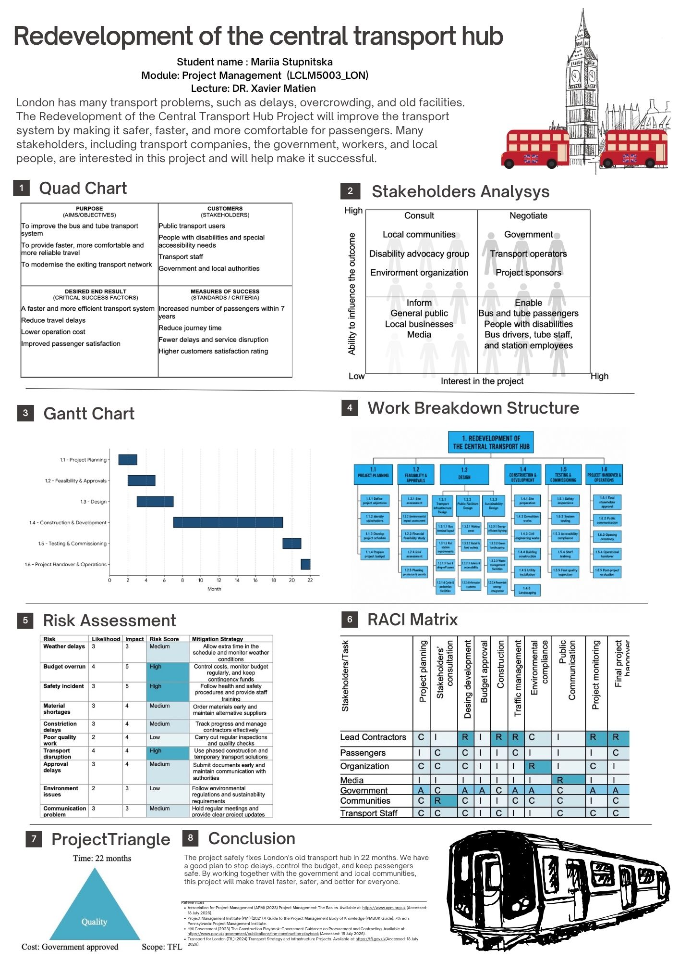
Part B – Critical Reflection
For this project, I created a poster about the redevelopment of a central transport hub in London. The poster presents the main project information and shows how the project can be planned and managed. I used project management tools such as a Gantt Chart, stakeholder analysis, WBS, risk assessment, RACI matrix and Project Triangle, which helped me understand how the project can be planned and organised. During the class, I received positive feedback from my classmates about my poster design. They said it looked clear and interesting. My teacher preferred my previous design, so present this design in report.
This feedback helped me understand that both design and complete content are important, and I learned to check the requirements carefully before submitting my work.
At the beginning, I felt confident about idea because I believe that improving a transport hub can make public transport safer, faster and more comfortable. I also felt interested in identifying the different stakeholders because many people and organisations can be affected by the project. However, I was also nervous about the project taking longer than planned. The 22-month schedule looks realistic on the poster, but unexpected problems such as construction delays, weather, material shortages or approval delays could make the project longer.
The presentation went well overall, and I think the content of my poster was strong and complete. The main idea was clearly shown in the poster, and it included the required project management tools and evidence. However, I identified that my communication during the presentation could be improved. To make the presentation more interesting and catch the audience’s attention, I needed to explain my ideas in more detail instead of only describing what was shown on the poster. I think the poster showed the project clearly, but the presentation needed more critical explanation. In my report, I can explain these ideas in more detail and show a deeper understanding of the project.
Looking back, there are clear reasons why my poster had some weaknesses. First, my Quad Chart could have been better because I focused more on internal stakeholders and did not show the wider project context clearly enough. Second, my poster design had too much empty space between some tables, which made the layout look less balanced. Third, I did not explain the Project Triangle in enough detail. I showed the main elements of time, cost and quality, but I did not clearly explain how they affect each other and can create trade-offs during the project. This shows me that I need to focus not only on including information but also on explaining it clearly and critically.
I learned that a good project manager cannot focus only on the visual layout. A good plan needs clear and accurate details, so the project team knows what to do, when to do it and how to keep the project safe and on time.
In future projects, I will check all requirements carefully, improve my communication during presentations, give more detailed explanations of project decisions and consider all stakeholders equally. I will also practise my presentation before delivering it so I can explain my ideas more confidently and critically

Part C – Project Management Plan

Introduction
The proposed project is the Redevelopment of the Central Transport Hub in London. The project responds to problems associated with transport delays, overcrowding and outdated facilities. The redevelopment aims to provide a safer, more accessible and more efficient environment for passengers and transport staff. The project also considers the needs of local communities, government, transport operators, people with disabilities and other stakeholders.
The project is planned around a structured project life cycle covering planning, feasibility and approvals, design, construction, testing and final handover. The overall programme is identified as 22 months. Effective planning is particularly important in construction projects because the quality of project planning can influence cost and schedule performance (Zwikael and Globerson, 2006).
This Project Management Plan applies project management techniques to control the project's scope, schedule, stakeholders, resources and risks. The aim is not only to complete the physical redevelopment but also to ensure that the completed transport hub provides the intended benefits to its users. Project success can involve both project management performance and the success of the final product or outcome (Baccarini, 1999).

Project Description
The project focuses on the redevelopment and modernisation of a central transport hub in London. The proposed improvements include the bus terminal, rail station facilities, taxi and drop-off areas, pedestrian and cycling facilities, passenger waiting areas, toilets, accessibility facilities and transport information systems. Sustainable features such as energy-efficient lighting, green landscaping, waste management and renewable energy are also included.
The project has four main objectives: to improve the existing bus and tube system, provide faster and more reliable travel, modernise the transport network, and improve accessibility and safety.
The project follows a structured sequence from planning to operational handover. This allows activities to be divided into manageable stages and monitored throughout the project. The use of a Work Breakdown Structure is appropriate because WBS techniques break a complex project into smaller work packages and connect activities with resources and project objectives (de Heredia Scasso and Santana Larenas, 1991).
Project success is measured through project delivery and the performance of the completed transport hub. Key indicators include completion within the planned programme, control of costs, compliance with safety and accessibility requirements, reduced delays and improved passenger satisfaction. A broader definition of success is appropriate because project stakeholders may assess success differently (Davis, 2014).

Scope
The project scope defines the work included in the redevelopment. The scope is organised using a Work Breakdown Structure (WBS) consisting of six main work packages: Project Planning, Feasibility and Approvals, Design, Construction and Development, Testing and Commissioning, and Handover and Operations.
The first stage includes defining project objectives, identifying stakeholders, preparing the schedule and establishing the project budget. This stage provides the foundation for the remaining work. Effective planning supports better control of project activities and resources (Zwikael and Globerson, 2006).
The second stage includes site assessment, environmental assessment, financial feasibility, risk assessment and obtaining the required planning permissions and permits. These activities establish whether the proposed redevelopment can proceed.
The Design stage develops the detailed transport and passenger facilities, including the bus terminal, rail station, taxi and drop-off areas, pedestrian and cycling facilities, waiting areas, accessibility facilities and transport information systems.
This is the main physical stage. Activities include site preparation, demolition, civil engineering, construction, utility installation and landscaping.
This includes safety inspections, system testing, accessibility checks, staff training and final quality inspections.
The final stage includes stakeholder approval, public communication, opening of the transport hub, operational handover and post-project evaluation.
The scope therefore includes construction, testing, staff training and stakeholder communication, as well as design, accessibility improvements, transport facilities and final handover. Activities outside the redevelopment of the central transport hub are excluded.

Work Breakdown Structure
The WBS provides a structured breakdown of the project into manageable work packages. It helps define the activities required to deliver the project and links scope, resources and schedule. WBS is useful for complex projects because it provides a logical structure for monitoring progress (de Heredia Scasso and Santana Larenas, 1991).
Quad Chart
The Quad Chart provides a concise overview of the project's objectives, stakeholders, expected results and success measures. The project aims to improve the bus and tube system, provide faster and more reliable travel and modernise the existing transport network.
The main stakeholder groups include passengers, people with disabilities, transport staff, government, transport operators, local communities and project sponsors. Expected results include reduced travel delays, improved transport efficiency, improved passenger satisfaction and lower operating costs.
The Quad Chart helps stakeholders understand the project quickly and connects objectives with measurable outcomes. This is important because project success should be assessed using both delivery measures and the benefits achieved by the completed project (Turner and Zolin, 2012).

Gantt Chart
The Gantt Chart provides a visual schedule for the redevelopment. It shows the main activities, planned duration and sequence. A clear schedule is essential because activities must be coordinated according to dependencies and planned completion dates (Zwikael and Globerson, 2006).
The schedule contains six main activities. Some activities overlap; for example, feasibility and approvals continue while elements of design begin. This can reduce unnecessary waiting time.
The schedule includes milestones and dependencies. Completion of approvals is required before construction can fully proceed. Construction must be substantially completed before testing and commissioning, while final handover depends on successful testing, quality checks and stakeholder approval.
The main critical path follows: Project Planning → Feasibility & Approvals → Design → Construction & Development → Testing & Commissioning → Handover & Operations.
A delay to a critical activity can affect overall completion. Progress should therefore be monitored against the Gantt Chart, particularly during the 12-month construction stage. No project manager can effectively control a complex redevelopment without a clear schedule.

Stakeholder Management
Stakeholder management is important because the redevelopment affects different groups with different interests and levels of influence. Stakeholders are particularly important in construction projects, where their decisions and expectations can affect project outcomes (Littau, Jujagiri and Adlbrecht, 2010).
The project uses four engagement approaches: Consult, Negotiate, Inform and Enable. Local communities, disability advocacy groups and environmental organisations are consulted. Government, transport operators and project sponsors are involved in negotiation. The public, local businesses and media are informed. Passengers, people with disabilities and transport staff are enabled to provide feedback and participate.
Stakeholder involvement continues throughout the project. Regular meetings, progress updates and consultations allow concerns to be identified early. This is important because stakeholder groups can have different perceptions of project success (Davis, 2014). Communication is particularly important during construction because temporary transport disruption may affect passengers, local businesses and transport operators.

Allocation of Resources
Every project consumes resources, and effective resource allocation is necessary to achieve planned time, cost and quality requirements. The main resources are people, equipment,
Human resources include the project manager, engineers, architects, construction workers, safety specialists, environmental specialists, transport staff and contractors. Government and local authorities provide approvals and oversight, while transport operators support operational planning. Project managers also require communication, leadership and
Construction requires machinery, tools, safety equipment and testing equipment. Equipment needs to be available according to construction and testing schedules to avoid unnecessary delays.
Technology includes transport information systems, communication systems, testing systems and digital infrastructure. These resources support construction and future operation.
The existing transport hub is the main facility being redeveloped. Temporary facilities are also required for workers, equipment and materials. The completed hub will include improved passenger waiting areas, toilets, accessibility facilities and transport information facilities.
Material resources include construction materials, building components, utilities, transport infrastructure materials, accessibility equipment and landscaping materials. Material shortages are a medium-level risk, so early ordering and alternative suppliers are required.
Time is a critical resource because the project has a planned 22-month programme. Resources must be available when required by the WBS and Gantt Chart. Construction receives the largest time allocation, followed by testing and final handover.
Financial resources are required for planning, design, construction, labour, materials, equipment, testing and contingency. Budget overrun is a high risk, so costs require regular monitoring and contingency funding.
Information is required for decision-making. The project team needs accurate information about the site, design, budget, schedule, risks, stakeholders, safety requirements and construction progress.
Resources should be reviewed throughout the project and matched to WBS activities. This reduces the possibility of labour, material or equipment shortages affecting the critical construction stage.

Risk Analysis
Risk management is essential because construction and transport projects involve uncertainty. A likelihood and impact assessment is used to identify priority risks. Qualitative risk assessment is widely used in construction project management, with risk identification, assessment and response forming important elements of the process (Lyons and Skitmore, 2004).
The project identifies budget overrun, safety incidents and transport disruption as high-priority risks. Weather delays, material shortages, construction delays, approval delays and communication problems are medium-level risks.
The project does not simply identify risks; it establishes how each risk will be managed. Each risk has an owner responsible for monitoring and implementing mitigation. Mitigation reduces likelihood or impact, while contingency provides a response if the risk occurs.
For example, early ordering and alternative suppliers reduce material shortage effects. Phased construction reduces transport disruption. Safety training and inspections reduce safety risk. Contingency funds provide a response to unexpected costs.
Risk management is continuous. Risks should be reviewed during project meetings and updated when circumstances change. Risk and stakeholder management should also be integrated because stakeholders can influence the identification and management of construction risks (Xia et al., 2018).
A risk register should record the risk, likelihood, impact, mitigation, risk owner, contingency and status. High-priority risks should be escalated to the Project Manager and relevant senior stakeholders.

Conclusion
The Project Management Plan provides a structured approach for delivering the Redevelopment of the Central Transport Hub in London. The project has a defined scope and is divided through a WBS into six main work packages: Project Planning, Feasibility and Approvals, Design, Construction and Development, Testing and Commissioning, and Handover and Operations.
The WBS provides the foundation for the Gantt Chart and resource allocation. The Gantt Chart provides a visual schedule showing activities, milestones, dependencies and the critical path. Stakeholder analysis ensures that groups affected by the redevelopment are appropriately consulted, informed or involved. Resource planning considers people, equipment, technology, facilities, materials, time, budget and information.
Risk management provides a structured response to uncertainty. The project identifies major risks and assigns mitigation, contingency and responsibility to each risk. This approach supports proactive rather than reactive project management.
Project success should not be measured only by completing the redevelopment within the planned schedule and budget. Efficiency is important but does not represent the complete definition of project success (Serrador and Turner, 2015). Stakeholder satisfaction, safety, accessibility and the performance of the completed transport hub are also important.
Overall, the plan provides an integrated approach to managing the redevelopment. Effective control of scope, time, resources, stakeholders and risks should support the delivery of a safer, more accessible and more efficient central transport hub.

References
Alvarenga, J.C., Malinowski, R., Kniess, C.T., Bizarrias, F.S. and Quelhas, O.L.G. (2020) ‘The project manager core competencies to project success’, International Journal of Managing Projects in Business, 13(2), pp. 277–292.
Baccarini, D. (1999) ‘The logical framework method for defining project success’, Project Management Journal, 30(4), pp. 25–32.
Cooke-Davies, T. (2002) ‘The “real” success factors on projects’, International Journal of Project Management, 20(3), pp. 185–190.
Davis, K. (2014) ‘Different stakeholder groups and their perceptions of project success’, International Journal of Project Management, 32(2), pp. 189–201.
de Heredia Scasso, R. and Santana Larenas, G. (1991) ‘Project-breakdown structure: the tool for representing the project system in project management’, International Journal of Project Management, 9(3), pp. 157–161.
Littau, P., Jujagiri, N.J. and Adlbrecht, G. (2010) ‘25 years of stakeholder theory in project management literature (1984–2009)’, Project Management Journal, 41(4), pp. 17–29.
Lyons, T. and Skitmore, M. (2004) ‘Project risk management in the Queensland engineering construction industry: a survey’, International Journal of Project Management, 22(1), pp. 51–61.
Müller, R. and Turner, R. (2007) ‘The influence of project managers on project success criteria and project success by type of project’, European Management Journal, 25(4), pp. 298–309.
Serrador, P. and Turner, R. (2015) ‘The relationship between project success and project efficiency’, Project Management Journal, 46(1), pp. 30–39.
Turner, J.R. and Zolin, R. (2012) ‘Forecasting success on large projects: developing reliable scales to predict multiple perspectives by multiple stakeholders over multiple time frames’, Project Management Journal, 43(5), pp. 87–99.
Xia, N., Zou, P.X.W., Griffin, M.A., Wang, X. and Zhong, R. (2018) ‘Towards integrating construction risk management and stakeholder management: a systematic literature review and future research agendas’, International Journal of Project Management, 36(5), pp. 701–715.
Zwikael, O. and Globerson, S. (2006) ‘Benchmarking of project planning and success in selected industries’, Benchmarking: An International Journal, 13(6), pp. 688–700.

