PROFESSIONAL CAREER DEVELOPMENT
BMSW4005
ASSESSMENT 2

Scarleth Salome Vera Zambrano
2010790
Mary March
University of Wales Trinity Saint David
2020-2021

TABLE OF CONTENTS

INTRODUCTION………………………………………………………….……………………..3
ROLE PLAY…………………………………………………………………….………………..4
SELF-EVALUATION…………………………………………………………………….………6
PERSONAL DEVELOPMENT PLANNING…………………………………………..……….7
CONCLUSION…………………………………………………………………………………….9
REFERENCES…………………………………………………………………………………..10
APPENDIX 1: LIFELINE EXERCISE…………………………………………...…………….11
APPENDIX 2: APPLICATION FORM…………………………………………………………13
APPENDIX 3: JOB DESCRIPTION………………………………………………..………….23

INTRODUCTION

To introduce this report, I have worked with the lifeline exercise (Appendix 1) to demonstrate key events of my life and thus where I can place myself in present (NHS, 2021). This exercise has helped me to understand what I have been doing during my academic and professional life, and it made me realize I am very young to keep developing myself and I have loads of time and opportunities in my future.
I am currently working as a nanny for two families, the children are 2, 7, and 12. I started my working life as a nanny a long time ago in Spain, looking after family friends’ children and little cousins, it was a part-time job because I was finishing my A-levels in high school.
I moved to the UK 4 years ago, I started my first job here working as a cashier, then as a barista and then I got promoted as a team leader. Later, I decided to change my career and wanted to try to work in retail, in a clothing shop, and later in an outlet and combine it with cleaning jobs. After a long time changing, I decided to just have one job and relax for a bit and I started to work as a barista again: the payment was really good and the atmosphere in the workplace was very enjoyable. Once I was constant, I started to think again: what do I want for my future? Is it to be changing jobs all my life? So I started to build a small plan:
I realized that what I wanted to do was to be in the healthcare industry, so I asked friends and they recommend I work as a care worker, get the first aid certificate, and get a DBS done, that would be my start. After some investigations, I realized that If I have experience working with children it would be easier to get a pediatric first aid certificate, as I would understand everything better. I did the course and the training, and during that session, I realized that being aware of children’s health and wellness is something that matters to me.
After that, I started working as a nanny and I consider that I am good at working with children, so I focused since then that I wanted to be a pediatric nurse. I have researched what I needed, and this course was the first step to achieving my goal.
The following information in this report will focus on a specific work done during this module: The role-play task, a self-evaluation about motivation and learning styles that work better for me, and finally a personal career development from when I finish this course until when I achieve my final goal, going through some personal aspects I want complete during my way.

ROLE PLAY

For the first part of this assessment, we did a Role Play of an interview to act out others’ behaviors by assuming a role (Wikipedia, 2021). My role-play was done with our lecturer Mary March. I started as the interviewer. The questions I did were:
- How are you?
- Did you find well joining this meeting?
- Why are you leaving your current job?
- How do you think our company can help you develop your career?
- Is working within a team one of your social skills? What teamwork means for you?
- What is your strongest skill to secure/target a sale?
- Can you describe yourself in five words?
- Why should I hire you?
I chose these questions because my interviewee was applying for Travel Consultant. I read very carefully her application form and I could see she had loads of experience in the industry, so I focused my questions on how both parties could take advantage by working in my company to see if she is worth hiring. I read her application form many times, I focused on the criteria needed for the position to understand who a travel consultant is really; I also focused on her experience and I imagined myself as the manager of the company to see what profit I could take from her previous knowledge. And finally, I focused on her hobbies and interests to see how I could use her personal/social skills and personality to include her in my team.
After I finish my role play as the interviewer, the lecturer gave me the following feedback: she suggested I end it by saying something like: “we have many applicants for this position, after this interview, I will review your application form and I will be in touch with you by next week with a decision”.
When I asked Mary if she liked working within a team, she answered that she doesn’t, and I did not ask why. Miss Mary suggested I be more challenging as an interviewer in the future.

Later when I was the interviewee, I was asked these questions:
- How are you?
- did you find well the building?
- Why did you choose this position?
- How can you bring your experience into your new job place?
- what is the skill you think will help you better to work with sick children?
- Do you have any questions?
- We have many applicants, we will review your application form and we will be in touch with you soon.
After I finish my role play as an interviewee I asked her 3 questions to expand my knowledge about the position, these were:
- what are the big challenges that someone in this position would face?
- what types of skills is the team missing that you are trying to fulfill with a new hire?
- Do you have any trainings available for your employees?
From my point of view, the role play was very successful. I prepared both parts (interviewer and interviewee) very well. For the second part, when I completed the application form (Appendix 2), I tried to explain everything in detail. I also read very well the job description (Appendix 3) and the criteria and was sure that I would fit for the position before to apply for it..
I received good feedback from the lecturer, she said it was very well prepared, I looked confident because I knew what I was talking about. She said the questions I chose as an interviewer were very convenient and that she was blank when I asked “describe yourself in five words”. When I was the interviewee, she said that I looked a bit nervous, but I knew how to answer all the questions, and she also said that it was good to show interest by asking questions at the end of the interview.

SELF-EVALUATION

For this part of the assessment, I will do a reflection based on the Gibbs cycle about myself and how I could improve in my professional development. I focused on my self-motivation and my learning styles because I think these are two important things to get started in every new project: The levels of motivation of an individual will push you to move on, to achieve, produce and develop to a better result (Mindtools, 2021), and the way someone will get knowledge to achieve their goal is base for a better outcome.
- Description:
In week two we talked about what motivates us and what are our preferred learning styles. For this session, we did two quizzes to self-analyze our answers.
For self-motivation, I got a 49 score, which on the website means: “Wonderful! You get things done, and you don't let anything stand in your way. You make a conscious effort to stay self-motivated, and you spend significant time and effort on setting goals and acting to achieve those goals. You attract and inspire others with your success. Treasure this - and be aware that not everyone is as self-motivated as you are!” (Mindtools, 2021)
For the VAK quiz for learning styles, I got the following scores:
A: 10 B: 7 C:13
A corresponds to visual, B auditory, and C corresponds to kinaesthetic learning which means that I will find it easier to learn by experiences, feelings, or emotions. It will be easier for me to try new things to learn rather than visual or listening.
- Feelings:
Since I started studying this course, my self-motivation was big enough to understand what I wanted for my career. When I did the quiz I felt happy and it made me feel confident about myself because I had loads of problems before about finding out what I want for me, what could I be good at,…
For when I did the quiz for the learning style, it was a good feeling as well, because one of my biggest weaknesses is that I lose focus very easily, and learning what is the better way for me, was very beneficial because now I can put on a side learning techniques that before wouldn’t work for me, and put more effort on those where I am better at.
- Evaluation:
What went well for the self-motivation quiz was that I could see that I am not on the wrong track. For success having self-motivation is key. So, knowing that I have good levels of it made me increase my self-esteem and made me want to push myself even more.
What went well for the learning styles quiz was that now I can focus more on kinaesthetic strategies, and I will save more time when I study.

- Analysis:
After doing this module, I am more confident on how I want to address my career what steps I will follow and I can set up goals that I know I can complete. After doing both quizzes I feel more motivated and excited to see myself improving.
- Conclusion:
It has been rough to start studying again, and since I lose concentration very easily, sometimes feels like I will not be capable enough to complete my targets. But after this course, I have my ideas clear and the outcome of this is very positive.
- Action plan:
After this module I will follow my development plan, I will work more on my self-motivation, self-confidence, and put more effort into kinaesthetic learning, and hopefully, I will be better at a concentration to achieve my goals on the right deadline.

PERSONAL DEVELOPMENT PLANNING

“Personal development planning is the process of creating an action plan based on awareness, values, reflection, goal-setting, and planning for personal development within the context of a career, education, relationship or for self-improvement.”
(Wikipedia, 2021)
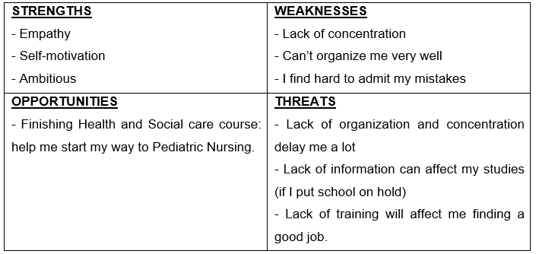
To start creating my personal development planning (PDP) I have done a SWOT analysis:

After doing the SWOT analysis, I can focus on the SMART goals I want to achieve in the following three years, and what skills I will need, and which ones I will need to improve to be successful.
SMART stands for:
S= Specific M= Measurable A=Achievable R= Realistic T=time bound
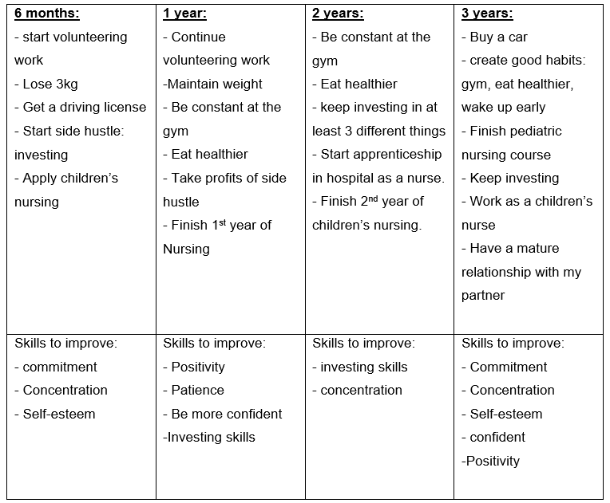

CONCLUSION

This module has helped me a lot to find myself, knowing where I am right now, what I want to do in the future and how to get there. I have clear how I will work on that, I have the tools to achieve my goals, I know, and the most important thing: Motivation.
For me, the most helpful tools have been the learning style quiz and the personal development planning. With these two I feel like I can save a lot of time that I used to waste before by changing jobs many times or by losing concentration all the time when studying.
Understanding how to set up SMART goals has been also a very good tool because now I will not feel frustrated for not completing goals that probably will not be as realistic as they should.

REFERENCES

Mind tools (2021) How Self-Motivated Are You? Available at: https://www.mindtools.com/pages/article/newLDR_57.htm (Accessed on: 29 December 2021)

NHS (2021) Lifeline exercise. Available at: https://www.healthcareers.nhs.uk/career-planning/resources/life-line-exercise (Accessed on 27 December 2021)

Wikipedia (2021) Role-playing. Available at: https://en.wikipedia.org/wiki/Role-playing (Accessed on 28 December 2021)

Wikipedia (2021) Personal development planning. Available at: https://en.wikipedia.org/wiki/Personal_development_planning (Accessed on: 30 December 2021)

Mind tools (2021) SMART Goals. Available at: https://www.mindtools.com/pages/article/smart-goals.htm (Accessed on: 30 December 2021)

APPENDIX 1: LIFELINE EXERCISE

Your lifeline
Many people find it helpful to look back on their experiences in order to think about what their priorities are and what they want from life. Producing a lifeline helps to give shape to the past rather than see it as a confusing jumble of events and experiences. This can be the first step towards considering the future and moving forward.

- Print this form and, starting from your birth to the present day, note down key events in terms of the extent to which they mark high or low points of your life.
- Were these key events instigated by you or the result of outside influences?
- Do these experiences have anything in common?
- Think about what happened and how you felt. What does this say about you and how might that affect your future decisions?

This lifeline should show your high and low points. Include key events in your life.
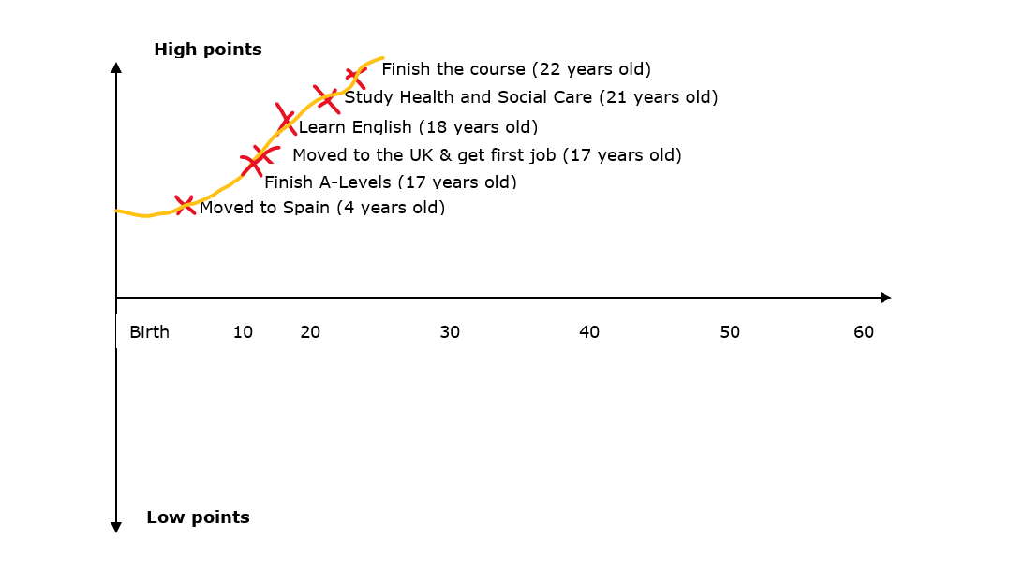

ANSWERS:

2. the first key point was influenced by parents, but the rest were my decision.
3. what they have in common is that all key events are positive and have helped me for my personal growth.
4. Some changes are difficult, and sometimes can feel scary and overwhelmed, but all these changes are worthy for what I want in my future, so I think this are clear examples that is better to take risks even if you feel afraid rather than stay still forever and not to develop.

APPENDIX 2: APPLICATION FORM

Application for Employment
Position Applied For | Nursing Assistant
How did you learn about this vacancy? | NHS Jobs Website
To ensure that you are able to complete the application form in full, please refer to the short-listing criteria on the job description.

1. Personal Details
Title | Miss
Surname | Vera Zambrano
Previous Name
Forenames | Scarleth Salome
Address | N/A
Post Code | N/A
Telephone number |  |  | Mobile No |  |  | N/A
E-mail address | 2010790@student.uwtsd.ac.uk
National Insurance  Number | ZV326798C

1a. Additional Information
Do you hold a full, clean driving license valid in the UK? |  |  |  |  | Yes |  | X |  | No
Do you have the right to work in the UK without restriction?  (Proof of right to work in the UK ID will be required) |  |  |  |  | Yes |  | X |  | No

2. Employment History
The last 5 years employment should be detailed, including any gaps in employment.
Please continue on a separate sheet if required.

Current or Most Recent Employment
Employers Name | Alexis Cuddyre
Address | N/A
Postcode | N/A
Job Title | Nanny
Dates of Employment | From |  | March 2020 | To |  | Present
Reason for leaving | Change career |  |  | Salary |  | £12500 annum
Brief outline of main responsibilities and key duties | Looking after a 2 year old toddler, prepare healthy meals, help with pick ups and drop offs, laundry of the child, playtime with him, engage learning activities: paint, sensory play, construction, cooking together, read stories,… teach Spanish, occasionally babysitting, bath him, put down to sleep.

2. Employment History
The last 5 years employment should be detailed, including any gaps in employment.
Please continue on a separate sheet if required.

Current or Most Recent Employment
Employers Name | Richard Mott
Address | N/A
Postcode | N/A
Job Title | Nanny
Dates of Employment | From |  | November 2019 | To |  | Present
Reason for leaving | Change career |  |  | Salary |  | £9000 annum
Brief outline of main responsibilities and key achievements | Looking after a 7-year-old girl and 12 year old girl, pick up of from school of the younger one, organize playdates with other friends, prepare healthy snacks and dinner, engage learning activities such as painting, cooking, reading, sports, etc…  Occasionally baby sittings: help with dinner, read stories, put down to sleep

Previous Employment
Employers Name | Pret a Manger
Job Title | Barista
Dates of Employment | From | April 2019 | To | November 2019
Reason for leaving | Change career |  | Salary | £16000 annum
Brief outline of main responsibilities and key achievements | Prepare hot drinks following specific standards, make sure all the barista equipment is good and ready to use. Maintain clean and tidy all barista areas and equipment. Be aware of sales and waste. Restocking

Previous Employment
Employers Name | Four marketing
Job Title | Sales Assistant
Dates of Employment | From | October 2018 | To | April 2019
Reason for leaving | Change career |  | Salary | £16500 annum
Brief outline of main responsibilities and key achievements | Serving customers offering drinks and food. Keep the communal areas clean and tidy all the time. Receiving, scanning and pricing items from delivery and also send back to deposit items  not needed.

Previous Employment
Employers Name | Reserved
Job Title | Stockroom Assistant
Dates of Employment | From | January 2018 | To | October 2018
Reason for leaving | Change career |  | Salary | £17000
Brief outline of main responsibilities and key achievements | Receiving, handling, and help to manage the inventory of the items in a timely and organized manner. Replenish the shop floor bringing materials from the stockroom every hour during the day. Receiving overstock from the shop floor and put it away to keep the area clean and tidy. Receive, prepare, and organize the delivery of the week. Prepare deposits, do inventories  of the items.

Previous Employment
Employers Name | Upper Crust
Job Title | Team leader
Dates of Employment | From | July 2017 | To | December 2017
Reason for leaving | Change career |  | Salary | £16000
Brief outline of main responsibilities and key achievements | Maintain clean and sanitising work station. Know all the machines, their parts and so that each of them is used. Make and serve coffees and tea beverages. Follow health and safety guidelines. Follow recipes and presentations for food and beverage items.

Previous Employment
Employers Name | Upper Crust
Job Title | Team leader
Dates of Employment | From | July 2017 | To | December 2017
Reason for leaving | Change career |  | Salary | £16000
Brief outline of main responsibilities and key achievements | Maintain clean and sanitising work station. Know all the machines, their parts and so that each of them is used. Make and serve coffees and tea beverages. Follow health and safety guidelines. Follow recipes and presentations for food and beverage items.

Please continue on a separate sheet if required.

3. Formal Qualifications and Training & Development
Continue on a separate piece of paper if required. You will be required to provide original qualification certificates if successful.

Secondary Education Qualifications
Name of Qualification | Date Gained |  |  |  | Level | Grade |  | Awarding Body
GCSE | June 2015 |  |  |  | Level 2 | B

Further/Higher Education Qualifications
Name of Qualification | Date Gained |  |  | Level |  | Grade |  | Awarding Body
A-Levels | June 2017 |  |  | Level 3 |  | B

Professional Qualifications
Name of Qualification | Date Gained |  |  | Level | Grade |  | Awarding Body
Certificate of Higher Education for Skills in the workplace (Health and Social Care) | December 2021 |  |  | Level 4 | 60% |  | Award with merit

CPD / Training and Development
Brief description / course title |  | Date Taken
Paediatric First Aid Certificate |  | 23rd November 2019

4. Interests and hobbies

Please provide details of your hobbies / leisure activities / voluntary work
I like to travel, discover new places, new cultures, take pictures of it. I like to spend time with my family and friends. I like to dance, listen to music, and watch movies.

The past year I was very interested on doing a volunteering job in a hospital, but due to lack of time I had to leave it on a side as is something that I really want to do, but I need to find good time to manage it.

5. Referencing

Referencing required for 2 full years (with a minimum of 2 references). At least 1 reference should be your current of most recent employer. Please confirm any existing personal / family relationship with existing PRC employees

References (Current or most recent employer)
Name of Referee | Alexis Cuddyre
Job Title | N/A
Employers Name | N/A
Address | N/A
Postcode | N/A
Telephone Number | N/A |  | Ext. Number | N/A
E-Mail Address | N/A
Are you willing for this referee to be approached prior to interview? | Yes No

 | References
 | Name of Referee | Richard Mott
 | Job Title | N/A
 | Employers Name | N/A
 | Address | N/A
 | Postcode | N/A
 | Telephone Number | N/A | Ext. Number | N/A
 | E-Mail Address | N/A
Are you willing for this referee to be approached prior to interview? |  | Yes No

6. Reason for applying

Please detail below reasons for applying for the position including your skills, experience and attributes.
This job for me is challenging, is the beginning of my dreamt career. I would like to work as a children's nurse and being a health care worker is a step closer to achieve that goal.

I am an enthusiastic, empathetic, and hard worker person, I like to help others and I consider myself as a very committed individual. I like to take responsibility of what I do, I like to be reliant, confident and trustworthy. I like to give my best when completing an action and I will always try to do everything right.

I know how to work under pressure, I can be calm and complete a task when everything seems to be out of control, I also have very good leadership skills: I know how to organize a team, how to delegate tasks, how to manage the time and how to check information and put it together, and also, I know how to follow instructions.

I know that by applying for this role I will be able to enhance my skills mentioned above.

I already worked with children from new-born to 12 years old, I have seen how they developed with the pass of the years and I know how to act with children at different age.

I really enjoy working with children because I am likeable for them. I am creative, active, and very friendly. I think I engage them to develop their own confidence and curiosity.

Please specify how you meet the criteria for this role.
I consider that I meet the criteria starting from the qualifications: I recently completed my Level 4 certificate in Health and Social Care. I have lot of experience working with children and their families: dealing with meals, sicknesses, school problems (anxiety, pressure, ADHD…), change of plans in last minute, working under pressure, and if necessary I know how to manage my options to make a solution to solve a problem.

I am respectful and tolerant to others and that is key for working with vulnerable people as patients are. I am open to talk about any topic and I can engage people to open themselves and talk to me demonstrating a safe environment free of judgments.

7. Declaration
Please complete the following declaration and sign it in the appropriate place below.
I certify that:
- All the information given to me on this form is correct to the best of my knowledge
- All questions relating to me have been accurately and fully answered
- I possess all the qualifications which I claim to hold
Signed: Date: 23/11/2021

Print Name: Scarleth Vera

APPENDIX 3: JOB DESCRIPTION

WeCare about our ambition for excellence
Our WeCare values shape everything that we do, every single day. They are visible in every interaction we have with each other, our patients, their families and our partners.

WeCare about everything from the appointment letters our patients receive, to the state of our facilities when they walk through the door, to the care and compassion they receive when they are discharged. WeCare that the people who join our trust will hold the same values as we do, so our values are embedded within our recruitment and selection processes. WeCare that you feel valued working here, so our values also guide our training and development and performance and talent management. WeCare about working with suppliers that live and breathe our values too.


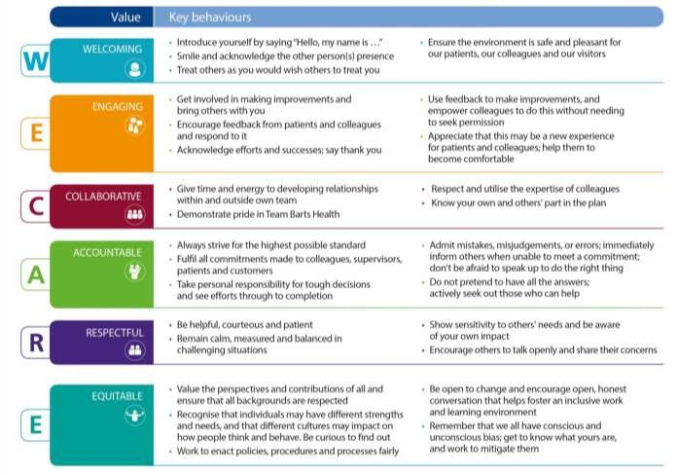
We have come a long way on our journey to delivering safe and compassionate care. By embracing these values as the way we behave around here, we will achieve our ambition for excellence.

Job Particulars

Job Title | Nursing Assistant
Pay Band | Band 2
Location | Childrens Ward, Royal London Hospital
Reports to | Ward Manager
Responsible to | Matron

- Job Purpose

The postholder will work as an effective team member and carry out a range of specific activities in support of registered nurses, involving the direct nursing care of patients.
They will assist in providing effective family centred nursing care to patients and their families and take responsibility for updating own knowledge and skill in line with Trust policies and procedures
- Key Working Relationships

Internal | External
Ward manager | Community Nursing teams
Allied Health Professionals | Health visitors
Medical teams | Social services
Play Specialists
Community Teams
Health Visitors
Carillion Staff
Clinical Nurse Specialists

- Main duties, responsibilities and results areas

The main duties and resoponsibilities are as below-

- To work as directed, and under the supervision of the registered nurse in charge of the ward.
- To effectively communicate changes in the condition of the patient or any untoward incidents to appropriate member of the team.
- To help promote and maintain the patients’ and families rights and personal cultural beliefs.
- To acknowledge and support individual patients’ dignity and specific needs at all times.
- Ensure the delivery of patient care in accordance with the principles of Essence of Care Standards and National Service Framework for Children & Young People.
- Plan working day, taking account of responsibilities and prioritising workload in discussion with a qualified nurse.
- Contribute to the movement and handling of patients to maximise their physical comfort.
- Undertake delegated individual care needs required for the comfort and well-being of the patients, following patients care plan or Integrated Care Pathway.
- Assist patients with fluid and dietary requirements, documenting all intake and output.
- Ensure that every opportunity to promote health education is undertaken at all times.
- Involves child/young person and/ or carer in decision making process and gains patient consent before commencement of any care respecting the patient choice where appropriate for child/young person’s development.
- Documents all individual care given to patients and ensures that any variance is reported to Registered Nurse.
- Works at all times in accordance with Trust Health Care Support Worker Code of Conduct and ensures that clinical competence has been agreed and assessed.
- Ensure effective communication channels between patients, relatives, staff and other outside agencies as appropriate.

Please Note –

Duties may change to meet the needs of the service or because of the introduction of new practices or technology.

- Working conditions

Criteria | Description
Physical | Standard keyboard skills required.  The postholder may be exposed to light exertion carrying out patient care.  The postholder will be required to move objects and machinery such as beds and IV pumps.
Emotional | The postholder is likely to be exposed to circumstances that are distressing or emotional  The postholder has to be able to work under pressure of time and resources  The postholder may have to deal with staff, patients and their families who may be tearful/upset/angry
Working Conditions | May be exposed to verbal abuse
Mental | The postholder requires high levels of concentration.  The work is unpredictable and the postholder may have to adapt to change.  The postholder will require stamina for long shifts and internal rotation from days to nights  May be exposed to verbal abuse

NHS Manager’s Code of Conduct

As an NHS manager, you are expected to follow the code of conduct for NHS managers (October 2002). www.nhsemployers.org/

Safeguarding adults and children
Employees must be aware of the responsibilities placed on them to maintain the wellbeing and protection of vulnerable children and adults. If employees have reason for concern that a patient is 'at risk' they should escalate this to an appropriate person i.e. line manager, safeguarding children's lead, matron, ward sister/change nurse, site manager, consultant (October 2002). www.nmc-uk.org/

Person Specification
Domain | Essential Criteria | Desirable Criteria
Qualifications | Numeracy and literacy  Diploma (NVQ) level 2 in Health and Social Care, Child Care or similar relevant qualification
Experience | Experience of a caring for children/young people preferably in a hospital or nursery/school setting | Experience in working with children undergoing surgery and/or children with complex  medical needs
Knowledge | Understanding of own Knowledge and Skills Framework and ability to identify learning needs and interests | Understanding of Child Development and how to communicate with children of  different ages.
Skills | Ability to work as part of a multi disciplinary team  Ability to communicate effectively to a range of people and understand the importance of the highest standards of customer care  Can demonstrate an enthusiastic, approachable and friendly manner and project a positive image  Ability to communicate effectively, both written and oral  Acts in a way that is consistent with legislation, policies and procedures and abide by the Trust Health and Safety policies  Able to recognise own limits and work within those limits of competence  Ability to treat everyone with whom s/he comes into contact with dignity and respect undermines equality and diversity  Ability to work in a structure, organised  manner | Ability to self reflect, carry out tasks of own job and identify what s/he needs to learn to able to do current job better  Ability to offer constructive suggestions for service improvement  Ability to work within set timeframes working to priorities and deadlines  Ability to use and maintain resources efficiently and effectively and encourage others to do so  Ability to identify and take action when own or other’s actions  Experience in processing information in an efficient and timely manner and to a high standard
Other | Ability to work flexible hours to meet service requirements  Can prove a basic computer literacy in Windows and IT systems

About Barts Health

Our group of hospitals provide a huge range of clinical services to people in east London and beyond.

We operate from four major hospital sites (The Royal London, St Bartholomew’s, Whipps Cross and Newham) and a number of community locations, including Mile End hospital. Around 2.5 million people living in east London look to our services to provide them with the healthcare they need.

The Royal London in Whitechapel is a major teaching hospital providing local and specialist services in state-of-the-art facilities. Whipps Cross in Leytonstone is a large general hospital with a range of local services. Newham in Plaistow is a busy district hospital with innovative facilities such as its orthopaedic centre. Mile End hospital is a shared facility in Mile End for a range of inpatient, rehabilitation, mental health and community services. And St Bartholomew’s in the City, London’s oldest hospital, is a regional and national centre of excellence for cardiac and cancer care.

As well as district general hospital facilities for three London boroughs, Tower Hamlets, Waltham Forest and Newham, we have the largest cardiovascular centre in the UK, the second largest cancer centre in London, an internationally-renowned trauma team, and the home of the London Air Ambulance. The Royal London also houses one of the largest children’s hospitals in the UK, a major dental hospital, and leading stroke and renal units.

We're also proud to be part of UCLPartners, Europe’s largest and strongest academic health science partnership. The objective of UCLPartners is to translate cutting edge research and innovation into measurable health gain for patients and populations through partnership across settings and sectors, and through excellence in education.

