Research Report
Student Name: Rasim Bunari
Student ID: 2130926

Abstract
The ability to use different technological tools gives a learner many opportunities to bring improvement in the study. Further the global pandemic has changed the definition of learning for both students and teachers. They have learned and adopted the online learning approach by coming out from the comfort zone of the offline interactive mode of teaching and learning. The following research has thus been done to identify whether using these technologies is facilitating the collaborative learning of the students or not. The researcher has done a survey among 20 students and has done secondary analysis and collected the data for this report. By maintaining all the ethics and a proper research methodology, the researcher has conducted this research report in a suitable manner.

Table of Contents
1. Introduction 5
2. Research Design 6
2.1. Research Questions 6
2.2. Methods 6
2.3. Ethical consideration 8
3. Results 9
4. Discussion 14
5. Conclusion 16
6. References 17
7. Appendix 19

1. Introduction
Global outrage of the Covid-19 pandemic has affected almost every sector across the globe, the education sector is one of them. Due to the nationwide lockdown, the educational institute including school college universities had to stop their offline classes. They started taking classes through different online mediums including google meet, zoom, Microsoft team skype, and Facebook live. Initially, both students and teachers faced various confusion regarding using these technological platforms. The perception of learning has changed during this global pandemic. At the same time, the places where the network connections remain unstable most of the time students of those areas are have faced and still facing internet-related issues. However, this method allows the students to learn some technical skills and now most of them have already adopted this new way of learning quite efficiently. Further to understand the perspective of the students in using the technologies to improve collaboration in their learning process researchers will do the research. The researcher will use a positivism philosophy and deductive approach to do the research. Additionally, to gather information both qualitative and quantitative data researcher will take and a questionnaire and survey analysis will be done during the data collection and analysis process. Data will be collected with the help of a survey by taking help of 20 students from Prifysgol Cymru University.

2. Research Design

2.1. Research Questions
Are students confident in using technology to collaborate?
Research Aim
To understand the perspective of the students while using the technologies to facilitate proper collaboration in their learning process.
Research Objectives
1. To identify the confidence level of the students about using the technologies for facilitating proper collaboration in their learning.
2. To analyse the obstacles that the students are facing in using the digital collaboration tools for their learning purpose.
3. To evaluate the ways through which students can overcome their digital collaboration issues to enrich their learning process.

2.2. Methods
Research Philosophy
The researcher has used the positivism philosophy research method during the research for the findings. Therefore, the researcher's work has been limited to data collecting from what is available in books and journals. The philosophy of the researcher reflects what is available in the text and will not be able to consider their own opinion. Under the process, the researcher can gain knowledge through empirical research, based on observation and measurement (Warren & Phair , 2021).
Research methods
During the research the researcher considered both quantitative and qualitative data which was later analysed to find the information, this method is known as the mixed method. This method collects information from many data thus it has given the researcher option to choose from. The method provides a panoramic view of the perspective (Pickell, 2021).
Research approach
The deductive approach has been followed by the research while conducting the report because the researcher used quantitative and quantitative research both which is related to positivim philosophy. This approach starts with a theory and then tries to build the aim on it to progress in the research. Further, this approach has helped the researcher choose the process of collecting information from all the available data (Warren & Phair , 2021).
Data collection and analysis process
There are two methods of research such as primary and secondary research which the researcher has followed for conducting this research. For the primary research, the researcher has conducted a survey. Further, the survey has consisted of some close-end questions that the participants answered which have been later analysed for collecting data (Pickell, 2021). On the other hand many secondary sources like books and journals have been accessed by the researcher. After collecting the data the researcher has followed the qualitative and quantitative approach.
Time horizon
Every research has to follow a fixed time period and the researcher needs to be finished within that time. The time period keeps checking on the data collected so it doesn’t get irrelevant due to new data that has been updated then the researcher have to restart the process. During the study, the researcher used a cross-sectional time horizon. Therefore, the researcher has collected the data at a certain point in time during the research (Stainton, 2021).
Sampling
Sampling is the data that has been collected with help of a group of people among a larger population. Particularly for this research, 20 students of Prifysgol Cymru University of Wales are asked to be part of the survey. Sampling needed to be analysed properly to get the information needed for the research. Basically, it is not possible to collect everyone's perspective thus a group of people from the population give their perspectives through the survey (research-methodology, 2022).

2.3. Ethical consideration
According to Brittain, et al., (2020) there are some ethics that the researcher has to follow while conducting research and collecting data. Researchers have to find an appropriate website for the research and make sure the data is authentic. Any wrong information can spoil the research and its results thus choosing the correct information is important. Further, the researcher should not copy and paste the information available in the open world. Using someone's research information can lead to copyright consequences, even if they use without giving credit can end up in legalisation. Thus, the researcher has to avoid using other researchers for information both offline and online data.

3. Results
Secondary Analysis
Analysis has made to know how confident the students are in using technologies to collaborate. From the data of secondary analysis, it can be stated that 49% of students felt very confident and they thought that they have skills and opportunities to study online (Sumuer,2018). On the other hand, 28% of students preferred offline classes while 32% preferred to be assessed online. Along with this 28 % of learners prefer a combination of these two methods. At the same time, 56% of students feel that the quality of learning they have received online is better than the teaching of offline university classes. Additionally, 70% of teachers have felt that digital teaching and e-learning provides them with new ways and exciting teaching approach which they can use to improve learning (Liu et al.,2020).
Primary Analysis
Figure 1
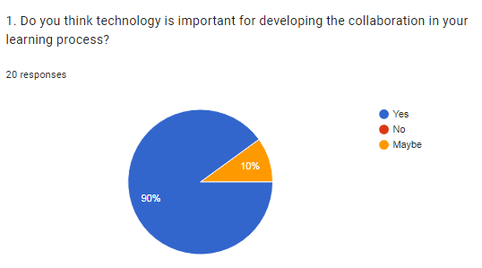
Source: (Google, 2022)
Analysis
Presently, technological assistance in learning has helped the students to enrich their learning process in a great way. As per the above gained resultant figure, 90% of the respondents agreed about their willingness in taking technological assistance for developing collaboration in their learning process. On the other hand, the rest 10 % of the respondents are not sure about this statement.
Figure 2
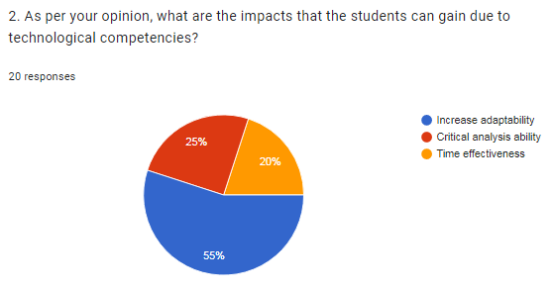
Source: (Google, 2022)
Analysis
Technological competencies help learners to gain different basic learning skills and these can boost their study. As per the above data, 55% of respondents said that it helped Increase their adaptability. Another 25% of respondents state that their critical analysis ability has improved. On the other hand, the rest 20% of technological competencies have the best impact on-time effectiveness.
Figure 3
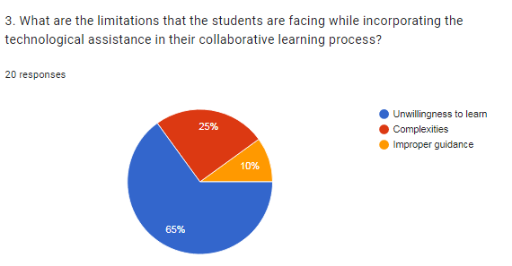
Source: (Google, 2022)
Analysis
Some students are not very much habituated to the technological platforms and they have faced difficulties during online classes. as per the above information of figure, 65% of the respondents responded about their unwillingness to learn. Another 25% said that complexities they have faced during classes Lastly the rest 10% have faced improper guidance.
Figure 4
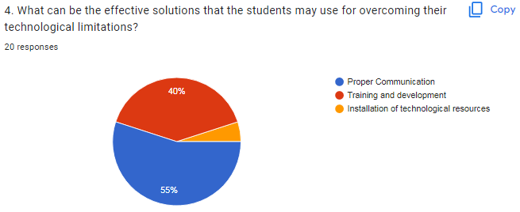
Source: (Google, 2022)
Analysis
Proper strategies and actions can help to mitigate the issues which the learners are facing during their e-learning sessions. As per the above-gained data of the figure, 55% of the respondents think that proper communication can help them. On the other hand, 40% of respondents feel proper training and development will help them to improve. Rest 5% responded installation of technological resources can assist them.
Figure 5
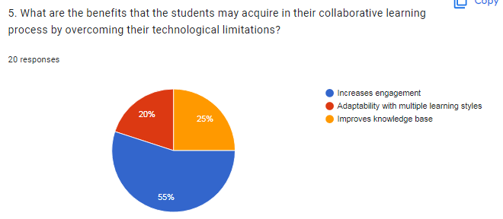
Source: (Google, 2022)
Analysis
Although learners are facing different issues they have also gained various benefits. As per the above diagram, 55% of respondents state that it increases engagement. Another 20% of respondents felt that it helped them to adapt to multiple learning styles. On the other hand, 25% of respondents felt that it is helping them to improve their knowledge base.

4. Discussion
Technology has been helpful in education and since the pandemic, most of institute has moved to online classes. There are some students who is preferring this form of education whereas some are preferring the old style (DeCoito, and Richardson,2018). Thus, many educational institutes are undecided whether to reopen the institute or continue with the online classes (Magdalena, and Napitupulu,2018). The researcher has conducted a study to find how confident students are in using modern technology. The researcher has conducted both primary and secondary research to understand what the students are preferring (Crick et al., 2020).
While analysing the secondary research the researcher found, that around 49 % of students were confident and prefer online classes. Those students have all the opportunities and skills to continue their studies in online classes. Further, around 28 % want to go back to offline classes and prefer in-person studies once the pandemic is over. About 32% just want an online assessment and 28% are comfortable with both thus they prefer a combination of both styles. Around 56% of the student think they have received the same or more than what was claimed by the university in their online classes. Therefore, they seem to be preferring online classes more than offline classes for receiving education. Additionally, when teachers were asked to share their information, around 70% were ready for online classes. They mentioned that digital teaching is more exciting and gives the opportunity to adopt new ways of teaching. However, the researcher wanted to know what are a student of the Prifysgol Cymru University of Wales prefers (Ting et al.,2021).
The researcher has conducted primary research among 20 students for a more detailed analysis of the student preference. The survey reported that around 90% think technology is important for developing collaboration in learning. Whereas 10% of them are not sure whether technology helps the students in their learning. The researcher asked what are the impact of online classes on the student to which 55 % think it increases adaptability. Around 25% claim it helps in developing critical analysis and 20% think it is time effectiveness. Later when asked what could be the limitation students may face while incorporating technology, 65% think the unwillingness to learn. About 25% think its complexities and 20% think there don't get proper guidance in understanding and learning. Thus, the researcher asked how can students overcome this limitation, for which 55% said better communication can be helpful. Training and development were chosen by 45% of the remaining and 5% agreed on installing technological resources. The last question was what are the benefits that students may acquire by overcoming their limitations (Schnaubert and Bodemer,2019). Answering the question 55% said it will increase engagement which will help them to focus on their studies. Further 25% of the students said it does improve their knowledge base and develop skills, whereas 20% said it will help in adopting multiple learning styles. The researcher can conduct an overall analysation to reach the conclusion of the research and find a result (Blau et al.,2020).

5. Conclusion
The pandemic has had its negative impact on nearly every sector and the education sector was among those got affected the most. Students got detached from education and their schools colleges and universities for so many days but to restart their learning online education was started. The research has been done to know how technology is helping the students to develop collaboration in their learning process. The researcher has taken 20 students of the Prifysgol Cymru University of Wales and has done a survey to know the impact of online learning. Difficulties which the students are facing, the steps they think they adopt regarding the use of technology will help them in their future learning and help them to collaborate Further the researcher has also done the research to conclude the secondary analysis. Lastly, the researcher has also discussed the findings and the analysis briefly.

6. References
Blau, I., Shamir-Inbal, T. and Avdiel, O., (2020). How does the pedagogical design of a technology-enhanced collaborative academic course promote digital literacies, self-regulation, and perceived learning of students?. The internet and higher education, 45, p.100722.
Brittain, S., Ibbett, H., de Lange, E., Dorward, L., Hoyte, S., Marino, A., Milner‐Gulland, E.J., Newth, J., Rakotonarivo, S., Veríssimo, D. and Lewis, J., (2020). Ethical considerations when conservation research involves people. Conservation Biology, 34(4), pp.925-933.
Crick, T., Knight, C., Watermeyer, R. and Goodall, J., (2020), September. The impact of COVID-19 and “Emergency Remote Teaching” on the UK computer science education community. In United Kingdom & Ireland Computing Education Research conference. (pp. 31-37).
DeCoito, I. and Richardson, T., (2018). Teachers and technology: Present practice and future directions. Contemporary Issues in Technology and Teacher Education, 18(2), pp.362-378.
Liu, Q., Geertshuis, S. and Grainger, R., (2020). Understanding academics' adoption of learning technologies: A systematic review. Computers & Education, 151, p.103857.
Magdalena, Y. and Napitupulu, T.A., (2018). Critical factors in e-learning influencing student motivation and collaboration in indonesian higher education institution. The Winners, 19(1), pp.9-19.
Pickell, D., (2021). What Is the Data Analysis Process?. [Online] Available at: https://www.g2.com/articles/data-analysis-process
research-methodology, (2022). Sampling. [Online] Available at: https://research-methodology.net/sampling-in-primary-data-collection/
Schnaubert, L. and Bodemer, D., (2019). Providing different types of group awareness information to guide collaborative learning. International Journal of Computer-Supported Collaborative Learning, 14(1), pp.7-51.
Stainton, H., (2021). The research onion for beginners. [Online] Available at: https://tourismteacher.com/research-onion-beginners/
Sumuer, E., (2018). Factors related to college students’ self-directed learning with technology. Australasian Journal of Educational Technology, 34(4).
Sumuer, E., (2018)Ting, D.S.J., Krause, S., Said, D.G. and Dua, H.S., (2021). Psychosocial impact of COVID-19 pandemic lockdown on people living with eye diseases in the UK. Eye, 35(7), pp.2064-2066.

7. Appendix
Questionnaire
1. Do you think technology is important for developing the collaboration in your learning process?
Yes
No
May be
2. As per your opinion, what are the impacts that the students can gain due to technological competencies?
Increase adaptability
Critical analysis ability
Time effectiveness
3. What are the limitations that the students are facing while incorporating the technological assistance in their collaborative learning process?
Unwillingness to learn
Complexities
Improper guidance
4. What can be the effective solutions that the students may use for overcoming their technological limitations?
Proper Communication
Training and development
Installation of technological resources
5. What are the benefits that the students may acquire in their collaborative learning process by overcoming their technological limitations?
Increases engagement
Adaptability with multiple learning styles
Improves knowledge base

