PROFESSIONAL CAREER DEVELOPMENT

Student:Nadezhda Petkova 1905356
Tutor: Charles Oham
Date: 30.08.2020
Table of Contents
Introduction 3
A personal reflection on role play 3
Skills and knowledge required for professional practices 4
Understanding and knowledge about PDP 5
Employment goal establishment 6
Personal application development plan 9
Conclusion 12
References list 13

Introduction
Professional career development is a requirement of all people to develop their skills, knowledge and contribute that knowledge in organisational development. The report is focused on the development of my professional career and its importance in personal growth and organisational growth. It consists of a transitory understanding of Professional Career Development (PCD) in the organisation. The study mainly derives a sense of knowledge and understanding of PCD in the context of employed growth and development. In order to gain in-depth knowledge about PCD, its analysis and application in practical life have been determined along with the skills that are required during professional practices.

A personal reflection on role play
I have my own cafe-breakfast-snack shop for 20 people seated in a small garden in my country Bulgaria. I run this shop for more than twenty years that makes me acquire ideas and skills regarding small cafe management. After that I had applied for the Assistant restaurant manager job for the management of award-winning restaurant and bar. The job that has there in the restaurant for me demands 40 hours per week, which is a day shift job at the moment later it may change according to the requirement. In the interview it is told me that this is a brand-new farm shop that requires motivation and training of employees that has been recruited for other works. Here my 20 years of experience works wonders for me. In addition, in the restaurant some other works are there that needs to be managed such as stocks ordering, dealing with customers compliant and queries along with an excellent knowledge of foods and beverages that is required for management of award-winning restaurant. Furthermore, the perks and benefits provided from the restaurant are £26,000 annually along with the share of tips, meal on duty and free parking.
In order to check my eligibility for the restaurant management the interviewer asked me about the unique qualities that I possess, which are going to help in managing all the required works of the restaurant. Therefore, I replied to the interviewer about my skills and qualities that I acquired during my 20 years of café management. It provided me first hand experience and developed the ability to understand the customers needs that generated successful leadership and positive attitude in me. On the other hand, my passion about making customers and colleagues happy makes me a natural problem solver. In addition, my ability to delegate the task efficiently, significantly help in providing advantages to the new organisation. Therefore, learning and knowledge from awards winning restaurant can add up practical experience of managing things in a whole big level.

Skills and knowledge required for professional practices
The skills required for managing a restaurant are excellent customer service skills, good interpersonal skills, communication skills and organisational skills. As per the influence of Bussard et al. (2016), in order to deal with the customers, there is a requirement of soft skills such as polite behaviour with the customers, on the other hand, good communication skills as I have experience in cafe and snacks shop management. Therefore, I identified that in order to become a sales manager in the next two years I need to develop my soft skills along with management skills since these two come in the key elements of management skills. Communication skills help in clear conveying of messages and ideas regarding restaurant development with employees. On the other hand, management skills assist in the management of orders and their bill payment in the organisation. As per the analysis of Lin (2018), effective communication skills help in increasing teamwork along with the growth and productivity of the organisation.
Apart from these, in order to become a restaurant owner, I need to develop those communication skills furthermore to increase the effectiveness of restaurant management. The experience of restaurant management as a restaurant manager helps in analysing various things such as organisational skills and team management that further help me as an owner. Moreover, as per the analysis of Mealey (2019), the practical experience, personal qualities and business acumen is an advantage and regarded as crucial as academic qualification. These practical experiences add up an advantage in the business that provides all practical knowledge of the market about food items rate and the taste of people that they want to eat.
These are the skills required in order to become a restaurant owner, apart from these the knowledge about hiring, order supplies and audit along with revenue meeting, food safety and safe work culture in the organisation is required. As per the analysis of Datta (2018), an owner has to manage all the work in the organisation such as maintenance of work culture in the restaurant, hiring of teams for different works, enforcement of company policies, the achievement of revenue objectives and management of audit order and supplies. For this certain skill such as leadership, communication and conflict management skills are required along with flexibility and positive attitude in the business is praised. In the view of these requirement, the restaurant management skills that has been developed in me from managing and delegating all the works in café, increased flexibility, conflict management skills and makes me aware of all the restaurant activities that help in further management of award-winning restaurant and bar.

Understanding and knowledge about PDP
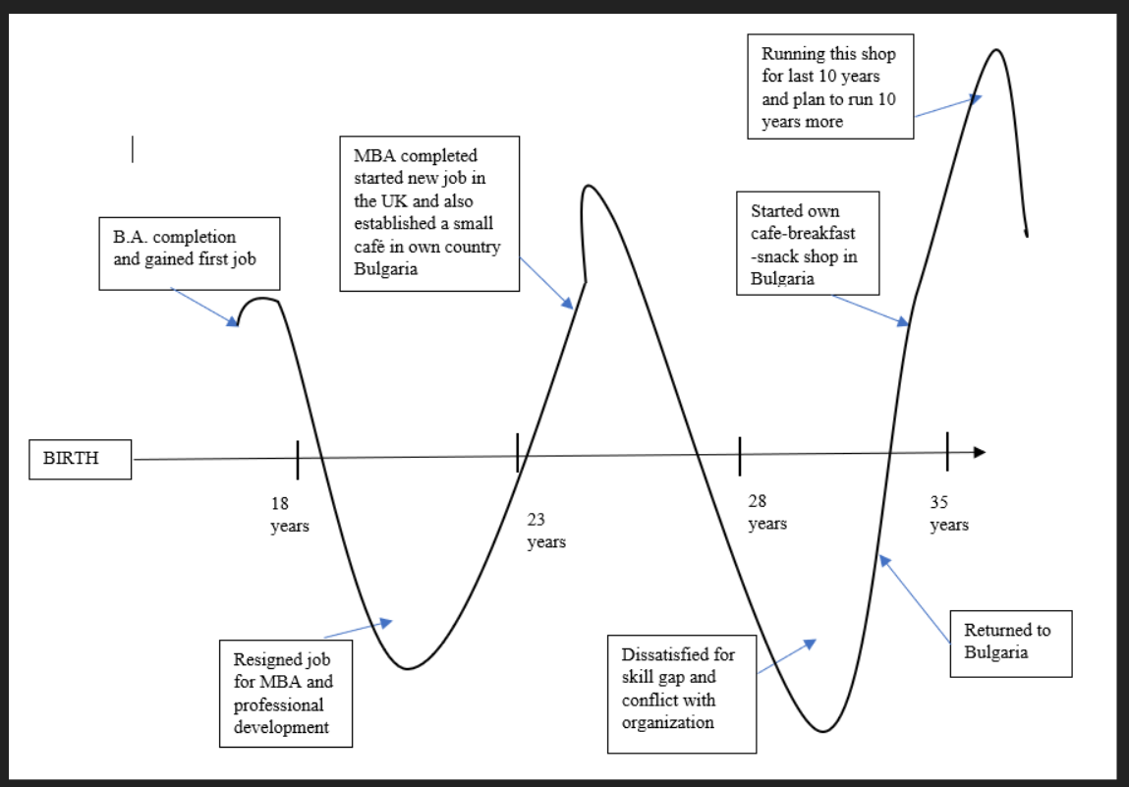
Figure 1: My Life Line
(Source: Influenced by Datta, 2018)
Professional career development can assist individuals in advancing the career by the process of self-assessment, planning and career exploration, as per the influence of Olivia (2020), the principles that underlie the process of professional career development are basically five focused on five things that are always exploring different things and learning from it, learning must be ongoing. Secondly, focus on professional skills achievement, always believe in yourself and continue positive attitude towards career development and believe in a team effort by relying on the support of family (Target jobs, 2020). These are the basic principles that helped me in my entire journey of 20 years while working in a cafe-breakfast-snack shop.
The lifeline that has been depicted in the Figure below shows that I had completed my MBA degree and management course in hospitality from Bulgaria then opened my cafe named cafe-breakfast-snack shop, which has a place for 20 people in an open garden area in Bulgaria. In addition, in the experience of 20 years, I have learnt three different languages after interacting with different customers, employees and suppliers that added advantage in me. Now, these effective skills help in interacting with different people from different linguistic backgrounds that help in relationship building in the market (Impraise, 2020). As per the influence of Mealey (2019), for growth and increment in the market, a good relationship is the most required thing to establish a business in the new market.
Furthermore, in the management days, I got an appreciation for my polite behaviour and management skills that helped me at the time of cafe management. These all incidents signify the lifeline of my entire journey till now. As per the view of Olivia (2020), lifeline evaluation helps in reviewing all the high and low points that I have gone through, which help in gaining experience. On the other hand, it is depicted in the lifeline figure that I left my first job and filled my communication and skills gaps that help in the establishment of my own cafe and its management. Defining all the activities of life in chronological order helps in analysing the growth and productivity of a cafe and individual development. In addition, the understanding of professional career development helps in increasing readiness of development plans for future targets achievement.

Employment goal establishment
The employment goal and personal career development established in the vision to become a restaurant manager in the next two years. In order to become a restaurant manager, the goals that have been set by me are defined in the following ways. It includes the first and foremost thing is to behave as a role model in the organisation as the employees that are working under me watch and follow me. Therefore, in order to become an asset and increase the productivity of the restaurant, there is a need for productive conflict resolution skills in the manager. As per the influence of Olivia (2020), a manager has to manage almost all the work within a restaurant that requires certain skills. However, I have 20 years of experience and practical exposure in the field of cafe management that adds an extra edge to my management skills.
The next goal for the professional development of a career requires effective communication skills. As per the illustration of Campbell (2017), in order to communicate with the employees, staff, customers and higher hierarchies of the restaurant, it is required to develop effective communication skills along with a positive attitude. This goal establishment will help in increasing employee’s morale and motivation along with it the clear communication of targets and ideology help in the achievement of the ultimate revenue goals of an organisation. Therefore, these are the priority goals that help in the achievement of professional career development.
On the other hand, various other little goals comprise of own mistake acceptance, improvement of time management strategy, run with the pace of technology advancement and enhanced strategic thinking (Von Heupt, 2017). Therefore, these are some other employment goals that need to be established and achieved in order to become a restaurant manager in two years. On the other hand, the experience of these two years further helps in the development of a career in becoming an owner of the restaurants in the next five years. In order to become an owner, there is a need for polishing these goals that will be possible after practising professional skills in the real environment.
Goals | 6 months | 6 months | 6 months | 6 months | 6 months | 6 months | 6 months | 6 months | 6 months | 6 months
Leadership strategy development
Conflict resolution skills
Nurturing communication skills
Staring work as a restaurant manager
Self-assessment and on-job learning
Time management strategy
Technological and financial understanding training
Owning a restaurant
Table 1: Timeline of personal development
(Source: Influenced by Campbell, 2017)

Personal application development plan
The personal development plan made for the increasing professional efficiency in the restaurant management. Besides it, the unique quality that developed during café management help a lot. However, management of big restaurant and bars requires polished professional skills such as teamwork, training of employees, motivation and morale boost for work process needs leadership skills along with strategic thinking. In addition, time management skills help in management of activities and task that assist in completion of works before time in late shift. Therefore, a PDP structure has been made for development of required skills for the management of restaurant.
What professional skills are to be learnt? | What is to be done? | Support and resources required | Measurement of the success
Team working skills | There is a requirement of leadership personality development and listening ability to manage conflict among employees and colleagues. Hence, training of personality development and different negotiation practices in the current organisation regarding management and operation of the restaurant must be done. | Support from family, friends and colleagues is required. Additionally, I must enhance thoughts and skills sharing abilities with colleagues for developing servant leadership skills and interpersonal skills. | It can be measured by the feedback of employees and the professional growth of career in the organisation.
Time management skills | In order to manage time, schedule plan of every day must be incorporated in the routine to check all the works and manage those on time | Resources required for time management are a checklist of work and activities of the restaurant operation and financial details. | It can be measured by the timely completion of all tasks such as financial and audit work along with the daily operation of the floor.
Development of strategic thinking | For the development of strategic thinking, certain habits must be included in the behaviour such as prioritisation of things, always adhere to a positive attitude and looking for solutions to optimise performance. | Resources that help in the development of strategic thinking are the incorporation of others' innovative view and understanding the perspective of working of experts and known leaders. | It can be measured by self-assessment and feedback of hierarchy, employees and colleagues.
Development of Problem-solving skills | It requires active listening, communication and productive conflict resolution approach that develop problem-solving skills in an individual. | Employees support, along with soft skills training and development class. | Measured by self-assessment with employees’ feedback
Team management skills | Leadership quality building along with enhanced solution providing skills that help in the management of team and resolution of their problems | Employees and soft skills as a resource | Measured with the help of employee’s performance as a team
Decision-making skills | Taking a calculated risk for growth and productivity along with decreasing dependability on the thinking of others | Employees and colleagues, along with the ability to take a calculated risk for these management materials, might work. | Organisational and employee’s performance along with the growth rate of the company help in measuring the right decision-making skills
Table 2: PDP structure
(Source: As influenced by Von Heupt, 2017)

Conclusion
It has been concluded based on the above findings that for professional career development, there is a requirement of personal development to achieve the organisational target that ultimately helps in professional and career development goal achievement. In addition, the lifeline helps in reviewing past achievements that help in the growth of a professional career. Therefore, in order to achieve the professional career growth of restaurant manager in the next two year and owner of a restaurant in next five years, the professional development plan has been made to know that target and the work for its achievement is also mentioned.

References list
Beuscart, J.S., Mellet, K. and Trespeuch, M., 2016. Reactivity without legitimacy? Online consumer reviews in the restaurant industry. Journal of Cultural Economy, 9(5), pp.458-475.
Campbell, S. 2017. Restaurant Management Tips: What Every New Manager Needs to Know, When I Work. Available online at: https://wheniwork.com/ restaurant-management-what-every-new-manager-needs-to-know [Accessed on 30 July 2020]
Datta, S., 2018. A Complete Guide To Restaurant Management Systems, Lime tray. Available online at: https://limetray.com/ restaurant-management-system/ [Accessed on 4th October 2018]
Impraise, 2020. 7 examples for setting professional development goals at work, Impraise. Available online at: https://www.impraise.com /7-examples-for-setting-professional-development-goals-at-work [Accessed on 17th august 2020]
Lin, T.C., 2018. Impact of restaurant owners'/managers' handling of customers' unexpected incidents on customers' revisit intention. International Journal of Economics and Business Research, 15(1), pp.108-124.
Mealey, L., 2019. Management, The Balance Smb. Available online at: https://www.thebalancesmb.com/restaurant-management-facts-2888650 [Accessed on 20th August 2019]
Olivia, 2020. 6 Simple Tips for Effective Team Management, Meister Task. Available online at: https://www.meistertask.com/6-simple-tips-effective-team-management/ [Accessed on 17th August 2020]
Rubens, A., Schoenfeld, G.A., Schaffer, B.S. and Leah, J.S., 2018. Self-awareness and leadership: Developing an individual strategic professional development plan in an MBA leadership course. The International Journal of Management Education, 16(1), pp.1-13.
Target jobs, 2020. RESTAURANT MANAGER: JOB DESCRIPTION, Target jobs. Available online at: https://targetjobs.co.uk/careers-advice/job-descriptions/278839-restaurant-manager-job-description [Accessed on 17th August 2020]
Von Heupt, N., 2017. Creating a continuing professional development plan. Training & Development, 44(6), p.16.

