350 years ago, there was a man called Thomas Coram, he fought to protect the rights of those who could not do so themselves. Thomas founded the Foundling Hospital in 1739. The hospital was set up to help destitute children and protect the rights and freedom of young children in the UK. In 2017 and exhibition was put together in the Central Family Court in High Holborn, this exhibition was focusing on respect and protection. It highlighted how important the rights of a child are and it looked at 4 key areas particularly, Identity, Education, Work and military service. It was seen that a child cannot claim other rights until they have an identity. Every child is seen as a future citizen and should be taught useful skills to become a useful member of the public.

Before the UNCRC came into play, a charity called ‘Save the Children’ was founded by a lady called Eglantyne Jebb. A former teacher and reformer, she was hugely affected by the images she was seeing in the papers of starving children, this is what led her to beginning her work in helping children. Eglantyne done many amazing things, in 1921 she chartered a cargo ship called the SS Torcello to carry 600 tons of food and medical supplies to Russia due to a poor rail system. This saved hundreds of thousands of lives. In 1924 she presented a Declaration of the Rights of the Child to leaders around the world. She stressed the importance of remembering the forgotten children. This led to the UN Convention on the Rights of the Child in 1959 and a document that was by almost every country in the world. The only two countries not to sign to this date are South Sudan and the United States. Eglantyne’s Charity Save the Children today has Global programmes focusing on Health, Education, Protection, Hunger and livelihoods, Emergency and Global Advocacy. Helping 155 million children in 120 different countries.

(Source: Save the Children, No date)

The United Nations Convention on the Rights of the Child

The United Nations Convention on the Rights of the Child (UNCRC) is a known declaration that children have the basic human rights, these rights should be respected and promoted. Within this there are 54 articles and 42 of these are rights of a child up to the age of 18. These were decided upon and then came into play in 1989. These rights can be separated into 4 broad categories of Life, Development, Protection and Participation. The other 12 articles are all explaining how any adult and governments should work together to ensure that children can enjoy and access all of their rights.

(Source: Pool Hayes Primary School, No Date)

Each and every article is just as important as the article before and after. However, 4 key articles that can be identified are;
Article 3 – All organisations concerned with children should work towards what is best for each child. (UNICEF, 2011)
Article 6 – All children have the right to life. Governments should ensure that children survive and develop healthily. (UNICEF, 2011)
Article 12 – Children have the right to say what they think should happen, when adults are making decisions that affect them, and to have their opinions taken in to account. (UNICEF, 2011)
Article 31 – All children have the right to relax and play, and to join in a wide range of activities. (UNICEF, 2011)

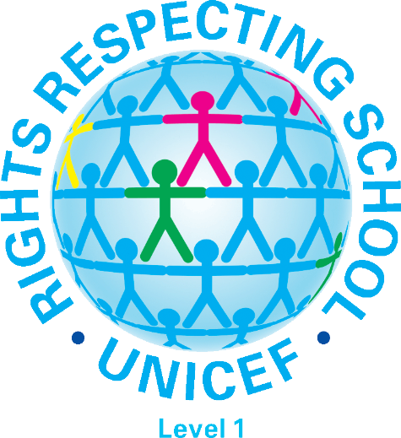
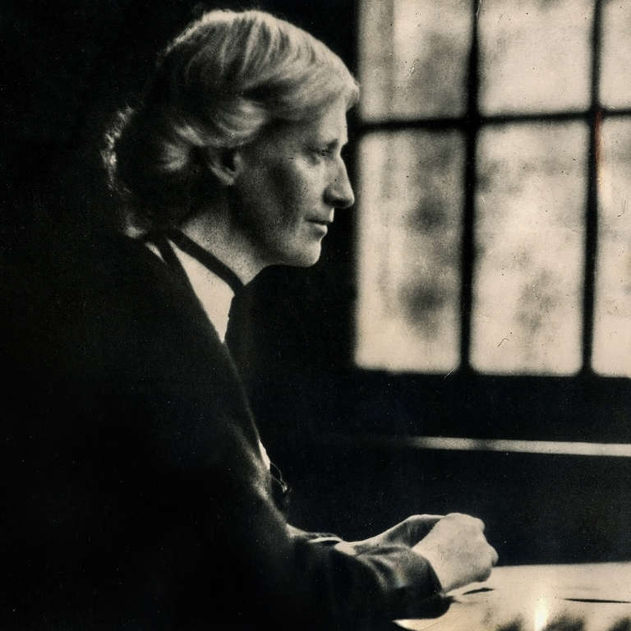

Article 2 – The convention applies to everyone whatever their race, religion, abilities, whatever they think or day and whatever type of family they come from. (UNICEF 2011)
This is seen as one of the main articles of the UNCRC because it is wrong to be stereotypical towards children and adults. You must have diversity meaning that you celebrate all children regardless of their differences and also having equality where you treat everyone the same no matter their circumstances of differences.

Article 19 – The right to be looked after and kept safe. (UNICEF, 2011)
This is implanted in schools in a number of different ways, for example a mainstream primary school will have all their staff CRB/DBD checked to make sure that they are all safe to work with children and have no previous convictions. Visitors books at the school office where all visitors must sing in and out, so the school knows who is on the ground/premises at all times. School gates and doors are to be kept locked during the school day with only access being available via the school office.

Article 12 - Children have the right to say what they think should happen, when adults are making decisions that affect them, and to have their opinions taken in to account. (UNICEF, 2011)
It is emphasised that it is very important to listen to the wishes of the child. However, authorities have the duty of acting in the best interest of the child and this may mean contradicting their wishes. (NSPCC, 2018)

Reference List – Briefing Paper
Children and young people measure Wales, ‘the purpose of this proposed measure is to impose a duty upon the Welsh Ministers and the First Minister to have due regard to the rights and obligations in the UNCRC and its Optional Protocols, when making decisions of a strategic nature about how to exercise functions which are exercisable by them’ (National Assembly For Wales, 2011).
The measures began its passage through the Welsh Assembly in 2010 and then gained its royal approval in 2011.

The Social Services and Well Being (Wales) ACT 2014.
This offers more support, changes in assessment and equal rights for children, adults or people with disability. This act changes how people’s needs are assessed, and the way services are delivered, meaning people have more of a say in the care and support they receive. (Gov.wales, 2017) What this would mean for a child is that they need support to make their voice heard then someone will speak on their behalf. It also means that the laws to keep them safe are stronger. A lot more services are available to a child when they need them so that their problems do not get worse.

Article 23 – Children who have any kind of disability should have special care and support so that they can lead a full and independent life. (UNICEF, 2011)
Mary Warnock fought for children with disabilities to be taught in mainstream schools. She succeeded with this. Mary argued that all children should be taught in mainstream schools, and with this schools were giving extra funding per child for specialist teachers, building adjustments, classroom assistants or even the setting up of units.

Gov.wales. (2017). Welsh Government|Care and support in Wales is changing. [online] Available at: https://gov.wales/topics/health/socialcare/act/?lang=en [Accessed 2 Nov. 2018].

National Assembly for Wales. (2011). Rights of Children and Young Persons (Wales) Measure 2011. [online] Available at: http://www.assembly.wales/en/bus-home/bus-third-assembly/bus-legislation-third-assembly/bus-leg-measures/business-legislation-measures-rightsofchildren/Pages/business-legislation-measures-rightsofchildren.aspx [Accessed 2 Nov. 2018].

NSPCC. (2018). Legal definitions. [online] Available at: https://www.nspcc.org.uk/preventing-abuse/child-protection-system/legal-definition-child-rights-law/legal-definitions/ [Accessed 2 Nov. 2018].

Pool Hayes, Primary School. (No Date). Rights Respecting School UNICEF. [online]. Available at: http://www.poolhayesprimary.co.uk/unicef_rrs.html [Accessed 1 Nov. 2018].

Save The Children. (No Date). Eglantyne Jebb. [online]. Available at: https://www.savethechildren.org/us/about-us/why-save-the-children/eglantyne-jebb [Accessed 1 Nov. 2018].

UNICEF. 2011. Convention on the Rights of the Child. [online] Available at: https://www.unicef.org.uk/what-we-do/un-convention-child-rights/ [Accessed 21 Oct. 2018].

Reference List – Presentation

NSPCC. (2018). Legal definitions. [online] Available at: https://www.nspcc.org.uk/preventing-abuse/child-protection-system/legal-definition-child-rights-law/legal-definitions/ [Accessed 2 Nov. 2018].

UNICEF. 2011. Convention on the Rights of the Child. [online] Available at: https://www.unicef.org.uk/what-we-do/un-convention-child-rights/ [Accessed 21 Oct. 2018].

