BA International Hotel Management
Module: Cultural Awareness
Module code: BMIH5003
Name: Lonela Flavia Lapka
Student ID: 2130481

An executive summary
This report mainly uses to analyse and compare the hotel services in regards to hotel staff, department and service delivery to serve the guests' needs. Hence, the country chosen is Italy in order to see the hotel staff help them to prepare and manage the guest experience for international visitors. Hence, in Italian culture mainly, the culture and values are different than in Germany.

Table of Contents
An executive summary 2
Introduction 4
Cultural differences 4
Italy 4
Germany 4
Analysis 4
Guest implication in Italy and Germany 4
Summary 5
Recommendations 6
Conclusion 7
References 7

Introduction
In regards to this report, mainly, cultural differences, customs and behaviour will be analysed in regard to main hotels. Hence, it would tell dos and don'ts to the hotel staff to manage guest experience and accommodate guests regarding service delivery. Therefore, the chosen country here is Italy, in accordance with comparing and contrasting guest service implications. Therefore, the culture and values are different in Italy in regard to pinpointing guest implications for local and international visitors. A study suggested there should be a requirement for unusual accommodations for all types of guests in all hotels (Kim et al., 2012).

Cultural differences

Italy
The main culture of Italy is related to its rich history and past, with it focusing on warm hospitality and focus on relationships with other people. Hence, they connect on a personal level, communicate expressively and have a relaxed approach. Therefore, the dining culture lasts for hours and has relaxed dining experiences and local cuisines. The society is men-oriented with decentralised power (Abarate et al., 2021).

Germany
Germany in terms of more literature, art, philosophy, logic, and reason. Hence, it also has a rich history and European politics, thought and art with a more fixed and stern approach among people. The people have a love for beer and sausages. Hence, Germans are private and involve very direct structures and routines in their life (Sandford, 2013).

Analysis

Guest implication in Italy and Germany
The main guest's implications after the pandemic hit the hotel industry hard. Hence, there is a need to show the health vaccination in order to pass on current regulations. Hence, in 2023, this regulation will be smoothed out. Therefore, due to compliance with health and safety guidelines, hotel dining options for restaurants and breakfast services have become limited. Therefore, outdoor dining is mainly preferred by customers. Also, the Italian hotels welcome them warmly to the guests, with friendly interactions. Hence the front desk should focus on greeting, smiles and willingness to take queries.
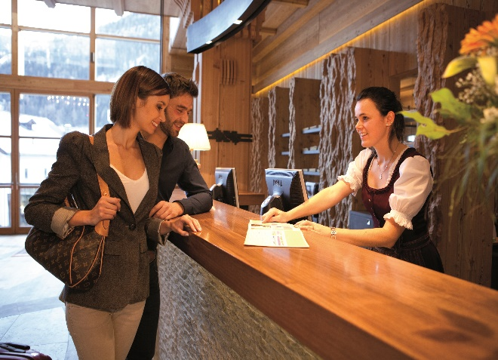
Figure: Warm welcome by Italian hotel
Mainly the words used by the guests in regard to the hotel the staff can greet in Italian language and use phrases such as Buon Giorno, Grazie, per favore, etc. Hence, the hotels in Italy do not focus on one dress code (formally for staff), which may be needed in front of guests from another country where the hotel staff wears a uniform in their culture. Henceforth, guests are showered with gratitude and appreciation for good services; customers appreciate it. The customers should also interact with the local customers, culture and values, which is the staff's responsibility (which can be the front desk or other departments) (Buso et al., 2017). According to expectancy disconfirmation theory, when hotels apply, guests' satisfaction is influenced by services provided by the hotel in terms of meeting and exceeding it, which is determined by the performance of the hotel in terms of expectations fulfilled by the employees (Abarate et al., 2021). Hence, in regard to Italian hotels, guests' satisfaction is seen as their cultural value, which is exceeded.
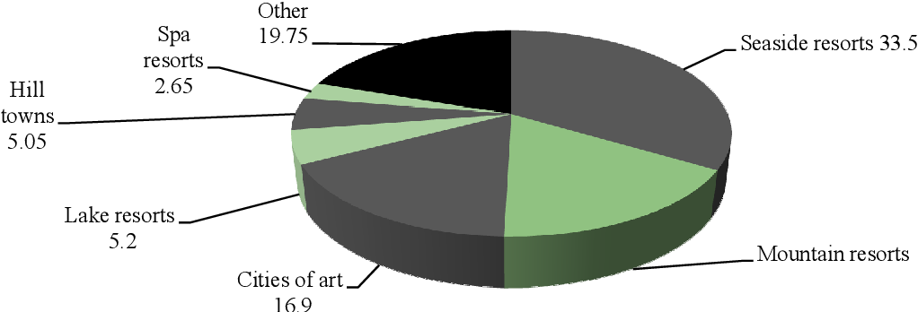
Figure: Italian Model for Cultural Tourism
Source: Quattrociocchi et al., 2017

According to service quality theory, customers' expectations and perceptions of service quality have five dimensions, including reliability, assurance, empathy, responsiveness and tangibles, which is needed to be performed by employees in order to ensure services (Mohamad et al., 2017). The main hotel services and culture are mainly related to proper check-in and out processes using the latest technology. Hence, there is the reception and multilingual staff. Hence, German hotel services also include punctuality and time management in their service delivery (De Carlos et al., 2019).
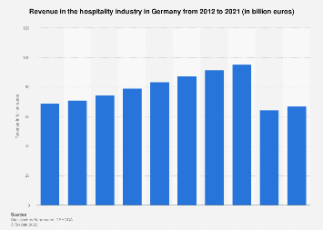
Figure: Hospitality industry revenue in Germany
Source: Koptyug, 2023

There is also professionalism and attention to detail in regard to staff being properly trained and dressed and providing accurate information with the provision of cleanliness, amenities and guest preferences. In Germany, the services are also more seen as professional than in Italy, where the employee to provide services are less stern. Italy prefers ambience, décor, lighting and pleasant experience, whereas Germany stands for precision and efficiency. Germany focuses on being private and hence needs the customers when they want something. They have a structured approach as their sign of respect towards people from around the globe.

Summary
Do | Don’ts
The staff should have emotional intelligence and cultural intelligence in order to increase customer satisfaction. | The employees should not show a bad attitude towards customers.
The employees should be quick in action in order to help the customers. | The hotel should not be ignorant of other cultures.
The front desk person should be quick and calculative with actions. | Stereotypes should not be formed which can hinder the services of the hotel or discriminate against any customer.
The hotel staff should be appreciative of the cultural differences. | There is a need to provide respect for other's cultures and values.
There should be entertainment in the local language (German or Italy). | Common language should also be used in terms of welcoming the guests.
Being friendly while welcoming the guests in the local language. | Not being welcoming during the arrival is wrong, and being stern with guests.

Recommendations
The first recommendation for the hotel is to advance and invest in cultural sensitivity and training of their staff in order to ensure that greetings, customs, communication styles and etiquette are properly communicated to the staff. Hence, it will ensure cultural awareness with the help of an inclusive and welcoming environment.
Another recommendation for the hotel is to mainly focus on personalisation and customisation according to the customer. Hence, Italy is a country where tourists come from different cultures; hence, accommodation of restrictions, multilingual staff should be hired and amenities according to culture (Hussain et al., 2016).

Conclusion
To sum up this report, mainly, Italy country was chosen concerning their services trends and implications towards guests with different cultures, backgrounds and values. Hence, employers and hotels should implement a set of recommendations in order to cater to international visitors in terms of cultural awareness and sensitivity. The employees should follow certain rules and regulations which do not hinder the services and discriminate towards international visitors. The culture and values in Italy vary from Germany in accordance with pinpointing guest implications and trends for local and international visitors.

References
Abrate, G., Quinton, S. and Pera, R., 2021. The relationship between price paid and hotel review ratings: expectancy-disconfirmation or placebo effect? Tourism Management, 85, p.104314.
Buso, T., Dell’Anna, F., Becchio, C., Bottero, M.C. and Corgnati, S.P., 2017. Of comfort and cost: Examining indoor comfort conditions and guests’ valuations in Italian hotel rooms. Energy research & social science, 32, pp.94-111.
De Carlos, P., Alén, E., Pérez-González, A. and Figueroa, B., 2019. Cultural differences, language attitudes and tourist satisfaction: A study in the Barcelona hotel sector. Journal of Multilingual and Multicultural Development, 40(2), pp.133-147.
Hussain, K., Konar, R. and Ali, F., 2016. Measuring service innovation performance through team culture and knowledge sharing behaviour in hotel services: a PLS approach. Procedia-Social and Behavioral Sciences, 224, pp.35-43.
Kim, W.G., Stonesifer, H.W. and Han, J.S., 2012. Accommodating the needs of disabled hotel guests: Implications for guests and management. International Journal of Hospitality Management, 31(4), pp.1311-1317.
Koptyug, E. (2023) Hospitality Industry Revenue in Germany 2021, Statista. Available at: https://www.statista.com/statistics/563490/hotel-and-restaurant-industry-revenues-germany/ (Accessed: 15 June 2023).
Lam, R., Cheung, C. and Lugosi, P., 2021. The impacts of cultural and emotional intelligence on hotel guest satisfaction: Asian and non-Asian perceptions of staff capabilities. Journal of China Tourism Research, 17(3), pp.455-477.
Mohamad, H.A.D., Ab Yazid, M.S., Khatibi, A. and Azam, S.F., 2017. Service quality, customer satisfaction and customer loyalty of the hotel industry in United Arab Emirates (UAE): A measurement model. European Journal of Management and Marketing Studies.
Quattrociocchi, B., Mercuri, F., Perano, M. and Calabrese, M., 2017. Tourism supply chain & strategic partnerships for managing the complexity of the tourism industry. Enlightening Tourism. A Pathmaking Journal, 7(1), pp.62-93.
Sandford, J. ed., 2013. Encyclopedia of contemporary German culture. Routledge.

