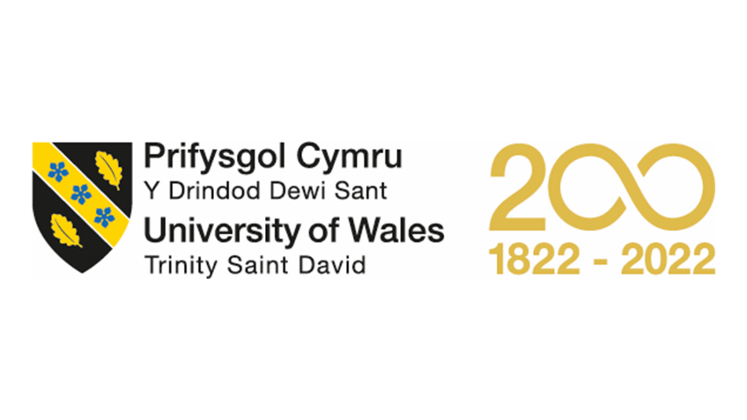

Assignment Title: Individual project report

Module Name: Global Business Management

Module Code: LCBB4005_BIRM

Program of Study: BA (Hons) Business Management – Skills for the Workplace

Student Name: Hamdan Ahmad

Student ID #: 2208436

Lecturer Name: Dr. Eric Osei

Table of Contents
INTRODUCTION 3
OVERVIEW OF HIGHER EDUCATION SECTOR 3
PESTEL FRAMEWORK 4
Political environment 4
Political analysis of Higher Education Sector in the UK 5
Economic environment 5
Economic analysis of Higher Education Sector in the UK 6
Socio Cultural Environment 6
Socio-cultural analysis of Higher Education Sector in the UK 7
Technological Environment 7
Technological analysis of Higher Education Sector in the UK 7
Environmental Analysis 8
Environmental analysis of Higher Education Sector in the UK 8
Legal Environment 8
Legal analysis of Higher Education Sector in the UK 8
PORTER’S FIVE FORCES ANALYSIS 9
Applying Five Forces to Higher Education Sector UK 10
How much UWSTD is affected by global factor 11
Conclusion 12
References 13

INTRODUCTION
The higher education sector is one of the major businesses on the global platform and the UK has an inimitable repute as a home of reputable institutions including, Cambridge, Oxford, and University College London. In this assignment report using PESTEL and Five forces analysis, key business environment factors are identified in the higher education sector and the impact of the business environment on University of Wales Trinity Saint David are observed.

OVERVIEW OF HIGHER EDUCATION SECTOR
The country of the UK is identified as a developed country known for renown scientists, scholars, statesman and policymakers who have given to the world very useful inventions, ideas, and industrial revolution. The world came to know about television, radio, steam engine, and world wide web by UK also industrial revolution took place in Great Britain from 1770s making it the world’s first industrial economy, (Britannica, 2022). Globally, UK has established repute in a country of great academic institutions as University of Oxford founded in the year 1096 so as the University of Cambridge in the year 1209 making them the oldest academy in continuation. In the year ending June 2022, there were 486,868 Sponsored study visas granted (including dependents), (Universities UK, 2022) and according to 2020-2021 statistics, 605,130 international students are living in the UK, (Study in the UK, 2022). The higher education sector contributes to the economy of the UK with the total gross output by £95 billion, estimated total GDP contribution of £52 billion and 815,000 jobs altogether, making a significant source of income for the country (Universities UK, 2022).
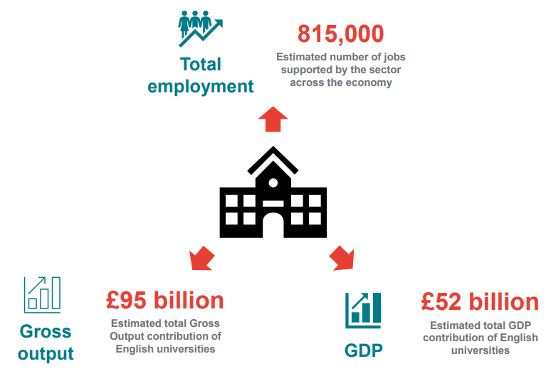
Figure 1: Role of Higher Education Sector in UK Source: frontier economics, (2021)
In this individual project report using PESTEL framework and Porter’s five forces analysis, key business environmental factors are identified in higher education sector.

PESTEL FRAMEWORK
PESTEL framework based on political, economic, socio-cultural, technological, environmental and legal entities to define a macro-environmental factors used in the environmental scanning for any business. This framework is a strategic tool to know about the rise and decline of the target market, business position, potential and direction for operations. In addition, this framework is used to know the external environment of the company and its relationship to the outer world. The components of PESTEL framework are discussed below and higher education sector is observed with the lenses of each component respectively.

Political environment
The political environment is linked with political systems, political economic environment, taxation, financial regulation, government policies and its implementation to the society (UWTSD lecture notes, 2022). Below the figure 2 shows the role of governments in political factor.
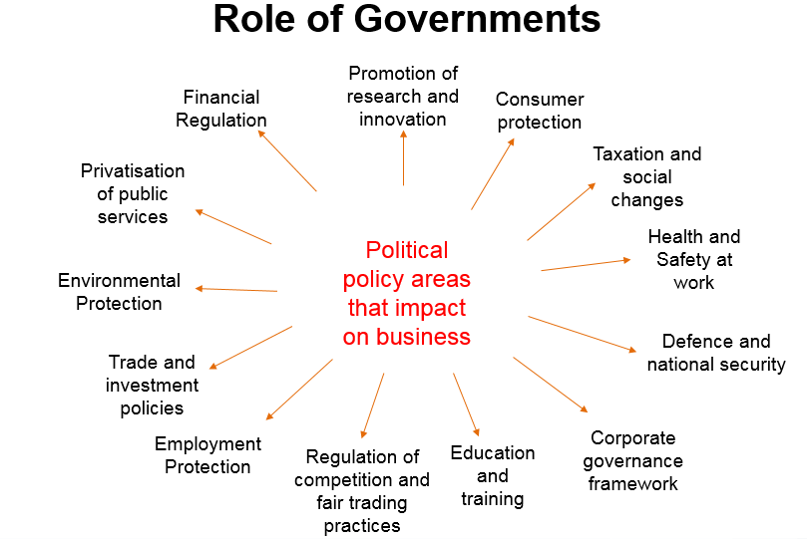
Figure 2: Role of Government Source UWTSD Lecture Notes, (2022)
Any business or industry gets influence from the political environment of the country, for example, instability of government, civil war and unfavourable policies can harm the business operations. In contrary, favourable policies, political stability and good trade relations with other countries provide opportunities for businesses to grow locally and globally.

Political analysis of Higher Education Sector in the UK
Higher education sector in the UK has support of public funding from the government, which somehow benefits the students as end user. The public funding from the government is getting lower gradually which is not a good sign of growth of universities in the future, (Bush, 2019). Recently, the Covid-19 pandemic has disturbed everything in the UK and the phase of lockdown imposed by the government also applied on higher education sector. From 2020 till late 2021 many universities and colleges have stopped face to face classes and moved to learning online. McKie, (2020) reported that universities hit by a 2.6 billion shortfalls in the academic year 2020-21 due to reduction of student enrolment by 47%. In this connection, the higher education sector UK also faced loss of 30,000 jobs, (McKie, 2020).
International students are a big source of income for UK universities as 20% of students in higher education are from abroad and to postgraduate level the figures rise to 40%, (Bush, 2019). International students pay higher fees compare to local students it’s mean they are highly beneficial for the growth of education business on global perspective. In addition, after execution of BREXIT, European Union countries students have lost home fee status in the UK so they have to pay international students fees which may come 3 or 4 times higher depending on the university and degree, (Balan, 2022). Politically, there has an upside risk and downside risk both are available due to BREXIT as European students are likely to pay in full without any concession but also there is a risk of losing students from that region.

Economic environment
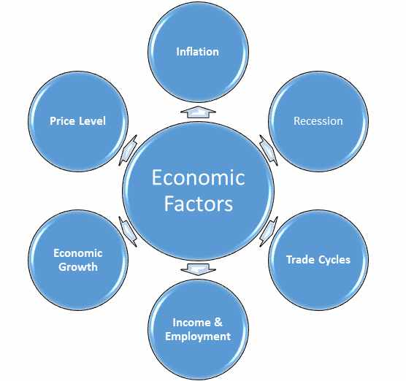
Figure 3: Economic factors source UWTSD Lecture Nores, (2022)
The Economic environment in PESTEL framework is further distributed to micro and macro factors. The Micro factors comprised of demand/buying behaviour of customers, supply, market structures and income (UWTSD Lecture Notes, 2022). On the other side, Macro factors based on growth, productivity, employment, income, inflation, interest rates, exchange rates and balance of payments, (UWTSD Lecture Notes, 2022).
For the growth and establishment of any business economic environment is necessary to observe. The economic environment based on economic stability, taxes, employment conditions, buying power of consumers and interest rates is those realities need to consider before taking any step.

Economic analysis of Higher Education Sector in the UK
Higher education sector just came out after Covid-19 loss, but currently one of the major problems student debts. Many higher studies students in the UK get loans to pay their fees and after pass out, they are already in debt before start of their professional career (Bush, 2019). The problem of loans is making the higher education sector less attractive for potential students because they will be not able to pay back these loans.
For ages UK was the most popular destination for study, but on global perspective overseas governments are giving an economical option for students such as, Germany and many other countries offer free higher education to students. Ultimately, the UK has no solution for free education policy and governments are not willing to do much for that.
Another negative issue related to the economic situation in the UK is weak job market for fresh graduates compare to other countries like Australia and USA, (Bush, 2019). Many students think of studying in other countries to start a better career compare to the UK due to weak job market. In recent times UK is facing tough time economically and jobs are shrinking, which really raise questions on credibility of the higher education sector. It would be better to give job surety to students after graduation from the higher education sector.

Socio Cultural Environment
The Socio Cultural environment in the PESTEL framework includes social values, attitudes, beliefs, demographic trends, lifestyle preferences and skills availability, (UWTSD lecture notes, 2022). The socio cultural environment observes what is in practice in society how people feels and prefer for their lives. For example, most of the Indian origin students in UK are studying subjects in higher education related to computer technology and infrastructure because they have a big market back home related to that field.

Socio-cultural analysis of Higher Education Sector in the UK
Higher education sector is no more attractive for many students because high cost of fees causes big debts to them. in addition, no guarantee for good jobs after graduation are the issues distracting students in going to English universities, (Bush, 2019). Another aspect which declines interest of students in higher education because they can jump to jobs after completion of their high school. Good jobs demand relevant experience too with higher education degree making the employability bit difficult for fresh graduates that’s why entry-level positions are more attractive nowadays, (Bush, 2019).

Technological Environment
Technological environment in in the target market of country is about those forces affect in creation, usage, and knowledge of tools, machines, crafts, techniques, systems or methods of organization in order to solve a problem or perform a specific job, (UWTSD Lecture Notes, 2022). Technology can be divided in two types, the first one is information and communications technology (ICT) which used the hardware and software to do the operations and process the data, whereas, information technology infrastructure (IT) provides the platform of shared information technology sources for the organization, (UWTSD Lecture Notes, 2022).
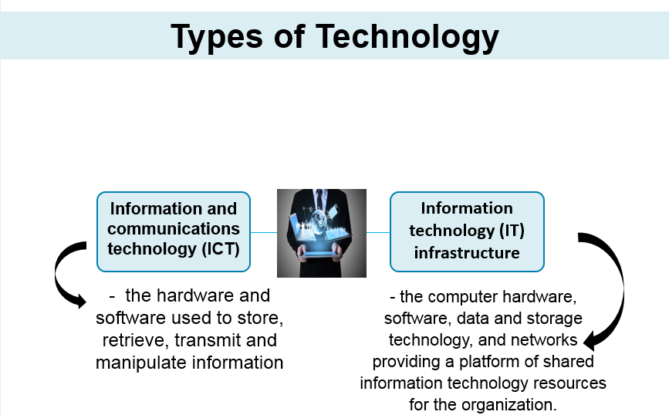
Figure 4: Types of Technology source UWTSD Lecture Notes, (2022)

Technological analysis of Higher Education Sector in the UK
In fact, higher education sector is a big resource for technology transfer and technological diffusion among developed and developing countries. Many researchers, scholars and scientists come to developed countries to gain technological knowhow through study programs and helps the process of technological diffusion to their developing countries. UK has been the most prestigious destination for technological revolution in past and still considered a reputable region for this purpose.
The use of technology in teaching, such as, online classes, course lectures available online, and educational videos available on youtube helps students in their higher studies.
Role of higher education in taking the technological analysis is very much influential because universities of UK has partnership programs globally with other universities and colleges (Price and Kirkwood, 2008). The online learning, distance learning and affiliated institutions are some of the major examples showing importance of higher education sector on global perspective.

Environmental Analysis
Environmental analysis in PESTEL framework refers to issue related to environment such as, global warming, degradation, depletion of natural resources and pollution. Businesses observe environment of the target region for their business operations such as, UK has the higher standard for environmental care and all the factories operating in the country has proper procedure for dumping of their wastage.

Environmental analysis of Higher Education Sector in the UK
Higher education UK is playing significant role for sustainable development and environmental protection in the UK and globally. Many universities in UK have signed Environmental Association for Universities and Colleges' (EAUC) Sustainable Development Goal (SDG) Accord, (IAU_HESD, 2017). In addition, universities are encouraging workshops and seminars for environmental protection and carbon free environment.

Legal Environment
Legal environment in PESTEL framework refers to legislation, taxation policies, consumer rights, and legal matters. To operate any organization in the target region awareness about their laws is radical because it protects from legal matters and goes in good benefit of a business.

Legal analysis of Higher Education Sector in the UK
Higher education sector of the UK is operating under the protection of government and all universities and colleges are duly registered with the concerned legal bodies. The rules and regulations apply to all institutions and there is no point to discuss here with is exceptional. In global perspective higher education UK follows the regional rule of the countries with proper understanding of own rules and operate accordingly.

PORTER’S FIVE FORCES ANALYSIS
Michael Porter has presented five forces analysis a framework to determine the competitive intensity and therefore attractiveness (the overall industry profitability) of a market, (UWTSD Lecture Notes, 2022). The five forces are rivalry of competitors, threat of new entrants, threat of substitutes, bargaining power of buyers, and bargaining power of suppliers.
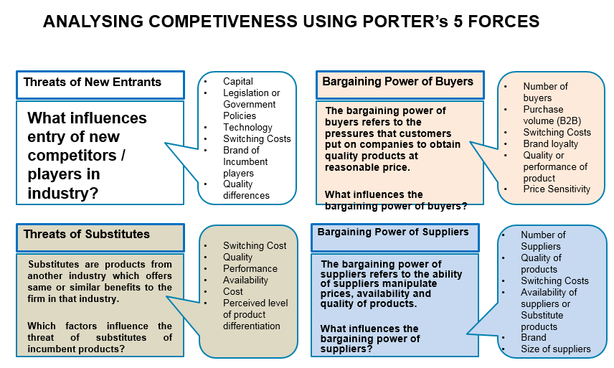
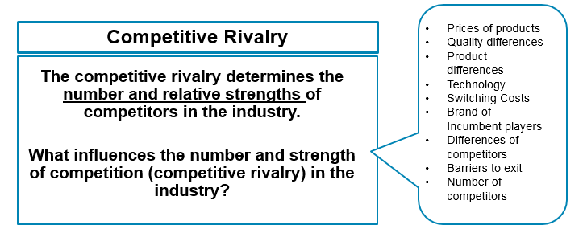
Figure 5: Porter’s five forces source UWTSD Lecture Notes, (2022)
As shown above in the pictures threat of new entrants are new companies which may bring new technology which gives competition to existing players, for example, cars on solar batteries was a potential threat for gasoline cars initially. Threat of substitutes means products from another industry which provides similar benefits to firm in that industry, for example, coffee may get replaced by tea due to some medical reasons. Bargaining power of buyers refer to the pressure customers put on companies for prices and quality of products. Bargaining powers of buyers very much depends on the market if the number of buyers are less and supplier are many then buyers enjoy the bargaining power, for example, there is a range of soft drinks in UK because supplier are many and buyers have a choice to switch. Bargaining power of supplier refers to the ability of suppliers manipulate prices, availability and quality of products. If suppliers are few and buyers are many then suppliers enjoy the bargaining power, such as, De Beers has a monopoly on diamond market globally because they are the only suppliers. Competitive rivalry determines the number and strength of the competitors in the current market, for example, ASDA, Tesco, and Sainsbury are supermarkets in the UK and they have competitive rivalry because they sale similar products.

Applying Five Forces to Higher Education Sector UK
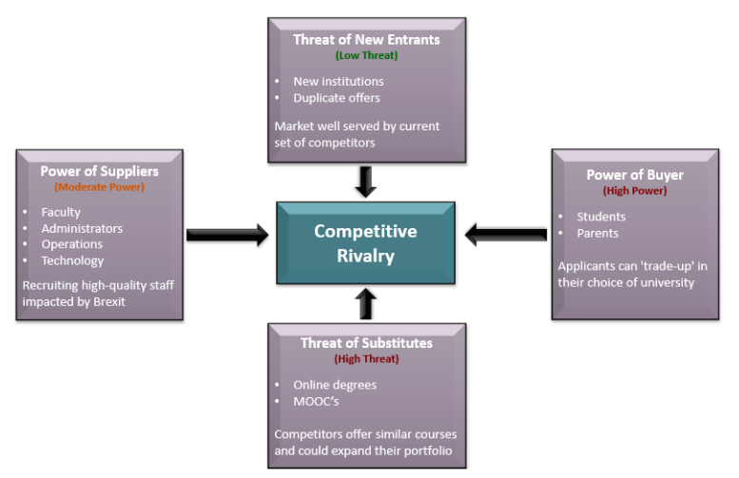
Figure 6: Five forces analysis of higher education sector UK source Spruin, (2022)
To apply five forces on the higher education sector UK the results comes as follows. The threat of new entrants would be new institutions, international institutions, duplicates from existing players. If universities from other countries come in higher education sector it looks as a possible threat for local institutions operating in the UK. Currently, higher education sector has low threat but the high rise of tuition fee may open doors for those countries in UK offer reasonable fees for students. The suppliers in higher education sector are faculty, administrators, operations and technology. The suppliers have moderate power now because just after the BREXIT high quality staff get hired from the UK who were demanding good money. The buyers are students and their parents who have high power now because there are range of universities providing quality education. Now potential students do good search through internet about universities and try to negotiate for scholarships or concessions. Threat of substitutes comes as online degree programs which comes as high threat because they are less expensive compare to in class learning. The Covid-19 phase popularised online education and all the universities in the UK moved to online learning which came back to normal routine now but students now give preference to online learning. Competitive rivalry is about facing competition from existing rivals in the market, in case of higher education sector UK they are only operating body in the UK but on global perspective they have competition from European rivals and international competitors. The native students in the UK may get better option in low fees abroad than they like to move there for higher education, similarly, many international students may switch to those destinations where low fee or free education is available.

How much UWSTD is affected by global factor
University of Wales Trinity Saint David is established in 2010 after the merger of University of Wales, Lampeter and Trinity University College. The university with the strength of 12,700 students as per 2019-20 figures has faculties in business, architecture, computing, engineering, education, humanities and arts for both taught and research programs, (UWTSD, 2022). The university has partnership in the UK with the London School of Commerce, NPTC group, Gower College Swansea, and The Prince's Foundation: School of Traditional Arts, (UWTSD, 2022). UWTSD meets the standard of any international university as provides online resources Moodle, Hwb, Library & learning resources, and IT service desk available to facilitate students and faculty members.
Globally, UWTSD has association with number of countries and institution as their office in India facilitates Indian students for their recruitment. The Indian office of UWTSD has partnership with Elizabeth School of London (ESL) which facilitates students in getting places at higher education institutions in UK, (UWTSD, 2022). The University has opened office in China to facilitate students from China, Hong Kong SAR, Japan, Mongolia, South Korea, and Taiwan. The strategy of opening office in India and China is actually increasing recruitment of students because these regions are emerging economy and a good source for income for higher studies.
UWTSD has a good reputation for sustainability as being the first university to place at its core sustainable development. The university's Institute of Sustainable Practice and Resource Effectiveness or INSPIRE is designed to teach students how to make the workplace and society more sustainable, (the guardian, 2012).

Conclusion
in a nutshell, after taking analysis of higher education sector through PESTEL and five forces many findings came into the consideration. From political perspective the higher education sector has visible threat from those countries offering free or economical education and currently the government has no planning for this issue as the fee is raising on annual basis. Taking the economic and socio-cultural point of view, the number of students in coming years may get reduced in higher education because they get loans to pay tuition fee which is burden and not guarantees good jobs after graduation. Technologically, higher education has noteworthy contribution because of different programs and affiliations globally. Environmentally, higher education UK has played important part for sustainability and legally the sector is operating within the limitation of national and regional governments.
The five forces analysis of higher education sector revealed the understandings that from new entrants that sector has low threat because market is well served by current competitors. The threat of supplier which are faculty member and administration show moderate threat because after BREXIT the sector has to rely on them. The buyer which are students show high threat because they are smart enough to bargain with higher institutions. The online degree programs as a cheaper substitute for in class learning is comes as high threat. The competitive rivalry on global perspective is present because many countries are offering same quality of education in cheaper price.
By summarising both analysis which were discussed above higher education sector must think about the fees structure or make some arrangements which helps student to afford their fees like job surety after graduation.
The global factors gave positive influence on the performance of UWTSD because the progressing and bringing more international students through affiliation and partnership policies.

References
Universities UK, (2022) International student recruitment data. [Online]. Available from: https://www.universitiesuk.ac.uk/universities-uk-international/explore-uuki/international-student-recruitment/international-student-recruitment-data#:~:text=Key%20facts%3A,visas%20granted%20(including%20dependents) [Accessed on 18-Oct-202].
Study in the UK, (2022) International Student Statistics in UK 2022. [Online]. https://www.studying-in-uk.org/international-student-statistics-in-uk/#:~:text=Top%20Countries%20of%20Origin%20of,605%2C130%20as%20of%202020%2F2021 [Accessed on 18-Oct-202].
Britannica, (2022) Industrial Revolution. britannica.com/event/Industrial-Revolution. Available at: https://www.timeshighereducation.com/news/uk-universities-face-ps26bn-coronavirus-hit-30k-jobs-risk
Study portals, (2022). Higher tuition fees for EU/EEA and Swiss studentsAvailable at:https://www.mastersportal.com/articles/2843/uk-tuition-fees-for-eueea-students-in-2022-changes-after-brexit.html [Accessed on 18-Oct-202].
Price, L., and Kirkwood, A., (2008) Technology in the United Kingdom’s Higher Education Context.
IAU_HESD, (2017) The SDG Accord: the University and College Sector’s Collective Response to the SDGs. Available at: https://www.iau-hesd.net/news/3716-sdg-accord-university-and-college-sectors-collective-response-sdgs.html [Accessed on 19-Oct-202].
Spruin, E, Dr., (2021) Creating a Competitive Advantage in the UK Higher Education Sector through Mirrored Course Delivery: A case example. Kent: Canterbury Christ Church University.
UWTSD, (2022) UK PARTNERSHIPS (FRANCHISE OR VALIDATION). Available at: https://www.uwtsd.ac.uk/collaborative-partnerships/register-of-collaborative-partnerships/ [Accessed on 19-Oct-202].
UWTSD, (2022). University guide 2013: University of Wales, Trinity St David https://web.archive.org/web/20130801181810/https://www.theguardian.com/education/2009/may/10/universityguide-uni-wales-lampeter [Accessed on 19-Oct-202].

