Charles Lloyd Jones
(2030806)
Abstract
[Draw your reader in with an engaging abstract. It is typically a short summary of the document.
When you’re ready to add your content, just click here and start typing.]

Water – the main culprit behind many OME PROBLEMS
OME HNC Chemistry
Contents
1. Physical and Chemical Properties of Water: 2
2. Water in the Atmosphere and Relative Humidity: 3
3. The Role of Water in Acid-Base Chemistry and Redox Reactions: 4
4. The Adverse Effect of Water on Various OME Materials, Articles and Processes: 4
5. Solutions to Prevent Performance Issues Associated with Moisture Ingress: 4
6. References 5

Physical and Chemical Properties of Water:
Water makes up a large part of the worlds surface and is universally used in daily life, whether that be for drinking, cleaning, industrial processes etc. It also makes up sixty-five per cent of the human body and is vital in the survival of life on earth. In its normal state (liquid) water is colourless and tasteless. Water is a chemical substance and has the chemical formula of H₂O. Meaning that one molecule of water consists of two hydrogen atoms covalently bonded to one oxygen atom. (See Fig. 1) for a simple example of the covalent bonds between the one atom of Oxygen and the two atoms of Hydrogen. A covalent bond is a shared pair of electrons, so where the Hydrogen and Oxygen atoms form a bond. [1] Oxygen becomes the central atom as it has a higher number of valence electrons.
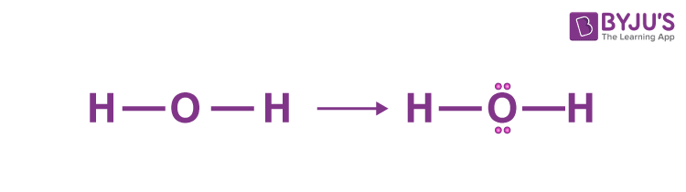
Fig.1 Showing covalent bond and valence electrons. [2]
Water has three physical states: solid, liquid and gas. It is the only known substance that exists in all three forms, in the range of temperatures and pressures found on earth. When considering states of matter, solids are denser than liquids and liquids are denser than gases. However, with water this is not the case. The different states of water depend on the temperature or thermal energy. By adding or removing thermal energy it increases or decreases the kinetic energy of the water particles. Added thermal energy results in the breakdown of molecular bonds and changes the state from solid to liquid then finally gas. Solids or ice in this case, melt once they have received enough thermal energy. When water is cooled it releases thermal energy and returns to a solid state. When in a solid state the molecules are packed closely together, which prevents it from changing shape. Ice has a regular pattern with molecules set rigidly apart from each other, connected by Hydrogen bonds which form a crystalline lattice. The crystals have several open spaces making ice less dense than liquid water. This is how ice will float on liquid water. Ice forms when the temperature goes below freezing 0° Celsius. Ice when warmed above freezing melts and becomes liquid water. In this form the forces between molecules weaken and individual molecules can move around each other. As the molecules can move round freely this explains how liquid water takes the shape of any container in which it is held. In its gaseous state, (water vapour). The molecules can move very quickly and are not bound together. Water will boil at 100° Celsius creating water vapour. The steam that can be seen from a boiling kettle consists of small water droplets suspended in the air, to see these droplets an infrared sensing instrument can be used [3]. (See Fig. 2) for an image of water molecules in its three states.

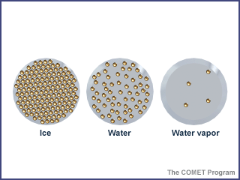
Fig. 2 Image showing water molecules at different physical states. [3]

Water in the Atmosphere and Relative Humidity:
The atmosphere is full of water. An estimate of the volume of water in the atmosphere is that there is three thousand, one hundred cubic miles at any one time. The water cycle is all about storing water and moving water on, in, and above the Earth. Although the atmosphere may not be a great storehouse of water, it is used to move water around the World. Evaporation and transpiration change liquid water into vapor, which then rises into the atmosphere due to air currents. Cooler temperatures above cause the vapor to condense into clouds and strong winds move the clouds around the world, until the water falls as precipitation to replenish the earthbound parts of the water cycle. Ninety percent of water in the atmosphere is produced by evaporation from water bodies like oceans and lakes, while the other ten percent comes from transpiration from plants [4]. (See Fig. 3) for an example of the processes water goes through in the atmosphere.
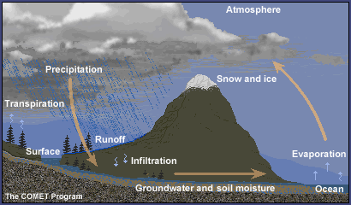
Fig. 3 Image showing water and processes in the atmosphere. [3]
Relative Humidity is the most common measurement of humidity and is expressed as a percentage between zero and one hundred. It shows the amount of water vapor in the air at a certain temperature and compares it to the maximum possible water vapor amount at the same temperature. For example, relative humidity of fifty percent means that air is at half of its water vapor capacity [5]. One hundred percent relative humidity means that the air is completely saturated with water vapour, meaning the air is unable to store anymore and with the correct conditions will turn the water vapour to water and fall as precipitation. Humidity is affected by temperature, the warmer the air the more water it can hold. Relative humidity is widely used in weather forecasting.

The Role of Water in Acid-Base Chemistry and Redox Reactions:
Water due to its solvent ability, enables the movement of ions and compounds and allows many reactions to take place. The movement of the ions and compounds once dissolved in water means reactions can occur more easily [6]. Water is an acid and a base and is known as an amphiprotic compound. It acts as an acid and a base with other molecules and with itself. Water can function as an acid and a base at the same time, which is known as an autoionization reaction [7]. When acids are dissolved in water, they donate Hydrogen ions. Hydrogen ions are Hydrogen atoms that have lost an electron and are left with a proton, which means they have a positive electrical charge. Bases mixed with water yield Hydroxide ions; Hydroxide ions are formed with the loss of a proton in a water molecule. In several acid-base reactions the products are water along with a salt. When Hydrochloric acid and Sodium Hydroxide are combined the Hydrogen ions in the acid are neutralized by the Hydroxide ions in the base to form water [8]. Rusting of iron and steel is an example of a Redox reaction, it occurs when the metal reacts with the air and water in the atmosphere. When a drop of water is left in contact with iron or steel, the concentration of dissolved Oxygen in the water drop will decide which areas of the metal surface will be reduction areas and which will be oxidation areas. The concentration of dissolved Oxygen at the edge of the drop will be higher, so the Oxygen will be reduced to Hydroxide ions. The electrons required to reduce the oxygen are from the oxidation of the metal at the centre of the drop, where the dissolved Oxygen concentration is low. When the electrons are released, they flow on the metal surface to the edges of the drop. Therefore, corrosion is always greater at the centre of a water drop or under layers of paint where the oxygen supply is low [9]. (See Fig.4) for an image of a water drop on a piece of iron or steel and the movement of electrons and the chemical formulas.
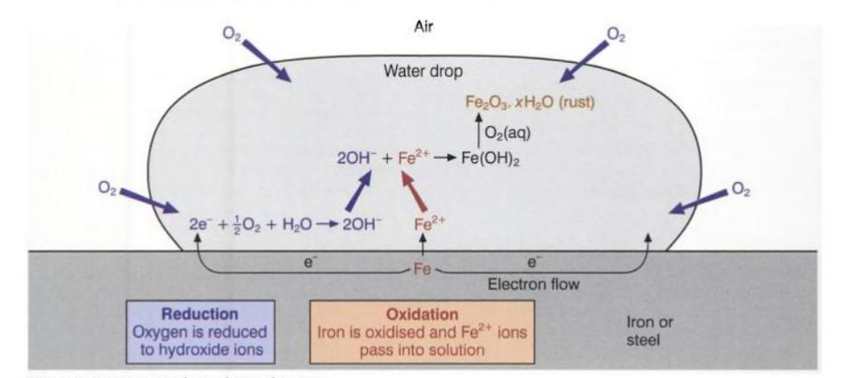
Fig. 4 Image showing a drop of water in contact with iron or steel [9].

The Adverse Effect of Water on Various OME Materials, Articles and Processes:
Ingress of moisture can cause ageing of pyrotechnic materials. Exposure to moisture is a threat to pyrotechnic substances when they are being packaged and during storage periods. There have been several studies to determine the effect of moisture on pyrotechnic mixtures [10]. For an example Lee et al [11] tested Boron Potassium Nitrate (BKNO₃) under accelerated aging conditions of seventy-one degrees Celsius and fifty percent relative humidity. They found that humidity was a crucial external factor in the oxidisation of Boron, this resulted in undesired pre reactions and a drop in the efficiency of (BKNO₃), even though only the surface of the Boron particles had been oxidised. Zirconium Potassium Perchlorate (ZPP) is a standard National Aeronautics and Space Administration (NASA) initiator, which is thermally stable and has a long shelf life. The binder’s performance degrades with time and higher relative humidity, exposing ZPP to the atmosphere. As ZPP ages, its composition changes and so do its thermodynamic characteristics, resulting in a drop in performance.
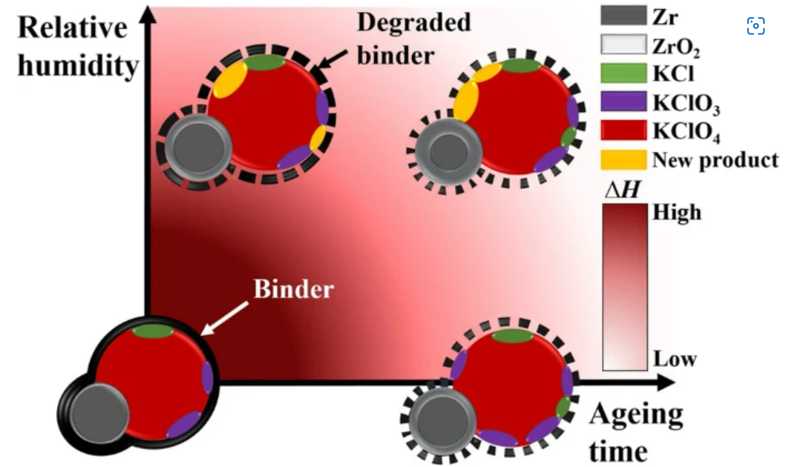
Fig. 5 Image showing the relationship between relative humidity and the aging duration for ZPP.
Composite propellants that are used in rockets and missiles contain more than eighty percent solid raw materials. Commonly used fillers for solid propellants are inorganic salts like ammonium perchlorate (AP) or ammonium nitrate (NH4NO3) which are oxidisers and aluminium or magnesium as fuel. Mass production in the propellant industry requires these to be dried before mixing to remove moisture contents. Slight changes in the process conditions can lead to performance variation in the propellant grain. Ammonium oxalate (AO) is added into AP composite propellants to reduce the burning rate. AO is highly hygroscopic and absorbs moisture from the air. The moisture content in AO affects the finished propellant during production and under storage conditions [12]. The authors in [12] state that two possible sites of hydrolysis of composite propellants are the double bond of Hydroxyl-terminated polybutadiene (HTPB) polymer backbone or the binder and filler interface. Uniaxial tensile test data showed that the modulus and maximum strength decreased in the presence of water in the raw materials. These results suggest that moisture does not affect the HTPB binder network and suggests that it affects the interaction between the binder and propellant. When wet small arms ammunition is inserted into the chamber of a weapon, the round will bring water molecules with it. Water which is virtually incompressible will reduce the internal chamber space and will stop the brass from expanding as intended. This results in an increase in chamber pressure, if the ammunition is at the high end of the pressure scale to begin with the presence of water could elevate the pressure to dangerous levels. [13]. In the table below (see Fig.6) the author conducted tests on ten rounds of dry ammunition and ten rounds of wet ammunition. The wet rounds produced higher pressures and lower average velocities; the standard deviation was three times the figure of the dry ammunition. The main problem with this is that there is no way to know how much water is on the rounds and in the chamber, so each round will act differently under ignition.
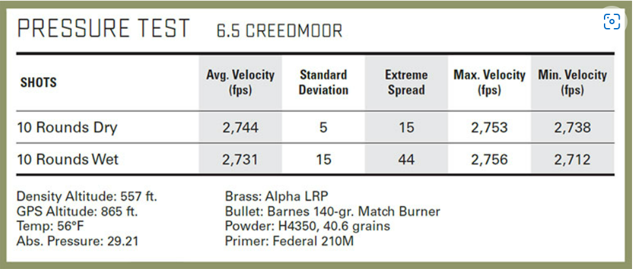
Fig. 6 Pressure test of rifle ammunition [13].

Solutions to Prevent Performance Issues Associated with Moisture Ingress:
In [14] the authors conducted experimental studies to try and understand why AP agglomerates and how they could possibly reduce it. They found that by increasing the percentage of activated charcoal over the AP decreased the rate of which AP agglomerates. The decreased rate of AP was attributed to the porous nature of activated charcoal. The activated charcoal was exposed to the atmosphere instead of AP, the pores of activated charcoal absorbed the moisture, preventing AP from agglomerating. They also found that AP coated with one percent of activated charcoal was observed to not absorb any moisture for short handling times, this ensured that there would not be any change in the burning rate from its designed value. Temperature, humidity monitoring and air flow are all considered when storing explosives and ammunition. All magazines and storehouses should be designed so that the internal temperature rarely falls below five degrees Celsius and rarely above twenty-five degrees Celsius. Rocket and gun propellants that contain nitroglycerine or other nitrate esters, will not be stored in a building that is liable to be below 5 degrees Celsius for a continuous period more than one month. As discussed previously elevated temperatures will cause propellants and other explosives containing nitrate esters to deteriorate in terms of physical properties, performance, and shelf life. A temperature of thirty degrees Celsius should not be exceeded. Surveillance of the chemical properties in storage should be conducted to avoid issues of autoignition. Packages of explosive stores should be situated so that air can flow freely between the stacks of explosives. The containers should also be raised off the floor with the use of battens to avoid moisture ingress and the stacks should be at least half a metre away from the walls [15]. A relative humidity of between thirty-five and fifty percent is suggested for storage of explosives, with a relative humidity of sixty-five percent for manufacturing processes, as low relative humidity could cause static electricity and spark ignitions [16]. When moving ammunition containers from cold to hot temperatures or vice versa, it is good practice to open the container to allow the condensation to evaporate. Once the ammunition has been exposed to the ambient temperature each round can be wiped down prior to inserting into the chamber to remove the presence of water [13].

References

[1] | BYJU'S, “www.byjus.com,” [Online]. Available: https://byjus.com/chemistry/physical-and-chemical-properties-of-water/. [Accessed 05 July 2022].
[2] | BYJU'S, “Chemical Bonding and Molecular Structure,” [Online]. Available: https://byjus.com/chemistry/lewis-structure-h2o/#:~:text=Water%2C%20one%20of%20the%20Earth's,bonds%20to%20form%20a%20compound.. [Accessed 5 July 2022].
[3] | UCAR Center for Science Education, “scied.ucar.edu,” [Online]. Available: https://scied.ucar.edu/activity/learn/ModelingPhasesWater. [Accessed 10 July 2022].
[4] | Water Science School, “www.usgs.gov,” United States Geological Survey, 8 June 2019. [Online]. Available: https://www.usgs.gov/special-topics/water-science-school/science/atmosphere-and-water-cycle#:~:text=There%20is%20always%20water%20in,too%20small%20to%20be%20seen.. [Accessed 10 July 2022].
[5] | N. Chandler, “science.howstuffworks.com,” 30 May 2018. [Online]. Available: https://science.howstuffworks.com/nature/climate-weather/atmospheric/question651.htm. [Accessed 12 July 2022].
[6] | StudySmarter, “www.studysmarter.co.uk,” StudySmarter, [Online]. Available: https://www.studysmarter.co.uk/school/chemistry/physical-chemistry/water-in-chemical-reactions/. [Accessed 12 July 2022].
[7] | A. Robb, “study.com,” 12 August 2021. [Online]. Available: https://study.com/learn/lesson/properties-water-acid-base.html#:~:text=Bronsted%2DLowry%20definition.-,Water%20can%20act%20as%20both%20an%20acid%20and%20a%20base,and%20acts%20like%20an%20acid.. [Accessed 12 July 2022].
[8] | Home Science Tools, “learning-center.homesciencetools.com,” 2021. [Online]. Available: https://learning-center.homesciencetools.com/article/acid-base-water-science-lesson/. [Accessed 12 July 2022].
[9] | G. Burton, “Rusting,” in Chemical Storylines, Pearson Education, 2000, pp. 172-173.
[10] | J. Ryu, J. Yang and J. Yoh, “A non-calorimetric approach for investigating the moisture-induced ageing of a pyrotechnic delay material using spectroscopies.,” Scientific Reports, vol. 9, no. 15228, 2019.
[11] | J. Lee, T. Kim, S. Ryu and et al., “Study on the Aging Mechanism of Boron Potassium Nitrate (BKNO3) for Sustainable Efficiency in Pyrotechnic Mechanical Devices.,” Scientific Reports, vol. 8, no. 11745, 2018.
[12] | M. Iqbal and W. Liang, “Modeling the moisture effects of solid ingredients on composite propellant properties,” Aerospace Science and Technology, vol. 10, no. 8, pp. 695-699, 2016.
[13] | J. Kauber, “gunsandammo.com,” 12 December 2019. [Online]. Available: https://www.gunsandammo.com/editorial/effects-moisture-rifle-cartridges/370226. [Accessed 15 July 2022].
[14] | K. Ishitha and P. Ramakrishna, “Reducing Agglomeration of Ammonium Perchlorate Using Activated Charcoal,” Propeelants, Explosives, Pyrotechnics, vol. 40, no. 6, 2015.
[15] | GOV.UK, MOD Explosive Regulations JSP 482, 2013.
[16] | Engineering Toolbox, “Relative Humidity in Production and Process Environments.,” 2003. [Online]. Available: https://www.engineeringtoolbox.com/relative-humidity-production-process-d_511.html. [Accessed 15 July 2022].

