STUDENT NAME: Cristina Tudureanu
STUDENT NUMBER: 1917153
PROGRAMME: Business Management
MODULE NAME: Project Management
ASSIGNMENT TITLE: Assessment 1
MODULE CODE: LCBB5005
LECTURER’S NAME: Sadeque Shaikh

Salisbury House
Project

Table of contents

- Introduction…………………………………………………..…………..………4
- Project Initiation Document (PID)………………………………….……..……4
  - Project objectives and critical success factor………….……..………5
  - Project scope……………………………………….……………..……..5
  - Assumptions…………………………………………….……….....……5
  - Constraints ………………………………………….……………..…….5
  - Stakeholders’ analysis………………………………………..…………6
    - Types of project stakeholders ……………………………………..………..6
    - Identification, prioritization and management over the project stakeholders………………………………………………………..…………7
  - Project organisation structure…………………………….……………9
  - Project control mechanisms…………………………………………..10
    - The project control importance…………………………………………….12
    - Project control stages……………………………………………………….12
  - Reporting framework…………………………………………………….13
    - Communication………………………………………………………………14
  - Project planning………………………………………………………..16
    - Gantt Chart…………………………………………………………………...16
    - Milestones…………………………………………………………………….17
- Appendix 1: Cost estimation report…………………………………………….19
- References………………………………………………………………………..21

- INTRODUCTION

PM is the foundation that guides the entire team to success. It includes long-term goals, tools, and tactics, as well as daily tasks. Organisations can avoid overspending and errors by prioritising the use of good project management approaches and frameworks. Project management is essential in today's fast-paced organisations (S.B.Joseph, 2021).
This report has as main focus the University of Wales Trinity Saint David (UWTSD) project. The university has purchased a new building block on the Kennington industrial park, Salisbury House. The project consists in renovating, furnishing and the needed hardware and software for students classrooms and staff administration offices. There will be added kitchen appliances in order to create a lunch area and there will be designed and furnished a toilets area. The new building will have additional classrooms and administrative offices to suit the increasing number of students and employees.

- PROJECT INITIATION DOCUMENT (PID)
One of the most important parts of any project is the "Project Initiation Document (PID)" or "Project Brief." The parts of the PID that are relevant to each organisation and project are different. As a whole, they provide a comprehensive look into all aspects of a project—from its purpose to its goals to its constraints to its members to its risks to its tolerance to its signatures (P.Coleman, 2022).

  - Project objectives and critical success factor
The project consists in renovating, furnishing and install all needed goods in Salisbury House in order to create a great learning environment, a relaxing lunch area, a spacious toilet and 2 administration offices for staff.
  - Project scope
The project's major goal is to renovate the entire building and equip students and teachers with cutting-edge learning and teaching materials through upgrading classrooms and teaching facilities, as well as network infrastructure. Moreover, improving internal communication and data sharing in order to produce better learning outcomes by upgrading network hardware, software, and infrastructure.
Upgrading educational facilities to include cutting-edge technology would benefit students' ability to learn more successfully.
In the end to equip the lunch area and toilets as these two spaces are necessary for students.
  - Assumptions
Can be assumed that every level within the project will be closely discussed between the director and the project manager. Every stage of the project has its importance and needs its time. We can assume that the entire building block has 6 learning classrooms, one dining area, one toilet space with 12 toilets, two administration offices for staff, one reception office.
  - Constraints
The main constraint is time. The university needs the space because of the big increase of students and staff. The interval for project will be 02 August to 02 September , after that is starting of the academic year. This means that the project needs to focus on run as quickly as it can and to run as smooth as possible to ensure start of the courses.
This will imply the workings during night. This happening there needs to be assurance that if there are any neighbours in the area, they will be asked for approval.

  - Stakeholders analysis
In project management, a "stakeholder" is someone, group, or organisation who has an interest in the choices, activities, or outcomes of a project and may be impacted by those choices, activities, or outcomes. Stakeholders will be numerous, for example, if a dam is being built. They will include governments, local governments, the displaced people, the population living around the dam, environmentalists, the project management team, and upper management, among other parties.
Stakeholders are not all on the same level playing field. The needs and expectations of each person are unique. People's wants and expectations must be taken into consideration when interacting with them. Failure to do so could jeopardise the project's success.
The final stages of the project will be more difficult if you ignore any important stakeholders. In extreme cases, the project may be terminated due to project delays and expense overruns.

    - Types of project stakeholders

- Internal Stakeholders: the sponsors, the project team, the program and portfolio managers, functional and operational manager administration manager. There has the highest interest of the good operation of the project and overall, its success.
- External Stakeholders: external customer, students, staff, teachers, suppliers, contractors and subcontractors, local authorities and the local community.
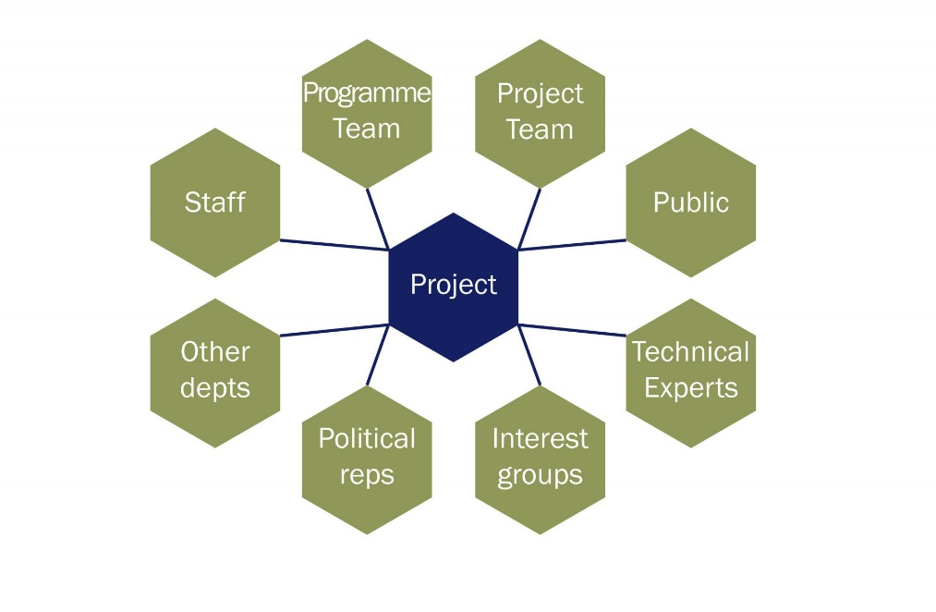
Fig,1: Project Stakeholders
Source:
    - Identification, prioritization and management over the project stakeholders
Placing stakeholder names on the grid makes it easy to see next moves and this can be seen in stakeholder analysis document.
- People of great power and high interest: these people need a close attention and maximum effort. These stakeholders need to be keep satisfied by having a good communication with them.
- People with high power but less interested: These stakeholders need to be kept satisfied by having a good communication but not an intense one.
- People with little power and lots of interest: need to keep in touch to avoid major issues. People in this area are the people who are helping with the details of the project.
- People with low power, less interest: This group of stakeholders are students who need to be monitored with not a severe need of talking to them. Likely to be interested in them is the director of university, who has tremendous authority and influence over them.
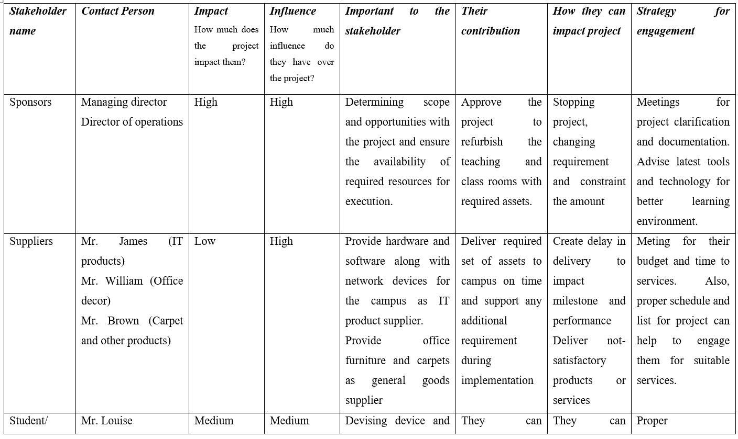
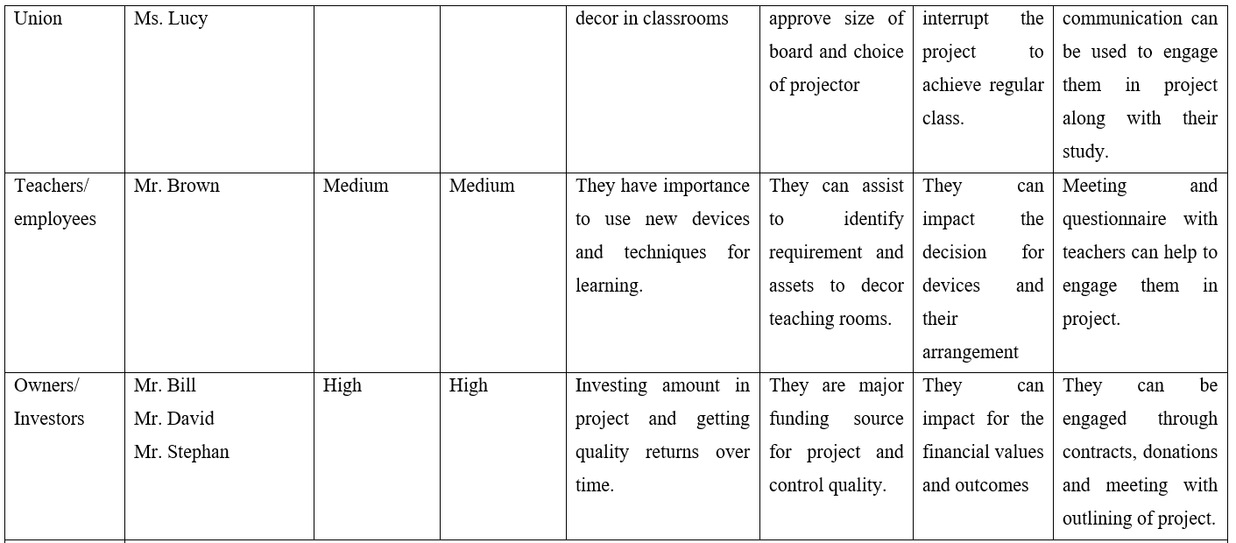
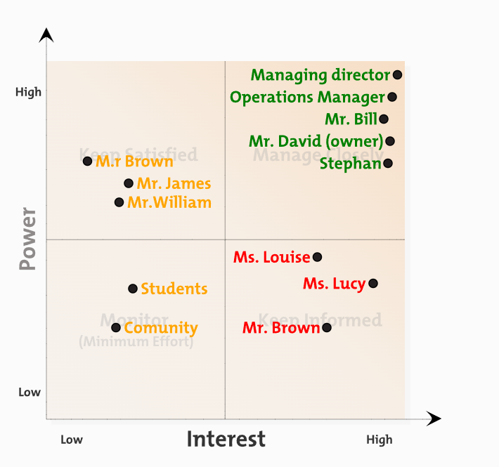
Fif.3: Stakeholder Power and interest Graph

  - PROJECT ORGANISATION STRUCTURE
In order for the project to be successful, it must have a well-defined hierarchy, roles, process, and reporting structure. One of the most critical elements in the management of an organization's day-to-day operations.
According to the industry in which the company operates and the activities it is engaged in, the structure used to be functional or Centralized Organization.
A functional organisational structure has the organisation organised into numerous departments, each of which is staffed by individuals with similar talents. It is the traditional organisational structure in which employees are organised into sectors and departments such as sales, marketing, and finance. This structure is functional since it increases each working group's efficiency.

PROJECT MANAGER

INTERIOR DESIGNER MANAGER
IT MANAGER
RENOVATION MANAGER

HARDWARE MANAGER
SOFTWARE MANAGER
TEAM MANAGER
OPERATIONS ADMIN

Supervisor
Assembly Supervisor
Engineer
Engineer

Assembly Engineer
Engineer
Engineer
Engineer
Engineer
Engineer
Engineer
Assembly Engineer
Engineer
Assembly Engineer
Engineer
Assembly Engineer
Engineer
Engineer
Assembly Engineer
Engineer
Assembly Engineer

Engineer
Delivery driver

Fig.4: Project organizational structure

  - PROJECT CONTROL MECHANISMS
Project controls are the data collecting, administration, and analytical processes used to foresee, comprehend, and constructively impact the time and cost outcomes of a project or programme.
Project controls specialists report to the project manager but oversee the entire project team. Because project controls let the project manager make informed judgments.
    - The project control importance
The scope of project controls is broad, which alone should attest to their importance. A project manager's sole duty is to oversee the entire project. Managing is part of the job title, and project controls are only another tool. Project controls are vital to a project's success. Project controls help align the entire project with the organization's larger strategic goals. This saves the project and the organisation time and money.
Project controls also help answer crucial project-related questions. The project's value or quality? How much will it cost, how long will it take to complete?
    - Project control stages
- Planning
Project controls are required for planning, forming a team, decomposing tasks, identifying stakeholders, and determining the project's goal. Cost and time estimation controls are crucial. These two limits are major threats to the project. As a result, exact estimations are necessary.
- Project Development
This is where the road meets the rubber. Cost estimates provide budgets, and time estimations ton create the project schedules. Throughout this phase, project controls are crucial. They help oversee the project's scope, money, and timeline. The more effective the project controls, the faster a project may be redirected. The same is true for budgets and spending. Project controls also work with risk management to identify cost and schedule risks.

- Implementation
Executing the project requires team focus to avoid delays and budget overruns. To do this, reliable progress monitoring is essential. Project controls help uncover problems and bottlenecks. You need project controls to analyse data on team hours worked versus budget spent and more to detect and fix issues quickly.
- Closure
Good outputs and satisfied stakeholders are not the end result. Project controls, team relinquishment or reassignment, and paperwork are all required. Finalizing the project is like performing a post-mortem to discover what worked and what didn't so that future projects can learn from your mistakes
    - Project control implementation method
Effective project management relies on people, and the right tools may go a long way toward making that work easier for everyone involved. The project manager will distribute tasks to the relevant team members using award-winning Gantt charts. Team managers can monitor the progress of tasks in real time and make sure that everything is going according to plan. In order to keep the project on track, certain duties can be transferred.
  - REPORTING FRAMEWORK
The primary objective of sustainability reporting frameworks is to translate abstract concepts into actionable steps. By highlighting both positive and negative consequences, sustainability reporting assists the project in prioritising activities necessary to achieve environmental and social impact goals.
To keep everyone informed and on target, communication is crucial in project teams made up of experts with diverse backgrounds and abilities. As leaders, project managers spend much of their time talking with their teams to ensure project success.
While project managers prioritise communication, other professionals must also commit to enhancing their communication abilities. This may include asking questions about the project or making suggestions to help it progress.

    - Communication
Communication in project management refers to the exchange of ideas and opinions between specialists with similar or related roles. Communication within this project can guarantee that everyone working on the project understands the project's goals and expectations. This allows experts to work more effectively and improves the quality of their job.
To effectively manage this project, there must be understood the team dynamics and for this there is need an effective communication strategy. The strategy adopted is below:

- Make a project plan
Consider communication early in the project's planning. There will be considered creating a detailed project strategy and carefully selecting the team of experts. Early planning allows for easier team communication later on.
- Open a communication channel
After gathering a team and formulating a strategy, there will be established a crucial communication channel. While using different means of communication is beneficial, telling team members about the principal mode helps structure the project. There will be opened a group chat at the start of the project and invite professionals to communicate there.
- Set project goals
There will be assured the entire staff that they will be regularly informed of the project's goals. This ensures that all specialists understand the work's goals. All managers will be invited to share their ideas on how to achieve the project's goals. This may help us achieve the project's goals with more quality or efficiency.
- Focus on the team
Communication requires active listening. As a project manager I will listen to my team and try to elicit their perspectives on specific themes. This shows my appreciation and regard towards my employees. When showing someone that they have respect by listening to them, they are more likely to reciprocate. This can improve my leadership skills and helps me achieving the project’s goals.
- Keep everyone informed
The team will be kept updated on changes to the project. Updates on project progress, policy changes, new approaches, etc. Keeping the team updated ensures everyone is aware of the project's status. By involving everyone in the project's processes.
- Monitor employee performance
Monitoring employee performance allowing us to discover those who need extra help.. Knowing how each team member performs might help in determining the most effective communication methods for the project. If there can be observed that a few employees are not sticking to the latest project terms, there may need to consider changing the communication technique.

PROJECT MANAGER

INTERIOR DESIGNER MANAGER
IT MANAGER
RENOVATION MANAGER

HARDWARE MANAGER
SOFTWARE MANAGER
TEAM MANAGER
OPERATIONS ADMIN

Supervisor
Assembly Supervisor
Engineer
Engineer

Fig.3. Project reporting framework

  - PROJECT PLANNING
    - Gantt Chart
Project managers use Gantt charts to plan and schedule projects. A Gantt chart is highly useful for breaking down big projects into manageable chunks and tracking progress. Gantt charts also help in tracking the project deadlines, milestones, and hours worked, allowing you to spot delays or overages early on.
In order to maximise resource utilisation and guarantee that all requirements are completed, the project work must be broken down into summary activities. It is also necessary to segment the project's outcomes. To facilitate grouping of processes, the project will be executed in summary tasks.
- Planning
Goals, scope, and possibilities are defined in this first step of the project. The summary activity's main goal is to develop the UWTSD campus's capabilities for necessary teaching, dining and resting and toiletry renovations, furnishment and installation of a software and hardware. The time period for the project is: 2 July to 2 November.
- Clarification of requirements:
Its main goal is to understand the institute's needs in order to improve learning and teaching. It includes tasks that are used to determine the project's requirements (Kerzner and Kerzner, 2017). It uses discussions, questionnaires, and other tools to gather information on the abilities and restrictions required to attain the goal.
- Designing:
All efforts required to build the solution's logical foundation. Assemble the rooms for the gadgets, map the carpet, set up the projectors and screens in every classroom, and arrange the chairs and tables, including a desk for keeping notes and luggage. Designing also picks the best solution from a range of equipment and software options to create a happy learning environment.
- Implementation
Installing the resources within the university and configuring them through software or other techniques to achieve the appropriate décor and functionality in rooms is its main goal. Implementation is focused with exact component placement to ensure customer satisfaction and task quality (Heagney, 2016). In terms of network infrastructure, security and device configuration are essential success factors.
- Evaluation
It comprises all actions that can be used to assess the project's quality and performance. For example, initialization is required to link the outcome to the specification. Also, evaluating outcomes and their validations is required (Harrison and Lock, 2017). If the project changes, the review process ensures that the adjustments are accurate and viable.

    - Milestone
A milestone is vital in a project because it can help meet quality and outcome goals. Milestones let leaders track progress and make lasting changes that improve performance. Three milestones can be used to track progress and ensure the project meets its objectives.
1st Milestone:
This milestone accomplished all planning, requirement collection, and design elements. Now is the time to finish logical design with iterations for inspection and verification. The stage creates a logical framework for asset deployment and network infrastructure operation.
The 2nd Milestone:
Implementation and configure technical and non-technical components to create an amazing learning environment (Heagney, 2016). The stage outputs a functional model of the requirements that has been improved, adjusted, and optimised in terms of component selection and use throughout time.
The 3rd Milestone:
Finishing: Its main goal is to offer the organisation with a finished project. Assuring the project integrates all modifications and needs while meeting projected goals is a milestone. It is the stage where the project is declared complete, and no tasks remain. It used to bring the project to a close.

Appendix 1: Cost estimation

Total classrooms =6 rooms
IT laboratory = 4 rooms
PC needed for 1 IT laboratory= 25
PC needed for admin offices and reception =6
Cost of one computer=£900
Hardware total cost = £900 x (25 x 6 + 4) = £95,400
Total number of projectors needed = 11 x £2,900 =£31,900
Projector price: £ 2,900
Total projector cost = £31,900
Carpet cost x Surface needed (m) = £5 x 18000 sq ft =£90,000
Chair price x total number or chairs needed = £210 x [(25x10) + (2x7)] = £210 x 264 = £55, 440
Board screen x total boards needed = £70 x 11 = £770 (one in every room from the university)
Lunch area appliances: 700£ (fridge) + 150£ x 3 (microwave) + 40£ (water heater) + 220£ (coffee machine) =1410£
Tables dinning:1550£
Tables classrooms: 20£ x 290 (units)= 5,800£
Offices: 290 x 3 ( 2 admin offices and reception) = 870£
Furnishing cost = £155,920
Renovating cost: 59,000
Toilets cost: 75,000
Renovation and toilets cost: 134,000£

Switch price x number = £80 x 20= £1600
Router price x number = £110 x 6 = £660
Cable price/m x length needed = £3 x 4500 = £13,500
Cooling systems = £4995 x 4 = £19,980£
Software cost = £9000
Total cost for networking = £44,740
Total cost = £ 461,560 where 25% is managed for risk and rest is cost of human resource and efforts.

- REFERENCES

J. Heagney,( 2016), “Fundamentals of project management”. Amacom
S.B.Joseph, (2021), “Your complete guide to project management in 2022”, Available at: https://monday.com/blog/project-management/guide-to-project-management/ , Accessed: 10.04.2022.
F.Harrison and D. Lock, (2017), “Advanced project management: a structured approach”. Routledge.
P. Coleman, (2022),” What Is the Project Initiation Document?” , Available at: https://www.wise-geek.com/what-is-the-project-initiation-document.htm , Accessed: 10.04.2022.
C.Carleton, (2018). “Project Initialization plan template” , Available at: https://carleton.ca/its/project-office/wp-content/uploads/ProjectInitiationPlanTemplate.docx, Accessed On: 12.04.2022.
F.Usmany, (2021), “Stakeholders in Project Management”, Available at: https://pmstudycircle.com/stakeholders-in-project-management-definition-and-types/ , Accessed: 10.04.2022.
W.Malsam, (2020), “Project Controls: A Quick Guide”, Available at: https://www.projectmanager.com/blog/project-controls-a-quick-guide , Accessed: 11.04.2022.
J.Freeman, (2022), “What is a Milestone in a Gantt Chart”, Available at: https://www.edrawsoft.com/project/what-is-milestone-in-gantt-chart.html , Accessed: 11.04.2022.

