DS 1 Template

My Screenshots/Photos
- Please add 4–6 screenshots or photos of your digital life.
- You can use your phone or laptop.
- For each screenshot, write one or two sentences explaining what it shows.

Screenshot/Photo 1
[Insert Photo/Screenshot below]
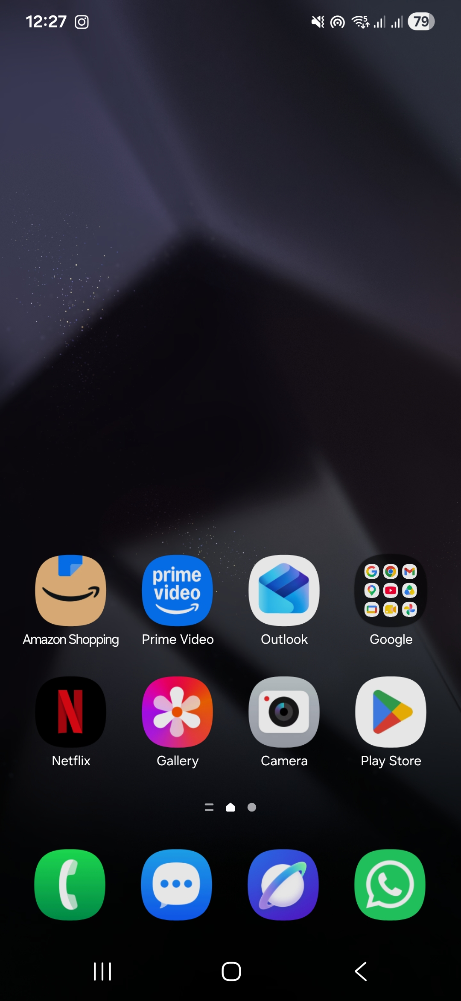
I utilise essential digital skills on a daily basis by navigating a smartphone interface to manage professional communications through Outlook, handle everyday retail tasks via Amazon, and maintain instant communication using WhatsApp.

Screenshot/Photo 2
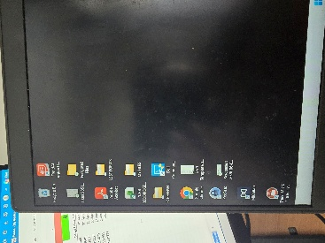

I apply essential workplace digital skills by securely managing sensitive administrative data using file encryption tools, organizing professional documentation into structured folders, and utilising spreadsheets for data tracking.

Screenshot/Photo 3
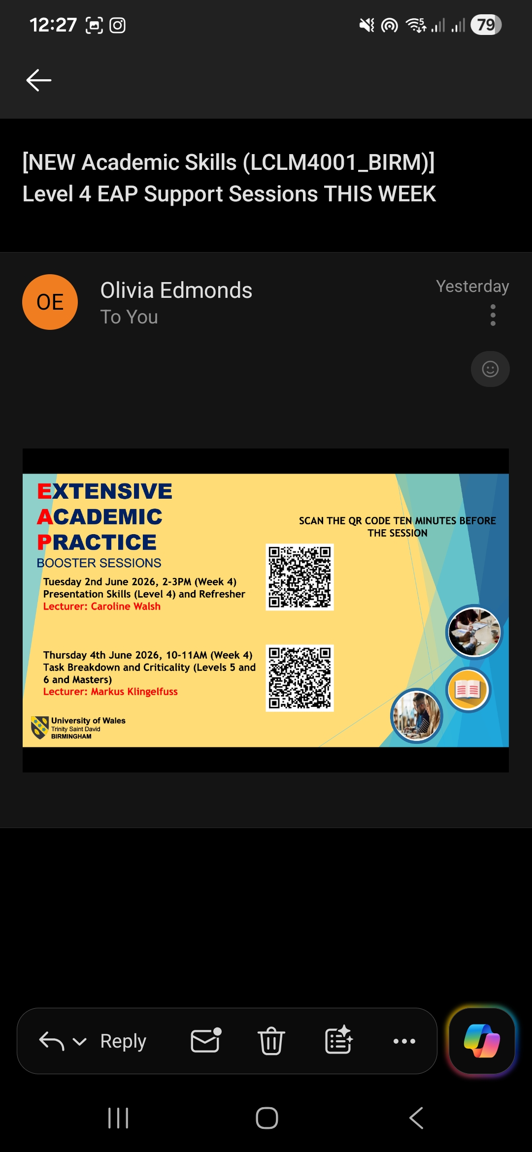
I actively apply my digital skills for university by regularly monitoring my student email inbox to review academic updates, ensuring I never miss crucial information regarding upcoming Level 4 support sessions and presentation skills workshops.

Screenshot/Photo 4
[Insert Photo/Screenshot below]
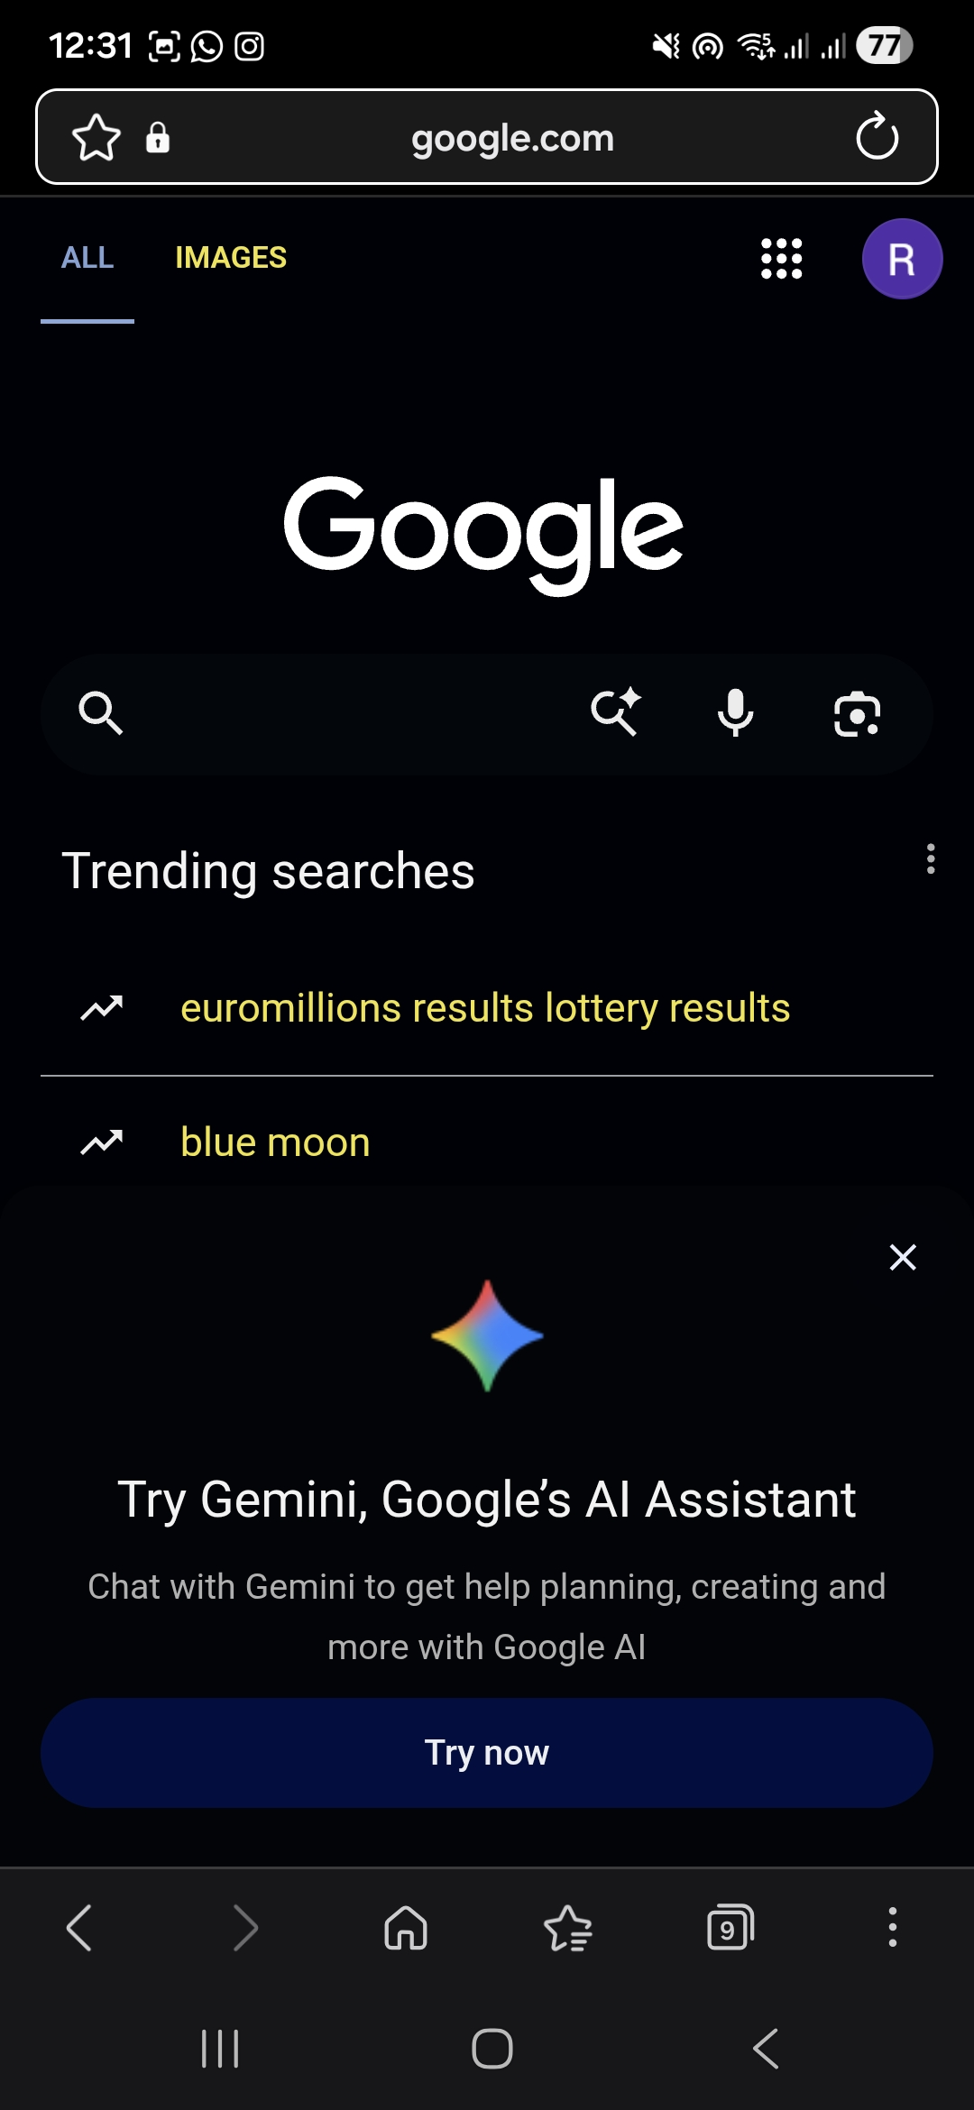
I use the Google search engine via my mobile browser to efficiently look up information, research topics, and navigate the wider web.

Screenshot/Photo 5
[Insert Photo/Screenshot below]
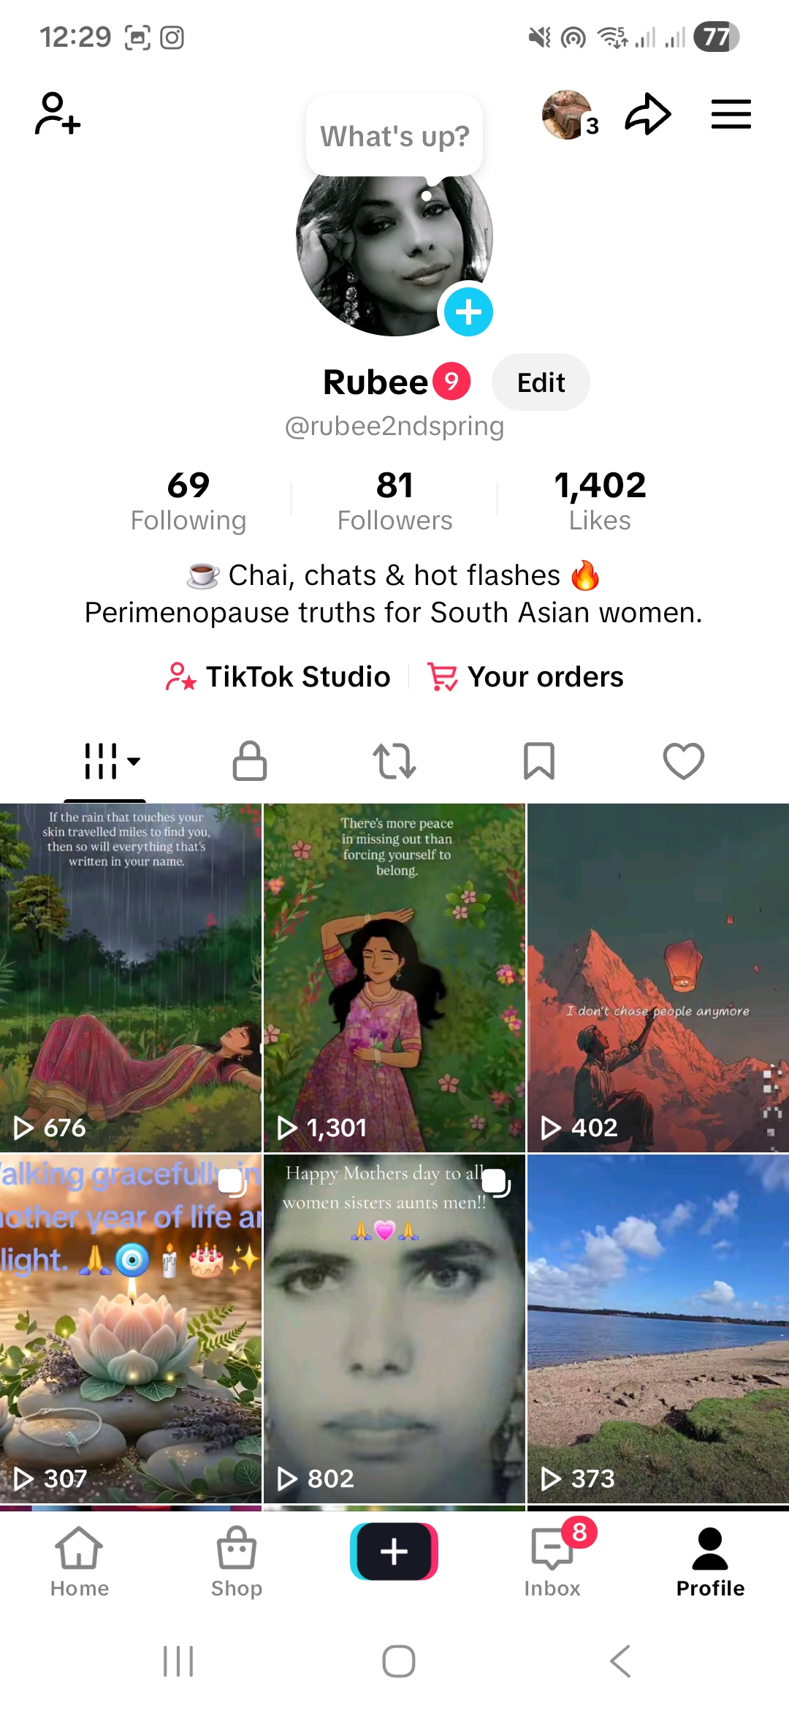
I apply my digital skills to navigate social media platforms like TikTok, where I manage a personal profile page, engage with online communities, and track content performance metrics such as likes and views.

Screenshot/Photo 6
[Insert Photo/Screenshot below]

[Write what this shows of your digital life]

My Short Reflection
- Write 5–8 simple sentences about your digital life.
- You can use the sentence starters below if helpful.

Sentence starters
- I use digital tools to …
- I feel confident when I …
- I want to improve …
- I often use these tools: …
- I sometimes feel nervous about …
- I hope this module will help me …
- Digital skills are important for me because …
You can write more if you want.

Submission Checklist
Before you submit, please check:
​​​ ☐ I added 4–6 screenshots
☐ I wrote short sentences for each screenshot
☐ I wrote my short reflection
☐ My work is my own
☐ My file opens correctly
​​☐ My file opens correctly

