Entrepreneurship
BMIH5001
Individual Business Model Canvas with entrepreneurial reflection
Rework

Lecturer: Ka Po Chong
Student id: 2213957
Student name: Georgiana Cucu
Word count:2117

Part 1
The proposed business is an organic eating venue that prioritises locally sourced and sustainable products. The goal of this restaurant is to address the growing demand for healthy, environmentally friendly dining options. By using organic, locally produced products, the restaurant hopes to offer a menu that is both delicious and eco-friendly. This technique decreases the carbon impact of food transportation while helping local producers (Stein and Santini, 2022). By focusing on these components, the restaurant hopes to set a new standard for sustainable food and set itself apart in the extremely competitive hospitality business.

A value proposition is a brief statement that articulates a company's distinct worth to its clients, explicitly articulating the benefits of its products or services in meeting specific customer demands or challenges (Kotler et al., 2019). It is an important component of corporate strategy, distinguishing the company's offerings from those of competitors by emphasising special characteristics, advantages, and reasons why customers should choose them (Keller and Kotler, 2015). This notion is crucial for steering marketing and sales operations, ensuring that the value supplied is successfully communicated to the target audience, influencing their purchasing decisions. The restaurant's value proposition is based on its commitment to providing a health-conscious culinary experience with a finely curated menu of organic items. The emphasis on local procurement promotes sustainability, benefits the local ecosystem, and ensures access to fresh products (Osterwalder et al., 2015). The restaurant's location in prominent urban neighbourhoods guarantees that customers can easily reach it. Furthermore, to enhance the dining experience, the business prioritises modern amenities and thorough hygiene. Additionally, it takes an inclusive approach by providing areas for children's amusement, so welcoming families. This strategy demonstrates business responsibility and sustainable practices by meeting the needs of health-sensitive and environmentally conscious consumers (Williams, 2021).
Additionally, collaboration with local organic farms and co-ops is central to the business plan, ensuring a regular supply of fresh products, which is vital to maintaining the restaurant's commitment to offering organic and nutritious meals (Taylor, 2008). Forming ties with organisations such as the Soil Association ensures that the organic produce used is authentic (Soil Association, 2020). Specialised logistics businesses are critical to ensure the safe shipping of perishable items while maintaining their organic integrity. Similarly, makers of eco-friendly packaging follow the brand's environmental principles (Blackwell, 2011). Renewable energy providers are critical to the business's long-term viability. This strategy entails a number of critical activities, including cultivating strong supplier relationships to ensure product quality, adhering to stringent organic certification criteria, consistently introducing new dishes to meet diverse dietary needs, and leveraging traditional and digital marketing channels to increase market penetration (Shekarian et al., 2022). Distinctive culinary events and great customer service are intended to promote brand loyalty and increase brand awareness. Streamlining the ordering and payment processes for in-person and online transactions is critical to boosting revenue and improving the customer experience (Zimmerer and Scarborough, 2011).

The organic restaurant's concentration on customer categories is consistent with market segmentation and consumer behaviour theories, emphasising the need of catering to certain groups with distinct preferences (Minaee et al., 2021). Health-conscious customers want healthy, high-quality food that fits their lifestyle. Organic farming advocates prefer businesses that get materials responsibly, hence encouraging sustainable agricultural practices. Environmentalists are drawn to businesses that work to lessen their environmental impact. Menus that meet the nutritional needs of those with allergies or food sensitivities are essential, with a focus on safety and inclusivity. Individuals looking for novel and extraordinary eating experiences are drawn to distinctive culinary offerings. Finally, buyers seeking a "organic lifestyle" want firms that represent their values and preferences, exhibiting how their product offers are consistent with their personal values and lifestyle (Jungles et al., 2021).

The restaurant takes a personalised approach to establishing client connections, tailoring the culinary experience to specific dietary constraints and personal preferences. This customisation is increased by ethically utilising consumer data, allowing the restaurant to recall returning customers' preferred foods or allergies, creating loyalty and a sense of inclusion (Mariotti and Glackin, 2012). A rewards programme that associates client participation with concrete benefits, such as seasonal meals or attendance at wellness events, encourages repeat visits and healthy eating habits by granting points for such behaviour (Hisrich, Peters and Shepherd, 2017). Promoting feedback channels, both real and virtual, encourages a reciprocal flow of communication, making customers feel appreciated and valued. The restaurant's proactive involvement in community health-related events enhances its reputation as a brand that values local community well-being (Jiang and Stylos, 2021). Furthermore, using email newsletters, social media, and other digital channels enables the restaurant to educate clients about future events, health advice, and new menu items, thereby keeping a discussion outside of the establishment (Helmold, 2022). This method promotes a sense of community based on a common appreciation for health and sustainability. Relationship Marketing emphasises the importance of these strategies in developing long-term consumer connections. Huggins et al. (2020) argue that relationship marketing prioritises customer happiness and retention over short-term transactions. In this theoretical framework, the restaurant's efforts to tailor experiences to individual preferences, incentivize customer loyalty, elicit feedback, foster community involvement, and maintain open communication are critical in fostering long-term relationships and customer retention. By implementing this strategy, the restaurant not only develops a distinct position in a highly competitive business, but also meets current consumers' expectations of personalised and meaningful brand engagements (Lindecrantz, Gi and Zerbi, 2020).
The restaurant's capacity to deliver its value offer of providing nutritional and environmentally friendly food is significantly dependent on vital resources. Organically certified ingredients are essential for ensuring the quality and sustainability of the food while sticking to the restaurant's environmental policy. A suitably supplied cooking space allows for the development of organic and allergen-free dishes, increasing the gastronomic experience for customers who value their health (Abdou, Hassan and Salem, 2023). Efficient point-of-sale (POS) systems and robust IT infrastructure enable seamless in-store and online transactions, such as order processing and reservation management (Timmons and Spinelli, 2008). The kitchen staff's ability to create health-conscious cuisine demonstrates the importance of human resources in carrying out the restaurant's mission (da Silva et al., 2022). The strategic use of marketing technologies like pay-per-click, social media, email marketing, and search engine optimisation is critical for optimising distribution channels and improving the restaurant's visibility and contact with potential customers. Implementing a customer relationship management system is essential for building long-term client relationships, administering loyalty programmes, and tracking consumer feedback (Dwivedi et al., 2021). Physical resources, such as a welcoming dining space that symbolises the brand's beliefs and meets the diverse demands of customers, are critical for creating a positive atmosphere. The availability of financial resources makes it easier to implement premium pricing strategies and manage cash flow across many revenue streams, including delivery, in-house dining, and event coordinating (Rane, Achari, and Choudhary, 2023). The Resource-Based View emphasises the importance of both tangible and intangible assets in meeting strategic goals and creating a competitive advantage. According to Barney (1991), the RBV asserts that an organization's distinctive talents and resources are critical to its strategy and performance. This highlights the importance of these crucial resources to the restaurant's success.

The organic restaurant's cost structure reflects the enormous expenditure required to maintain its value proposition. Organic ingredients are more expensive than non-organic products due to sustainable agricultural practices and limited economies of scale (Fernandes et al., 2020). Another significant cost is the remuneration of skilled chefs and workers with experience in organic products and dietary restrictions, emphasising the value of human capital in providing excellent service. Marketing and advertising demand ongoing financial expenditures, particularly in the digital arena, to effectively engage the target audience and develop brand recognition (Burns, 2022). To meet regulatory criteria, the restaurant must incur additional costs for obtaining and maintaining organic certification, as well as complying with health and safety protocols. Significant operational resources include investments in specialised culinary equipment for making allergen-free and organic meals, as well as advanced information technology systems for reservation and customer relationship management. Menu development, which necessitates research and creativity to meet the demands of health-conscious clients, as well as quality control and compliance to assure adherence to organic and nutritional standards, are both significant financial investments. These expenses are critical for the restaurant's competitive advantage and are consistent with value chain analysis theory, which emphasises the significance of maximising customer value-creation activities (Dubey et al., 2020).
To effectively engage its customers, the restaurant uses both traditional and digital media. Traditional media, such as pamphlets, billboards, and television commercials, reach a wide demographic and raise awareness in the near vicinity. Online channels such as email marketing, pay-per-click advertising, social media, and LinkedIn increase engagement and improve marketing precision by targeting specific demographics and interests (Chaffey and Elis Chadwick, 2019). Revenue streams are diverse, with a large amount coming from premium pricing that represents the health advantages, quality, and provenance of the food, as well as the whole culinary experience (Roysko, 2023). Take-away services and event coordination are additional revenue sources, with an emphasis on atmosphere, service quality, and unique features such as family-friendly settings. Offering many payment methods for both in-store and online transactions improves consumer convenience and satisfaction.

In conclusion , the planned organic eating restaurant, with its emphasis on health and sustainability, is a strong business concept. The restaurant used8jmmnjj the Business Model Canvas framework and entrepreneurial theories to strategically plan and execute its operations. Addressing the unique needs of various client segments, leveraging essential resources and alliances, and retaining a compelling value offer will be critical to success. Furthermore, focusing on personal entrepreneurial tendencies and gaining essential skills will help you navigate and prosper in the competitive hospitality business. This complete study will allow the restaurant to build a unique position in the market, aligning with current consumer wants and supporting long-term success.

Part 2
In 1988, Graham Gibbs developed the Gibbs Reflective Cycle as a structured approach for reflecting on the many stages of an activity or event. Subsequently, it has been widely utilised in the fields of education and professional development (Adeani, Febriani, and Syafryadin, 2020). To explore this model, I will begin by describing my experience with the GET2 test, which evaluates an individual's propensity for initiating and managing projects. The assessment results classified me as "Occasional Enterprising," indicating a moderate level of engagement in entrepreneurial activities. The results evoked a blend of astonishment and self-reflection, as they seemed to challenge my preexisting beliefs about my abilities as an entrepreneur. Upon considering this outcome, I contemplated the consequences of embracing a cautious attitude in some situations, which could limit certain possibilities but also reduce the chances of failure in important undertakings. According to Osemeke and Adegboyega (2017), humans are motivated by a specific combination of needs for power, affiliation, and accomplishment, as outlined in McClelland's Theory of Needs. The results I achieved are in line with an entrepreneurial profile that emphasises making well-thought-out risks and pursuing sustainable growth rather than engaging in high-risk endeavours. This is consistent with having a moderate need for achievement. After thoughtful consideration, I have come to the realisation that my entrepreneurial tendencies, although not excessively forceful, may be a good fit for organised settings that appreciate creative yet cautious approaches, comparable to those of an intrapreneur as defined by Pinchot, as referenced in Orchard (2015). This modest predisposition towards enterprise indicates a balanced approach, which may reflect a strategic risk orientation that aligns with the planned conservatism commonly seen in business situations. Embracing this mentality enables one to identify and take advantage of possibilities within defined levels of risk, which is a beneficial perspective in dynamic and competitive corporate environments. I aspire to pursue professional possibilities that encourage creativity and strategic risk-taking. To further these skills, I intend to engage in targeted educational efforts, such as participating in Massive Open Online Courses offered by FutureLearn (FutureLearn, n.d.). The systematic strategy I am taking to develop my entrepreneurial abilities is focused on optimising my ability to pursue company opportunities in settings that effectively manage risk while encouraging innovation. In addition, including business simulation tools and case studies, as recommended by Rae (2008), will further improve my entrepreneurial competency by refining my market analysis and strategic thinking skills. By integrating these elements into my own growth and development, my objective is to enhance my entrepreneurial capacity, by this means making significant contributions to organisations that prioritise both innovation and prudent administration. By engaging in this self-reflective process and utilising the Gibbs model as a structure, I have discovered a method to efficiently utilise my entrepreneurial characteristics. I have also established a strategy for advancing my career that is in harmony with my personal attributes and the nature of the business landscape.

References

- Abdou, A.H., Hassan, T.H. and Salem, A.E. (2023). Promoting Sustainable Food Practices in Food Service Industry: An Empirical Investigation on Saudi Arabian Restaurants. Sustainability, [online] 15(16), p.12206. doi:https://doi.org/10.3390/su151612206.
- Adeani, I.S., Febriani, R.B. and Syafryadin, S. (2020). Using Gibbs’ Reflective Cycle In Making Reflections Of Literary Analysis. Indonesian EFL Journal, [online] 6(2). Available at: https://journal.uniku.ac.id/index.php/IEFLJ/article/view/3382.
- Barney, J., 1991. Firm resources and sustained competitive advantage. Journal of management, 17(1), pp.99-120.
- ‌Blackwell, E., 2011. How to prepare a business plan: Create your strategy; forecast your finances; produce that persuasive plan. Kogan Page Publishers.
- Burns, P. (2022) Entrepreneurship and Small Business, 5th Ed., Palgrave Macmillan: Basingstoke
- Chaffey, D. and Ellis-Chadwick, F., 2019. Digital marketing. Pearson uk.
- da Silva, L.B.P., Soltovski, R., Pontes, J., Treinta, F.T., Leitão, P., Mosconi, E., de Resende, L.M.M. and Yoshino, R.T. (2022). Human Resources Management 4.0: Literature Review and Trends. Computers & Industrial Engineering, 168(108111), p.108111. doi:https://doi.org/10.1016/j.cie.2022.108111.
- Dubey, S., Singh, R., Singh, S.P., Mishra, A. and Singh, N.V., 2020. A brief study of value chain and supply chain. Agriculture Development and Economic Transformation in Global Scenario, pp.177-183.
- Dwivedi, Y.K., Ismagilova, E., Hughes, D.L. and Carlson, J. (2021). Setting the Future of Digital and Social Media Marketing research: Perspectives and Research Propositions. International Journal of Information Management, [online] 59(1), pp.1–37. Available at: https://www.sciencedirect.com/science/article/pii/S0268401220308082.
- Fernandes, S. da C., Pigosso, D.C.A., McAloone, T.C. and Rozenfeld, H. (2020). Towards product-service system oriented to circular economy: A systematic review of value proposition design approaches. Journal of Cleaner Production, 257, p.120507. doi:https://doi.org/10.1016/j.jclepro.2020.120507.
- FutureLearn (n.d.). FutureLearn: Online Courses and Degrees from Top Universities. [online] FutureLearn. Available at: https://www.futurelearn.com/?utm_source=google&utm_medium=paid_search&utm_campaign=fl_All_Products_Brand_UK_IRE&gad_source=1&gclid=Cj0KCQjw6uWyBhD1ARIsAIMcADr1GJlPuYZBZcfXaOIiXA7s8etCrR3nNwNUrKrmt6BWBf6fk0vo-kcaAmrDEALw_wcB [Accessed 15 May 2024].
- Jungles, B.F., Garcia, S.F.A., de Carvalho, D.T., Junior, S.S.B. and Da Silva, D., 2021. Effect of organic food-related lifestyle towards attitude and purchase intention of organic food: Evidence from Brazil. ReMark-Revista Brasileira de Marketing, 20(4), pp.267-299.
- Helmold, M. (2022). Supply Chain Management and Distribution Channels. pp.185–198. doi:https://doi.org/10.1007/978-3-031-10097-0_18.
- Hisrich, R.D., Peters, M.P. and Shepherd, D.A. (2017). Entrepreneurship. [online] thuvienso.hoasen.edu.vn. McGraw-Hill Education. Available at: https://thuvienso.hoasen.edu.vn/handle/123456789/6936.
- Huggins, K.A., White, D.W., Holloway, B.B. and Hansen, J.D., 2020. Customer gratitude in relationship marketing strategies: A cross-cultural e-tailing perspective. Journal of Consumer Marketing, 37(4), pp.445-455
- Jiang, Y. and Stylos, N. (2021). Triggers of consumers’ enhanced digital engagement and the role of digital technologies in transforming the retail ecosystem during COVID-19 pandemic. Technological Forecasting and Social Change, 172(2021), p.121029. doi:https://doi.org/10.1016/j.techfore.2021.121029.
- Keller, K.L. and Kotler, P., 2015. Holistic marketing: a broad, integrated perspective to marketing management. In Does marketing need reform?: Fresh perspectives on the future (pp. 308-313). Routledge.
- Kotler, P., Brady, M., Goodman, M. and Hansen, T., 2019. Marketing management: European edition. Pearson Higher Ed.
- Lindecrantz, E., Gi, M.T.P. and Zerbi, S. (2020). Personalized experience for customers: Driving differentiation in retail | McKinsey. [online] www.mckinsey.com. Available at: https://www.mckinsey.com/industries/retail/our-insights/personalizing-the-customer-experience-driving-differentiation-in-retail.
- Mariotti, S. and Glackin, C. (2012) Entrepreneurship: Starting and Operating a Small Business (3rd Ed), London: Prentice-Hall.
- Minaee, S., Boykov, Y., Porikli, F., Plaza, A., Kehtarnavaz, N. and Terzopoulos, D., 2021. Image segmentation using deep learning: A survey. IEEE transactions on pattern analysis and machine intelligence, 44(7), pp.3523-3542.
- Orchard, S. (2015). Entrepreneurship and the Human Capital of Organizational Innovation: The Intrapreneur. The Entrepreneurial Rise in Southeast Asia, pp.111–138. doi:https://doi.org/10.1057/9781137373809_6.
- Osterwalder, A., Pigneur, Y., Bernarda, G. and Smith, A., 2015. Value proposition design: How to create products and services customers want. John Wiley & Sons.
- Osemeke, M. and Adegboyega, S. (2017). Critical review and comparism between maslow, herzberg and mcclelland’s theory of needs. Funai Journal of Accounting, [online] 1(1), pp.161–173. Available at: https://www.fujabf.org/wp-content/uploads/2018/01/Critical-Review-and-Comparism-between-Maslow-Herzberg-and-McClellands-Theory-of-Needs.pdf.
- Rae, D. (2008) Entrepreneurship: from opportunity to action, 2nd Ed., Basingstoke: Palgrave Macmillan
- Rane, N.L., Achari, A. and Choudhary, S.P., 2023. Enhancing customer loyalty through quality of service: Effective strategies to improve customer satisfaction, experience, relationship, and engagement. International Research Journal of Modernization in Engineering Technology and Science, 5(5), pp.427-452.
- Röyskö, M., 2023. Utilizing pay-per-click search engine marketing for an SME’s B2B marketing mix.
- Shekarian, E., Ijadi, B., Zare, A. and Majava, J. (2022). Sustainable Supply Chain Management: A Comprehensive Systematic Review of Industrial Practices. Sustainability, [online] 14(13), p.7892. doi:https://doi.org/10.3390/su14137892.

- Soil Association (2020). Soil Association. [online] Soilassociation.org. Available at: https://www.soilassociation.org/.
- Stein, A.J. and Santini, F., 2022. The sustainability of “local” food: A review for policy-makers. Review of Agricultural, Food and Environmental Studies, 103(1), pp.77-89.
- Taylor, D.W., 2008. Entrepreneurship from opportunity to action. International Journal of Entrepreneurial Behavior & Research, 14(1), pp.61-62.
- Timmons, J. & Spinelli, S. (2008) New Venture Creation: Entrepreneurship for the 21st Century, McGraw Hill: Boston
- Williams, S. (2021). FT Guide to Business Start Up 2021-2023. [online] Google Books. Pearson UK. Available at: https://www.google.co.uk/books/edition/FT_Guide_to_Business_Start_Up_2021_2023/xxXQEAAAQBAJ?hl=en&gbpv=1&dq=Williams [Accessed 11 May 2024].
- Zimmerer, T.W. & Scarborough, N.M. (2011) Essentials of Entrepreneurship, 6th Ed., Prentice Hall:New Jersey

‌

Appendix

Get2Test Results
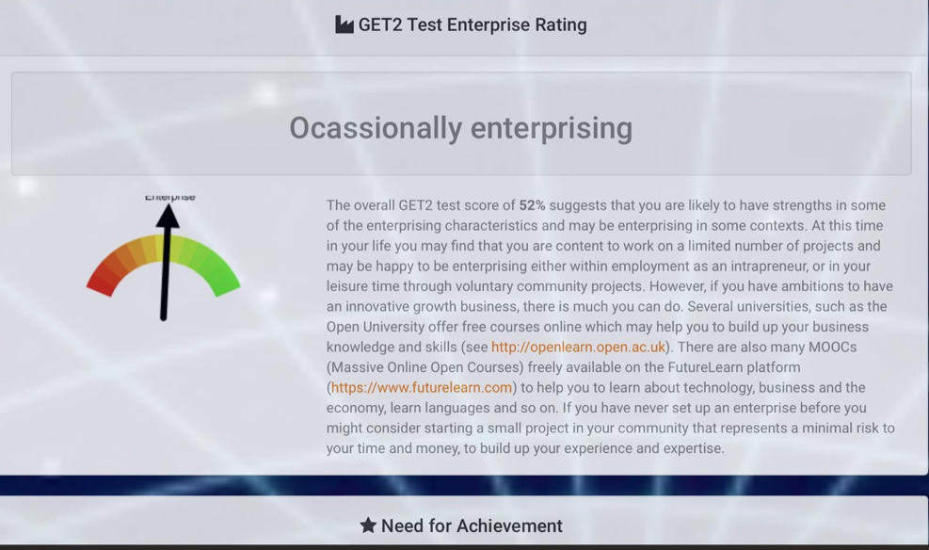

Concept map of the business
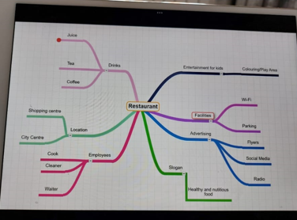

Business Model Canvas



