Appendix

Appendix A

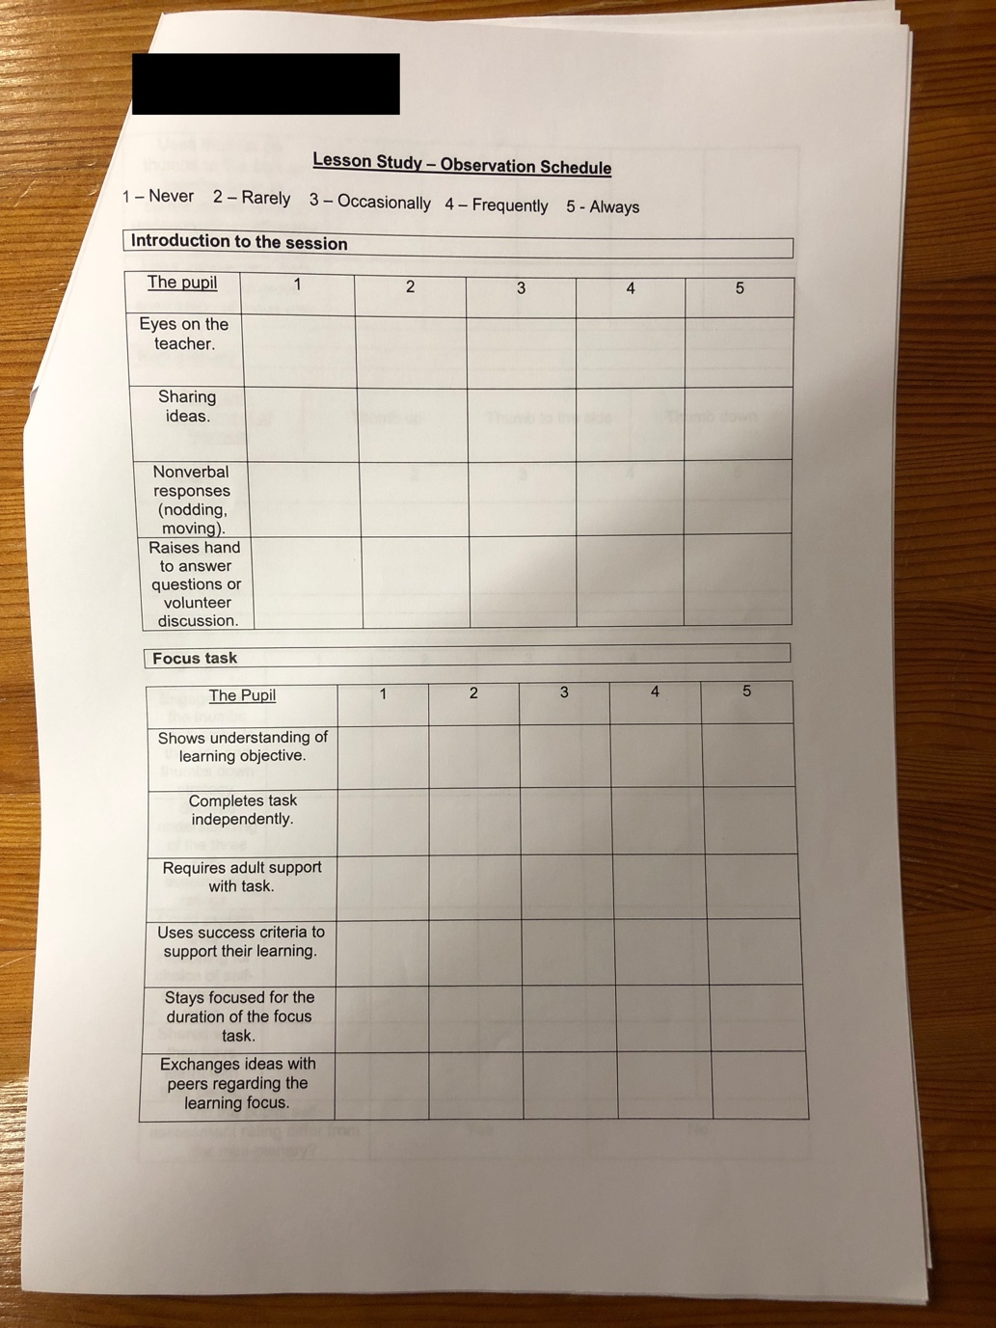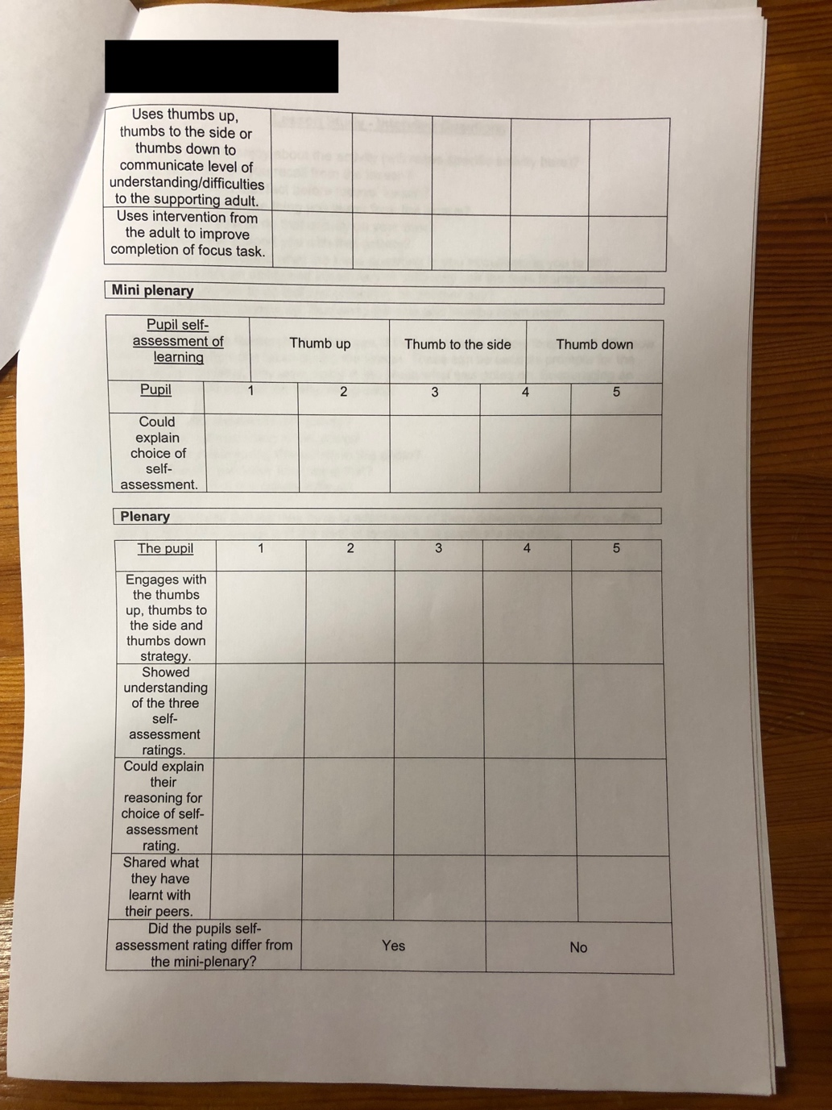

Appendix B

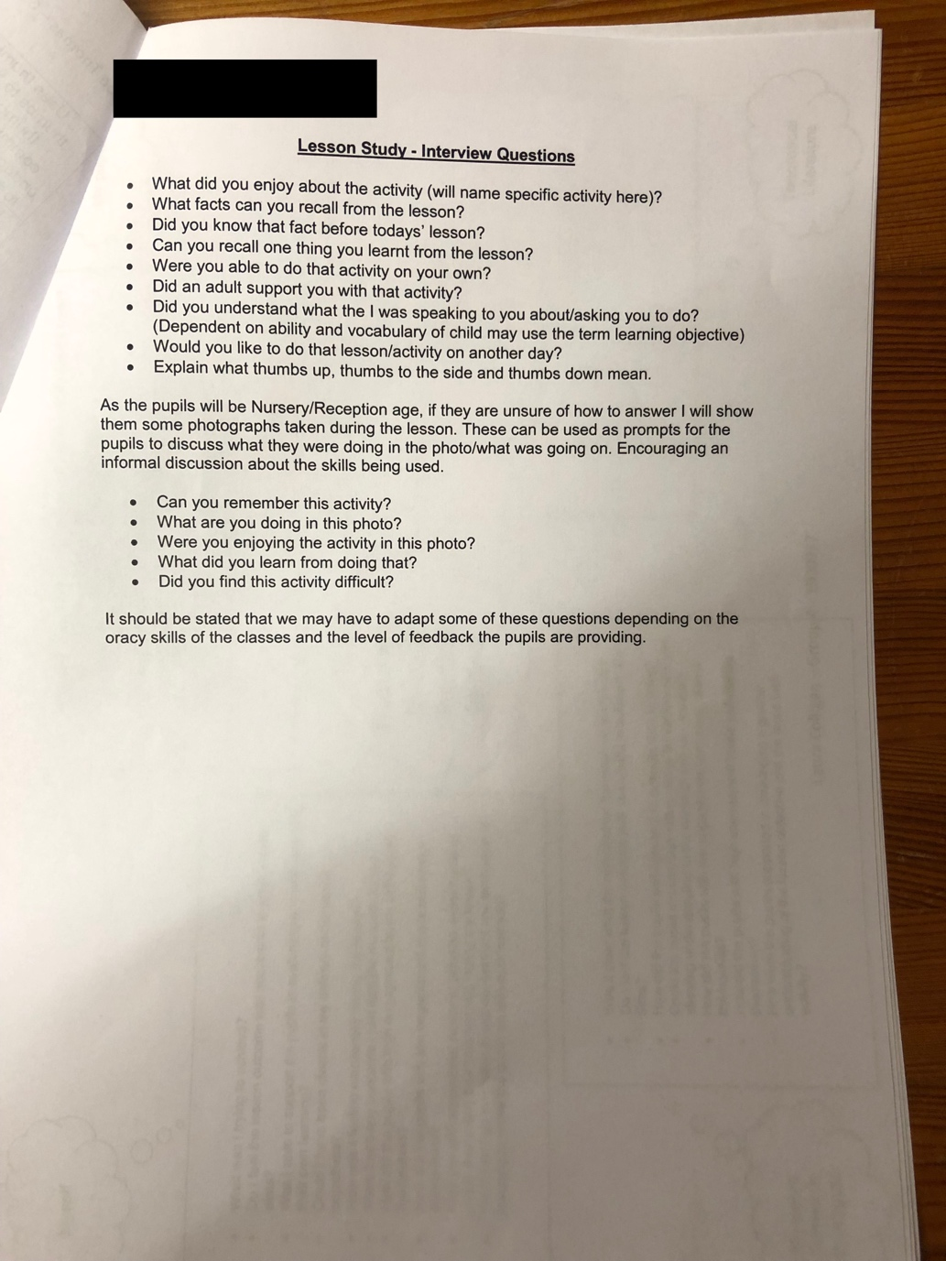

Appendix C

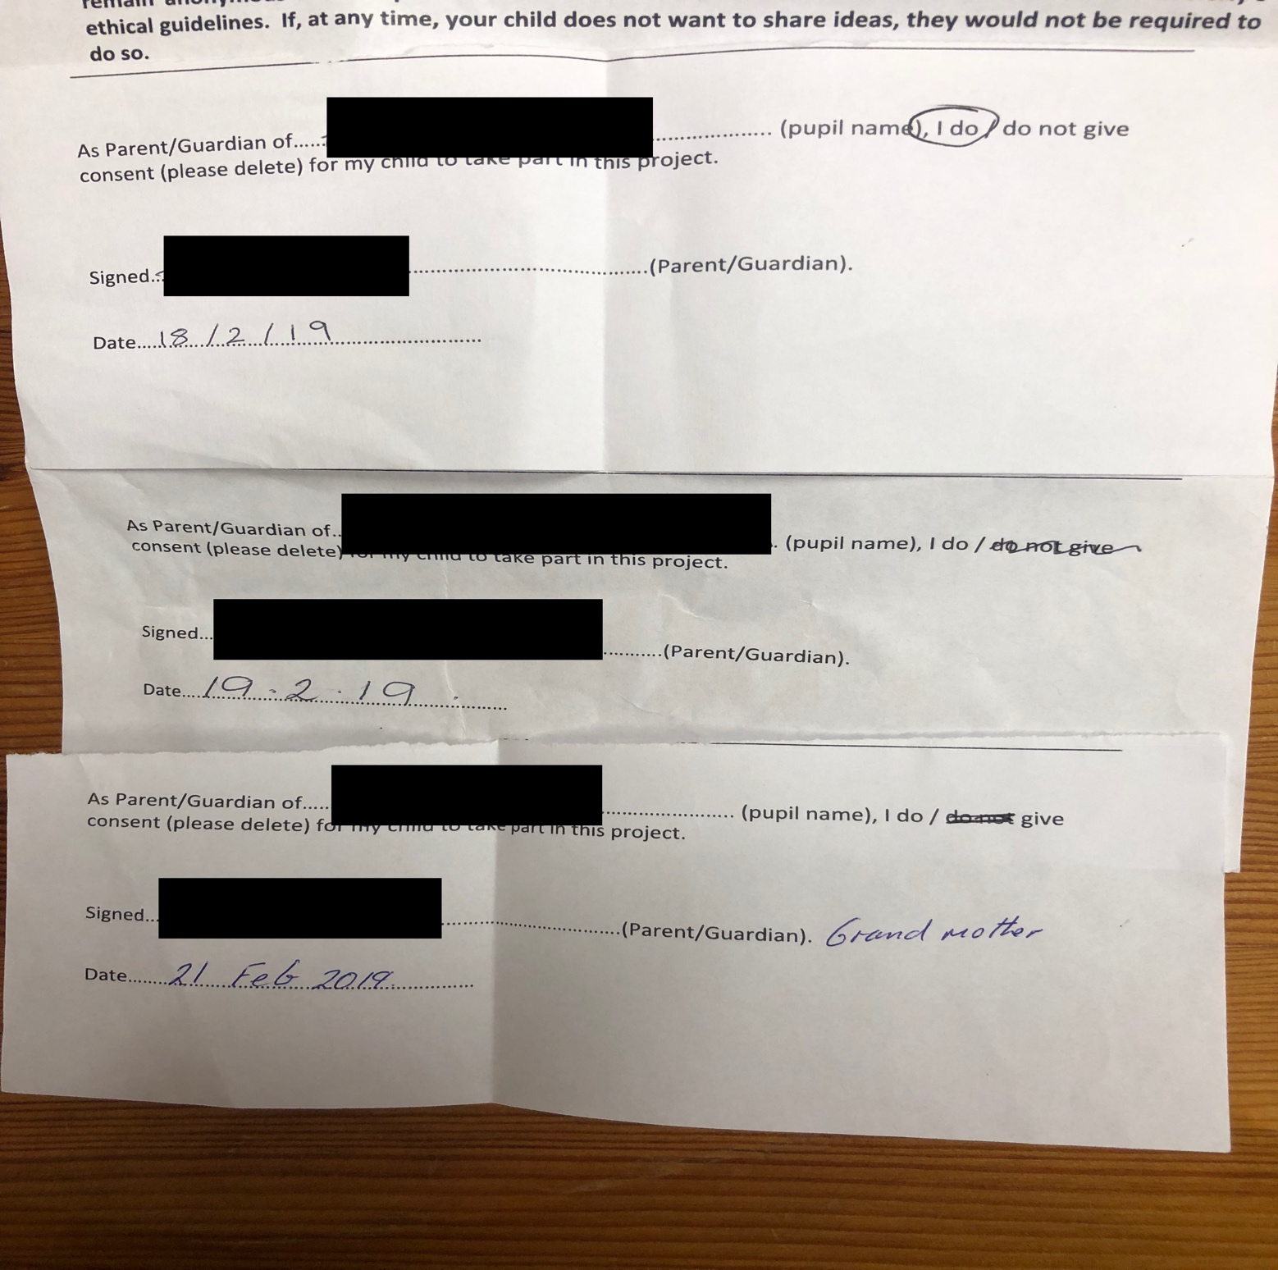
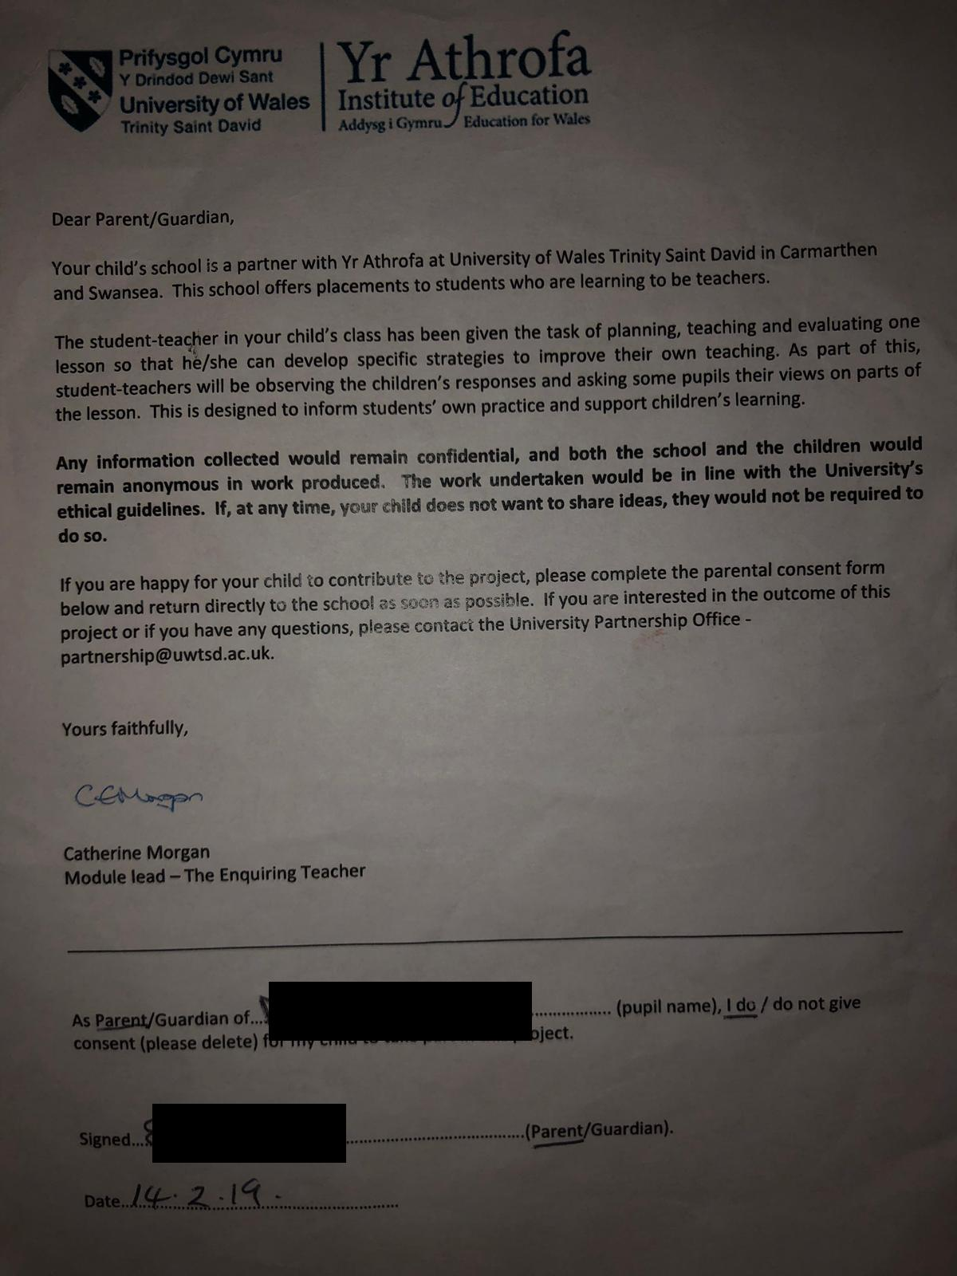
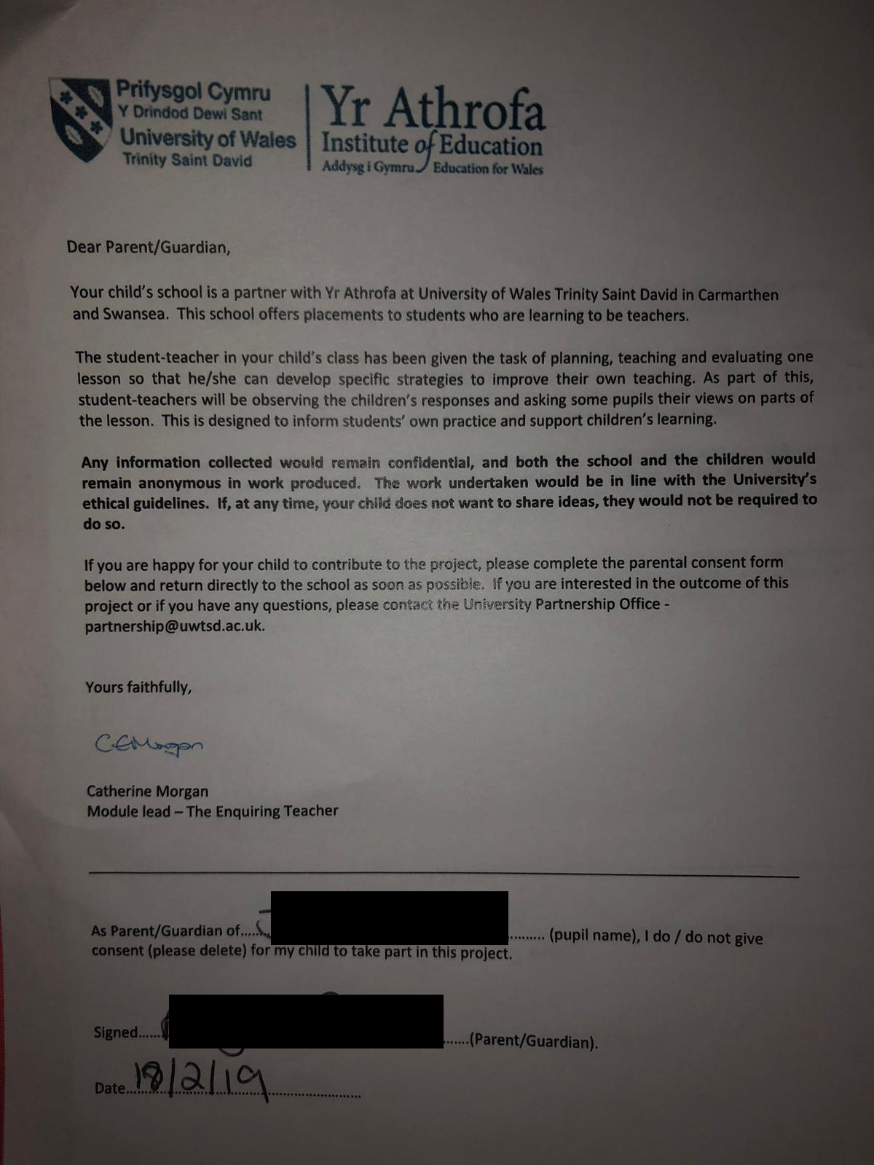
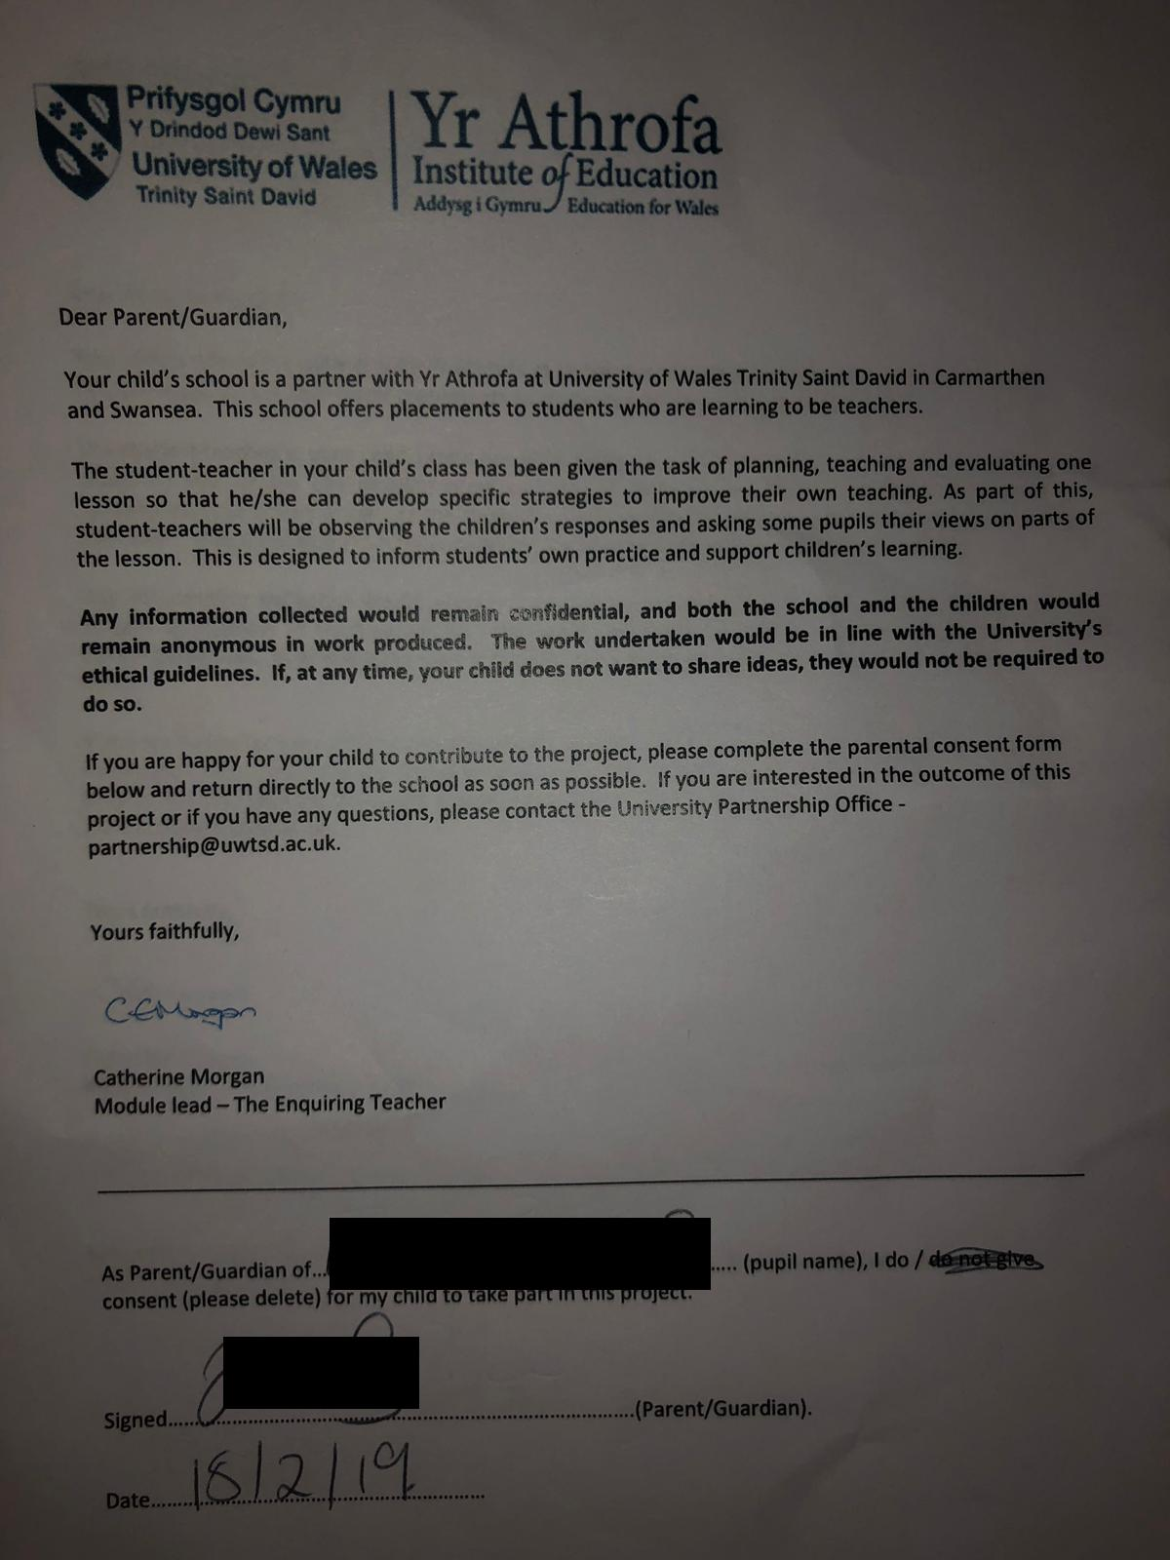

Appendix D

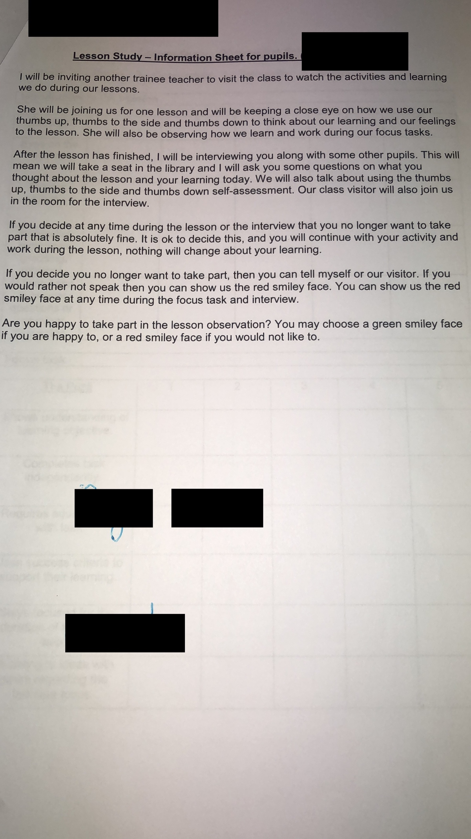
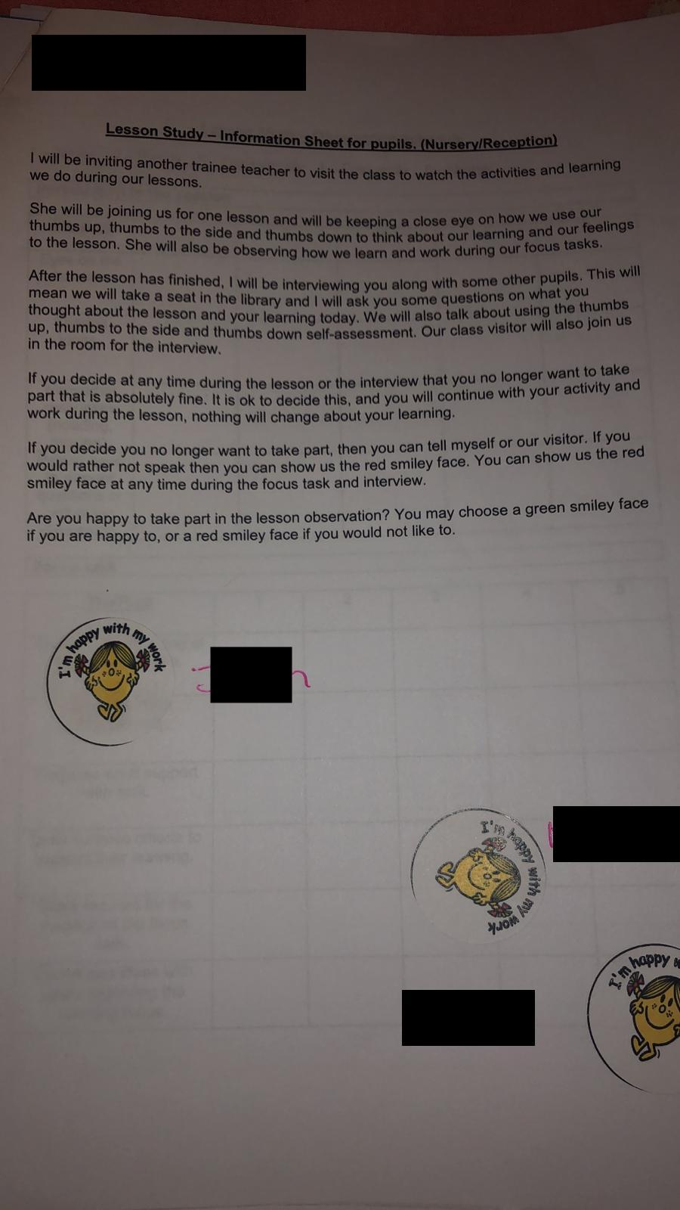

Appendix E

Name of Trainee: |  |  |  | Session ref: |  | 20/02/2019 (3) Maths | Date: |  |  | 20/02/2019 |  | Class: | Early Years |  |  | Cynllun Ffocws y Cyfnod Sylfaen  2d
Targed(au) Hyfforddi Personol |  |  | S3.2.2 They monitor and assess as they teach, giving immediate and constructive feedback to support learners as they progress. They involve learners in reflecting on, evaluating and improving their own performance. |  |  |  | Number of learners: |  |  |  | 40 | Age: | 3-4 Years Old |  |  | Cynllun Ffocws y Cyfnod Sylfaen  2d
Learning objectives/intentions: | Teacher Focus  - Nursery - Use and build with 2D shapes within play-based activities.  - Reception - Use 2D shapes to make models and pictures.  - Year 1 - Use 2D shapes and describe how they fit together.  LSA Focus  - Nursery – Sort and match sets of objects by recognising similarities.  - Reception – Sort and classify objects using one criterion.  - Year 1 – Collect information by voting or sorting and represent it in pictures, objects or drawings. |  |  |  |  |  |  | Success Criteria | Teacher Focus  - Cold Task – use the 2D shapes to create a Chinese dragon.  - Peer assess your talk partners work, identify tickled pink elements and green for growth areas.  - Create a success criteria to create a successful Chinese dragon.  - Use the success criteria to improve your Chinese dragon.  LSA Focus  - Go on a 2D shape hunt in the outdoors.  - Sort and post 2D shapes into the correct box.  - Create a group tally chart of 2D shapes.  - Use your tally chart to create a pictogram of 2D shapes found on shape hunt. |  |  |  | Meeting learners’ needs: |  | 4 x Mini explorers.  KO, TP, MV and MM – Following on from the 13/02/2019 Literacy session, all pupils should now transfer their oracy skills to develop a Success Criteria for creating a 2D shape dragon. They have built the skills to identify the key features of a model or drawing.
Introduction/plenary tasks – 9:30 – 9:45 |  |  |  |  | Main activities – 9:45 – 10:05 |  |  |  |  |  |  |  | Resources/  Key Vocabulary | Assessment for Learning (strategies and opportunities)
Introduction  Follow ppt slides.  Pupils to turn to their talk partners and name the shapes. Can they identify the number of sides or corners the shape has?  Warm up – Place large circle, square, rectangle and triangle on the floor. Using lollypop sticks, pupils to take a shape or picture from the feely bag, and sort into the relevant large shape on the floor.  Read pupils the story book “Mouse Shapes”. Discuss shapes and their properties as we travel through the story.  Pupils to turn to their talk partners, What did the mice find? What did the mice do with the shapes they found?  Show pupils the chatterpix message from the pig. In their talk partners, pupils to discuss how we could trick the fox. Look for pupils who relate back to the “Mouse Shapes” story, the mice tricked the cat by creating bigger mice shapes. Pupils to identify that we can use our 2D shapes to create a big dragon shape.  Questioning  - How did the mice trick the cat?  - What materials could we use to trick the fox?  - Who will we make out of the 2D shapes?  Explain Grwp Melyn will be working with myself to create a 2D shape dragon.  Grwp Oren will be going outside with LSA to complete a 2D shape hunt. |  |  |  |  | Trainee focused task (purpose, outline of trainee’s role and children’s learning):  Grwp Melyn  Cold task – Pupils are to be given a range of 2D shapes, triangle, rectangle, circle, square and star. With no prior discussion on what makes a successful dragon, pupils to have a go at creating a dragon out of the 2D shapes. Allow the pupils a few minutes to explore the 2D shapes and have a go.  Use the five minute/one minute timer so pupils are aware of the time being given. After a few minutes, stop the pupils and ask them to turn to their talk partners and discuss what they have made. What shapes have they used? Can they explain why they have chosen that shape? Look for pupils who are able to describe the shape.  Can they discuss a tickled pink element for their talk partner? Can they provide their partner with a green for growth?  Place a WAGOLL of a 2D shape dragon on display.  Question pupils;  - What shapes can you see?  - What shape is the dragons face?  - What shape is the dragons body?  - Would it be better to use big shapes or small shapes? Why?  - How many eyes does a dragon have?  - How many ears does a dragon have?  - How could we describe the dragons teeth?  - What 2D shape is pointy?  Discuss with pupils we are going to create a success criteria for building a successful dragon out of the 2D shapes.  KO, TP, MV and MM – prompt pupils to activate their prior knowledge and consider the features of a successful dragon, encouraging pupils to use descriptive language when discussing features.  Success Criteria  - A large circle for a face;  - 2 small circles for eyes;  - Small triangles for teeth;  - Triangles for spikes.  Model creating a 2D shape dragon using the Success Criteria created.  Allow pupils another 5 minutes to now improve their dragon models and make changes using the success criteria developed. Use the five minute/one minute timer so pupils are aware of the time being given and the time left. After 5 minutes, stop the pupils and ask them to turn to their talk partners once more, has their partner managed to improve their 2D shape dragon? Talk about tickled pink – have they been able to include elements of the success criteria? Are their areas for improvement – green for growth?  To conclude, pupils will self-assess their own work using the Mr Men stickers, how do they feel about their 2D shape dragons?  Red Lego Challenge  Use and build with 2D shapes within play-based activities. Can you build a Chinese dragon using 2D shapes?  Yellow Lego Challenge  Use 2D shapes to make models and pictures. Can you create a success criteria using the 2D shapes to make a suceessful Chinese dragon?  Green Lego Challenge  Use 2D and 3D shapes and desrcribe how they fit together. Can you talk about your Chinese dragon and explain which 2D and 3D shapes you have used? |  |  |  |  |  |  |  | Resources  - 2D Shapes;  - Triangle;  - Square;  - Circle;  - Rectangle;  - Star;  - Lego bricks;  - WAGOLL – 2D Shape dragon;  - iPads x8.  - 2D shapes for outdoors.  - Tally chart on flipchart.  Key Vocabulary  - Square;  - Triangle;  - Circle;  - Rectangle;  - Pa siap..?  - Sgawr;  - Triongl;  - Cylch;  - Perthyn;  - Sawl un..?  - Barod;  - Dyma..  - Edrychwch. | - Lollypop sticks;  - Lego challenges;  - Talk partners;  - Success criteria;  - Mr Men stickers.
Additional adult tasks (purpose, outline of additional adults’ role and children’s learning):

LSA Activity – Outdoors – Grwp Oren.

Pupils to go on a shape hunt around the outdoors area.

When they find a shape they will need to bring the shapes back to the post box and post the shapes into the relevant post boxes – clearly marked square, rectangle, circle and triangle. This should only take 5 minutes max.

LSA to bring the pupils back into the class where they will count how many shapes are in each box. Activivating their prior knowledge of pictograms on JIT, they will record their findings creating a pictogram on the iPads.

Red Lego Challenge
Sort and match sets of objects by recognising similarities. Can you find the 2D shapes in the outdoors and sort them into the correct boxes?

Yellow Lego Challenge
Sort and classify objects using one criterion. Can you count the 2D shapes and identify how many of each shapes there are using a tally chart?

Green Lego Challenge
Collect information by voting or sorting and represent it in pictures, objects or drawings. Can you create a pictogram of your findings?

Plenary  Amser Tacluso music to play to alert children it is time for the plenary.  - “What have we been learning today?” Song.  - Children to come back to big group circle and discuss what they have been learning in their activities.  - Both groups to discuss whether they were able to complete the lego challenges.  - Grwp Melyn to share their wanted posters.  - Grwp Oren to share their vocabulary board.  - Discuss tickled pink and green for growth. |  |  |  |  | Independent learning opportunities:  Grwp Gwyrdd and Grwp Coch - Amser Dewis  Pupils to listen to the “The Great Race” story. Practice Chinese New Year nursery rhymes and songs.  Special Learners Activities  - Maths;  - Role play – Chinese Restaurant;  - Creative cwtch – painting and decorating paper plates in preparation for creating musical shakers;  - Outdoors construction;  - Small world role play in the Water tray;  - Digi den;  - Fine motor;  - Playdough;  - Juicing station;  - Stage area;  - Bee-Bots;  - Mud kitchen and;  - Mark making.  When “amser tacluso” music plays, pupils to tidy up and go back into their big group “Amser Dewis”.

Appendix F

Reflecting through the four lenses.
Myself
The objective of the lesson was for the pupils to create a 2D shape dragon, using the WAGOLL provided and activating their own knowledge of what they know are the key features of a dragon. What I had hoped was for the pupils to explore and play with the 2D shapes initially, and then be able to come up with their own ideas and discussion of what shapes would make a successful 2D shape dragon. Throughout the cold task when I allowed the pupils to explore and play, I felt disappointed in their lack of enthusiasm and engagement for creating a Chinese dragon, they were happy playing with the shapes and creating their own models of everyday objects.

Activating their prior knowledge, I wanted the pupils to create and develop their own success criteria as a group. Creating the success criteria as a group proved more difficult than I had hoped for and had experienced in the past with similar activities, the pupils needed a lot of support and scaffolding and did not show very much interest in creating the piece of work. I don’t feel the outcome of this was successful.

I felt that during the introduction my delivery of the lesson objective was clear, and the pupils showed good understanding of what I was asking of them. They were providing discussion and also recalling the problem I had posed to the group.
During the focus task I felt the pupils had lost engagement and forgotten what the learning objective was. Instead they wished to simply play with the 2D shapes and build their own models, although this behaviour does correspond to the Nursery Foundation Phase skill.

I used two forms of self-assessment during the lesson, within the teacher focus task the pupils worked towards red, amber and green lego challenges. Pupils were able to assess their own learning through thinking about and discussing whether they feel they had met these challenges. During a mini-plenary pupil were also able to consider what they liked and what had worked well with their 2D shape dragon, and also consider what they could improve. Pupils used a thumbs up, thumbs down to give me an indication of their level of understanding and enjoyment of the task so far, all case pupils showed a thumbs up during the mini-plenary. I allowed the pupils to then go back to the learning and work on their improvements. During the plenary at the end of the session I used the Mr Men self-assessment criteria displayed on the whiteboard, “Dw i’n hapus” and “Dw i’n gallu gweneud gwell”, where pupils then have another opportunity to use thumbs up, and thumbs down to assess their learning. Both these self-assessment methods I have used in the classroom on several occasions previously and they have proved successful in pupils taking ownership for their own work. Although as pupils self-assessed using the thumbs up, I feel they were assessing their level of enjoyment for the activity rather than their level of understanding of the learning intention.

What I found surprising during today’s session was the case pupil who I had considered to usually portray a highly engaged attitude towards learning, usually leading the group in their learning and discussions, did not demonstrate to me a sound understanding of the learning intention. Although in the mini-plenary the highly engaged pupil assessed herself as being happy with her learning, she was unable to contribute to discussion and provide as high contribution to the success criteria as I had hoped.

The pupil with lower engagement also self-assessed themselves with a thumbs up, however failed to produce any work to display by the end of the session.

The environment in the classroom today was very hectic and loud, I found this made it difficult for the pupils in the teacher focus group to stay engaged and also difficult for myself to focus the pupils.

During the plenary I could have shared photos of the pupils work or asked the pupils to keep their 2D shape dragons to share with the rest of the class. This may then have created a better discussion and pupils looking in from the outside may have been able to share ideas on how the teacher focus group could improve and move their learning on. From this advice the case pupils may then have given a more realistic self-assessment.

Assessment Reform Group (2002) discusses that understanding of the learning intention develops when the learners have a role in identifying the success criteria and goals. Learners can only begin to successfully self-assess when they have a criteria to assess against. (ARG, 2002) Not creating a success-criteria to display to the learners prior to the lesson and planning for the learners to activate their prior knowledge and create a success criteria collaboratively meant that I was able to involve the learners in a discussion of the learning intention. I had hoped that pupils would be able to pause throughout the lesson and consider for themselves whether their 2D shape dragons matched that of the criteria we had just discussed. From there the learners should be able to identify any areas for development and improvement through identifying if there were any elements of the success criteria they had missed.

I endeavoured to reflect Clarke’s (2004) idea that teacher modelling is a key activity in enabling self-reflecting learners. I modelled how we could use the success criteria, that we had just developed together, to use almost like a checklist when creating our own 2D dragons. I used the success criteria to make my own 2D shape dragon in front of the learners.
My pupils
During the lesson the engagement and focus of all three case pupils varied and changed over the course of the lesson.

Pupil B, who often portrays a middle-level of engagement in learning, showed very little interest in the learning intention. When asked what he was building (which should have been a 2D shape dragon) he stated that he was building traffic lights, when asked if he could develop his traffic lights into a 2D shape dragon using the success criteria, he ignored instructions on two occasions, however self-assessed as a thumbs up during both the mini-plenary, and the main plenary. During the interview pupil B did not demonstrate much enjoyment of the lesson, he was quite reluctant to discuss afterwards.

During the interview which took place post research lesson, pupil A was able to confidently explain what the learning intention of the lesson was, even though she had failed to demonstrate a sound understanding during the actual lesson. Pupil A appeared very confident in her learning and felt she had been able to achieve the success criteria on her own, pupil A demonstrated a high level of enjoyment for the lesson when reflecting during the interview.

Pupil C, demonstrated enjoyment of the activity during the lesson. He was able to communicate non-verbally the majority of the time and when in the small group teacher focus he would often confidently pick up the correct shapes when questioned. During the focus-group interview pupil C did not engage with conversation unless spoken to first, mainly due to speech development.

By ensuring the learners were involved in the creation of the success criteria, this influenced their ability to attempt to complete the task independently. I identified that the environment of the class was very hectic, and the daily routine was very intense, and may have had an influence on the engagement of the learners, both with the task and the AfL strategies. As an observer it was difficult to keep a non-participatory role and not engage with the learners as they were very inquisitive and busy throughout the lesson. The learners were engaged with the 2D shapes but weren’t necessarily completing the learning objective. Being involved in the creation of the success criteria meant that all learners were at some point able to recall an element of the steps to success, but couldn’t always put this into practice.
My peers (research colleague)
Theoretical Literature

Appendix G

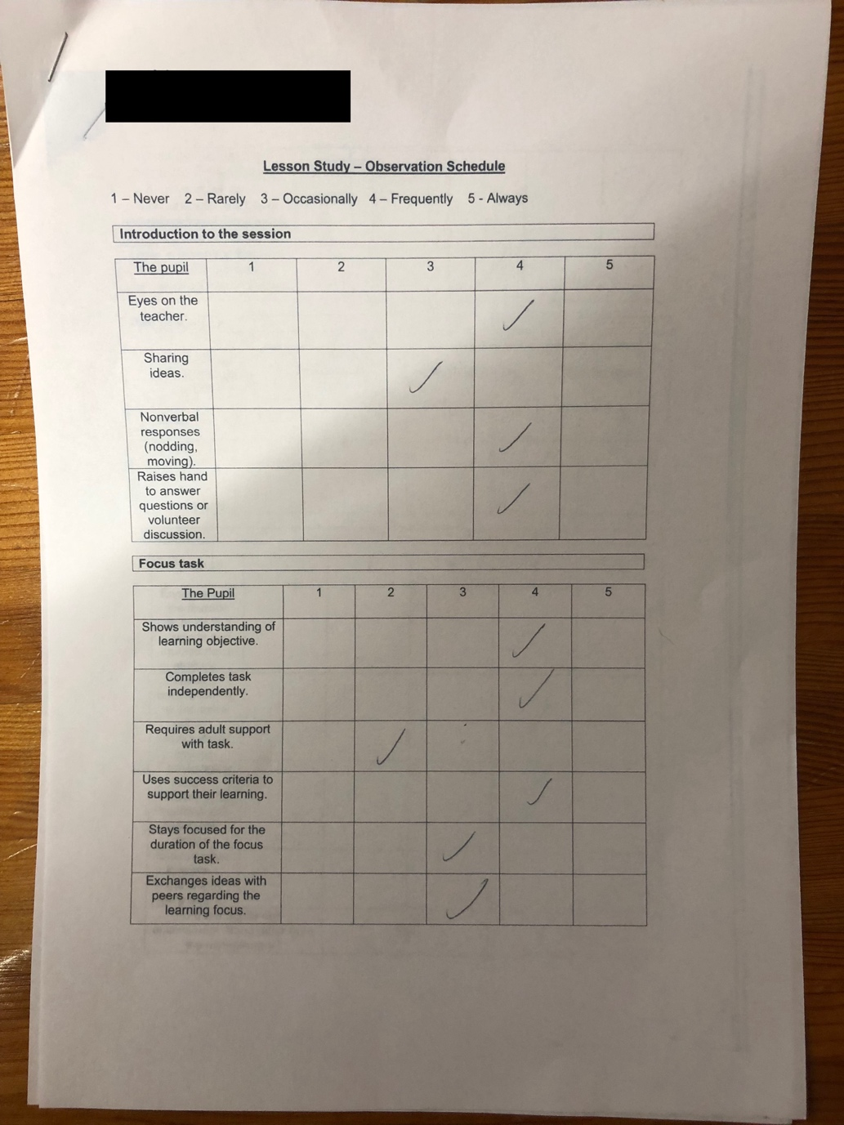
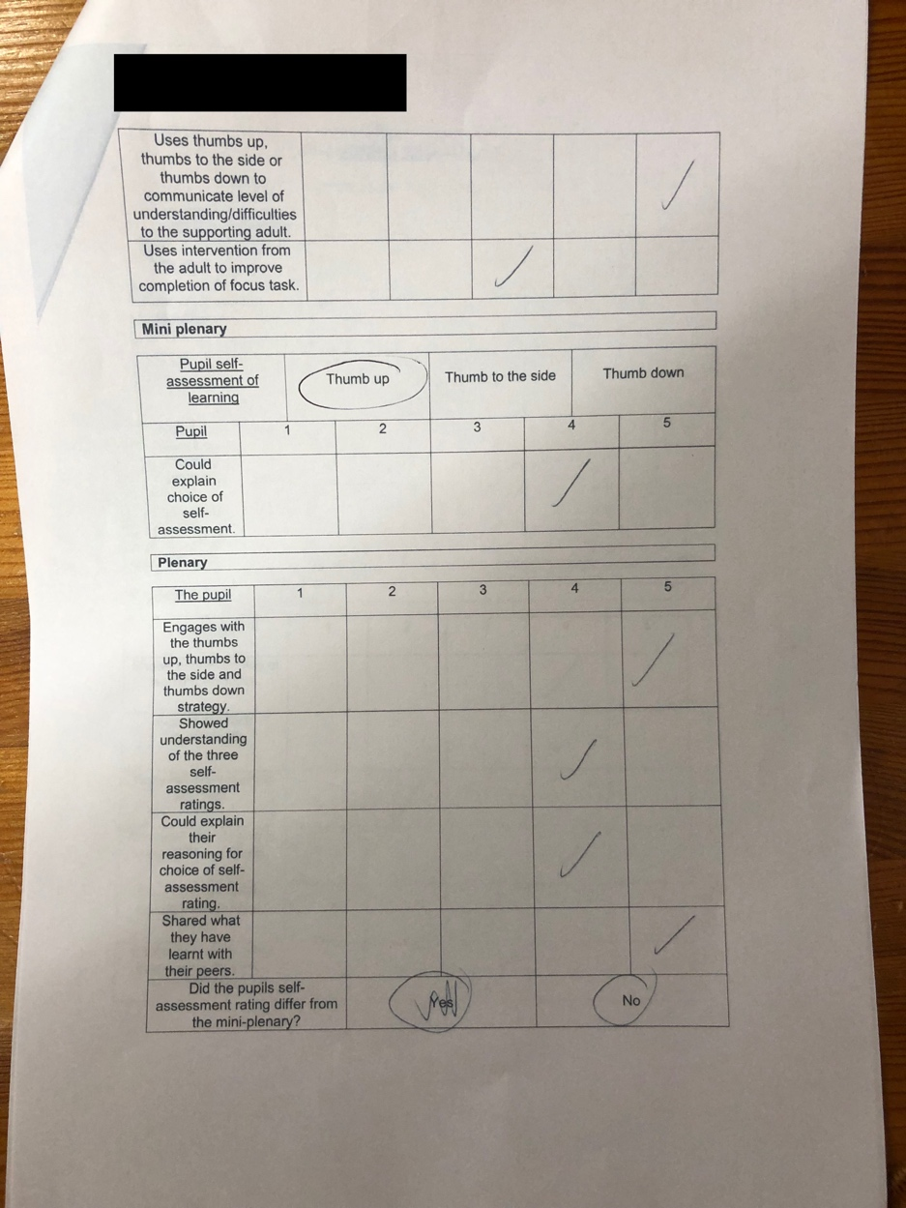

Appendix H

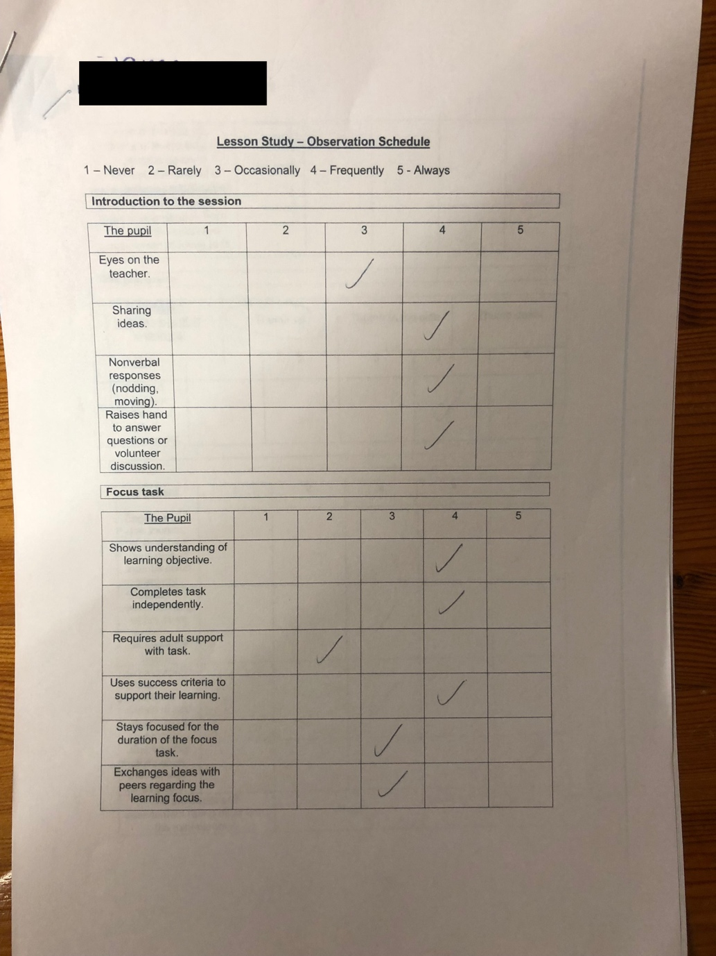
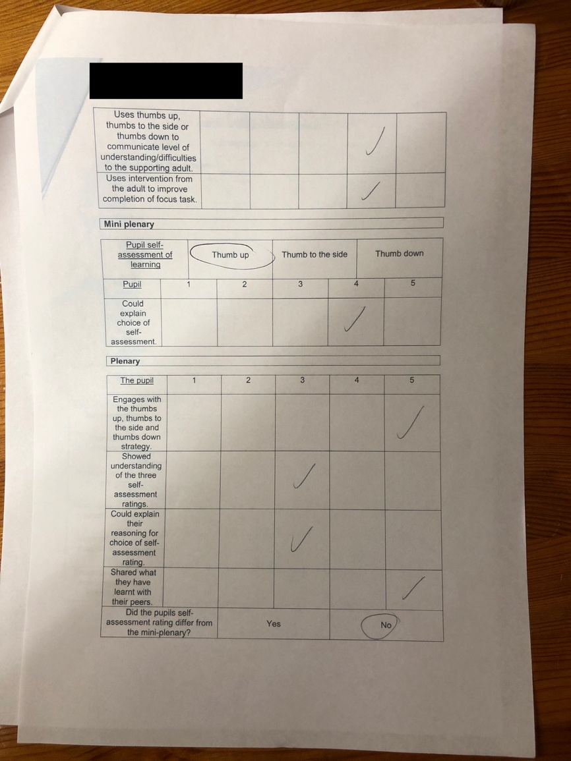

Appendix I

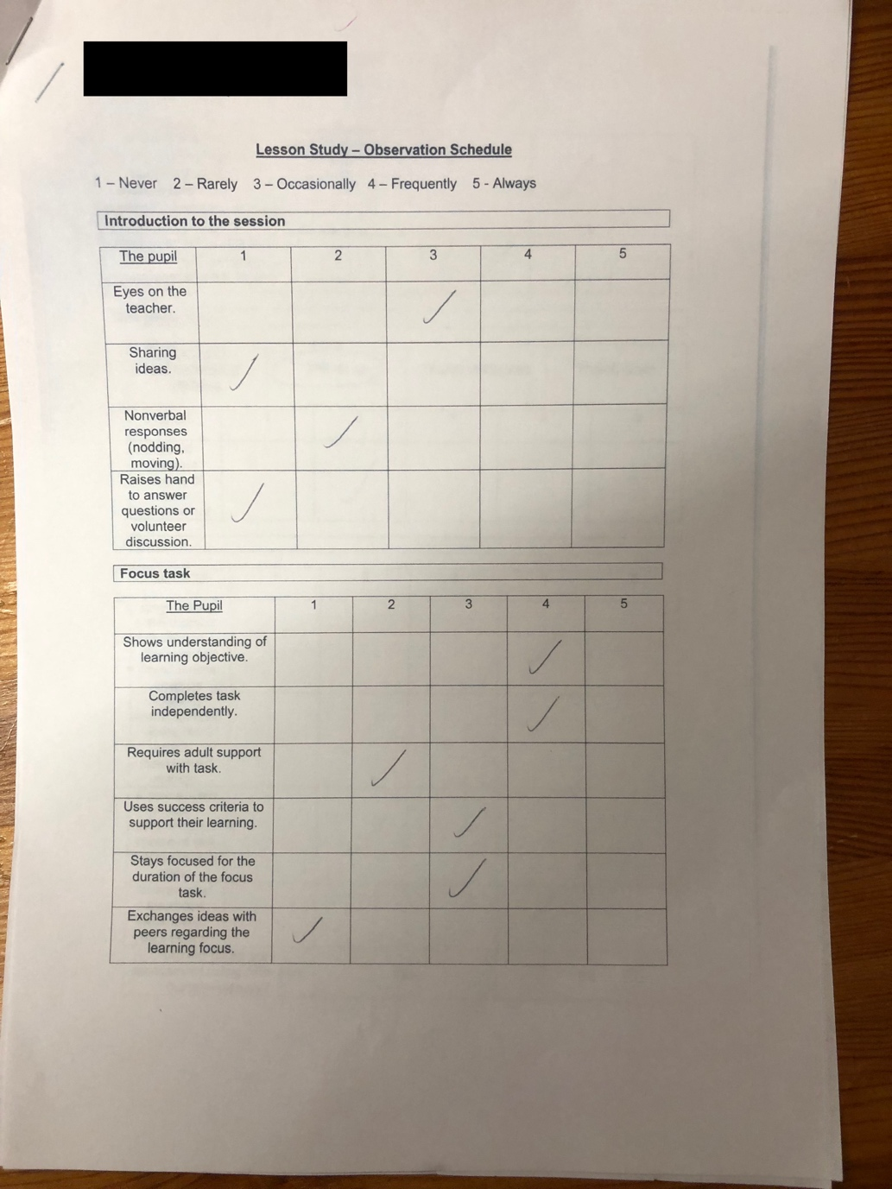
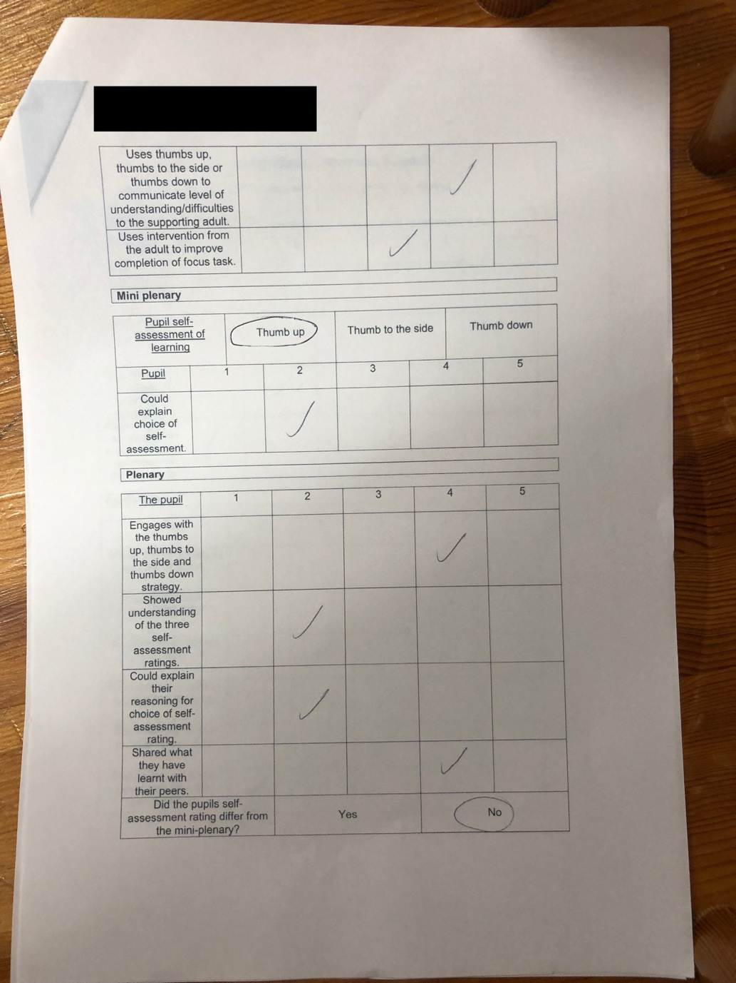

Appendix J

Case pupils interview transcript.

Focus group location: Adjoining open plan classroom to the main classroom.
Date: 20th February 2019
Number of attendees: Two interviewers, three interviewees – research study case pupils.

Interviewer 1: What did you enjoy about today’s lesson?

Pupil A: I enjoyed, um, making our dragons.

Interviewer 1: You enjoyed making the dragon? What did you do to make the dragon?

Pupil A: Um, put a big circle on his um his head, um.

Interviewer 1: You made a circle for his head, Pupil C can you remember what else we did? Pupil C?

Pupil C makes round circle actions for eyes, pointing to his own eyes.

Interviewer 1: Can you say what they were called?

Pupil A and Pupil C: Eyes!

Interviewer 1: Eyes, thank you Pupil C. And what shape did we use for the eyes Pupil C?

Pupil C: Er, a circle.

Interviewer 1: Circles, good boy. And what else did you use?

Pupil C points to his teeth.

Interviewer 1: Teeth.

Pupil C: Teeth.

Interviewer 1: Can you remember what shape the teeth were? How did we describe the dragon’s teeth?

Pupil C: Mumbles. [Unclear]

Interviewer 1: They are what?

Pupil C: The fox runs away. [Unclear]

Interviewer 1: The dragon? So the fox runs away? He is going to show his scary teeth!

Interviewer 2: Pupil B, did you know all of the names of the shapes before Miss told you? When Miss showed you a shape did you know the name of it? Already?

Pupil B nods.

Pupil A: And I do.

Interviewer 1: What were the shapes? Can you remember the shapes we were using?

Pupil B: Circle, triangle, square, rectangle, circle.

Interviewer 1: Good boy, so a circle, a rectangle, a square and a triangle. Am I right?

All pupils nod.

Interviewer 1: Did you know the names of the shapes before the lesson then?

Pupil B: Yeah.

Interviewer 1: Have you looked at shapes before with Miss?

Pupil B: Umm..

Pupil C: No.

Pupil A: Yeah I do but we didn’t do bendy banana.

Pupil C: I did.

Interviewer 1: Bendy banana? What is bendy banana?

Pupil A: Where you rock backwards and then you go forwards back to your left.

Interviewer 1: Right so you learnt that with Miss.

Pupil B: Left, right, left.

Interviewer 1: Can you tell me, Pupil B, one thing you have learnt in today’s lesson?

Pupil B: The timer has finished!

Interviewer 1: No that’s not something you have learnt today. What is one thing you have learnt in today’s lesson?

Pupil B: The timers nearly finished.

Interviewer 1: Pupil B, name me one thing you have learnt in today’s lesson.

Pupil B takes a long pause.

Interviewer 1: Can you remember something you have learnt today? Well we learnt that the fox was scared of a dragon in today’s story didn’t we?

Pupil B: Yeah.

Interviewer 1: What did we learn about a dragons face Pupil C?

Pupil C uses actions with his finger once more to trace a circle around his own face.

Interviewer 1: What did we learn? What shape is his face?

Pupil C: Umm

Interviewer 1: Can you remember what that shape is called?

Pupil C takes a pause.

Interviewer 1: Pupil A, I wonder if you can help Pupil C.

Pupil A: Circle.

Interviewer 1: A circle, we also learnt that he has got sharp..

Interrupted by Pupil A.

Pupil A: Sharp teeth.

Interviewer 2: Did any of you need help with making your dragon? Did Miss have to help you at all?

Pupil A: No only myself did.

Interviewer 2: You just did it on your own. Pupil C, did Miss have to help you make your dragon?

Pupil C nods.

Interviewer 2: And Pupil B, did Miss help you make your dragon? Did you need some help? Did you need a bit of prompting?

Pupil A: I didn’t need a bit of prompting.

Interviewer 1: Pupil B, I think I needed to remind you at one point didn’t I? I needed to remind you what you were making. What did you try making to begin with?

Pupil B pauses.

Interviewer 1: You were making traf..

Interrupted by Pupil B.

Pupil B: Traffic lights!

Interviewer 2: Yes, and what we you supposed to be trying to make?

Pupil B: A dragon. Not traffic lights.

Interviewer 1: Good boy, now you know we weren’t making traffic lights.

Interviewer 1: Who can tell me, what does thumbs up mean? When I show the thumbs up what am I meaning?

Pupil B: HAPUS!

Pupil A: Mmm..hapus.

Interviewer: I am dw i’n hapus. What if I show the thumbs down, Pupil C? What does that mean?

Pupil B: Better!

Pupil C: Better.

Interviewer 1: You need to do better, good boy. So next time, if I showed the thumbs down it means next we need to try working a little better when we are making our dragons. Am I right?

Pupils give a small nod.

Interviewer 1: What could I have given you then, if you were all a thumbs down, could I have given you some green for growth?

Pupil B: I’m finished.

Pupil C: NO!

Interviewer 1: No? You want tickle pink?

Pupil C: Yeah.

Pupil A: I have my own tickle pink.

Interviewer: Pupil A, what were you tickled pink about?

Pupil A: All of my things on my dragon.

Interviewer 1: Everything on your dragon!

Interviewer 1: Pupil B, what were you tickled pink with for your dragon?

Pupil B: Umm..

Pupil pauses.

Interviewer 1: Well I liked your tail, I thought your tail was a good idea.

Pupil B: Yeah.

End of Interview

Appendix K

Name of Trainee: |  |  |  | Session ref: | 21.02.19/03 | Date: | 21..02.19 |  |  | Class: |  | 2 |  |  | Cynllun Ffocws y Cyfnod Sylfaen  2d
Targed(au) Hyfforddi Personol |  |  | Use IT more effectively in my teaching. |  |  | Number of learners: |  |  | 29 | Age: |  | 5-7 |  |  | Cynllun Ffocws y Cyfnod Sylfaen  2d
Success Criteria | - I know the difference between a simile and an adjective.  - I know what a shape poem is.  - I can use my previous knowledge to create an ice cream shape poem. |  |  |  |  |  |  |  |  |  | Meeting learners’ needs: |  |  | Differentiation shown throughout between year groups. MC 1.1 for this lesson with TH – supporting him with the use of his laptop and keyboard and sounding out words for him to spell – possible use of whiteboard to write things down for TH to type into word
Introduction/plenary tasks |  |  | Main activities |  |  |  |  | Resources/  Key Vocabulary |  |  |  |  | Assessment for Learning (strategies and opportunities)
Introduction (Whole Class)  Ensuring the children are aware of the thumbs up, thumbs to the side or thumbs down strategy and how to use it – with specific focus on thumbs to the side.  Recap – what do we already know about similes? – what do we already know about shape poems? – using questioning during carpet discussion – talk to their partner about what they have previously learnt – ask for some examples of similes that the children already know.  Explain activities for the lesson. |  |  | Trainee focused task (purpose, outline of trainee’s role and children’s learning):  Year 2 - using the scrumptious similes brainstorm from last lesson and their knowledge of shape poems from the lesson before that, children are to complete an ice cream shape poem using the template provided – it should be stated clearly to the children that the poem does not have to rhyme – some children may need more support that others – encourage use of wordbooks for spelling especially for the Middle Ability children - ice cream is as colourful as a rainbow, ice cream is as cold as a blizzard, ice cream is as sweet as honey |  |  |  |  | Similes  Adjectives  Poem  Shape poem  Previous Knowledge  Interactive whiteboard  Shape poems  Ice cream template  What do we already know? |  |  |  |  | Assess understanding in introduction through questioning and answers – whole class  Assessment throughout adult tasks.  Assessment through thumbs up, thumbs to the side or thumbs down AfL strategy during mini-plenary and penary.  Assessment through WALT when marking books.
Additional adult tasks (purpose, outline of additional adults’ role and children’s learning):

Year 1 – Using the ‘Ice cream is as …. as ……’ activity from the previous lesson, the children are required to complete an ice cream shape poem – some children will need to be heavily supported by SE– if the children wish to add more than what is on the sheet and create their own then they are to do so – some children may need encouragement to write smaller than they usually would – year 1 children expected to write less than the year 2 children (lines are bigger) – children should be encouraged to use their wordbooks if they have difficulty with spellings – some children may wish to have it written on a whiteboard but they must attempt to sound the word out to the teacher first.

Plenary

Whole Class – teacher to ask some pupils to read some out their poems out to the class or some similes they created.

Curriculum coverage (range and skills)
- Communicate purposefully in writing and write for different purposes.
- Write text which makes sense to the reader.
- Understand different types of writing.
- Form upper and lower case letters that are clearly shaped and correctly orientated.
Literacy (LNF)  - Give reasoning and express opinions. |  |  |  |  |  |  |  | Numeracy (LNF)
DCF |  |  | Thinking  - Thinking logically |  |  |  |  | ESDGC |  |  |  |  | YCC

WALT – Complete an ice cream simile shape poem | Teacher | Notes if needed  I – Independent  S – Some support  HS –Heavily supported
Success criteria | AFL
I can write words that describe ice cream.

I can write similes of these words using ‘as’.
I can put these words and similes into a shape poem.
Next steps | Have I been an independent learner?

Appendix L

Myself
Reflecting through the four lenses.
The objective of the lesson was for the pupils to create an ice cream shape poem using similes. Using their prior knowledge and what they had learnt in their previous poetry lesson with myself, I hoped that the children would create new similes using different adjectives and not ones that they had been provided with by myself or the support staff in the class. The pupils, both Year 1 and 2 were able to refer back to the WALT (We Are Looking To) in their poetry books at any times if they needed reminding of the success criteria or the task they were required to complete. The children were encouraged to use their wordbooks to help with their spelling by trying to spell the word for themselves before approaching the staff present in the classroom, therefore encouraging being an independent learner.

During the introduction, I was encouraged by the children’s enthusiasm about the task and what they were expected to do and the children showed a good understanding of this. I hoped for the children to use and explore with a wider variety of adjectives than what was given to them in the previous lessons. I feel that this was somewhat successful as some children in the class enjoyed thinking and using other describing words for ice cream and were enthusiastic about writing similes about these words. I felt that my delivery throughout the introduction was clear and the children knew what was expected of them, showing good understanding of the task. The majority of the children in the class were more than willing to raise they hand and provide answers to the questions that I was posing to the entire class. During the main focus task, I was pleased with how many children appeared to be engaged throughout and stayed on task.

Throughout the task, the pupils used the thumbs up, thumbs to the side or thumbs down Assessment for Learning (AfL) strategy. As the student teacher, I introduced this strategy when my placement in this class first began. The children were aware of how to use this strategy and, during the introduction and for the purposes of the research lesson, they were reminded how to do so. In using this strategy, the pupils were able to indicate their understanding of the task and I was then able to give them some ‘next steps’ to improve their learning. All case pupils showed a thumbs up during both the mini-plenary and the overall plenary. I feel that, despite instruction of ho to use the strategy during the lesson introduction, these case pupils will still interpreting this strategy as how much they enjoyed the task rather than their understanding of it. In addition to this AfL strategy to the children were also able to use the self-assessment squares on the WALT against the success criteria, showing green for if they felt they completed that section of the success criteria, and pink for if they feel they had not.

I was evident from the lesson that many children in the class were engaged throughout and when marking their work, I was pleased with how imaginative and independent they had been when attempting to complete the task and meeting the success criteria. All three case pupils in this class produced fantastic work when taking their abilities into consideration.

The class environment was relatively calm and relaxed and I feel that this aided the children in completing the task. The class environment was especially beneficial to those children that often struggled in loud and disruptive environments or had previously shown difficulty in completing tasks when the class was noisy and distracting. I was grateful for this.

During both the mini-plenary and the overall plenary I feel that perhaps I could have encouraged further discussion about the pupil’s work as this would have then given the children more guidance about what to do next and what they had done well when undertaking the task set for that lesson. This may have provided a better level of self-assessment for those pupils that struggled to grasp that the AfL strategy used was more than just the level of enjoyment of the task.

Theoretical Literature
My peers (research colleague)
The learners in this research session were more engaged with the focus task than the pupils in the previous research session. However, the learners in the first research session did have a greater input into the development of a success criteria and were able to use that with the support of questioning to recall elements of the learning intention. Therefore, I wonder if the learners had had some form of involvement in the development of today’s success criteria, would they have been able to recall what they had learnt and how they had learnt it more independently? My research colleague supported the pupil with lower engagement levels in completing the shape poem after further investigation of the learner’s work revealed she wasn’t showing understanding of the learning intention, even though she had used the thumbs up. Again, in the interview it was found the learners couldn’t justify their thumbs up, thumbs down rating and the connection we can make to further learning. I found a great deal of questioning and prompting was needed to identify what the next steps could have been.
The University of Western Sydney (2003) declared that pupil self-assessment is a crucial factor in the learning process as it allows children to fully understand what is expected of them in both present and future learning. It was my intention to reflect this during this research lesson and I agree with this statement. It is documented by many (Bryant and Timmins, 2003; Hart, 1999; Black and Wiliam, 1998) pupil self-assessment is of great benefit to teachers and pupils however, the University of Western Sydney (2003) argue that research is lacking when attempting to take pupil self-assessment beyond reflection of what was learnt. They state that we must consider pupil engagement with both the activity and the Afl strategy and this was evident when reflecting on this research study. The pupils needed to be more engaged with the activity in order for them to achieve their learning objective. Similarly, The Welsh Assembly Government (2010) stated that for self-assessment to be both effective and beneficial for learners, the learner must first be engaged. The University of Western Sydney (2003) explains that “critical connections” between pupils self-assessment and pupil engagement emerge from the three frames of engagement defined by Bernstein (1996). It should be stated that engagement can be perceived in many different ways. The results from this study explore the relationship between engagement and pupil self-assessment.

My pupils
During the introduction and using the observation checklist provided to myself by my research colleague, it is evident that the engagement and focus of all three case pupils varied.

Pupil D was the most engaged throughout the introduction and activity and showed a very good understanding of the learning objective and completed the task independently. However, when being asked about their work, they failed to explain what they had done and why but self-assessed using a thumbs up during both the mini-plenary and the overall plenary. However, this pupil could explain why they had chosen the thumbs up self-assessment rating but seemed to have merged the strategy with the level of enjoyment. Out of the three case study pupils, Pupil E portrayed a middle level of engagement throughout. Again, this pupil showed a good understanding of the learning objective but did need some adult support. They remained relatively focused for the duration of the task but again when being asked to self-assess, appeared to confuse this strategy with level of enjoyment rather than understanding. Pupil E appeared to demonstrate a high enjoyment of this task and was more than willing to discuss the reasoning behind this. Pupil F was concluded to be the least engaged throughout the activity and was very heavily supported. However, during the mini-plenary and overall plenary, this pupil showed a thumbs up. Myself and my research partner concluded that this was perhaps because they did not want to show their true self-assessment rating in the entire class environment.

During the focus group interview, pupil D was still reluctant to discuss their work but was able to confidently explain what the lesson objective was. Pupil E appeared very confident in their learning but upon reflection, agreed that perhaps they could have done more to improve their work. From the interview, it appeared that Pupil F seemed to be agreeing with the other pupils and did not express their own thoughts of their learning or self-assessment but did appear to enjoy the activity.

My peers (research colleague)

Appendix M

Case pupils interview transcript 2

Focus group location: School library.
Date: 21st February 2019
Number of attendees: Two interviewers, three interviewees – research study case pupils.

Interviewer 1: What did you enjoy about today’s activity, the lesson that just took place?

Pupil D: That one, um, because I like doing work.

Interviewer 1: Yes you liked doing work, that’s really lovely but what about the work did you like and enjoy?

Pupil D: Um, I liked writing lots because I like writing.

Interviewer 1: What did you enjoy about today’s activity pupil E?

Pupil E: You’ve got to, um, I just like writing basically.

Interviewer 1: Do you like thinking?

Pupil E nods head.

Interviewer 1: Did you like thinking of the describing words for ice cream?

Pupil E: Yes I loved it.

Interviewer 1: Pupil F, what did you enjoy the most?

Pupil F: The same as pupil D really.

Interviewer 1: Really? Did you like writing the similes?

Pupil F: Yes I did.

Interviewer 1: What can you remember? What facts can you remember from the lesson?

Pupil E: I used ice in mine, on my simile.

Interviewer: So what did you write? Ice cream is as frozen as …?

Pupil E: Ice

Interviewer 1: Good girl, well done.

Interviewer 2: Can anyone describe what a simile is?

Pupil D nods.

Pupil D: It’s something with ‘as’ in or ‘like’.

Interviewer: So we use the words ‘as’ or ‘like’ but what is it? What is a simile?

Pupil D: Ummm….

Interviewer 2: What are you doing? You’re …

Pupil D: You’re describing a shape.

Pupil F: ‘Like’ or ‘as’

Interviewer 2: But what are you doing, you’re com…

Pupil E: Comparing and um, one is, the urm similes are as well as like um, the butterfly was a tough as the lion or as pretty as a picture.

Interviewer 1: Yes so last week we looked at similes like as brave as a lion didn’t we?

Pupil F: Yeah exactly.

Pupil E: Yeah and as colourful as a rainbow.

Interviewer 1: Oh my, well done. That’s a brilliant simile. Can you remember one thing that you learnt from today’s lesson? Pupil D, can you tell me?

Pupil D: Ummmm I’m trying to think. I don’t know.

Interviewer: You can’t remember even one thing that you have learnt?

Pupil D: I didn’t.

Interviewer 2 : What makes you think that? Did you know everything about similes before we did today’s lesson?

Pupil D: Yeah but only because we started learning about them last week too.

Interviewer: Okay so did you know everything about similes before last week’s lesson?

Pupil F: I think I did similes in a big snowflake.

Interviewer 1: No those weren’t similes. Those were just Winter words or words about Winter.

Pupil F: Okay.

Interviewer 2: But did you use the skills you learnt last week in today’s lesson so everything you learnt last week you were able to put into practice today?

Pupil D: Yes really.

Interviewer 2: How do you know you were able to do that?

Pupil D: What do you mean? To practice and do it?

Interviewer 2: Did you need any help? Did you need much support?

Pupil D: No, not really.

Interviewer 2: Because you recalled what you did last week?

Pause.

Interviewer 1: Did you need much support Pupil E?

Pupil E: Only a tiny bit.

Interviewer: What did you feel you needed help with?

Pupil E: I didn’t. Maybe. Sorbet.

Interviewer 1: Sorbet? Oh the word sorbet? How to spell the word sorbet? Yes and Mrs Evans helped you with that didn’t she?

Pupil E: Yeah she did.

Interviewer: What about you Pupil F? Did you need any help or were you able to complete the task independently?

Pupil F: Um, only a little bit.

Interviewer 1: Okay, did you understand what I was asking you to do or what I was speaking to you about? Did you understand the task?

Pause.

Pupil D: Yeah.

Interviewer: Why?

Pupil D: I gave it a thumbs up!

Interviewer 2: What was the task?

Pupil D: [Sigh] Writing um a similes.

Interviewer 2: In a what Pupil F?

Pupil F: Ice cream.

Interviewer 2: In a shhh…

Pupil F: Shape of an ice cream.

Pupil E: Shape poem.

Interviewer: Well done, that’s right. A shape poem. Would you like to do that lesson again using another shape? Writing similes about another object?

All pupils: Yeah.

Interviewer 1: So what would you like to write about next time?

Pupil E: A rainbow

Pupil F: Rainbows.

Pupil D: Probably a rainbow too.

Interviewer 1: Ooh 3 rainbows, that would be interesting and fun.

Interviewer 2: That would be an interesting shape wouldn’t it.

Pupil E: Yeah so you could write all the words in the things, the columns, where the colours go.

Pupil F: Yeah or you could write them round it and colour the rainbow instead.

Pupil E: Or we could colour the rainbow and then do it on the Ipad and then stick it down.

Interviewer 1: Good ideas, we could do. Okay so when I ask you to put your thumbs up, thumbs to the side or thumbs down, what does that mean?

Pupil E: Um, did you like it or did you like it a bit…

Pupil F: [Interrupting] Or did you not like it at all.

Interviewer 1: Not quite because what do I then ask you? If you put your thumbs down…

Interviewer 2: Is it about liking it or is it about..

Pupil F: [Interrupting] Not liking it.

Interviewer 2: Do you think it has got something to do with how much you understood and how well you think you completed the task?

Interviewer 1: Because like we have discussed before, I think if you understand something you might like it a bit better, do you agree?

All pupils: Yeah

Pupil F: I think you’re right Miss.

Pupil D: Maybe thumbs to the side is that we could do a bit better?

Pupil E: Yeah.

Pupil D: And thumbs up is we understand and did it good.

Pupil E: Thumbs down means you didn’t get it and you’re not happy.

Interviewer 2: That’s a bit better, exactly. Does thumbs down mean that you need a bit of help?

Pupil F: Yeah that’s what that means.

Pupil E points thumb to the side

Pupil E: That means that you needed a bit of help and a bit on your own when you point to the middle.

Pupil D: And the top means that you didn’t need any support.

Interviewer 1: Okay, well done. Thank you everyone.

End of Interview

Appendix N

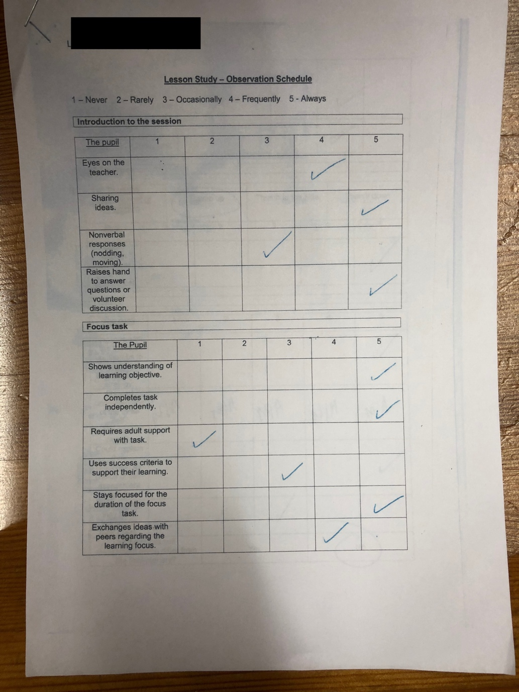
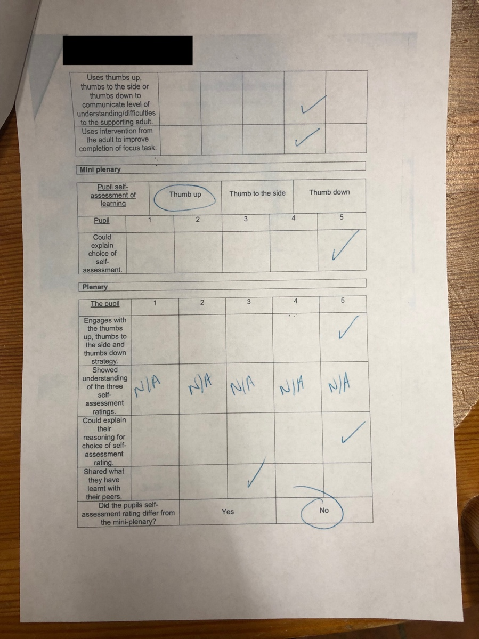

Appendix O

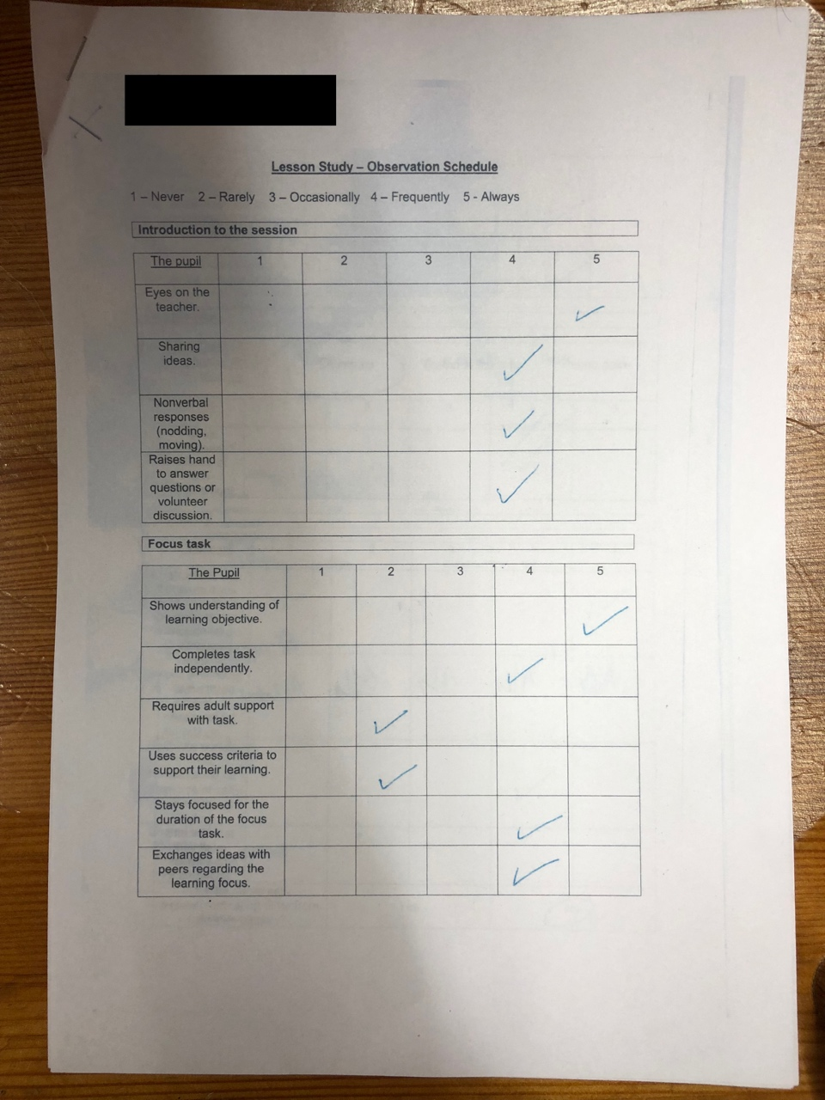
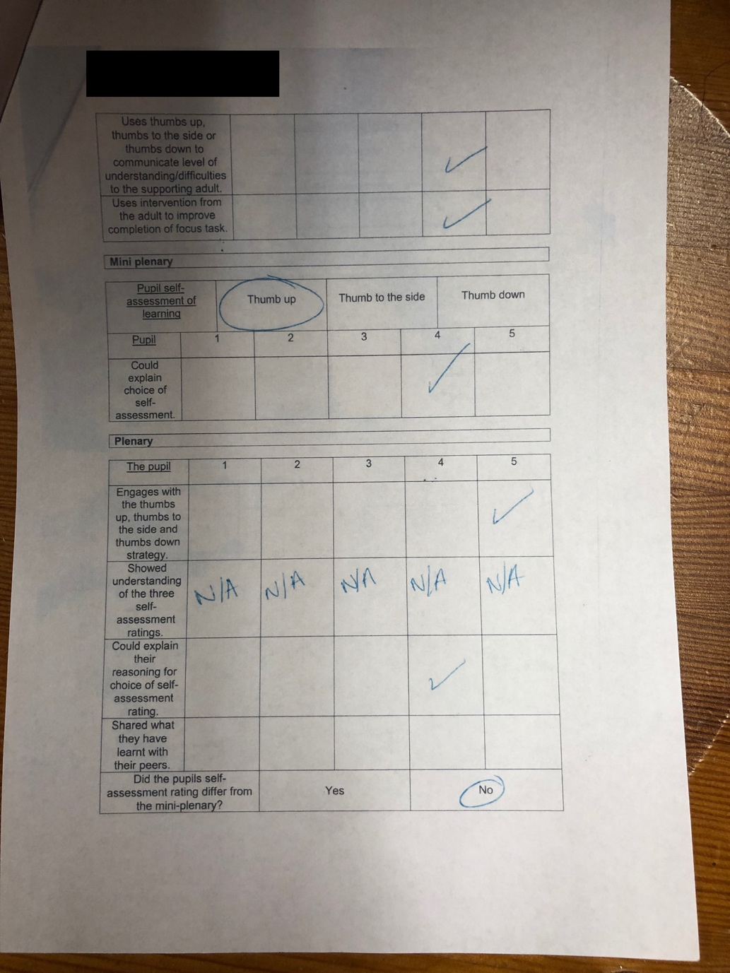

Appendix P



