
Skills for the Workplace
Module Assignment Submission
Student Name: | Jamil Hussain Chowdhury
Student Number: | 1604178
Module Number: | BMSK6003
Module Title: | Leading and Implementing Workplace Change
Module Tutor: | Dr Rexon Nting
Submission Date:  Submission Time: | 07 January 2020  14:45 Hours

Statement of Confirmation of Authenticity
By the act of making this submission, the student declares that this is the work of the student named above. The work has not, in whole or in part, been knowingly presented elsewhere for assessment, or where assessment has been built on a previous assessment, this has been identified. Where materials have been used from other sources it has been properly acknowledged. If this statement is untrue, the student acknowledges that an assessment offence has been committed. Attention is drawn to the plagiarism and unfair practice policies of both the University and of ILM.
BMSK6003

Leading and Implementing
Workplace Change
In
Unilever

Student: Jamil Hussain Chowdhury
Student Number: 1604178
University of Wales, Trinity St David, London.
Executive Summary
In this report, workplace change is discussed throughout the study. The relationship between organizational change and environmental changes are discussed in this study and two factors of environmental changes are described in this study. Environmental change and organizational responses make effective changes for macro and competence environment. Internal and external planned and unplanned changes are also described in the report. A conclusion has been made at the end of the report to show the reflectiveness of changing strategy in Unilever.

Table of Contents

Introduction 5
1. Contemporary Issues and their Impact on Business Management 6
1.1 Relationship between Environmental Change and Organizational Capability 6
1.2 Hard and Soft Model of Changes 7
1.3 Role of Managers as Change Agents 9
1.4 The Nature of Change and Concepts Relating to Leadership about Chain Management 10
2.0 Lewin’s Change Model 10
2.1 Politics of Change and Conflict Resolution 11
2.2 Organizational Change and Culture 12
2.3 Organizational Change and Structure 13
3.0 Contingency Theory for Environmental Change and Organizational Science 14
3.1 Environmental Change and Organizational Response 15
3.2 Nature of the Change Process 15
3.3 Planned Change 16
3.4 Planned and Unplanned Change 16
4.0 Evaluation of the Relationship between Organizational Culture and Change 18
4.1 Organizational Culture 18
4.2 Organizational Change 20
4.3 Relationship between Organizational Culture and Change 21
Conclusion 24
Reference 25

Introduction
Leaders in an organization play an important role in the chain management process. The human resource department of every company and organization makes the change process successful. This changing process helps to develop organizational performance by implementing different theories and processes. Effectiveness for organization and employees are increased by changing events. Changing events include the process that helps to diagnose tools, programs, consultation, and advice. Changing management is a process that helps the organization to develop from current state to future state. It is an organizing process that empowers employees and managers for accepting changes in current environments. In this assignment, different streams of changing processes are described throughout the report. Implementation of the workplace develops the working procedures of the companies. In this report, the relationship between environmental change and organizational capability is described that gives an overview of the changing management process. Changing management process is a critical part for the leader or managers, and also the employees of an organization. Different and new technologies, new approaches, structures, and values are implemented by this change management process. In this stage, stakeholders are those employees who will be impacted by the change. Some contemporary issues are also described throughout the report that describes how new technologies and systems are influencing the employees. The new change makes some difficulties to approach new strategies in the companies. This report also evaluates the relationship between organizational culture changes.

1.0 Contemporary Issues and their Impact on Business Management
Modern issues and different current events affect organizational performance and culture. These contemporary issues affect organizational behavior, business owners of Unilever helps to make changes in their micro environment and legal environment (Hatch et al. 2015). Contemporary issues in business planning include different types of technological advancement for changing the face of the leading market. Contemporary issues on business management are:
● Legal issues: Unilever keeps information for adopting new advancements in local state and federal business. Due to some legal issues in the market area of their business, they have to face those legal issues. They have to establish their market under pressure to change or fade away. Due to this reason, they get competitive advantages by facing a hindrance from new laws.
● Technological issues: Due to the high rates of raw materials, Unilever has to face some technological issues. These issues contain various types of technological involvement that increases the cost of production of their products (Hoover and Harder, 2015). This issue also helps to give them a competitive edge and struggle to adopt new customer’s preferences.
● Financing: Unilever gets better emphasis by planning on financing and seeking advantages to appeal to lenders and investors. Well-Developed financing of an organization help them develop their market business.
● Marketing: Marketers make innovation strategies to develop the marketing of the company. Owners of Unilever plans to change their customer’s strategies and product categories.

1.1 Relationship between Environmental Change and Organizational Capability
Environmental changes consist of some external conditions that influences Unilever to have some potential changes. According to the organizational capability of an organization, environmental changes are broken down into two components macro environment and competitive environment. The macro-environment consists of different events and societies with technological development. The economic condition of an organization is also developed by these environmental changes (Abbott et al. 2016, p.277). In a competitive environment, organizations make competitive development by providing similar goods, service or both.
An organizational capability is a company's capability to manage employees and managers to get effective advantages from its competitors. Organizational capabilities help small business to gain advantages from a competitive environment and focuses on the areas which can be developed. As per the view of Ajayi et al. (2016), organizational capabilities help the companies to get advantages from their competitors. It also includes knowledge about products and innovative designs that can be implemented for developing organizational capabilities. Flexibility and responsiveness are an important factor that helps to make a relation between environmental changes and organizational capabilities. The responsiveness of an organization makes the ability to make changes according to customer demand. In a competitive environment, skilled and knowledgeable employees provide the company to respond to customer demand and also remain flexible in their works and business environment (Briody, 2018).

1.2 Hard and Soft Model of Changes
There are several models for handling change in situations for hard complexity. The hard system model of change is one of them. Change situations of Unilever are characterized by hard complexity. A high level of emotional involvement usually achieved by the stakeholders to achieve soft complexity (Nicolini et al. 2017). Hard system models are for designing methods and prove complexities. There is also a unitary ideology of relationships that prevails in the approach. This also sets the goals settings for developing the change operations and explicit the criteria.
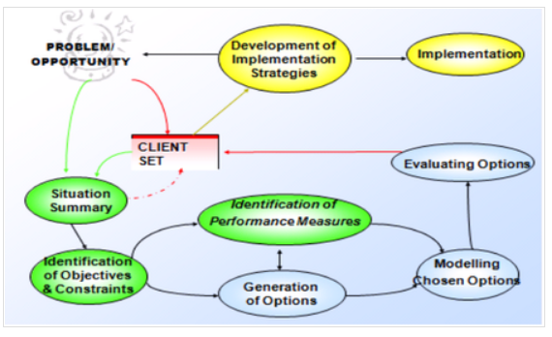
Figure 1: Hard complexity models
(Source: Nicolini et al. 2017)
This model makes an organization-wide change by an emphasis on the facts that it is implemented for having the changes throughout the dimensional concepts. The soft models also have some interconnected and interdependent variables to know the changes. People, Task, Design, Strategy, and Culture are the factors that make the involvement changing process (Polychroniou,2018). Changing the process for management process that refers to developing organizational performance by having systematic communication and making responsibilities and accountabilities. Through this model strategic development of the company is also made. According to the models change agents works along with the individuals, groups, and department (Shah et al. 2017). An alternative approach is also made through this soft model implementation in Unilever.

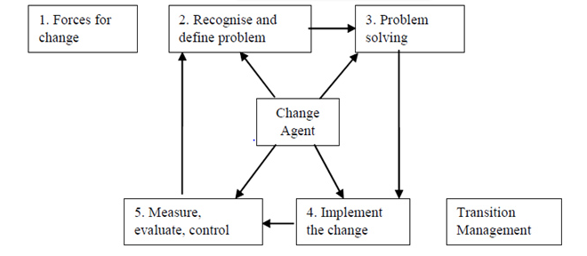

Figure 2: Soft systematic model for changing
(Source: Polychroniou, 2018)
1.3 Role of Managers as Change Agents
The managers in Unilever play an important role as a changing agent. They help in informing their employees and motivating them by implementing various business procedures (Král and Králová, 2016). As changing agent managers ensure that this process for changing flows smoothly until the next change is being complete.
Skills: As an effective manager they must grow well-developed skills that can bring implications of change. They empathize with their employees those who get scared due to workforce and work pressure. They also must be good motivators to encourage their employees, which helps them to make a positive contribution.
Decisions: A well-developed manager never takes negative decisions. Managers of Unilever tries to develop communication between the employees. They decide if the employees can adopt new technologies or not. Managers must make themselves available to all types of questions that are asked by the employees.
Communication: Communication is an essential changing process. Managers help to build understanding that may create barriers for implementing successful changes. Managers always make them themselves available to answer all the questions by having discussions on individual concerns (Laforet, 2016). Managers of Unilever's makes a continuous motivation to their employees.

Figure 3: Role of Managers as change agents
(Source: By researcher)
1.4 The Nature of Change and Concepts Relating to Leadership about Chain Management
The leaders in Unilever supply chain management process for developing the logistic operations. In Unilever entire departments are developed for transportation and information system analysis. Leaders develop this chain management system to increase the organizational performance of Unilever (Tidd and Bessant, 2018).

2.0 Lewin’s Change Mode
This model is a popular approach used by Unilever. Lewin's described this model in three stages that help to make the relation between environmental change and organizational capabilities.
Unfreeze
This step helps Unilever to make human interactions for having potential changes. This helps give perspective to the company what things need to be changed and what not needed. According to that Unilever goes through this idea and makes bias on a commonly accepted mistake. It helps to prepare the team of Unilever to accept new things for their environmental change.
Make change
Communication and support are given by this process to their employees. According to this company makes an idea and outline that which particular things need to be changed in the organization (Hoover and Harder, 2015). Adopting new market policies Unilever makes development in its organizational performance.
Refreeze
This method helps the organization to go through all the points repeatedly. Reviews are given in this stage to give large support and uphold the changes in Unilever. This stage helps to shape the changes according to the needs of the company and keep measuring and reinforcing a new state of things.

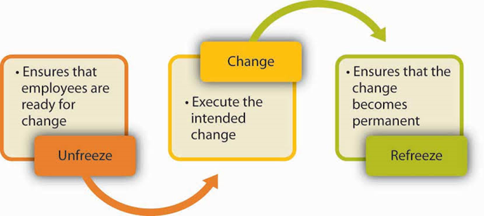
Figure 4: Lewin’s Change Model
(Source: Hoover and Harder, 2015)

2.1 Politics of Change and Conflict Resolution
The basic model of conflict structure is used by Unilever that illuminates the questions that may change in the basic structure of any or all conflicts. This model consists of four components. According to the model, conflicts arise in Unilever due to the mismatch between the social structure of the company and their society (Vaara et al. 2016). It helps to distribute political, economic and social goals. It helps to format the capability of the company to achieve its goals and attitudes. Using this model, Unilever leads the possibilities of changes that help to develop the organizational performance of the company. In this situation goals produce conflict situations to decrease their administrative and structural functions of the company. As per the view of Warrick (2017) this model of changing agents mainly depends on three factors Situation, Behavior, and Attitudes.

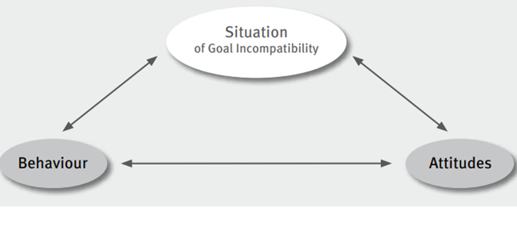
Figure 5: Conflict structure model
(Source: Vaara et al. 2016)

2.2 Organizational Change and Culture
This organization is largely unsuccessful to make changes in their departments. These changes can be complex and cause failure at any level. Lack of miscommunication and mismanagement of employees breaks their trust. Employees in this organization make change efforts because of their resistance power which may give a positive or negative result. Due to the organizational changes, employees are unable to connect with the new things (Zibarras, 2015). Employees work actively to know their development in their workplaces. Affective commitment and normative commitment are the two types of factors that give employees perception by beneficial changes. Changing organizational changes is one of the most difficult challenges for leadership management (Fitzgerald, 2019).
Leadership tools, management tools, and power tools are the factors that give inspiration, information, and intimidation. Changing a culture in an organization is a large scale undertaking that helps to adopt new changing minds with new tools. Leaders of these organizations take the risk to develop new changes to give success in their market. Eventually, interlocking elements make drawback into the existing organizational culture (Zhu, 2015).
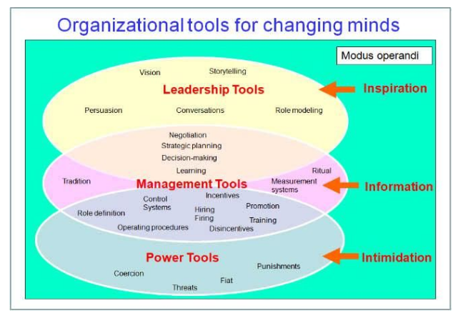

Figure 6: Organizational change and culture
(Source: Zhu, 2015)

2.3 Organizational Change and Structure
Organizational change and structure is a form of design for developing managerial hierarchies. Unilever formed its organizational changes upon operational policies. They involve employees from all levels of the department for their planning stage so that they can also venture their views to speak about their needs. Also, other employees keep informing other employees about their organization to help those (Hartnell et al. 2016). The planning process in this stage gives excitement to their employees about their changes.
Communicate the planning process across the organization helps the employees to get connected. The employees get connected via emails and company newsletter that keeps the change fresh in employees mind. As per the view of Feather (2016) administrative level employees explain all the changes clearly to their subordinates. They hold meetings with their departmental managers to manage the entire management process of the company. Managers and leaders also identify their logistical issues and make change implementation plans.

3.0 Contingency Theory for Environmental Change and Organizational Science
This theory is a major theoretical lens that is viewed by environmental changes based on contemporary organizational science. It helps to manage the traditional management approach which makes the best way to organize various aspects of Unilever. In the middle period of the twentieth-century organizations are viewed by as closed from the external environment (Ceulemans et al. 2015). This theory helps to develop an open system approach in this company that makes continuous contingency. This theory is mainly based upon organizational adaptation that helps to find certain organizational designs. The environmental conditions of these companies are developed by this theory. This helps to make plans and according to that, they develop action plans for their business. It helps to find the best way to know the performances adapted by their contingencies (Feather, 2016). According to this theory, Unilever as an organization seeks to adapt environments in two levels: first, sub-units of this organization align specific strategies and the second, Unilever as a larger organization, aligns with the overall environmental process. According to the contingency theory, organizations are compelled to make changes to develop the performance of the employees.

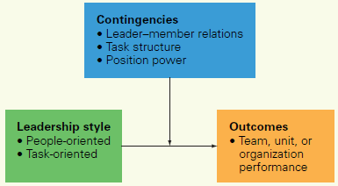

Figure 7: Contingency theory
(Source: Feather, 2016)

3.1 Environmental Change and Organizational Response
The concept of the environment has been proven from a variety of perspectives. According to the perspective view of organizational capabilities and responses, environment has been classified according to its structural layers or constituent elements. Different types of environmental changes require different types of organizational responses. Equilibrium model for Unilever makes organizational changes. However organizational adaptation consists of vis-a-vis existing theory in Unilever that makes development in environmental change (Cameron and Green, 2019).

3.2 Nature of the Change Process
The term change refers to the alternation of physical, biological and social changes. It is also an alternation of organizational change. Changing processes in an organization helps to implement the new equilibrium of different components like technology and structural changes (Feather, 2016). Different types of strategies are also developed by these changes, to develop the design of the organization. Following features may contain organizational change which is known to be the nature of the changing process:
● When changes occur it may reflect its result on the new equilibrium. The type of this new equilibrium depends on the degree of changes that may impact on organizational performance.
● Changes affect the whole organization. During these changes, some departments of this company may affect less and some more. Many departments of Unilever are affected directly and some of them are affected indirectly.
● Organizational change is a continuous process. This changing process helps to take advantage of different competitors that may require special change efforts (Fitzgerald, 2019).
3.3 Planned Change
Planned change is a deliberate design that has the implementation of structural changes for getting new policies and goals and changes that will operate the changing process of Unilever. Nature of plans, attempts all types of aspects for developing structure, technology and people (Hatch et al. 2015).
● Technology related changes: Unilever has changed different types of technological development that helps to develop the manpower of their company. These changes included different inventions and techniques that affect the designing of their company. Technological development in Unilever makes changes in the departments for producing and distributing products. It also includes different types of decision-making procedures (Hartnell et al. 2016). Automatic data processing devices are developed by different features in this company.
● Task-related changes: These changes require what type of task is proceeding by the company. Skill variety, task identity, all these things are developed by task-related changes. High quality work performance is developed by this motivation.
● People related changes: This change depends on two types of skills and behavior. The magnitude of these changes depends on how people are changing in an organization. It requires different types of skills and behaviors of the people that are compared with their previous skills. Social-psychology factors are determined by this process (Hornstein, 2015).

3.4 Planned and Unplanned Change
Planned internal changes are a strategic move which is implemented by Unilever in their organization to change the nature of the business. They have followed some of the points to make planned changes in their company.
● Change in the service or products: Unilever usually goes ahead with planned changes that help them to give new direction for their business. New services and products are delivered by these changes. This strategy requires all types of planning and according to that, they move forward to making different types of objective changes (Killett, 2016).
● Change in the administrative system: Administrative changes are developed by this process. Unilever makes all types of administrative changes according to the organization's needs. The pressure for the administrative level of Unilever comes from the top level of management. Organizational performance by this change is also developed by the administrative. Administration development is the important thing that is changed in Unilever within the context of a two-stage of the environment (Král and Králová, 2016).
The planning process also involves some external changes by both internal and external factors. Technological innovation and the advancement of innovation is mentioned in this process. These two factors are essential to make enhance changes in Unilever (Laforet, 2016). Through technological advancement, they made contemporary development for organization functions.
● Technological innovation: Technological development gives Unilever to make its workforce developed. Employees get new technologies to reduce man force. These are all the implementation of the changing process that makes Unilever success in its market.
● Advancement in communication: In this present era communication is an important thing that needs to be developed by information processing technologies. In this communication system, Unilever makes satellite communication, fiber optic cables and wireless technologies (Nicolini et al. 2017).
Unplanned internal changes in an organization take place which is not planned. It helps to make demographic changes in an organization due to organizational performance. Strategic interventions are also developed through this process.
● Change in demographic composition: This change makes helps to identify in Unilever about several women joined the company. Old employees are started to join their company after completing their service from government sectors. Rapid changes help to develop the demographic composition in Unilever (Pakdil, 2015).
● Performance gaps: Due to the unplanned decisions employees of Unilever faces some performance gap. The performance of the employees is decreased for some unexpected reasons.
There are two factors in unplanned external changes.
● Governmental regulation: Changes in governmental rules and regulations helps the organization to develop its organizational performance. It helps to give a highly competitive environment. Due to the globalization Government has enforced some changes in Unilever.
● Global economic Competition: Global economic conditions are developed by these changes. This helps to achieve winnings edge in the international market place and customer expansion (Shah et al. 2017). It helps the organization to stay ahead in the competitive race.

4.0 Evaluation of the Relationship between Organizational Culture and Change
4.1 Organizational culture
The foundation of a successful organization is to develop a culture within an organization that can have similar beliefs and helps by strong structure and strategy. A strong organizational culture can let employees have knowledge on how management expects them to respond to any situation. An organization’s culture describes the away people must behave within that organization (Laforet, 2016). Culture in an organization is made of beliefs that are established by leaders and shared by employees. These beliefs and values are reinforced and communicated by using different methods. This helps to mold the understanding, perception, and behavior of employees. Culture within an organization sets circumstances for all things. This varies according to the industry and size of organization.
A stable organizational culture is a crucial factor for all successful organizations. The aim of organizations is to reach above by developing a culture that focuses on the goals of the organization and not the goal of individuals (Pakdil and Leonard, 2015). Leaders in those organizations that are successful, maintain a culture each day within the organization and make communication with employees about cultural identity. They have a clear and specific set of values that defines how an organization operates.
There are several factors that shape a culture within an organization. These factors vary in different organizations according to their field of operation (Hatch et al. 2015). The culture in most organization’s team-oriented and focuses on the development of team members along with finding success for the organization. In the present era, organizations are driven as those are having strong competition in the market. The factors that shape up organizational culture are:
Values:
The foundation of the culture of any organization is a common set of values that each employee of an organization shares (Hoover and Harder, 2015). An organization makes the decision on the values that it will put emphasis on. The values are made of results and achievements of an organization, tolerance, and respect for individuals and strong attention to details in finding solutions to the problems. A competitive spirit and eye for innovation are other crucial values for an organization.
Hierarchy:
The hierarchy of an organization has a strong impact on the culture within that organization. There are generally three levels of hierarchy in an organization that contributes to the culture of that organization. The members of higher-level work in the official channels and develops a formal culture in an organization (Abbott et al. 2016). The members of moderate and low levels have defined organizational structure but they also work in unofficial channels and establishes a more informal culture in the organization.

Level of urgency:
The level of urgency can define how the organization is required to make decisions and seek innovation. There is some organization that has control on their level of urgency but other organizations are driven by the scenario of the marketplace (Hoover and Harder, 2015). An organization that has a high level of urgency develops a fast-paced working culture when compared to an organization that has a low urgency level develops a culture where employees work at a low pace and focus more on the quality of the outcome rather than efficiency.
Orientation of people or task:
Organizations have a way of valuing tasks or people. Some organizations value their employees more as they think that the people of an organization is the major factor of its productivity and performance (Nicolini et al. 2017). There are also some organizations that prioritize tasks over anything else. This orientation has an impact and shape on the culture of an organization.
These are some factors that can be influential in developing the culture of Unilever the managers must make proper strategies in order to maintain a strong culture within the organization.

4.2 Organizational Change
Organizational change is the alteration and adaptation that an organization is required to make in order to survive in the market. It is an important aspect for an organization as change is a process that is required to survive in progressive culture. The market is always changing along with the changing behavior of customers (Feather, 2016). Modern organizations make constant changes in structural relationships and the roles of people in order to find success in that market. The change can be related to any infrastructure, change in people, change in technology and various other aspects. The growth and survival of an organization depend upon behavioral changes of its employees. Changes usually disrupt the existing balance in an organization and there is a tendency among people to resist the change.
There are several reasons for change within an organization. These are:
● Technological change- There is constant advancement in technology in the present era. Organizations are required to incorporate new technologies and make adjustments.
● Market condition- There are always changes in consumer behavior and also suppliers. These factors change the market conditions and organizations need to make changes in order to maintain success.
● Socio-political changes- The social and political scenario of a country can change and an organization has little control over it (Pakdil and Leonard, 2015). These changes can have an effect on the organization and the organization is forced to make changes.
● Changes in personnel- There are some situations where some changes are required to personnel’s, one of them could be as required for administrative reasons. With the change in managerial personnel, the method of operations requires a change.
● Organizational deficiencies- There can be some deficiencies in an organization that it requires to overcome. In order to overcome those deficiencies, organizations are required to make structural changes.

4.2 Relationship between Organizational Culture and Change
The culture of an organization has a significant effect on the implementation of change and its management (Zibarras and Coan, 2015). The process of change in an organization has various steps and those steps involve aspects that are related to an organization’s culture. The process has the following steps:
Unfreezing:
This is the situation when a person realizes that the existing way is not effective or relevant. The current situation of the organization requires changes. An organization that has a culture that encourages its employees to have flexibility can go through this phase of change with relative ease.
Changing:
The next process is to make the necessary changes (Shah et al. 2017). The new methods of operations are required to be adapted and organizations give instructions to employees what changes are required to be made. Those organizations that manage a culture where employees can communicate effectively and managers can properly instruct their followers to perform the changes in a better way.
Refreezing:
In this stage, the new methods of working are established among the employees. Their performance and adaptations depend upon the organization’s culture as an organization with a fast-paced culture can make changes more frequently whereas an organization with slow-paced culture requires more time in implementing changes.

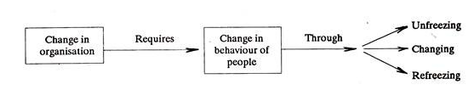
Figure 8: Change the process within an organization
(Source: Briody et al. 2018)

The values and beliefs within an organization are developed by the internal and external factors and these factors have an effect on the change management process. The hierarchy of an organization makes up organizations’ culture. It is influential in implementing changes in an organization as these people are involved in identification of the requirement of change as well as planning and execution of it (Zhu, 2015). The orientation in an organization is also a crucial part of its culture and this is also related to the process of change. Orientation determines how a change will be implemented in an organization.

Conclusion
It can be concluded that the change in the workplace is an integral process that is essential to maintain competitiveness. A modern organization is required to adapt frequently in order to maintain success in a highly changing market scenario. The consumer behavior varies and supplier also changes. This requires an organization to make changes in its internal structure or people or method of operation. Technological development gives Unilever to make its workforce developed. Employees get new technologies to reduce man force. These are all the implementation of the changing process that gives makes Unilever’s success in its market. In this assignment, various streams of changing processes are described throughout the report. Implementation of the workplace develops the working procedures of the companies. In this report, the relationship between environmental change and organizational capability is described that gives an overview of the changing management process. The role of leadership is crucial in the change process as leaders are the ones that communicate with all the employees and coordinates their actions. The requirement of change is identified by the person and new and effective methods are created. It can be seen that there is a tendency among people to resist change as it pushes them to come out of their usual comfort zone. A strong organizational culture must be developed in an organization where the employee is focused on learning new skills and are always ready to accept changes for the welfare of the organization. The management of Unilever must focus on developing a set of values and transmitting it onto the employees to build a strong culture where the employees are dynamic and flexible. This can enable the organization to continue its path of achieving success around the world.

Reference
Abbott, K.W., Green, J.F. and Keohane, R.O., 2016. Organizational ecology and institutional change in global governance. International Organization, 70(2), pp.247-277.
Ajayi, S.O., Oyedele, L.O., Akinade, O.O., Bilal, M., Owolabi, H.A., Alaka, H.A. and Kadiri, K.O., 2016. Reducing waste to landfill: A need for cultural change in the UK construction industry. Journal of Building Engineering, 5, pp.185-193.
Bergs Timber AB: Organization change at the Bergs Timber (UK) Group of Companies 2019, , New York.
Bergs Timber AB: Organization change at the Bergs Timber (UK) Group of Companies 2019, , New York.
Bowers and Wilkins Restructures to Invest in Product and Brand: Leading global performance audio brand makes organization changes to drive innovation and growth 2018, , New York.
Briody, E.K., Berger, E.J., Wirtz, E., Ramos, A., Guruprasad, G. and Morrison, E.F. 2018, "Ritual as Work Strategy: A Window into Organizational Culture", Human organization, vol. 77, no. 3, pp. 189-201.
Cameron, E. and Green, M., 2019. Making sense of change management: A complete guide to the models, tools and techniques of organizational change. Kogan Page Publishers.
Ceulemans, K., Lozano, R. and Alonso-Almeida, M., 2015. Sustainability reporting in higher education: Interconnecting the reporting process and organisational change management for sustainability. Sustainability, 7(7), pp.8881-8903.
Change Organisation signs distribution deal with Microworld 2015, , Dennis Publishing Ltd, London.
CytoSorbents Changes Contract Research Organizations and Temporarily Pauses Enrollment in REFRESH 2-AKI Study 2019, , New York.
Feather, D. 2016, "Organisational culture of further education colleges delivering higher education business programmes: developing a culture of 'HEness' - what next?", Research in Post-Compulsory Education, vol. 21, no. 1-2, pp. 98.
Fitzgerald, N. 2019, "How do you change an organisation's culture?", Accountancy Ireland, vol. 51, no. 5, pp. 68-70.
Hartnell, C.A., Kinicki, A.J., Lambert, L.S., Fugate, M. and Doyle Corner, P., 2016. Do similarities or differences between CEO leadership and organizational culture have a more positive effect on firm performance? A test of competing predictions. Journal of Applied Psychology, 101(6), p.846.
Hatch, M.J., Schultz, M. and Skov, A.M., 2015. Organizational identity and culture in the context of managed change: Transformation in the Carlsberg Group, 2009–2013. Academy of Management Discoveries, 1(1), pp.58-90.
Hoover, E. and Harder, M.K., 2015. What lies beneath the surface? The hidden complexities of organizational change for sustainability in higher education. Journal of Cleaner Production, 106, pp.175-188.
Hornstein, H.A., 2015. The integration of project management and organizational change management is now a necessity. International Journal of Project Management, 33(2), pp.291-298.
Johnson Matthey: Organisation Changes 2017, , Melbourne.
KILLETT, A., BURNS, D., KELLY, F., BROOKER, D., BOWES, A., LA FONTAINE, ,JENNY, LATHAM, I., WILSON, M. and O'NEILL, M., 2016. Digging deep: how organisational culture affects care home residents' experiences. Ageing and Society, 36(1), pp. 160-188.
Král, P. and Králová, V., 2016. Approaches to changing organizational structure: The effect of drivers and communication. Journal of Business Research, 69(11), pp.5169-5174.
Laforet, S. 2016, "Effects of organisational culture on organisational innovation performance in family firms", Journal of Small Business and Enterprise Development, vol. 23, no. 2, pp. 379-407.
Nicolini, D., Sher, M., Childerstone, S. and Gorli, M., 2017. In search of the ‘structure that reflects’: promoting organizational reflection practices in a UK health authority. In Organizing reflection (pp. 95-118). Routledge.
Organization and Change Management Consulting Market Procurement Intelligence Report | Increase in Supplier OPEX to Impact Procurement Spend 2019, , New York.
Organization and Change Management Consulting: Market Intelligence, Procurement Research, Supply Market Forecasts, Cost Drivers, Trends, Category Management Insights Now Available from SpendEdge 2018, , New York.
Pakdil, F. and Leonard, K.M., 2015. The effect of organizational culture on implementing and sustaining lean processes. Journal of Manufacturing Technology Management, 26(5), pp.725-743.
POLYCHRONIOU, P. and TRIVELLAS, P., 2018. The impact of strong and balanced organizational cultures on firm performance. International Journal of Quality and Service Sciences, 10(1), pp. 16-35.
Rollins, Inc. Announces Organization Changes 2018, , New York.
Shah, N., Irani, Z. and Sharif, A.M., 2017. Big data in an HR context: Exploring organizational change readiness, employee attitudes and behaviors. Journal of Business Research, 70, pp.366-378.
The Intelligent Change Management Guide: How To Successfully Lead And Implement Change In Your Organisation 2019, , Coventry.
Tidd, J. and Bessant, J.R., 2018. Managing innovation: integrating technological, market and organizational change. John Wiley & Sons.
Vaara, E., Sonenshein, S. and Boje, D., 2016. Narratives as sources of stability and change in organizations: approaches and directions for future research. Academy of Management Annals, 10(1), pp.495-560.
Warrick, D.D., 2017. What leaders need to know about organizational culture. Business Horizons, 60(3), pp.395-404.
Zhu, C., 2015. Organisational culture and technology-enhanced innovation in higher education. Technology, Pedagogy and Education, 24(1), pp.65-79.
Zibarras, L.D. and Coan, P., 2015. HRM practices used to promote pro-environmental behavior: a UK survey. The International Journal of Human Resource Management, 26(16), pp.2121-2142.

