4. Findings and Analysis
4.1 Introduction
The previous chapter outlined the methodology used to investigate the effects of IOPC and PSD misconduct investigations on police officers. This chapter presents the findings of that research, which was conducted via an online survey hosted on Google Forms and made accessible through the Gwent Police intranet page, “The Beat.” The survey specifically targeted officers and staff who had experienced at least one misconduct investigation. A total of 11 responses were collected.
The findings are divided into two sections: quantitative results drawn from closed-ended questions (multiple-choice and yes/no), followed by a qualitative thematic analysis of open-ended responses. Together, these findings provide insight into the duration and emotional impact of investigations, the perceived fairness of procedures, and potential areas for reform.

4.2 Quantitative Findings
4.2.1 Prior Involvement in Investigations
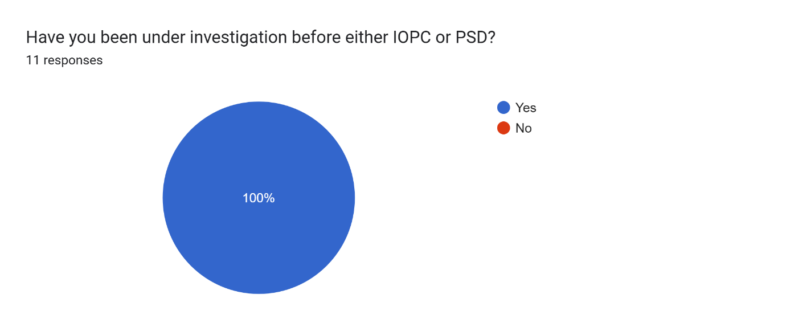
All 11 respondents confirmed they had been subjected to at least one misconduct investigation. This indicates that the sample was appropriately targeted and highly relevant to the research objectives.
4.2.2 Duration of Investigations
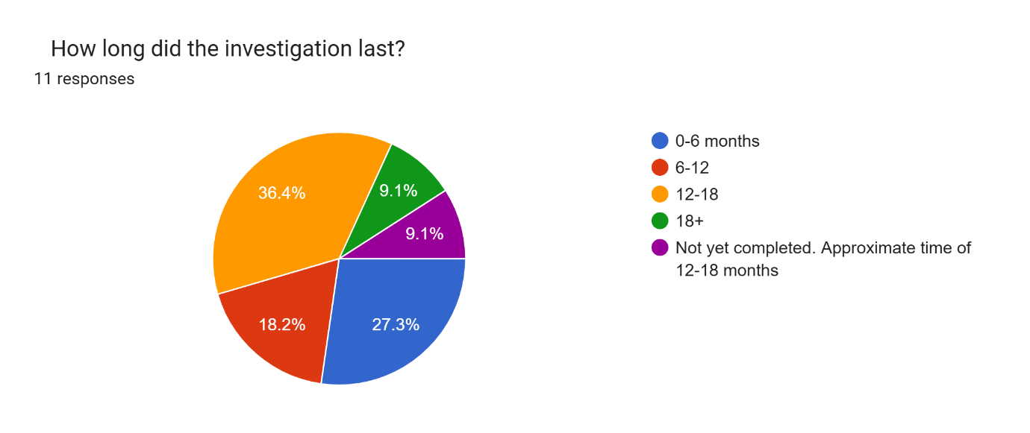
Responses revealed variations in the length of investigations. While 3 participants reported their investigation lasted 0–6 months, and 2 experienced investigations lasting 6–12 months, the majority experienced longer processes: 4 reported durations of 12–18 months, and one case extended beyond 18 months. An additional respondent noted their case was still ongoing after nearly 18 months. Overall, 63.7% of participants experienced investigations lasting a year or more. These extended durations point to systemic inefficiencies and suggest that delays are common, with possible psychological repercussions.
4.2.3 Mental Health Impact Due to Length of Investigation
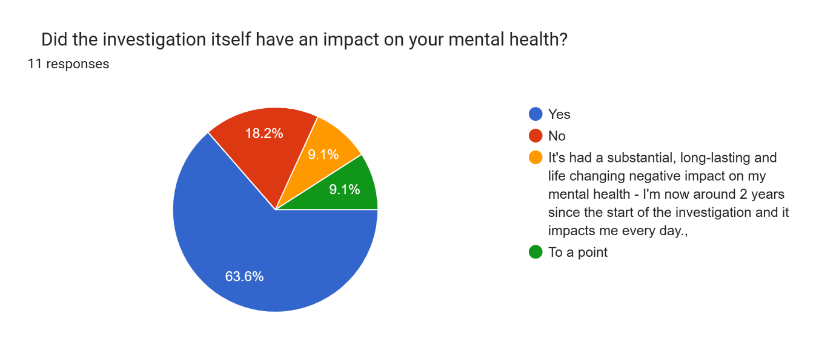
When asked whether the length of the investigation had an impact on their mental health, all 10 respondents answered yes. This finding is particularly striking and points to the duration itself as a significant stressor, increasing the overall burden of being under investigation.
4.2.4 General Mental Health Impact
The broader question of whether the investigation had a general impact on mental health bought similar concern. Seven respondents said yes, while two reported no impact. One respondent felt the effect was present “to a point,” while another described the impact as “substantial” and “life changing.” These results suggest that for most officers, the process leaves lasting psychological effects, even when no professional sanctions follow.
4.2.5 Suspension or Change in Duties
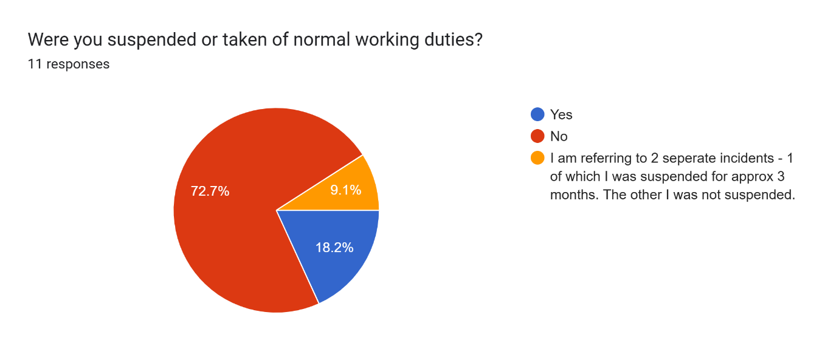
The professional ramifications also extended to work assignments. Two officers reported being suspended or removed from normal duties, and one experienced mixed outcome across different investigations. Eight respondents were allowed to remain in post, although some noted being reassigned to less public-facing roles, suggesting informal sanctions may also be in play.
4.2.6 Final Decision's Impact on Mental Health
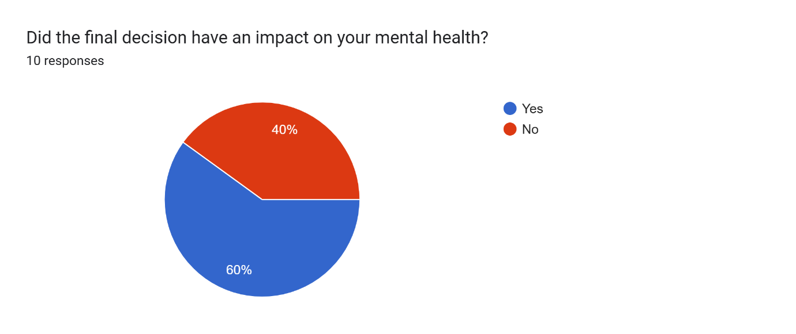
Even after the conclusion of proceedings, the aftermath continued to affect many officers. Six respondents reported a lingering impact on mental health related to the final decision. Four reported no further emotional burden. This suggests that while closure can bring relief, it does not necessarily reverse the psychological toll already incurred.

4.3 Thematic Analysis of Qualitative Data
A thematic analysis was undertaken to explore open-ended responses. The themes below offer rich, contextual insights that deepen understanding of the quantitative findings.
4.3.1 Psychological Distress and Anxiety
Nearly every respondent described experiencing significant emotional distress. Officers spoke of feeling “in limbo,” especially when updates were sparse or non-existent. The unpredictability of the timeline, coupled with the gravity of potential outcomes, triggered anxiety, stress, and clinical depression in some cases. One respondent described it as “nearly 18 months of limbo,” and another mentioned, “Stress, lack of sleep, overthinking, it’s impacted my life every day since the start.” The lack of resolution left many feeling vulnerable, and emotionally exhausted.
4.3.2 Impact on Work Performance and Confidence
The investigations not only harmed mental health but also affected job performance. Officers reported a decrease in confidence and a reluctance to act for fear of further scrutiny. Some became overly cautious or withdrew from public-facing roles. One officer wrote, “I questioned myself on the smallest calls… recording things that don’t need to be recorded.” This hyper-vigilance was not only self-sabotaging but also potentially detrimental to operational effectiveness and team dynamics.
4.3.3 Effects on Personal Life and Relationships
The psychological effects extended into officers’ personal lives. Many spoke of strained or broken relationships, social withdrawal, and irritability. As one respondent explained, “It affected my relationship, which then ended.” Another noted, “I was irritable, snapped at the slightest thing, and felt distant from people.” The inability to compartmentalise work stress from home life underscores the holistic impact of prolonged investigative processes.
4.3.4 Fairness and Transparency
A recurrent grievance was the perceived lack of fairness and transparency. Officers criticised the communication practices of both IOPC and PSD, stating that they were often left uninformed or provided with vague, unhelpful updates. One described the process as “business as usual” despite the emotional gravity of the situation. Others felt unsupported by police unions or internal departments. “The Fed were extremely poor and passive… I ended up leaving them,” one respondent wrote, highlighting feelings of abandonment.
4.3.5 Support Systems
While a few officers accessed Occupational Health or counselling, most relied on informal support from family and colleagues. Several received no support at all, with some even stripped of the ability to use communication devices due to their investigation. “I had no means to call the numbers they sent, my phone had been taken,” one respondent recalled. This lack of structured emotional support compounded the feelings of isolation and institutional neglect.
4.3.6 Recommendations for Improvement
Respondents provided clear and constructive feedback. Their recommendations were:
- Regular and specific case updates.
- Clear timelines and firm adherence to deadlines.
- Improved transparency when no criminal element is involved.
- Comprehensive mental health support that addresses the root causes of distress.
- Enhanced accountability for PSD and IOPC investigators.
Many felt that senior leadership prioritised public image over officer welfare, as captured in this poignant remark: “We’re expected to risk our lives… but when criticism comes, support disappears.”

4.4 Summary
The findings of this study indicate that misconduct investigations, particularly those that are lengthy, poorly communicated, or lacking in transparency, have far-reaching and often damaging effects on the mental health and professional identity of police officers. The data reveals a system that is widely perceived as slow and unsupportive, exacerbating stress, eroding morale, and harming not only officers but also the broader functioning of the police service.
There is an urgent need for procedural reforms that prioritise timeliness, fairness, and psychological safety. Ensuring that officers are treated with dignity and supported through difficult processes is not only a matter of organisational responsibility but a prerequisite for a healthy and functional police force.

