Software Development

Report on C# Part I



Student Name: Borislav Dimitrov Student ID: 1921770 Student Course: BCs Cloud Computing UWTSD 2019-2022 Module Lecturer Name: Mr. Suneth Fernando

Table of Contents
I. Understanding 3
1. Variables vs Constants: 3
2. Data Types in C#: 4
3. Data Type Casting: 8
a) Implicit Casting: 9
b) Explicit Casting: 9
4. Control Structures in Programing: 10
a) For loop 11
b) Do Loops 11
c) Foreach Loop 12
d) While loops 12
e) Nested Loops 12
II. Interpretation 13
1. How the application works. 13
2. Line-by-Line Explanation of the code 14
3. Flowchart of the Program 15
III. Implementation 16
Exercise 1 16
Exercise 2 18
Exercise 3 19
Flowchart for Exercise 3 20
References 21

I. Understanding

1. Variables vs Constants:
Variables store data values in containers. Creating a variable consists of choosing the data type you need and assign it with a value (using the equal sign ‘=’). In order for the programmer, to store permanently the value for constant variable, the keyword “const” is being add in front of the code line. This will declare the variable as constant/unchangeable). Without declaring “const” everyone can change the value of the variable (Microsoft, 2015).
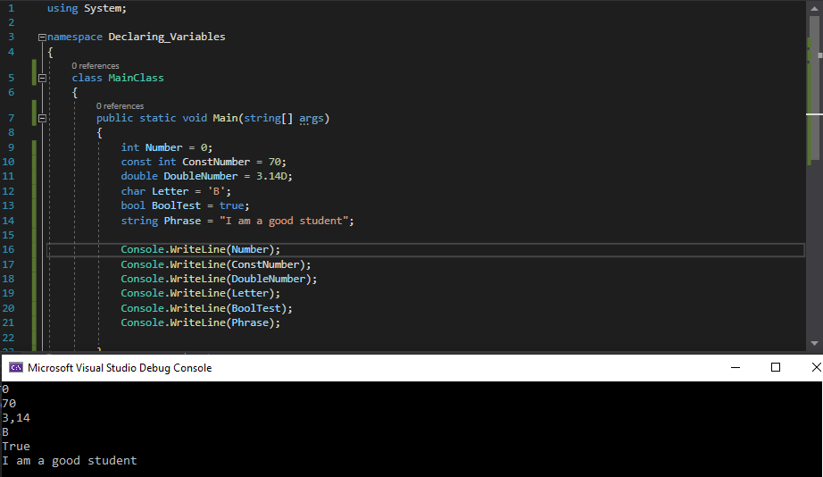
Example1
If someone try to change the Constant value, an error will occur. The same problem will happen if the value is not declared.

If the value is not declared | Attempt to change the value
const int number;  number = 70; // error | const int number = 100;  number = 70; // error

To create a variable, we must specify the type and assign it with a value. There are different Data types, which we will discuss in point 2.
2. Data Types in C#: the use of them is necessary for specifying the size and type of variable values. The use of the correct data type for corresponding variable must be strictly monitored, in order to avoid errors, memory drain and makes the code mode readable and structured. Most used for numbers are: ‘int’ (for whole numbers) and ‘double’ (floating point numbers) (Microsoft, 2016).

Next Table reveals data types in C#:
Data Type | Size | Description
int | 4bytes | Integer (stores: whole numbers from -2B to +2B)
char | 3bytes | Character (stores: surrounded by single quotes ‘character’)
double | 8bytes | Stores fractional numbers (best for 15decimal digits)
bool | 2bit | Boolean (True of false)
long | 8bit | Stores big number of whole numbers
float | 4bytes | Stores fractional numbers (Best for 6 to 7 decimal digits) *F
string | 2bytes/ character | Stores a sequence of characters, text, surrounded by double quotes

Groups on which data types are divided:
*Integer types: ‘int’ and ‘long’ stores whole numbers, negative/positive, without decimals. Only difference depends on the numeric value.
*Floating point types: ‘float’ and ‘double’ can represent numbers with a fractional part, with one or more decimals.

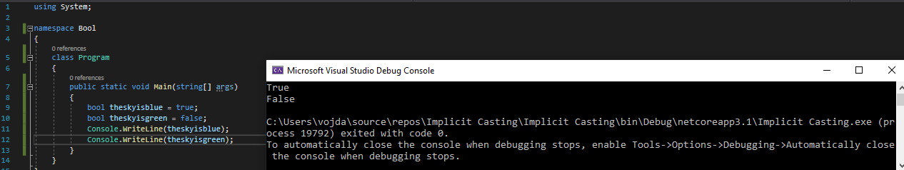
Bool Data Type Example
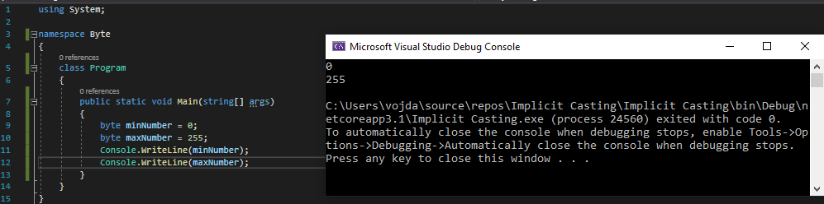
Declaring Byte Example

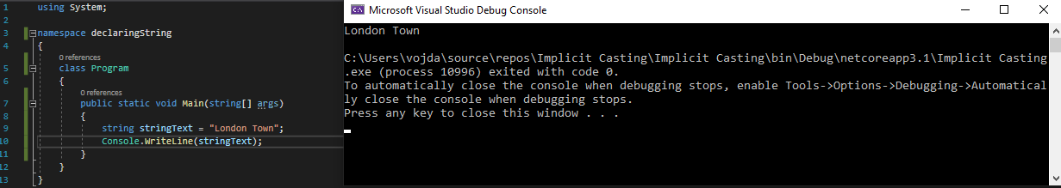
Declaring String Example

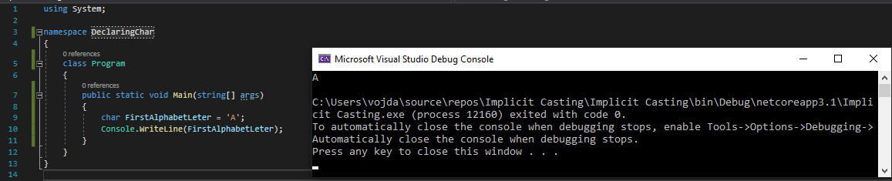
Declaring Char Example

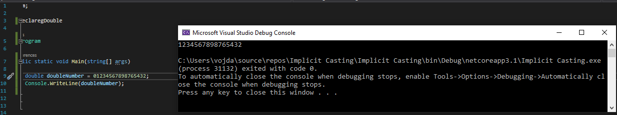
Declaring Double Example
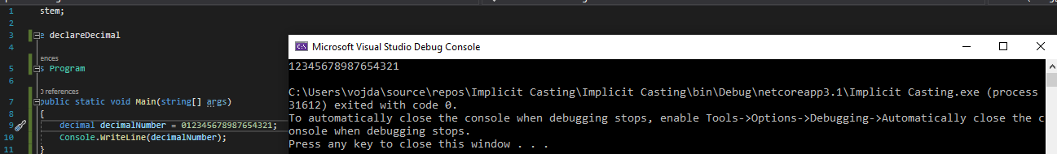
Declaring Decimal Example

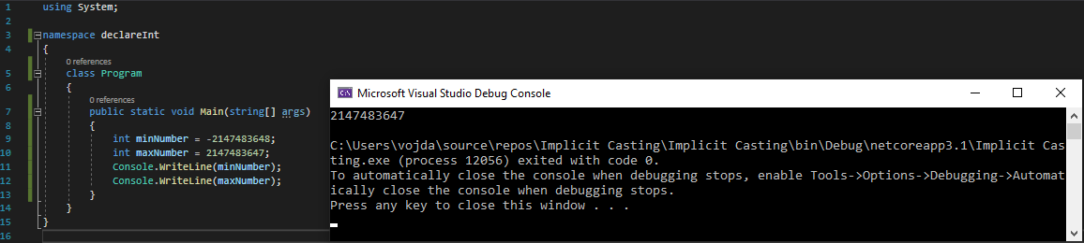
Declaring Int Example

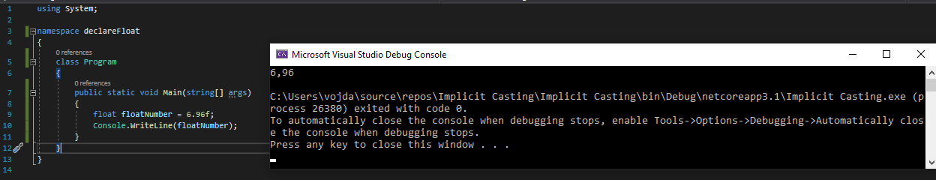
Declaring Float Example

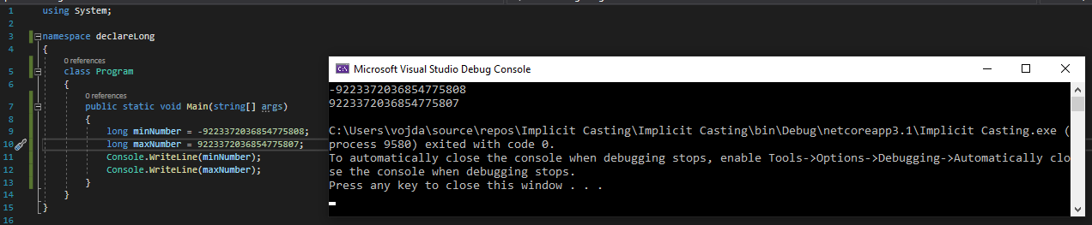
Declaring Long Example

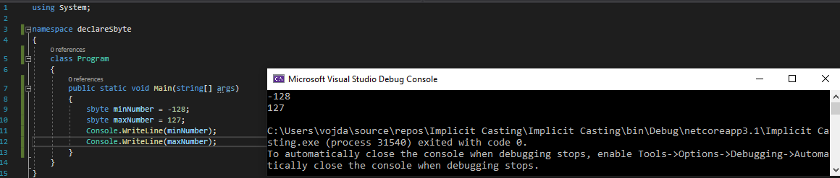
Declaring byte

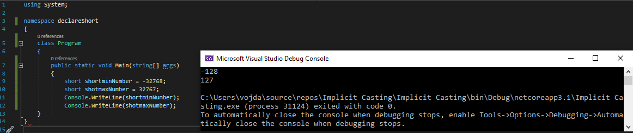
Declaring Short Example

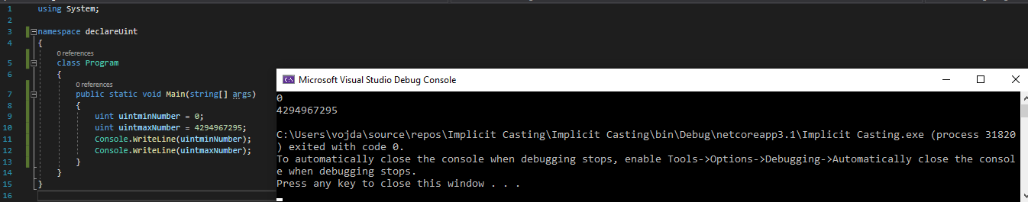
Declaring Uint Example

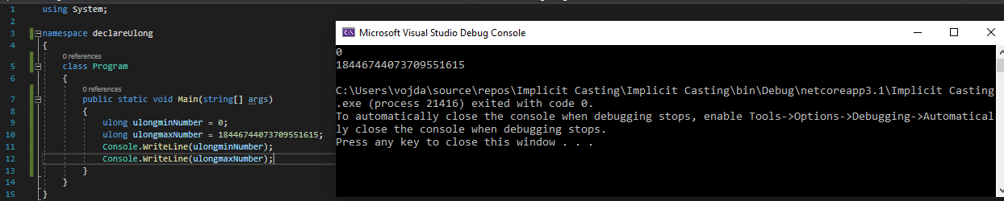
Declaring Ulong Example
3. Data Type Casting: the process of assigning a value of one data type to another. C# is statically typed at compile time, once a variable is declared, by default it cannot be declared or assigned with a new one, except that type is implicitly convertible to different type. For example, the ‘double’ cannot be implicitly converted to ‘int’, error will occur (Microsoft, 2020).
Type conversions’ in C#. In some scenario we need to copy a value into a variable of another type. For example, If we have an integer variable that is going to be passed to a method with ‘double’ typed parameter, or assigning a class variable to an interface type.

Explicit Casting Implicit Casting
Highest Rank
Highest Rank
Double
Double

float
float

long
long

int
Int

char
Char

Lowest Rank
Lowest Rank

As show on the figure, we classify the types per rank.
- Implicit Casting: automatically convert a smaller type to a larger.
For built-in numeric types, when the value we want to store fits into the variable without being rounded off, an implicit conversion can be made. With integral types, the range of the source type is a correct subset of the range for the target type. For example, a variable long(64-bit integer) can store any value from an int(32-bit integer) type. In the following example, we use the compiler to implicitly convert the value of ‘int’ to a type ‘long’ before assigning it to ‘numTwo’ (Microsoft, 2015).
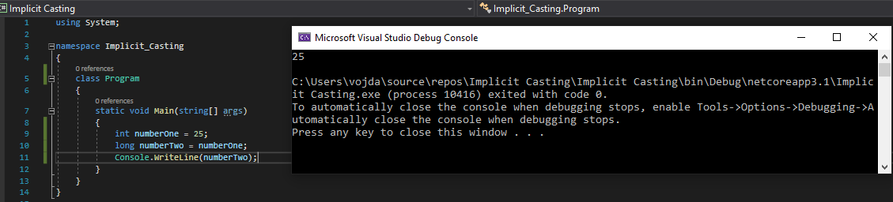
Implicit Casting Example

- Explicit Casting: manual convert from larger type to a smaller size.
If a conversion would follow to risk of losing data, the compiler will request for manual explicit conversion or ‘Cast’. Cast is used to inform the compiler that we intend to make the conversion, by over righting the possibility of losing data or any false during runtime. Performing the cast is to specify the type that we are casting and put it in a parenthesis in front of the value or the variable that will be converted. In the example, the program will cast ‘double’ to ‘int’. Without the cast the program will fail (Microsoft, 2020).
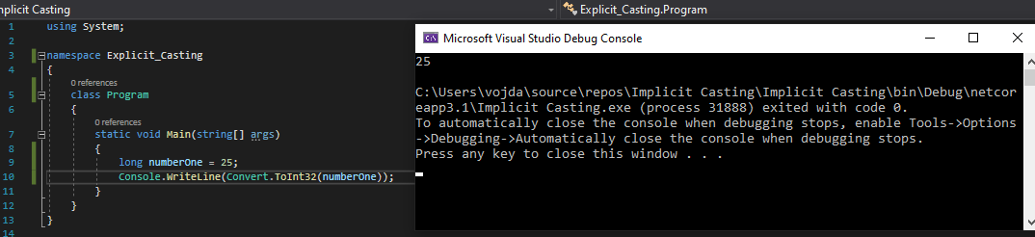
Explicit Casting Example

4. Control Structures in Programing:

A. Sequential Logic or Sequential Flow: Sequential logic follows a serial of instructions given to the computer. The modules are executed in the obvious sequence unless new instructions occur. The sequences may be, explicitly numbered step by step. Also, implicitly follows the order in which modules are written. This elementary flow pattern will be followed in most processing and even some complex problems (Recnac, 2019).
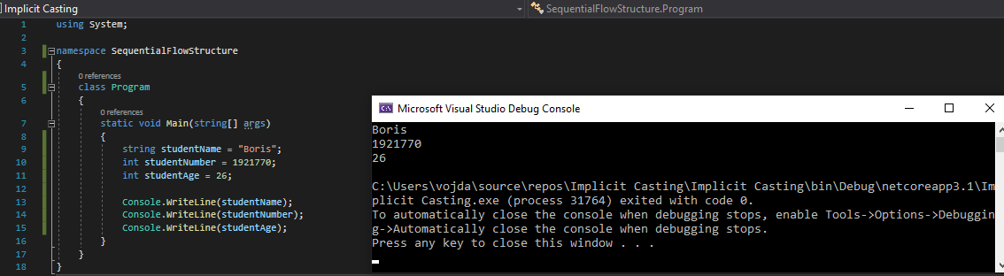
Sequential Flow

B. Selection Logic (Conditional Flow): The Conditional Structure is known for involving a number of condition and parameters which decides one out of several written modules (Recnac, 2019) (Recnac, 2019).
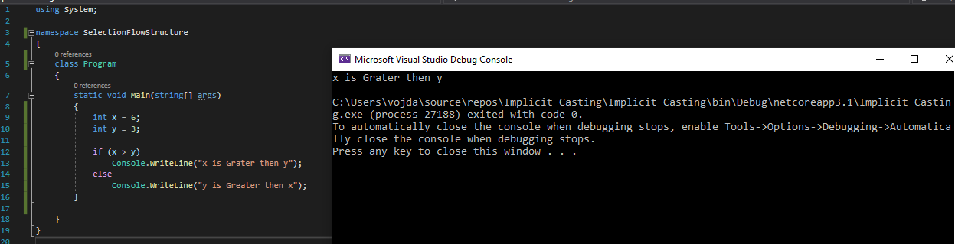
Conditional Flow Example

C. Iteration Logic (Repetitive Flow): Repeat statement followed be module is the body of the loop, which The Iteration logic employs. There are programs that can use different types of loops (Recnac, 2019):

- For loops: executes statement or a block of them while a written Boolean expression evaluates to True. Very common situations require loop which enumerates every element of a list. (Microsoft, 2018)

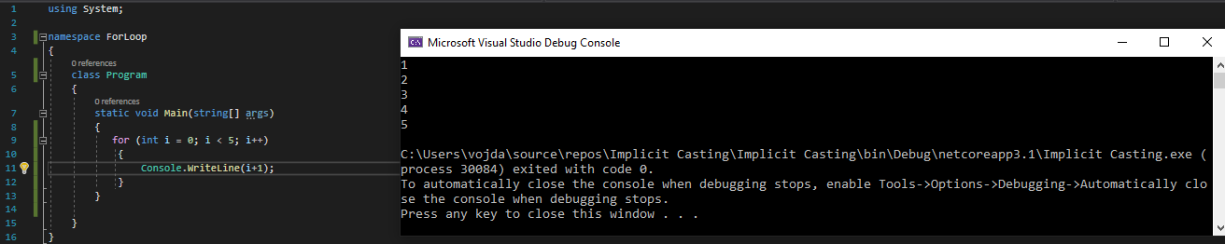
For Loop Example

- Do Loops: do while and loop while will not stop the executing until a certain condition is true. ‘Until loop’ will loop if a certain condition is false. The difference between using ‘Do’ or ‘Loop’ will be that ‘Do’ will check when the loop starts. Loop will do the check after the loop ends (Microsoft, 2018).

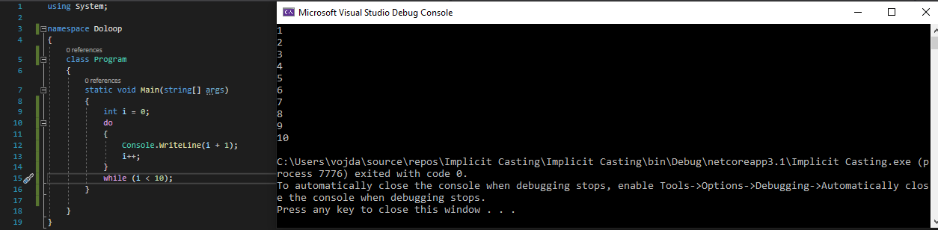
Do-While Loop Example

- Foreach Loop: is used when we don’t specify an operation to every single item in the array or collection. Declaring a specific operation inside the loop will apply on the whole array or collection (Microsoft, 2020).

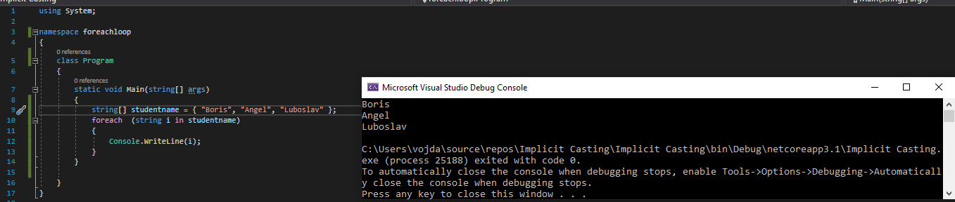
For-Each Loop Example

- While loops: same as Do loops, but in this case the tested condition will always appear at the top of the loop. In case, on the first entry into the loop the condition is false, the loop content will never be executed (Microsoft, 2018).
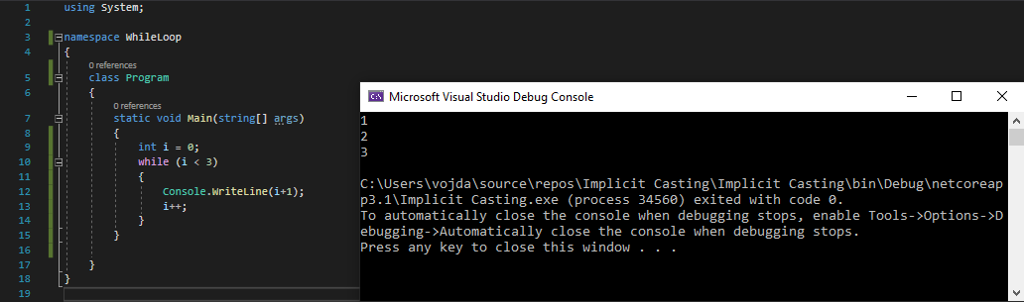
While Loop Example

- Nested Loops: is any type of loop built inside an already existing loop. The inner loop will execute its normal amount multiplied by how mane times the outer loop runs (Microsoft, 2020).
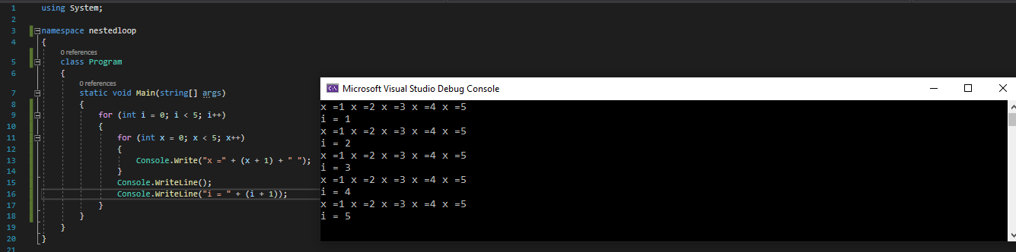
Nested Loop Example

II. Interpretation

The source code provided in Appendix A.
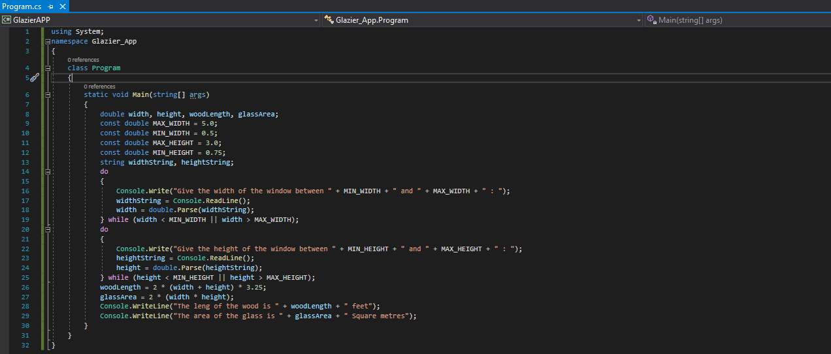

1. How the application works.
1. First step: Requires from user to insert window width between 0,5 and 5m. If the input value is out of that specific range, it will require another input.
2. Second Step: Requires from user to insert a value for window height between 0.75 and 3m. If the input value is out of that specific range, it will require another input.
3. Third Step: The application calculates the wood length and the glass square meters.

2. Line-by-Line Explanation of the code

Line1: System has predefined classes, that we are using.
Line2: Namespace, which contains our classes and organize the code.
Line4: Default class, which contains data and methods.
Line6: The code between curly brackets will be execute. Static is the method belongs to the program class. Void meant that the method does not return a value. String is to define string arrays. They can pass arguments in the command line. Args is the name of the array.
Line8: Declaring variables of double. Line9: Declaring Constant Double.
Line10: --||-- Line11: --||-- Line12: --||-- Line13: Declaring string widthString and heightString.
Line14: Do is Repetition type control structure which use while loop.
Line16: Console.WriteLine is Function from the system namespace for displaying information to the user.
Line17: Console.ReadLine requires a value from the user and stores it under the defined name (widthString).
Line18: Method for converting the string to a double data type.
Line19: While loop prompting for width of the windows.
Line20: Do is Repetition type control structure which use while loop.
Line22: Function for displaying information to the user.
Line23: Function for taking value from the user and stores it under the name (heightString).
Line24: Converting the string to double.
Line25: While loop prompting for height of the windows.
Line27: The Formula for calculating the glass area.
Line28: Displaying the woodLenght to the user.
Line29: Displaying the glassArea to the user.

3. Flowchart of the Program

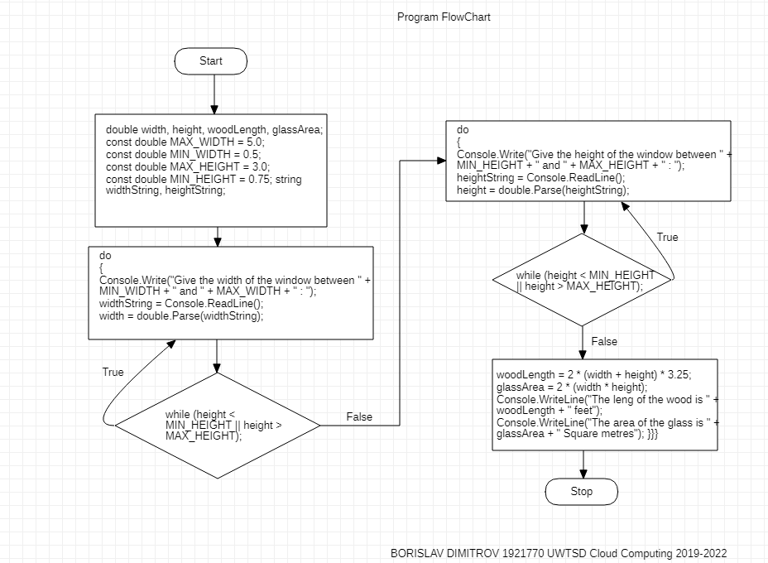
Flowchart for Part II

III. Implementation

Exercise 1

The program needs to get input from the user, for eight subjects and calculate the average marks. Firstly, we declare variables, then we chose the sequence control structure, then is the formula. With the method try and catch the user cannot input wrong value, because an error will occur. Final command is the Console.Readkey, which is user to prompt for key input in order to close the terminal.
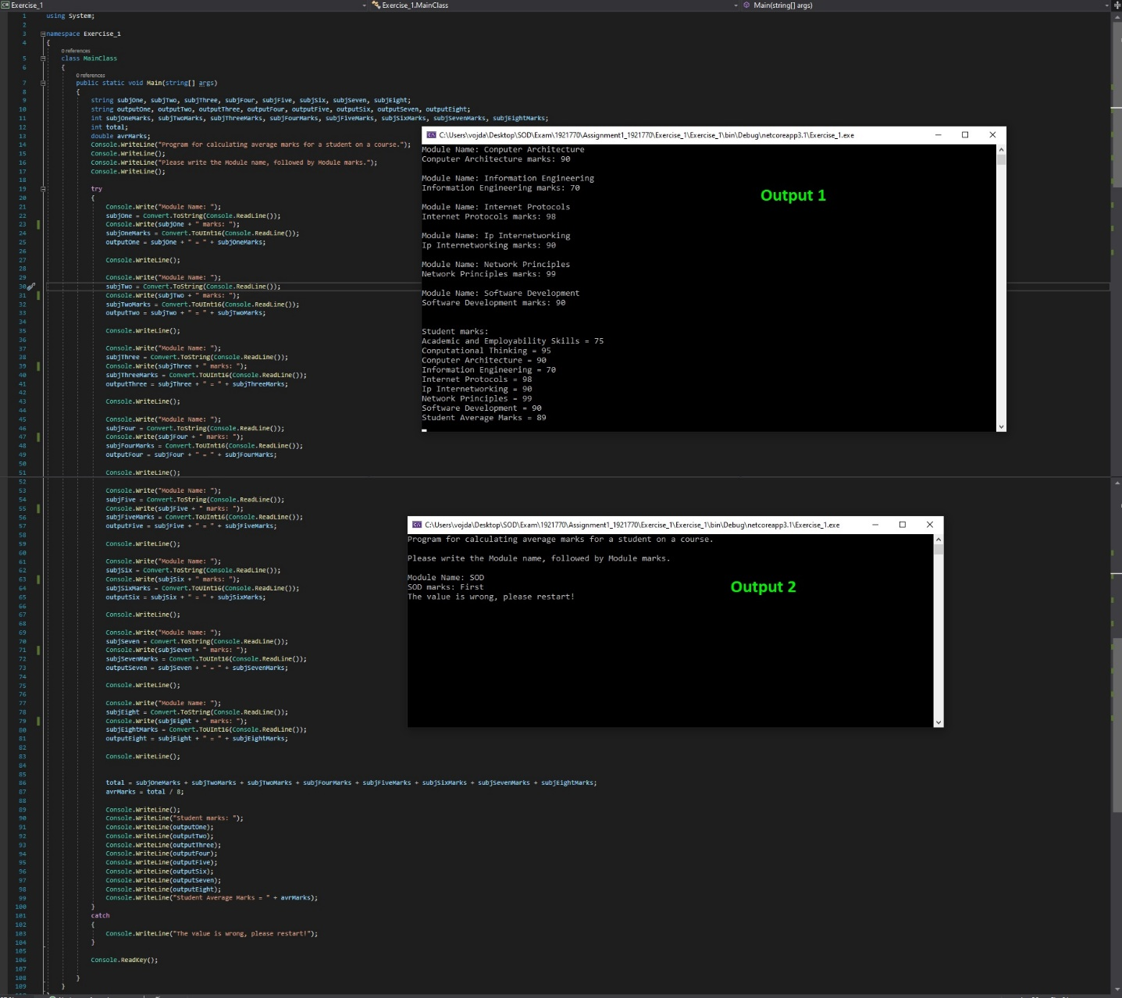

Exercise 2

Program for calculating the shaded area is required. Control Structure and If condition will be used. The value of circle 2 must be greater then circle 1, or the output will be negative. The method try and catch is perfect for the scenario.

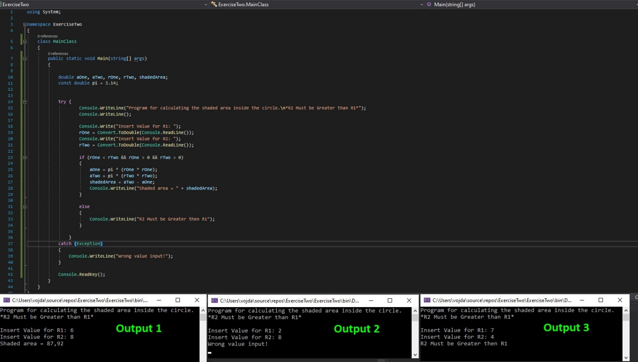
Exercise 2

Exercise 3
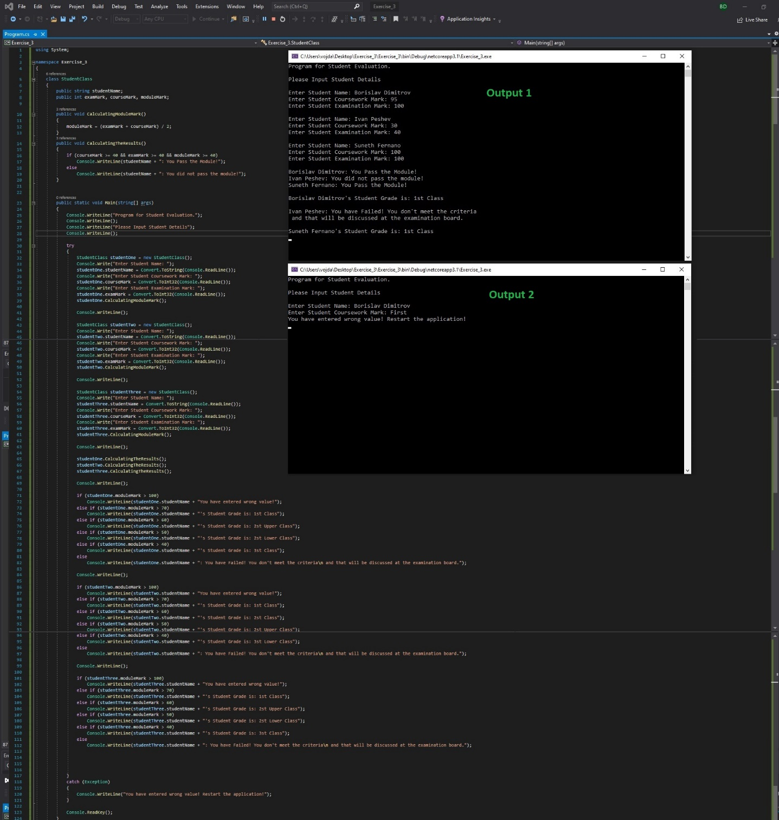 This program will require the use of classes and methods. We defined class Student and two methods “CalculatingModuleMark” and “CalculatingResult”. Next step is to created subclasses and call the methods to calculate the value from the user. “If condition” is required, to compare the values from the user, to check if the student is passing or not, and then to calculate the grade class. With the help of ‘if statement’’ the program calculated and displays the marks simultaneously. Try and catch method in use again.

Flowchart for Exercise 3

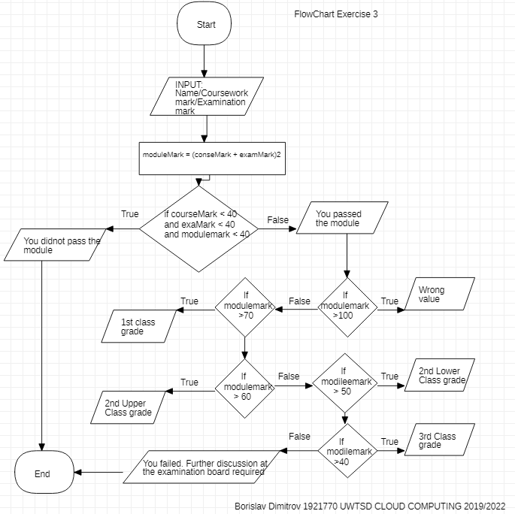

References
Microsoft, 2015. Docs.Microsoft. [Online]
Available at: https://docs.microsoft.com/en-us/dotnet/csharp/language-reference/keywords/const
[Accessed 20 Dec 2020].
Microsoft, 2015. Docs.Microsoft. [Online]
Available at: https://docs.microsoft.com/en-us/dotnet/csharp/programming-guide/classes-and-structs/implicitly-typed-local-variables
[Accessed 20 Dec 2020].
Microsoft, 2016. Docs.Microsoft. [Online]
Available at: https://docs.microsoft.com/en-us/dotnet/csharp/basic-types
[Accessed 20 Dec 2020].
Microsoft, 2018. Docs.Microsoft. [Online]
Available at: https://docs.microsoft.com/en-us/dotnet/csharp/language-reference/keywords/for
[Accessed 20 Dec 2020].
Microsoft, 2018. Docs.Microsoft. [Online]
Available at: https://docs.microsoft.com/en-us/dotnet/csharp/language-reference/keywords/do
[Accessed 20 Dec 2020].
Microsoft, 2018. Docs.Microsoft. [Online]
Available at: https://docs.microsoft.com/en-us/dotnet/csharp/language-reference/keywords/while
[Accessed 20 Dec 2020].
Microsoft, 2020. Docs.Microsoft. [Online]
Available at: https://docs.microsoft.com/en-us/dotnet/csharp/programming-guide/types/casting-and-type-conversions
[Accessed 20 Dec 2020].
Microsoft, 2020. Docs.Microsoft. [Online]
Available at: https://docs.microsoft.com/en-us/dotnet/csharp/language-reference/keywords/foreach-in
[Accessed 20 Dec 2020].
Microsoft, 2020. Docs.Microsoft. [Online]
Available at: https://docs.microsoft.com/en-us/dotnet/csharp/programming-guide/classes-and-structs/nested-types
[Accessed 20 Dec 2020].
Microsoft, 2020. Docs.Microsotf. [Online]
Available at: https://docs.microsoft.com/en-us/dotnet/csharp/programming-guide/interfaces/explicit-interface-implementation
[Accessed 20 Dec 2020].
Recnac, 2019. A Comprehensive Walkthrough of C#. [Online]
Available at: https://www.pluralsight.com/guides/flow-control-csharp-iterative-statements-while-do
[Accessed 20 Dec 2020].

