Name:_Rubens Malaguti

Student Number: 2501521
__________________________________________________________

WORKSHEET 3 – TESTING (Olympic Athlete)

- Original code:
[Copy and paste your original code from Moodle into this box. Do not change it.]

World_record = float(input("Enter the World Record time in seconds: "))
Olympic_record = float(input("Enter the Olympic Record time in seconds: "))

winner_laps = []
for i in range(1, 6):
time = float(input("Enter the winner lap " + str(i) + " the time in seconds: "))
while time <= 0:
print ("wrong enter an appropriate time")
time = float(input("Re enter the appropriate winner lap " + str(i) + " the time in seconds: "))
winner_laps.append(time)

second_laps = []
for i in range(1, 6):
time = float(input("Enter the second place lap " + str(i) + " the time in seconds: "))
while time <= 0:
print("wrong enter an appropriate time")
time = float(input("Re enter the winner lap " + str(i) + " the time in seconds: "))
second_laps.append(time)

print ("welcome to the Olympic Athlete program")

# this is the overall lap time
total = sum(winner_laps)
print("the overall time is :", total, "seconds")

# this is the average lap and lap time
average = total / 5
print("the average lap time is :", average, "seconds")

# this is the fastest lap and lap time
fastest_time = min(winner_laps)
fastest_lap = winner_laps.index(fastest_time) + 1
print("Fastest lap: was lap", fastest_lap, "in", fastest_time, "seconds")

# this is the slowest lap and lap time
slowest_time = max(winner_laps)
slowest_lap = winner_laps.index(slowest_time) + 1
print("Slowest lap: was lap", slowest_lap, "in", slowest_time, "seconds")

if total < World_record:
print("Congratulations the winner has broken the world record")
elif total < Olympic_record:
print("Congratulations the winner has broken the Olympic record")
else:
("print the user has not beaten it ")

- Code Testing
For each test below, run your code and show the results of the scenarios below. Present a screenshot of what happened when the programme ran. Did the programme behave correctly or did it do something unexpected, and if so, why?

- Test a lap time for your programme:
- 56.7 seconds
- 5 seconds
- -4 seconds
- 53444 seconds

- Using the same five lap times for the winning athlete/2nd placed athlete as the sample output shown on the Worksheet:
- Examine each statistic (1-6) and comment on whether the correct answer(s) are displayed or not. (If any statistics were incomplete after Phase 1 (code completed in class) simply note “Unfinished” for that statistic)

- Test two further sets of lap times of your own choice.

- Check that the 2nd placed competitor’s times are reasonable (eg the overall time should not be faster than the winning athlete’s)

Template for tests:
Test: i Test a lap time for your programme: 56.7 seconds
Screenshot(s) of output:
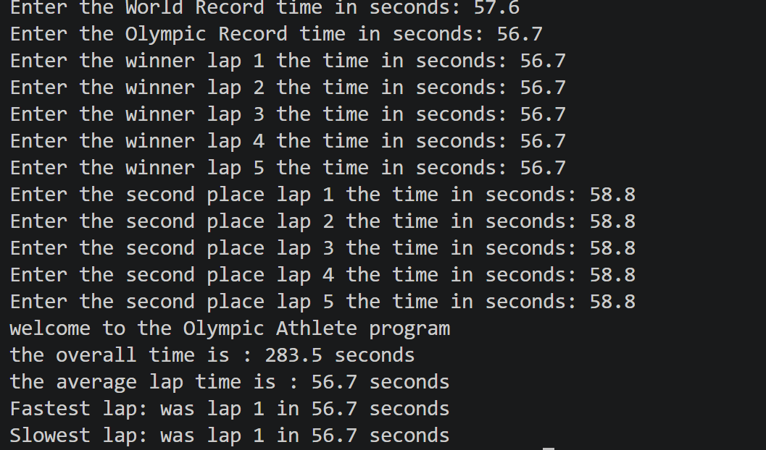
Result: Did the programme behave as expected ie syntactically and logically correct?
YES/NO (delete as appropriate)
If YES, comment on what happened.
If NO, what went wrong and why? Suggest how things could be improved

Yes, the program is behaving as expected and accepts the lap time, and it shows some statistics on it like overall time, fastest and slowest lap times

Test: ii Test a lap time for your program: 5 seconds
Screenshot(s) of output:
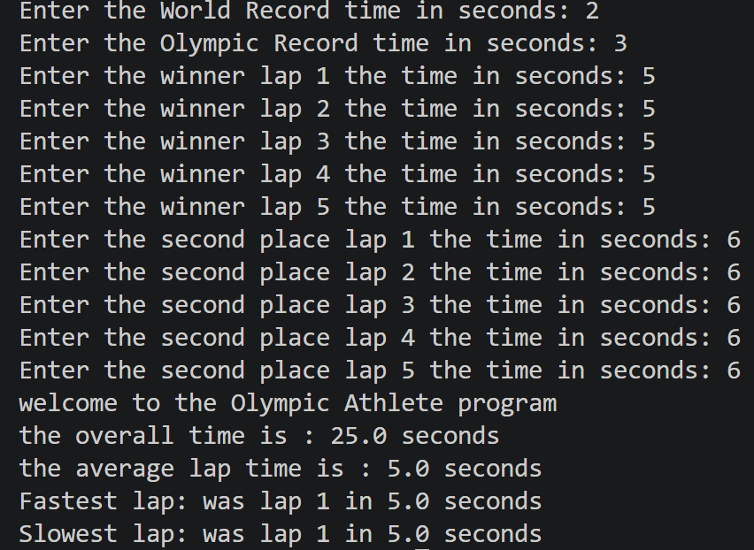
Result: Did the programme behave as expected ie syntactically and logically correct?
YES/NO (delete as appropriate)
If YES, comment on what happened.
If NO, what went wrong and why? Suggest how things could be improved

Yes, the program is behaving as expected and accepts the lap time of 5 seconds, and it shows some statistics on it, like overall time, fastest and slowest lap times

Test: iii Test a lap time for your program: -4 seconds

Screenshot(s) of output:
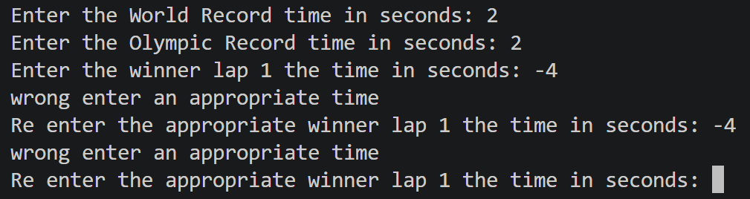
Result: Did the programme behave as expected ie syntactically and logically correct?
YES/NO (delete as appropriate)
If YES, comment on what happened.
If NO, what went wrong and why? Suggest how things could be improved

Yes, the program is working as expected and rejects the negative value -4 of the lap time and asks to re-enter an appropriate positive one

Test: Test a lap time for your program: 53444 seconds

Screenshot(s) of output:
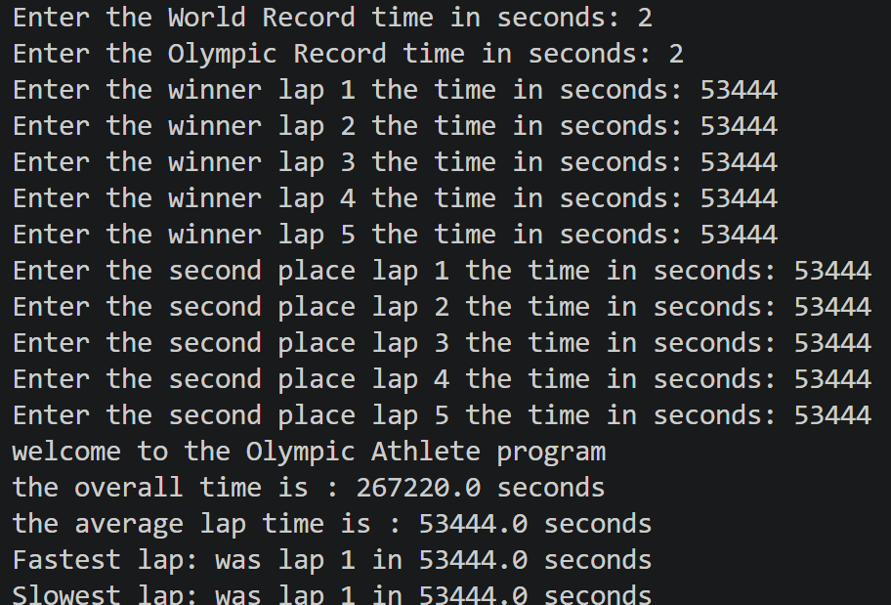
Result: Did the programme behave as expected ie syntactically and logically correct?
YES/NO (delete as appropriate)
If YES, comment on what happened.
If NO, what went wrong and why? Suggest how things could be improved

Yes, the program is working as expected and accepts 53444 as a valid number for seconds lap time, even if it's very slow

Test: B
Screenshot(s) of output:
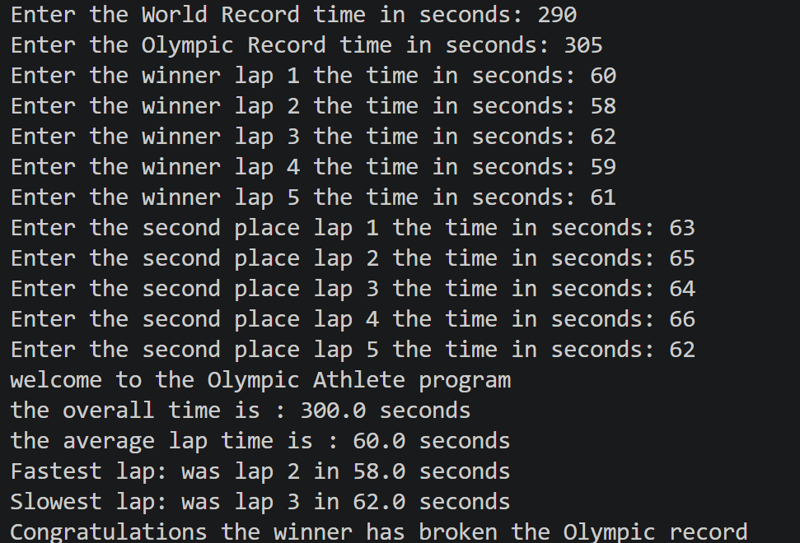
Result: Did the programme behave as expected ie syntactically and logically correct?
YES/NO (delete as appropriate)
If YES, comment on what happened.
If NO, what went wrong and why? Suggest how things could be improved

Yes, the program is behaving as expected because for every lap completed by the runner, the statistics are calculated correctly, and no error is being made by the program

Test: C two further sets

Screenshot(s) of output:
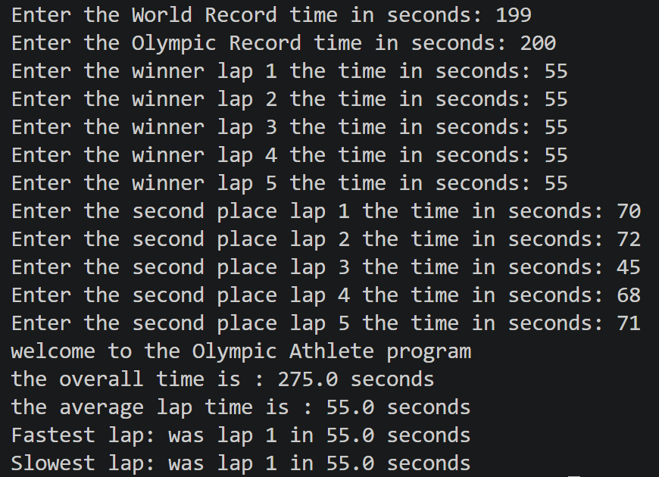
Result: Did the programme behave as expected ie syntactically and logically correct?
YES/NO (delete as appropriate)
If YES, comment on what happened.
If NO, what went wrong and why? Suggest how things could be improved

No, the program is not behaving as expected since the fastest lap should be 45 seconds, and the slowest one should be 72 seconds, meaning that there is an issue in the program logic

Test: D 2nd place checks

Screenshot(s) of output:
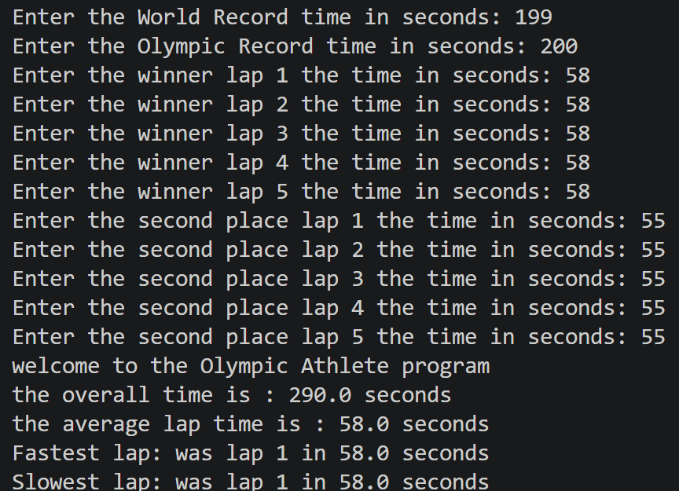
Result: Did the programme behave as expected ie syntactically and logically correct?
YES/NO (delete as appropriate)
If YES, comment on what happened.
If NO, what went wrong and why? Suggest how things could be improved

No, the program is not behaving as expected since the second-place lap times are faster than the first-place one, which does not make any sense, and the reason is that the program is not comparing the average time between first and second place

- Consider the results of the above tests and revisit your original code in order to address any tests that failed and/or improve code efficiency.

(Note: you may not be able to solve all of the problems that were encountered, but solve as many as you can.)

Paste your full revised code here :

[Copy and paste your full revised code here – note, do not use a screenshot]

print("welcome to the Olympic Athlete program")

World_record = float(input("Enter the World Record time in seconds: "))
Olympic_record = float(input("Enter the Olympic Record time in seconds: "))

winner_laps = []
for i in range(1, 6):
time = float(input("Enter the winner lap " + str(i) + " the time in seconds: "))
while time <= 0:
print("wrong enter an appropriate time")
time = float(input("Re enter the appropriate winner lap " + str(i) + " the time in seconds: "))
winner_laps.append(time)

second_laps = []
for i in range(1, 6):
time = float(input("Enter the second place lap " + str(i) + " the time in seconds: "))
while time <= 0:
print("wrong enter an appropriate time")
time = float(input("Re enter the second place lap " + str(i) + " the time in seconds: "))
second_laps.append(time)

total = sum(winner_laps)
print("the overall time is :", total, "seconds")

average = total / 5
print("the average lap time is :", average, "seconds")

fastest_time = min(winner_laps)
fastest_lap = winner_laps.index(fastest_time) + 1
print("Fastest lap: was lap", fastest_lap, "in", fastest_time, "seconds")

slowest_time = max(winner_laps)
slowest_lap = winner_laps.index(slowest_time) + 1
print("Slowest lap: was lap", slowest_lap, "in", slowest_time, "seconds")

if total < World_record:
print("Congratulations the winner has broken the world record")
elif total < Olympic_record:
print("Congratulations the winner has broken the Olympic record")
else:
print("The winner has not beaten any record")

second_total = sum(second_laps)
if second_total < total:
print("error: 2nd place total is faster than the winner")
else:
print("2nd place overall time:", second_total, "seconds")

