Introduction:
The report will critically assess the current environmental forces and their impact on Nokia. Firstly, PESTEL and Porters Five Forces analysis will be used to assess the current external environment. Secondly, relevant findings from the PESTEL analysis and Porters Five Forces will then be utilised within a SWOT analysis to ascertain where Nokia sits within its current environment.
Furthermore, findings from the SWOT analysis will then be used to outline the potential opportunities that Nokia can undertake and the potential threats that Nokia could possibly face in the long-term. To discuss this, a discussion will be undertaken which will look into the potential of taking up any opportunities and also nullifying the threats that have been identified.
Finally, out of the four possible global challenges highlighted below by IMF, one will be chosen and discussed in further detail in terms of its implications on Nokia.

Background to Nokia
Nokia is a Multinational Corporation (MNC) headquartered in Finland (Nokia 2018). Nokia currently operates within multiple industries including smartphone/mobile phone Industry, Information Technology (IT), Multinational Communications (MC) and Consumer Electronics(CE) industry (Nokia 2019).
Nokia’s business model is divided into three key areas. These include:
Alcatel and HDMI Global: Nokia-branded Android based devices such as smart and mobile phones have been licensed to HDMI Global.
Nokia Networks: providing professional services to operators and service providers.
Nokia Technologies: imaging, wireless connectivity and IP Licence programming.
For the purpose of this report, I will be focusing on Nokia within the smartphone industry.
(Nokia 2019)

In order to identify and analyse the macroeconomic forces facing Nokia, PESTEL and Porters 5 Forces analysis will be utilised.
External Environment
Aguillar (1967) created PEST analysis framework to analyse and monitor the macroeconomic environment of a business. Ethical and legal framework were added to cater for the modern business environment (Robert 2016).

PESTLE Analysis
Political:
The impact of political factors on Nokia are difficult to establish. The company is based in Finland, however the government of Finland refuses to give bailout or special favours which means that Nokia lacks governmental support, although Nokia is seen as a national pride and success (The Irish times 2015). Unlike some smartphone companies like Apple, Nokia lacks strong government support because it is based in a small country (The Irish Times 2015). This can both help and hurt the company because it is not associated with a major power but it might lack the political clout of American- or Chinese-based rivals.
Economic
Economic downturn in Europe hurt Nokia significantly as it limited Nokia’s buying power in its home market (BBC NEWS 2013). Unlike Apple, Samsung and Google Nokia found it difficult to tap into the lucrative Chinese markets (Yu 2017). Furthermore, Nokia also lacks the economic resources which means their ability to finance and conduct research and development is limited. This factor has limited their ability to innovate and develop flagship smartphones (Doz 2017).
On the other hand, Google, Apple and Samsung have vast economic resources at its disposal. This has enabled them to innovate, invent and revolutionise therefore it has enabled them to develop and gain access to new markets (Economist 2018).

Global unemployment:
Unemployment has a significant impact on the purchasing power of consumers (Hopewell 2008). It is an important measure for a country’s or region’s economic health . A low employment rate is a positive indicator for an MNC that there products are more likely to be purchased (Chuan 2011).
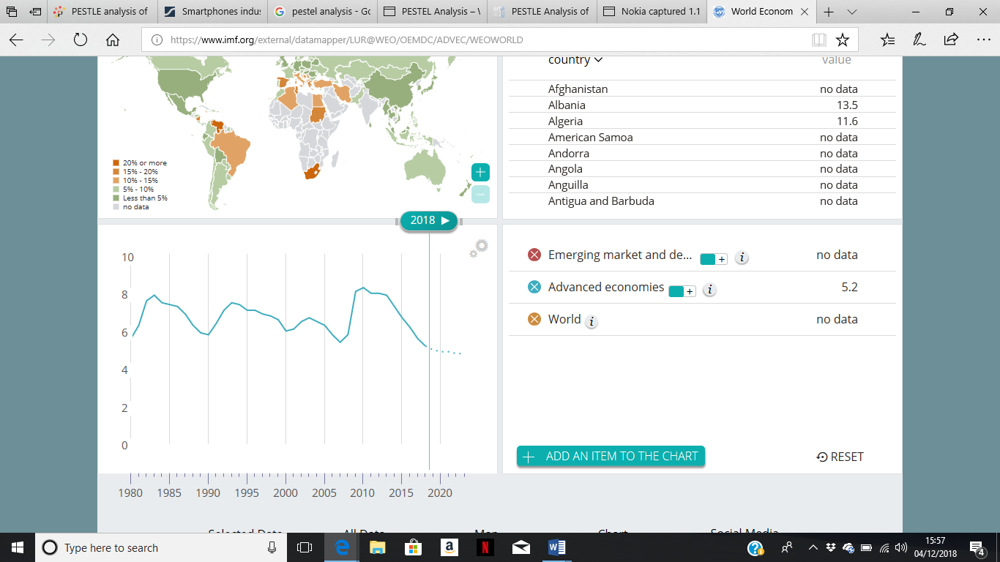

(The Financial Times 2018 )
The graph above shows that there has been a steady decline in the global unemployment rate. Between 2015 and 2018 the unemployment rate reduced by 2%, from 7.2% to 5.2%. It also shows that there will be a further decline in unemployment by 0.4 between 2018 and 2020, indicating a positive and optimistic forecast for the future.

Unemployment by continent
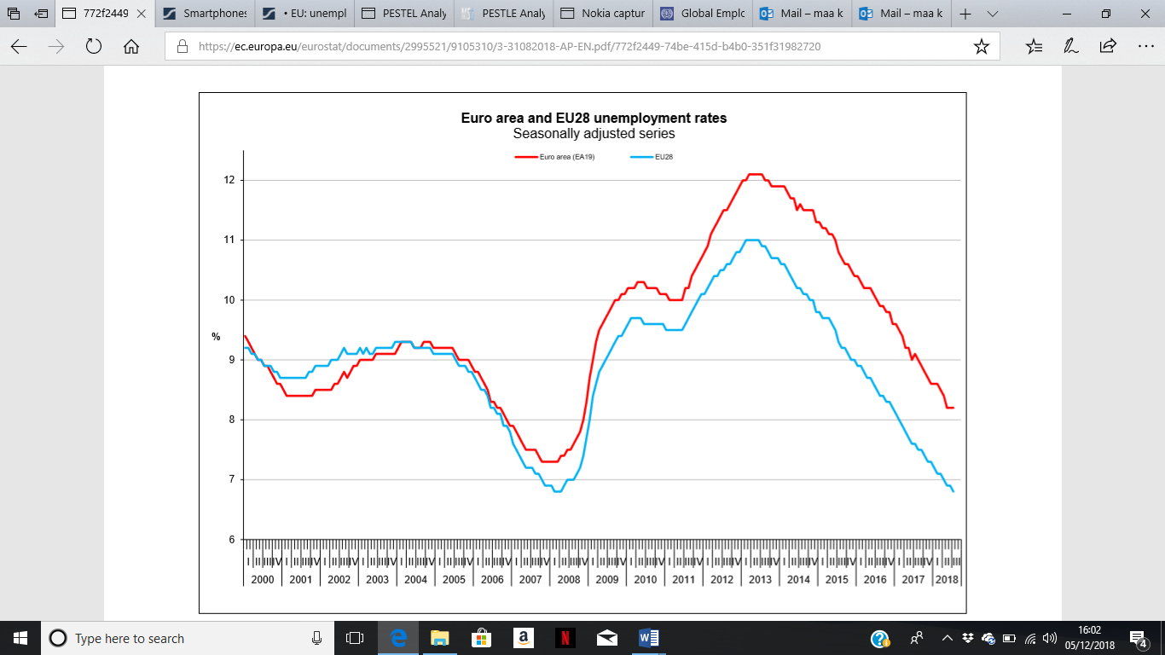
(The Financial Times 2018)
The above graph shows that labour market conditions have considerably improved across Europe compared to the crisis peak of 2009. Unemployment significantly dropped between 2014 and 2018, showing that employment growth continued to outpace labour force expansion across Europe.
Unemployment across developing and developed nations:
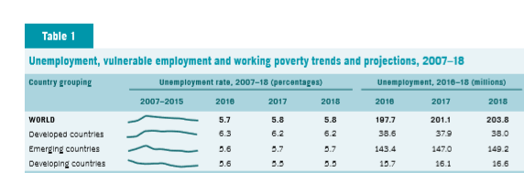
(Financial Times 2018)
The table/graph above shows the unemployment patterns across the developed, developing and emerging economies. The graph shows that unemployment increased incrementally across the developed economies between 2007-2010, whereas emerging and developing economies saw a less increase in unemployment. This means the developed nations mainly faced the impact of the economic downturn.
However, unemployment rates across the country grouping look consistent and low between 2016-2018, indicating stability in the labour markets and a positive outlook for the future.

Economic Growth
Mourdoukoutas (2018) outlined China, India, Pakistan, Brazil and Bangladesh as the most lucrative countries to sell smartphones due to the share size and attractive growth rates.
Country | 2017 (Growth Rate in %) | 2018 (Growth Rate in %)
China | 6.9% | 6.6%
India | 6.7% | 7.3%
Pakistan | 5.4% | 5.8%
Brazil | 3.2% | 5%
Bangladesh | 7.4% | 7.5%

Economic boom, soaring and greater prosperity within the emerging and developing economies has created significant opportunities for smartphone companies to develop their product range (Economist 2018). It gives smartphone makers multiple opportunities to get a foothold within these lucrative markets and build their respective market shares (Financial Times 2018).
The table above shows that countries such as China, India, Pakistan and Bangladesh have an annual economic growth rate of 5% and growing each year. This means that the demand for more sophisticated and well branded smartphones will increase significantly within the foreseeable future.
Technological
Nokia has significantly lagged behind in utilising technological advancements to its advantage (Bedhall 2017). Competitors such as Apple, Samsung and Hawaei have been more successful and flexible in incorporating technology within their Smartphones. Examples include facial recognition, faster wireless charging, improved core processors, speed and performance (O’Hara 2018). In addition, Apple and Samsung provides its own additional services such as ITunes, Apple Music, ICloud and Apple Pay which significantly has improved consumer experience and increased brand loyalty (Porter 2018).
Instead of taking advantages of technological advancement Nokia stuck to its Symbian OS which had significant problems such as poor internet performance, unsatisfactory app availability as well as frequent screen freezes and call drops which led to the decline and demise of Nokia mobile phones (Metha 2016).
Hailey (2018) anticipated the future success of Smartphones. She confirmed that to enhance consumer experience smartphone companies should create holographic displays, flexible frames, educational tools as well as eco-friendly smartphones.
Legal:
Patent and licensing infringement are common within the smartphone industry (Reuters 2010). Apple filed patent infringements lawsuit against Nokia on the grounds that Nokia was copying various hardware and software features of iPhone (Reuters 2010). Nokia needs to ensure they do not infringe competitor products when producing creating their Smartphones instead need to model their products.

Social and ethical factors
Cultural factors that had negatively impacted Nokia is the move from mobile phones to smartphones. Nokia focused more on hardware (mobile phones) and less on software (smartphones). This indicates that they were not able to adapt and keep up with instantaneous shift.
Porters 5 Force:
Porter five forces model will be used to analyse, assess and evaluate Nokia’s competitive strength and positioning within the Smartphone industry. Porter (1979) developed the model which has 5 key areas. These include the following:

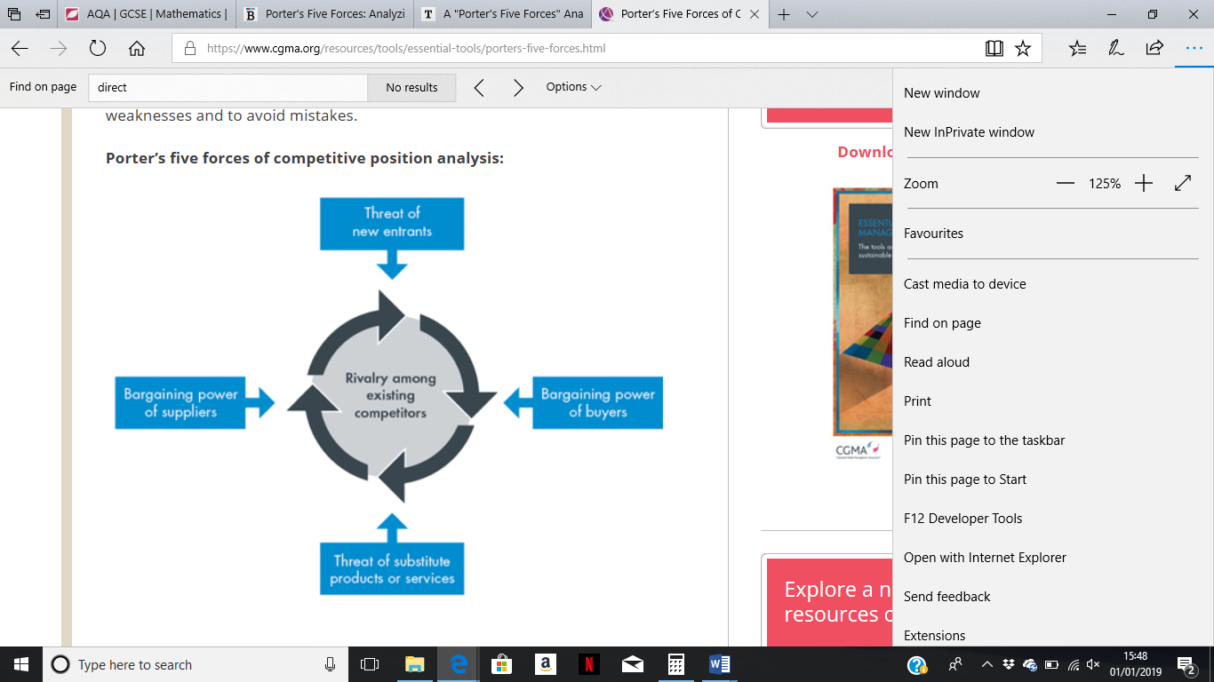
(Porter 1979)
Rivalry Amongst existing Competitors
The rivalry amongst existing competitors is competitive, fierce and aggressive (The Economist 2017). Market leaders Samsung and Apple are competing on the basis of quality, positive consumer experience and hardware and software capability (The Economist 2017). On the other hand, Nokia are significantly lagging behind in competition as it does not have R&D capability and financial resources (The Economist 2017).
Threat of new entrants:
The threat of new entrants within the smart phone industry is low. This because the market is well established market and is therefore maturing. Currently, successful players such as Apple, Samsung, Google and Huawei currently control over 75% of the market (Statstica 2018). Samsung and Apple have been able to hold and increase their respective market shares because they have created Smartphones that have met the needs of their target markets better than Nokia (The Economist 2017).
The barriers to entry in the smartphone industry is high due to high research and development, marketing and technological costs. This means Nokia does not need to worry about new entrants instead needs to focus on how it can compete its existing players in the market.

Threat of substitute products/services
The threat of substitute products within the Smartphone industry is low. Smartphones are multipurpose devices which can be used for personal, professional and social purposes. On the contrary, substitute devices such as tablets and iPads are mainly used for social and leisure purposes. This means that they cannot model or replicate the full use of a smartphone, therefore threat is significantly low.
Bargaining power of buyers
The bargaining power of customers high. This is because there are increasing number of choices for customers within the smartphone industry (Economist 2017). In addition to Nokia, customers have a choice of other more established and successful brands such as Apple, Samsung, Huawei and Google to choose from (The Economist 2017). This indicates that the market is highly competitive and the ability to choose means customers are able to switch brands without any issues (Scott 2014).
On the other hand, brand loyalty is significantly high within this industry, which somehow reduces the power of customers. Brands such as Apple and Samsung have over the years conditioned their customers positively by meeting their needs and introducing new smartphone models that are continuously evolving in terms of new features, designs and increased performance (Scott 2014). This means that customers influence on pricing significant drops as customers are happy to pay a premium as long as their needs are being met.
This is an area that Nokia have significantly lacked in leading to significant loss of market share and poor customer retention.
Bargaining power of suppliers
The bargaining power of suppliers is within the smartphone industry is dependent on the organisation. For Nokia bargaining power of suppliers is high this is because is currently using Android operating system for its new smartphone range. Nokia are currently licensing the Android operating system which is owned by Google. This means that Google can demand higher licencing fees, which can significantly impact Nokia’s pricing strategy and in return profitability.
On the other hand, Apple owns its operating system and has strong brand power and reputation which means that supplier bargaining power is significantly low.

I will now be utilising the findings from the PESTEL analysis and Porters 5 Forces within the SWOT Analysis to see where the company currently sits within its current environment.
Strength | - Hereditary brand loyalty.  - Reputation.
Weakness | - Lack of innovation capability R&D funding  - Lack of economic resources  - Poor customer knowledge - market segmentation  - Poor product demand.  - Reactive culture.
Opportunities | - Access to new lucrative markets.  - Incorporate new technology within future developments.  - Rebrand and model existing market leaders.  - Bargaining power of buyers
Threats | - Competition  - Bargaining power of supplier- Android license.

Strength
Reputation and simplicity is Nokia’s key strengths. Many customers still prefer Nokia more than other brands because of reliability and durability. Nokia needs to use these strengths to their advantage.
Weaknesses:
The table above confirms that Nokia has multiple weaknesses. These include lack of innovative capability and poor R&D spending. This means that Nokia needs to pore more money into its research and development so that it can gain its lost ability to innovate, create smartphones which have state of art features and functions. This will help them improve their productivity, efficiency and cost intensity.
However, for this to take place Nokia needs to ensure that it starts to increase its financing within this area. However, a difficulty that Nokia has is that it has the lowest R&D budget amongst its established competitors. This means there needs to be a complete change in the company culture and strategy for this materialise.
Another major weakness of Nokia is poor customer knowledge which has resulted in poor demand for their Smartphones. Nokia have failed to respond and adapt to the market demands which meant that the demand for their smartphones has declined impacting significantly on their market share. This means that Nokia need to ensure that it changes its market segmentation strategies and introduces smartphone in the market that have a Unique selling point (USP).
Opportunity
The table above indicates that there are significant opportunities for Nokia. Gaining access to new lucrative markets such as Pakistan, Bangladesh and India means that customers have better disposable income which in return means that customers are more likely to purchase Smartphones. For Nokia to be successful it needs to firstly understand the diverse needs of these lucrative markets and then align its Smartphone functions, designs and software capability with the demands, need and wants of the customers. Given that Nokia has lost significant ground and market share it is pivotal for them to use low pricing strategies within these markets. This will help Nokia penetrate the market, stimulate demand and gain value in market shares within these markets.
Rebranding itself by incorporating technological advancements within its future developments is a significant opportunity for Nokia. Nokia previously lost competitive edge due it not using technology to its advantage. Nokia needs to rebrand itself by embracing and adapting new technology in its smartphones. This includes ensuring speed, performance, reliability, app availability, facial recognition and wireless charging are all incorporated into new Smartphones so that it provides Nokia with a Unique selling point (USP) and help them compete against market leaders.
Bargaining power of buyers within the smartphone industry is high where brand loyalty is significantly low. This creates an opportunity for Nokia on the basis that if it produces successful smartphones customers are more likely to switch brands indicating an increased demand for its smartphones.
Threat
Competition is a significant threat for Nokia. Nokia operates within an oligopoly market structure where competition and the drive to innovate is significantly fierce. Apple and Samsung have a dominance within the market, hence will aim to drive Nokia completely out of the market. This means that Nokia will need to be extremely interdependent where it needs to closely monitor the strategic moves of its rivals so that they can be proactive enough and counteract any threat with a positive response.
Nokia currently licenses the Android operating system from Google. This means that Google have more bargaining power over Nokia which suggests that Google can apply pressure on Nokia by raising prices, lowering quality of Android system and reducing availability as well as demanding more money from Nokia for using the system. This will make Nokia less competitive amongst its arrivals as Apple has its own operating system.
I will now analyse the potential of Nokia to undertake the opportunities as addressed in the SWOT analyses and nullifying the threats with the implications of weaknesses and strengths they bring.
Option 1: Gain access to lucrative markets – South Asian markets.
Gaining access to the south Asian market means that it will give Nokia an opportunity to sell its Smartphones to a market that has a population of over 1.5 billion. Given the share size of the market the potential for Nokia to gain a significant foothold in the market and become successful is extremely promising.
However, bearing in mind that Nokia is a European country will mean that they will face significant cultural challenges in south Asia. According to McGrae (2002) culture has a significant impact and influence on consumer behaviour, lifestyle and purchasing decisions.
Hofstedes theory of cultural dimensions explores cultural difference and similarities amongst different nations (Hofstede 2007). The analysis is based on 6 key areas:
- Individualism vs collectivism
- Masculinity vs Femininity
- Uncertainty avoidance
- Power distance
- Time perspective
- Indulgence and restrain.
From the macroeconomic research it can be identified that in the past Nokia’s key target markets have been Europe and USA. As Nokia is a Finnish country it would be wise to analyse the results of Finland and south Asian countries such as Pakistan, India and Bangladesh.
Finland
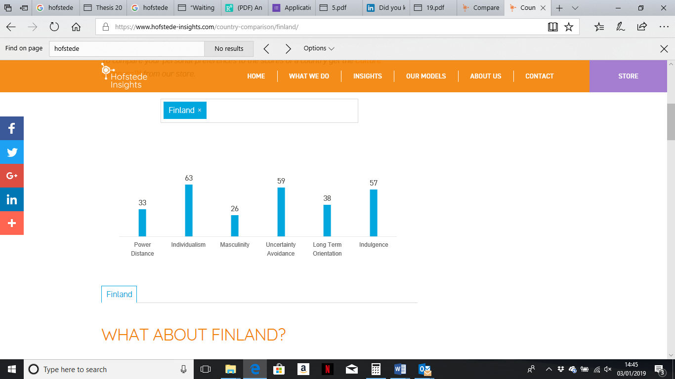
(Hofstede-Insights 2018)

Pakistan
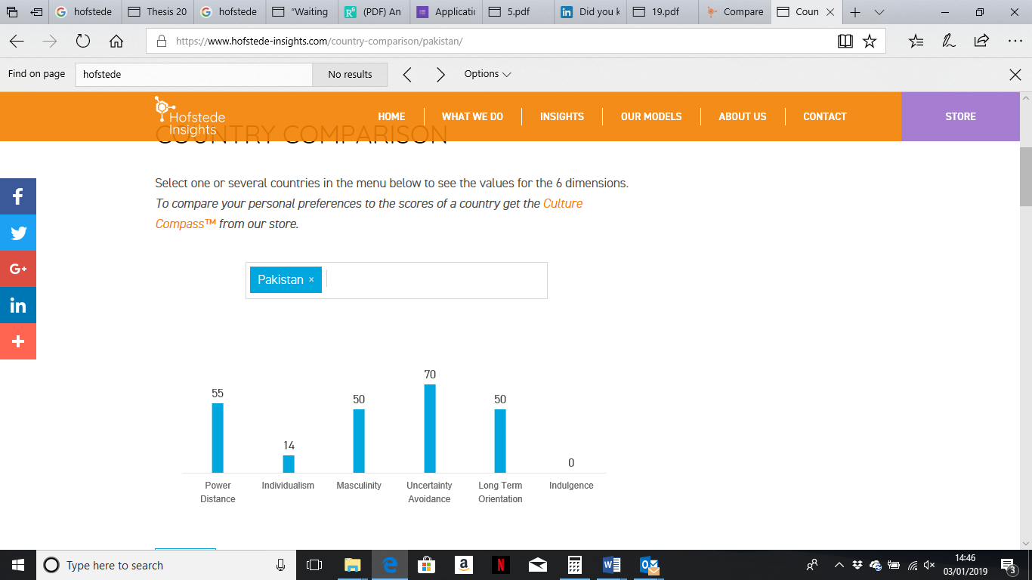
(Hofstede-Insights 2018)

India
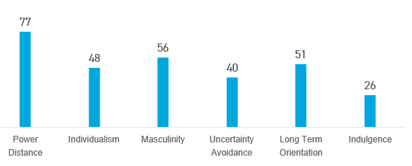

(Hofstede-Insights 2018)

Bangladesh

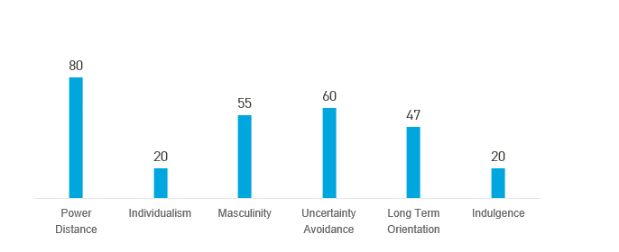
(Hofstede-Insights 2018)
Looking at the results above Finland results significantly different from the south Asian countries in the area of indulgence, individualism, power distance. South Asian countries are more likely to refrain from indulgence, focus more collectively and have a long term orientation. On the contrary, people in Finland are more likely to indulge, think individualistically and have short term orientation.
Implications for Nokia
Low level of indulgence:
Low level of indulgence in South Asian markets means that Nokia will find it harder to acquire new customers. This is because customers are more likely to control their desires and impulses. This means that customers in South Asia are likely to restrict and refrain themselves from buying a new product in the market instead will wait until prices have dropped. This means that Nokia are likely to experience sluggish growth and poor customer acquisitions. On the other hand, Nokia can take this as an opportunity to create and launch Smartphones that are of budgeted and medium range and refrain itself from launching flagship smartphones.
Individualism vs collectivism
High level of collectivism means that customers from south Asian countries are more likely to purchase smartphones for their loved ones compared to individualistic societies. Also they are more likely to use similar smartphones. This means Nokia will need alter its marketing strategies and target the customer rather than the consumer.
In order for Nokia to enter the south Asian markets it will need to make some important decisions in choosing the best market entry strategies to service the market. This type of decision is pivotal because it will have an ongoing impact on a Nokia’s overall international business and finance performance (Anderson and Coughlan 1987; Klein and Roth 1990).
First market entry strategy that Nokia can implement is exporting. Exporting is the activity of sending or carrying goods abroad to sell for trading purposes (Baker 2013). There are two exporting methods that Nokia can implement direct exporting and indirect exporting (Patterson and Cicic 1995).
Indirect exporting
Adopting indirect exporting strategy will mean Nokia using domestic management companies, merchants and distributors to manage and market their smartphones abroad (Lambin 2007). The benefit that this option will bring is low level of risk and cost benefits. This is because minimal investment will be needed abroad which means that it will be extremely cost effective for Nokia. Nokia will be able to use domestic companies that may have a better understanding of the home market conditions as compared to themselves. This means that domestic intermediaries will be able to better market the unique selling point (USP) of Nokia smartphones to their respective target markets. This is because the domestic intermediaries will provide Nokia with “readily available” expertise (Chung 2001) that Nokia do not immediately possess.
On the other hand, adopting this strategy also means that Nokia will have least market control. Nokia can overcome this issue by taking on management companies that operate on flexible and adaptable terms and conditions.
Direct exporting
Adopting a direct exporting strategy will mean Nokia becoming actively involved in selling and managing its products in the south asian markets (Lieberman and Kang 2008). This automatically means that Nokia need to setup set up offices, shops and also to some extend distribution channels. This means that Nokia will incur significant financial implications relating to fixed, variable, direct and indirect costs. On the other hand, profits are likely to be greater where high risk means higher returns.
Nullifying the threats
Competition
One of the major threats for Nokia is competition from Apple, Samsung, Huawei and Samsung. Nokia will need to resist and overcome competition from these market leaders. However, the only way this can be done is by creating smartphones that are unique, innovative and with the latest features and technology. Lowering the price is pivotal as it will allow Nokia to penetrate the market, gain market share and simultaneously recover its lost reputation as a market leader. Once customers start to engage with Nokia’s smartphones and really appreciate the value of them Nokia can then change their pricing strategy, which will give them more profitability. In other words they will need to take the hit in the short term to accumulate then benefits in the long term.
Bargaining power of supplier: Nokia Licencing Android Operating system from Nokia.
Nokia is currently licencing Android operating system from Nokia. This means that the licensor Google are allowing the licensee Nokia to use Android OS in exchange for royalty fees. This is a threat in the long term as Google can demand more royalty fees which can eat into Nokia’s profits, forcing them to drive smartphones price up, hence making Nokia less competitive.
In an ideal world it would be great for Nokia to overcome this threat by firstly investing into its R&D and develop a similar operating system like Android. However, the feasibility of this move can be questioned. Firstly, Nokia will need to spend billions developing a flagship operating system like Android. Currently, this is not likely as Nokia has a low R&D capability and budget. However, to become market leaders they will need to take these steps in the long run. If Nokia does create its own operating systems it needs to ensure that they do not infringe patent or licences.

IMF (2018) have outlined many challenges that the global economy is facing. The one I believe that will significantly affect Nokia is
“slow growth in labour productivity combined with aging populations in developed countries and the rise in AI and robotics”
(IMF 2018 page 1)
Labour productivity can be defined as the amount of output that is gained from each employee per hour or per shift (Rudolf and Zurlinden 2010). There are three key determinants of labour productivity. These include human capital, technological change and economies of scale (Heshmati 2011).
Nokia’s key manufacturing plant for smartphone production are based in European countries such as Finland and Germany. It also has some overseas manufacturing plants based in China.
Slow growth in labour productivity means that Nokia are not utilising the human capital available to them to its full potential. There can be many reasons including stagnant wages, poor morale, nature of employment and skills and qualifications of workers. This can have significant impact on Nokia’s ability to be competitive, efficient and cost effective. Lack of labour productivity means Nokia not benefiting from economies of scale (Pedroni 2004).
The graph below demonstrates the concept behind economies of scale. Currently Nokia are at AC2 stage where the labour cost per unit (LCPU) is high due to poor productivity as they are only producing at Q2 stage. This means the cost of employing an employee is significantly higher as due to low output levels
However, if Nokia become more productive, it will move to AC1 stage where the cost of employing will significantly reduce as the employee is now producing more output per the hour, hence becoming more effective and efficient.

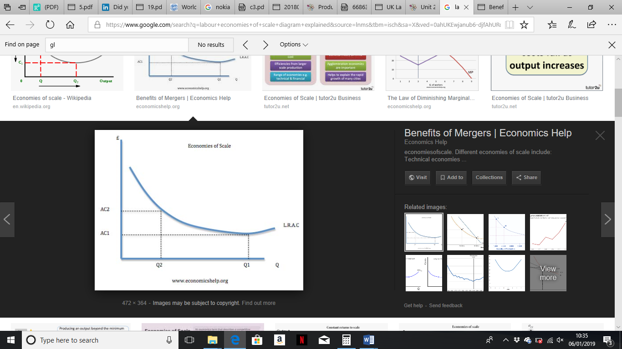
(Heshmati 2011)
In order for Nokia to benefit from economies of scale it needs to invest in its human capital. This means Nokia needs to provide the necessary training and development to its employees so that they can become more effective, productive and also efficient. This will make Nokia extremely competitive. However, to make this practical, changes in company policy and significant financial investment in human capital is required. However, from the PEST analysis it can be identified that Nokia are a cash trapped company. This means such move is unlikely to happen in the near foreseeable future. However, Nokia can make it a long term strategic move for themselves by encompassing into the their future missions, aims and also objectives.
Aging population in the developed countries:
Aging population in developed countries will bring both benefits and also challenges for Nokia.
Benefits:
Nokia’s mobiles and smartphones are known for their simplicity and reliability. The older population also prefer to purchase mobile phones that are easy to function and use. This means that there is a potential market that Nokia can target and tap into. The older generation have excellent disposable which means that if they are attracted to a potential product they are more likely going to buy it without considering the price of the product. This means Nokia should produce smartphones which are easy to use and have applications and software that are extremely user friendly. Such move will bring significant benefits to Nokia, firstly, it will increase their competitiveness, customer acquisition as well as market share which is pivotal for Nokia given that their share of the market has reduced significantly.
Disadvantages:
Aging population means that it will be difficult for Nokia to find younger staff. This means that they will need to keep employing older staff which can bring significant challenges including health related absences, employees retiring earlier and as well as out of date skills and qualifications. This will have significant implications for Nokia. Firstly, they will need to change their HR policies and practices as well as health and safety policies. Secondly, they will need to change their employee benefits package and well being strategy. This means that there will need to be a total cultural change in Nokia as well as a shift in strategy and direction.
An older population means that It will be difficult for Nokia to replace existing employees once they retire. Older employees bring significant skills, abilities and attributes such as experience, expertise and dedication to their job. This means their will be significant knowledge gap at Nokia which will be detrimental to the competitiveness and productivity of Nokia.
AI and Robotics:
Artificial Intelligence is a process of creating intelligent machinery that work and react like humans. This compasses speed recognition, learning and planning. Nokia, have various AI machinery on the production line which helps improve productivity and also efficiency. The benefit of using AI means that output levels will increase significantly, hence making Nokia extremely competitive.
The advancement in artificial intelligence means that Nokia should use AI as a mechanism to grow and develop and become competitive. Nokia can do this by either acquiring AI technology firms or invest in R&D to develop. This can help them keep up with competitors across mobile computing. Example can include purchasing machine-learning technology which will help Nokia facilitate hands free communications.

Conclusion:
From the external environment analysis it can be confirmed that there are many factors affecting Nokia’s ability to be competitive. Examples include economic factors, the extent of technological change and the fierce competition amongst from its competitors. Nokia has been unable to compete successfully due to the lack of investment in research and development and poor understanding of customer needs. It can also be noted that Nokia has not been able to take advantage from the advancement in technology, which has led to the demise of Nokia.
However, from the SWOT analysis it is evident that there are opportunities for Nokia which will help them with customer acquisition, customer retention and hence improve its market share. These include access to new lucrative markets, incorporation of new technology within future developments as well as the ability to acquire customers from competitors.
This means that Nokia does opportunity to build its lost reputation and also become a market leader. However, this is cannot happen overnight instead it will need significant alterations in Nokia’s long term aims and objectives as well as its long term strategy. For instance, more investment in research and development is pivotal for Nokia. Such changes will aide Nokia’s development and help them become more successful within the smartphone industry.
Overall, it can be stated that Nokia has many challenges in the foreseeable future and will need to safeguard itself from competitors through continuous improvement and also innovation.

Bibliography
Aguilar, FJ. (1967). Scanning the international business environment. 2nd ed. [Cambridge].
Anderson,E.andA.T.Coughlan(1987).“InternationalMarketEntryandExpansionviaIndependentorIntegrated Channels of Distribution.” Journal of Marketing 51, 71–82
Bedhall J. (2017). The Rise and Fall of Nokia Mobile Phones | Finland Today. [ONLINE] Available at: https://finlandtoday.fi/the-rise-and-fall-of-nokia-mobile-phones/. [Accessed 06 January 2019].
Chuan, J. (2011). Permanent versus Mobile Entry Decisions in International Construction Markets: Influence of Home Country and Firm Related Factors Journal Of Management In Engıneerıng.
Chung, H.F.L. (2001). “An Analysis of Taiwan’s Distribution System.” International Journal of Retail and Distribution Management 29, 87–98.
Doz Y, (2017). The Strategic Decisions That Caused Nokia’s Failure | INSEAD Knowledge. [ONLINE] Available at: https://knowledge.insead.edu/strategy/the-strategic-decisions-that-caused-nokias-failure-7766. [Accessed 06 January 2019].
Financial Times. (2018). Global Employment hits its lowest point | Financial Times. [ONLINE] Available at: https://www.ft.com/content/1e8f4cf4-f257-11e8-ae55-df4bf40f9d0d. [Accessed 06 January 2019].
Hailey, P (2017). The smartphone is eventually going to die, and then things are going to get really crazy | The Independent. [ONLINE] Available at: https://www.independent.co.uk/life-style/gadgets-and-tech/smartphone-iphone-die-fashion-technology-apps-trends-future-crazy-advancement-a7674991.html. [Accessed 06 January 2019].
Heshmati, A. (2011). Development and Sources of Labor Productivity in Chinese Provinces. IZA Discussion Paper, (No 6263), 1-30. Retrieved from http://ftp.iza.org/dp6263.pdf
Hofstede Insights. (2018). National Culture - Hofstede Insights. [ONLINE] Available at: https://www.hofstede-insights.com/models/national-culture/. [Accessed 06 January 2019].
Hofstede, G. (2007) A european in Asia. Asian Journal of Social Psychology, 10, pp. 16–21.
Hopewell A. (2008). Breaking Into The Trade Game: A Small Business Guide To Exporting, U.S. Small Business Administration International Publication www.sba.gov/international
Klein,S.andV.J.Roth(1990).“DeterminantsofExportChannelStructure:TheEffectsofExperienceandPsychic Distance Reconsidered.” International Marketing Review 7, 27–38.
Lieberman, M. B., & Kang, J. (2008). How to Measure Company Productivity Using Value-Added: A Focus on Pohang Steel (POSCO). Asia Pacific Journal of Management, 25(2), 209-224.
McCrae, R.R. (2002) neO-PI-R data from 36 cultures, in Marsella, A.J. & McCrae, R.R. (eds) The Five-factor Model of Personality Across Cultures. Dordrecht, the netherlands: Kluwer
Metha J (2016). How The Mighty Have Fallen: Lessons From The Death Of Blackberry And Nokia | HuffPost India. [ONLINE] Available at: https://www.huffingtonpost.in/2016/09/30/the-reason-behind-the-death-of-blackberry-and-nokia_a_21483784/?guccounter=1&guce_referrer_us=aHR0cHM6Ly93d3cuZ29vZ2xlLmNvbS8&guce_referrer_cs=mtOnJ5CZaFzGTnl4v9PS3Q. [Accessed 06 January 2019].
Mourdoukoutas, P. (2018). Samsung Beats Apple In The Global Smartphone Market As Chinese Brands Close In. [ONLINE] Available at: https://www.forbes.com/sites/panosmourdoukoutas/2018/09/13/samsung-beats-apple-in-the-global-smartphone-market-as-chinese-brands-close-in/#1cd7708d697d. [Accessed 06 January 2019].
Nokia. (2018). Our history | Nokia. [online] Available at: https://www.nokia.com/about-us/who-we-are/our-history/ [Accessed 3 Jan. 2019].
Nokia. (2019). Our approach | Nokia. [online] Available at: https://www.nokia.com/about-us/sustainability/our-approach/ [Accessed 3 Jan. 2019].
O’Hara A (2018). These are the top 7 features of the new iPhone XS & iPhone XS Max. [ONLINE] Available at: https://appleinsider.com/articles/18/09/29/these-are-the-top-7-features-of-the-new-iphone-xs-iphone-xs-max. [Accessed 06 January 2019]
Patterson, P.G. and M. Cicic (1995). “A Typology of Service Firms in International Markets: An Empirical Investigation.” Journal of International Marketing 3, 57–8
Pedroni, P. (2004). Panel Cointegration: Asymptotic and Finite Sample Properties of Pooled Time Series Tests with an Application to the PPP Hypothesis. Econometric Theory, 20(3), 597-625. https://doi.org/10.1017/S0266466604203073
Philips.J (2017). Power and inequality in the global political economy | International Affairs | Oxford Academic . [ONLINE] Available at: https://academic.oup.com/ia/article/93/2/429/2997439. [Accessed 06 January 2019].
Reuters (2010). Nokia sues Apple for infringing patents, industry back on war footing | Reuters. [ONLINE] Available at: https://www.reuters.com/article/us-nokia-corp-apple-patent-idUSKBN14A228?il=0. [Accessed 06 January 2019].
Robert, M (2016). The New Strategic Thinking: Pure & Simple, McGraw-Hil
Rudolf, B., & Zurlinden, M. (2010). Productivity and Economic Growth in Switzerland 1991-2006. Swiss journal of Economics and Statistics, 146(3), 577-600
Scott, M (2014). Nokia Announces New Strategy, and a New Chief to Carry It Out - The New York Times. [ONLINE] Available at: https://www.nytimes.com/2014/04/30/technology/nokia-announces-new-strategy-and-chief-executive.html. [Accessed 07 January 2019].
The Economist. (2017). Rivalry between Apple and Samsung in smartphones will grow fiercer - Phone tag. [ONLINE] Available at: https://www.economist.com/business/2017/09/14/rivalry-between-apple-and-samsung-in-smartphones-will-grow-fiercer. [Accessed 06 January 2019].
The Economist. (2018). The world’s most valuable resource is no longer oil, but data - Regulating the internet giants. [ONLINE] Available at: https://www.economist.com/leaders/2017/05/06/the-worlds-most-valuable-resource-is-no-longer-oil-but-data. [Accessed 06 January 2019].
The Irish Times. (2015). Finland struggling to find way in post-Nokia world. [ONLINE] Available at: https://www.irishtimes.com/business/technology/finland-struggling-to-find-way-in-post-nokia-world-1.2178606. [Accessed 03 January 2019].
Yu H. (2017). LESSONS FROM AN UNLIKELY CANDIDATE: NOKIA IN CHINA (2001 to 2008). [ONLINE] Available at: https://www.imd.org/research-knowledge/articles/lessons-from-an-unlikely-candidate--nokia-in-china-2001-to-2008/. [Accessed 06 January 2019].

