Assignment 2:
Project Management & Innovation

COURSE: BSc Applied computing
Module NaMe: Changemakers: Creativity and Value Creation
Module Code: ACCA5033
Lecturer: DR Fahad AHMED
submission DATE: 15th DECEMBER 2025
date submitted: 11th December 2025

Trinity saint david University of Wales (London Campus)

Meliha Redzhep (2416885)



Table of Contents:
Task 1: Project Management 4
Project Management & Planning: 4
Project Design: 6
Storyboard produced on Figma: 6
Wireframes produced on Figma: 7
Task 2: Enterprise & Innovation: 9
T2- Enterprise: 9
PEST & SWOT: 9
Start-up Concept: 10
Task 3: Project Reflection: 11
Conclusion: 13
References: 14
Appendices: 15

Introduction:
This report explores the creation of a “Digital Wellbeing Analytics Platform” to assist users in tracking their screen usage, behaviour, productivity, and general mental health. The platform seeks to encourage professionals and students to adopt better digital habits through automated data gathering and visual analytics. The report demonstrates a thorough grasp of innovation, creativity, and value creation by covering project management techniques, design artefacts, enterprise factors, and personal reflection. The research illustrates how a technically viable concept may be developed into a significant digital solution with both social and financial effect using well-established theoretical models and approaches.

Task 1: Project Management

Project Management & Planning:
A Digital Wellbeing Analytics Platform (DWAP) is a data-driven system that tracks screen time, focus sessions, frequency of breaks, mood entries, and general device usage patterns to assist users in understanding and controlling their digital behaviours. The goal of the project is to create a working prototype with three main components: a secure backend for data storage, a visual analytics dashboard, and a data-input module. Due to time, budget, and technological complexity, advanced capabilities like predictive analytics, or behavioural AI modelling, are unable to be incorporated in the initial phase. The main goal is to create a functional system that shows how digital conduct may be recorded, analysed, and displayed in a meaningful way. This aligns with “Unit 3 Topic 4: Making it Happen” which emphasises planning realistic implementation and managing constraints effectively.
The proposed solution is a mobile-responsive online application that lets users manually enter wellness measurements while the platform automatically monitors patterns of device engagement. Weekly and monthly summaries, alongside trend visualisations promote attempts to enhance digital wellness by helping users recognise harmful patterns, such as excessive screen time or poor focus-to-break ratios. This approach addresses common worries about burnout, technostress, distractions, and digital fatigue, all of which have gotten worse as a result of remote learning and hybrid work situations. [1]
The project's development is aided by a variety of technologies. Figma will be used in the interface's design to guarantee user-centred structure and clear layout planning. “HTML, CSS, and JavaScript” will be utilised to develop the prototype. Firebase will provide a cloud-based backend, and “Chart.js” will be used to produce visual charts. Task management and scheduling are supported by programs like “MS Excel” and “GanttProject”. However, project constraints include limited development time, balance between analytical depth and visual clarity, and fundamental privacy rights.
The twelve-week project timetable starts with research (Weeks 1-2), moves on to design (Weeks 3–4), implementation (Weeks 5–8), testing (Weeks 9–10), and final project assessment (Weeks 11–12). The Agile methodology with a “Kanban workflow” was chosen because it allows for flexible adaption, constant testing, and iterative improvements. [2] These aspects are advantageous for a project that prioritises design and usability. A Gantt chart shows each phase, its dependencies, and its expected length to display this structure. [3]

Table for Gantt Chart:
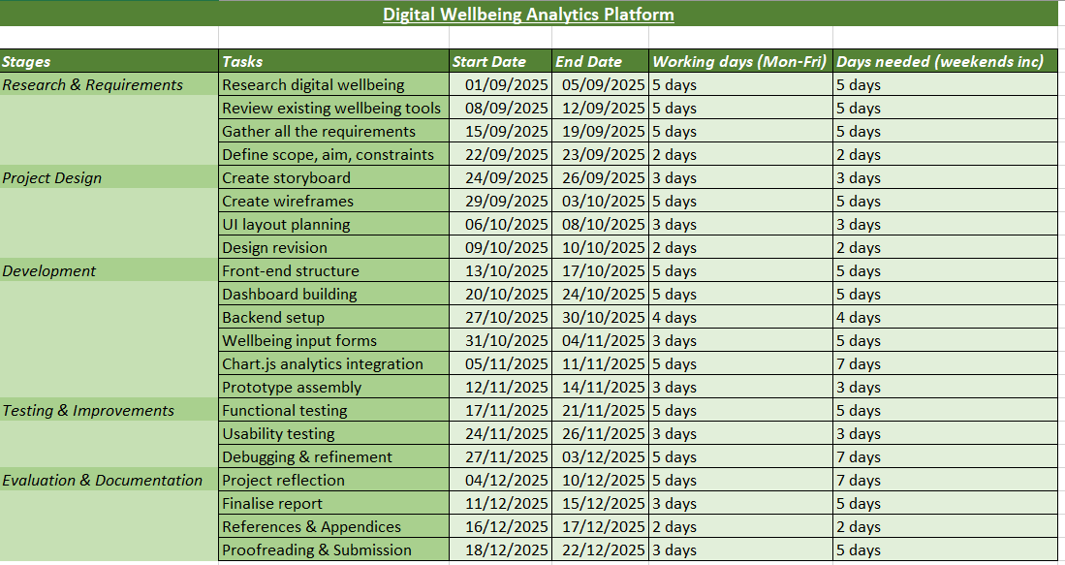
Gantt Chart:
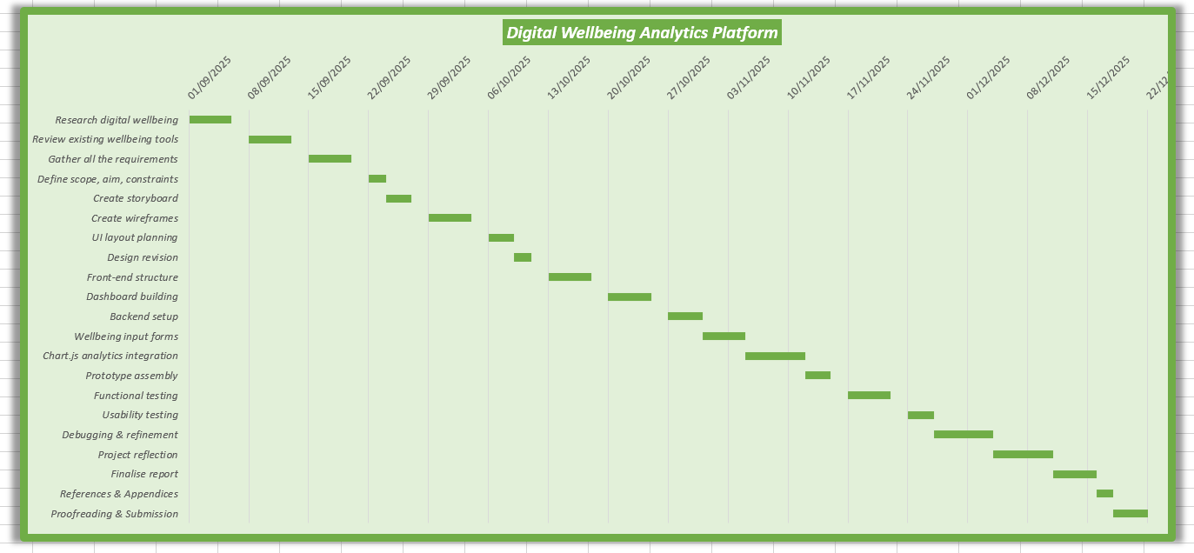

Project Design:
In order to visualise user interactions and guarantee a clear user experience prior to development, two design pieces were created, a storyboard and wireframe.
The main goal during the product design phase is creating concise, user-centred visual representations of how a Digital Wellbeing Analytics Platform would operate in a real-world scenario. Moreover, to maintain the suggested solution's accessibility, usability, and alignment with the principles of digital wellness, this stage aimed to convey the fundamental interactions, user objectives, and system reactions by using organised low-fidelity design artefacts. The two main deliverables are: an eight-frame storyboard which outlines the user’s journey and multiple low-fidelity wireframes depicting the primary user interface screens.
To illustrate the user's emotional and behavioural journey while engaging with the site, a storyboard was made utilising Figma's assistive design tools. Scenes including: diagnosing digital tiredness, examining activity insights, spotting usage trends, getting positive wellbeing recommendations, and creating individualised objectives were all featured. A brief description describing the user activity and the system's predicted response was included with each frame. By using Figma, it allowed me to make all creative and conceptual decisions while maintaining a consistent layout, clear images, and quick iterations. By doing this, the storyboard was guaranteed to be professional and in line for a user-centred design.

Storyboard produced on Figma:
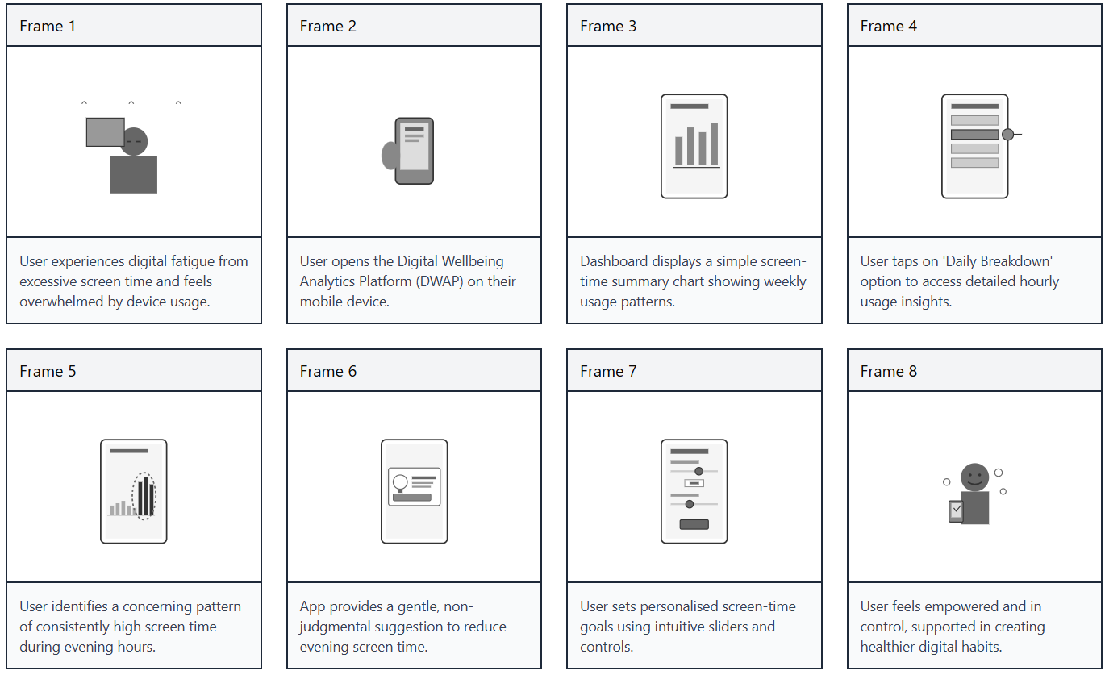

Furthermore, to prioritise structure over looks, the wireframes were also created in Figma using a low-fidelity technique. The Dashboard Overview, Daily Breakdown, Trends and Insights, Goal Setting, and Settings page are the five key displays that were created. Each wireframe illustrates layout, information hierarchy, and interaction flow using basic shapes, placeholder charts, and annotated explanations. This approach guaranteed that the design would be available for early assessment prior to any conceivable development.

Wireframes produced on Figma:
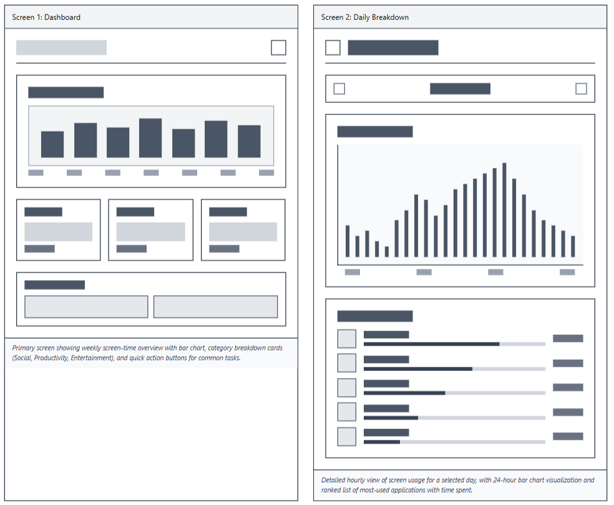
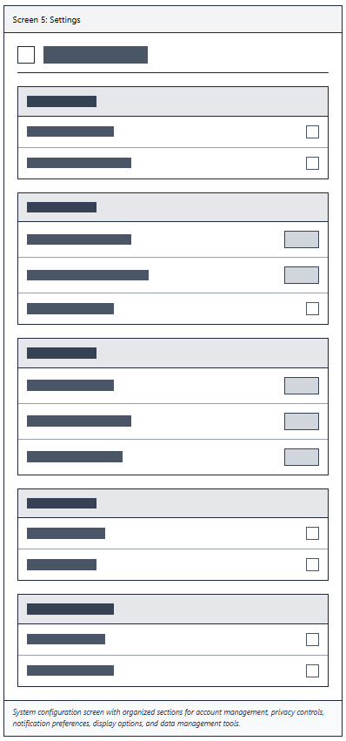
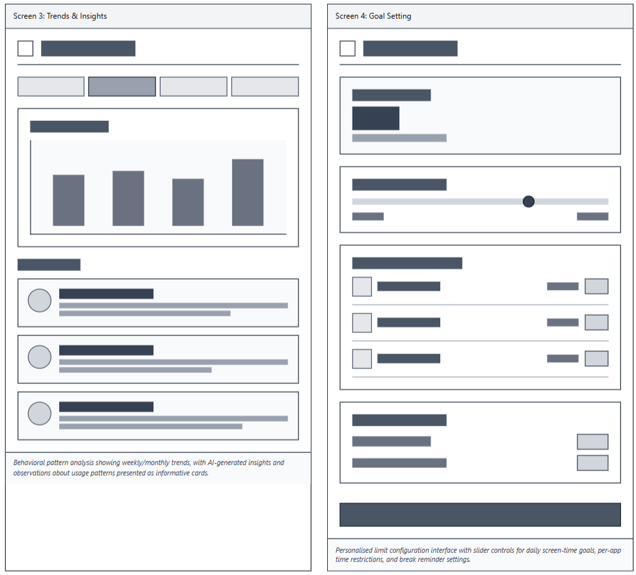
The storyboard and wireframes work together to create a cohesive design package that conveys the Digital Wellbeing Analytics Platform's planned functionality. These design pieces display professional consideration of usability, cognitive load, and wellbeing-focused interaction design.

Task 2: Enterprise & Innovation:

T2- Enterprise:

PEST & SWOT:
Due to its significant involvement in analytics, wellness tools, and behavioural insights, "Google" is used as the reference business for the PEST and SWOT analysis in order to contextualise the organisational environment surrounding digital wellbeing technology. This analysis aligns with “Unit 2 Topic 4: Creating Value” by examining how organisations generate meaningful impact within their sector.
The “PEST (Political, Economic, Social, Technological factors)” analysis [4] identifies a number of outside variables influencing the field of digital wellness. Politically, Google has to abide by strict international laws like the CCPA and GDPR, which have an impact on the collection, processing, and storage of wellness data. Google's strategic approach is impacted economically by changes in digital advertising marketplaces and investments in wellness-focused technology. Social reasons include growing public interest in self-tracking technologies, work-from-home exhaustion, and growing worry over digital addiction. Rapid developments in AI, cloud computing, and behavioural analytics are examples of technological variables that put Google in a position to innovate in wellness solutions. [5] This review reflects the principles from “Unit 3 Topic 1: Power of Networks” by considering how PEST factors shape strategic opportunities.
Google's strategic environment is further examined via the SWOT analysis. A “SWOT (Strength, Weakness, Opportunities, Threats)” analysis helps discover and analyse an organisation’s strengths, weaknesses, opportunities, and threats. [6] Its extensive ecosystem, sophisticated AI capabilities, worldwide user base, and financial resources are among its strengths. Weaknesses include reliance on data-driven business models and public mistrust of data privacy. Opportunities exist for integrating wellness analytics into industrial, hospital, and educational settings. Apple's competitors, governmental pressure, and the dangers of cybersecurity flaws are all threats. [7] This evaluation supports “Unit 3 Topic 4: Making it Happen” by identifying practical conditions and constraints that influence how a digital product can be developed and sustained.
For the Digital Wellbeing Analytics Platform, this study offers insightful information. The platform's development principles are strongly influenced by the significance of ethical analytics, responsible data usage, and transparency. Additionally, there is a lot of room for innovation and expansion in this industry given the market prospects that have been discovered, such as the growing need for wellness technology.

Start-up Concept:
Derived from the idea, MindTrack Analytics, a digital wellbeing firm committed to empowering consumers with insightful, data-driven information, is the start-up concept. The company's goal to integrate cognitive awareness ("Mind") with methodical data monitoring ("Track") is reflected in the name. The brain icon in the logo, which has incorporated data connections, represents analytics and well-being in a contemporary, minimalistic manner.
MindTrack Analytics Logo (Created on Canva):
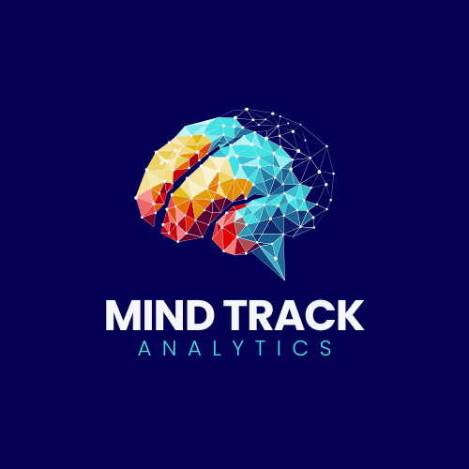
Due to its scalability, investor appeal, and liability protection, MindTrack Analytics would function as a Private Limited Company (Ltd). Collaborations with organisations like universities, mental health networks, and workplace wellness programs are made possible by this framework, which supports the professional credibility needed when managing sensitive wellbeing data.
The three main components of the business plan are long-term scalability, evidence-based design, and accessibility. A free baseline edition with daily logs, restricted analytics, and basic summaries would be part of the initial design offering. Deeper insights, trend analysis, tailored suggestions, and device connections would all be available in a premium membership. Digital advertising, social media interaction, and collaborations with academic institutions are key components of the optimum marketing strategy. Partnerships with psychologists and wellness specialists boost the product's scientific legitimacy and set it apart from rivals, ensuring product success.

Task 3: Project Reflection:
Creating the Digital Wellbeing Analytics Platform has been a rewarding endeavour that has greatly advanced my technical, creative, and personal growth. One of the most beneficial areas of development was exploring how I would create user-centred digital solutions, where technology promoted wellness. I gained an improved grasp of how people may engage with data-heavy interfaces and learnt how I would aim to communicate complicated analytics in an understandable way through wireframing and storyboarding. This increased my understanding of usability principles, layout consistency, and the significance of lowering cognitive load which are all crucial elements for creating systems that promote health.
Additionally, the project improved my project management abilities. I became familiar with how I would adopt iterative development through the usage of the Agile approach, which would require regular assessment and adaptable changes to improve concepts. I would be able to efficiently manage deadlines, keep consistent progress across all stages of development, and arrange activities by using tools like “MS Excel” and “GanttProject”. My ability to prioritise important features, avoid unnecessary complexity, and adjust to unforeseen obstacles would be enhanced by this methodical approach. Professional computer settings, where time management and iterative development are crucial, benefit from these abilities.
My involvement was further inspired by the project's societal importance. Many people suffer from digital fatigue, burnout, and bad screen habits. By assisting users in identifying unhealthy patters, platforms such as DWAP could provide valuable support. The platform would help people make thoughtful and healthier digital decisions by offering visual insights into activity. This may enhance mental health, boost output, and help people who struggle with focus, worry, or distractions. The research demonstrated how technology can play a significant role in encouraging better living.
However, there would also a number of risks and difficulties associated with the project. Managing sensitive data appropriately would be one of the main challenges. Strong ethical concerns are necessary for wellbeing information, even in prototype form. This would highlight the necessity of minimising needless data collecting, implementing safe data storage structures, and following the “Privacy by Design” principles. [8] Accurately analysing behavioural data could present another difficulty. I would create the analytics component with an emphasis on descriptive insights rather than prescriptive assessments in order to minimise misleading concerns. This can make it possible for consumers to be empowered by knowledge without being overtaken by automated suggestions.
Additionally, there are likely to be technical difficulties, especially when integrating Chart.js and making sure it is responsive on mobile devices. Early prototype, modular design, and ongoing testing would be used to solve them. Another issue would be time management, particularly when juggling design and development work at the same time. This problem would be managed by setting weekly objectives and upholding an Agile process. Risks to user engagement could emerge, for example: if insights are not visually appealing or relevant, users may get disengaged. [9] I concentrated on simple visual design and intuitive navigation to resolve this.
Overall, the project improved my technological proficiency, solidified my comprehension of ethical technology design, and increased my self-assurance as an inspiring computer professional. It illustrated how innovative thinking, methodical planning, and reflective practice can result in the creation of significant digital solutions that are beneficial to people and society as a whole.

Conclusion:
Through the combination of project management, enterprise awareness, and project reflection, this assignment has shown a thorough approach to developing and evaluating a Digital Wellbeing Analytics Platform. The project effectively demonstrated how a functional wellbeing-tracking prototype, can be produced within realistic restrictions by utilising structured planning methodologies, such as Agile methodology and user-centred design concepts. The enterprise study revealed the strategic, ethical, and legal factors required for introducing an innovation like MindTrack Analytics and highlighted the wider commercial environment of digital wellness solutions. The project reflection also highlighted the intellectual, social, and personal benefits of the development process, showing how innovative problem-solving, responsible design, and creative thinking can lead to significant technical solutions.
Overall, the project shows how innovation and value creation can be applied to a current digital-wellbeing health concern, highlighting the possibility of building technology that is both effective and morally based.

References:
[1] | J. J. Garrett, The Elements of User Experience, Berkeley: PeachPit, 2011.
[2] | S. Buehring, “Kanban project management,” AgileKRC, 3 April 2024. [Online]. Available: https://agilekrc.com/agile/kanban/kanban-project-management#:~:text=995%2026%20Jan-,Kanban%20within%20Agile,can%20be%20visualised%20and%20improved.. [Accessed 5 December 2025].
[3] | Anonymous, “Gantt Chart - What is a Milestone Chart?,” ASQ, 2019. [Online]. Available: https://asq.org/quality-resources/gantt-chart. [Accessed 5 December 2025].
[4] | W. Keyser, “PEST Analysis,” Venture Founders, 2018. [Online]. Available: https://venturefounders.com/pest-analysis/. [Accessed 6 December 2025].
[5] | C. Rowland, “Google (Alphabet) PESTEL/PESTLE Analysis & Recommendations,” Panmore, 14 November 2024. [Online]. Available: https://panmore.com/google-pestel-pestle-analysis-recommendations#google_vignette. [Accessed 6 December 2025].
[6] | Anonymous, “SWOT analysis: Do you know your business’s strengths and weaknesses?,” BDC, 1 December 2025. [Online]. Available: https://www.bdc.ca/en/articles-tools/business-strategy-planning/define-strategy/swot-analysis-easy-tool-strategic-planning. [Accessed 6 December 2025].
[7] | D. Pereira, “Google SWOT Analysis,” The Business Model Analyst, 13 December 2024. [Online]. Available: https://businessmodelanalyst.com/google-swot-analysis/?srsltid=AfmBOoo6QcLErd8yUGvcorkMyxcCNGt-3gBCMrg0-tk5be6DK2h6-6Tm. [Accessed 6 December 2025].
[8] | Anonymous, “Understanding Privacy by Design Principles,” Privacy Engine, 7 November 2023. [Online]. Available: https://www.privacyengine.io/blog/understanding-privacy-by-design-principles/. [Accessed 6 December 2025].
[9] | Anonymous, “Common Challenges During Prototype Development & Their Solutions,” Nectarbits, 4 December 2024. [Online]. Available: https://nectarbits.ca/blog/common-challenges-during-prototype-development-their-solutions/. [Accessed 7 December 2025].

Appendices:
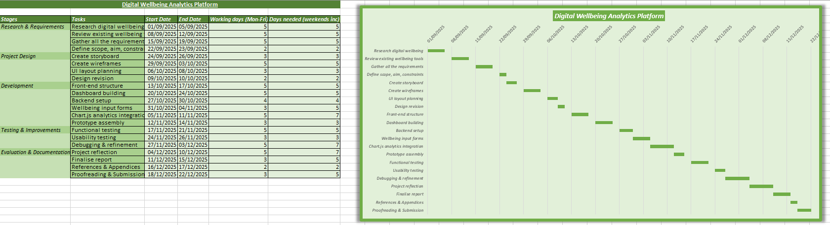
Full Screenshot for Gantt Chart Creation:

