
DIEGO GUAZZAROTTI
1816567
M5X01924
Management and Organisational Behaviour
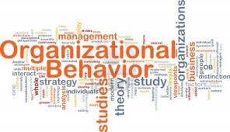

Lecture: Janet Green

PAGE CONTENTS

- INTRODUCTION 3

- STRUCTURE OF ADMINISTRATIONS 4

- ADMINISTRATION STRUCTURE BASED ON ADMINISTRATION PERFORMANCE 7

- CULTURE BASED ON ADMINISTRATION PERFORMANCE 8

- LEADERSHIP BASED ON ADMINISTRATION PERFORMANCE 9

- CONCLUSION 10

- REFERENCES 11

INTRODUCTION
Inside a corporation, the administrative structure is the source of it, but what consents the business itself to accomplish on the market is its organization. The history and progression of management, its accomplishment, and difficulties are all founded on an uncommon crucial value. Organization concerns individuals. It determines to make employees skilled in working fine with each other, to carry out their strong points, and to remove weaknesses. Assumed that the organization has to do with the amalgamation of individuals within an assembly, we may comprehend how it has a thoughtful link with cultural values. Every single corporation should assume in its entirety to accomplish the points set for reaching or sustaining its success. “The discussion of political processes in organisations pulls together an overarching framework for defining organisations and many of the processes that occur within them” (Duncan Kitchin, 2010). The focal work of those who deal with the administration is to reflect, typify, and set these points so that they are clear to everybody and beneficial for the development of the corporation. The management should also make certain that the business and to each of its affiliates may progress workwise, familiarising with the variations that are arranged in the external and internal setting. Every single corporation is made up of individuals who have diverse knowledge, capabilities, skills, and practices who do works that are dissimilar from each other. Nevertheless, every one of these people requires to be able to reflect on their group as a sole unit that changes in the course established by the organization and to be able to see themselves within this corporation.



STRUCTURE OF ADMINISTRATIONS
The administrative structure is the basis of the organization of a corporation. It is crucial to instrument the most suitable structure with the corporation. Thinking of business administration, we frequently have a habit of assuming the current administrative structure as an unmodifiable element, and consequently not to query it much. The administrative structure, on the other side, is like the strategic set-up of a squad. The whole thing is assembled on its fundamentals and dissimilar methods may be approved, suggested depending on the category of corporate and the absolute key achievement factors. The focal administrative structure formations are divided into three points:
- practical frame;
- divisional frame;
- matrix frame.

The most used structure is a practical one. It is separated into numerous parts which are typically comparable to each other. The optimistic part of this structure is the practical inevitability of accomplishing high productivity in every single part by having a piece of high knowledge in characters and consequently bigger functioning productivity in every single occupation. Then again, the main difficulty originated is that every single occupation runs practically as a corporation on its own, regularly with the hazard of unfortunate management between them and complications in chasing mutual purposes. We discover this company structure chiefly in corporations that generate nearly standardized services or products and mostly ended in markets with comparable appearances and where productivity is a vital competitive aspect.
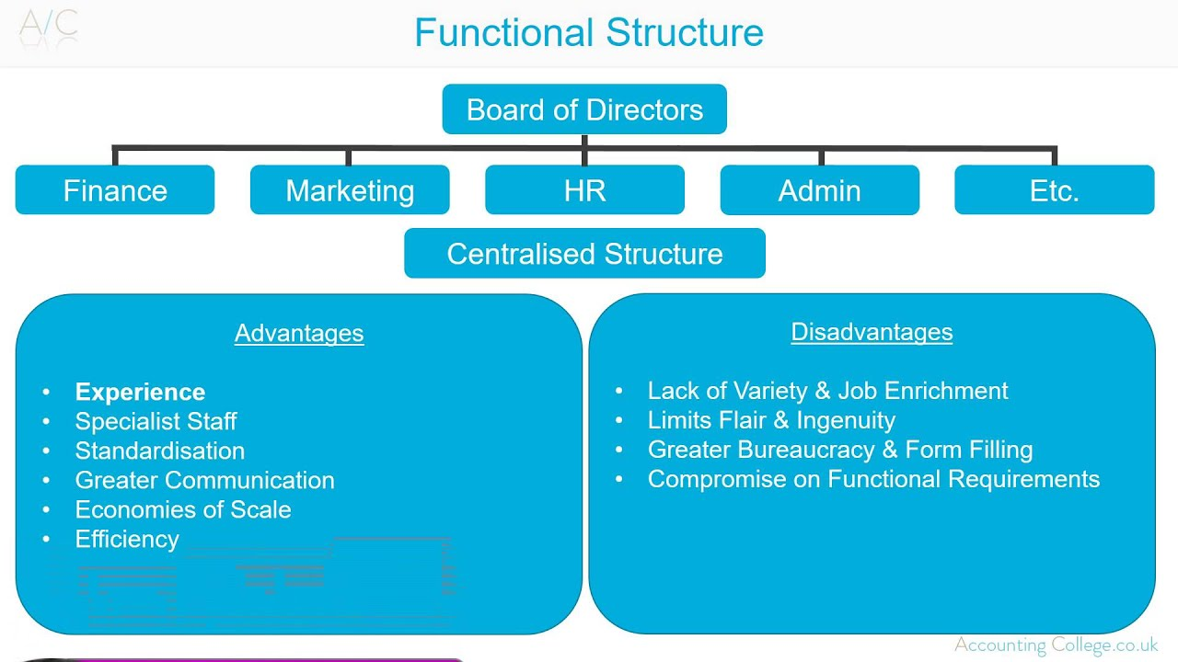

The administrative divisional structure, which is different respect of the functional one, offers that the corporation is internally separated conferring to the proportions of the corporate. Every single separation within the corporation typically has an efficient structure in it. This frame generates the benefit of producing, principally, a procedure of inner competition among the several parts. The main difficulty is originated in the effort of exploiting the frugality of gage and even irregular collaborations. It bonds the hazard with the countless functional frames, specifically: the formation of distinct corporations within a similar business.

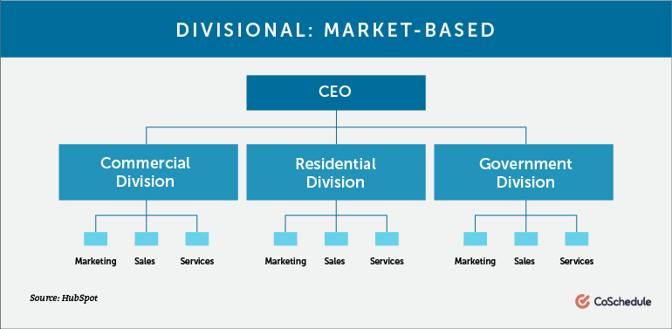

The last frame recorded but not tiniest for productivity is the supposed matrix structure. A combination of the preceding ones formed to overwhelm the difficulties of the others. The frame of the matrix advanced on equal proportions. One characteristically practical and an additional precise to the corporation. A characteristic illustration of the above-mentioned frame is when in the administrative plan we find more than a few development administrators, product administrators, or market administrators. They are answerable for an exact share of the company horizontally and who attract on period and income for several purposes. The matrix frame has the benefit of being able to impeccably combine knowledge and organization but then again, it gives the impression to have complex overall administration expenses. These costs are current as several expert figures work in binary scopes such as horizontal and vertical.
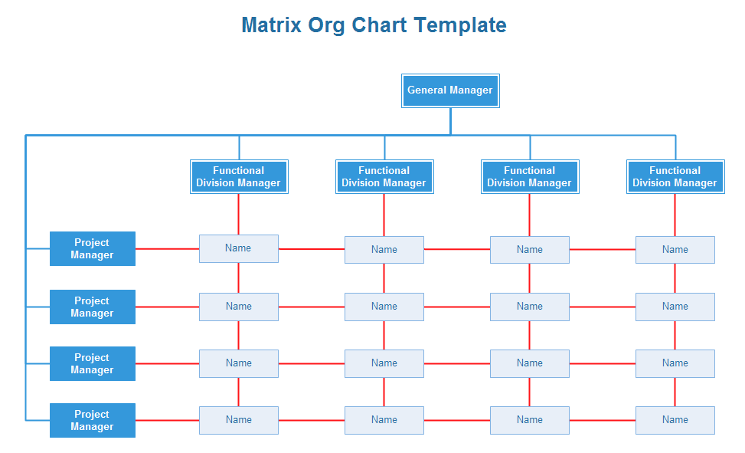
Closing this concise summary, there is no improved administrative frame nonetheless, once more, the optimal rest on the specificity of the corporation and necessitates accurate good.
The decent update, nevertheless, is that whatever frame chooses to use, the corporation organization may offer values and procedures that may lessen the intrinsic difficulties.

ADMINISTRATION STRUCTURE BASED ON ADMINISTRATION PERFORMANCE
The minute we dialog around performance, we are speaking about the performance of one or extra topics to accomplish the company goal. Through constructive presentation, unlike the undesirable one, we specify an activity achieved to the supreme of prospects from a topic, surely attributable to the procedure planned and applied to accomplish the goal, the diverse habits in which the schedules are completed to accomplish the target and in conclusion, the outcome gained. It is vital, for a corporation, to make the several shareholders contribute, through which financial dealings are shaped, concerning corporation performance with the intention of interest innovative liquidity or investment to be able to capitalize. Simultaneously, the business administration is assigned with the laborious commission of observing the main company actions, which have a correspondingly important, if not bigger, attention in the accurate development of separate and cooperative effort performance.
A performance administration organization or better identified as performance management should be understood as the established of the correct business direction and its greatest essential capitals. As a non-stop procedure of documentation, measurement, and growth of the performances of persons and groups and placement of these performances with the planned purposes of the association. Companies with their quotidian facilities supported out in all divisions of the association, permit the accomplishment of the business purposes, which are three. Financial outcomes, product market performance, and investor return. Constructive performances are an amalgamation of various incomes, informs have originated some outcomes such as usefulness, effectiveness, growth, and gratification of the members. The grouping of all these aspects, emotive and non-emotive, consent the manufacture of a service or product that would feed administrative performance.



CULTURE BASED ON ADMINISTRATION PERFORMANCE
What describes the method in which a corporation's personnel complete their responsibilities and how they cooperate is verbalized by the corporation's administrative culture. Cultural variation, a very lively subject in the former period agreed globalization, is occupied with countless principles, symbols, ceremonies, and morals that oversee the functioning style of individuals within a business. “A sociological approach has a broader emphasis on human behaviour in society” (Laurie J. Mullins,2016). The primary objective of company culture is to best fusion the personnel by providing an indiscriminate way to personnel and the corporation.
We may discover, in corporations, diverse administrative styles, and dissimilar business administrative cultures, for instance:
- extremely organizational and well-structured administrations;
- competitive administrations;
- cooperative culture.

The corporation cultures are mixed and consent us to align personnel with the similar moral principles and ethics ​​of the corporation where they work. An excessive frame of the team is obvious when the corporation's purposes are in step with the principles and moral values ​​of the workforces, a connection of faith and common admiration between the corporation and personnel results. “Taking investigations beyond failures brings into focus the performance of the person managing, designing, constructing or operating hazardous facilities” (John Bernard Taylor, 2010). Administrative cultures unquestionably disturb worker performance and enthusiasm levels. Frequently, some workers have a habit of working more constantly to accomplish their goals and this occurs if they sense they are considered part of the business situation. Furthermore, employment is enormously vital within administrations with a distinct work philosophy. This employment procedure is accepted out with the equal principles and ethics that brand up the values of the organization. This confirms the integration of the novel member of staff to the corporation and further reinforces the business culture.

LEADERSHIP BASED ON ADMINISTRATION PERFORMANCE
History displays us that it is of essential importance that people have their place to a group classify with the individual located in their expertise. “The right to give orders and the power to exact obedience” (H. R. Appannaiah, 2010). The leader should be classified as "front-runner", in instruction to keep the staff, cohesive and compact, hitting a conclusion to any inner debates, and acting as a bond among the corporation and the crew itself. To this could be added the administrative skills of handling the crew's actions, along with defining a recompense scheme executed through a valuation of the performance of every single individual and the following potentials of career improvement. A corporation in which the setting group does not back modernization may simply destabilize the optimistic effects of some solid team. In this opinion, the leader should be able to generate an administrative structure proficient in increasing the functionality of his squad. One of the thinkable tactical difficulties is that of having to generate an organization that is favorable to modernization and the expansion of collaboration. “One of the major sources of anxiety and stress is our work. However, finding a low-stress job is not easy” (Koushiki Choudhury, 2013). The insinuation that tracks is that lacking the interposition of the management, the associates of the association focus consideration on routine actions and not on the doings answerable for ground-breaking developments. Very frequently the drives of individuals do not agree with those of the society, somebody should, through real achievement, manage and guide the association in instruction to advance and guarantee supportive performance.
In this intricate determination that should be delineated the core of achievement for administration and those who lead the association, a core that changes the systems of social control. In this fashion, we try to encourage original methods based on values and ​​ principles for example directness, integration, and improvement of relationships. The dominant responsibility and part that leadership has in generating the company administrative culture and in the organization of its diverse parts, be they, teams or divisions. This concern may be recognized in a few different important aspects. Defining the established task. Adopting the organizational and structure scheme to accomplish the established goals. Defending the veracity of the association. Mitigating inner struggles.

CONCLUSION
As emphasized by the statement, the intricate performance of a corporation ascends from the administrative structure that is envisioned to be given to the upcoming association. “Organizational behaviour is strongly influenced by the advancement of information technologies, virtual business transactions, multicultural business partnerships” (Paul Jackson, 2006). From practical to divisional to close with the matrix frame, all are formed to be manipulated by the corporation grounded on confident reasons such as invention, market, facilities accessible, and so on. To have defined the corporation frame, it is significant to train the administration at a maximum of all. For the destiny of the corporation, it is essential to have professionals in the segment in expertise who, given the essential information, permit the corporation to generate income and remain strong over long periods. “When we see someone fail or behave in certain ways, we believe it is due to their personality, attitude, or disposition” (Stewart Clegg, 2015). The administration has the commission of forming the corporation and guaranteeing that personnel follows the company objective. This could be done through a strong association, where the member of staff recognizes what responsibilities to complete and feels the wish to carry out a portion of the employed family in which they help. It is significant to have every person interested and acting by taking leaders talented in doing this. A company philosophy where there is no judgment and the countless principles of the personnel are taken into deliberation with genuine admiration. Furthermore, it is energetic to teach the business philosophy of the novel implants, in instruction to be able to have the correct method of the latter to the reason. The management has to be suitable to the situation, which sustains the whole crew of workforces unified, consistent, and solid in accomplishing the ultimate goal to be accomplished. “Every time we were beginning to form up into teams, we would be reorganized” (George Bradt, 2018).

REFERENCES
D. Kitchin, (2010), An Introduction to Organisational Behaviour for Managers and Engineers, Elsevier, Burlington, P. 11.
G. Bradt, (2018), In Praise Of Matrix Organizations, Available at: https://www.forbes.com/sites/georgebradt/2018/10/09/in-praise-of-matrix-organizations/#1b2b05617032, (Accessed 10/07/2020).
H. R. Appannaiah, (2010), Organisational Behaviour, Himalaya Pub. House, New Delhi, P. 7.
J. B. Taylor, (2010), Safety culture, Gower, Surrey, P. 16.
K. Choudhury, (2013), Managing Workplace Stress, Springer India, India, P.15.
L. J. Mullins, (2016), Management and Organizational Behaviour, Pearson Education Limited, United Kingdom, P. 33.
P. Jackson, (2006), Developments in Work and Organizational Psychology, Emerald Group Publishing, Oxford, P. 22.
S. Clegg, (2015), Managing and Organizations: An Introduction to Theory and Practice, SAGE Publications Ltd, London, P. 107.

