
Programme: Master of Business Administration
Module: Marketing Management
Module Code: LCMB7024
Assignment Title: Marketing Environment Analysis
Lecturer: Laila Maazouz, Taonga Kaonga, Sobere-Snithers

Chosen Company: BHP Group Ltd (Australia)
Word Count:
Submission Date:

Student Name:Sohil Qamran
Student ID:2534038

Table of Contents
Task 1: Marketing Environment Analysis 3
Core marketing framework (Kotler) 3
Nature Environment Actor 3
Portfolio realignment and future-facing commodities 3
The downstream value chain and scope 3 challenge 4
Political and legal environmental actor 5
Domestic mandates: Australia's safeguard mechanism 5
Task 2: Strategic Growth and Competitive Positioning 7
Ansoff Matrix 7
Porter’s Framework for achieving competitive rivalry 9
Task 3: Critical Reflection on AI Usage 10
Tood disclosure and functional application 10
Critical evaluation and hallucination mitigation 10
Contribution analysis 10
Ethical and professional reflection 11
References 12

Task 1: Marketing Environment Analysis

Core marketing framework (Kotler)
As per the views of Kotler et al. (2024), the marketing macro environment includes the larger societal forces that widely affect the whole macro environment, posing systemic threats and shaping the commercial opportunities for the organisation. In the case of a global heavy industry sector, these macro forces are precipitating a basic structural transition. The large resource organisations can no longer depend wholly on the historical volumes of extraction. Instead, they are required to dynamically manage the external pressures to maintain their commercial and societal license to operate in the industry. For a diversified global resource enterprise such as BHP, navigating this macro environment needs and advanced understanding of how the external factors intersect with the customer value propositions and product strategy. Design analysis critically appraises the ways in which the 2 dominant macro environmental forces (the natural environment actor and the political/legal environment actor) converge to compel BHP to shift its basic portfolio towards the cleaner production methodologies and lower carbon products. As per Global Data (2026), BHP Group Ltd is a global organisation of resources that is engaged in the production and extraction of essential commodities.

Nature Environment Actor

Portfolio realignment and future-facing commodities
The natural environment actor consists of the physical environment and natural resources that are required as the inputs by the industrial marketers or are directly affected by the operational activities (Kotler et al., 2024). In the case of BHP, the sector faces unprecedented pressure because of the finite nature of the carbon budgets and the increasing physical impact of global climate change. In reaction to this environmental macro force, BHP executed a vital, multibillion-dollar product portfolio realignment. The organisation has widely divested from the assets of high-carbon fossil fuels, like thermal coal, while deliberately repositioning the brand equity around what it called ‘future-facing commodities’, particularly nickel, copper and iron ore. From the B2B marketing perspective, this shows the structural transition and the definition of the product. Nickel and copper are the physical building blocks that are required for global electrification, renewable energy infrastructure and electric vehicles (EVs) (Nguyen et al., 2021). By relocating its capital expenditure towards the assets, such as the Escondida copper mine in Chile and the operations of Western Australia Nickel, BHP is structurally matching the outputs of the resources to the physical barriers and demands of the rapidly decarbonising natural world. This shift allows the company to market its goods not only as raw materials but as important enablers of the global green transition.

The downstream value chain and scope 3 challenge
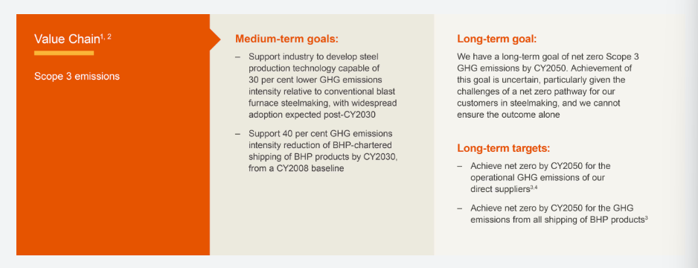
Figure 1: Value chain greenhouse gas (GHG) emissions targets and goals of BHP
(Source: BHP, 2025a)
Managing the operational emissions (Scope 1 and Scope 2) is a fundamental baseline, the most critical barrier emerging from the natural environment actor resides within the value chain of BHP, particularly its Scope 3 emissions. As per the Climate Transition Actor Plan (2024) of BHP, the value chain emissions comprise 377.6 Mt CO2-e for the FY2024. Of this stock, about 83% stamps directly from the downstream processing of the BHP, steel making, coal and supplied iron ore within the steel mills of the customers, particularly in Japan, China and South Korea (World Economic Forum, 2024). As these emissions take place within the independent customer operations, BHP doesn't have direct management control over them (BHP, 2026a). Meanwhile, as per the contemporary marketing theory, the raw material supplier needs to actively assist the downstream sustainability in order to preserve the market share, because the industrial B2B consumers highly demand low-carbon supply inputs. To address this, BHP has moved from the transactional supply model to the partnership-based, highly collaborative marketing strategy. The company has now established a formal technical partnership with the major producers of steel, including HBIS Group and China Baowu Steel Group, co-investing in the pathways of technology that are designed to decarbonise the steel value chain.
These technological interventions environmental demand of the macro environment. As shown above, these value chain partnerships emphasise adopting the traditional blast furnace roots through carbon capture, usage and storage (CCUS) to attain the short to medium term emission intensity decreases. Concurrently, they also explored the secondary pathway of shifting towards the hydrogen-based direct reduced iron (DRI) and electric arc furnaces (EAFs), which can achieve about 85% of decrease in the intensity of carbon (BHP, 2025b). Using these collaborative research and development investments, BHP directly addresses the natural environmental actor and ensures that its iron ore remains the preferred, commercially viable input as the global steelmakers experience increasing pressure due to a decrease in carbon outputs.

Political and legal environmental actor

Domestic mandates: Australia's safeguard mechanism
The legal and political environment includes the government agencies, loss and influential pressure groups that affect all and limit the individuals or different organisations within the given society (Kotler et al., 2024). Governments around the globe are increasing the usage of legislative mechanisms to internalise the environmental costs, shifting the climate compliance from the voluntary CSR initiatives to the strict and legally binding operational requirements. For BHP, the most immediate domestic legal force is the reformed Safeguard Mechanism of Australia, which has entered its enforcement phase and full compliance. This regulatory framework is applicable strictly to facilitate emitting more than 1,00,000 tonnes of carbon dioxide equivalent (CO2-e) of direct emissions per year, capturing the primary coal, iron ore and nickel operations of BHP (Department of Climate Change, Energy, the Environment and Water, 2026). Under the reformed rules that are administered by the Clean Energy Regulators, keyboard facilities are legally mandated to decrease their fundamental emissions intensity by 4.9% yearly until 2030. If the facility increases its decreasing legislated baseline, the liable entity must manage the increased emissions by surrendering and purchasing the regulatory carbon credits, like the Australian carbon credit units (ACCUs) or face severe civil penalties. As several structural technologies are required to fully upgrade the mining emissions (like fugitive methane capturing systems and heavy battery electric haul trucks), which are not yet commercially deployable at the scale, this legal actor leads to the direct financial liability (BHP, 2026b). BHP is forced to manage the balance between its operational cost structures and the proactive capital allocation for carbon offset procurement and abatement, which can help the company to prove that legal mechanisms can directly change the economics of mineral extraction.

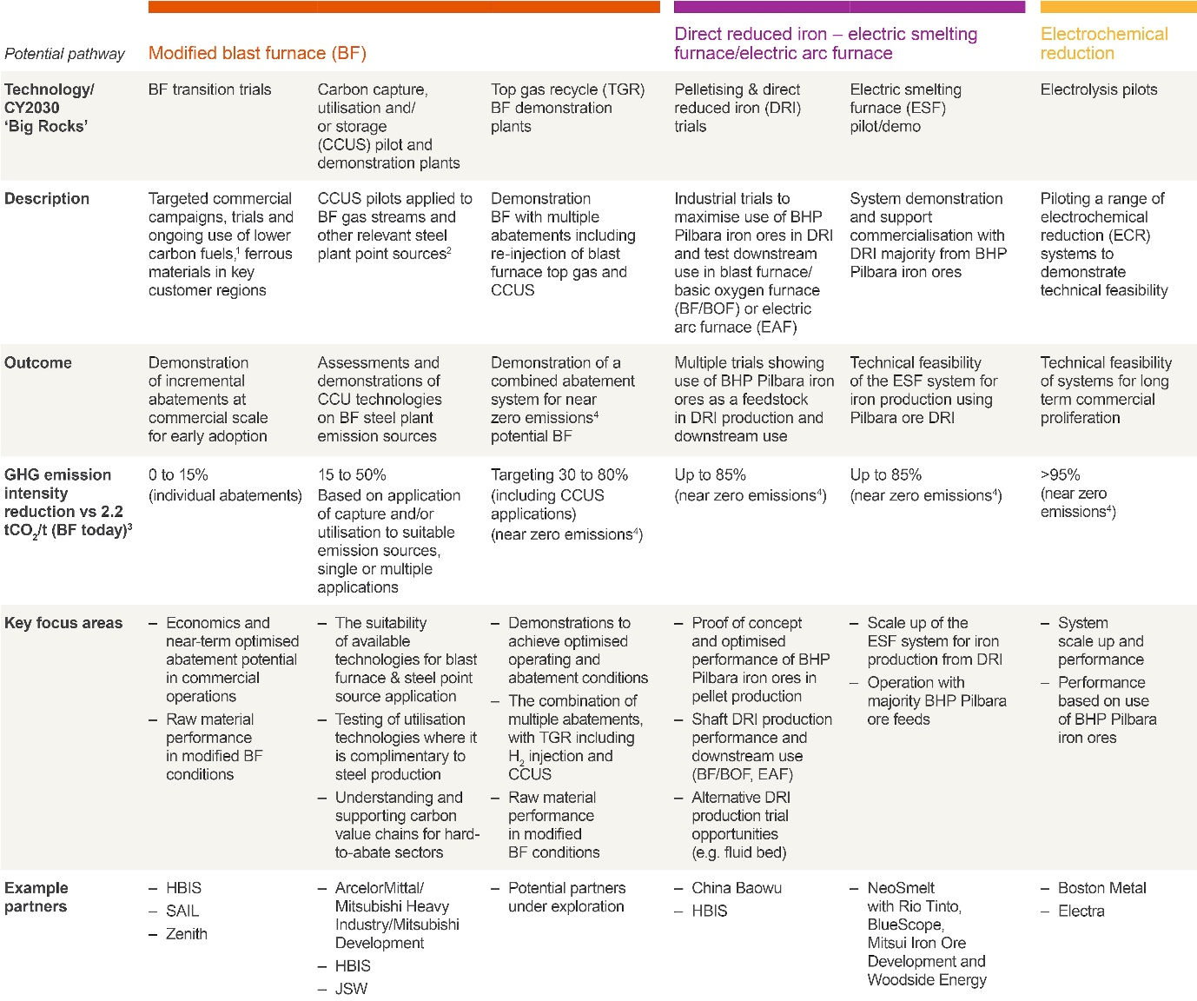
Figure 2: Value Chain GHG emission reductions
(Source: BHP, 2025a)

Task 2: Strategic Growth and Competitive Positioning
On the basis of the environmental analysis presented above, BHP is required to proactively manage the external pressures by choosing clear pathways for growth. When the organisation faces a massive transition in its business environment, it cannot stand still. It is required to decide how to grow while making changes to the arts business model. To evaluate how the company can achieve long-term growth while also moving towards a low-carbon business model, the Ansoff matrix has been used. This classic marketing framework is helpful for honing stations to select between the 4 different growth strategies on the basis of whether they are working with existing or new products and existing or new markets. By integrating Michael Porter’s Generic Strategies with the Ansoff Matrix, it will be evaluated how BHP can develop a lasting competitive rivalry over its competitors during the global green transition.

Ansoff Matrix
Ansoff matrix provides 4 different pathways for growth of the organisation, including market penetration, market development, diversification and product development. In the case of BHP, the movement toward the low-carbon economy needs a mixture of these strategies to decrease the risk and capture new market value.
 | Existing Products | New Products
Existing Markets | Market Penetration  (high-grade iron ore) | Product Development  (carbon abated raw materials/green hydrogen)
New Markets | Market Development  (copper and nickel into new battery value chains) | Diversification  (Jansen Potash Project for sustainable farming)

Market Penetration
It takes place when the organisation tries to sell more of its existing products to the current customer base. For BHP, this includes selling the existing high-grade iron ore and metallurgical coal to the established steel-making customers of Asia. Even during the period of green transition, the world still requires a massive amount of steel for infrastructure. Market penetration can be achieved by BHP by convincing the existing clients that using the premium, high-priority iron ore of BHP helps them decrease their own emissions quickly (The Guardian, 2026). It needs high-grade iron ore, less coal, and less energy to melt in the traditional blast furnaces. If the organization will market the environmental efficiency of the current premium products, it can capture a larger share of the purchases from the current clients who are desperate to meet their climate targets without completely replacing their costly factory machinery.
Product development
It includes the creation of a completely new product or a heavily modified product and selling them into the existing customer networks. This is where the technology partnership of BHP became the central growth strategy. BHP is not only selling the raw rocks anymore. It is developing well-modified, low-carbon raw material inputs (World Bank Group, 2026). It is working with the downstream steelmakers to develop the carbon capture systems and testing direct reduced iron (DRI) modules. It is creating ‘cleaner raw materials’ tailored for the contemporary, low-emission steel factories. Moreover, the investments are also made in green hydrogen technologies. If the company can successfully supply the green hydrogen along with its minerals to the traditional steel-making customers, it will lead to a whole new product stream for the audience, which is already known.
Market development
It happens when the organisation takes the goods and introduces them to a whole new market or a customer segment. In the case of BHP, this strategy is widely visible in the nickel and copper business lines. Historically, BHP was viewed as selling its metals primarily to the traditional industrial manufacturers and the construction organisations. Meanwhile, the introduction of the green economy has opened a huge new market segment of renewable energy grid developers and electric vehicles (EVs). The company is actively redirecting its existing nickel and copper outputs away from the traditional manufacturing and into these new, high-growth technological sectors. For example, a major supply agreement has been signed between BHP and the automobile manufacturers to provide high-purity nickel directly for the production lines of EV batteries (BHP, 2021). This is a classic market development approach, which is taking the existing mind commodities and finding a brand new luxury customer base for it.
Diversification
It is the most risky quadrant of growth as it needs the organisation to enter a whole new market with completely new products. For a mining organisation completely dependent on fossil fuels, diversification is necessary for long-term survival. The major diversification move of BHP is its multi-billion-dollar investment in the Jansen Potash project in Saskatchewan, Canada (Ralph et al., 2023). Potash is the potassium-rich salt that is used primarily as a nutrient for agricultural fertilisers. This project presents a whole new product (potash) sold into a whole new market segment (the global agricultural sector). As the change in the climate shifts the global weather patterns and also places pressure on the finite arable land, the demand for high-yielding and sustainable food production is skyrocketing. The entrance into the potash market is exciting, and BHP is completely decoupling a portion of its future revenue from the supply chain of metals, pivoting towards food security globally. This offers a structural hedge against the long-term decrease in the traditional industrial commodities.

Porter’s Framework for achieving competitive rivalry
In order to successfully ensure growth strategies, BHP is required to maintain competitive rivalry. As per Michael Porter, organisations can compete either by differentiation or by cost. Historically, it has been viewed that the mining organisations operate as the cost leaders. As the minerals are fundamental commodities, the organizations having lowest cost of extraction generally wins. BHP has always been viewed as enjoying low operational costs as it operates on a massive scale and has high-quality geographic assets in Australia. Meanwhile, the low-carbon transition allows the company to overlay the differentiation strategy on top of its cost leadership, which creates a powerful hybrid advantage for the organisation. The hybrid positioning can create a massive challenge to entry for the small rivals in the industry. The small mining firms generally lack the huge amount of capital investment which is required and the green technologies or the value chain R&D. By managing the traditional law operational cost and simultaneously offering the low carbon product attributes, BHP can secure a good position as the preferred global supplier of raw materials.

Task 3: Critical Reflection on AI Usage

Tood disclosure and functional application
In writing this strategic marketing analysis, generative AI was used strictly within the boundaries that are authorised in the specification of the assessment. Particularly, the air assistance was limited to the categories of bibliographic cross-referencing, research assistance and structural proofreading. Advanced language models were used to summarise the critical corporate disclosures, like the BHP Climate Transition Action Plan 2024, and to cross-examine the industry data and its relation to the impact of the Safeguard Mechanism of Australia. Moreover, the AI tools helped me in formatting the final output as per the guidelines of the UWTSD Harvard referencing style. N Astro compliance with the academic honesty mandates of the module, AI was totally excluded from the core composition and structural organisation of the text. The conceptual synthesis and strategic directions were purely written by me.

Critical evaluation and hallucination mitigation
A rigorous validation protocol was used to ensure that the academic integrity has been maintained in the report and to remove the AI hallucination (situations in which the large language models invent false data or non-existent citations). Every regulatory figure, statistical claim and corporate target that was generated during the preliminary research phase was manually cross-referenced against the primary authoritative sources that were found by me. For example, when the initial outputs of AI presented differences of percentages for the Scope 3 emission obligations of BHP, the data was cross-checked directly against the Annual Report 2025 of BHP. This process of verification has exposed the minor discrepancies in the early summarisation of data, where the AI conflicted with historical baseline data and the projected 2030 targets of the company. Moreover, the legal boundaries cited in relation to the operational triggers for the Safeguard Mechanism were also validated directly using the official portal of the Clean Energy Regulators. There is a stopover site that has ensured that there are no manufacturer citations, logical errors or inaccurate statistics of the industry were incorporated into the final document.

Contribution analysis
There was a clear line of demarcation that separated the mechanical contributions of the AI from my very own original critical analysis. Air was acting purely as the intellectual filing helper and the language editor. It helped me in streamlining the raw data and refining my grammatical errors for the initial drafts. However, the intellectual architecture of the report was completely human-driven. The critical evaluation in relation to how the downstream Scope 3 partnership acts as the B2B brand defence strategy, the argument for green differentiation/hybrid low cost positioning strategy under Porter's framework, presented my own original academic synthesis.

Ethical and professional reflection
Presenting on this process shows the significant ethical implications in relation to the AI development in contemporary marketing management. Professionally, AI helps us as an invaluable efficiency multiplier and helps the managers to process the critical macro environmental variables and trade regulations quickly. Meanwhile, the non-critical dependence on these tools poses severe ethical hazards, such as data privacy breaches when uploading corporate information, potential reproduction of the algorithmic bias, and erosion of the authentic intellectual ownership of data.

AI Declaration
I acknowledge the use of the large language models to support the primary background information, data summaries, and text proofreading for this report. All the text, strategic conclusions, and conceptual framework applications were written wholly by my own hand, and all the referenced sources have been independently verified for better accuracy.

References
BHP (2021) BHP enters into nickel supply agreement with Tesla Inc. Available at: https://www.bhp.com/news/media-centre/releases/2021/07/bhp-enters-into-nickel-supply-agreement-with-tesla-inc (Accessed: 24 June 2026).
BHP (2025a) Value chain GHG emissions (Scope 3 emissions). Available at: https://www.bhp.com/sustainability/climate-change/value-chain-ghg-emission-reductions (Accessed: 24 June 2026).
BHP (2025b) Steelmaking decarbonisation: Transition to new pathways, progress and industry insights. Available at: https://www.bhp.com/news/bhp-insights/2025/12/steelmaking-decarbonisation (Accessed: 24 June 2026).
BHP (2026a) Our latest Climate Transition Action Plan (CTAP). Available at: https://www.bhp.com/sustainability/climate-change/climate-transition-action-plan (Accessed: 24 June 2026).
BHP (2026b) Carbon offsetting. Available at: https://www.bhp.com/sustainability/climate-change/carbon-offsetting (Accessed: 24 June 2026).
Department of Climate Change, Energy, the Environment and Water (2026) Safeguard Mechanism overview. Available at: https://www.dcceew.gov.au/climate-change/emissions-reporting/national-greenhouse-energy-reporting-scheme/safeguard-mechanism (Accessed: 24 June 2026).
Global Data (2026) BHP Group Ltd: Overview. Available at: https://www.globaldata.com/company-profile/bhp/ (Accessed: 24 June 2026).
Kotler, P., Armstrong, G., Harris, L.C. and He, H. (2024) Principles of marketing. 19th edn. Harlow: Pearson.
Nguyen, R.T., Eggert, R.G., Severson, M.H. and Anderson, C.G. (2021) 'Global electrification of vehicles and intertwined material supply chains of cobalt, copper and nickel', Resources, Conservation and Recycling, 167, p. 105198. Available at: https://www.sciencedirect.com/science/article/am/pii/S0921344920305152 (Accessed: 24 June 2026).
Ralph, S., Loney, J.C., Riley, B., Johnson, R. and Klug, S. (2023) 'Richard Riegert Memorial Lecture: the Canadian Critical Minerals Strategy: unearthing energy Security in Canada', Alberta Law Review, pp. 385–385. Available at: https://journals.library.ualberta.ca/www.albertalawreview.com/index.php/ALR/article/download/2769/2718 (Accessed: 24 June 2026)
The Guardian (2026) 'Revealed: the internal BHP memo that slammed the brakes on the world’s biggest miner’s climate push', The Guardian, 25 May. Available at: https://www.theguardian.com/world/ng-interactive/2026/may/25/bhp-files-internal-memo-revealed (Accessed: 24 June 2026).
World Bank Group (2026) Mining Value Chains. Available at: https://documents1.worldbank.org/curated/en/099101723140622516/pdf/P17516105e95da0de0a34c0dd670e6f75cf.pdf (Accessed: 24 June 2026).
World Economic Forum (2024) BHP’s approach to Scope 3 reporting supports progress towards value chain decarbonization. Available at: https://www3.weforum.org/docs/WEF_ISSB_Knowledge_Hub_BHP_Case_Study_November_2024.pdf (Accessed: 24 June 2026).

