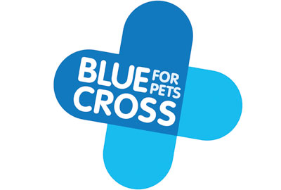
Leadership and Management Skills
Leading and Implementing Change
Name: Beata Maciazek
Student ID: 224700
Module: LCLM6003
Lecturer: Nadeem Mirza

Declaration of Generative AI Use
For this assessment, Generative Artificial Intelligence (AI) tools were not used to support research activities, data analysis, the development of arguments, or the structuring of the report. All research, analysis, interpretation of theories and models, and the overall structure of the submission are the student’s own original work, based on independently sourced academic and sector literature.
Generative AI tools were used solely for proofreading purposes, specifically to check grammar, spelling and sentence clarity, and to receive suggestions for minor rephrasing. No content was generated by AI, and no ideas, arguments, or written sections were created using AI tools.
This submission complies fully with the university’s policy on the ethical use of Generative AI and reflects the student’s own understanding, critical analysis and academic judgement.

Executive Summary
This report presents a comprehensive strategic change management analysis and implementation plan for Blue Cross, one of the UK’s leading animal-welfare charities. Established in 1897, Blue Cross has a long-standing history of delivering veterinary care, rehoming services, behavioural support and community-based programmes for pets and their owners across the UK (Blue Cross, 2023). Despite its strong heritage and charitable mission, the organisation is currently facing significant internal and external pressures that necessitate strategic change to ensure long-term sustainability.
Key challenges include rising demand for low-cost and charitable veterinary services, rapid digital disruption, the increasing integration of artificial intelligence (AI) within service delivery and administration, shifting donor behaviours, heightened competition within the third sector, and escalating financial pressures linked to the UK cost-of-living crisis (NCVO, 2023; Charities Aid Foundation, 2022). These factors have intensified operational strain and highlighted the need for a structured and forward-looking change management strategy.
The report begins by outlining the organisational context of Blue Cross, followed by an evaluation of the internal and external forces shaping its operations using PESTLE analysis and organisational assessment frameworks. Particular attention is given to the impact of digital transformation, online fundraising trends, regulatory requirements and social expectations on the charity’s existing service delivery model. To support effective organisational transformation, the report critically examines established change management models, including Lewin’s Change Model, Kotter’s Eight-Step Model, and the McKinsey 7-S Framework, assessing their relevance and applicability within the Blue Cross context (Lewin, 1951; Kotter, 1996; Waterman et al., 1980). Issues such as resistance to change, leadership capability, resource constraints and organisational culture are explored as key determinants of successful change implementation.
Leadership is identified as a critical enabler of change within third-sector organisations. The report evaluates the role of transformational and situational leadership approaches in guiding Blue Cross through periods of transition, with a particular focus on communication, staff engagement and the development of a shared organisational vision (Bass, 1985; Hersey et al., 2013). Organisational culture, values and behavioural norms are also analysed to assess how they support or potentially hinder the achievement of strategic change objectives.
The final section proposes a structured and evidence-based change management plan designed to support Blue Cross in transitioning towards a digitally enabled, financially sustainable and future-oriented operating model. The proposed plan incorporates SMART objectives, financial planning considerations, a stakeholder-focused communication strategy, and a robust monitoring and evaluation framework. Successful implementation is expected to enhance operational efficiency, strengthen donor engagement, improve accessibility to veterinary and pet-related services, and secure long-term organisational sustainability.
Overall, this report argues that Blue Cross must adopt a systematic, inclusive and data-driven approach to organisational change. Such an approach will enable the charity to respond effectively to rising service demand, evolving digital expectations among donors and service users, and increasing sector-wide challenges. The strategic roadmap provided offers practical guidance for leadership to navigate change while maintaining alignment with Blue Cross’s core mission of supporting pets and their owners across the UK.

Table of Contents
Declaration of Generative AI Use 1
Executive Summary 1
Strategic Change Management at Blue Cross 4
1. Introduction 4
2. Analysis of Blue Cross’ Recent History and Environmental Pressures 5
External Environmental Analysis (PESTLE) 5
PESTLE Analysis of Blue Cross (UK) 7
3 Internal Environment 7
Structure and Services 7
Internal Environment: Financial, Cultural and Strategic Overview 8
SWOT Analysis of Blue Cross 9
Evaluation of Change-Management Models 10
McKinsey 7-S Framework Table 12
Evaluation Action Plan Template 12
Strategic Change Evaluation Action Plan – Blue Cross 13
Monitoring and Review 13
4. Leadership and Organisational Culture in Change 13
5. Proposed Change Management Plan 14
Financial Plan Template 16
6. Conclusion 18
References 20

Strategic Change Management at Blue Cross

1. Introduction
Blue Cross is a UK-based animal welfare charity that provides a wide range of services including veterinary care, behavioural support, rehoming services, community outreach and pet-bereavement support. Established in 1897 as the Our Dumb Friends League, the organisation was originally founded to protect working horses in London before expanding its mission to support domestic pets and their owners (Blue Cross, 2024). Today, Blue Cross operates animal hospitals, rehoming centres, charity retail outlets and community-based services across the UK. Its vision is “a world where all pets enjoy a healthy life in a happy home”, reflecting its long-term commitment to animal welfare and social responsibility (Blue Cross, 2024).
The organisation operates within a complex and increasingly dynamic external environment shaped by rising levels of pet ownership, growing demand for low-cost and charitable veterinary services, and rapid digital transformation across the charity sector (NCVO, 2023). Financial pressures resulting from the UK cost-of-living crisis have further intensified demand for Blue Cross services, while simultaneously constraining household donations and charitable giving (Charities Aid Foundation, 2022). In addition, the sector has become increasingly competitive, with pressure from other animal welfare charities, online fundraising platforms and private veterinary providers, all competing for limited financial and volunteer resources.
Like many third-sector organisations, Blue Cross relies heavily on income from donations, legacies, fundraising activities and retail operations, making it particularly vulnerable to fluctuations in donor behaviour, economic uncertainty and changing public expectations (Sargeant and Shang, 2017). At the same time, advancements in digital technologies and data-driven service delivery are reshaping how charities engage with donors, manage resources and deliver services, creating both opportunities and challenges for organisational change (Dunlop and Radaelli, 2016).
This report analyses the strategic challenges and pressures currently facing Blue Cross, evaluates relevant change management models, and proposes a structured change programme aimed at enhancing organisational resilience, operational effectiveness and strategic capability. Particular emphasis is placed on the need for the organisation to adapt its service delivery model through digital innovation, improved resource allocation and the development of a supportive and change-ready organisational culture. Through this analysis, the report seeks to demonstrate how effective leadership and structured change management can support Blue Cross in achieving long-term sustainability while remaining aligned with its charitable mission.

2. Analysis of Blue Cross’ Recent History and Environmental Pressures
Over the past decade, Blue Cross has experienced significant operational growth alongside a sustained increase in demand for its services. The COVID-19 pandemic led to a sharp rise in pet ownership across the UK, which in turn increased demand for veterinary care, behavioural support and rehoming services; however, the pandemic also disrupted traditional fundraising activities and reduced income from charity retail operations, creating substantial financial pressures for the organisation (Civil Society, 2023). These challenges were further exacerbated by the subsequent cost-of-living crisis, which placed increased strain on pet owners and charitable providers alike, resulting in a growing number of individuals seeking low-cost veterinary services and, in some cases, being forced to rehome pets due to financial hardship (Kennel Club, 2023). Blue Cross has publicly acknowledged that many of its veterinary clinics and rehoming centres have been operating at or beyond capacity, highlighting systemic pressures on service delivery and organisational resources (Blue Cross, 2022). In parallel, rising veterinary costs driven by supply-chain disruptions and widespread staff shortages across the profession have increased operational complexity, while the Competition and Markets Authority’s 2023 investigation into the UK veterinary sector has introduced further regulatory uncertainty affecting both private and charitable providers (CMA, 2023). Collectively, these developments underline the urgent need for strategic and organisational change within Blue Cross to ensure service continuity, financial sustainability and long-term resilience.

External Environmental Analysis (PESTLE)
Blue Cross operates within a complex external environment shaped by political, economic, social, technological, legal and environmental factors. Politically, the UK charity sector is regulated through charity law, fundraising governance standards and animal-welfare legislation, with recent regulatory developments affecting veterinary practice, animal importation and welfare enforcement influencing Blue Cross’ operational responsibilities (DEFRA, 2023). Increased government scrutiny of veterinary pricing has also placed pressure on organisations to demonstrate transparency, affordability and public value. Economically, persistent inflation and economic uncertainty have resulted in increasingly volatile donation patterns, as donors reduce discretionary spending, while operational costs for veterinary services have risen due to higher prices for medical supplies, energy and staff wages (NCVO, 2023). At the same time, a growing number of pet owners are unable to afford private veterinary care, leading to increased reliance on charitable provision and creating a dual challenge of reduced income and rising demand. Socially, there has been a cultural shift towards viewing pets as family members, raising expectations around welfare standards, medical care and behavioural support. Although pet ownership increased following the COVID-19 pandemic, many owners were unprepared for long-term financial commitments, contributing to higher levels of rehoming and further demand for subsidised services (PDSA, 2022). Technological factors have also significantly reshaped the charity sector, with online donations, crowdfunding platforms, social media engagement and digital storytelling becoming central to fundraising and public engagement strategies (Charity Digital, 2023). Additionally, artificial intelligence is increasingly used for donor analytics, customer-service automation and veterinary diagnostics, presenting opportunities for improved efficiency and decision-making; however, Blue Cross remains constrained by legacy systems and underinvestment in technology, highlighting the need for digital modernisation (RVC, 2023). Legally, the organisation must comply with Charity Commission governance requirements, fundraising regulations, GDPR data-protection legislation and professional veterinary standards set by the Royal College of Veterinary Surgeons. Finally, environmental factors are growing in importance, with increasing public and regulatory expectations for charities to reduce environmental impact through improved energy efficiency, waste reduction and ethical procurement across veterinary, retail and operational activities.

PESTLE Analysis of Blue Cross (UK)

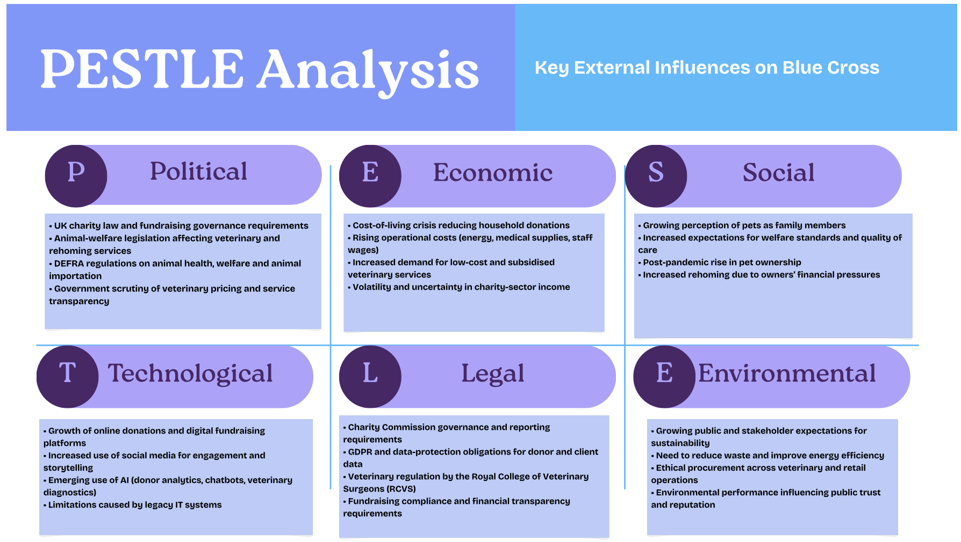
The PESTLE analysis draws on external sector reports and regulatory guidance, including DEFRA (2023), NCVO (2023), Charity Digital (2023), PDSA (2022), and the Competition and Markets Authority (2023). These sources provide evidence of the political, economic, social, technological, legal and environmental pressures influencing Blue Cross.

3 Internal Environment

Structure and Services
Blue Cross operates through a geographically dispersed network of animal hospitals, veterinary clinics, rehoming centres, charity retail shops and central administrative functions across the UK. The organisation employs a multidisciplinary workforce that includes veterinary surgeons, veterinary nurses, behavioural specialists, fundraising professionals and retail staff, all of whom are supported by a substantial volunteer base (Blue Cross, 2024). While the charity’s mission-led focus fosters a strong service-oriented culture and commitment to animal welfare, its decentralised organisational structure has contributed to operational fragmentation, particularly in relation to the standardisation of processes, service delivery and digital systems. Research suggests that such fragmentation is a common challenge within large third-sector organisations, often limiting efficiency, data integration and the effective implementation of strategic change initiatives (NCVO, 2023; McKinsey & Company, 2018). Addressing these structural and operational inconsistencies is therefore critical to enhancing organisational coordination, improving service quality and supporting Blue Cross’s wider strategic transformation objectives.

Internal Environment: Financial, Cultural and Strategic Overview
Recent financial performance indicates that Blue Cross has experienced periods in which organisational expenditure exceeded income, highlighting ongoing financial vulnerability and limited financial resilience (Blue Cross, 2023). Such financial pressure is not uncommon within the UK charity sector, where income streams are often unpredictable and closely linked to wider economic conditions. Blue Cross’s reliance on donations, legacies, fundraising events and retail income constrains long-term financial planning and limits the organisation’s capacity to absorb external shocks, particularly during periods of inflation and reduced discretionary spending among donors (NCVO, 2023). These conditions emphasise the importance of improving cost efficiency and strengthening income diversification through strategic change.
In addition to financial challenges, Blue Cross operates within a deeply mission-driven organisational culture that prioritises compassion, collaboration and animal welfare. This culture represents a significant internal asset, supporting high levels of staff and volunteer commitment, strong service quality and alignment with organisational values. However, research suggests that strongly values-based cultures can also hinder organisational change, as emotional attachment to established practices may generate resistance to innovation and increase risk aversion (Cameron and Quinn, 2011; Schein, 2010). Within Blue Cross, this may manifest as reluctance to adopt new digital systems, anxiety about technological change and concerns over the perceived impact of efficiency-driven reforms on service ethos.
A strategic internal and external assessment highlights several strengths that position Blue Cross well for future development. These include a highly trusted national brand, a dedicated workforce and volunteer base, a diverse portfolio of veterinary, rehoming and community services, and a wide geographical footprint across the UK. At the same time, structural and operational weaknesses remain evident, particularly in relation to legacy IT systems, inconsistent communication across dispersed sites, staff capacity constraints and a continued dependence on volatile income sources (Blue Cross, 2023; Charity Digital, 2023). Addressing these weaknesses is essential to improving organisational agility and resilience.
From an external perspective, significant opportunities exist to enhance sustainability and service effectiveness. Digital fundraising, AI-enabled veterinary diagnostics, enhanced online engagement and strategic partnerships offer potential to improve efficiency, donor reach and service accessibility (Royal Veterinary College, 2023). However, Blue Cross also faces substantial threats, including prolonged economic uncertainty, increasing competition for charitable donations, regulatory scrutiny within the veterinary sector, rising clinical costs and growing donor fatigue (NCVO, 2023; CMA, 2023). Together, these factors underline the necessity of a structured and proactive strategic change approach.

SWOT Analysis of Blue Cross
Strengths | Weaknesses
Strong national brand and public trust | Dependence on volatile income streams
Committed staff and volunteer workforce | Legacy IT and digital infrastructure
Diverse multi-service delivery model | Staff capacity and workload pressures
Nationwide operational presence | Inconsistent internal communication
Opportunities | Threats
Digital fundraising and online engagement | Economic uncertainty and inflation
AI-enabled veterinary diagnostics | Increased competition for donations
Strategic partnerships and grants | Rising veterinary and operational costs
Expansion of community services | Regulatory pressure and donor fatigue

The SWOT analysis highlights that Blue Cross benefits from strong internal strengths, including a trusted national brand, a committed workforce and a diverse service model, which support organisational resilience and stakeholder confidence (NCVO, 2023). However, internal weaknesses such as reliance on volatile income streams, legacy digital systems and staff capacity constraints limit organisational agility and decision-making, reinforcing the need for digital investment (Charity Digital, 2023). Externally, opportunities related to digital fundraising, AI-enabled veterinary services and strategic partnerships could enhance sustainability and service accessibility, while ongoing economic uncertainty, regulatory pressure and competition for donations represent significant threats that increase financial and operational risk (Royal Veterinary College, 2023; Burnes, 2017).

Evaluation of Change-Management Models
Effective organisational transformation at Blue Cross requires a structured, evidence-based and theory-informed approach to managing change within a complex and mission-driven charity environment. Change-management theory provides valuable frameworks for understanding how organisations can transition from existing practices to more sustainable and future-oriented operating models. Lewin’s Three-Stage Change Model conceptualises organisational change as a process involving unfreezing existing behaviours, implementing change and refreezing new practices into organisational culture (Lewin, 1947). This model is particularly useful in emphasising the importance of readiness for change and the need to address psychological and cultural resistance before new initiatives are introduced.
Applied to Blue Cross, the unfreezing stage involves raising awareness among staff and volunteers of the risks associated with maintaining outdated digital systems amid rising demand for low-cost veterinary services, financial pressures and increasing stakeholder expectations. The change stage would include the implementation of integrated digital systems, revised service-delivery processes and the adoption of new leadership behaviours that support innovation and collaboration. The refreezing stage focuses on embedding these changes through training programmes, updated policies and procedures, and consistent communication to ensure that new ways of working become standard practice. Despite these strengths, Lewin’s model has limitations in the context of modern charities such as Blue Cross, as its linear and episodic view of change does not fully reflect the continuous environmental volatility and ongoing adaptation required in the third sector.
Kotter’s Eight-Step Change Model offers a more detailed and action-oriented framework, placing strong emphasis on leadership, communication and stakeholder engagement throughout the change process (Kotter, 1996). The model’s focus on creating a sense of urgency, forming a guiding coalition and developing a clear vision is particularly relevant to Blue Cross, given its geographically dispersed sites and diverse workforce of employees and volunteers. Effective communication across hospitals, rehoming centres and retail operations is essential to maintain consistency and trust during change. Kotter’s emphasis on generating short-term wins, such as the successful rollout of digital appointment booking or online fundraising tools, can help build confidence, reduce resistance and sustain momentum. However, while Kotter’s model provides a robust implementation roadmap, it offers limited guidance on ensuring long-term alignment between organisational components.
The McKinsey 7-S Framework addresses this limitation by offering a holistic perspective on organisational alignment across seven interdependent elements: strategy, structure, systems, shared values, leadership style, staff and skills (Waterman et al., 1980). When applied to Blue Cross, the framework highlights the importance of aligning the organisation’s strong welfare-driven values with innovation and digital capability, modernising legacy IT systems, developing digital and analytical skills, and shifting leadership style towards a more transformational approach. Given the complexity of Blue Cross’s operations and its deeply embedded mission-led culture, a combined approach is recommended. Using Kotter’s model to guide implementation alongside the McKinsey 7-S Framework to ensure organisational coherence increases the likelihood of achieving sustainable, embedded and long-term change.

McKinsey 7-S Framework Table
Element | Description
Strategy | The organisation’s long-term plan to achieve its objectives and remain sustainable
Structure | How the organisation is arranged, including reporting lines and coordination
Systems | Formal and informal procedures, processes and IT systems that support operations
Shared Values | Core beliefs, mission and culture that guide behaviour (central element)
Style | Leadership and management approach adopted by senior leaders
Staff | Employees and volunteers, including roles, motivation and engagement
Skills | Organisational capabilities and competencies, including digital and technical skills
The McKinsey 7-S Framework provides a holistic tool for assessing organisational alignment by examining strategy, structure, systems, shared values, leadership style, staff and skills (Waterman, Peters and Phillips, 1980).

Evaluation Action Plan Template
The purpose of this action plan is to translate change-management theory into practical actions that support the successful implementation and evaluation of strategic change at Blue Cross. Drawing on Kotter’s Eight-Step Change Model to guide implementation and the McKinsey 7-S Framework to ensure organisational alignment, the plan outlines key actions, responsibilities, timescales, success measures and evaluation methods (Kotter, 1996; Waterman et al., 1980).

Strategic Change Evaluation Action Plan – Blue Cross

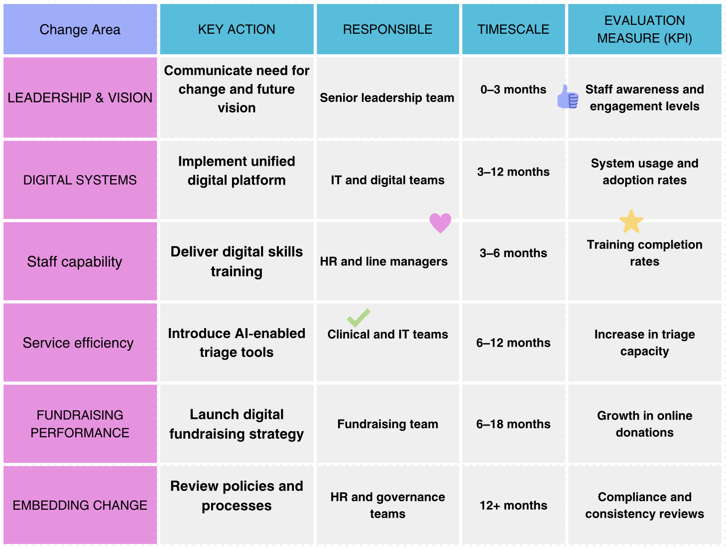

Monitoring and Review
Progress will be monitored through monthly internal reports, six-month reviews against SMART objectives and an annual impact evaluation. Feedback from staff and volunteers will be used to identify challenges and inform continuous improvement, ensuring that change is embedded and sustained over time (Burnes, 2017).

4. Leadership and Organisational Culture in Change
Leadership and organisational culture play a critical role in shaping the success of change initiatives within mission-driven organisations such as Blue Cross. Transformational leadership is particularly relevant in the charity sector, as it motivates and inspires employees through a compelling vision, empowerment and role-modelling, thereby supporting social impact and organisational commitment (Bass and Avolio, 1994). Within Blue Cross, this leadership style can reinforce the organisation’s animal-welfare mission, encourage staff and volunteers to embrace digital transformation, promote collaboration across dispersed operational units and support emotionally intelligent leadership in response to the sensitive nature of animal welfare work. In addition, situational leadership theory emphasises the need for leaders to adapt their approach based on the competence and readiness of followers, suggesting that while some teams may require directive leadership during periods of digital adoption, others may benefit from more supportive or delegative styles (Hersey et al., 2013). Historically, leadership at Blue Cross has prioritised operational continuity over transformational change, contributing to slower digital investment compared to wider sector trends and limiting the organisation’s capacity to adopt data-driven and digitally enabled services. This highlights the importance of active leadership engagement in driving future change initiatives. Organisational culture at Blue Cross is deeply compassionate, supportive and mission-driven, fostering strong internal cohesion and commitment; however, such cultures can also unintentionally inhibit change due to emotional attachment to established practices and systems (Schein, 2010). This may manifest in resistance to process standardisation, anxiety surrounding digital adoption and a preference for familiar ways of working. Consequently, a deliberate cultural shift towards innovation, continuous learning and digital confidence is required to support sustainable organisational change and long-term strategic resilience.

5. Proposed Change Management Plan
The proposed change management plan for Blue Cross centres on a comprehensive digital transformation of both service delivery and internal operations, aimed at improving organisational efficiency, financial sustainability and service capacity in response to rising demand and sector-wide pressures. The proposed change includes the development of a unified digital platform integrating veterinary bookings, donations and stakeholder communication, the introduction of AI-enabled triage tools to support clinical decision-making, the digitisation of client and donor records, the implementation of a revised digital fundraising strategy, targeted staff and volunteer training in new digital systems, and investment in secure, cloud-based data infrastructure to ensure resilience and regulatory compliance (Charity Digital, 2023; RVC, 2023). These initiatives are underpinned by a set of SMART objectives, including improving operational efficiency by 25% within two years, increasing online donations by 30% over 18 months through data-driven engagement, reducing manual administrative tasks by 40% within 12 months, training 95% of staff and volunteers within six months of system rollout, and increasing veterinary triage capacity by 20% through AI-supported tools. (RVC, 2025)
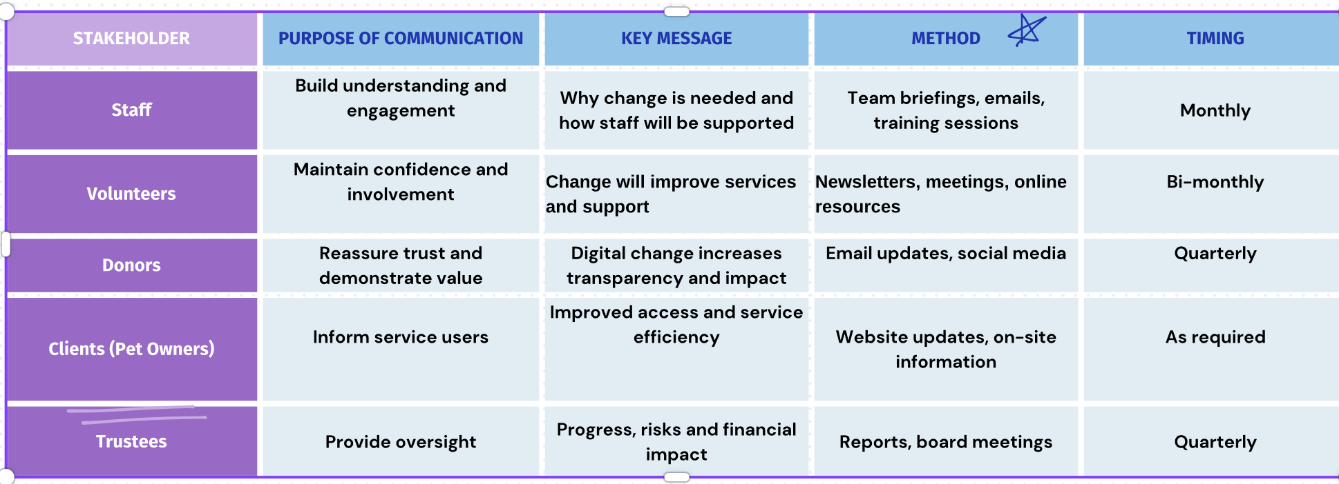

Financially, the proposed programme is estimated to require an investment of approximately £1.3 million, covering digital platform development, AI tools, staff training, cybersecurity upgrades and structured change-management support, with funding to be sourced from a combination of legacy income, targeted fundraising campaigns, grant funding, retail income surpluses and corporate partnerships (NCVO, 2023). The anticipated benefits include reduced administrative labour costs, improved donation efficiency, reduced clinical bottlenecks and enhanced transparency for regulators and donors. Effective implementation will be supported by a structured communication plan targeting key stakeholders including staff, volunteers, donors, clients, regulators, trustees and corporate partners using methods such as briefings, workshops, digital training materials, newsletters and formal reporting, with messaging focused on sustainability, mission enhancement and ongoing support throughout the change process (Kotter, 1996). Progress will be monitored through clearly defined key performance indicators, including system adoption rates, online donation metrics, triage throughput, staff training completion rates and client satisfaction measures, supported by monthly progress reporting, six-month performance reviews and annual impact evaluations to ensure continuous learning and long-term change sustainability (Burnes, 2017).

Financial Plan Template
The financial plan outlines the estimated costs, funding sources and anticipated benefits associated with the proposed digital transformation programme at Blue Cross. Effective financial planning is essential to ensure that the change initiative is affordable, sustainable and aligned with the organisation’s long-term strategic objectives, particularly given existing financial constraints within the charity sector (NCVO, 2023).

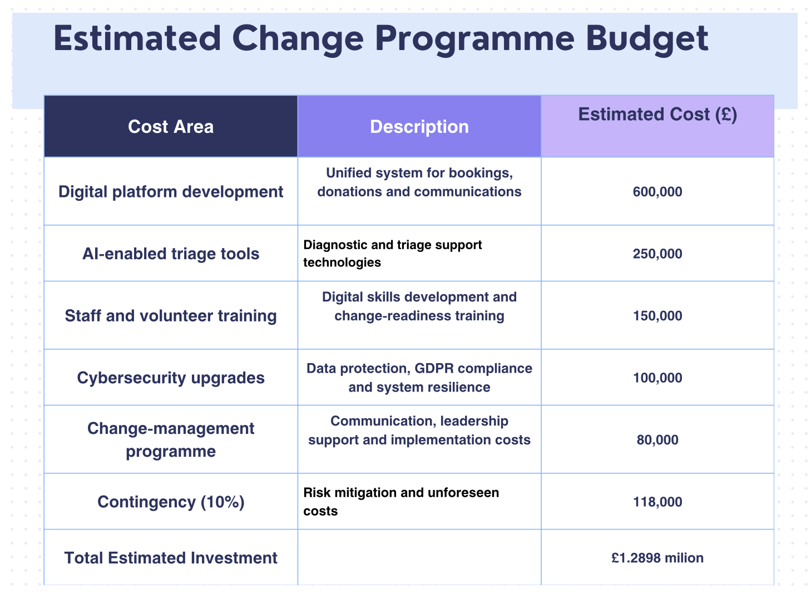

The proposed change programme at Blue Cross will be financed through a diversified and strategically balanced funding approach designed to minimise financial risk while supporting long-term organisational sustainability. As a charity operating in an increasingly volatile economic environment, Blue Cross must reduce its reliance on any single income stream and ensure financial flexibility throughout the change process. Funding will therefore be drawn from a combination of allocated legacy income reserves, targeted digital fundraising campaigns, grant funding such as that provided by the National Lottery Community Fund, surplus income generated through charity retail operations, and carefully selected corporate partnerships and sponsorship arrangements. Research indicates that charities adopting diversified funding portfolios are better positioned to manage income volatility and maintain service continuity during periods of economic uncertainty and changing donor behaviour (Sargeant and Shang, 2017; NCVO, 2023).
Investment in digital transformation is expected to deliver both financial and operational benefits that justify the initial expenditure and strengthen the organisation’s long-term viability. The automation of administrative processes and digitisation of client records are likely to reduce manual workloads and associated labour costs, allowing staff and volunteers to focus on frontline service delivery. In addition, the use of data-driven digital fundraising tools can improve donor targeting, engagement and retention, increasing the efficiency and return on investment of fundraising activities (Charity Digital, 2023). The introduction of AI-enabled triage tools within veterinary services is also expected to reduce clinical bottlenecks, improve appointment allocation and enhance overall service capacity, particularly in high-demand contexts (Royal Veterinary College, 2023). Collectively, these improvements contribute to enhanced transparency, more accurate financial reporting and improved accountability to regulators, trustees and donors, reinforcing organisational trust and credibility (Burnes, 2017).
Effective financial governance will be critical to ensuring that the change programme remains aligned with Blue Cross’s strategic priorities and operational capacity. Financial risk will be managed through regular budget reviews, detailed expenditure monitoring and robust oversight by trustees and senior leadership. A phased implementation approach will allow costs to be spread over time, reducing pressure on cash flow and enabling adjustments in response to performance data and emerging risks. The inclusion of contingency funding further strengthens financial control by providing flexibility to address unforeseen challenges without compromising service delivery. Strong governance structures and transparent financial management are widely recognised as essential enablers of successful change in third-sector organisations, particularly when implementing large-scale digital transformation initiatives (Burnes, 2017; NCVO, 2023).

6. Conclusion
This report has examined the need for strategic change at Blue Cross within the context of increasing environmental pressures, financial constraints and evolving expectations within the UK charity and veterinary sectors. Through an analysis of the organisation’s external environment using the PESTLE framework and an assessment of its internal structure, culture and resources, the report identified significant challenges including rising demand for low-cost veterinary services, economic uncertainty, digital disruption and operational fragmentation. These pressures highlight the limitations of existing systems and practices and reinforce the need for a structured and proactive approach to organisational change.
The evaluation of change-management models demonstrated that while Lewin’s Three-Stage Model offers a useful foundation for understanding readiness and cultural embedding, it lacks the flexibility required for complex and continuously changing environments such as the third sector. Kotter’s Eight-Step Model was identified as particularly effective in providing a clear and structured roadmap for implementation, especially in relation to leadership engagement, communication and stakeholder involvement. The McKinsey 7-S Framework further complemented this approach by highlighting the importance of aligning strategy, systems, skills and organisational culture with change objectives. Together, these models provide a robust and integrated framework capable of supporting sustainable change at Blue Cross.
Leadership and organisational culture were shown to be central to the success of any change initiative. The report emphasised the relevance of transformational and situational leadership styles in motivating staff and volunteers, managing resistance and supporting digital adoption. While Blue Cross benefits from a strong, compassionate and mission-driven culture, this has also contributed to risk aversion and resistance to innovation. A deliberate shift towards a culture that values continuous learning, digital confidence and adaptability is therefore essential to enable long-term transformation.
In response to these findings, the report proposed a comprehensive change management plan centred on digital transformation, supported by SMART objectives, a realistic financial plan, a structured communication strategy and a simplified evaluation and monitoring framework. The proposed initiatives are designed to enhance operational efficiency, strengthen donor engagement, improve service accessibility and ensure financial sustainability while remaining aligned with Blue Cross’s charitable mission. Overall, the report concludes that by adopting a systematic, inclusive and theory-informed approach to change, Blue Cross will be better positioned to respond to ongoing sector challenges, meet rising demand for services and secure its long-term ability to support pets and their owners across the UK.

References
Bass, B.M. (1985) Leadership and Performance Beyond Expectations. New York: Free Press.

Bass, B.M. and Avolio, B.J. (1994) Improving Organizational Effectiveness through Transformational Leadership. Thousand Oaks, CA: Sage.

Blue Cross (2022) Annual Statement on Service Demand. London: Blue Cross.

Blue Cross (2023) Annual Report and Accounts. London: Blue Cross.

Blue Cross (2024) About Blue Cross. Available at: https://www.bluecross.org.uk (Accessed: 15 November 2025).

Burnes, B. (2017) Managing Change. 7th edn. Harlow: Pearson Education.

Cameron, K.S. and Quinn, R.E. (2011) Diagnosing and Changing Organizational Culture: Based on the Competing Values Framework. 3rd edn. San Francisco: Jossey-Bass.

Charities Aid Foundation (CAF) (2022) UK Giving Report. London: CAF.
Charity Digital (2023) Charity Digital Skills Report. London: Charity Digital.

Civil Society (2023) ‘The impact of COVID-19 on the charity sector’, Civil Society News, 22 June.

Competition and Markets Authority (CMA) (2023) Veterinary Services Market Investigation. London: CMA.

Department for Environment, Food & Rural Affairs (DEFRA) (2023) Animal Welfare Legislation and Policy Framework. London: DEFRA.

Dunlop, C.A. and Radaelli, C.M. (2016) ‘Policy learning in the Eurozone crisis: Modes, power and functionality’, Policy Sciences, 49(2), pp. 107–124.

Hersey, P., Blanchard, K.H. and Johnson, D.E. (2013) Management of Organizational Behavior: Leading Human Resources. 10th edn. Harlow: Pearson Education.

Kennel Club (2023) Cost of Living Crisis and Its Impact on Dog Ownership. London: The Kennel Club.

Kotter, J.P. (1996) Leading Change. Boston: Harvard Business School Press.

Lewin, K. (1947) ‘Frontiers in group dynamics’, Human Relations, 1(1), pp. 5–41.

Lewin, K. (1951) Field Theory in Social Science. New York: Harper & Row.

McKinsey & Company (2018) The New Organisation for the Future. London: McKinsey & Company.

National Council for Voluntary Organisations (NCVO) (2023) UK Civil Society Almanac. London: NCVO.

People’s Dispensary for Sick Animals (PDSA) (2022) PAW Report: Pet Ownership and Welfare. London: PDSA.

Royal Veterinary College (RVC) (2023) The Role of Digital Technology and AI in Veterinary Services. London: RVC.

Royal Veterinary College (RVC) (2025) Guidelines for Setting SMART Objectives. London: Royal Veterinary College.

Sargeant, A. and Shang, J. (2017) Fundraising Principles and Practice. 2nd edn. Hoboken, NJ: Wiley.

Schein, E.H. (2010) Organizational Culture and Leadership. 4th edn. San Francisco: Jossey-Bass.

Waterman, R.H., Peters, T.J. and Phillips, J.R. (1980) ‘Structure is not organisation’, Business Horizons, 23(3), pp. 14–26.

