April 26, 2025
Emma Moseley (2317703)
BEng Embedded Electronics Systems Engineering
Design and Analysis of Electromagnetic Systems
Electromagnetic Radiation
Abstract
This report describes the simulation and theoretical analysis of key electromagnetic systems with Ansys HFSS. Section 2 analyses a rectangular waveguide filled with vacuum and Teflon across a 2-30 GHz frequency range. It confirms the TE₁₀ mode as dominant and highlights a predicted reduction in cutoff frequencies due to higher permittivity. Section 3 covers the making of a half-wave dipole antenna that approaches resonance near 1.2 GHz, has an omnidirectional radiation pattern, and a peak gain of 4.9 dB. Section 4 discusses recent advances in radar technology for drone detection, such as mmWave sensing, AI-based processing, and passive detection methods, while considering broader social impacts. Overall, the results illustrate the importance of simulation tools in demonstrating electromagnetic theory and advancing the development of new high-frequency technology.

Contents
1 Introduction 7
2 Rectangular Waveguide Simulation and Analysis 7
2.1 Methodology 7
2.1.1 Waveguide Design and Simulation Setup 7
2.1.2 Theoretical Calculations 8
2.2 Results 9
2.2.1 Field Distributions 9
2.2.2 Gamma Plot 22
2.3 Discussion 24
2.4 Concluding Analysis 24
3 Half-Wave Dipole Antenna Design and Analysis 24
3.1 Methodology 25
3.1.1 Antenna Design and Simulation Setup 25
3.1.2 Theoretical Calculations 27
3.2 Results 28
3.2.1 Return Loss Plot 28
3.2.2 Far-Field Radiation Pattern 28
3.2.3 Antenna Gain 29
3.3 Discussion 29
3.4 Concluding Analysis 30
4 Evaluation of Radar Technologies for Drone Detection 30
4.1 Literature Review 30
4.1.1 Challenges of Traditional Radar Systems 30
4.1.2 High-Resolution and mmWave Radar 30
4.1.3 Passive Radar Systems 30
4.1.4 Cognitive Radar 31
4.1.5 Artificial-Intelligence Signal Processing 31
4.1.6 Multi-Sensor Fusion 31
4.2 Discussion 31
4.2.1 Technical Challenges 31
4.2.2 Society and Environmental Considerations 32
4.2.3 Future Developments 32
4.3 Concluding Analysis 32
5 Conclusion 33
6 References 33

Table of Figures
Figure 1: Rectangular Waveguide dimensions. 8
Figure 2: TE₁₀ for both Port 1 and 2 (vacuum and Teflon). 10
Figure 3: TE₂₀ for both Port 1 and 2 (vacuum and Teflon). 10
Figure 4: TE₀₁ for both Port 1 and 2 (vacuum and Teflon). 10
Figure 5: Electric Field Vector for TE₁₀ vacuum. 11
Figure 6: Electric Field Vector for TE₂₀ vacuum. 11
Figure 7: Electric Field Vector for TE₀₁ vacuum. 12
Figure 8: Electric Field Vector for TE₁₀ Teflon. 12
Figure 9: Electric Field Vector for TE₂₀ Teflon. 13
Figure 10: Electric Field Vector for TE₀₁ Teflon. 13
Figure 11: Magnetic Field Vector for TE₁₀ Vacuum. 14
Figure 12: Magnetic Field Vector for TE₂₀ Vacuum. 14
Figure 13: Magnetic Field Vector for TE₀₁ Vacuum. 15
Figure 14: Magnetic Field Vector for TE₁₀ Vacuum. 15
Figure 15: Magnetic Field Vector for TE₂₀ Vacuum. 16
Figure 16: Magnetic Field Vector for TE₀₁ Vacuum. 16
Figure 17: E-Field Magnitude for TE₁₀ Vacuum. 17
Figure 18: E-Field Magnitude for TE₂₀ Vacuum. 17
Figure 19: E-Field Magnitude for TE₀₁ Vacuum. 18
Figure 20: E-Field Magnitude for TE₁₀ Teflon. 18
Figure 21: E-Field Magnitude for TE₂₀ Teflon. 19
Figure 22: E-Field Magnitude for TE₀₁ Teflon. 19
Figure 23: H-Field Magnitude for TE₁₀ Vacuum. 20
Figure 24: H-Field Magnitude for TE₂₀ Vacuum. 20
Figure 25: H-Field Magnitude for TE₀₁ Vacuum. 21
Figure 26: H-Field Magnitude for TE₁₀ Teflon. 21
Figure 27: H-Field Magnitude for TE₂₀ Teflon. 22
Figure 28: H-Field Magnitude for TE₀₁ Teflon. 22
Figure 29: Gamma plot showing cutoff frequencies for TE₁₀, TE₂₀, and TE₀₁ for the vacuum-filed rectangular waveguide. 23
Figure 30: Gamma plot showing cutoff frequencies for TE₁₀, TE₂₀, and TE₀₁ for the Teflon-filed rectangular waveguide. 23
Figure 31 Dipole antenna showing the feed gap for lumped port excitation. 25
Figure 32: Placement of 50Ω lumped port at the dipole feed point. 26
Figure 33: Overall view of the dipole antenna model along the Z-axis. 26
Figure 34: Radiation box surrounding the dipole antenna for boundary definition. 27
Figure 35: S-Parameter plot showing return loss performance of the half-wave dipole antenna. 28
Figure 36: 3D far-field radiation pattern illustrating the omnidirectional gain distribution of the half-wave dipole antenna. 29

Table of Tables
Table 1: TE-mode cut-off frequencies (vacuum vs Teflon). 9
Table 2: Simulated results of Cutoff Frequencies for TE Modes in Vacuum and Teflon-Filled Waveguides with theory results for comparison. 23

Table of Equations
Equation 1: Rectangular Waveguide cut-off frequency formula 8
Equation 2: Electromagnetic Wave Speed (Phase-Velocity) Formula 8
Equation 3: Wavelength-frequency Relation for a Wave in Free Space. 27
Equation 4: The calculation using the wavelength of 231mm for the simulation 27
Equation 5: Half-wave Dipole Length. 28

Introduction
This report examines the design, simulation, and assessment of electromagnetic systems through both research-based analysis and real-world modelling. Section 1 explores the modal behaviour of Teflon and vacuum-filled rectangular waveguides using Ansys HFSS to simulate their cutoff frequencies. Section 2 looks at the design and simulation of a half-wave dipole antenna, as well as how its resonance and radiation performance compare to theoretical expectations. Section 3 presents a research-driven look at advancements in radar technology for drone detection, considering both scientific achievements and the societal and environmental implications. When seen as a whole, these studies show how simulation tools may assist integrate theoretical concepts with practical challenges in high-frequency electromagnetic applications.

Rectangular Waveguide Simulation and Analysis
This section analyses the propagation of electromagnetic modes in a rectangular waveguide using Ansys HFSS. Rectangular waveguides used in radar and microwave systems can operate in either transverse magnetic (TM) or transverse electric (TE) modes, depending on their shape and boundaries. The simulation analyses how Teflon dielectric and vacuum influence cutoff frequencies and modal behaviour.

Methodology

Waveguide Design and Simulation Setup
The dimensions of the rectangular waveguide were calculated using the student ID (2317703) - width 23mm and height 9mm (rounded from 17 ÷ 2). The waveguide length was set at 50mm along the z-axis (see Figure 1). The design was consistent for Teflon and vacuum simulations, providing a controlled assessment of the material's characteristics. Conductive boundaries were simulated using Perfect Electric Conductor (PEC) walls, and each waveguide model included two wave ports at opposite ends. To analyse the excitation and propagation of TE modes, a frequency sweep from 2 GHz to 30 GHz was used.
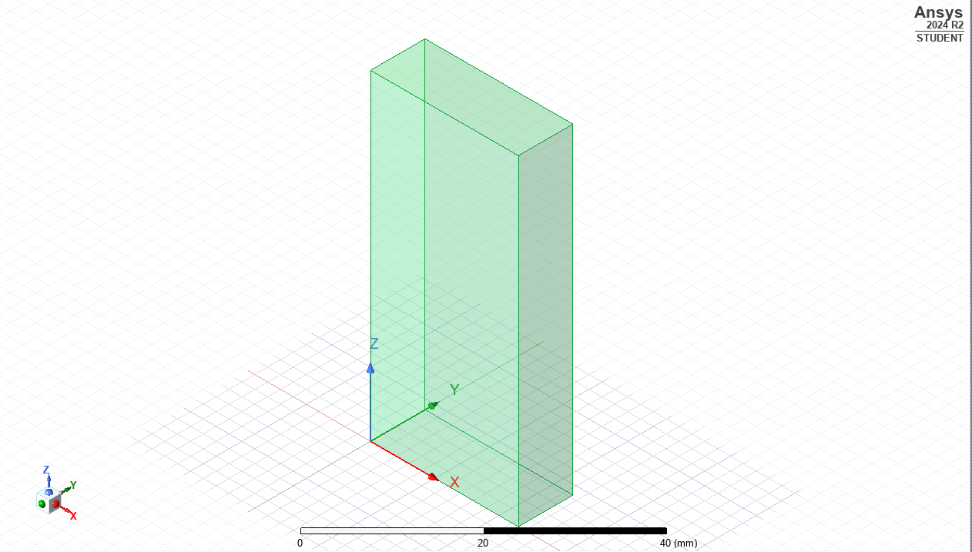
Figure 1: Rectangular Waveguide dimensions.

Theoretical Calculations
Equation 1 was used to calculate the cutoff frequencies for TE modes. In this equation, c represents the speed of light (3×108 m/s), m and n are mode indices, while a and b are waveguide dimensions in meters. Teflon (εᵣ = 2.1, μᵣ = 1) and vacuum (εᵣ = 1, μᵣ = 1) were the material constants used.
Equation 1: Rectangular Waveguide cut-off frequency formula
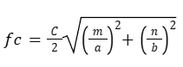
For waveguides filled with dielectric materials, the speed of light is reduced using equation 2:
Equation 2: Electromagnetic Wave Speed (Phase-Velocity) Formula
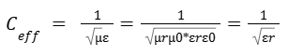
Applying this, the Teflon-filled waveguide has an adjusted speed of 2.07*108m/s. This reduced speed was used in the cutoff frequency equation to reflect the influence of material permittivity. A comparison of the calculated cutoff frequencies for vacuum and Teflon is presented in Table 1.
Table 1: TE-mode cut-off frequencies (vacuum vs Teflon).
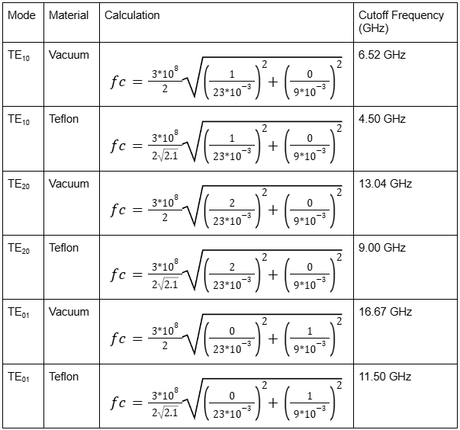

Results

Field Distributions
Figures 2-4 show the three TE modes identified in the simulation: TE₁₀, TE₂₀ and TE₀₁. These modal profiles were identified at wave ports and validated via field visualisation.

Figure 2: TE₁₀ for both Port 1 and 2 (vacuum and Teflon).
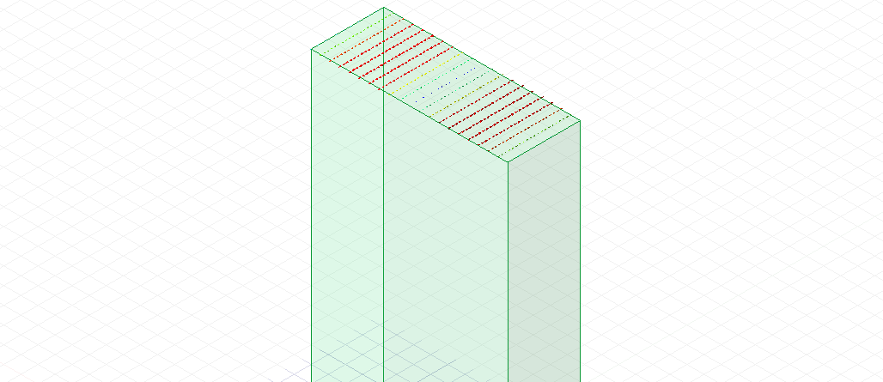
Figure 3: TE₂₀ for both Port 1 and 2 (vacuum and Teflon).
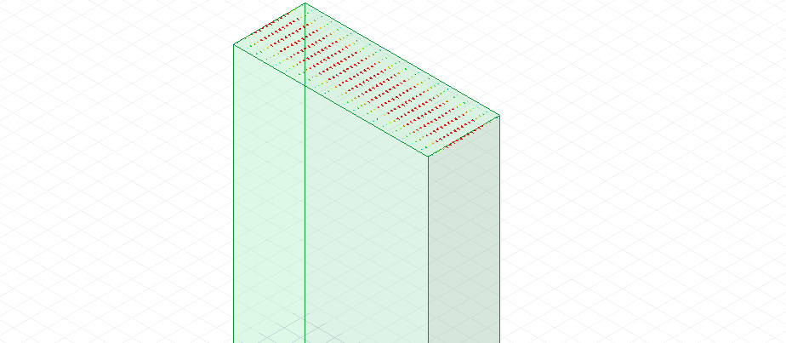
Figure 4: TE₀₁ for both Port 1 and 2 (vacuum and Teflon).
Electric Field Vectors (E-field):
At Wave Port 1, the field vectors demonstrated clear modal behaviour for the three TE modes (Figure 5-7 for vacuum, 8-10 for Teflon). TE₁₀ mode has the most consistent and concentrated E-field across the waveguide's larger diameter, confirming its dominant nature.
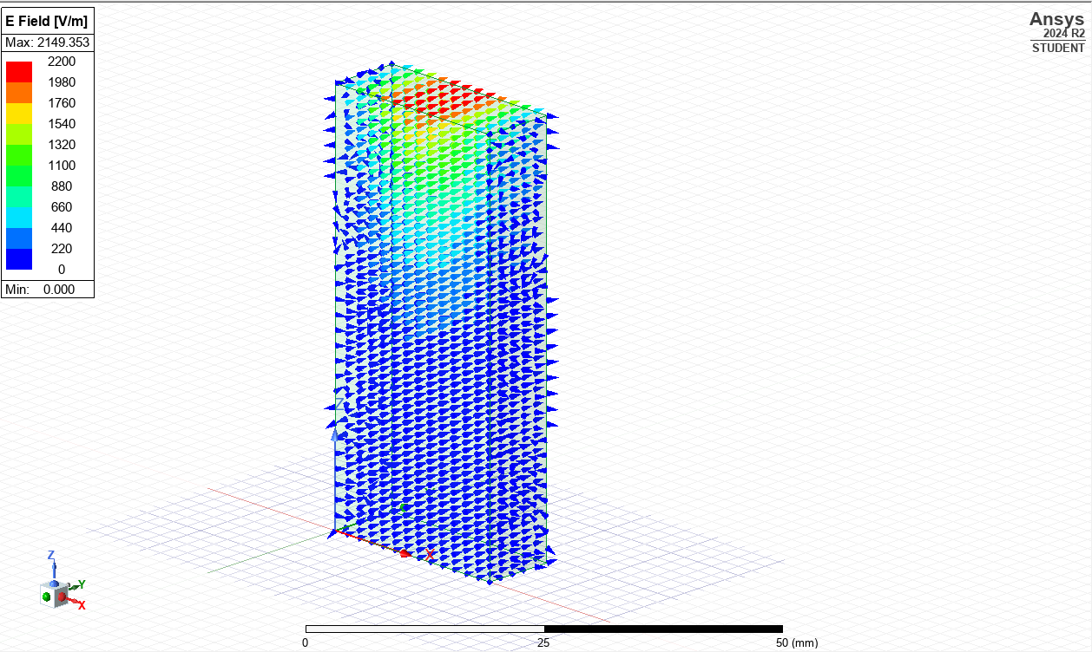
Figure 5: Electric Field Vector for TE₁₀ vacuum.
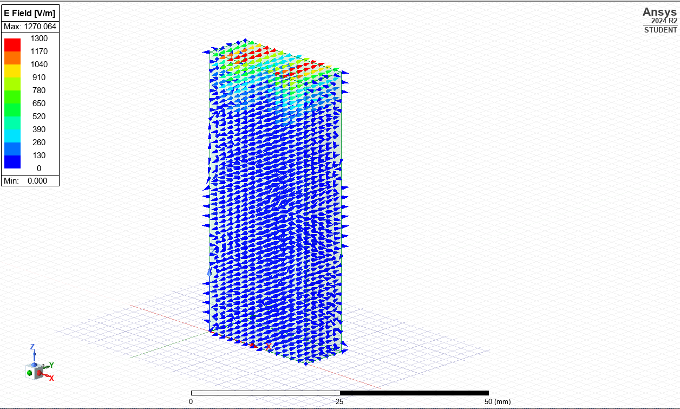
Figure 6: Electric Field Vector for TE₂₀ vacuum.
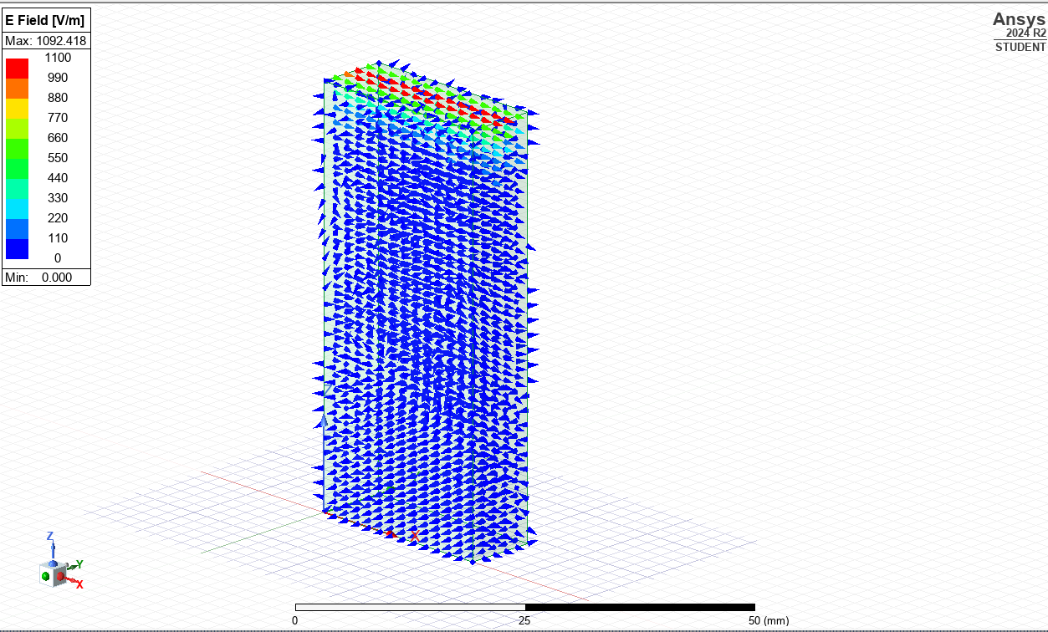
Figure 7: Electric Field Vector for TE₀₁ vacuum.
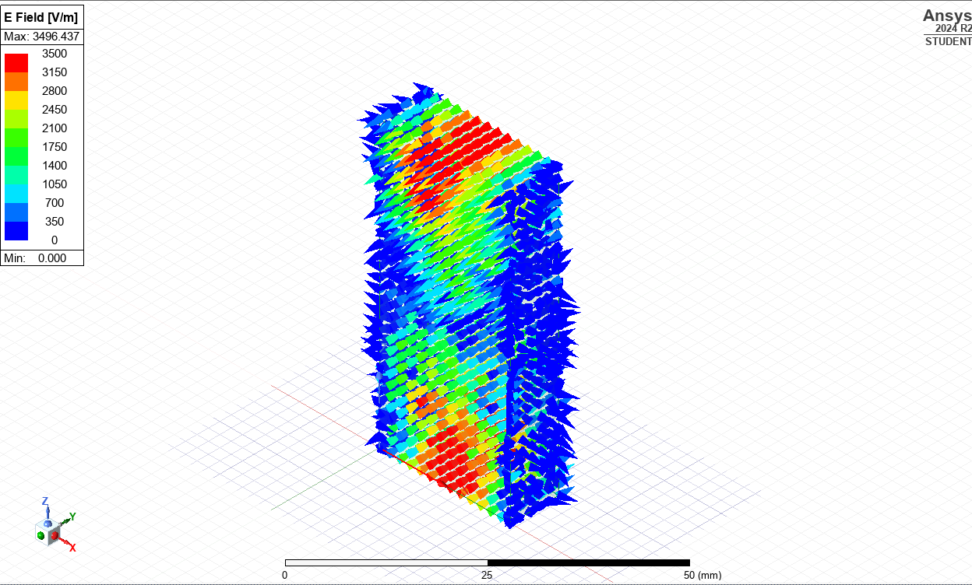
Figure 8: Electric Field Vector for TE₁₀ Teflon.
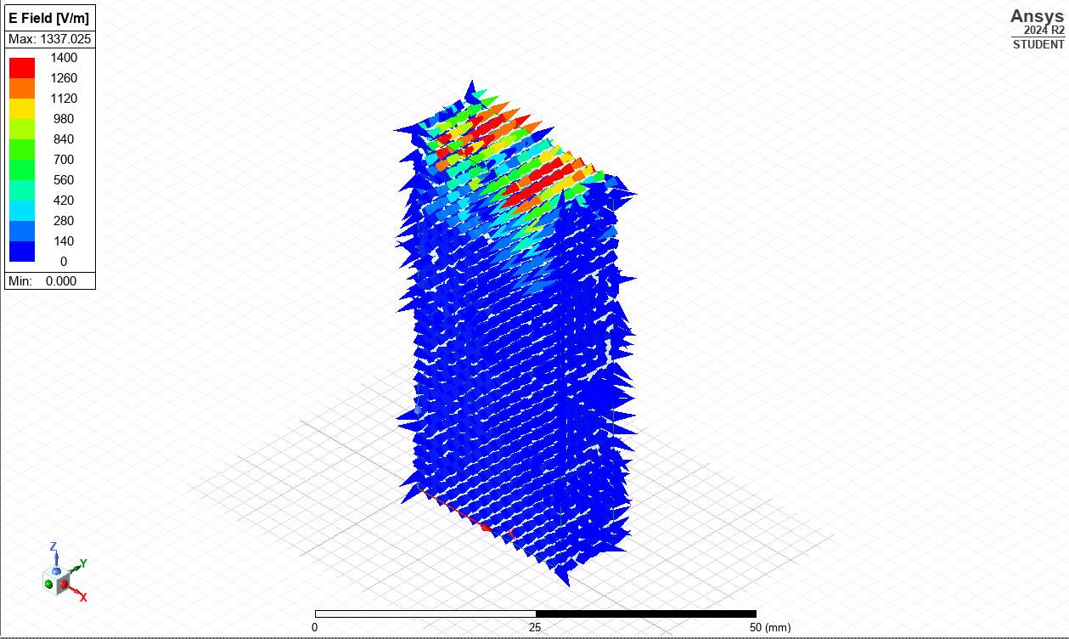
Figure 9: Electric Field Vector for TE₂₀ Teflon.
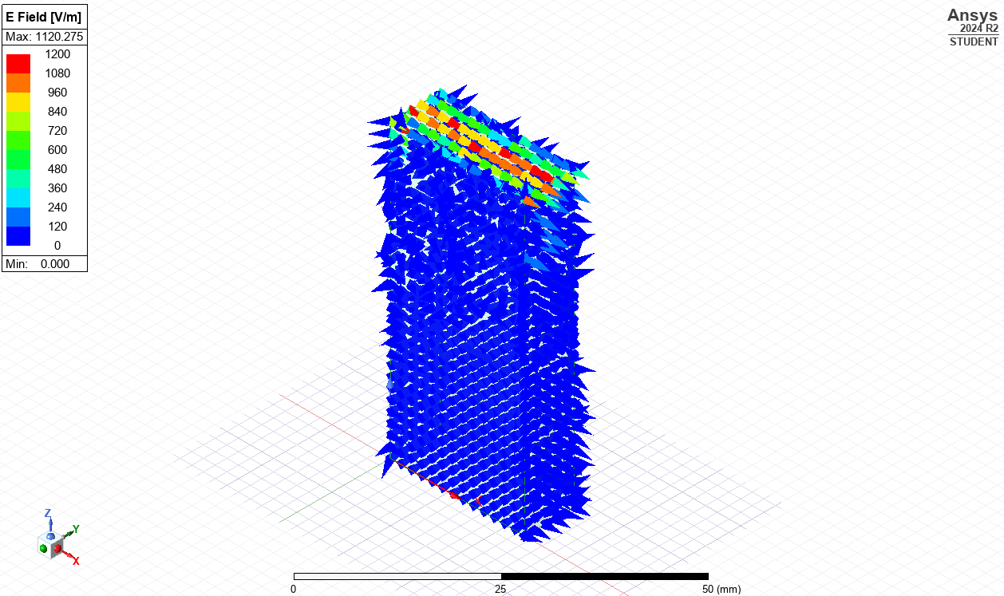
Figure 10: Electric Field Vector for TE₀₁ Teflon.
Magnetic Field Vectors (H-field):
Magnetic field vector visuals gave a clear view of modal orientation and propagation. The H-field's symmetry and directionality helped identify TE₁₀, TE₂₀, and TE₀₁ modes (Figures 11-13 for vacuum, and Figures 14-16 for Teflon).
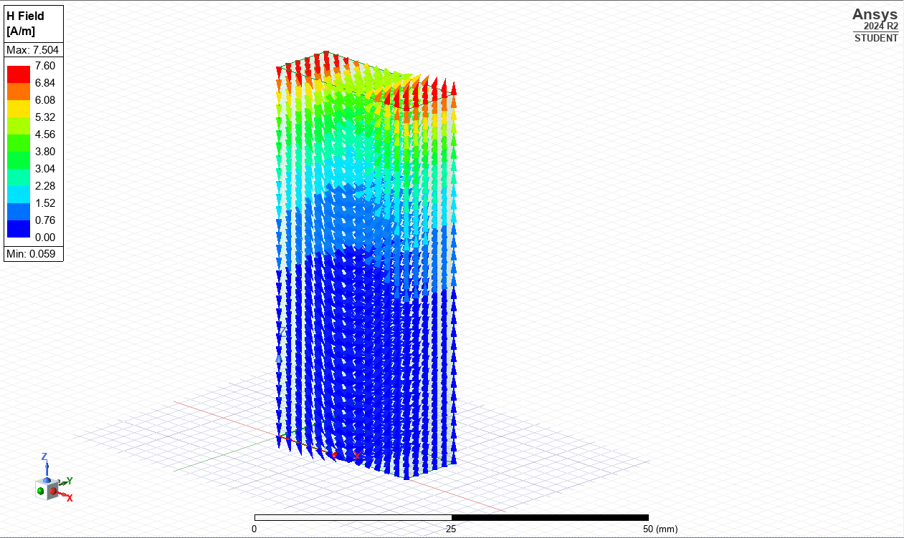
Figure 11: Magnetic Field Vector for TE₁₀ Vacuum.
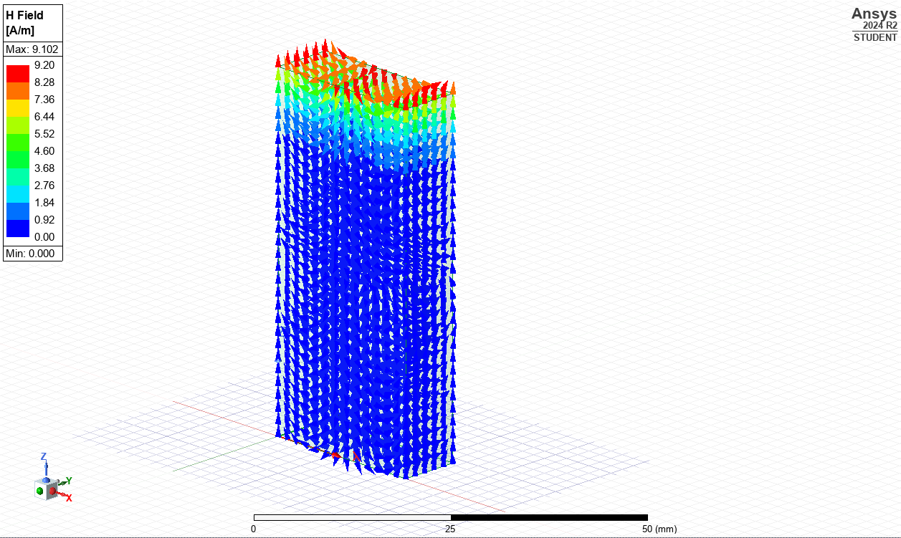
Figure 12: Magnetic Field Vector for TE₂₀ Vacuum.
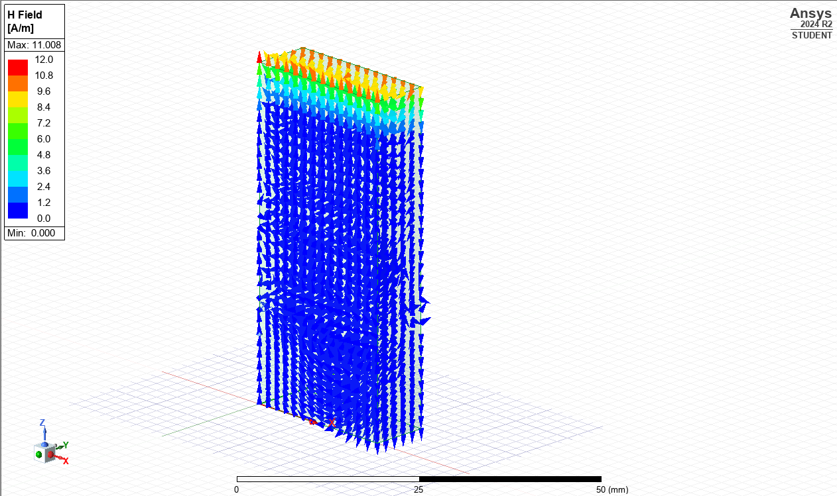
Figure 13: Magnetic Field Vector for TE₀₁ Vacuum.
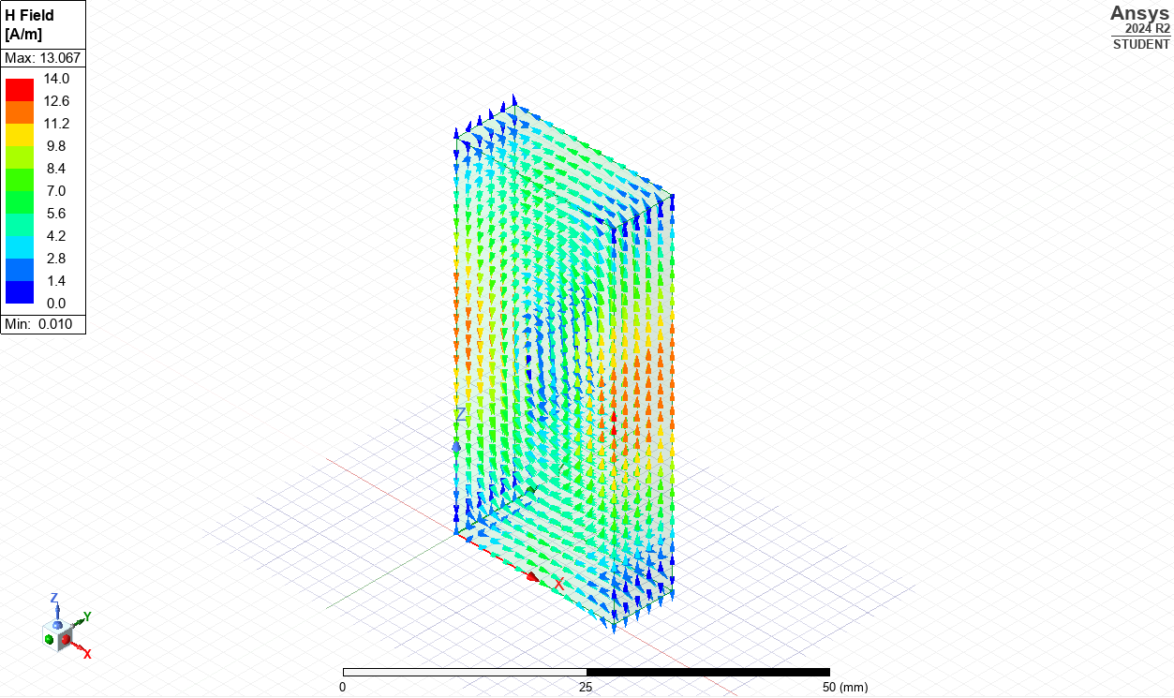
Figure 14: Magnetic Field Vector for TE₁₀ Teflon.
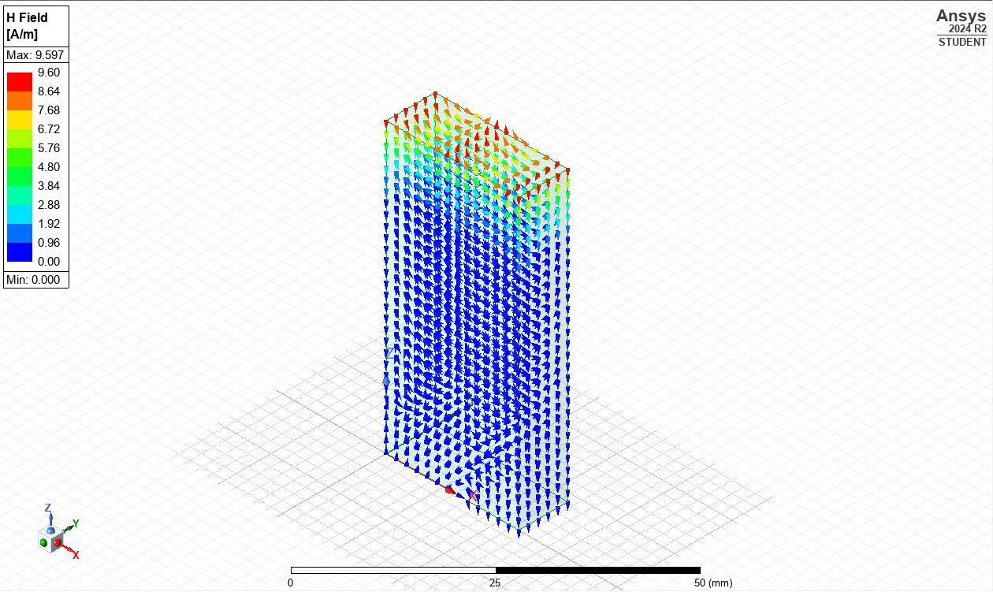
Figure 15: Magnetic Field Vector for TE₂₀ Teflon.
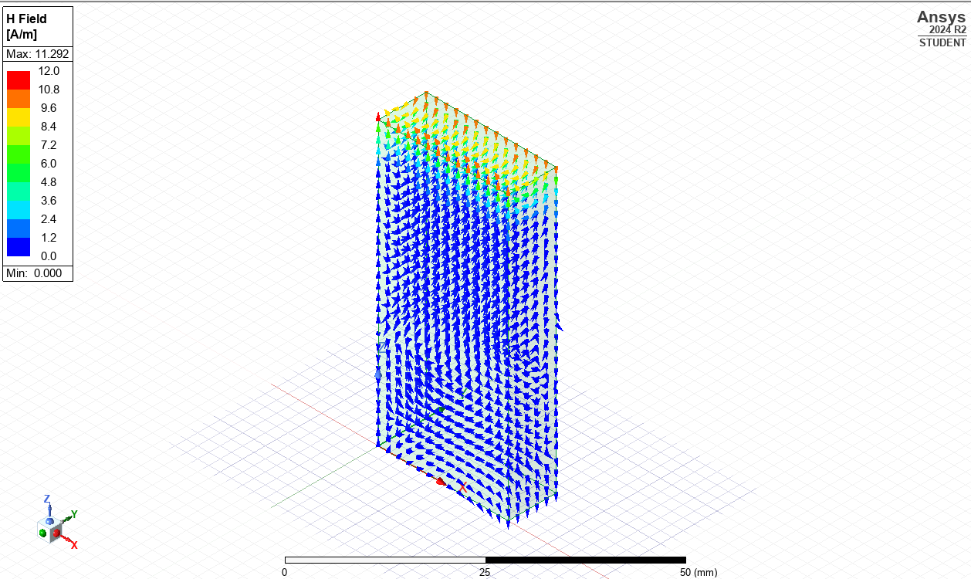
Figure 16: Magnetic Field Vector for TE₀₁ Teflon.
Magnitude Plots (E-field & H-field):
The spatial intensity distributions of the electric and magnetic fields are shown along the waveguide cross-section. These magnitude maps depict the nodal patterns and field strength variances associated with each mode under both vacuum and Teflon-filled conditions.
Figures 17-19 show the E-field Magnitude plots for vacuum-filled, and Figures 20-22 for the Teflon-filled.
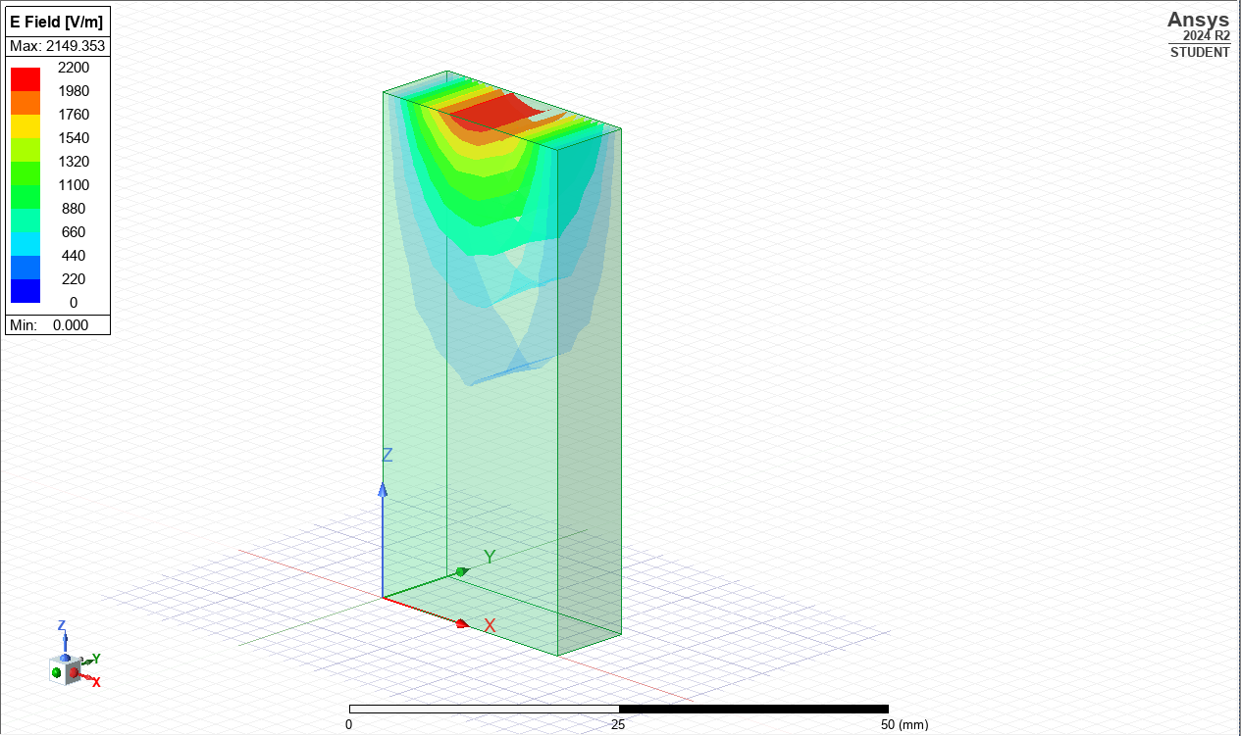
Figure 17: E-Field Magnitude for TE₁₀ Vacuum.
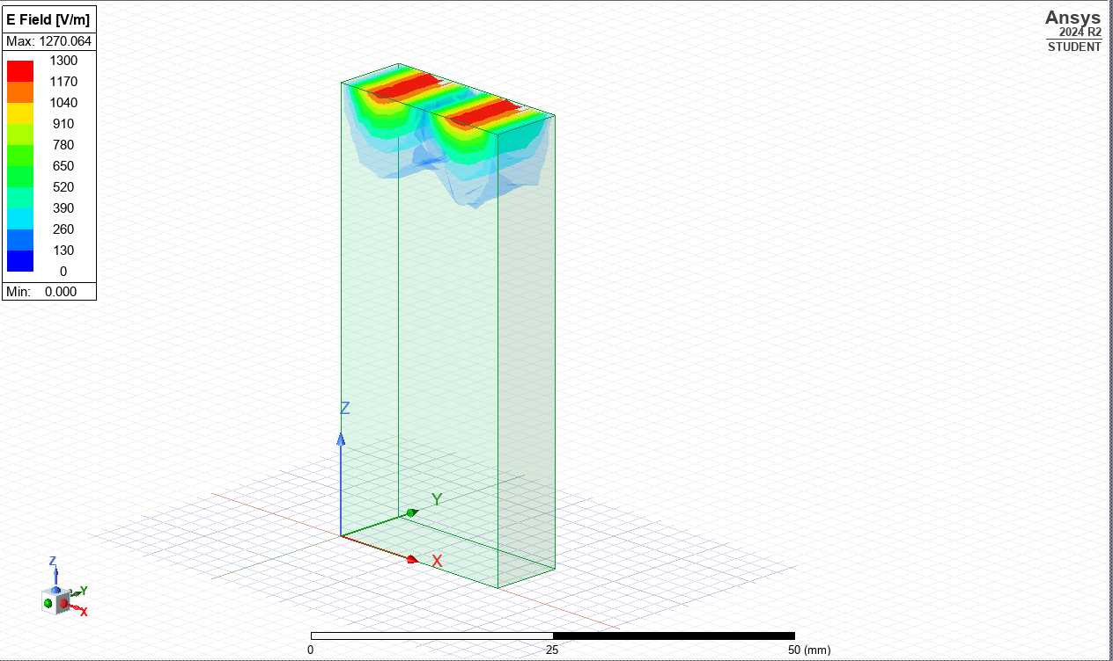
Figure 18: E-Field Magnitude for TE₂₀ Vacuum.
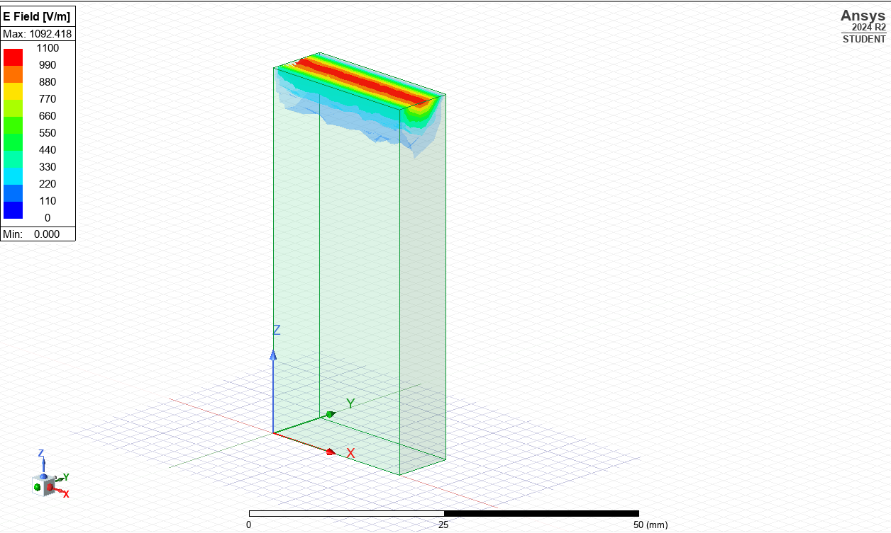
Figure 19: E-Field Magnitude for TE₀₁ Vacuum.
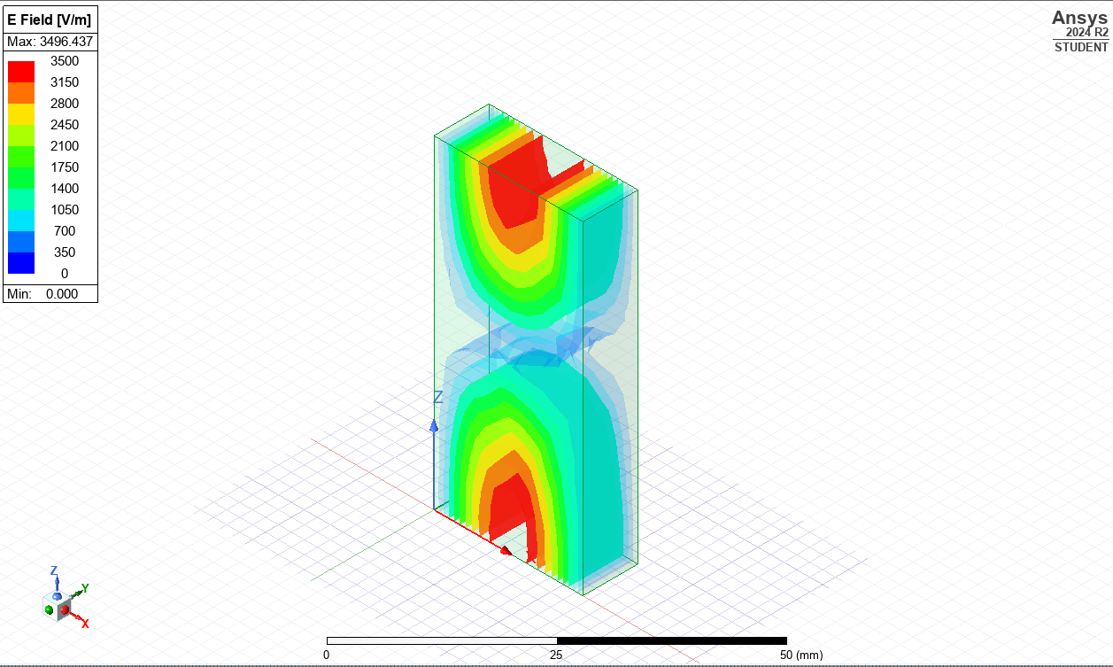
Figure 20: E-Field Magnitude for TE₁₀ Teflon.
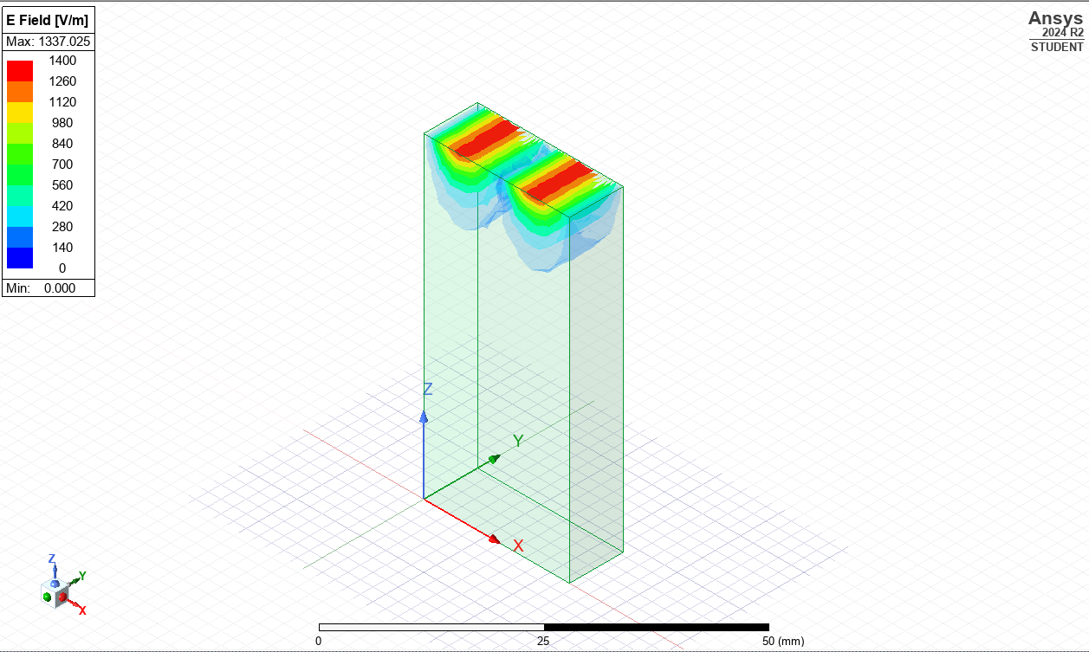
Figure 21: E-Field Magnitude for TE₂₀ Teflon.
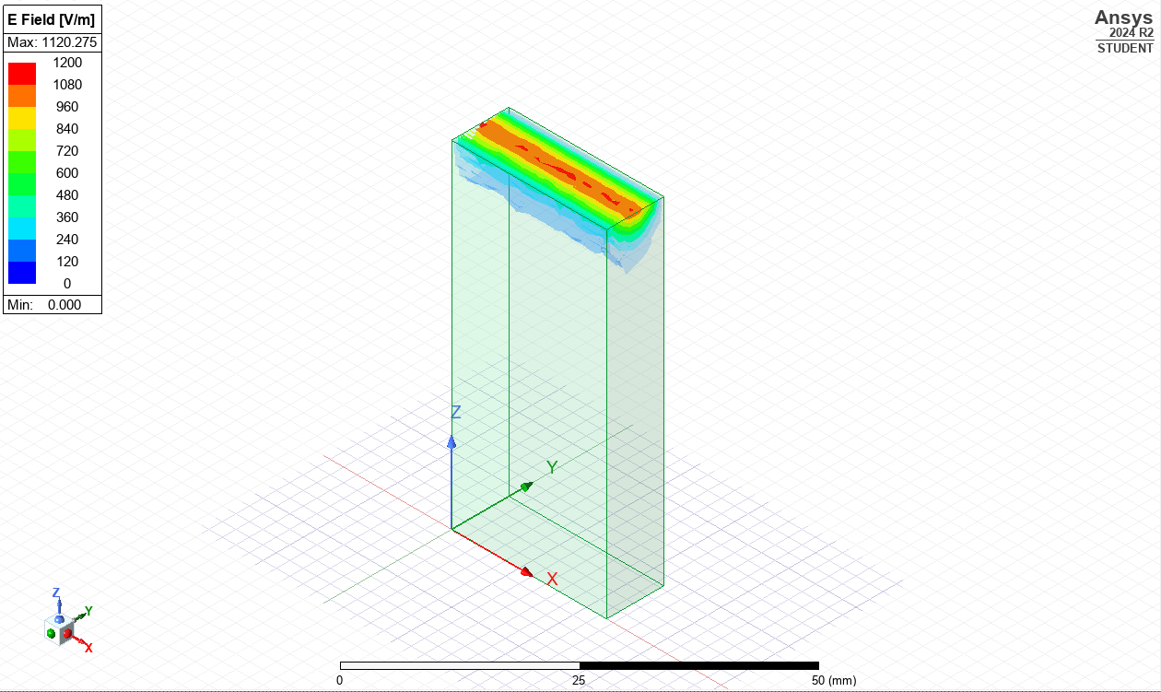
Figure 22: E-Field Magnitude for TE₀₁ Teflon.
Figures 23-25 show the H-field Magnitude plots for vacuum-filled, and Figures 26-28 for the Teflon-filled.
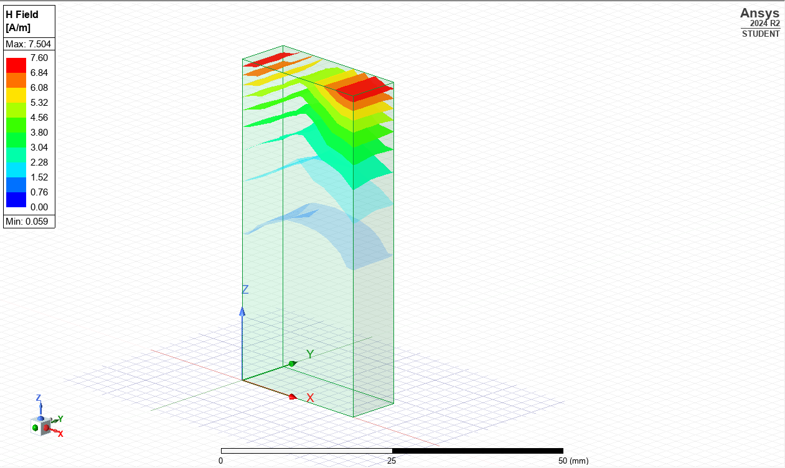
Figure 23: H-Field Magnitude for TE₁₀ Vacuum.
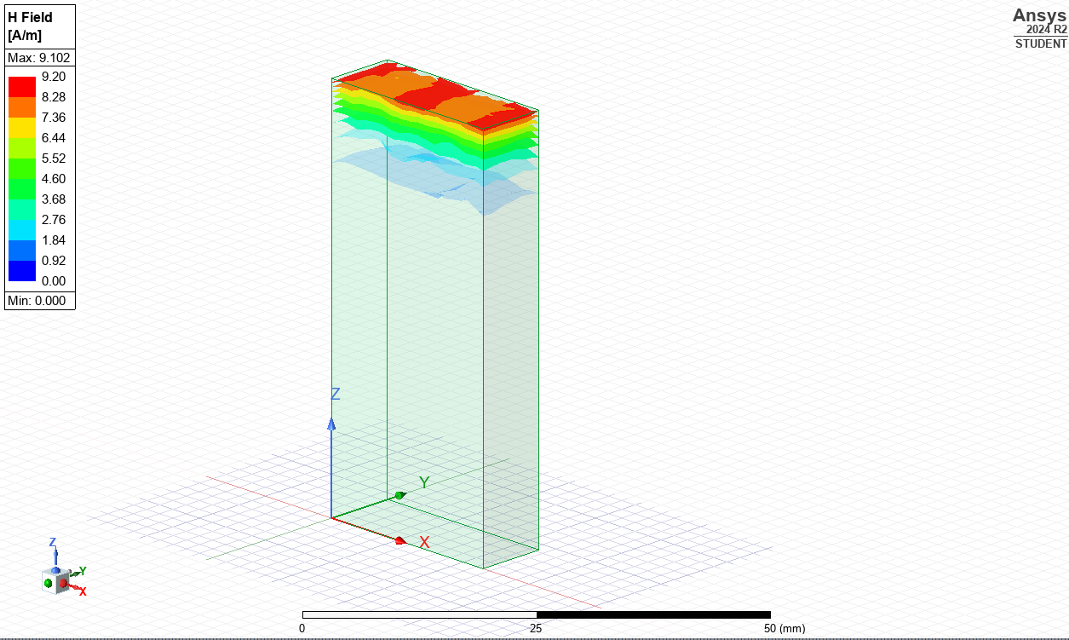
Figure 24: H-Field Magnitude for TE₂₀ Vacuum.
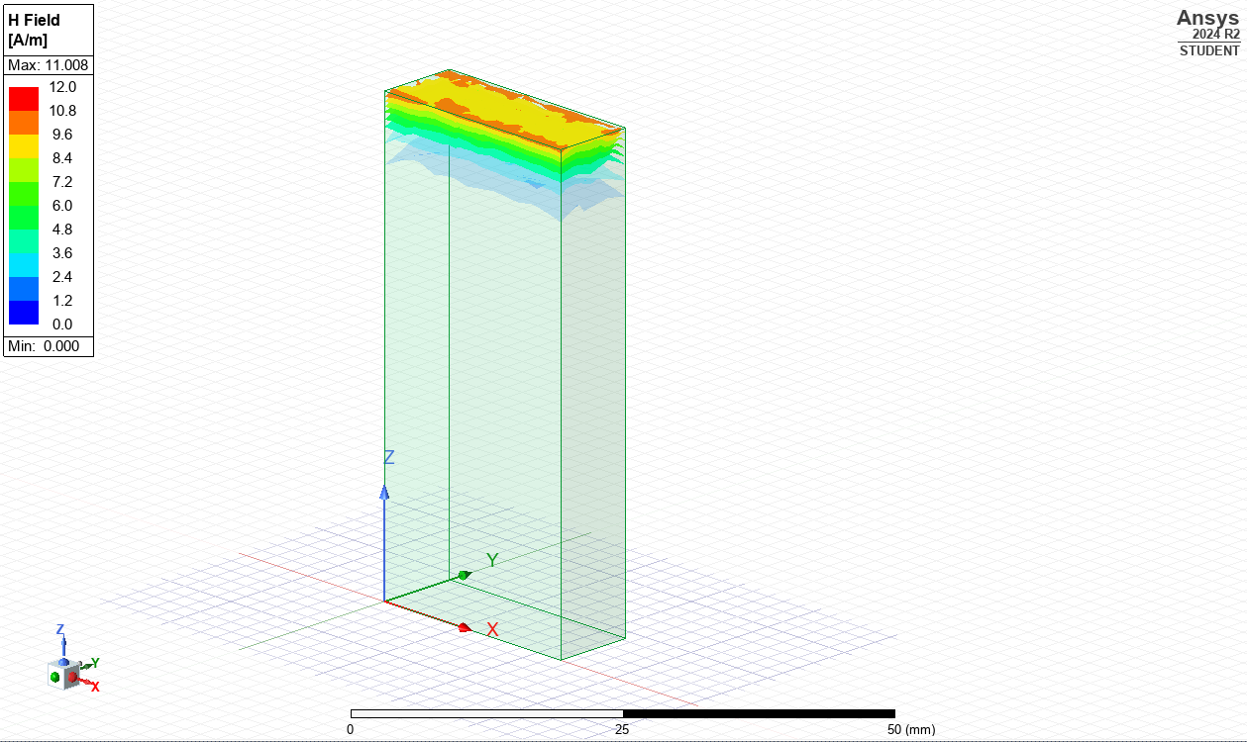
Figure 25: H-Field Magnitude for TE₀₁ Vacuum.

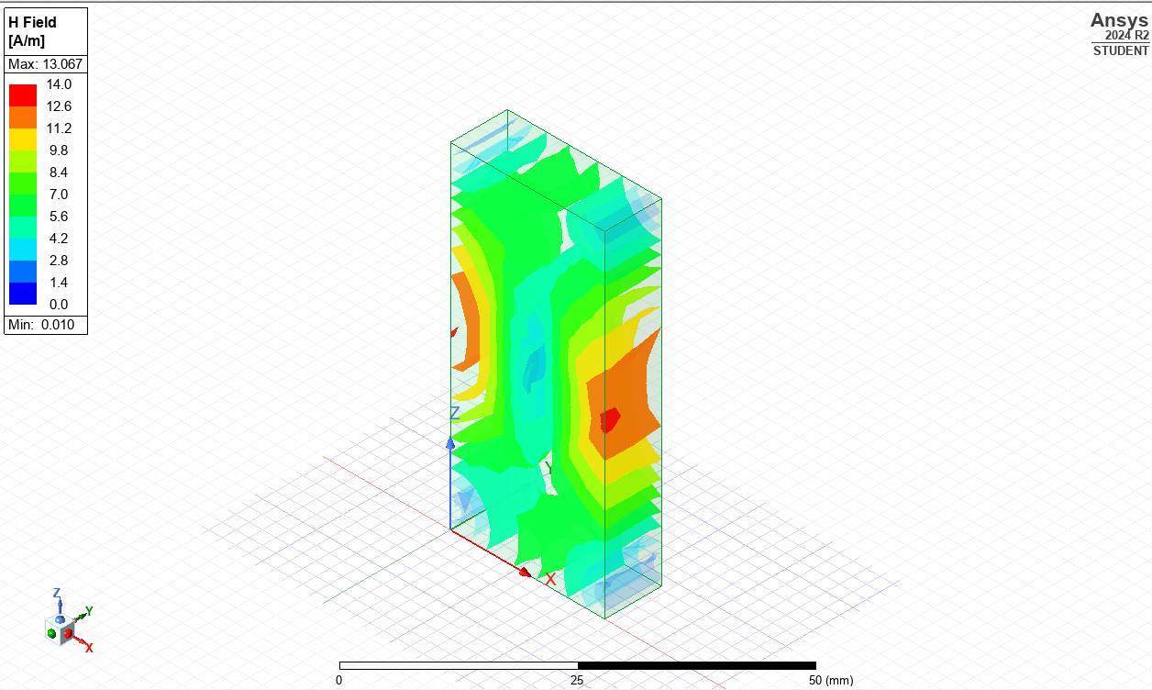
Figure 26: H-Field Magnitude for TE₁₀ Teflon.
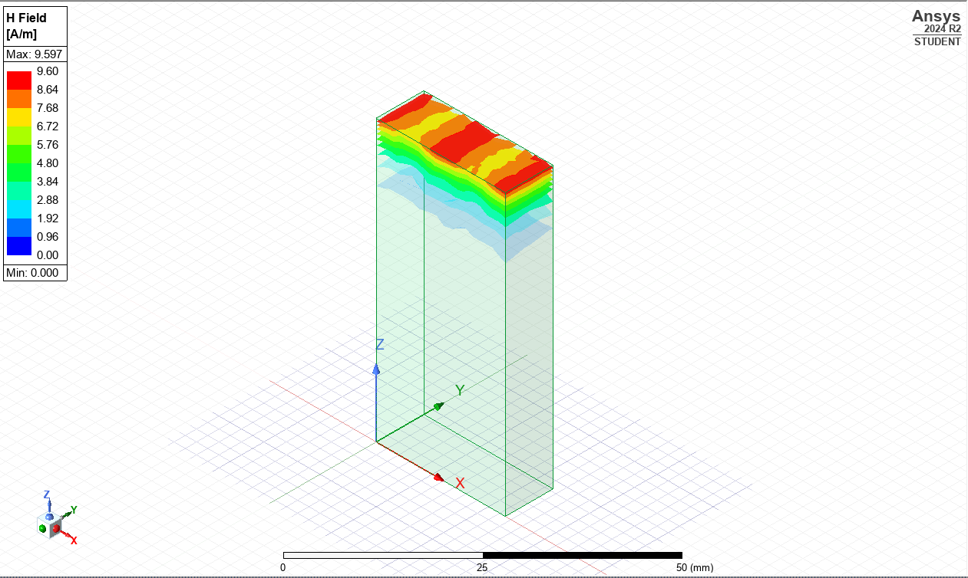
Figure 27: H-Field Magnitude for TE₂₀ Teflon.
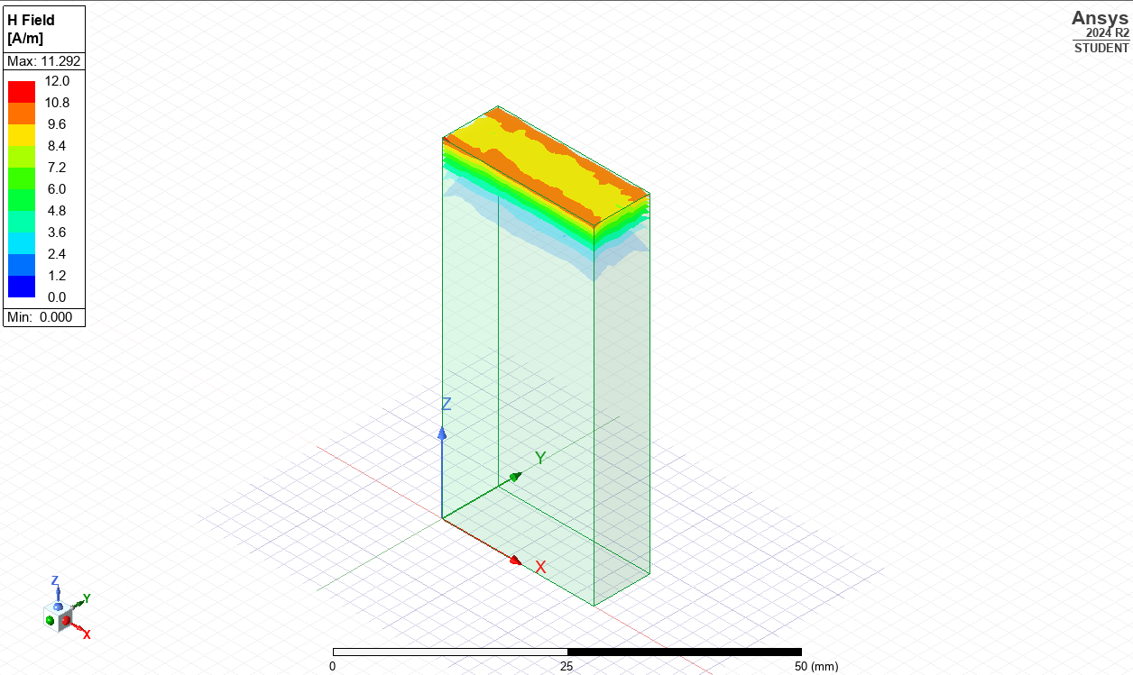
Figure 28: H-Field Magnitude for TE₀₁ Teflon.

Gamma Plot
The cutoff frequencies were calculated using the gamma plots (Figures 29 and 30) by determining the point where the wave went from decaying (non-propagating) to actively moving through the waveguide. Table 2 summarises the extracted cutoff frequencies for each TE mode under vacuum and Teflon conditions.
Table 2: Simulated results of Cutoff Frequencies for TE Modes in Vacuum and Teflon-Filled Waveguides with theory results for comparison.
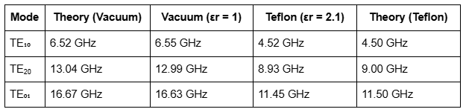
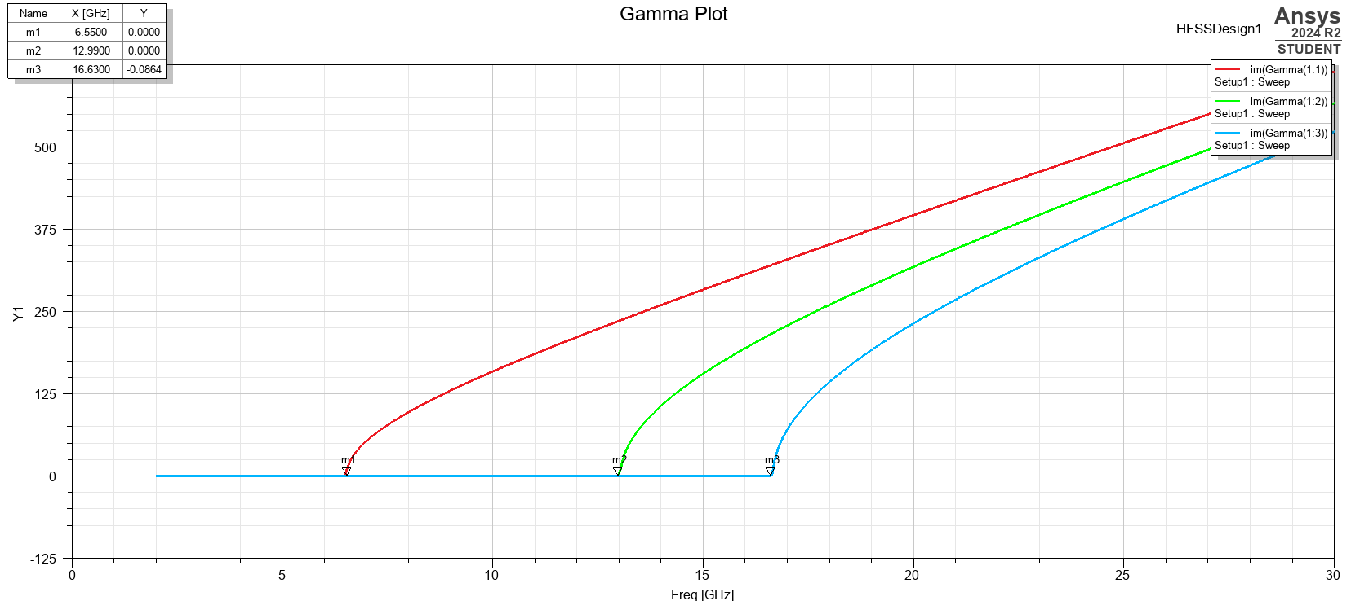
Figure 29: Gamma plot showing cutoff frequencies for TE₁₀, TE₂₀, and TE₀₁ for the vacuum-filled rectangular waveguide.
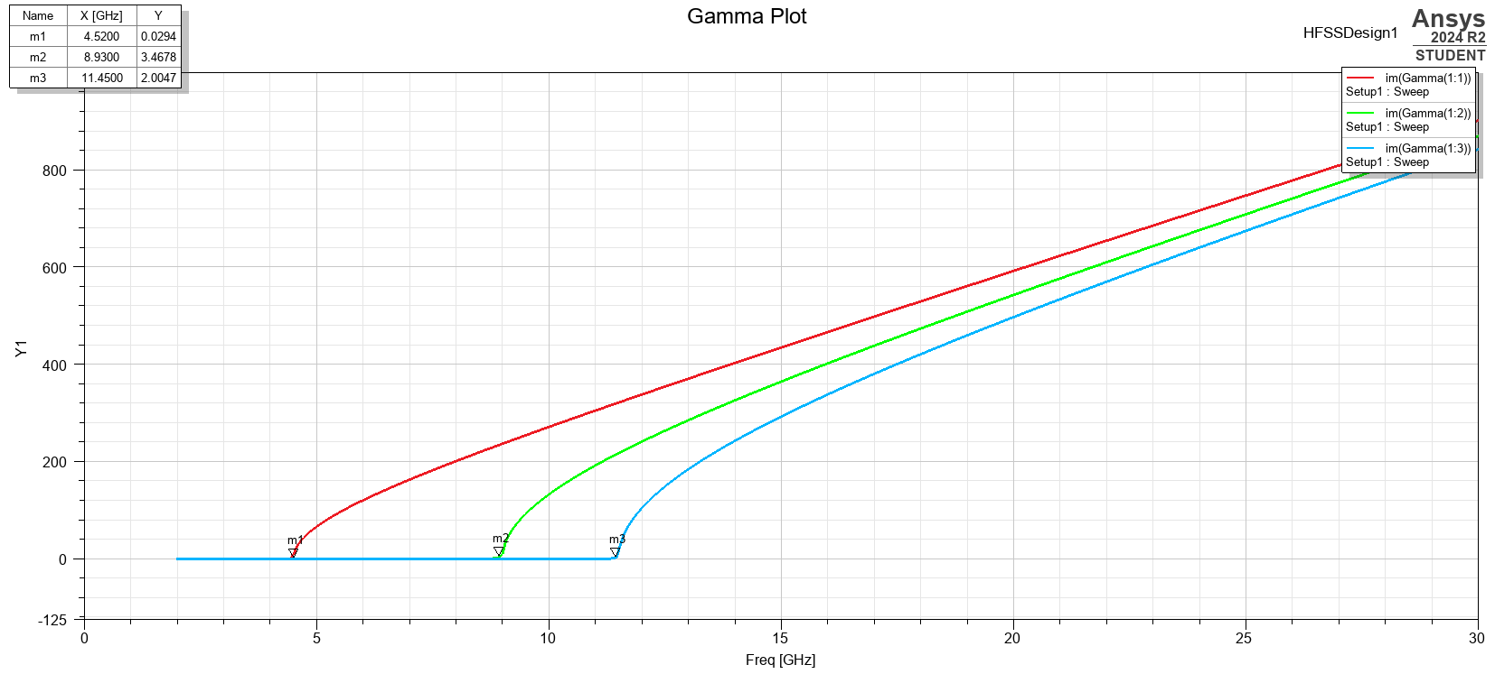
Figure 30: Gamma plot showing cutoff frequencies for TE₁₀, TE₂₀, and TE₀₁ for the Teflon-filled rectangular waveguide.

Discussion
Both Teflon-filled and vacuum-filled waveguide simulation results closely matched theoretical predictions. The TE₁₀ mode, which has the lowest cutoff frequency, propagated first in all instances. The gamma plots confirmed this, indicating that propagation began at the selected cutoff point.
The inclusion of Teflon reduced the cutoff frequencies in all modes. This conclusion is compatible with theory because higher permittivity increases the effective electrical length of the waveguide, lowering the phase velocity and allowing modes to propagate at lower frequencies [1].
Field vector plots showed clear modal structural changes. The TE₀₁ and TE₂₀ modes displayed increasingly complicated patterns, including extra lobes and null zones across the cross-section. The TE₁₀ mode produced a strong, uniformly distributed electric field aligned along the waveguide's larger diameter.
Despite the lack of physical testing and using ideal settings, the findings show how waveguide geometry and dielectric properties influence electromagnetic behaviour [1]. This improved theoretical understanding.

Concluding Analysis
The rectangular waveguide simulation demonstrated mode propagation in both vacuum and Teflon-filled environments, with results that closely match the theoretical predictions. The use of HFSS validated the predicted decrease in cutoff frequencies due to Teflon's enhanced permittivity. This allowed for clear visualisation of cutoff behaviour throughout TE₁₀, TE₀₁, and TE₂₀ modes.

Half-Wave Dipole Antenna Design and Analysis
This section examines the simulation and evaluation of a half-wave dipole antenna using Ansys HFSS. The antenna was modelled with Perfect Electric Conductor (PEC) material and fed by a 50Ω lumped port, with its dimensions designed for resonance at the target operating frequency. Resonance characteristics and far-field radiation behaviour were analysed and compared against theoretical predictions.

Methodology

Antenna Design and Simulation Setup
The half-wave dipole antenna was designed with a radius of 1mm. The student ID's first three digits (2317703) were used to calculate the wavelength (λ) of 231mm. To achieve resonance at the desired frequency, an antenna length of 115.5mm (λ/2) was needed. To simulate ideal radiation behaviour, the antenna was modelled in Ansys HFSS with Perfect Electric Conductor (PEC) material. The antenna was positioned inside a rectangular radiation box with Perfectly Matched Layer (PML) boundaries to prevent reflections and absorb outgoing waves. A 50Ω lumped port was used at the feed point to replicate the input signal.
Figures 31–35 show key stages of the dipole antenna setup in Ansys HFSS, such as the feed gap, lumped port location, and surrounding radiation box. These images demonstrate the simulation's correct structure and boundary assignment.
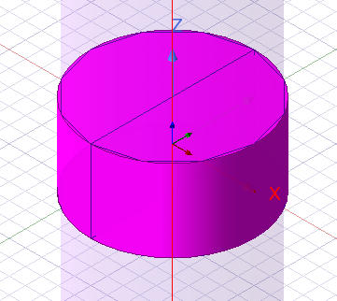
Figure 31 Dipole antenna showing the feed gap for lumped port excitation.
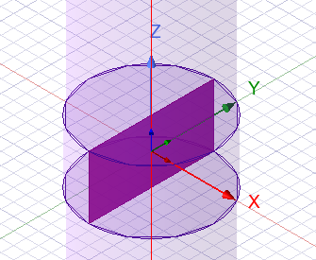
Figure 32: Placement of 50Ω lumped port at the dipole feed point.
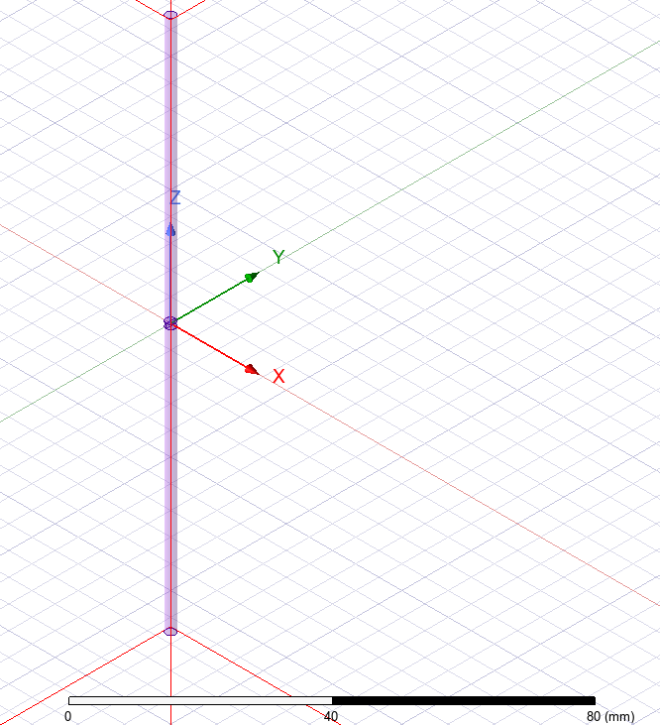
Figure 33: Overall view of the dipole antenna model along the Z-axis.
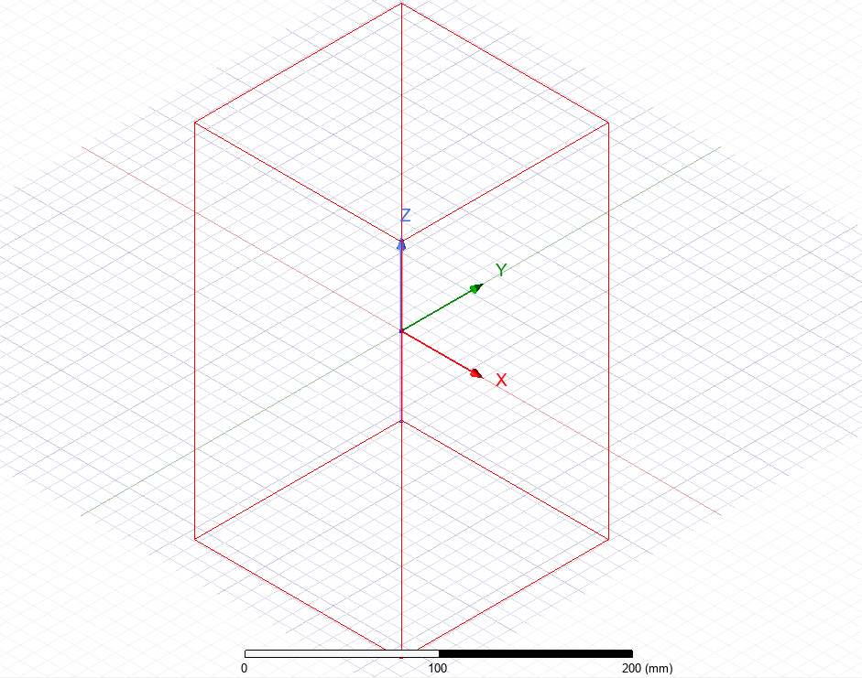
Figure 34: Radiation box surrounding the dipole antenna for boundary definition.

Theoretical Calculations
The antenna's operating frequency was calculated using Equation 3, where f is the frequency, C the speed of light (c = 3×10⁸ m/s), and wavelength is λ. Equation 4 shows the specific mathematical calculation used for the simulation
Equation 3: Wavelength-frequency Relation for a Wave in Free Space.
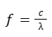
Equation 4: The calculation using the wavelength of 231mm for the simulation
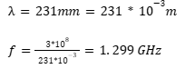
Equation 5 shows how the corresponding half-wave dipole length was calculated.
Equation 5: Half-wave Dipole Length.
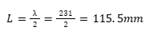
These numbers were used as measurements to validate the resonance behaviour and return loss seen in the simulation.

Results

Return Loss Plot
The simulated S-parameter plot (Figure 35) showed a distinct resonance dip around 1.2 GHz, indicating strong impedance matching and low reflected power. This corresponds closely to the theoretical frequency of 1.298 GHz.
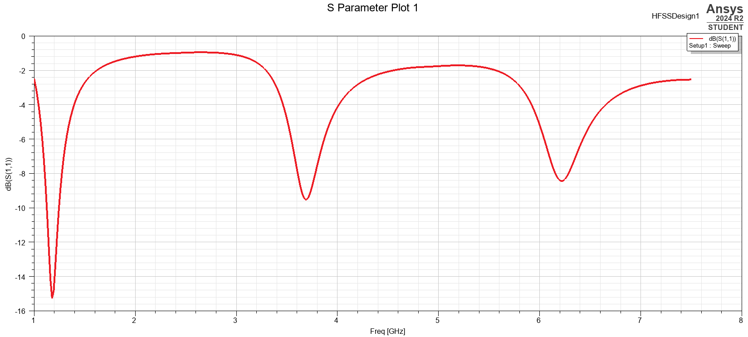
Figure 35: S-Parameter plot showing return loss performance of the half-wave dipole antenna.

Far-Field Radiation Pattern
The 3D gain plot (Figure 36) showed a typical doughnut-shaped radiation profile associated with half-wave dipole antennas, with greatest radiation occurring perpendicular to the antenna axis and minimal radiation at the antenna ends.
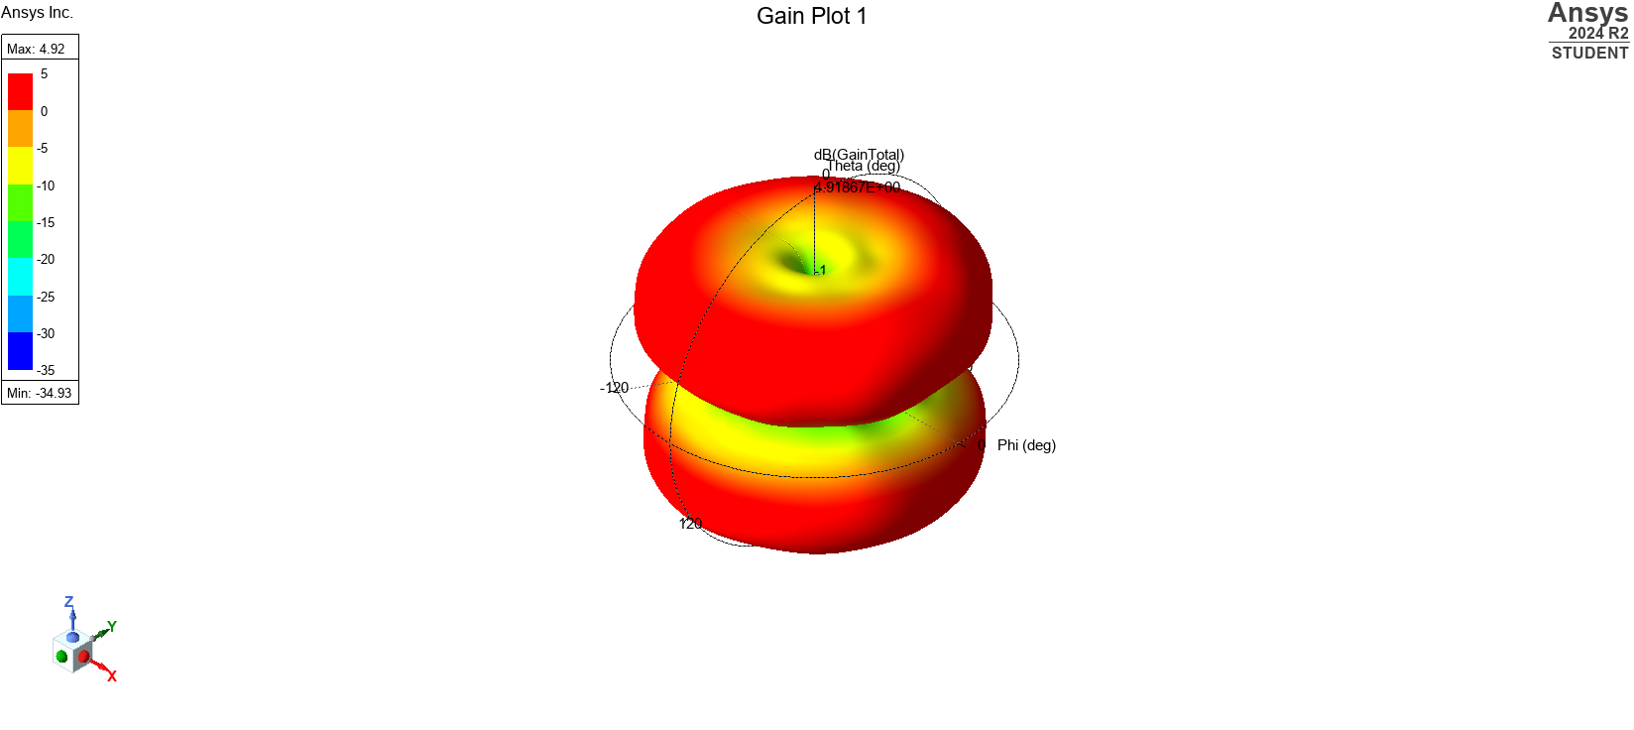
Figure 36: 3D far-field radiation pattern illustrating the omnidirectional gain distribution of the half-wave dipole antenna.

Antenna Gain
The antenna achieved a peak gain of approximately 4.9 dB, consistent with theoretical expectations for a PEC half-wave dipole in free space [2].

Discussion
The simulation results closely matched the theoretical expectations for a half-wave dipole antenna [2]. The resonance occurred around the predicted operating frequency, indicating that the antenna dimensions were set up for the ideal impedance matching. The observed doughnut-shaped radiation pattern was consistent with that of a half-wave dipole, with maximum radiation perpendicular to the antenna axis, as theoretically expected [2].
The peak gain of around 4.9 dB was in line with the ideal performance of a PEC-based antenna operating in free space [2]. Although the simulation used perfect material conductivity and ideal boundary conditions, real-world issues such as material losses, faulty connections, and environmental impacts would most likely result in slight reductions in gain and minor frequency shifts in a practical setup.
Overall, the results support the design process and indicate that a half-wave dipole antenna, when modelled using HFSS under ideal conditions, behaves similarly to theoretical predictions. Future experimental validation would be required to assess the antenna's performance in non-ideal, real-world conditions.

Concluding Analysis
The half-wave dipole antenna simulation effectively displayed resonance behaviour near the theoretical frequency, resulting in effective impedance matching and an omnidirectional radiation pattern with a peak gain of about 4.9 dB. Despite the use of perfect conditions, the results closely matched theoretical assumptions and demonstrated the value of HFSS as a tool for early-stage antenna design and validation.

Evaluation of Radar Technologies for Drone Detection
This section focuses on recent advances in radar technology for detecting unmanned aerial vehicles (UAVs). It examines high-resolution sensing, Artificial Intelligence-driven signal processing, and passive detection methods, considering both technical performance and societal and environmental implications.

Literature Review

Challenges of Traditional Radar Systems
Conventional radar systems are designed to identify huge, fast-moving targets. Small drones with radar cross-section (RCS) values of -10 to -20 dBsm frequently travel slowly or hover, making them far more difficult to detect [3]. Their low flight paths and similarity to birds make things much more challenging, particularly for systems that use Doppler shift to filter moving objects [3].

High-Resolution and mmWave Radar
To boost detection, newer radar systems now use higher frequencies like as Ka-band and mmWave (about 60 GHz) [4]. These systems obtain greater precision and sub-meter resolution using MIMO antennas and FMCW waveforms [4]. They can also detect micro-Doppler effects caused by a drone's spinning rotors, which aids in the separation of drones from background clutter and birds [5].

Passive Radar Systems
Passive radar operates by picking up existing signals, such as TV, radio, or 5G, rather than emitting its own [3]. This makes it more discrete and effective for locating low-RCS drones, particularly in crowded areas. Using numerous receivers in various locations enhances the ability to track small, slow targets from various angles [3].

Cognitive Radar
Cognitive radar systems can alter themselves in real time, adjusting frequency, waveform, or direction in response to the current scenario [6]. Some systems, such as the DLR and HENSOLDT MIMO Air prototypes, use artificial intelligence to make these adjustments automatically, allowing the system to operate more effectively with busy towns and cities [7].

Artificial-Intelligence Signal Processing
Artificial-intelligence, especially deep learning models like convolutional neural networks (CNNs), is being used to detect drones by identifying microscopic patterns in radar signals, such as micro-Doppler effects [5]. AI also reduces false alarms by enhancing the way radar filters out noise and recognises unusual activities [5].

Multi-Sensor Fusion
Radar alone can be unable to properly differentiate drones from birds or other flying objects. Radar is now used in conjunction with optical, thermal, acoustic, and radio frequency sensors [5]. AI can then combine all this data in real time, making identification faster and more precise. Many commercial anti-drone systems currently rely on a hybrid approach [8].

Discussion

Technical Challenges
Although radar capabilities have improved, issues continue. mmWave radars provide higher resolution, but they suffer from signal loss (attenuation) and are expensive to deploy over wide areas [4]. Passive radar is strongly reliant on the quality and availability of external signals, which can change [3]. Cognitive radar systems, while adaptable, require substantial processing resources to function in real time. Distinguishing between drones and birds remains a challenge, especially at low altitudes or long distances [4]. The issue becomes significantly more complicated when dealing with drone swarms [6].

Society and Environmental Considerations
The increasing use of drone surveillance technologies presents ethical and privacy problems, especially when radar is combined with video or RF monitoring [4]. Regulatory criteria for drone detection systems are continuously evolving and vary by country, making large-scale deployment difficult. Environmental consequences must also be considered. Such as active radar systems generate RF energy, which can interfere with other technology and cause public health problems [4]. As a result, there is an increasing interest in adopting low-power radar or passive systems to reduce emissions and spectrum congestion.

Future Developments
Research into next-generation radar technologies is ongoing. Quantum radar, which uses entangled photons, may one day improve drone detection in overcrowded scenarios by improving sensitivity and noise rejection, although this is currently experimental [9].
Distributed and networked radar systems, especially those linked to 5G and future 6G networks, may enable larger coverage and more reliable tracking by using telecom towers as drone detection hubs [4].
AI models are projected to improve their real-time classification, anomaly detection, and trajectory prediction capabilities [5]. Additionally, radar platforms are increasingly being linked to automated response systems that can assess danger levels and, if necessary, initiate countermeasures such as jamming or drone interception [5].
Efforts are also underway to reduce radar systems' electromagnetic footprint through more energy-efficient antennas and better spectrum management [4].

Concluding Analysis
Modern drone detection requires more than traditional radar techniques. Technologies such as mmWave radar, passive detection, cognitive radar, and AI-driven processing have reshaped the use of radar, enabling the identification of smaller and slower aerial targets. However, technical, societal, and regulatory challenges continue. The aim is to develop distributed, adaptive detection networks that combine efficient technology with increased public acceptance and minimum environmental effect.

Conclusion
This report shows the effectiveness of electromagnetic modelling and analysis in real-world situations. The waveguide and antenna simulations closely matched theoretical expectations, demonstrating the impact of shape and material properties on electromagnetic behaviour. The radar detection research explained how advanced technologies, including AI, mmWave sensing, and sensor fusion, are addressing the problems presented by modern UAV threats. Overall, the findings highlight the importance of accurate modelling, strong theoretical foundations, and continuous advancement in the development of electromagnetic systems.

References
[1] H. Koc Polat, M. D. Geyikoglu, B. Cavusoglu, M. Ertugrul, and E. Parlak, "A comparative analysis of graphene cladding rectangular waveguides filled with various materials for 1.65 THz ablation system," Journal of Brilliant Engineering, vol. 4, 2023. [Online]. Available: https://doi.org/10.36937/ben.2023.4880
[2] C. A. Balanis, Antenna Theory: Analysis and Design, 4th ed. Hoboken, NJ, USA: Wiley, 2016.
[3] Z. Tang, H. Ma, Y. Qu, and X. Mao, "UAV detection with passive radar: Algorithms, applications, and challenges," Drones, vol. 9, no. 1, Art. 76, Jan. 2025. [Online]. Available: https://www.mdpi.com/2504-446X/9/1/76
[4] U.S. Government Accountability Office, "Science and tech spotlight: Counter-drone technologies," GAO-22-105705, Mar. 2022. [Online]. Available: https://www.gao.gov/products/gao-22-105705
[5] S. Samaras, M. Rodi, E. Mavrogiorgou, I. Giannopoulos, and I. Kostarakis, "Deep learning on multi-sensor data for counter UAV applications - A systematic review," Sensors, vol. 19, no. 22, Art. 4837, 2019. [Online]. Available: https://www.mdpi.com/1424-8220/19/22/4837
[6] W. Khawaja, Q. Yaqoob, and I. Guvenc, "RL-based detection, tracking, and classification of malicious UAV swarms through airborne cognitive multibeam multifunction phased array radar," Drones, vol. 7, no. 7, Art. 470, 2023. [Online]. Available: https://www.mdpi.com/2504-446X/7/7/470
[7] German Aerospace Center (DLR), "DLR test flights validate radar system for uncontrolled airspace," DLR News Release, Sep. 2024. [Online]. Available: https://www.dlr.de/en/latest/news/2024/dlr-test-flights-validate-radar-system-for-uncontrolled-airspace
[8] Echodyne, "What drone detection solution do you need?" Counter-UAS Hub, [Online]. Available: https://www.echodyne.com/resources/news-events/what-drone-detection-solution-do-you-need/
[9] Counter-UAS Hub, "What is quantum radar and how will it change drone detection?" Aug. 2023. [Online]. Available: https://cuashub.com/en/content/what-is-quantum-radar-and-how-will-it-change-drone-detection/

