Module: Financial Management for the Hotel Industry
Module code: BMIH5007
Lecturer: TRISTAN HAWKINS
Author:
MARINELA COVASNEANU
Student number: 1920078
Business report- Comparison of Shangri-La Hotels and Premier Inn Hotels
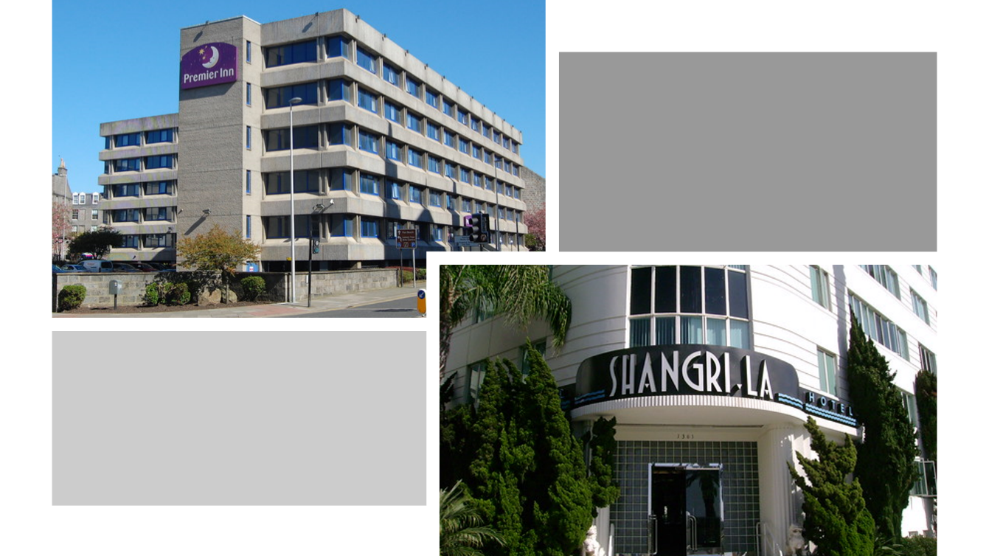
Word count: 2195

Executive Summary

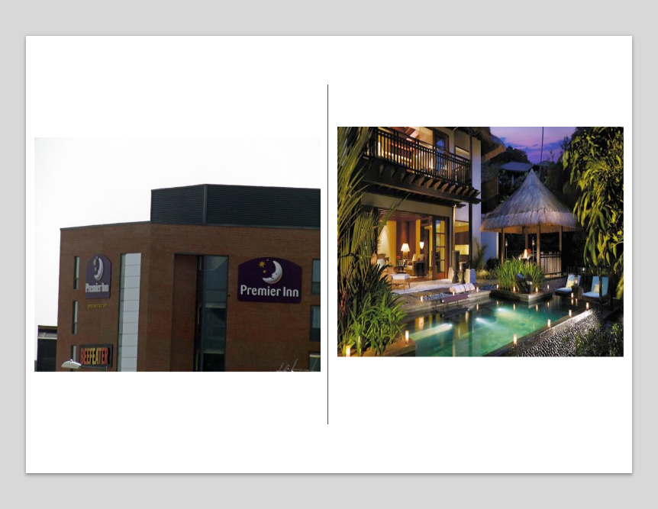

In this assessment using swot, pestle, growth potential, key and trends revenue, market position, financial commitment to CSR and potential challenges to achieve all enumerated, is summarised an in-depth analysis and comparison between Shangri-La Hotels and Premier Inn Hotels. It was evaluated their approaches to financial management and various critical areas that affects their financial performance and sustainability.

Table of Contents
0
Executive Summary 1
Introduction 3
Main body 3
Market position 4
Differentiation 4
Value proposition 5
Market share 5
Total revenue 6
Year 2020 6
Year 2021 7
Year 2022 7
Year 2023 8
Growth potential 8
Shangri-La Hotel 8
Premier Inn Hotel 9
Financial Commitment to CSR (Corporate Social Responsibility) 10
Economic 11
Legal 11
Ethical and Philanthropical 12
Conclusion 12
Recommendations 12
Reference 13
Appendices 18

Introduction
This assessment will summarise the analysis and comparison of Shangri-La Hotels and Premier Inn Hotels, regarding their approaches to financial management strategies and practices. It incorporates different critical areas, standards, best operations, and potential barriers that can impact their financial performance and sustainability. To compare these two different hotels a financial statement analysis has to be conducted in order to evaluate the company’s financial health and performance. As well to research into swot and pestle analyses to reveal the market targets and position, competitors, and growth opportunities.

Main body
City getaways or luxury hideaways, Shangri-La Hotels is part of Kuok Group, a multinational corporation in hospitality. It is a five-star refined business with deluxe facilities and services in some of most prestigious and exotic destinations. It sums up over 100 hotels in 22 countries and 76 destinations. (The Kuok Group, 2024) On the other side, established by Whitbread in 1987 to compete with Travelodge, Premier Inn Hotels is the largest hotel brand in UK and Ireland, exceeding 853 hotels with over 72000 rooms and with continuous growth into international markets. (Statista, 2024)

Market position

Differentiation
Is the way a brand differs to their competitors by distinguished product or services. (Hooley, et al.2020)
According to Bowman strategy clock (Echchakoui, 2018) and after conducting a rigorous swot (Appendix1) and pestle (Appendix 2) analysis Shangri-La hotels are situated on position 4-Differentiation as its brand and quality services are essential in their marketing strategy. They thrive to unicity and premium standard products and services. Shangri-la product mix is designed to offer luxurious accommodations, personal tailored experiences, exclusive leisure facilities to meet their customers grand expectations. (Shapiro, 2019)

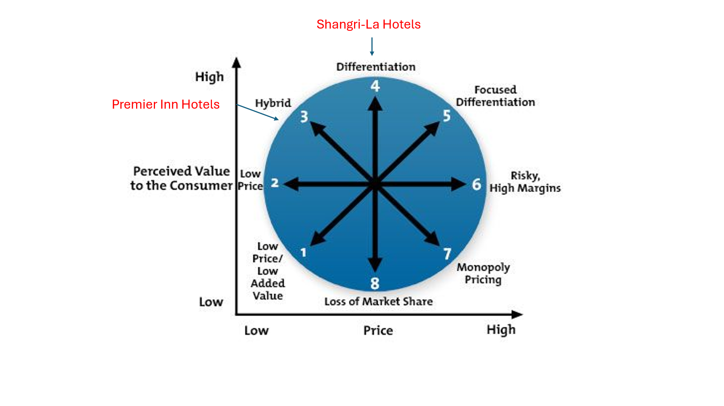
(Pinterest, 2024)
On the other hand, Premier Inn is positioned on 3-Hybrid as they are focused in offering lower prices than competitors still providing a fair value but with average standard and facilities. With competitors like Travelodge, Hyatt and International Hospitals Group, Premier Inn offers restful rooms, limited service, consistency with excellent value but at accessible prices. (Whitbread, 2024)

Value proposition

In order to communicate their values both hotels need to find their ideal customer target market. According to a Similar Web analysis both hotels have similar age and gender demographic data focused on middle-aged people, both female and male. (Similar web, 2024) Only that Shangri-La Hotels target the upper-middle and upper-class individuals with high incomes that can afford the purchase high quality, while Premier Inn Hotels customers are business, leisure or long stay travellers who are looking for a good night sleep and a good value for the money they pay.(Appendix 3) Geographical date shows that Shangri-la is more competitive in Australia and Philippine while premier Inn is leading in UK and Germany, while in US they both have equal audience. (Appendix 4)

Market share

Actual market cap for Shangri-La Hotels is $2.8 Billion value that place it 3725th most valuable company on the market. After almost 100% depreciation from 2017 the highest point data 2024 brings an increase of 14.07% from last year. (CompaniesMarketCap.com, 2024) It is ranked as strongest and most valuable Luxury and Premium brand and the best China brand. (Brand Finance, 2024)
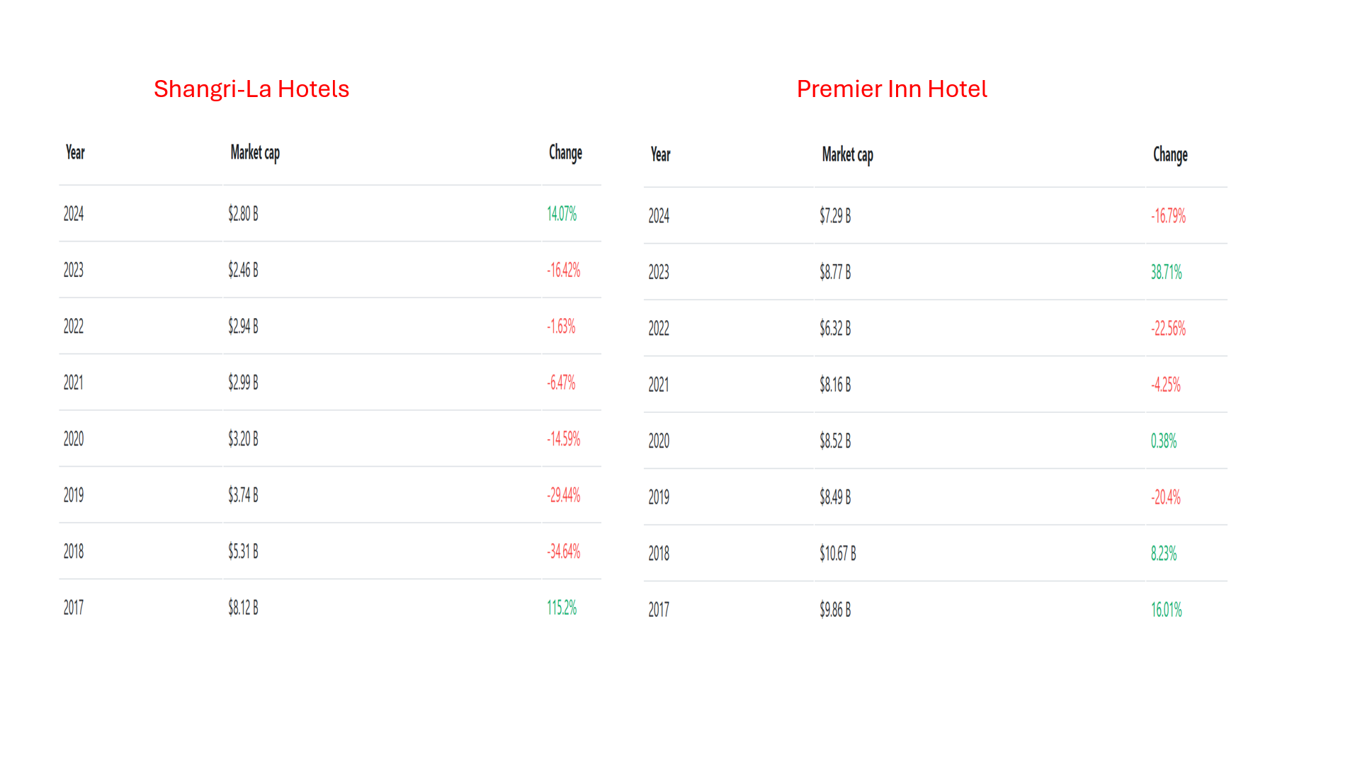
Premier Inn instead had a significant growth in 2021 of 4.6% and in 2022 of 12% in the hotel market. (Shares, 2021) It had a decrease this year around 16% making it have a market cap of $7.29 billion that is placing it 2172nd on global market. (CompaniesMarketCap.com, 2024) with a brand awareness of 14% from last year. (Premier Inn, 2024)

Total revenue
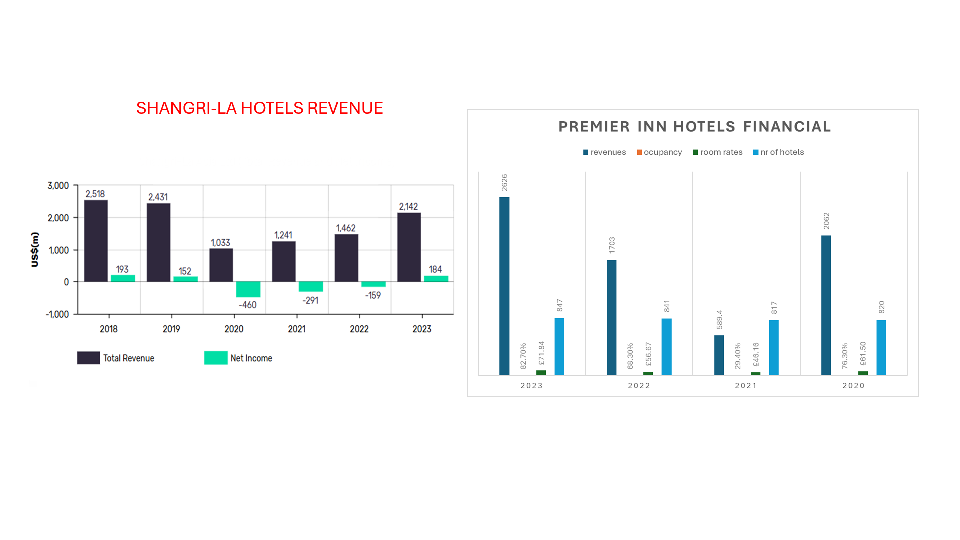

Year 2020
The Covid pandemic made the operating environment for both hotels’ groups exceedingly difficult and the impact on sales was severely showed. For Shangri-La Hotels revenues decrease with 57.7% from previous year with EBITDA (Earnings before interest, taxes, depreciations, and amortisation) to the group diminished by 79%. This drop was the consequence of the decline in occupancy of 34% from year before. Cash and other equivalents sum up around $990.9m. (Shangri-La Hotel, 2021) On the other hand Premier Inn had a slight increase revenue of 0.7% (Hatcher, 2019) with an occupancy less than 50%, and an average room rate of £50. (Statista, 2024)
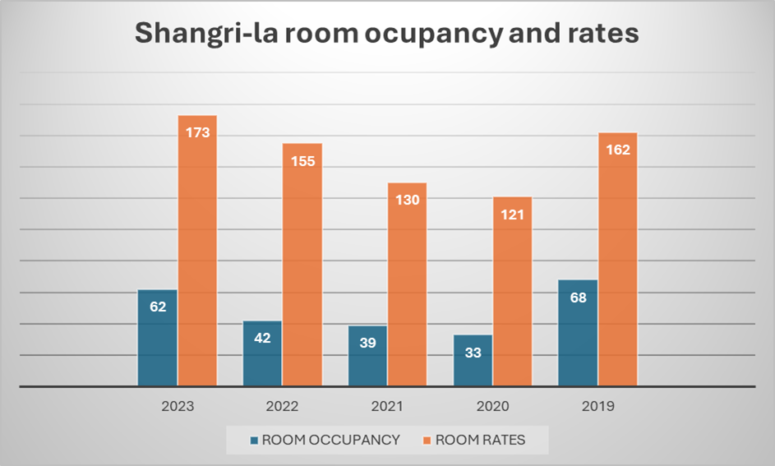

Year 2021

At the end of 2021 for Shangri-La the revenues show an increase of 20.1% mostly driven by the hotels in China and Hong Kong due the quarantine business and some permission in travel restriction being loosened in France. It also added to the value the 4.5% increase in investment revenue. The level of occupancy was 39% with a growth of 6% from 2020 with China on the first position with an increase of 23% from previous year with slightly negative impact in the second half due Covid outbreaks (Shangri-La Hotel, 2022) while Premier Inn Hotels despite restrictions had an occupancy of 23% with 30 hotels opened, but with statuary revenue down with 71.8%. A positive fact is that having a strong balance sheet and liquidity position Premier Inn had access to £1.256.0m cash and cash equivalents to give it some stability. (Griffin, 2021)

Year 2022
Shangri-La consolidated revenue had an increase of 17.8% from 2021 due the continuous work of improvement of the business environment with an average occupancy growing only with 3% with highest value in Singapore 61% with a rise of 24% from previous year. Added to this are the investment revenues 6.3% increase and 11.9% from the third-party. (Shangri-La Hotels, 2023) for Premier Inn the statuary revenue has seen an increase of 22% with a fall of 8% in occupancy but with the average room rate raised with 7.8%. (MarketLine Advantage, 2024)

Year 2023

With everything back to almost normal after Covid pandemic, with border open and restrictions lifted Shangri-La total revenue increase with 46.5% due the occupancy also raising with 20% reaching 62%. Investment properties revenue increase of 8.6% and 34.4% from the third-party are an addition to the growth in sales. The first positions in occupancy are Singapore 78%, Australia 81%, and United Kingdom 66%. (Shangri-La Hotel, 2024) On the other side Premier Inn also had their revenue increase by 22% from the previous year with adjusting operating profit up wit 12% due the group ability to face the rise of price goods with continuous focus on cost efficiency and estate growth. Occupancy saw a jump of 14.4% from 68.3% in 2022 to 82.7% in 2023. (Whitbread PLC, 2024)

Growth potential

Shangri-La Hotel

With a strong brand reputation and quality of service it can expand into emerging economies like South America and Africa to bring an increase on global sales. They will invest in new projects like upgrading the existing properties. (Business World, India, 2019) With 102 hotels in the world one of the future plans is to double the number within the next 3 to 5 years with the help of Shared Services platform to maximise its growing. (Business World, India, 2019) Another strategy is hiring activities mainly in sales and marketing to ensure perfect management plan of action for a successful new launch. (Global Data, 2021) Also, there are anticipation of to open dual brand Shangri-La and Traders Hongqiao in early 2025 and in 2026 Shangri-La Zhengzhou. In addition, implementing virtual reality advertising to simulate the bookings intention (Israel et al., 2019) and to offer a tool for raise the customer perception of their destination’s images. (Moro et al., 2019) 
(Campaign, 2015)
One of the barriers in achieving this is the fact that the hotel is dependable of the travel and tourism industry and makes it exposed to the fluctuations on travel market. As well the biggest challenge can be the competition from Airbnb or different luxury brands with lower prices. (Shangri-la Malaysia, 2023) In addition, luxury hotels face pressure in enforcing sustainable practices due the massive requires of investment, innovations, and exquisite locations. (Halmi, 2020)

Premier Inn Hotel

On account of pandemic, the drop of sales and cost inflation, hotel industry experienced challenging years. As a result, the UK hotel sites fell with 3% so Premier Inn is working on expanding his actual assets or acquire new ones. Recently 71bed in Keswick and 229bed in Manchester will be new constructions of the brand. (Akers, 2023) On top of that even if Premier Inn has 77.000 rooms in UK it thrives to increase that by 25% by the middle of 2029. Additionally, the parent group Whitbread wants to transform 112 unperforming restaurants into new Premier Inn hotels and add to the initial number another 3500 rooms. (Business Traveller, 2024) The company scale is permitting volume buying to better defend against inflation. Furthermore, tailoring the properties and its product to the needs of German target market, Premier Inn is looking to also become number one budget brand in Germany already having 57 hotels with 10250 rooms and a pipeline of over 5800 more. (Akers, 2023)
The principal challenges in achieving its goals are firstly competition and there are many budget hotels that compete with lower prices, uncertain economy, cyber-attacks, and bad publicity. Also, the change of the macro labour market that affects the talent attraction and retention. Supply chain interruption, social uncertainty and governance risks round up the list of barriers and challenge in potential growth of Premier Inn Hotel. (Batabyal & Das, 2019)

Financial Commitment to CSR (Corporate Social Responsibility)

Using Carroll’s CSR Pyramid model (Lu et al., 2020) it can be identifying four levels of sustainability in companies: Economical, Legal, Ethical and Philanthropic.
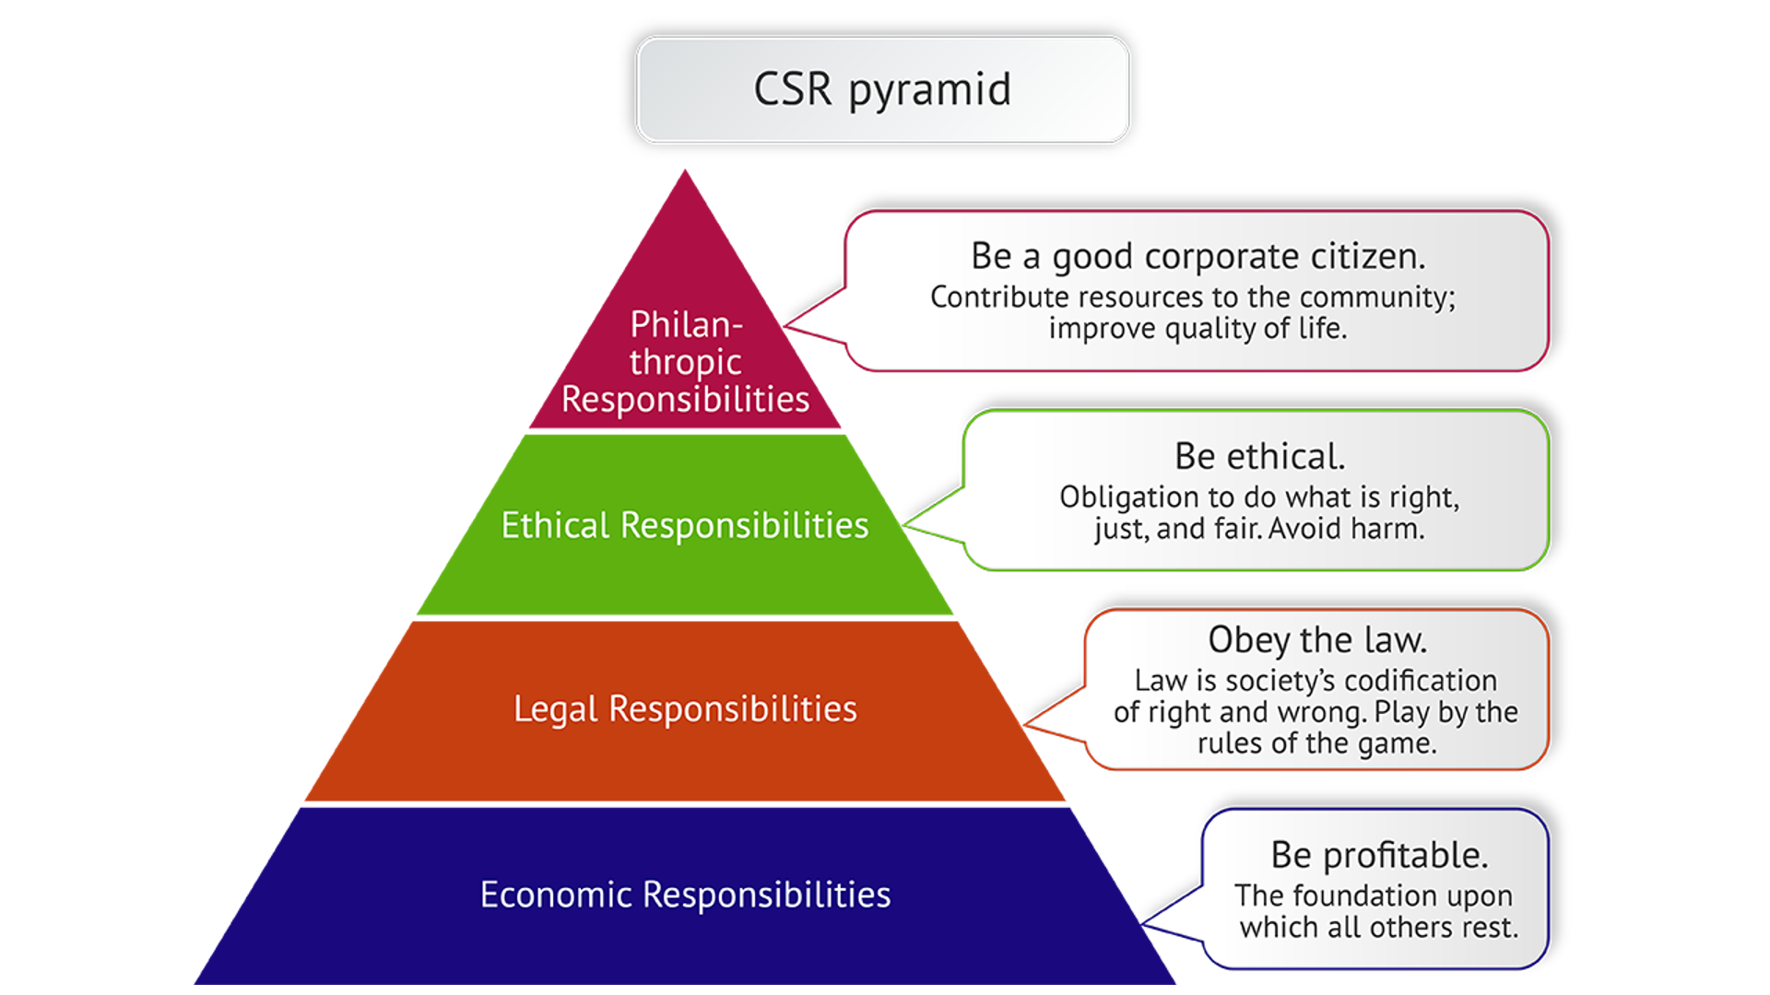
(Carroll, 1999)

Economic

While balance the interest of stakeholders Shangri-La have a positive impact on local communities. They used $3.2m in project expenses and donations and spend 124.000 hours towards engagement activities for helping 138.000 people. Also, they rehired 10% of an old factory employee to rejuvenate its premises. For all this contributions Shangri-La has been awarded with: Social Innovative Contribution Award in Yicai Media Group’s China CSR Rankings and Honour Award at the sixth Annual CSR Conference. (Su & Zabilski, 2022)
On the other side for Premier Inn their number of customers generate £1.6b every year for the local community’s economy. In addition, their plans to expansion and improve the actual sites will help with the needed economic growth and employment opportunities. Its program “Force of Good” is focused on enable people to live and work well. (Daily Telegraph,2023)

Legal

Adhering to legal norms and standards is essential for both hotel chains and give confidence among their stakeholders and customer target market. (Fung & Kim, 2020)
Environmental are the most important ones. A resemblance between Shangri-La and Premier Inn in order to address the environmental concern they make sure to function in compliance to “The Environment Protection Act.” Also, they both strive to cultivate an inclusive workplace by offering a wealth of perspectives and insights to create a diverse cultural and national background team. (Nguyen et al., 2022)
Shangri-La is implementing various measure to reduce its greenhouse gas emissions such as: supplier engagement (“Responsible Sourcing Policy” and “Supplier Code of Conduct”), waste reduction and water consumption. The company aims to achieve a 15% decrease of carbon emission and energy intensity, a 5% in water consumption and 50% in single-use plastic until the end of 2029. (Global Data, 2024)
Premier Inn aims by applying the “Force of Good” strategy to be net zero emission for Scope 1,2 and 3 by reducing with 20% water use per hotel guest and cut the food waste in half by 2030 and to be net zero carbon by 2040. (Business traveller Middle East, 2023) The company is also looking at 20% reduction in salt usage (Baseline2017), sugar (Baseline2015) and calories (Baseline2017) by the end of 2015. (Whitbread, 2024)

Ethical and Philanthropical

First for Shangri-La Hotels are their people. The company has over 43.600 employees and the retention rate is 90% due the Group’s aim to align their goals to their people expectation and wellbeing. The company total benefit expenses go over $762.1m. Also, through the “Friendship City” program Shangri-La offers support in building three hundred containers for over 1200 people affected by Türkiye earthquake. In addition, they distributed over 240000 hot meals to persons in need affected by the Covid19 pandemic.
Premier Inn is contributing by raising £3m per year for Great Ormond Street Children’s Hospital and donating 1384 hours to local community charities. Also, they raise over £680000 and donate 50000 worth in duvets and pillows to Disaster Emergency Committee for Ukraine. (Whitbread, 2024)

Conclusion

The comparison between Shangri-la and Premier Inn hotels it only can be done just by analysing their annual financial statements, swot and pestle, potential growth, and sustainability reports. One luxury and one budget hotel, one situated all over the world and another mainly in UK with different target audience market, their comparison can be achieved just researching and analysing their growth path and commitments.

Recommendations
Shanri-La can improve by a sever control cost and increasing the number of hotels. Improving employee training and study different customs and behaviour as well potential areas of development to diversify their locations and channels of communications.
Premier inn also can expand by entering in new markets, innovating, using Google Hotel Adds and by reducing his environmental impact. Keep supporting the community is also an effective way of building a great image to help to their growth.

Reference
Akers, C. 2023, "Bed down with this well-run growth stock", Investors Chronicle, pp. 50.
Batabyal, D. and Das, D.K. (eds) (2019) Global trends, practices, and challenges in contemporary tourism and hospitality management. Hershey, Pennsylvania: Business Science Reference, an imprint of IGI Global. Available at: https://doi.org/10.4018/978-1-5225-8494-0,
Brand Finance, (2024), Shangri-La Brand profile, available at: https://brandirectory.com/brands/shangri-la/, date of access: 07.10.2024.
Business traveller Middle East, (2023) ‘PREMIER INN LAUNCHES FORCE FOR GOOD IN THE MIDDLE EAST’, pp. 11-.
Business traveller (British ed.), (2024), ‘Whitbread to convert underperforming restaurants into Premier Inn rooms’ pp. 10-.
Business world (India) (2019), Shangri-la Group Commenced the Construction of Mixed-Use Development Complex in China New Delhi: Athena Information Solutions Pct. Ltd.
Business World, (2023), Shangri-La launches Global 'Find Your Shangri-La' campaign 2023, Athena Information Solutions Pct. Ltd, New Delhi.
Campaign, (2015), Shangri-La gets virtual about its hotel experiences, available at: https://www.campaignasia.com/article/shangri-la-gets-virtual-about-its-hotel-experiences/425746, date of access: 08.10.2024.
Carroll, A. B. (1999). Corporate Social Responsibility: Evolution of a Definitional Construct. Business & Society, 38(3), 268-295. https://doi.org/10.1177/000765039903800303, date of access: 10.10.2024.
CompaniesMarketCap.com, (2024), Market capitalization of Shangri-La (0069.HK), available at: https://www.bing.com/search?q=shangri+la+market+share&form=ANNTH1&refig=6a7cef72a9ef43d593e4c0d6bc932014&pc=HCTS, date of access: 07.10.2024.
Daily Telegraph (London, England: 1969) (2023) ‘Premier Inn sales surge 18pc as tourists flock to budget hotels amid cost-of-living crisis’, pp. 23–23.
Echchakoui, S. (2018) ‘An analytical model that links customer-perceived value and competitive strategies’, Journal of marketing analytics, 6(4), pp. 138–149. Available at: https://doi.org/10.1057/s41270-018-0043-9, date of access: 06.10.2024.
Financial Times, (2023), Premier Inn owner says inflation and labour shortages offer ‘growth opportunities’, available at: https://www.ft.com/content/e4c6f668-cfeb-466a-8db9-3e68d49612f5, date of access: 09.10.2024.
Fung Wong, A.K. and Kim, S. (Sam) (2020) ‘Development and validation of standard hotel corporate social responsibility (CSR) scale from the employee perspective’, International journal of hospitality management, 87, pp. 102507-. Available at: https://doi.org/10.1016/j.ijhm.2020.102507, date of access: 10.10.2024.
Global Data, (2024), Shangri-La Asia’s path to emission reduction: analysing targets and achievements, available at: https://www.globaldata.com/, date of access: 10.10.2024.
Global Data (2021), Shangri-La steps up hiring in line with expansion plans in Asia and Middle EastBusiness world (India). New Delhi: Athena Information Solutions Pct. Ltd.
Griffin, D. (2021) ‘It will take time for our central London hotels to return to pre-Covid occupancy levels, but we are on an upward trajectory’, The Estates Gazette, pp. 32–32.
Halmi, L., Peršić, M. and Poldrugovac, K. (2020) ‘HARMONIZATION OF SUSTAINABILITY REPORTING SYSTEM IN THE HOTEL INDUSTRY’, Tourism and hospitality management, 26(2), pp. 463–467.
Hatcher, D. (2019) ‘Whitbread mulls sale of up to 870m of Premier Inn hotels’, The Estates Gazette, pp. 38–39.
Hooley, G.J. et al. (2020) Marketing strategy and competitive positioning. Seventh edition. Harlow, England; Pearson.
Israel; C. Zerres; D.K. Tscheulin. (2019), Journal of Hospitality and Tourism Technology Vol. 10, Is. 3, 443-463.
Kim E. Woo M. Uysal N. Kwon. (2018) The effects of corporate social responsibility (CSR) on employee well-being in the hospitality industry, international journal of contemporary hospitality management. Bradford, England: MCB University Press, available at: https://doi.org/info:doi/, date of access: 09.10.2024.
Lu, J. et al. (2020) ‘Modified Carroll’s pyramid of corporate social responsibility to enhance organizational performance of SMEs industry’, Journal of cleaner production, 271, pp. 122456-. Available at: https://doi.org/10.1016/j.jclepro.2020.122456, date of access: 10.10.2024.
MarketLine Advantage (2024), Premier Inn Hotels Financial, available at: doi.org/10.26425/1816-4277-2022-3-75-83., date of access: 07.10.2024.
MBA Skool, (2024), Shangri-La Hotels and Resorts SWOT and PESTLE Analysis, available at: https://www.mbaskool.com/swot-analysis/tourism-and-hospitality/4277-shangri-la-hotels-and-resorts, date of access 06.10.2024.
Moro P. Rita P. Ramos J. Esmerado. (2019) Analysing recent augmented and virtual reality developments in tourism, Journal of hospitality and tourism technology. [Bingley, UK]: Emerald Group Publishing, Available at: https://doi.org/info:doi/., date of access: 08.10.2024.
Nguyen, N.T. et al. (2022) ‘Impact of diversity management on organizational performance in hotel organizations: a conceptual framework’, International journal of system assurance engineering and management, 13(Supply 1), pp. 186–196. Available at: https://doi.org/10.1007/s13198-021-01358-7.
Pinterest, (2024), Bowman's Strategy Clock - Making Sense of Eight Competitive Positions, available at: https://uk.pinterest.com/pin/470696598534975870/?lp=true, date of access: 06.10.2024
Premier Inn, (2024), Our awards, available at: https://www.premierinn.com/gb/en/why/awards.html#:~:text=An%20independent%20panel%20of%20senior%20travel, date of access: 07.10.2024.
ResearchGate, (2021), Shangri-La Hotels and Resorts' People and Culture Strategy in Deriving Employee Satisfaction. 1-11.". available at: https://www.researchgate.net/publication/352865653_Shangri-La_Hotels_and_Resorts'_People_and_Culture_Strategy_in_Deriving_Employee_Satisfaction, date of access: 08.10.2024.
Shangri-La Hotel (Malaysia) Bid SWOT Analysis’ (2023) Shangri-La Hotels (Malaysia) Berhad SWOT Analysis, pp. 1–8. Available at: https://research-ebsco-com.ezproxy.uwtsd.ac.uk/linkprocessor/plink?id=1a8dfde2-c501-350b-aedf-9f2c94658ee0, date of access: 06.10.2024.
Shangri-la Hotel, (2021), 2020 FINAL RESULTS ANNOUNCEMENT, available at: https://sitecore-cd.shangri-la.com/-/media/Project/Shangri-La-Group/Investor/Files/Public-Disclosures/Corporate-Presentation/2020-Final-Results-Announcement.pdf#:~:text=Results%20summary.%20Hotels%20and%20residential, date of access: 07.10.2024.
Shangri-La Hotel, (2022), 2021 FINAL RESULTS ANNOUNCEMENT, available at: https://sitecore-cd.shangri-la.com/-/media/Project/Shangri-La-Group/Investor/Files/Public-Disclosures/Latest-Top-Publications/2022-03-24-Final-Results-2021_E.pdf#:~:text=The%20board%20of%20directors%20(%E2%80%9CBoard%E2%80%9D)%20of, date of access: 06.10.2024.
Shangri-la Hotel, (2023), 2022 FINAL RESULTS ANNOUNCEMENT, available at: https://sitecore-cd.shangri-la.com/-/media/Project/Shangri-La-Group/Investor/Files/Public-Disclosures/Latest-Top-Publications/e_final-results_20230324.pdf#:~:text=2022%20FINAL%20RESULTS%20ANNOUNCEMENT.%20The, date of access: 06.10.2024.
Shangri-La Hotel, (2024), 2023 FINAL RESULTS ANNOUNCEMENT, available at: https://sitecore-cd.shangri-la.com/-/media/Project/Shangri-La-Group/Investor/Files/Public-Disclosures/Latest-Top-Publications/2024-03-22-Final-Results-Announcement_E.pdf#:~:text=(1)%20A%20hotel%20under%20management%20contract, date of access: 06.10.2024
Shapiro, K. (2019) FAMILY FOCUSED: Families get the VIP treatment at Shangri-La Hotel Singapore, Travel age west. NorthStar Travel Media, LLC, pp. 6-., date of access: 06.10.2024.
Shares, (2021), Premier Inn owner Whitbread grows market share during lockdown, available at: https://www.sharesmagazine.co.uk/news/shares/premier-inn-owner-whitbread-grows-market-share-during-lockdown#:~:text=In%20a%20third%20quarter%20trading%20update%20for, date of access: 07.10.2024.
Statista, (2024), Number of Premier Inn (Whitbread) hotels in the United Kingdom and Ireland from 2012/13 to 2023/24, available at: https://www.statista.com/statistics/739855/whitbread-premier-inn-hotels/#:~:text=As%20of%20the%20financial%20year%20ending%20in%202024, date of access: 06.10.2024.
Su, Z. & Zabilski, A. (2022), "What is the relationship between quality of working life, work–life balance and quality of life?", Worldwide Hospitality and Tourism Themes, vol. 14, no. 3, pp. 247-260.
The Kuok Group, (2024), Shangri-La Group/The Kuok Group, available at https://www.kuokgroup.com/businesses/shangri-la#:~:text=Building%20on%20our%20history%20innovating%20for, date of access: 06.10.2024.
The Strategy Story, (2024), Premier Inn Hotel PESTEL Analysis, available at: https://thestrategystory.com/blog/premier-inn-hotel-pestel-analysis/#google_vignette, date of access: 06.10.2024.
Whitbread PLC, (2024), Annual reports and accounts 2020/21, 2022/23, available at:
https://cdn.whitbread.co.uk/media/2021/02/15095755/whitbread-ar-19-20-1.pdf#:~:text=Award-winning%20Premier%20Inn%20is%20the%20UK%E2%80%99s, date of access: 06.10.2024.
Whitbread PLC, (2024), Our brands, available at: https://www.whitbread.co.uk/about-us/our-brands/#:~:text=Premier%20Inn%20is%20the%20UK%E2%80%99s%20biggest%20hotel, date of access: 07.10.2024.

Appendices
Appendix1
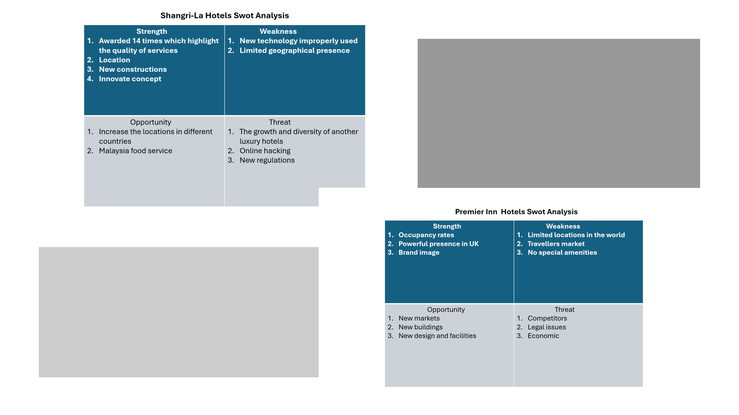

Appendix 2
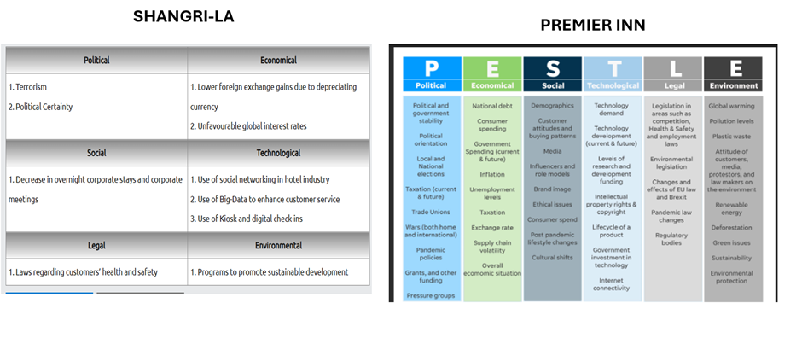
(MBA Skool, 2024), (The Strategy Story, 2024)

Appendix 3
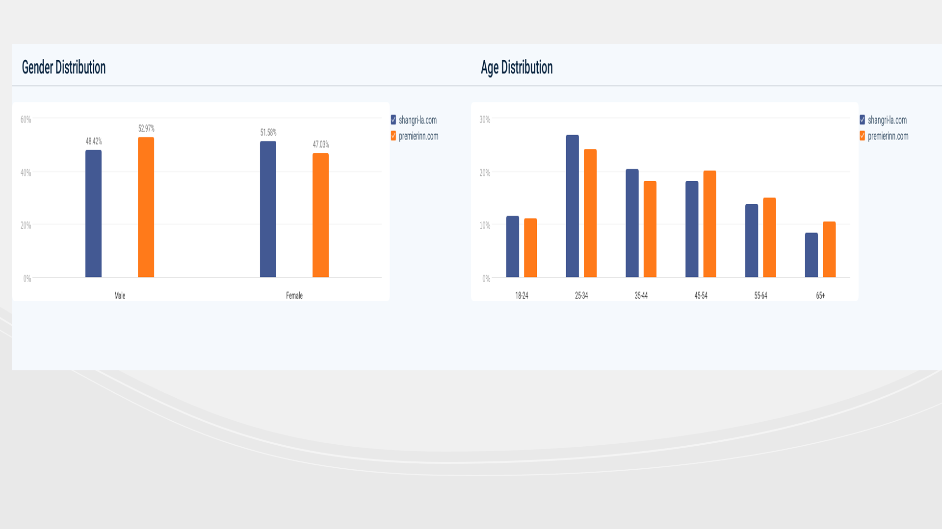
(Similar Web, 2024)

Appendix 4
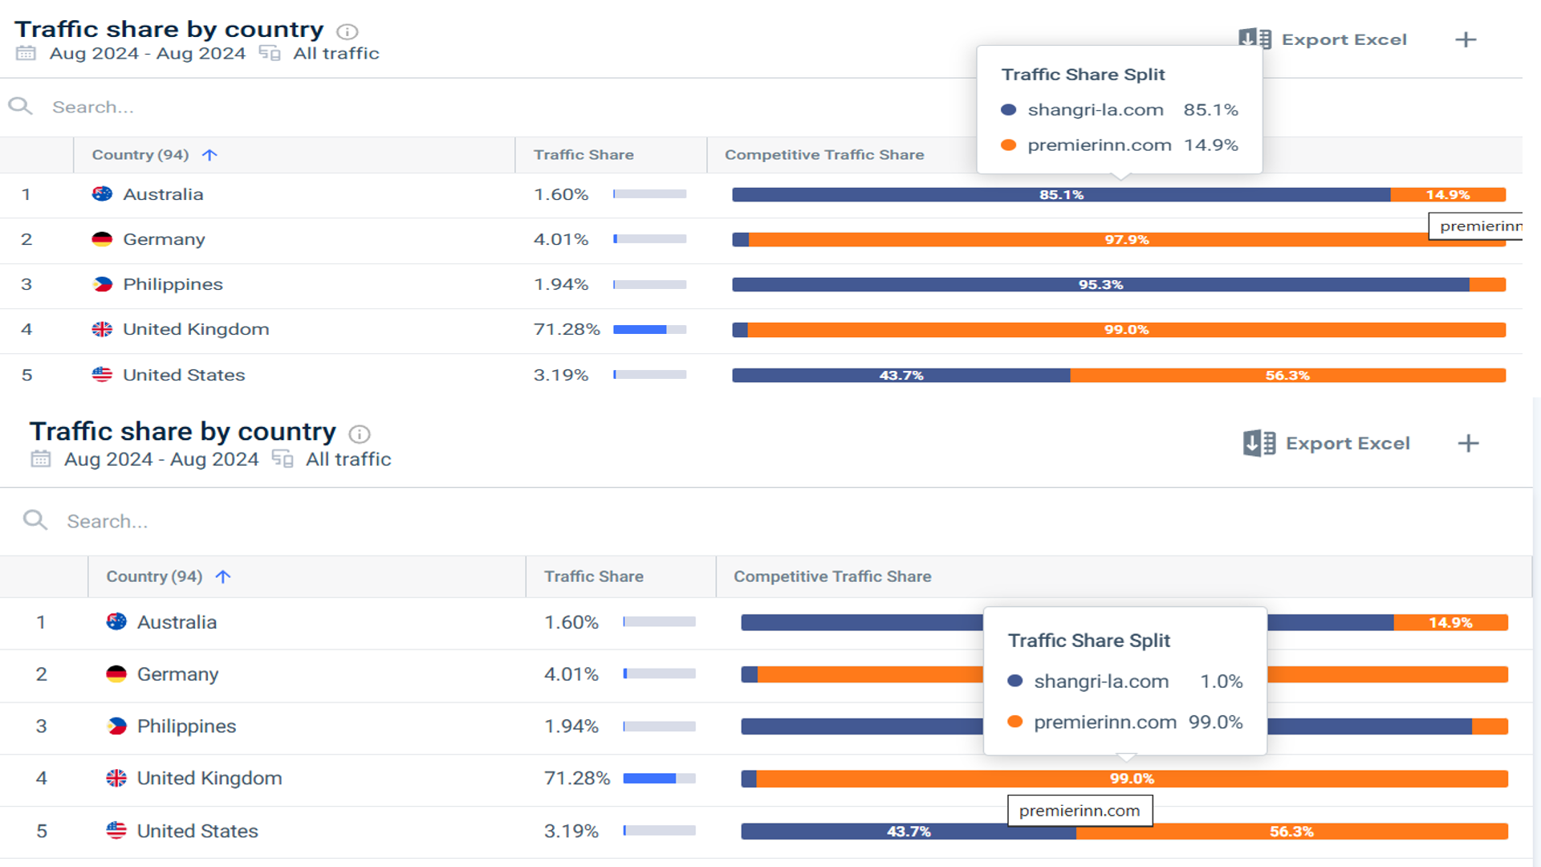
(Similar Web, 2024)

