[Date]
Suneth Fernando
[company name]
IWD : Database Design and Development
Assignment 01

Table of content

Introduction to the case study
This project explores the design of a database solution through ER modelling and practical tools. Using Visio, the relationships were mapped visually to ensure clarity and accuracy. Excel supported the simulation of data formats, calculations, and maintenance tables with realistic values. Access was used to implement the relational structure and test the integrity of the model. Together, these tools provided both a theoretical and applied foundation for the bike rental system.

Entity Relationship Diagram (ERD):
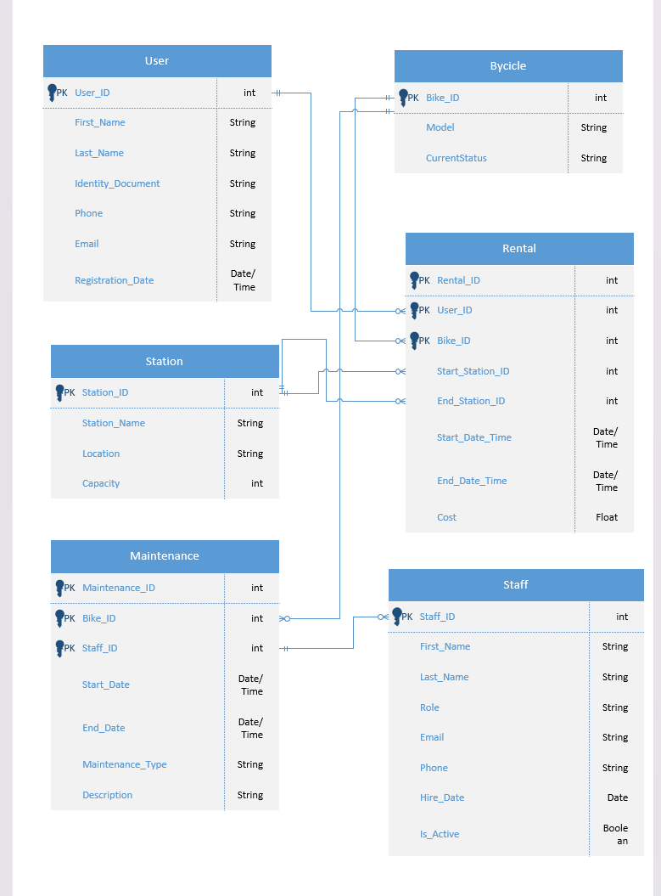
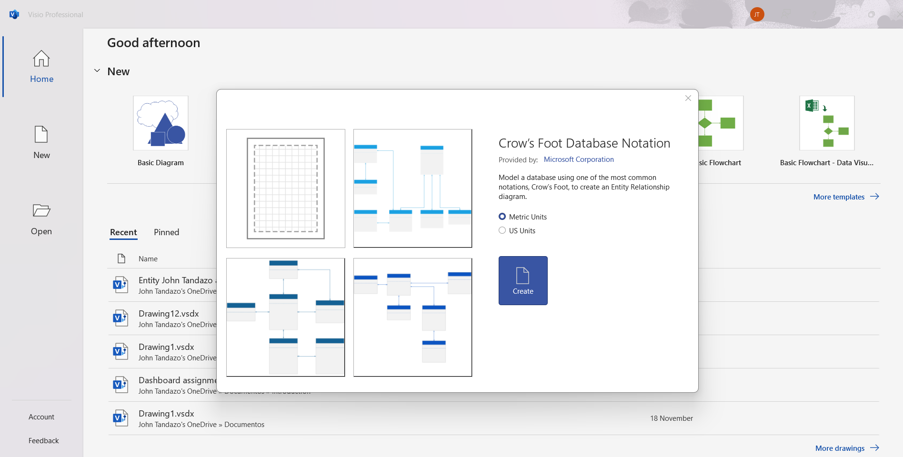

Type of Relationship between Entities (please explain each relationship with appropriate examples from the case study.)
1-User _ID to Rental User_ID (1 to many)
A single user can create multiple rentals over time, while each rental record is linked to one specific user. This shows how the system keeps track of every trip made by each person.
2-Bike_ID to Rental Bike_ID(1 to many)
A bike can appear in many rental records throughout its life, but every rental uses one specific bike. This makes it possible to follow the history of each bike and understand how often it is used.
3. Station_ID to Rental Station_ID (1 to many)
Stations can be the starting or ending point for many rentals. Each rental begins at one station and finishes at one station. This structure reflects how bikes move through the system and how busy each station can be.
4.-Bike_ID to Maintenance Bike_ID (1 to many)
A bike may go through several maintenance events, and each maintenance record belongs to a single bike. This allows the database to store a complete maintenance history for every bike.
5.-Staff to Maintenance Staff_ID (1 to many)
A staff member can perform many maintenance tasks, but every maintenance entry is assigned to one staff member. This helps identify who handled each job and supports accountability within the team.

Entities interact within the database
Entity-relationship (ER) modelling is important because it allows you to clearly see how everything in the system connects before creating the database. By drawing the entities and relationships, errors can be detected quickly and data duplication avoided. Furthermore, it facilitates understanding the system, as anyone can consult the diagram and see how it works without needing to read code. Cardinalities show how elements are related; for example, a bicycle linked to a rental or a bicycle with multiple maintenance records. This keeps the database organized, consistent, and reliable. Ultimately, the ER diagram functions as a simple roadmap that guides the entire design process.

Logical Design
Table Creation in MS – Access (take screenshots of each table (Datasheet view and design view) and paste it here and annotate each screenshot.
Customer Details table (Design view and datasheet view)
User table
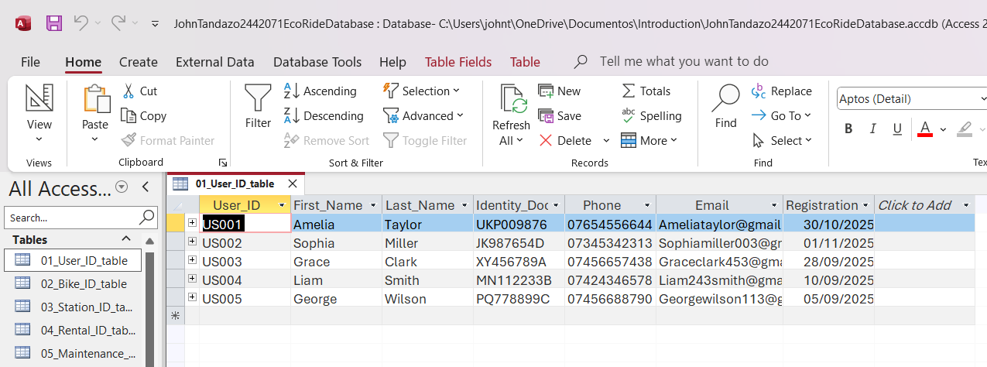
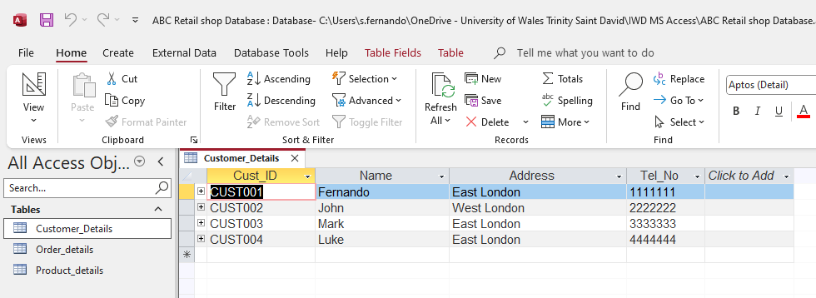

Design view
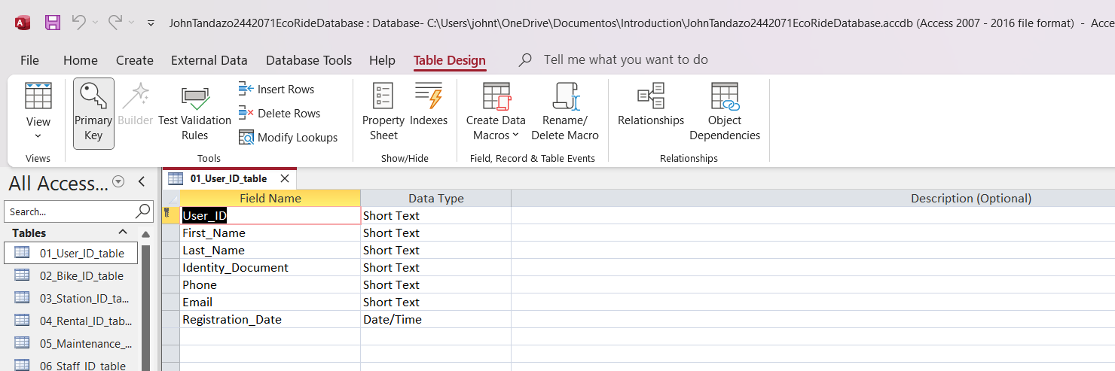

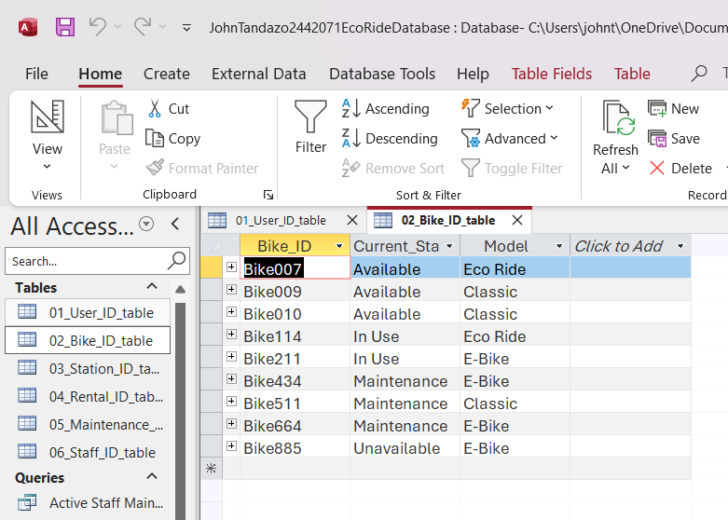
Bike table

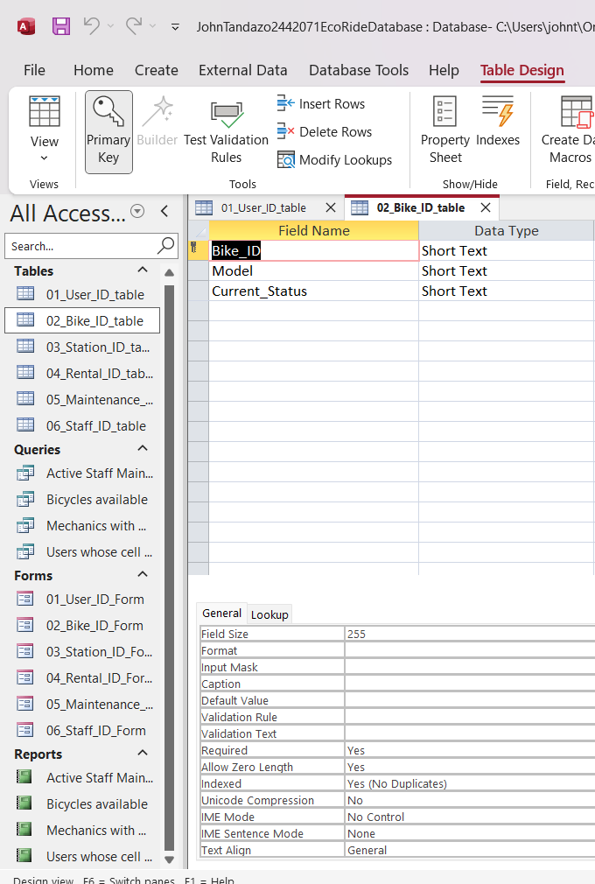
Design view

Station table
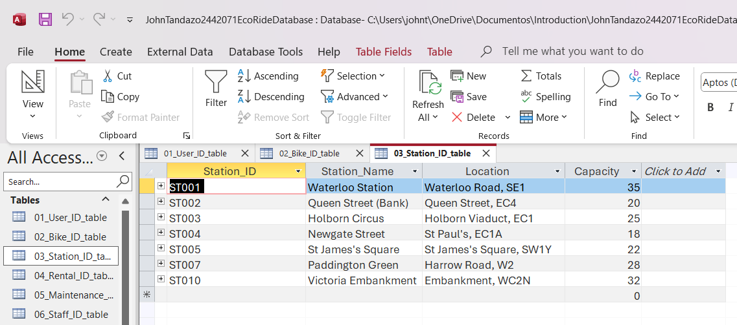

Design view
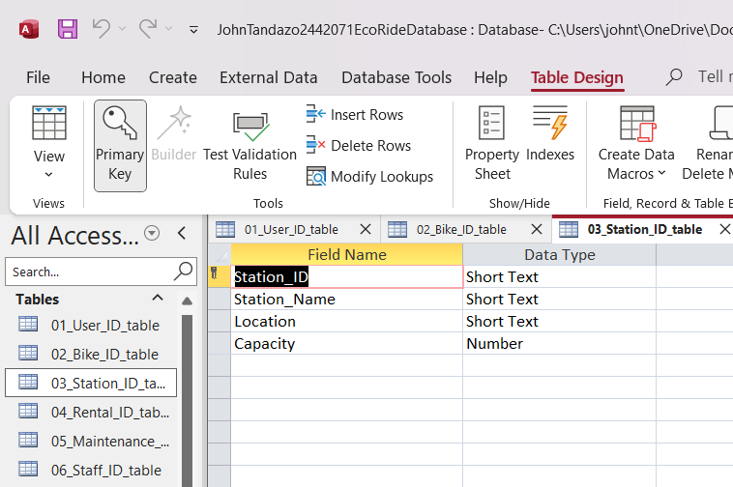

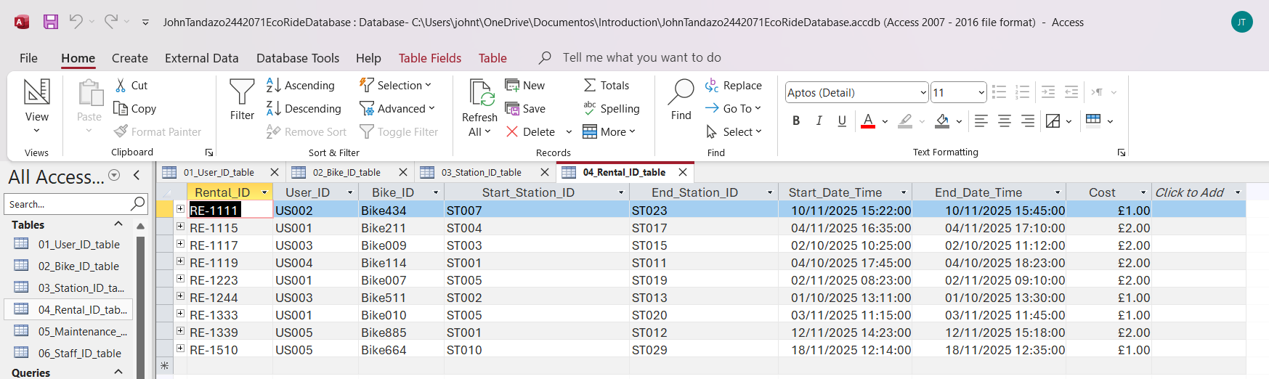
Rental table

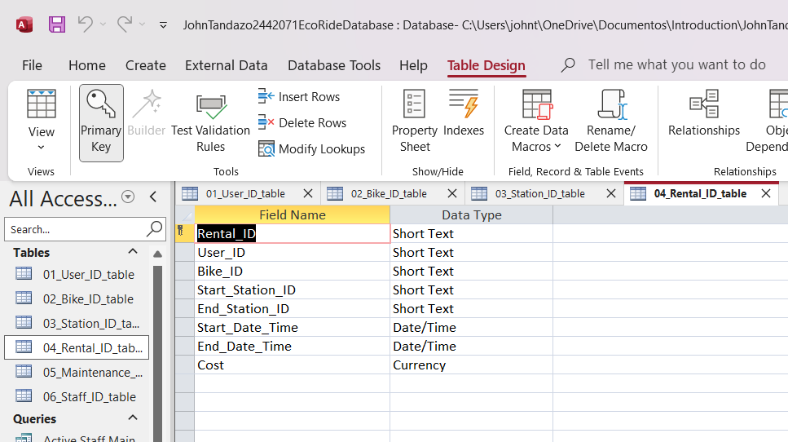
Design view

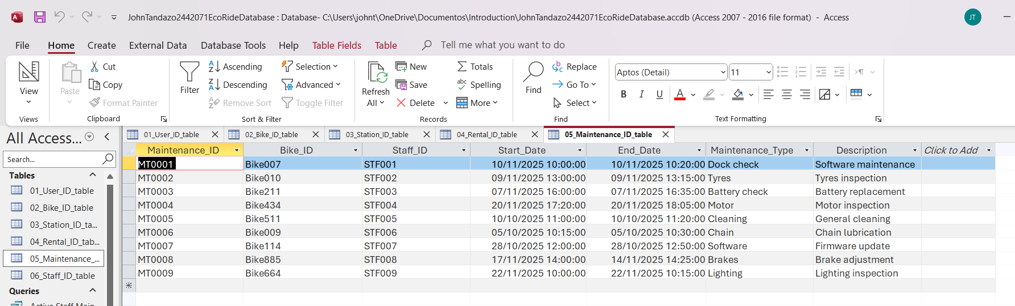
Maintenance table

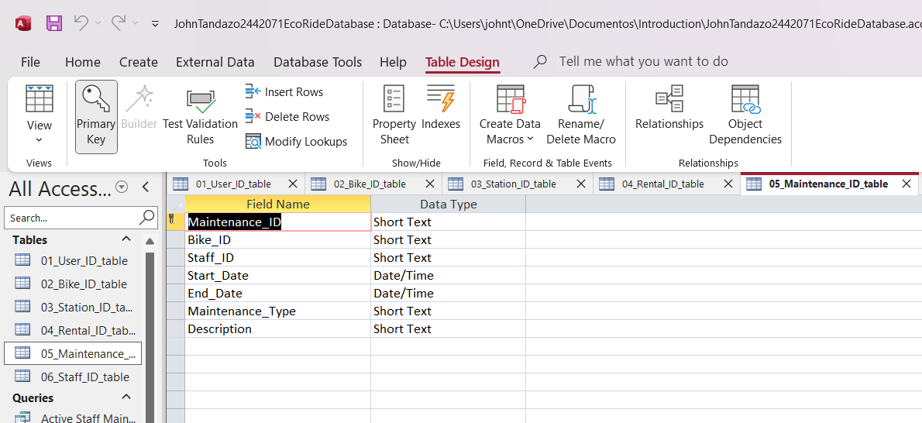
Design view

Staff table
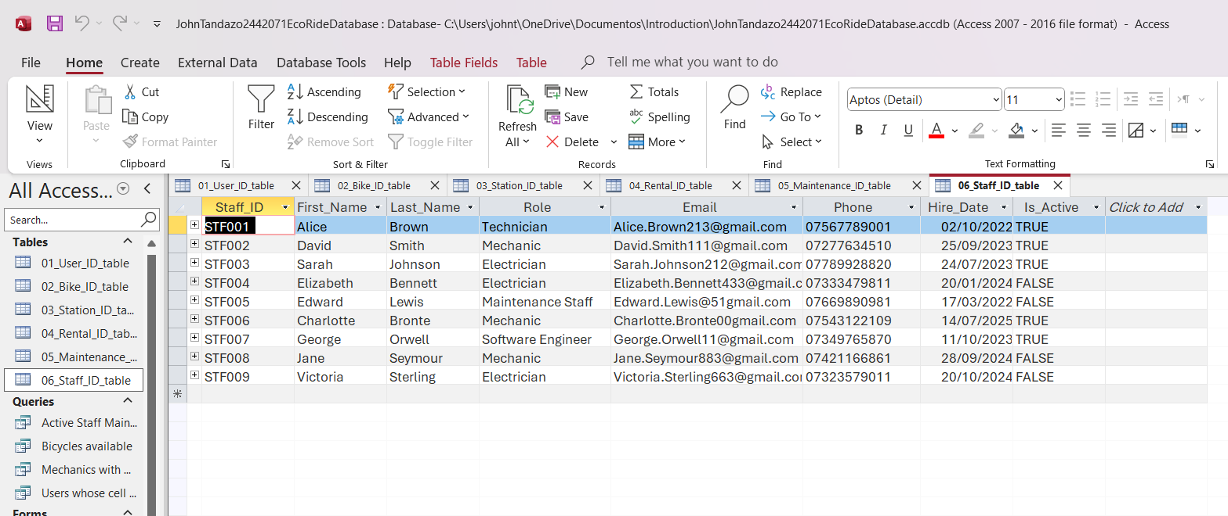

Design view
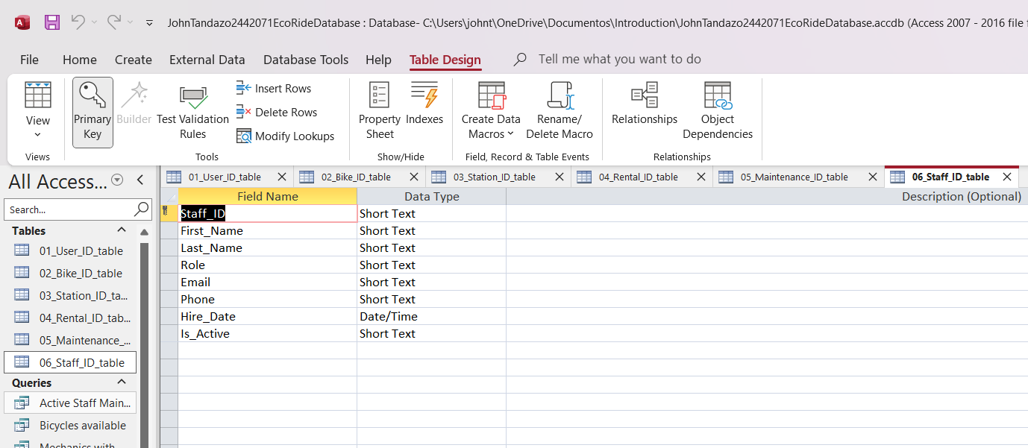

Relationships between tables
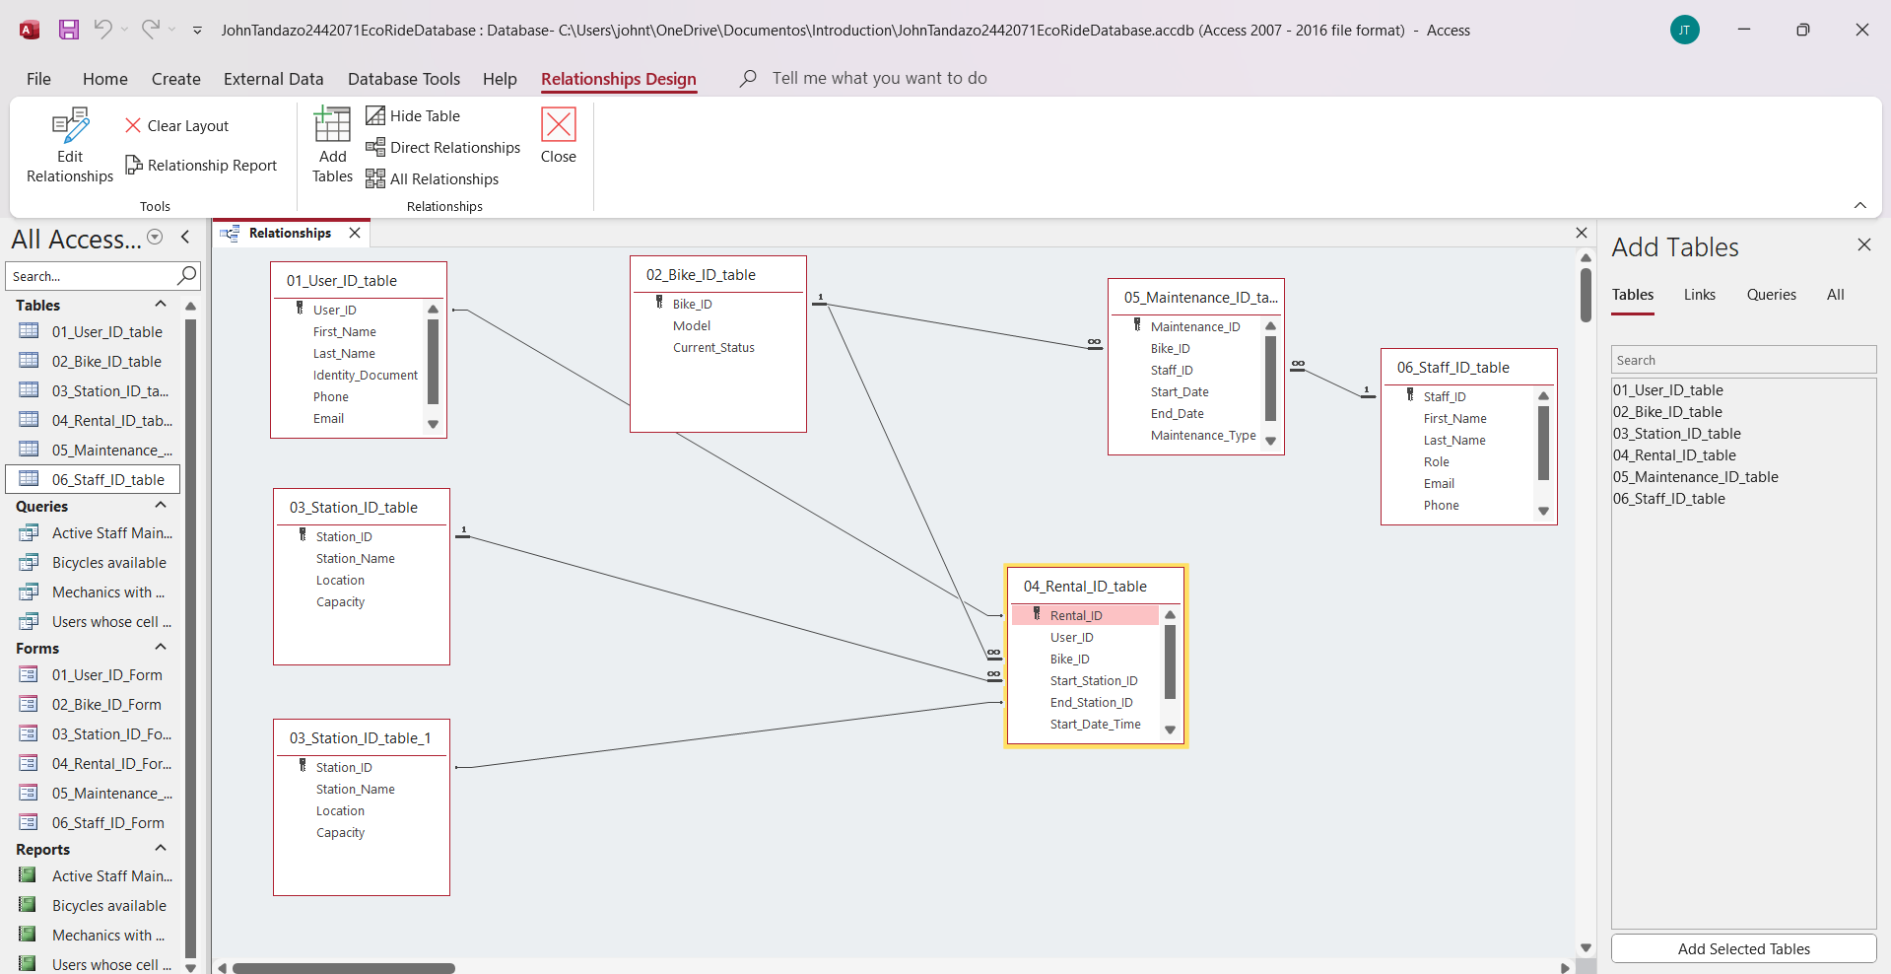

Each table in my database has a primary key that identifies each record, and these keys are used in other tables as foreign keys. This allows Access to understand how all the tables are connected and thus maintain data consistency.
01_Table_User_ID
The primary key is User_ID.
This same value appears in the Rental table as a foreign key, so the system knows which user made each rental
02_Table_Bicycle_ID
The primary key is Bicycle_ID.
This ID is used in the Rental and Maintenance tables, allowing the database to link each rental and maintenance task to the correct bicycle.
03_Table_Station_ID
The primary key is Station_ID.
This key is used twice in the Rental table (Station_ID_Start and Station_ID_End), which helps show where each rental begins and ends.
04_Rental_ID_Table
The primary key is Rental_ID.
This key remains within the Rentals table and is not used as a foreign key. It simply identifies each rental.
05_Maintenance_ID_Table
The primary key is Maintenance_ID.
The table also includes Bike_ID and Staff_ID as foreign keys, so each maintenance record is linked to the bike being repaired and the staff member who performed the work.
06_Staff_ID_Table
The primary key is Staff_ID.
This ID appears in the Maintenance table as a foreign key, allowing the system to record who performed each maintenance task.

Testing and Validation
Requirements of the case study
- Manage an inventory : in this case a table called, “product” has been designed and developed to maintain inventory of all the products.
- Customer Information : A table called "Customer” has been designed and developed……..

Test Cases | Expected Results | Actual Results | Any Discrepancies
Manage an Inventory | It is expected to manage an inventory for all the products of the shop | A table has been design and developed to maintain an inventory of the products. | No

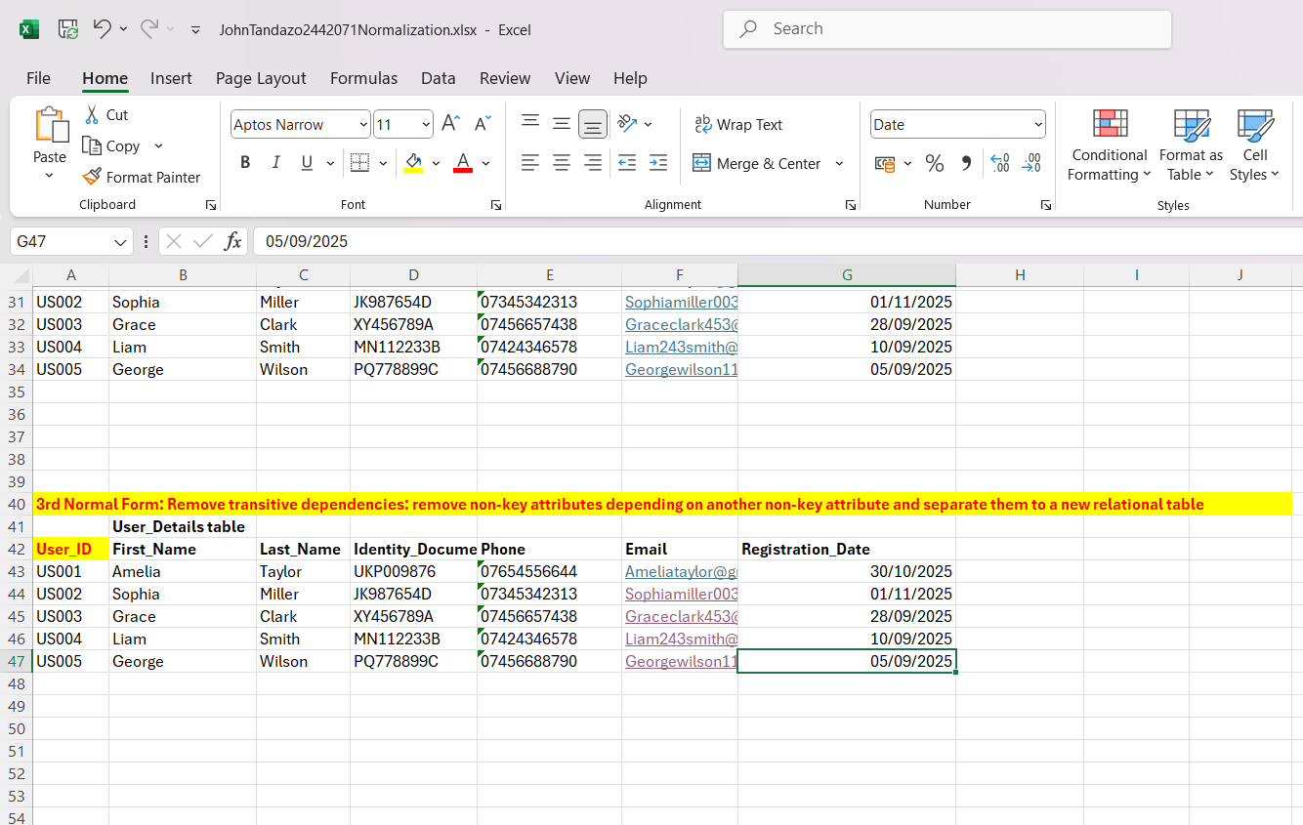
Normalization Process

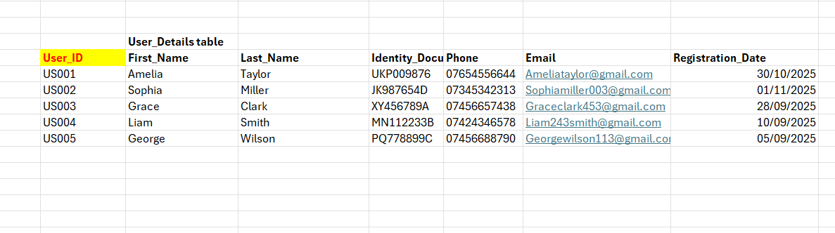

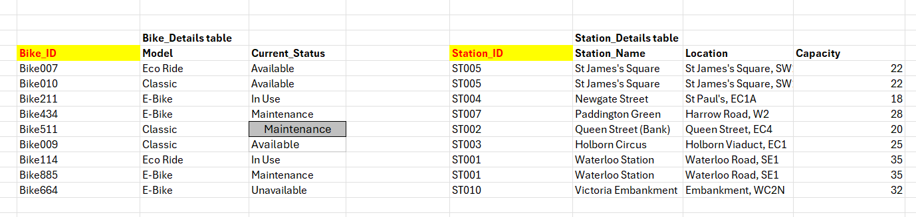

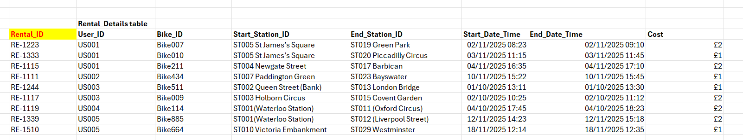

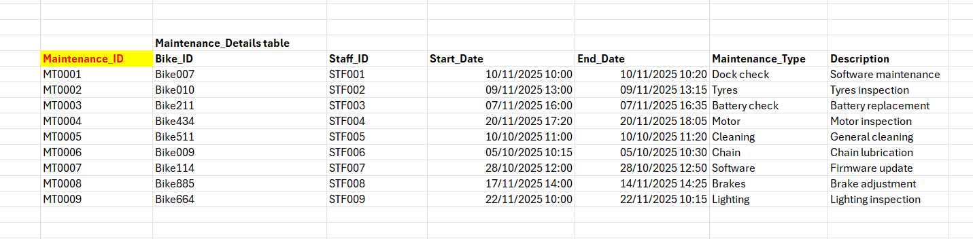

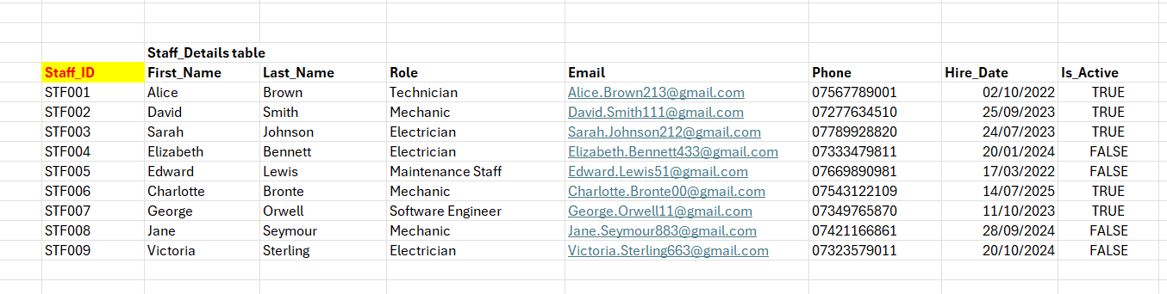

MS- Access

Forms Creation (take screenshots of all the forms and annotate them)
01_User_ID_Form
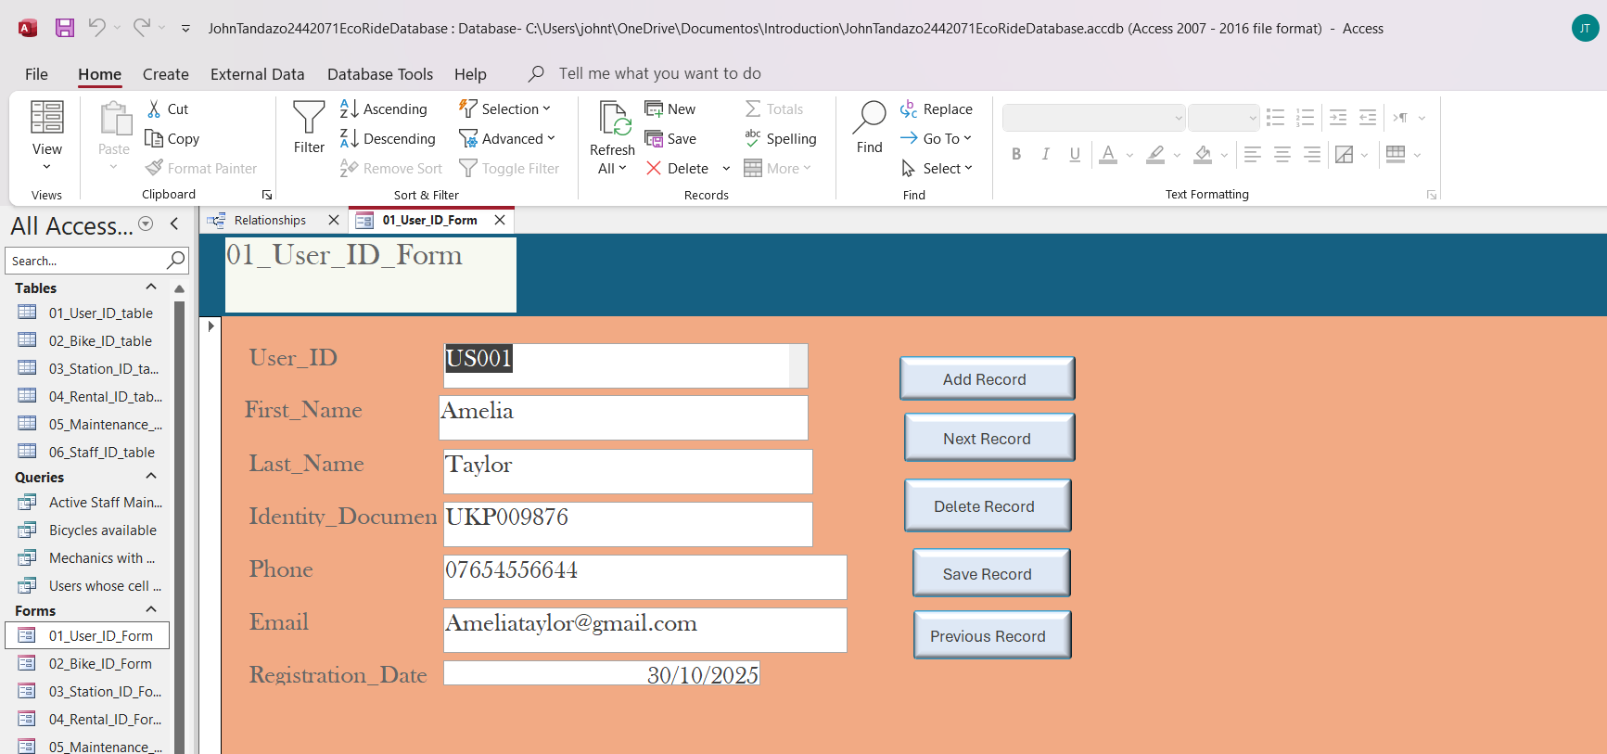

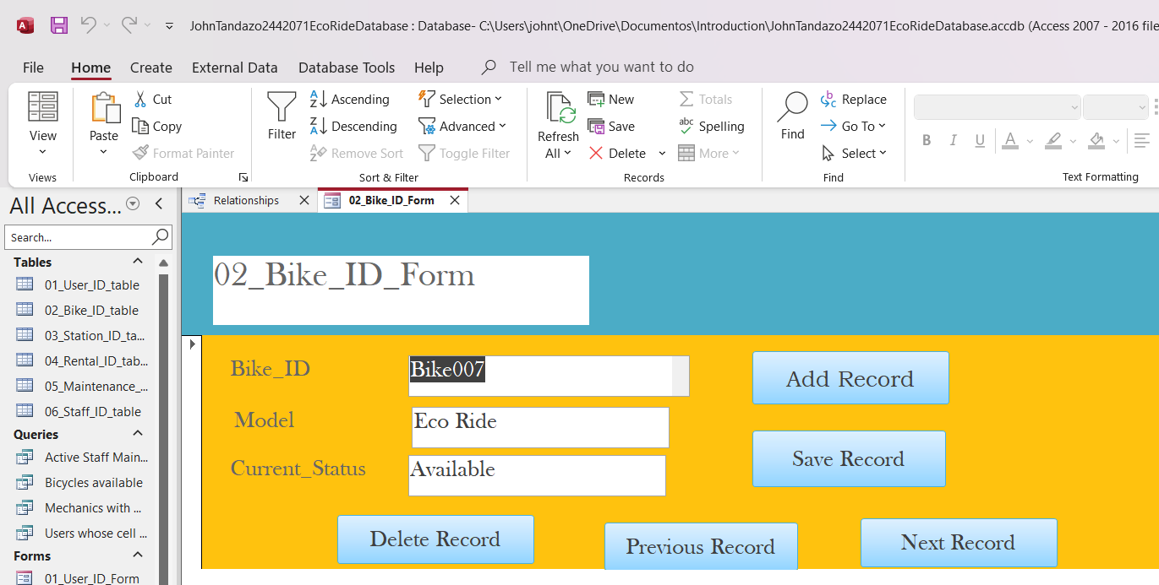
02_Bike_ID_Form

03_Station_ID_Form
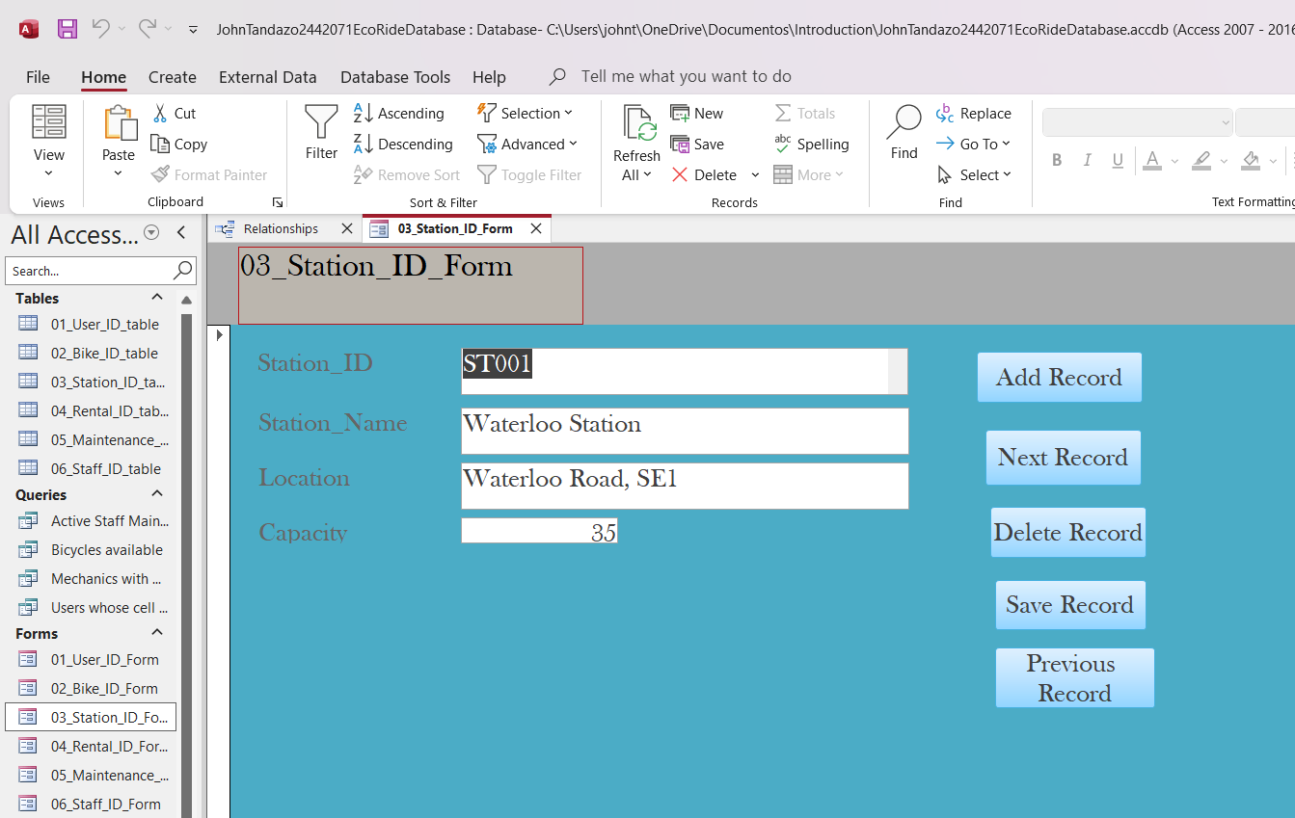

04_Rental_ID_Form
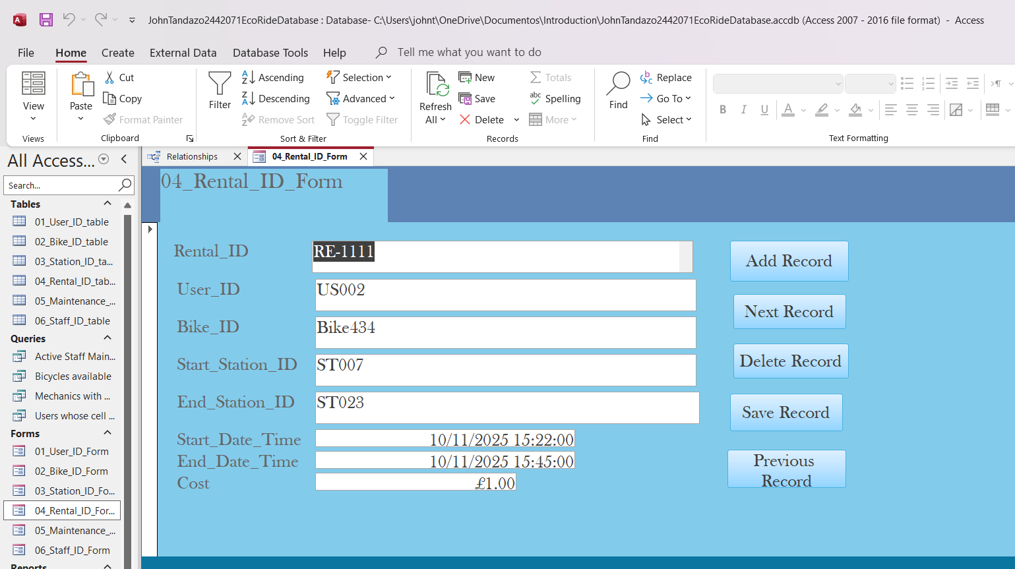

05_Maintenance_ID_table
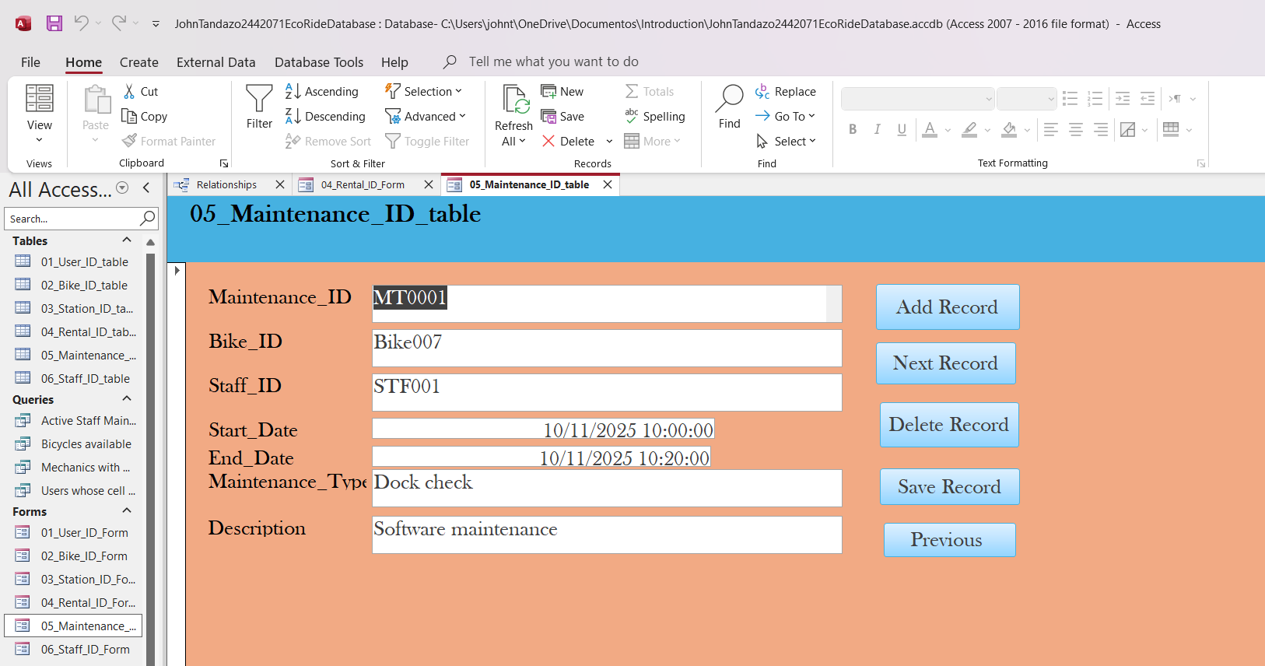

06_Staff_ID_Form
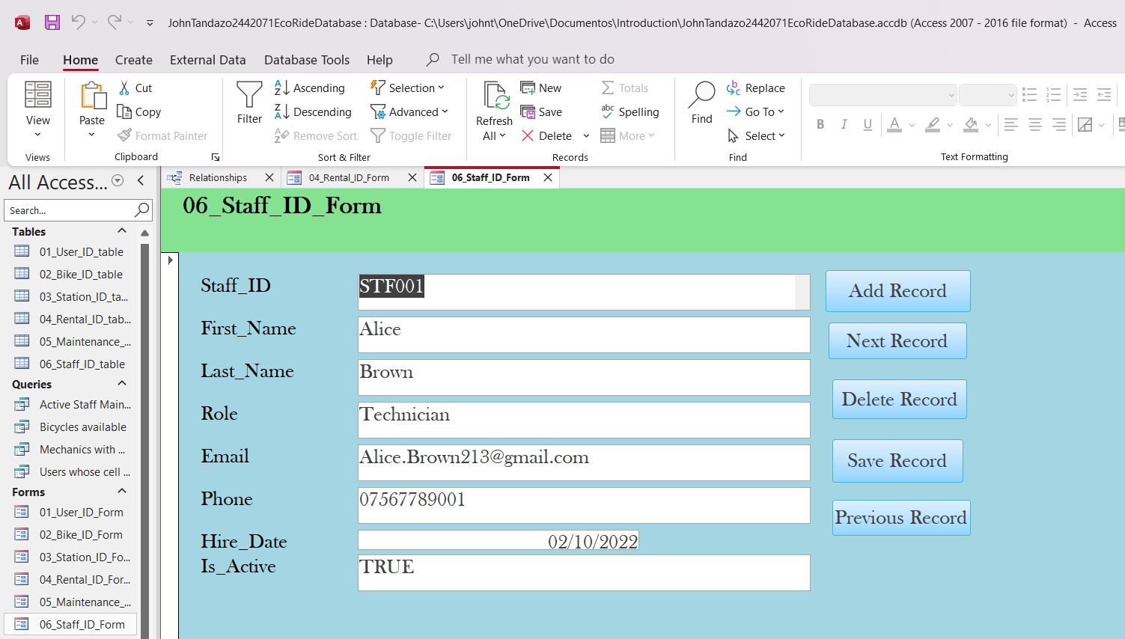

Queries Creation (take screenshots of the design view, datasheet view and SQL view of each query and annotate them)
Based on your critical thinking, create at least two – three queries
Active staff maintenance
datasheet
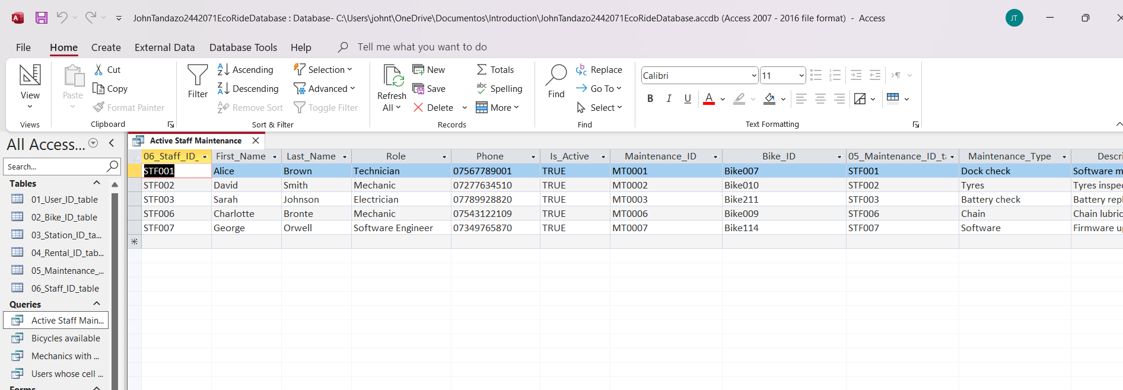

Design view
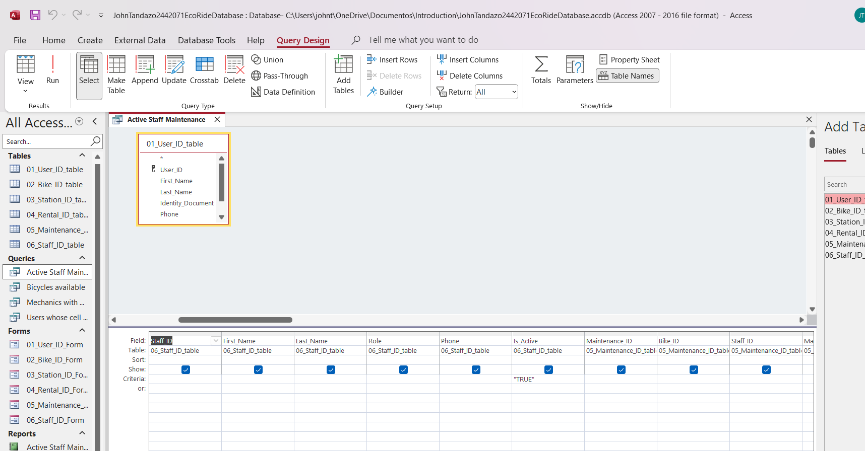

SQL
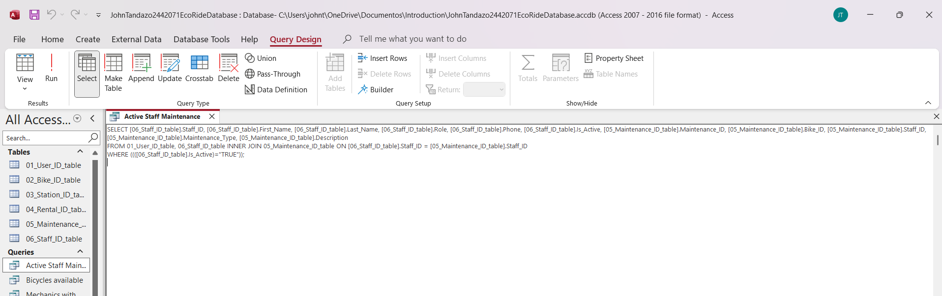

Bycicles available

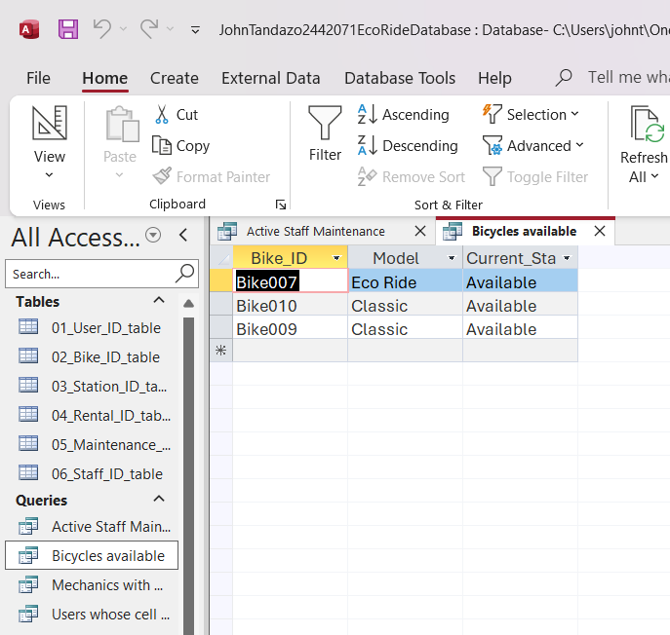
datasheet

Design view
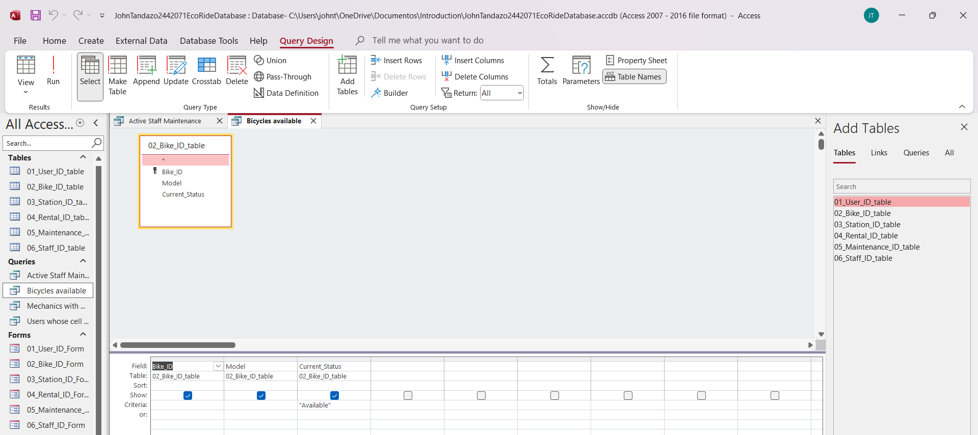

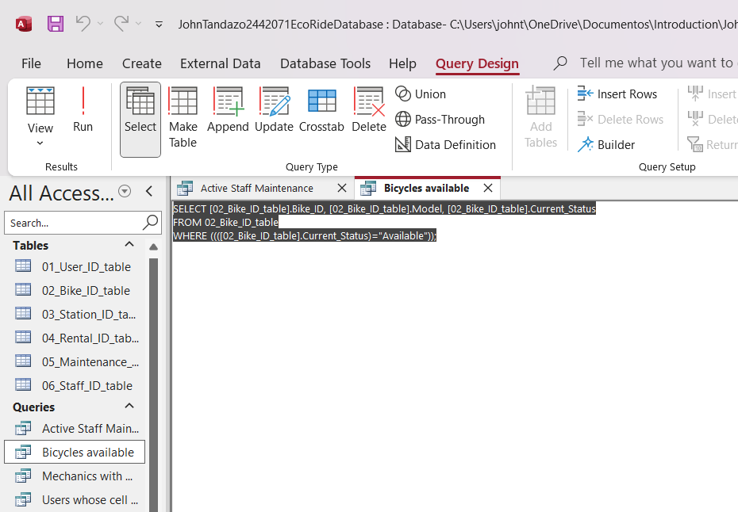
SQL

Mechanic with Maintenance
datasheet
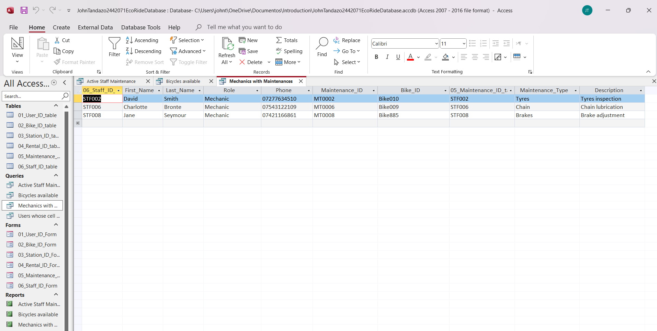

Design view
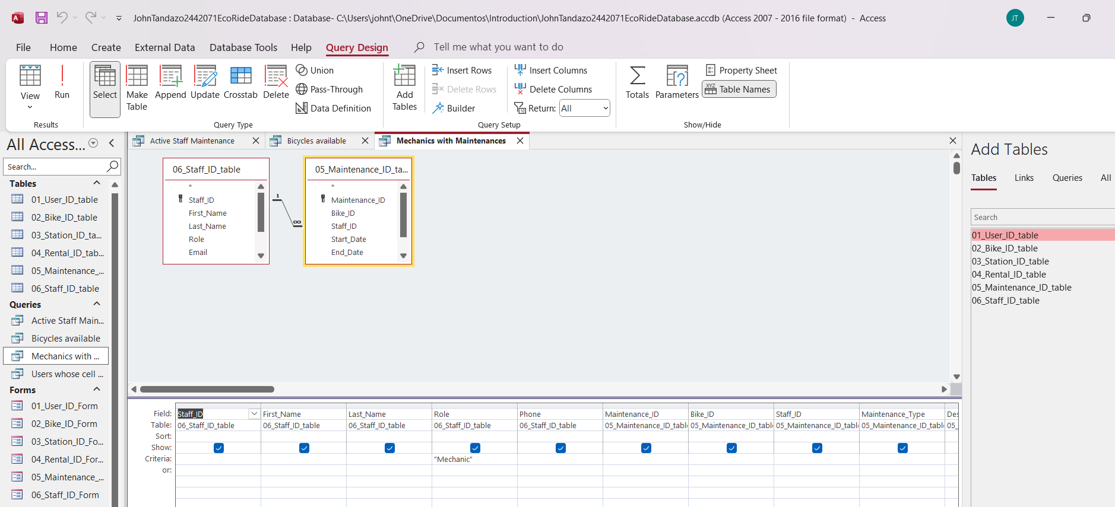

SQL

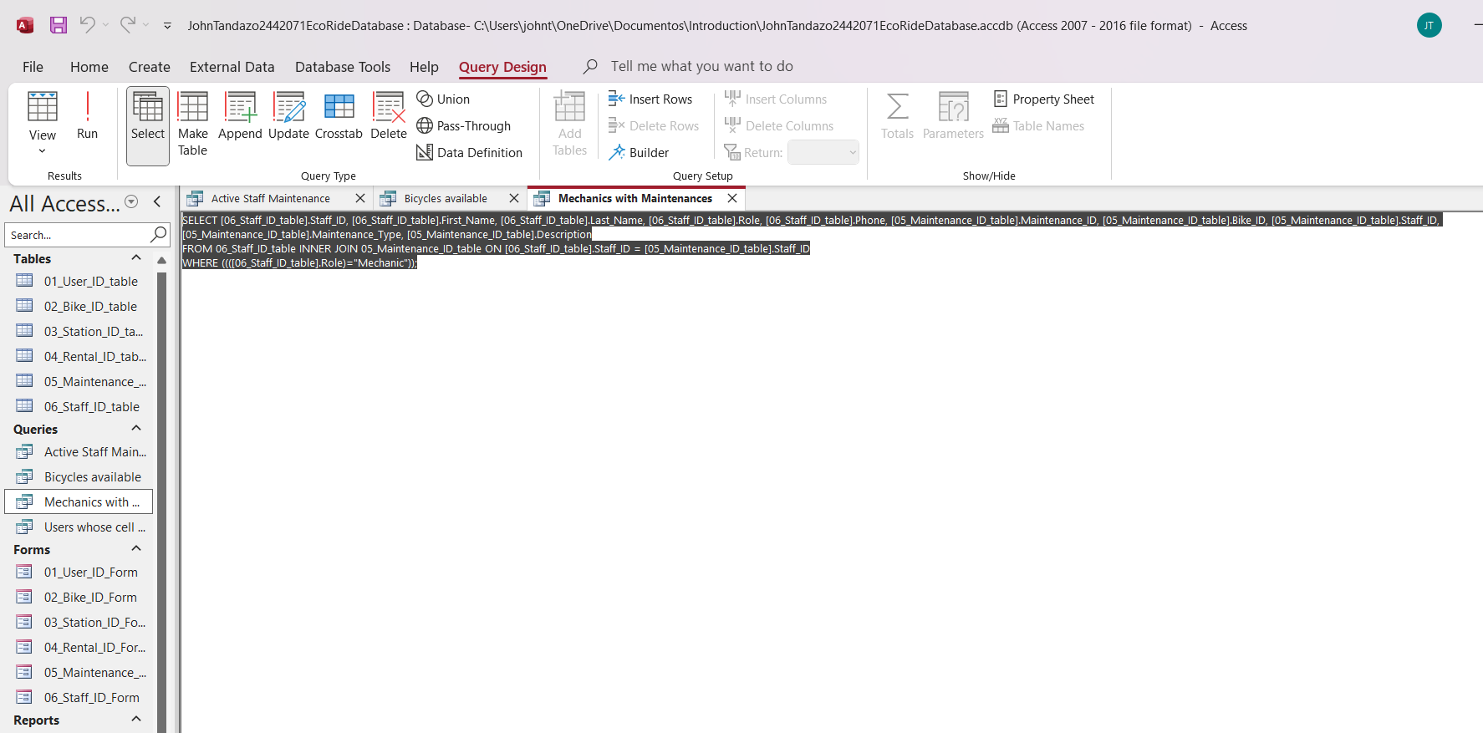

Users whose cell phone number starts with the prefix 074
DATASHEET
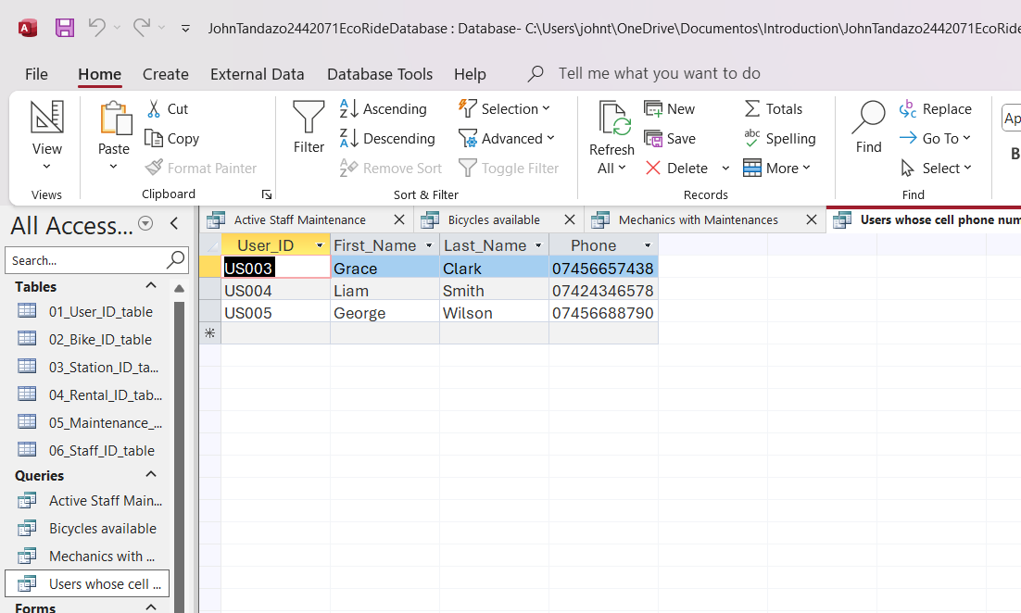

DESIGN VIEW

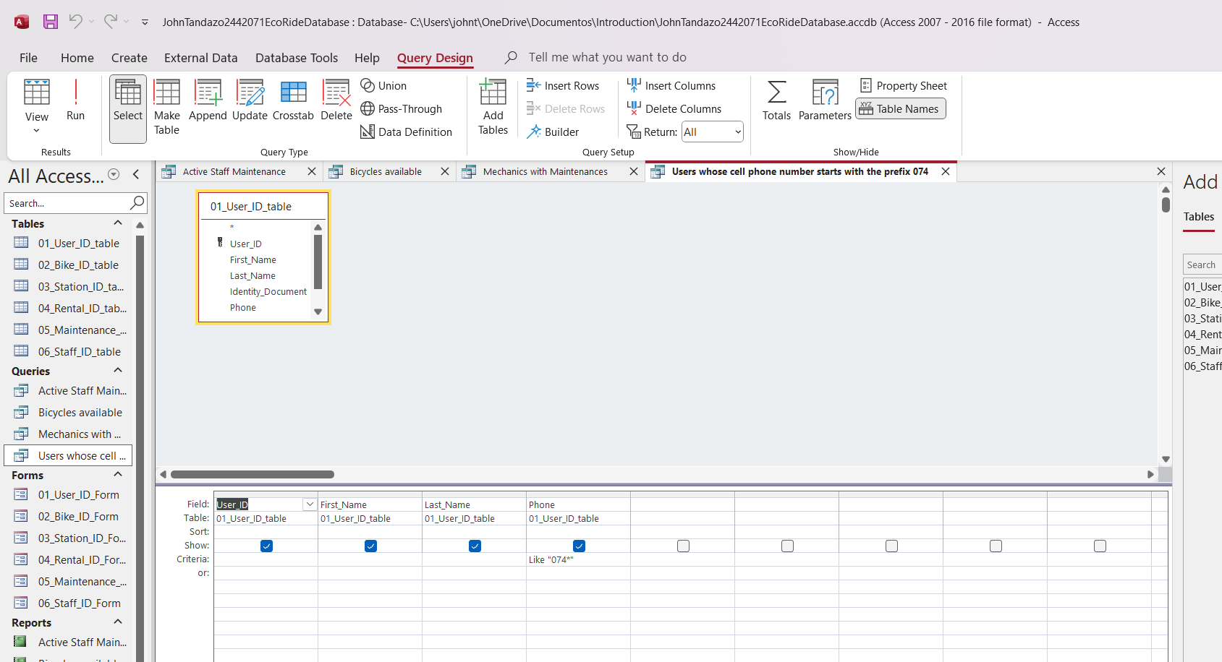

SQL VIEW
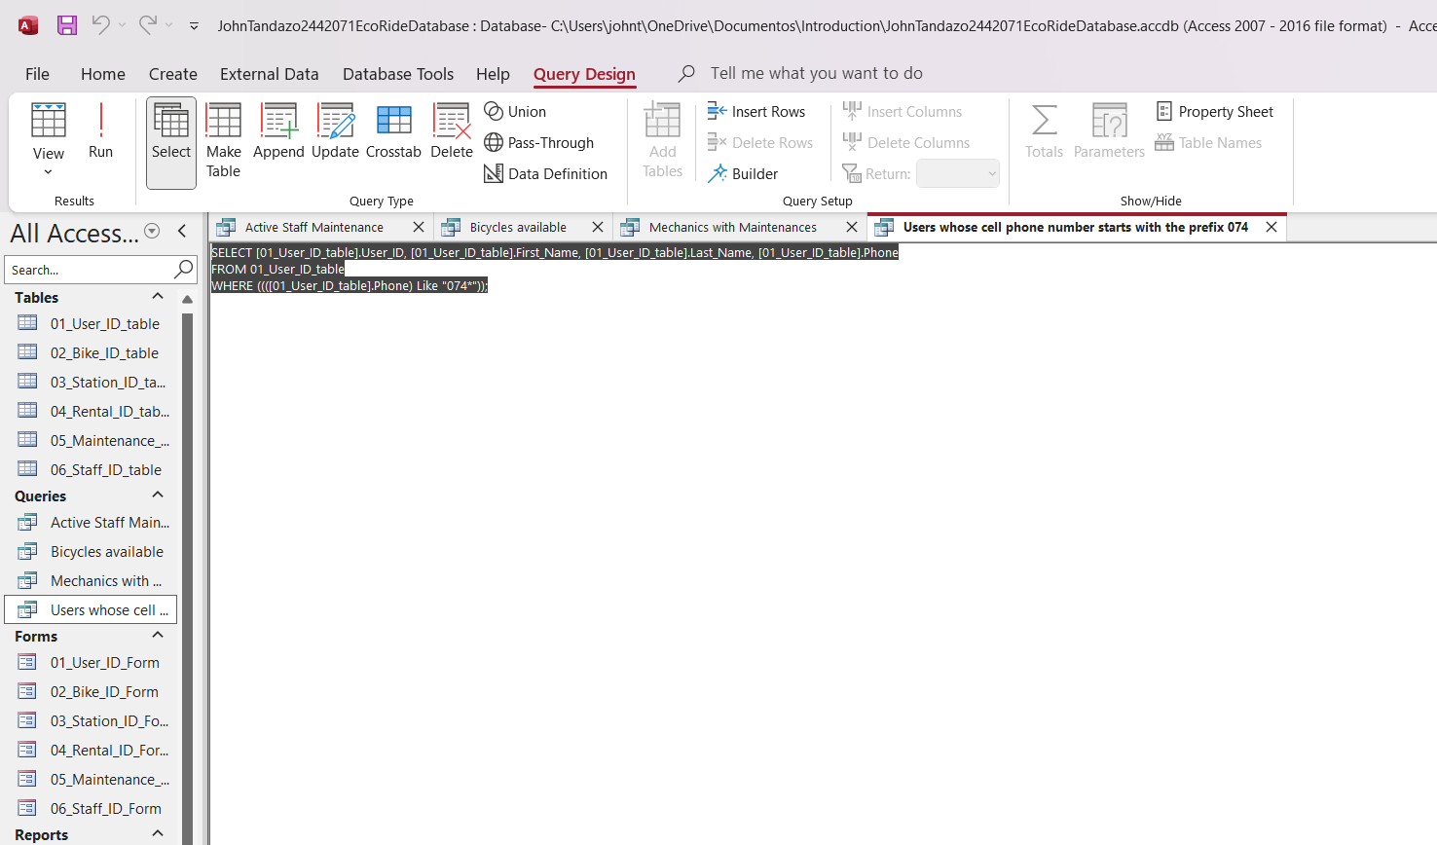

Report Creation (create reports from each query and annotate them)


