MANAGING ENTERPRISE IN THE 21ST CENTURY
Module: BMSW4006

Istvan Csizmar – 19222097

Samata Khatoon-1919228

Benjamin Alejandro Lierena Lora- 1921011

Saima Rahman- 1922002

Elina Fjodorova- 1920297

Name of lecturer: Afzal Munna

Name of University: University of Wales Trinity Saint David

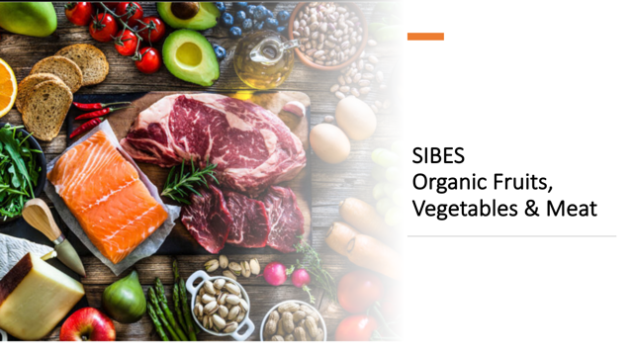
Submission date:10th Jan 2021

Table of Contents
Saima Rahman -1922002 ………………………………………………………………3-9
Benjamin Alejandro Lierena Lora- 1921011…………………………………………10-14

Elina Fjodorova- 1920297…………………………………………………………….15-21

Samata Khatoon-1919228…………………………………………………………….22-28

Istvan Csizmar – 19222097……………………………………………………………29-35

Appendix……………………………………………………………………………….36-52

SAIMA RAHMAN
1922002
MANAGING ENTERPRISE 21st CENTURY

ORGANIC FRESH FRUIT, VEGETABLE AND MEAT
TABLE OF CONTENTS
COVER LETTER
Cover letter
11/12/2020
Mr x
ORPINGTON, Kent
a.munna@uwtsd.ac.uk
dear Mr. x,
we are writing to you today to let you know about our interest to open an organic fresh fruit, veg and meat store. We are 5 people a group who has already some experienced in business field for last 5 years. Now we find a very suitable and good place where we can open a fresh vegetable and meat store.
When we survey at local community, we find out that people love, and they needed fresh vegetables and especially fresh meats. In ORPINGTON, there is very small number of shop where people can find fresh items every day. One of our partners who already has 2 more business like that his supplier will delivery fresh meat every day. The shop will be open 7 days a week 9a.m to 8pm. So that we can fulfill our customer daily need.
We hope you like our idea to open an organic fresh fruit, veg and meat store. We are sure that you and we always maintain a positive working relationship and for business development we will take each other opinion. So, we hope you will investment in our business and if you want any kind of information about our project, please do not hesitate to contract us.
Sincerely,
Organic fresh fruit veg and meat team.
1. Business overview

a) summary
B) mission/ vision
C) history
D) competition
E) products
F) management and finance
g) keys of success

2. product and service
a) description
b) product price
c) benefits of customers
d) growth strategy
3. Market audit
a) internal marketing audit
b) external marketing audit
c) marketing strategy

4. Target market
a) industry
b) technology adoption
c) demographic segmentation
d) geographic segmentation

5. Marketing Plan
a) market analysis
b) swot analysis
c) market strategy
d) budget
f) objectives
e) action plan

6. Management team
a) board of directors
b) supervisor
c) marketing manager
d) sales staff

7. financial plan
a) create budget
b) set financial goal
c) analyze and interpret
d) review progress and update
e) collect information
f) investment planning

Conclusion
Reference

Summary: organic fresh fruit, veg and meat is a small-town shop. It will be in ORPINGTON, Kent. At fresh veg and meat store, we are interested in more than a basic store like the average fruit, veg and meat store business. The local community and surrounding area approximate 4000 citizens live here. Organic fresh fruit, veg and meat store concept, as shown in our plan, it will be an excellent profitability level and growth rate. Our competitive edge, along with new retail techniques and technology, will put our store in the forefront of the retailing of perishable and nonperishable consumer goods. We are living an age where unique fresh fruit, veg and meat store environments are in great demand. Our store will differ from the traditional store because of our added personal touch.
History: In ORPINGTON, Kent there is a lot of small shops and there also live lots of Indian, Pakistani, Jamaican people and some Bangladeshi people also live there. Most of the people there love fresh veg and meat. But there is very small number of organic fresh shops so people most of the time go to London, which is 15 miles from ORPINGTON, for buy their needs. There is no other store like we planned for our store. Where we will open our store, there is train station, bus stop and lots of flats next to our store. Our store will be the big store among of other shops.

Mission / Vision: organic fresh fruit, veg and meat will be provided a broad selection of high quality and competitively priced products as well as exceptional customer service to satisfied customers. Our focus of organic fresh fruit veg’s, and meat is to create an environment that will be warm, friendly and clean. we will be committed to our employees by treating them with respect, fairness so that we can make a good team. The suppliers of organic fresh fruit veg, and meat will be also partner in the success of the company and we expect same in return. Our mission is to make our customers have access to all the products that they need to make their life comfortable. We will make sure that our customers get services of the highest quality from us.
Our vision will be to satisfied customers with selling good products and earns their trust.
Keys to success: The keys to success for organic fresh fruit, veg and meat are quality products and friendly service. Creating a positive relationship within the community.

Partnership/ownership: Organic fresh fruit, veg and meat store will be a partnership business. We are 5 partners with same share of this business. Now we only need an investor for our business.

Competition: Marketed at a lower shelf price than national brands, organic fresh fruit, veg and meat retailers a competitive advantage. The store will be in walking distance of area shoppers, whereas the next nearest shop in two to three miles from our store location. Lots of people who will be our customer, they told us they wanted only store brand and national brand products, another high end customers who request select gourmet products, such as capers, anchovies and the cost for these items is approximately 150/month, and finally healthy choice customers who requested a selection of organic products, the cost for these items approximately 2000/month. In order to maintain our customer loyalty base and continue to increase sales revenue, we make these products available. The community has become accustomed to these products and expects them to continue. Depending upon the size of the community, there may be several stores to chose from. Larger communities such as ORPINGTON, have server large chain grocery stores as well as smaller organic stores, whereas a small community may have a single organic fresh fruit, veg and meat store or possible two store to
choose from.

Products: organic fresh fruit, veg and meat is a small community store, that will offer store brand and national brand products. We offer a meat department where fresh cuts are will be available daily and there are no pre- package meats for sale. The store offers free delivery in the local. Our store also served its customers by special ordering items that are not available within the store or that cannot be found at a competitor location. We will be sales virtually products that is always people needed for day to running of the home. Products like food items, drinks, daily products, fruit, vegetable, meat etc.

Market analysis summary: ORPINGTON, Kent is located approximately 20 miles from east London, which is appealing to many home and property buyers who prefer country charm while being close to certain amenities. ORPINGTON and the surrounding community consist of a diverse population. To make our advertising and printing pound work their smartest, we need a team that will work its hardest. Organic fresh fruit veg, and meat store is ready to make those needs by providing everything from concepts and design to printed and signage. There are experts in the process of creating and printing advertising, newsletters, business card, business form etc.

Strategy and implementation: we have a clearly defined the target markets and have differentiated ourselves by offering a unique solution of our customer’s needs. Our sales and marketing strategy will be combination of community mailers as well as internet email blasts. Reasonable sales targets have been established with an implementation plan designed to ensure the goals set forth below are achieved. Organic fresh fruit veg, and meat will help us grow and develop our store.
Swot analysis also every important for any business and we also do our swot analysis. Organic fresh fruit veg, and meat has a valuable inventory of strengths that will help it success. these strengths include: a positive cash flow, major highway location and fresh cut meats daily.
The weaknesses will be inferior cooling and freezer units and limited deliveries.
Opportunities of organic fresh fruit veg, and meat is to offer customer their daily need so people will know about our store.
Competition is always a treat for business and if another similar store will open.

Management: The organic fresh fruit, veg and meat store has 5 partners and 5 employees as well. Two employ Samata and Isvan will be in till. Because they both did master’s in business and they are very good at accounting.
Ben and Elina will be in butcher section where they cut meats and they had 5years experienced. Another employ Saima will be assistant and give service to customer. She already worked grocery shop for 2 years. In the future if we need more employee, we can hire some experienced people. If we faced any problem for management, we could solve it together. Now we need someone who invest our business to make it complete and successful.
Finance: we make a finance plan for our business. We are 5 partners with same share. Each of us will invested 10,000 each as a startup. We make a complete plan for 5 years financial services that includes payroll service, tax return, bank, cash flow, break-even analysis, check printing, deposit advice etc. these kinds of information and thought allow organic fresh fruit, veg and meat store to make sound business decisions for the future.

Reference:

Lasher, W. (1994). The perfect business plan made simple. New York, NY: Doubleday Dell.

Covello, J., & Harzelgren, B. (1995). Your first business plan. Naper ville, IL: Sourcebooks.
MANAGING ENTERPRISE 21st CENTURY

Benjamin Alejandro Lierena Lora- 1921011

Organic Fresh Fruit, Vegetable and Meat

Product And Service
a) Description

All the products that we offer within Organic Fresh Fruit, Vegatable and Meat, are fresh, of quality and brought directly from the best distributors, always trying to preserve a product free of chemicals and maintaining a much more natural and organic flavor. Likewise, we will also have a great variety of national brand products and many others that are popular in large chains of shopping centers or supermarkets. From fruits to meat, everything we have for sale to the public is reviewed on a daily basis, always seeking to eliminate any type of flaw or imperfection in any of these, likewise they will not be wasted, but, on the other hand These could be available for sale at a discount thus avoiding wasted merchandise. All this is clear, either to help with the choice of the day's purchase, recommendations for the preparation of different dishes and knowing in detail each one of our products to give information in the clearest and simplest way to all our consumers.

And to conclude with this description of our products and services, we must also make clear another important point within the latter, and that is we also have a home delivery service, which can be managed from our website, controlling the delivery times, arrival and the route by which the delivery person is, achieving with this the power to keep track of all their purchases as accurately as possible. Likewise, within our website, different daily offers will also be published frequently, including among all the aforementioned a variety of products for daily use, which motivate our customers to make their purchases online or in turn, if they prefer to save money, the cost of shipping, they can make and pay for all their orders and pick them up ready to take away at our location at no additional cost.

Likewise, within the online space to place orders, a very useful option will also be available both for our clients and for us as a company, and it is the feedback system where comments and recommendations of any aspect and with any type of criticism can be expressed. , this in order to gradually improve the user experience and gradually improve the quality of customer service evolving into a more personalized system, making the trip to our store an experience to remember and that in turn reinforces more and more the loyalty of each of our consumers, likewise within the same platform a tool will be made available to share this experience in our premises with other people, whether they are family, friends, acquaintances or in any type of social network in which the user wants to share, this with the possibility of being able to win some type of reward in the form of a mini discount for prop Give us your comments.

b) Product Price

The price of the product may vary depending on the product that is being sold, and as this is one of the most important aspects for the company, we have decided that one of our differentiators against the competition is to provide food and merchandise with prices lower than those of other companies since our objective is to be able to cover the largest possible number of public.

This is the objective for which a price study was started and the entire price list of products of various categories of 3 of the most relevant supermarket companies currently within the country was taken as a reference, and from this point it was analyzed together with the purchase cost to our distributors to determine the prices of our products that will be shown later. All the analysis in order to maintain competitive prices but with justification of why those prices and give confidence to our customers why it is cheaper but maintains an equal and in some cases superior quality compared to our competitors, thus winning over their once the rest of the market could go down due to pressure from user demand.

Having said this, the price list was based on the cost of obtaining it by our distributors to obtain a high profit margin while maintaining the same or lower competitive prices with the rest of the companies. This is why the price list will be handled in the following way and taking into account that the products will be grouped by somewhat general areas:

1. Meats: Prices from £ 1.50 to £ 5
2. Fish: Prices from £ 2 to £ 5
3. Legumes: Prices from £ 1 to £ 3
4. Sausages: Prices from £ 0.75 to £ 2.50
5. Vegetables: Prices from £ 0.50 to £ 5
6. Fruits: Prices from £ 1 to £ 4
7. Cereals: Prices from £ 2 to £ 4
8. Spices: Prices from £ 0.50 to £ 3
9. Pasta: Prices from £ 1 to £ 4
10. Nuts: Prices from £ 1 to £ 3.50
11. Liquors: Prices from £ 4 to £ 15
12. Desserts: Prices from £ 1 to £ 5
13. Seafood: Prices from £ 2 to £ 6
14. Confectionery: Prices from £ 1 to £ 3
15. School and Office Materials: Prices from £ 1 to £ 5

c) Benefits of Customers:

The benefits that our company can obtain from each of our consumers are vast as well as important to the continued development and long-term growth of the company. Among the most beneficial are the expansion by comments, this factor is very important, since at the end of the day it counts as a type of advertising towards the business that can be done both by online means, whether they are reviews of the service, products, quality and user experience even through more traditional means such as advertising through oral communication between neighbors, friends, acquaintances or relatives.

Another very important benefit that consumers bring to the performance and development of the company is that it improves to achieve that the brand or the name of our company begins to stand out and little by little it is positioned among the best-known centers of the city. But just as there are many benefits that provide great value to improve and use the growth of the company, many of these also share a simultaneous objective that benefits all our consumers in equal parts, that is why we are going to present below the benefits that our clients provide to us and the company to them.

The benefits for the consumers of our company Organic fresh fruit, vegetables and meat are very varied, but they all share a common goal, which is to bring customer satisfaction as high as possible, and to achieve this goal we have proposed different methods and goals that will be met by all personnel who can maintain any type of interaction with the consumer.

Next, we will present what are these benefits, advantages or added value that our company has with respect to the competition, and to begin we must highlight the communication and disposition of each one of us with the clients, since we are willing to offer help to Each of these with any questions, recommendations, details about any product, whether about its nutritional value or ingredients, this with the aim of obtaining a closeness with each individual making their visit something more than just going to buy, but rather than take an experience that you want to return to, thus earning your trust and above all loyalty.

Another very important benefit, which many companies try but in the end always underestimate, is the application of all the feedback that each of our clients offers us, that is, we will listen to all opinions, whether good or bad about any aspect that they want to talk about during their experience within the company, which may be with respect to customer assistance during their purchases, product prices, store infrastructure, product location and in general it will be applied in any thought critical of the company always in order to make the user experience the best possible and if possible as personalized as possible.

d) Growth Strategy:
Regarding the growth strategy that we will use for the company, we plan to follow a plan based on two phases or two stages, which in turn are divided into two subtopics where each of these stages will be explained and developed in more detail. phases.

The first phase is basically based on trying to maintain a large part of the attention to consumers who already attend the business with a certain frequency, to convince them little by little that they are encouraged to buy more and more than they usually buy in each of your visits. To meet this objective we have in mind two subtopics that make up this strategy, the first is based on trying to raise the average purchase or purchase, for this the key is to offer items that complement others that the customer is already willing to buy and these add even more complementary suggestions, so on to gradually create a routine for each of our most recurring users, to in a certain way create a dependency on these articles and suggestions each time.

And to complement this, the second sub-topic of the first phase is included here, which aims to add added value to the most popular products or those that are known to be regularly purchased by certain customers in order to maintain loyalty with them. product that is only sold in our company, such as adding a sample of a product that accompanies another that is bought frequently, such as a bag of rice adding a free sample of salt and oil for the same price, this it would help to reduce the doubts of the clients when choosing where to go to make the purchase of their daily articles.

Next, the second phase of the growth strategy is focused on a different point whose pillar is to seek new consumers or customers, to achieve this goal a strategy to follow is to cover the widest possible audience, making promotions that attract children so that in this way they convince parents to enter and see and buy, also giving small details with each purchase and above all maintaining a fairly good advertising campaign both online, whether social networks, ads on streaming platforms, videos, etc., as in pamphlets, billboards among others, all supported in turn with recurring offers that help choose to buy from our company.

And, finally, although it was not mentioned, it will also include one of the most popular and well-known growth strategies worldwide by any emerging company, and it is basically business expansion, either by opening new branches, franchises or stores, the latter being the case of our company. But one of the reasons why this strategy was not mentioned from the beginning is because it is a procedure that, in the first place, takes place long term in most cases and secondly to carry out this procedure a large capital investment is necessary. But once the profits grow in the first location, everything will become a chain reaction, since from the first one a second crazy can originate, and from this a third one, and so on, since the capacity that this one has method once started successfully is almost unlimited.

References:
- Tesco (2020) Groceries Summary and Prices.
Avaliable at: https://www.tesco.com/groceries/en-GB/shop/fresh-food/all
(Accessed: 08 December 2020)
- M and S (2020) Mark and Spencer Food Summary and Prices.
Avaliable at: https://www.marksandspencer.com/c/food-to-order#intid=gnav_food
(Accessed: 08 December 2020)
- Sainsburys (2020) Sainsburys order and food prices.
Avaliable at: https://www.sainsburys.co.uk/webapp/wcs/stores/servlet/gb/groceries?storeId=10151&langId=44&krypto=o2Mca%2Bh0Wa9fyT3DmD7aDZlDwNsSXmP7FxWD3xHTt%2F9xMsAp45FglPUqTf7Q7%2BddfEKUobXSby7BFq2pflDgttvGlfUbbe9Retl46vzAwSXr7XO6HJ9aacc%2BIeC2rCaI&ddkey=https%3Agb%2Fgroceries
(Accessed: 08 December 2020)
- Hubspot (2020) 7 Growth Strategies Used By The Most Successful Companies.
Avaliable at: https://blog.hubspot.com/sales/growth-strategy
(Accessed: 08 December 2020)
- AulaFacil (NA) Estrategias de Crecimiento.
Avaliable at: https://www.aulafacil.com/cursos/marketing/distribucion-comercial/estrategias-de-crecimiento-l19593
(Accessed: 08 December 2020)
- Dinero (2019) Las estrategias de supermercados y discounters para ganar más clientes.
Avaliable at: https://www.dinero.com/edicion-impresa/negocios/articulo/estrategias-para-ganar-clientes-en-supermercados-y-discounters/267871
(Accessed: 09 December 2020)

Elina Fjodorova
1920297
MANAGING ENTERPRISE 21st CENTURY

Internal marketing audit
Running both the internal and external market audit is vital for the company, primarily to ensure that the audit process is comprehensive, and that all the matters relevant to enhance the business are covered. The management preparing the process is obligated to be comprehensive by making sure that the process is in-depth, to scrutinize all essential aspects likely to impact the business organization. Those who are responsible are also obligated to prepare to inspect the businesses promotional stand, mainly to utilize any possible opportunity for promotional development. By being systematic, there will be presence of guidelines that will keep the auditors on track, as they execute the analysis. While internal auditing procedure will primarily deal with the issues like training the employees and establishing the culture of the work to align with the mission of the company, external audit shall comprise execution of PESTLE analysis.
The internal marketing audit strategies underway comprise making the potential customers aware regarding the presence of the fruits, vegetables, and meat that does not contain chemicals.The language used to create the attention of the customers would merely be simple in all the target markets, and the goal of using such non-sophisticated language would include seizing the attention of the potential clients. As such, the company will include hiring and training marketers, besides the other employees that would undertake various roles at the business organization. The primary objective of training the marketing team purposely enhances their knowledge on how to make the customers comprehend the essence of the products brought to the market. For instance, one of the techniques that any organization can use to garner a substantial percentage of their target customers includes a communicating in a language that all of the potential clients can comprehend. To make the customers understand, it is critical to take the step of training the marketing team competency, mainly to attract more clients.
Importantly, all the employees, besides the marketing team that would be trained exclusively, must be enlightened concerning the goals and objectives of the organization. Purposely, the core reason of taking time to educate the working team includes ensuring that every task they undertake is aligned with the mission and vision of the business (Kot-Radojewska, 2018). Crucially, the task force team would also need to be granted a sense of security within the organization, apart from giving them the guidance for the duties they would be expected to execute within the company. AsKot-Radojewska (2018) says, thorough orientation that would be done on the process of commencing the company would critically pave the way for employees to be brought into line with the company’s set of values. Moreover, when employees have been trained regarding the mission and vision of the business, they are more likely to frame the right decisions, which will aid the company in achieving its set goals and visions.
To enhance the customer relations, employees would need to be included on the process of marketing the business organization especially within the various social media platforms, to ensure that they motivate the prospects to gain more trust for the company. As such, during the process of orientation, employees would form a crucial fragment of the marketing team. For instance, one core goal of involving the workers concerning marketing is to ensure that they also feel motivated to share the products of the company within the social media, essentially to inform them concerning the importance of organic products, which have no health demerits to the users, like in the case of inorganic products. Fundamentally, the goal of including the working team on the process of marketing includes enhancing the customer relations, which would in turn have a positive impact to the organization.
Crucially, training the employees to become part of the marketing process would ensure that they become brand ambassadors of the organization determined to affirm the company and its products to the potential customers. Since the company purposes to engage employees in marketing to ensure that the audience size is increased, it would be critical to ensure that all they are all aware concerning all the products and the services offered by the organization. Enlightening the working team about all the services and products made by the organization will be part of the orientation, and the objective encompasses increasing the online visibility of the company, enhancing the quality of the leads, and also conceiving more traffic to the website of the business. Advantageously, the employees will be in a position to market the company eve when they are off job. With the taskforce team involved in the marketing progression, the company will greatly attract more customers than when it is solely depending on marketers.
External marketing audit
The intent of conducting an external audit entails discovering whether the business is targeting the appropriate clients and if it is delivering customer experiences that are sufficiently persuasive to maintain and attract other customers. External audit would entail an array of procedures, and the core factors to analyze will be political, economic/competitive, socio-cultural, technological, legal, and technological aspects. Via the specific auditing process, the company will be in a position to discover its position in the market, and hence know the steps that it should take.Gâdău (2017)says that by conducting an external audit, the objective would include achieving favorable outcomes, and the process would comprise looking at the external elements that play the role of shaping the company’s market, and the strategies to develop the products. Meticulous evaluation must be performed, primarily for the business to be aware regarding the array of marketing matters that the corporation would be deal with.
In regard to ‘who we are serving’as an organic business, the analytics and the reports concerning the company’s customers will be checked and compared to the company’s buyer personas. In the recent society, most of the people are aware regarding their health, and therefore it is possible to create an incremental curve in sales, since huge numbers of fruits, vegetable, and meat buyers are tending to purchase non-chemical products. There is a growing demand for organic produced food products within numerous markets, primarily because such food stuffs have less negative effects on the human body, when compared to the inorganic food materials that health demerits on the human body. Since anyone can purchase organic products, systematic marketing would need to be undertaken, not only to market the company but also to ensure that target buyers are made aware concerning the health benefits linked to consumption foods made without chemicals.
Concerning the political factors that affect the sale of organic fruits, vegetable, and meat products, it is worth noting that organic food sector is currently facing legislations in the market similar to other products. Within the third world states, sale of organic products is also facing low labor standards, and thus the marketing department must remain aware to align with the policies (Thompson, 2018). However, the company will take the step of urging the government to promote purchase of meat products that do not contain chemical, similar to the case of fruits and vegetables. Crucially, the employees will take the profound step og creating more awareness to the public concerning the necessity of organic products within the human body via the various social media platforms used in the contemporary world. The obligation of persuading the government to promote the health trend for sale of organic fruits, meat and vegetables will be granted to be human resource department in the organization.
Fundamentally, undertaking an analysis regarding the economic, social, technological, environmental, and the legal aspect affecting the business is vital, for instance, the consistent fluctuations in the within the economies. As such, the marketing department will be supposed to run policies governing labor cost within the target markets, and as a result bring into line the selling prices and the supply cost with the labor cost of the various markets respectively. Markets that have not been mobilized concerning the importance of food that does not contain chemical material will be noted as the marketing department examines the social factors affecting organic foods. Nevertheless, that would a long term plan, where the target markets fall under the short term plan, specifically for the business to seize the markets that have potential customers first. Relevantly, proper evaluation of all the technological, environmental components influencing the market will conceive positive impact to the business, by ensuring that they are aware of all the factors they need to utilize to increase the sales and overall profits.
Market Strategy
A core strategy to market the organic fruits, vegetables, and meat would be through differentiation since the market for organic products is spreading very fast within the worldly markets. Companies that dealt with organic products within the past decade did not face much competition in the market, since not so many people had captured the fundamental nature of consuming such non-chemical products. However, currently the market for organic products is greatly saturated, hence the need for creating differentiation. Therefore, the marketers and the employees will be granted the duty of expounding to the consumers the most crucial and exceptional nutritious components that they will get with the organization, that will not be available within the products of the rivals. In this case, both the employees and other marketers can inform the clients that they obtain Omega-3s after they consume any of the three products sold by the business they are marketing.
Sharing customer -based stories is greatly crucial in attracting potential clients, and it should comprise telling customers’ problem, while including the solution within the tale. For instance, most of the customers have been facing health challenges primarily due to consumption of foods that do not contain the appropriate nutrients to make them strong within their immune system. For the marketers, it would be critical to apply user-experienced stories, as a technique to market the three products (Anderson, 2018). Since not everyone in the market will trust the specific marketers’ words as they market the products, it would be fundamental to rely on the strength of the words used by the customers. For instance, a marketer will often tell the customer that the products from the company are the best in the market, and thus if the client corresponds to such phrase, the marketer should use the given story to compel such customer.
Connecting with the potential clients is essential, and marketers will need to communicate in a very simple way that links them with potential customers within the target markets. Communicating in a simple way is a viable technique to pull a myriad of customers for organic products, essentially by creating awareness based on the level that a given consumers stand at. Critically, to connect with a wide range of consumers and make them potential clients, the marketer must communicate in a manner that they can comprehend. For the customers who are unaware regarding the significance of organic products like non-chemical meat ad fruits and vegetables, the best approach would include applying a simple language that grabs their attention. Notably, use of big and philosophical words cannot aid in passing the message across, and thus marketers would need to use a few words but capable of passing the targeted message.
Noteworthy, a substantial percentage of the people within the contemporary world have captured the attention on the importance of consuming products that have been grown naturally with no use of chemicals. Therefore, running the appropriate internal and external audit is imperatively essential to meet business goals and objectives, since the evaluation of the current market efforts will pave the way for improvement of the relevant areas, like further training the employees to take part in marketing. Aligning the structure of the marketing team to match with the level of the target market can only be met by training the marketers to use the approach that a given market can comprehend, and hence pull a wide range of potential clients. Through marketing approaches like differentiation and telling tales to solve customers’ problems, the business will capture the attention of its prospects in diverse markets to achieve growth.
References
Anderson, K. (2018). The Importance of Telling Your Story. Insidesmallbusiness. Https://Insidesmallbusiness.Com.Au/Growth-Development/The-Importance-Of-Telling-Your-Story
Thompson, J. J., Gaskin, J. (2018). An Extension Specialist’s Reflections from The Field: Discovering Age Of The Middle In The Shift From Direct Sale To Wholesale Vegetable Production. Culture, Agriculture, Food & Environment, 40(2), 124–129.

Samata Khatoon-1919228

Target Market and Marketing Plan
Introduction
SIBES Organic Fruits, Vegetables & Meat grocery originated as a partnership business to be the market leader in the retail industry and to be a household name. SIBES Organic Fruits, Vegetables & Meat grocery, have a detailed plan to initiate the operations as a small business and then grow further. This report will address a detailed marketing plan for SIBES to help us to achieve desired success as rapidly as possible keeping the quality of service intact.
Analysing and Setting Target Market Strategies
To make success obvious for SIBES Organic Fruits, Vegetables & Meat grocery, setting a good marketing plan is a major prerequisite condition. To help SIBES Grocery develop an effective marketing plan, marketing personnel must start from scratch. The 'scratch' portion directly indicates to the STP analysis for a business. Segmentation, targeting, and positioning which are shortly known as STP need a thorough analysis based on a business's views and capability to tailor the demand within a particular industry before offering service or products (Kotler et al., 2018).
An analysis centring segmentation, targeting, and positioning will be discussed below for SIBES Grocery which will help their marketing personnel find the exact type of customers their product should appeal to. Moreover, this will ensure cost minimization as well as profit maximization by helping SIBES Grocery successfully position their products which will certainly remove the interaction barrier between retailer and customer.
Segmentation for SIBES Organic Fruits, Vegetables & Meat grocery
The process of segmentation incorporates activities of analysing and dividing a broad market into small segments based on similar preferences of people (Kotler et al., 2018). This segmentation can be done based on geographic aspects such as location, ethnicity, etc, or demographic aspects such as age, gender, income, or psychographic aspects such as lifestyle, or behavioural aspect such as habit. The marketing department of any organisation can utilise the combination of the above-mentioned categories as well as generate better market prospects.
For a retail business like SIBES Grocery, it is recommended that their marketing department segments the customers based on their demographics as well as psychographic orientation. A person has to make day to day purchases from retail stores since the products offered in these stores are essentials. The grocery purchase pattern mostly depends on the income ranges of people within a community as well as their lifestyle and intentions that determine the demand for different sorts of brands (Lee, 2020).
For SIBES Grocery the primary segmentation can be done focusing on the income ranges of the people within Kent Locality. Since the age of retail purchasers doesn’t fall under the mid ages, there need not be any special consideration for age-based segmentation. Another segmentation consideration that is mandatory for SIBES Grocery to follow is the psychographic status of the Kent community. The marketing personnel must identify if there is any variation in demand for similar products by different personalities. These two sorts of segmentation are most commonly seen in the retail sector.
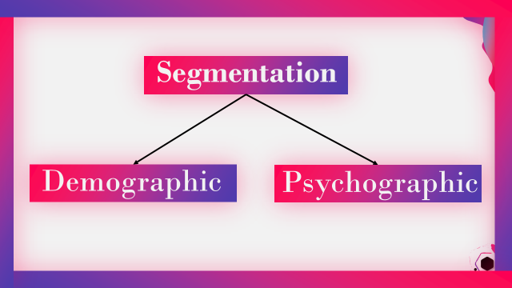
Figure 1: Segmentation Plan for SIEBS Grocery (Self-Made)

Targeting for SIBES Organic Fruits, Vegetables & Meat Groceries
Any business desiring to succeed in any industry by their product or service offerings must be able to carefully identify Since SIBES Grocery is determined at becoming a market leader within the retail industry and want to be a go-to brand by also introducing self-made products, SIBES grocery must identify the customer bases for its business who deem be profitable as well as supportive.
From the segmentation part, the marketing person has to become more precise now and decide on which of the segmented parts will be profitable for them, and then only those segments will be targeted as the final audience for the product offerings made by SIBES grocery.
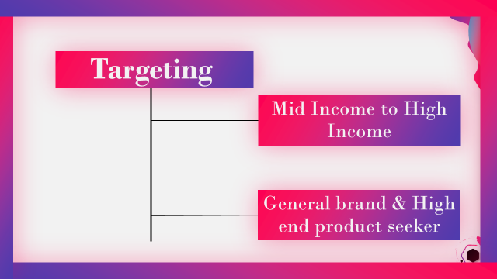
Figure 2: Target Audiences of SIBES Grocery (Self-Made)
As the visual suggests, the target customers by SIBES grocery will be people ranging within middle income to high-income variations. Moreover, SIBES grocery should shelve as well as tailor products to cater to the demand of general brands as well as high-end brands who prefer luxury lifestyles. By focusing on these two target audiences, SIBES grocery can ensure covering a big chunk of the total market share within the retail industry.
Positioning SIBES Organic Fruits, Vegetables & Meat Grocery
Positioning a brand or product offerings of a business is very challenging since the success of the brand or customer perception depends upon it (Muramalla, 2017). SIBES grocery should position itself as a retail brand that will cater to demand from all sorts of people wanting general brand experience to luxury brand experience. SIBES grocery can also incorporate that in their positioning strategy that they seek to enlarge their customer base by providing different sets of service having achieved customer satisfaction in the existing arenas.
Positioning this way will help SIBES grocery gain a strong foothold in the market as they can gain a huge amount of market share within the shortest possible time. Moreover, this image will help them roll out in house brands and be accepted by people in areas such as East London. Also, the inclusion of expansion foresight may help SIBES grocery gain more traction since people's perception of SIBES grocery will increase in terms of organisational value.
With the STP analysis, SIBES grocery now has a clear idea of whom they should target as its customer and how they should tailor their marketing strategies to gain traction as well as their trust. In case SIBES grocery wants to expand their business, which they have already a plan about, they should reiterate the same process for their expanded service category.
Setting out a Full-Fledged Marketing Plan for SIBES Grocery
Considering STP analysis done for SIBES Grocery, now it is time for the marketing personnel to move to make a full-fledged marketing plan for it. A full-fledged marketing plan must include an indication of how the product will be portrayed and positioned in the operating market, what places the product will be placed at, how the pricing will be determined so that the business can appeal to its target audiences, and finally how the product promotion will be done (Kotler et al., 2018).
Therefore, under the marketing plan for SIBES Grocery, the discussion of the above-mentioned factors will be done which is widely known as 4p.
Product: Referring to the case, SIBES Grocery desires to be a household brand in the future. To achieve that goal, SIBES grocery at first needs to attain the trust of their target audience as defined in the STP analysis part.
SIBES grocery must start their stores keeping the assortment of brands such as general brands as well as well established brands for now. The main reason behind maintaining such assortments of brands is to appeal to both general and premium customers. As defined in the STP analysis, SIBES grocery chose to target both mid-income as well as high-income people. For catering to both types of demands, SIBES grocery must maintain that assortment of brands mentioned above.
As SIBES Grocery wants to be a ‘go-to’ brand of households at least in East London, they must start working on introducing their brands such as healthy organic food products, natural beauty products, and many more. Once SIBES grocery can establish their product lines, they may need to let go of some of the brands from their shelves as well so that the consumers don’t get overwhelmed and confused regarding product selection (Hartog, 2020).
Price: Pricing of products or services is one of the crucial marketing strategies for any sort of organisation is it a smaller one or the largest. Pricing is regarded as the best possible strategy to appeal to the greater target audience since the purchase behaviour is mostly intrigued by this element in a marketing strategy (Sydney, 2020).
Since SIBES grocery is a very new business in the Kent locality, at first, they need to offer their products at a relatively lower price to attract the general customer within the locality. Once they are satisfied with the return and have ensured that they have gained a good amount of loyal customer bases, they can go on moving to a competitive pricing strategy. Moreover, they can charge a premium price for high-end products offered to premium customers. Since SIBES grocery desires to be the ‘go-to’ brand in the local community, they must start with low price offerings at first and can only move to a high scale price provided that people accepted their offerings positively and are satisfied with the quality.
To sum up, SIBES grocery must start with relatively low-price offerings and gradually they can go on charging competitive prices provided that they have gained a strong foothold in the market.
Place: In the beginning, SIBES grocery will start their initial operation at Kent and the desire to expand the business up to all East London communities. The places of operation of SIBES grocery must be at places closest to the communities so that customers can easily commute to the SIBES grocery stores. The core element that makes retail stores forerunner in the retail business is their placement in localities (Sydney, 2020). It determines the speed of success for businesses and the same will apply for SIBES grocery.
SIBES grocery must place its stores at the shortest distance from the communities wherever they open up any of their stores. Moreover, their stores must be interconnected with each other so that in case of delay in supply at one store can be helped by another through the personal transport system.
Once SIBES grocery has satisfied the demand of the whole UK, they should focus on getting bigger to compete in international markets. They can’t be daunted by the size and profit performances of other key players like Walmart, rather they should focus on basics to make a strong foothold in the international markets too.
Promotion: Promotion is the most crucial element of all in setting up a proper marketing plan. Without proper promotional strategies, it is quite difficult to keep satisfying the same customer base for a long time or to attract newer customers (Ellsworth, 2013).
Referring to the initial idea of the SIBES grocery start-up, they can plan to send in-mail coupons in the fall as well as summer seasons for intriguing bulk purchases from customers. Moreover, SIBES grocery can initiate rolling out engaging as well as catchy online content to intrigue people's high perception in terms of values towards SIBES grocery. Furthermore, they can roll out promotional packages such as discounts and redeemable coupon systems for regular customers. All these will drive purchases from new customers which will eventually increase the customer base of SIBES grocery.
SIBES grocery must keep it in mind while developing a full-fledged marketing plan incorporating 4p elements as suggested above that there must be enough scope for developing each of these elements. For example, when tailoring products for target audiences, SIBES grocery must communicate to its customer what future innovations or upgrades they can expect from such products or services and this is essential for rolling out in-house brands in the future. Likewise, they should nudge price ranges and future adjustment possibilities if not explicitly then in subtle ways at least. While deciding on a place-related strategy, there must be a clear indication of how many shops will be placed in a particular community, and if there will be any future increase in the number of stores.
Conclusion
With the recommendations provided in this report, the marketing personnel of SIBES grocery can effectively set out marketing plans which will bring bright prospects for the business. As the STP analysis suggested, SIBES Grocery must appeal to both general brand consumers and premium brand seekers to cover the requirements of all sorts of people within the community. Having successfully identified target audiences, SIBES Grocery must take care of its 4p elements to roll out an effective marketing plan as suggested in its discussion.

References
- Ellsworth, T., 2013. RETAIL MARKETING IN THE UK. Retail and Distribution Management, 5(3), pp.25-29.
- Hartog, N., 2020. Your Retail Business Plan's Marketing Strategy. [online] The Balance Small Business. Available at: <https://www.thebalancesmb.com/the-marketing-strategy-of-your-retail-business-plan-2890048> [Accessed 22 November 2020].
- Kotler, P., Armstrong, G., and Opresnik, M., 2018. Principles of Marketing. 15th ed.
- Lee, S., 2020. Retail Trends 2020 | Deloitte UK. [online] the Deloitte United Kingdom. Available at: <https://www2.deloitte.com/uk/en/pages/consumer-business/articles/retail-trends.html> [Accessed 22 November 2020].
- Muramalla, V., 2017. Retail Store Perceptions and Buying Behaviour of Consumers. SSRN Electronic Journal.
- Rosenbloom, B., 2016. Retail Marketing. 13th ed. New York, NY.
- Sydney, S., 2020. The 4 P's of Retail Marketing - Retail Minded. [online] Retail Minded. Available at: <https://retailminded.com/retai-marketing/> [Accessed 22 November 2020].
- Lecture notes: by Afzal Munna

Istvan Csizmar
(1921097)
Managing enterprise 21st century

Management Team

Management Summary:
a) board of staff
b) marketing manager
c) supervisor
d) sales staff

Board of staff
Manager: Mrs Saima
Supervisor: Mrs Samata
Till: Mr Istvan and Mrs Samata
Butcher: Mrs Elina and Mr Ben

Marketing manager:

Saima is the manager of the store. Her educational background includes a Master’s in Business Administration and she has various experiences as a Shop Manager. Her responsibility includes keeping in touch with the costumers, managing day-to-day operations of the market in absence of owners, ordering products, merchandising and entries of daily sales figures on a computer. All employees have to report directly to Saima or to Samata. They can cover each other.

Supervisor:

Samata can cover Saima when she is absent or has to leave the shop to arrange things related to the business. Her duty also includes helping the customers on the shop floor. She solves the arising problems related to the shop and the staff too. She must report everything to Saima and let her know if there is a problem. They manage the stock together based on their observations. And if needed, Samata can help Istvan in the till.
Sales staff:
-Till
Istvan is the cashier therefore his main duty is to be at the till and complete transactions. He responsible for opening and closing the till which includes counting the daily income (both cash and card) with the help of the supervisor. He also needs to make sure that the shop floor is clean and the shelves are tidy and organised. When he has time, he does the restocking of the shelves too and can report his observations regarded to the stock to Saima or Samata.
Mr Istvan and Mrs Samata’s are the ones working at the till so they have to be very accurate and they must be available for the customers in case of someone needs their help on the shop floor.
-Butchers:
Elina and Ben work at the butcher section. They responsibilities are preparing meats for sale, cutting, grinding, weighing, packaging, pricing, displaying products, cleaning tools and inventory.

One of the main element of a successful business is that colleagues trust each other and therefore they can discuss anything and everything with honesty. Our shop is small with just a few employee so we can get to know each other easier and build strong bonds which allows us to work well and efficiently together. In our team, everyone has a main duty but we must help each other and if possible, always discuss any kind of appearing problems so we can solve them faster. We must know that we can rely on each other and can share anything without fear. A strong team is key when it comes to a successful business.

It can happen that when the owner is away from his/her business (vacation, work related activities etc.), the business doesn’t run as well as when he/she is actually present and there because some employees don’t care about their job. They just perform their daily duties without passion and love for the things they do.
However, our business is different because we started together and build the business together therefore every one of us has the desire to make sure the business runs well. We are willing to put the effort and energy required for success.

Financial Plan

- Start-up funding
- Important assumptions
- Break-even analysis
- Target market segment strategy
- Sales forecast
- Projected profit and loss
- Industry analysis
- Competitive and buying pattern

Financial plan:

Organic food ratios can be seen in the table below. Standard Industrial Classification code 5411 (Supermarkets and Other Groceries) was used for Industry Profile comparisons.
We can predict that consulting and accounting costs will go down in the next three years. Normally, a start-up concern will operate with negative profits through the first two years. We will avoid that kind of operating loss by knowing our competitors, our target markets.

Start-up Funding:

This begins with our budgeting program that sets sales goals, establishes payroll budgets, and creates criteria for gross margin, shrink, expenses, and profit. Exception reporting directs operations in the right direction, saving time, and measuring results.
We will manage and grow our store with a full range of financial services that include five-year financial planning, business valuations, estate planning, buying/selling a store, and financing assistance. In the future our Organic Shop will save us valuable time and money plus the headaches and worry often associated with complex money matters.
We will making complete portfolio of financial, accounting, and payroll services, including comparative operating statements, bank reconciliations, sales tax returns, payroll tax returns, periodic and operational review, cash flows, break-even analyses, financial projections, wages, taxes, deductions, check printing, and deposit advice. These kinds of information and accurate record keeping help us to be able to run our business well.
During the summer months, sales may be slightly higher than during winter months.
Because the majority of community residents rely on monthly Social Security Income and/or government assistance, sales can be stronger during the initial 5 days of the month. The remaining days of the month may be slower, in terms of daily sales, however it is not noticeable in the big scheme. We can calculate with an average daily income, which can be around £400 - £600 (some days higher, some lower).
The balance sheet shows healthy growth of net worth, and strong financial position. The monthly estimates are included in the appendix. All of our tables will be updated monthly to reflect past performance and future assumptions. Future assumptions will not be based on past performance but rather on economic cycle activity and regional industry strength.
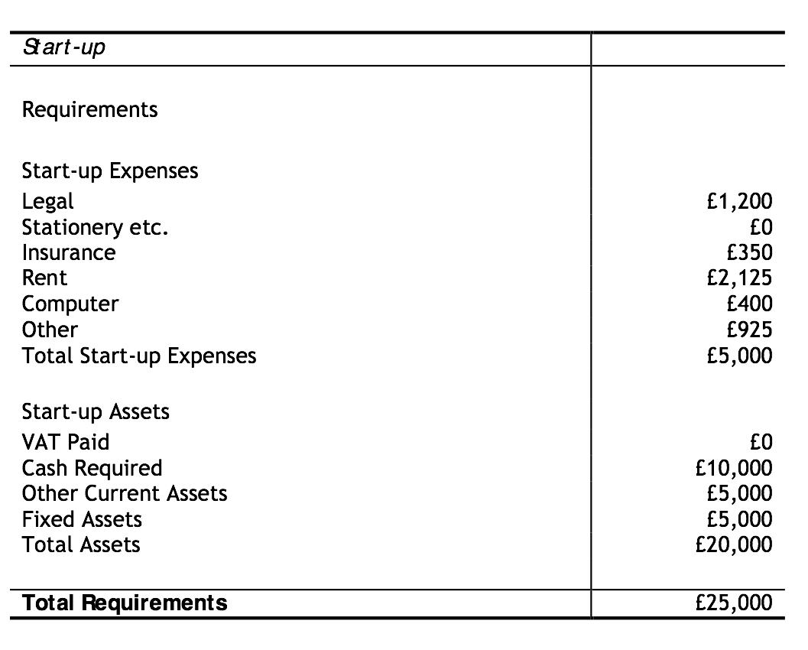

Important Assumptions:
The following table shows the General Assumptions for our shop. The average percent variable cost is 4%. The estimated monthly fixed cost is £30,000.
We do not sell anything on credit.

Break-even Analysis:
For our break-even analysis, we assume approximately £5000 per month is needed to break-even, which includes our full payroll, rent, and utilities, and an estimation of other running costs.
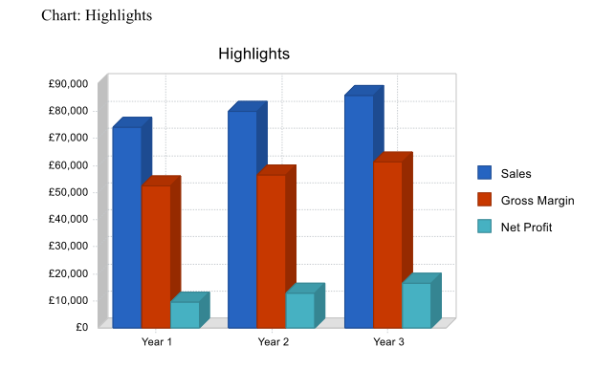
An organic food store has valuable strengths that will help us succeed.

Target Market Segment Strategy:
Our store will meet the or needs of the surrounding neighbourhood of female and/or male head of households earning £15,000 per year or more.
It is challenging to identify the right mix of products to attract the eclectic audience which is proof in and of itself that there is a definite need for a local orgnainic store offering fresh, organic products. The significant increase in annual sales is a clear indication that the market has no difficulty attracting customers. Once the local developments begin to accelerate, it will change the dynamics of the community and bring in new residents, therefore; the business will need to change and to accommodate the new residents for continued success.
All market segments are equally important to the success of the store and must be targeted as segments that demand a marketing strategy.

Sales Forecast:
Although the business will be relatively new, sales can increase by around 100K each year. By introducing prepared foods/meals/deli, the owners anticipate a grater increase in sales revenue.
The following table gives a run-down on forecasted sales and income. Our sales are based on the industry standard for our weekly sales estimate. We expect our sales grow at least 1 percent per new store brand item added to our product line for a total of 10 percent per year. We also expect to cut cost approximately 10 percent a year through bartering and other means of relationship building.
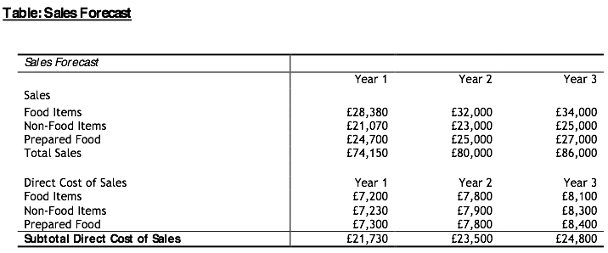

Projected Profit and Loss:
Sales have increased because we have attracted a greater customer base after purchasing the store. Once we have purchased all the new equipment, we'll be able to depreciate those assets.
We predict consulting and accounting costs will go down in the next three years. Normally, a start- up concern will operate with negative profits through the first two years. We will avoid that kind of operating loss by knowing our competitors and our target markets.

Industry Analysis:
We can become a progressive leader in the food distribution industry, based in Orpington, Kent. Under the direction of Mrs Saima, Organic Food Stores Inc. will continue to foster innovation, support and promote growth of the company to ensure its success.
We are very committed to our retail strategy and believe the approach will begin to show meaningful results. As we continue integrating our retail acquisitions and bring their performance to optimal levels through enriched promotional programs and expanding product lines, we expect financial profitability to accelerate.
Our organic food shop seeks to be a one stop shop for the local community, whether it be copying, faxing, shipping, or just daily shopping, we want local residents to know that we will be able provide for their diverse needs in a store with them in mind.

Competition and Buying Patterns:
The store will be in walking distance of area shoppers, whereas the next nearest organic store is two to three miles from our store location.
The customer base of Organic food shop can be very diverse in that there is a group of general customers that just purchase store brand and national brand products. Another group is a high end customer who request select gourmet products, such as capers, anchovies, special sugars, and the like and the cost for these items is approximately £150.00/month. And finally, we can have healthy choice customers who request a selection of natural/organic and possibly fresh products. The cost for these items is approximately £2000.00/month. In order to maintain our customers loyalty and continue to increase sales revenue, we make these products available. The community will become accustomed to these products and expects them to continue.

Conclusion:

These plans give us a great foundation to start our business, however we also know that things can change and therefore we are always ready to hear new ideas, adapt and make changes in our plans accordingly. We must keep our eyes open and it might be useful to know about the arising new trends. Be aware of what most people like and don’t like, what people desire to buy in the present. That’s why is also important to have a good connection with our customers, talk to them, ask open ending questions from them so we can collect important information from them. We can only satisfy our customers if we know their needs. Of course, we cannot satisfy everyone, we know that, so that’s not the goal, but to satisfy as many customer as possible.
We know our limitations however we rather focus on our strengths and use them for our benefits. We would like to run a successful business which is, of course good for us, but also we would like to make a difference in other people’s life by selling high quality products and offering high quality, friendly service every day.
Our team is willing to work hard and do everything we can to bring our business to fruition. We plan for long term therefore we do not worry if success is not immediate. A slow but steady increase of sales is what we aim for.

Reference
- Bureau of Labor Statistics: Career Guide to Industries, 2010-11 Edition: Grocery Stores
- MSDN: Challenges in Today's U.S. Supermarket Industry
- Valentin, E.K.. Business Planning and Market Strategy, SAGE Publications, 2014. ProQuest Ebook Central, http://ebookcentral.proquest.com/lib/trinity/detail.action?docID=4733107.
Created from trinity on 2020-11-27 10:34:34.
- https://contentstore-cla-co-uk.ezproxy.uwtsd.ac.uk/EReader

Appendix- Group presentation




