Business Plan.

Prepared by:
Alvina, Tina, Faizol, Naim.

Table of Contents

Executive Summary
- Overview of Business Plan
- Key Points
Introduction
- Business background
- Business Details
- Legal Status
- Owner/management team details
- Product/service details
- Plan for future
Market and Competitors
- Market Overview
- PEST analysis
- Customers/target markets
- Competitor analysis
Sales and Marketing Strategy
- Marketing objectives
- Marketing strategies
- Target market
- Pricing strategy
- Sales forecast
- Budget and timeline
Operations
- Location/premises/equipment
- Production and distribution process
- People/staff/suppliers
- Systems and procedures
- Health & Safety/quality control/ legal compliance
Financial Information
- Cashflow forecast
- Sales forecast
- Set up and operational costs
- Sources of finance/ funding requirements
- Profit and Loss statement
- Balance sheet
Appendices

1. Summary

- Our business is a small business based in Cardiff, currently looked after by 4 staff members.
- We offer unique and personalised desserts, made fresh to order. We specialize in chocolate covered strawberries.
- Our target market is all ranges of people within the Cardiff area as we offer local delivery and a collection service.
- Why us? Because we don’t do just use any product, we source via a Fairtrade Farm.
Our mission is to provide an exceptional service to our new and existing customers, and our long- term goal is to be able to expand out of Cardiff
Cardiff Delights is a micro business based in Cardiff founded by one chief executive producer who seen the market and decided to share the journey with three more CEO’s giving Cardiff Delights a strong, variable management. We offer unique and personalised deserts, made to order and tailored to each of our customers, whilst we specialise in chocolate covered strawberries. We offer a variety of sauces and toppings for customers to personalise their deserts. We target the market in the Cardiff area for anyone who loves chocolate, strawberries or even better, both. Cardiff Delights only uses products fresh to order and we provide a local delivery and collection service with the flexibility of four collection locations. Each chief executive producer lives around Cardiff in a variety of areas giving customers more choice and flexibility. We are looking for a £8000 investment for 10% of the business to help marketing and inventory costs. We are looking to invest 70% of the investment into the marketing to help advertise diversely to different consumers and 30% towards the inventory to help support the demand for bookings. We are also looking for the 10% stake to be dropped down to 4% after your £8000 investment has been returned. This will help the demand with future orders and the expansion of love for our luxury chocolate covered strawberries, but this will give us the ability to vastly advertise across Cardiff to make our company and our brand known using digital marketing and develop a taste like no other. There is an opening for an opportunity to provide deserts consisting of fresh fruit, chocolate and toppings whilst being able to deliver, pre order, tailor and collect from four different premises and produce luxury, photo worthy deserts for all customers to remember. Our goal at Cardiff Delights is to give our customers tasty desert boxes all around Cardiff and not just the city centre, we can locally travel out of Cardiff as we directly speak to all of our customers when making a special request order. We only use products we source via a Fairtrade Farm and we want to be able to meet the demand and achieve reaching a target market of people of all ages, anyone who loves chocolate or strawberries is all we need to know. All CEO’s want to be able to target this market and gather the inventory at a stage where we are starting up and still being comfortable, so we can successfully turnover a good proportion of a net profit and gross profit. Our mission is to provide an exceptional service to our new and existing customers, and our long-term goal is to be able to expand out of Cardiff and we need your investment to help us achieve this.

2. Introduction

- Cardiff Delights established when I started to receive an interest and demand for my products, at the time which weren’t for sale. This all stemmed from a simple marketing strategy, when a picture of the desserts was posted onto social media and gauged a high volume of interest. This then resulted in putting together a social media page dedicated to the business where customers could see the product and enquire and place orders. Everything was done via the social media platform (Instagram), which then expanded onto Facebook as well due to the high demand.
- Our business has grown vastly so we have decided to register our company as a Limited Liability Company on to Companies House meaning our business is now established and our details can be found by anyone.
- As mentioned, we have 4 employees, they’re roles are: Alvina, who is the distributor who looks after orders and also controls our social media business account. Tina who is our stock control manager, Faizol who is our Operational Manager, his role is to make sure that everything is run smoothly, which plays a vital role in Quality Control. Naeem is our Finance Manager who looks after all the budget and cost controls. The way we work as a team reflects Belbins model, and how we delegate our work streams with one another.
3. Market and competitors
We have priced our products, services and time by measuring how much time it takes to prepare and finish the product. We have estimated our products to be luxurious and exceptional and every customer is different. Our (USP) unique selling point is quantity over quality. We believe this is a personal experience for the buyer, and we have valued that in our agreement when pricing.
Cardiff Delights: Market Research.

Age: | Gender: | Income: | Types: | Target regions:
- 13 - 17yrs  - 18 - 30yrs | - Males  - Females  - All genders | - £0 - £25,000 | - Individuals  - Families | - Local

• Market overview: The size of the market is aimed mainly at the younger and middle-aged generation. Cardiff delights was first established on Instagram a social media sharing app. This was first uploaded as a hobby. By using Instagram as an advertising base, we were able to examine when and what areas showed the most interest in our product. Through market research we have found out there are estimated to be more than 500 million Instagram users, ages ranging from 12-29-year olds making the majority. we are mainly targeting the younger generation who are actively using social media as our target market. We gained a lot of interest from users in Cardiff and as the orders increased, we registered with companies’ house as we got more popular. We have estimated there are around 1,200 customers in our first financial year from the orders placed online. We have decided to use a cost leader strategy, this involves us putting ourselves in the mind of the customer as we want to give a great luxurious product to the consumer keeping the product high quality but for a lower cost, we want to give the customer exactly what they want.
We have also conducted a PEST analysis as a group to determine the potential opportunities and threats towards our business. We have identified there are no threats of political or economic factors. There could be potentially some technological factors as we are mainly running our bookings and orders online, so we have to make sure all UK guidelines and regulations, are met to provide our service professionally. The internet population is growing very fast every day and we have decided to do most of our advertising online, we have paid for adverts on Facebook, we have used our own marketing strategy on Instagram and offered freebies and raffles to attract more customers to our page.
Our business objectives are to increase our sales by 20% next year by exhausting more advertising options in its place of just on social media, we have invested into leaflets through possible customers doors and brochures we developed and printed and left with major supermarkets and retailers so they can promote it for us at no cost for us. By constantly reviewing the objectives (SMART) we can understand if we are improving and building profit.
Our products are freshly sourced strawberries from a Fairtrade farmer. We always use giant strawberries giving enhanced taste of flavour whilst offering a variety of toppings and flavour. We tailor to our customers, if a customer has a special request we always go above and beyond to help make this possible to fulfil the customer’s needs. We not only offer luxury boxes, but we also have multiple cyclists, pick up locations and flexibility of time that not many entrepreneurs tend to have.

4. Sales and Marketing Strategies

- Our sales strategy has worked by promotional offers when the business first launched, as this drew in a lot of our clientele. This then expanded by our existing customers bringing in new customers. This has helped better and establish our brand and getting our name out there.
- We also do set ups at events, we cater to small and large events which has helped build our brand, we also have business cards printed with our details which we distribute at the events to get more recognition and bring more revenue into our business.
- We price our products so that they are high quality and are affordable, a lot of research was conducted beforehand by looking at our competitors’ prices. We changed our prices to match our competition but still also providing high quality products, as our mission statement is quality not quantity.
- We measure our business growth by following a sales forecast, we do this annually covering expenses, profits and growth.
- We have identified our business needs and have calculated our expenses to comply with our budget. We understand that we have higher outgoings seasonally depending on the volume of orders that we get. We have concluded our busiest time of year is Summer, as it is the holidays and there is also a large influx of weddings going on at the same time, so we have extra budgeting in place to support this.

5. operations
• Location/premises/equipment
Homeowner in the heart of Cardiff with a professionally equipped medium kitchen that is built into a garage on premises that can facilitate up to 6 employees at one time. The kitchen is equipped with two double door fridges, oven, microwave and all essentials that is required for the process of our desserts.

• Production and distribution processes
Our products are made in our kitchen by buying all the ingredients from suppliers that is either delivered or either picked up, depending on the demand of our business. Our distribution is local service around the Cardiff area using bicycles, however we do have orders from arears outside of our radius, we are happy to supply them with a minimum order and a delivery charge.

• Order fulfilment:
We have a Facebook and Instagram page setup for our business with pricing and ordering, Customers message through our social media app or email us regarding what they want and when. Alvina who is the distributer and social media controller, who will manage all orders and payments.
• Payments:
Payments are made online or cash on delivery or collection. If payments are made by cash on delivery, there will be a £5 deposit charged on card in case of timewasters.
• Technology:
Our orders are taken by smart phones, every record that we have is on a cloud based system, to minimize risks of losing any records, we always keep them backed up on the cloud and do not require any paper based transactions, as we have gone all digitalized
• People/staff/suppliers
We are four people in partnership and are all contributing towards how we are operating our services, each team member has been allocated each task to take on which is making the small business work, as we are getting busier, we will hire more staff and expand our business to a bigger and better location in the future, however as for now our team consists of four members and our roles are:
Faizol- Operational manager, he checks quality control over all food preparations that’s handled in the kitchen, also checks all equipment like fridges are set on right temperatures, checking if strawberries are of best quality and when it should be consumed by, if any of the strawberries are coming near to sell by date, it is given out free and distributed to neighbours and potential future customers as a marketing strategy. He is also packaging all goods, making sure everything is up to standards.
Tina- Stock control manager and makes orders to our suppliers, her main role is preparing and making our desserts in the kitchen, she also does the marketing side offline and goes to events and food festivals to showcase our desserts by handing out business cards and flyers. Occasionally she delivers our products when it gets busy.
Alvina- She is the first point of contact to customers, she makes sure all orders go through and promotes all online marketing sides of things, she is our main distributor and handles all customer queries and any complaints. She is always finding new ways to improve our business by always checking our competitors’ prices and quality and always finding ways of promoting and getting new customers with offers that hit the sweet spot.
Naim- Finance manager, he deals with all the financial side of the business, controls all our budgets and any areas we might be at risk including any legal laws, he is our in-house accountant and does the vat for the business. He also handles food in the kitchen and does deliveries and picks up stock when there’s more demand in our products.
Our suppliers are a fair-trade strawberries company based in Wales, we buy directly from them as they are a wholesaler, they sell in open markets in stalls however we have been able to get these delivered to us because of the quantity we order. All our products are bought from wholesalers, including our Belgium chocolates and toppings are bought from seprha chocolate wholesale company ltd.
All our food package boxes are bought directly from aliexpress.com, another wholesaler however its based in china. This saves us cost and gives us more option in choices of unique styled boxes.
• Systems and procedures
We have systems in place for food hygiene regulations, all of our team members have food hygiene certificates and have taken courses of fire safety ,manual handling, health and safety and food safety, we take pride in our desserts, our aim is to provide a service from a team that understands the true value of food preparation and we comply with all regulations that is required for a 5* service, so customers can be reassured that they are getting food that is handled within a kitchen that is well maintained with hygiene regulations and that we are a business that takes food quality serious. We keep an electric diary for day to day safety until the next visit of local authority food safety officer.
• Health and safety /quality control/legal compliance
We at Cardiff delights are compliant with HSE health and safety executive, we have gone under great dedication to build an environment with safety measurements and have taken great care in quality assurance as by meeting legal requirements for our home business, we have had environmental health officers to inspect our premises and have been honored to be given a five star rating for standards. We have also taken cover for employer’s liability insurance and professional indemnity insurance, these both cover our employers and any clients who try to make a claim against us.

6. Financial information
Starting up expenses
Service charge | £200
Deposits | £1000
Accountant | £500
Rent and rates | £2400
Interior Modifications | £500
Equipment/Machinery Required:
mixers | £50
Oven usage | £50
Total Equipment/Machinery
Insurance | £1500
Stationery/Business Cards | £100
Brochures | £80
Pre-Opening Advertising | £100
Opening Inventory (stock) | £300
Other (list):
Total Startup Expenses | £6780

Cashflow
months | 1 | 2 | 3 | 4 | 5 | 6 | 7 | 8 | 9 | 10 | 11 | 12
Starting cash | £2000 | £1315 | £1330 | £1645 | £1960 | £2425 | £2840 | £3055 | £3470 | £4085 | £4500 | £5015
Cash in:
Cash Sales | £700 | £1000 | £1100 | £1000 | £1150 | £900 | £1100 | £1300 | £1100 | £1200 | £1000 | £1000
Receivables
Total Cash Intake | £700 | £1000 | £1100 | £1000 | £1150 | £900 | £1100 | £1300 | £1100 | £1200 | £1000 | £1000
Cash Out (expenses): | 0
Rent | £200 | £200 | £200 | £200 | £200 | £200 | £200 | £200 | £200 | £200 | £200 | £200
Utilities | £20 | £20 | £20 | £20 | £20 | £20 | £20 | £20 | £20 | £20 | £20 | £20
Payroll (incl. taxes) | 0 | 0
Benefits
Loan Payments | 0 | 0
travel
Insurance | £125 | £125 | £125 | £125 | £125 | £125 | £125 | £125 | £125 | £125 | £125 | £125
Advertising | £180 | £180 | £180 | £180 | £180 | £180 | £180 | £180 | £180 | £180 | £180 | £180
Professional fees | 0
Stock | £150 | £150 | £150 | £150 | £150 | £150 | £150 | £150 | £150 | £150 | £150 | £150
Miscellaneous | £10 | £10 | £10 | £10 | £10 | £10 | £10 | £10 | £10 | £10 | £10 | £10
Total Cash Outgo | £685 | £685 | £685 | £685 | £685 | £685 | £685 | £685 | £685 | £685 | £685 | £685
EndiNG Balance | £1315 | £1330 | £1645 | £2060 | £2375 | £2840 | £3055 | £3470 | £4085 | £4500 | £5015 | £5330

Profit and loss projection
For this year
Sales- £12550
Cost-£7340
Net profit £5210

Stock £1800
Utility cost £ 240
Rent and rates £2400
Business insurance £1500
And liability
Service charge £200
Decoration £200
Deposit £1000
Total expense =£7340

7. Appendices
Team cv’s

Tina Malik

About Me
I am friendly and outgoing character who enjoys making others happy.
Family means a lot to me and find it easy to make friends and adapt my skills to many different situations quickly.

I have previously worked for a number of customer service roles within call centres and face to face sales, where I have learnt a number of skills and attribute that will help me in any future role. I am now eager to gain more understanding and knowledge.

I am currently looking for full or part time role so I can financially support myself and my family.

Work Experience
Home Fundraising (Temp).May – September 2017
My role was a door to door ambassador for a number of well known charities to raise awareness and sign up new long term donors for causes such as Cancer Research, UNICEF & Marie Curie.
During my time there I exceeded my daily targets which increased donations for the well deserving charities. I became skilled at effectively dealing with objections, and overturn them into sales; I also dealt with difficult customers and defused hostile situations comfortably.

Customer Service SERCO Call Centre (Christmas Temp). September – December 2017
I was responsible for dealing with phone based customer services for a number of online retailers such as Littlewood’s & Very catalogues.
During my time there I was required to deal with difficult customers, track deliveries, make orders and process payments. I fitted comfortably into the team and learnt quickly on the job to make me one of the most efficient customer advisors on the team.

Conduit British gas- January – February 2018
My role to take incoming calls from customers and book engineer call outs. Also chase down engineers and see when they will be arriving. Handle complaints and enquiries efficiently and make sure every customer left happy. Due to family emergency could not stay on further.

Work Related Skills
Friendly, comfortable dealing with difficult situations,, able to overturn arguments into sales,, ensures the customer is always happy. I do not let negative experiences affect myself or my work. Work well as part of a team or individually to meet and exceed targets when possible. I am organised and reliable, able to learn product knowledge in depth and quickly & i do not shy away from extra work.

Reference
References can be given on request.
Thank You.

Alvina Liaqat
2 Wynnstay Close, Cardiff, CF11 8NB
Phone: 07463263194 |Email: alvina_441@hotmail.com
LinkedIn – Alvina Liaqat

Profile

I am a determined and ambitious individual willing to complete tasks efficiently. I am hard working, and I enjoy working in team environments. I pride myself in being organised; I believe I can adapt to my surroundings to get tasks done. My confident and sociable disposition has enabled me to create vibrant atmospheres in the past as well as making me a valuable asset to my teams.
Education

2018 – (Sept 2019) – University of Wales Trinity St David (weekend course)
Level 4 CertHE & ILM (Institute of Leadership & Management) Skills for the Workplace (Business Management)
Expected: 1st
- Academic and Employability Skills
- Professional Career Development
- Digital Skills and Research Methods
- Effective Team Working and Communication
- Problem Solving and Decision Making
- Managing Enterprise in the 21st Century
2017 to 2018 - Cardiff and Vale College - (Apprenticeship with CAVCA & Deloitte)
Level 3 Business Administration (City & Guilds)
- Essential Skills – Communication
- Essential Skills – Application of Number
- Essential Skills IT/Digital Literacy
- Employee Rights & Responsibilities.

2008 to 2013 - Fitzalan High School
9 A-C GCSEs: Including - English, Mathematics, Science and Welsh.

Employment history

2017 to Present - Deloitte LLP - Risk and Compliance Analyst – Quality, Risk & Security (QR Ops)
Individual Impact Award Winner 2018 for Deloitte Quality and Risk Operations
- Compiling compliance reports for Senior Risk Partners and other key stakeholders
- Working with the firm’s bespoke systems, assisting in identifying incidences of non-compliance and advising individuals in relation to their compliance responsibilities
- Managing calls and other communications to Quality & Risk Operations either for resolution or referral to colleagues
- In depth research on investments and pensions and other financial products;
- Conducting and analysing checks prior to client engagements to help prevent and conflict;
- Use of Excel and other Microsoft programmes on a day to day basis;
- Use of Outlook, sending and receiving emails at a professional level;
- Monitoring and managing the main mailbox and responsible for allocating and delegating work flow to colleagues;
- Quality checking team members work and providing feedback;
- Produce team MI data;
- Pulling daily reports and then presenting back with the relevant data;
- Data entry, recording and tracking of Clients’ personal investments on a “Personal Connections” system;
- Administrative support in relation to collating stats to match the MI database (pulling data and getting together stats)
- Providing consultation support and review of senior management individual records;
- Providing ad-hoc support to the wider Risk Management organisation as may be required from time to time Keep up to date with team Audits, conducting Audit Trails as of when;
- Involved in volunteering for 14-16 year old students as part of the Deloitte commitment to ‘One Million Futures’ – and going into partner schools working with pupils
- Becoming an Ambassador for Deloitte by organising and attending career fairs and schools to speak about opportunities available at the firm on an apprenticeship scheme.

2017 to 2017 – Hugh James (Industrial Disease Department/ Trust & Estates Administration (Administrator)
- Gained work experience in a law firm gaining knowledge of various legal services.
- Dealt with phone calls and liaised with clients waiting for legal advice.
- Ensuring in-house systems was frequently updated.
- First drafting emails to the clients on behalf of the solicitors.
- Preparing Court bundles and instruction to Counsel.
- Inbound/ Outbound calling to clients in regards to their Will.

2015 to 2016 - Sky (Customer Sales Advisor)

- Captured critical customer data to gain valuable business intelligence;
- Working with retentions and billing to collect arrear payments and explain pro rata billing;
- Working with customers to help manage their payments and packages to suit their affordability
- Articulated Sky products and services to customers as well as business changes to colleagues;
- Assisted clients in obtaining best protection plan after gathering necessary information;
- Upsold other offerings from understanding customers’ current position;
- Built rapport with these existing customers to enhance customer relationships.
- Provided memorable customer service;
- Developed an awareness of customer relationship management.

Skills
- Proficient user in Microsoft operating systems, particularly Microsoft Office & Excel; (Pivot Tables)
- Highly numerate and literate
- Volunteered at University of Wales Hospital (2015-2016)
- Bilingual speaker in English and Punjabi – Fluent
- Hold a full UK driving license.

Reference
Available upon request.

Faizol Ali
50 Machen place
Riverside
CF11 6EQ
Tel: 07808216161
Email: Faizolali@hotmail.com

Professional profile
I am a customer focused professional who possesses a strong sense of urgency with regard to client satisfaction. I have excellent interpersonal and communication skills, coupled with good relationship building capabilities and excellent negotiating abilities. I am someone who has a track record of creating a work culture that rewards teamwork and cooperation. As an experienced manager I fully understand the importance of appearance and behaviour in creating a positive impression in any face to face role, this is why I work hard at appearing professional, well-mannered and polite. My areas of expertise are precisely those that your company is looking for in an applicant. My core skills, combined with my passion, experience and ability to develop further I believe are well suited to your requirements. Furthermore, I am a true professional who will go that extra mile to exceed customer and company expectations with a track record to prove my ability.

Career summary

St David’s hotel – Conference and banqueting supervisor and concierge night manager
Key responsibilities:
- Dealing with business clients and high-profile guests – managing customer expectations
- Leading a team and delegating tasks to team members
- Time management - Working towards deadlines with quick turnaround times
- Preparing daily, weekly and monthly reports for senior managers
- Training staff members via training programmes including health and safety
- Customer service – including dealing with complaints and managing guest satisfaction

BT (British Telecom) – customer services advisor
Key responsibilities:
- Advising and dealing with customer complaints
- Telephone operations
- Point of call for all customer service issues
- Acting on customer feedback
- Motivating customers to use the company’s services more including promoting products and services

Primark – retail supervisor
Key responsibilities:
- Managing a team
- Assuring customer satisfaction
- Stock check
- Training new staff members
- Ensuring my department is organised and adhering to retail protocols
- Checking and organising inventories

Taste of Bengal – restaurant manager
Key responsibilities:
- Day to day running and management of a busy establishment
- Managing a core team
- Dealing with issues and customer satisfaction
- Handling finances and account management
- Management of third-party vendor work – contractors and suppliers

Barry cars – operator
Key responsibilities:
- Developing customer service personnel to their fullest potential
- Responding to issues such as service enquiries and problem resolution
- Building customer relationships and loyalty

Technical skills and vocational qualifications
University of Wales Trinity Saint David (2018-present) – BA leadership and management skills for the workplace
Fitzalan High school (1999-2004) – GCSE Business (B) Maths (C) English (B) Art (A) Science (C) Engineering (C) History (C)
Good working knowledge of word processing packages including Microsoft word and Excel spreadsheets.

References available upon request

NAIM CHOWDHURY
2 Leckwith Avenue, Cardiff, CF11 8HX
Tel: 02922211187 Mob: 07464444980
Email: nai.chowdhury@outlook.com

A hardworking, enthusiastic and capable individual keen to progress into a career in engineering. Being theoretical and practical I enjoy discovering logical explanations, using both lateral and creative problem-solving techniques to achieve success. Always keen to learn and acquire new skills I would welcome the opportunity to build on my knowledge further and extend my level of experience. With a cheerful, friendly outlook I work well as part of a team but also have the capacity to work independently using my own initiative, taking the greatest pride in everything I do.

KEY SKILLS

Confident delivery of a high level of customer service
Excellent communication and active listening abilities, including Bengali as second language
Strong IT skills, confident use of Microsoft Office, Word, Excel and PowerPoint
Solution focused, logical and analytical
Flexible, adaptable and well organised with good attention to detail
Experienced and competent in Health & Safety procedures
Car Owner with Full Clean Driving Licence

WORK EXPERIENCE

Cardiff & Vale College | 2017 – | Full-time Student | - Studying Aircraft Engineering at the college’s International Centre for Aerospace Training at Rhoose  - Carried out multiple practical’s on the bulldog and Jetstream aircraft
Tesco, Cardiff | 2018 – Present | General Assistant | - Assisting customers access products and services  - Ensuring shelves are fully stacked and the store well presented  - Adhering to all Health & Safety policies and legislation
TeamSport, Cardiff | 2018 | Marshal | - Looking after customers and ensuring track safety  - Track control and monitoring
Subway, Cardiff | 2017 – 2018 | Subway | - Preparing food to customer specification  - Managing cash flow and inventory during shift  - Awareness of safe food handling and hygiene standards
South Wales Police, Cardiff | 2015 – 2018 | Police Youth Volunteer | - Communicating with members of public and senior staff  - Attending events and workshops to promote service
Fitzalan High School, Cardiff | 2015 – 2016 | Student Support Volunteer | - Supporting students and their families to access school services  - Communicating in English and Bengali  - Providing information about courses and the school

QUALIFICATIONS

BTEC Extended Diploma in Engineering (QCF level 3) | Cardiff & Vale College  2018 | Pass
BTEC 90 Credit Diploma in Engineering  (QCF Level 3) | Cardiff & Vale College  2017 | Pass
AS Level Media Studies | Fitzalan High School, Cardiff  2016 | Pass  D
GCSEs  English Language  English Literature  Mathematics  Science  Additional Science  Further Additional Science  D&T Textiles Technology  Religious Studies  Geography  Welsh | Fitzalan High School, Cardiff  2014 - 2015 | Pass  A  B  C  B  B  C  C  A  C  C
BTEC Certificate in Applied Science  (QCF Level 2) | Fitzalan High School, Cardiff  2014 | Pass

HOBBIES AND PERSONAL INFORMATION

Cars are a real passion for me, and I enjoy working on my own car, maintaining it to the highest possible standard, as well as regularly meeting and socialising with fellow car enthusiasts. Keeping fit and healthy is also very important for me, and I regularly attend the gym to keep in shape.

REFERENCES

Excellent references available on request

Market research
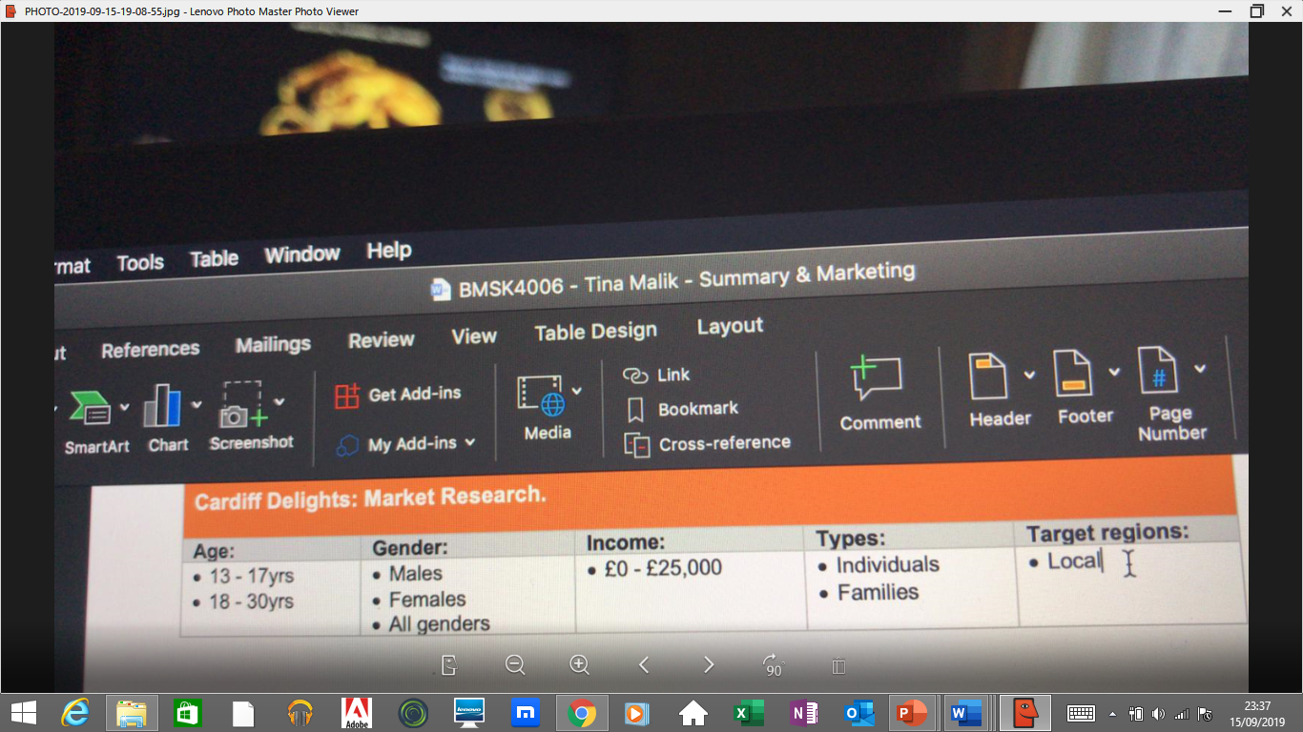

Pricelist
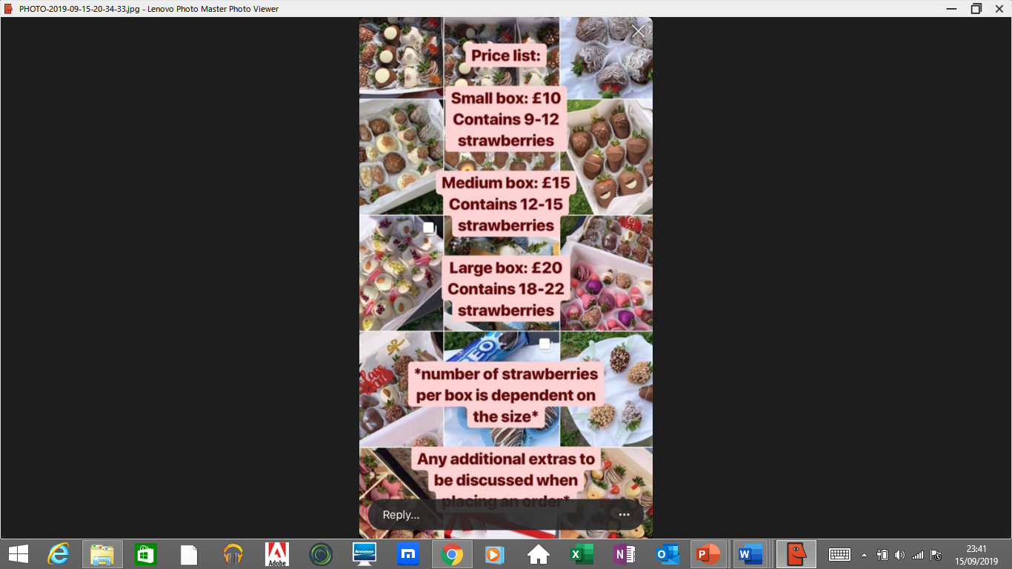
Replies and customer reviews


