

Silvia Flores De Hyland (2017650)

Changemakers: Building a Personal Brand for Sustainable Employment module.

Module Code: BMHP5015.

Effect of menopause symptoms on women.

.

Silvia C. Flores de Hyland
7 Harris Drive Smethwick B66 4RJ. Birmingham
07861487286
Sfloresdehyland@yahoo.com

November 4,2022.
Mrs. Sue Fairy
Manager Acre Wood Housing.
103 Cocksheds. Ln,Halesowen
B62 8LL
Birmingham.
Dear Mrs. Fairy:
I was recently informed that there is a new position available at your company for a Senior Support Worker/Team Leader. I am an experienced and committed care and support worker with over 7 years of experience supporting people with diverse healthcare needs. An expert in mental health, physical care, and youth and older adults with an emphasis on promoting patient independence and well-being. I am trustworthy, reliable and possess excellent communication skills. I have the ability to work well on my own initiative and also working in a team. I can demonstrate the ability to conduct patient assessments, lead patient-centred sessions, and provide compassionate care. I also have the necessary qualifications for this position, which is level 4 Health and Social Care, to carry out my task as a senior support worker. In addition to my vast experience and varied skills. I feel like I could offer guidance and support to people living in the home. I have excellent management skills and manage my time effectively and provide the highest standards of support while promoting company values. In addition to the above experience, I have a strong educational background, and passion for caring for people. I am pleasantly surprised by the approach and reputation that your company has, whose approach I share, so I would be delighted to contribute to your business success. My resume is attached and thank you for considering my application, for further details or references please feel free to contact me.

Your sincerely.
Silvia Hyland

CV

Name: Silvia Carolina Flores de Hyland
Address: 7 Harris Drive, Smethwick, Birmingham, B66 4RJ
Telephone: O1215725630
Telephone: (mobile):07861487285
E-mail: sfloresdehyland@yahoo.com
A confident reliable and dedicated person who is currently seeking employment with forward thinking employer that can fully utilise my existing skills and abilities. I possess excellent communication skills with the proven ability to work well using my own initiative and also as a part of a team. Willing to take part in any additional training in order to enhance my current skills set and abilities.

KEY SKILLS
*Good Communication Skills *Enthusiastic
*Hard working *Excellent Attention to Detail
*Food Hygiene Aware *Friendly
*Observant *Positive Attitude
*Able to Multitask *Health and Safety Aware
*Quick Learner *Organised
*Takes pride in Work *Spanish

Education and Qualifications:
Date: 1992 – 1997 University Don Bosco, El Salvador
Journalism
Date 1989 – 1991 Instituto Migueleño de Comercio
International Baccalaureate.
1986-1989 Ofelia Herrera Secondary School, El Salvador.
1979 – 1985 Ofelia Herrera Primary School

Additional Studies:
2010–South &City College, Handsworth, Birmingham
ISOL English language – Entry 1
2011 – South &City College, Handsworth, Birmingham
ISOL Entry 2
2015- South &City College, Handsworth, Birmingham
ESOL Entry 3.
2015 - Adult Care course, Level 1, Sandwell College
2016- Hairdresser level 1, South &City College Birmingham.
2016-Hairdresser level 2, South &City college.
Work Experience: Venue, dates, position held
Willow House (June 2022 currently)
Wellington Court (May2021-January 2022)
Bearwood Nursing Home, (Sept 17, 2019 – April 2021), Activities Coordinator
Hawthorns Residential Home (May 2018 -July -2019), Care Assistant
Hilltop Lodge, West Bromwich (June 2017 - May 2018), Care Assistant
Carer for family member (February 2016 – June 2017)
PHC Temps, Birmingham (April 2015-Februry 2016), Care Assistant
Skills
Languages: Spanish, English
IT skills: Computer literate
References: can be supplied upon request.



PITCH

Overview.
Menopausal symptoms are a major problem for older women, but there are still no uniform criteria to consider, which are inherent to it or result from aging, health deterioration, psychosocial factors or of lifestyle.
Symptoms are classified as physical, such as hot flashes, psychological, as mood swings, or mixed; cardiovascular disorders; have also been They are classified into typical and atypical:
the first group includes vasomotor symptoms (hot flashes, night sweats, and sleep disturbances) and the second to symptoms associated with both menopause and changes in age such as headaches, back and joint pain, dry skin, and decreased concentration. (Geraghty, 2022)

The symptoms that are reported in various groups of women are due to the ethnic difference and socio-cultural environment. There are several stages in the menstruation process, firstly 1) pre-menopause where there are minimal changes in menstruation.
2) Perimenopause includes one to two years prior to the last bleeding, in which there is more menstrual irregularity, and includes one year after the last bleeding.
3) Post menopause begins a year later from the last menstrual bleeding to the end-of-life women, in this period there are hormonal changes that occur before the last menstruation and that ends with the last bleeding, this is called menopause transition.
Some of the physical symptoms that occur in the transition to menopause are hot flashes, depression and emotional symptoms, genitourinary symptoms, urinary symptoms, vaginal atrophy, and other symptoms such as decreased sexual desire, decreased libido, digestive problems, breast pain, fatigue, dizziness, irritability etc.
Hot flashed: are a feeling of heat, sweating, chills, and flushing. Therefore, they are more frequent in the late phases of perimenopause and in the first years of post-menopause.
Night swears: Night sweats, medically known as night sweats, are like the hot flashes that occur in women during the day, with the difference that they occur at night and are accompanied by perspiration, which can be light or profuse.
Palpitations are a common symptom that many women experience during their transition to menopause. This phenomenon is often caused by changes in Strogen levels, which occur naturally as a woman nears the end of her fertile life.
To learn more about this problem I have chosen BBC radio 2 where they talk about menopause and at the same time, they give recommendations on how to overcome this difficult period for women as well as the presence of professional people on the subject. I chose this medium because it is accessible to everyone, it has a large audience of woman, and the information is true. (Panay, 2015).
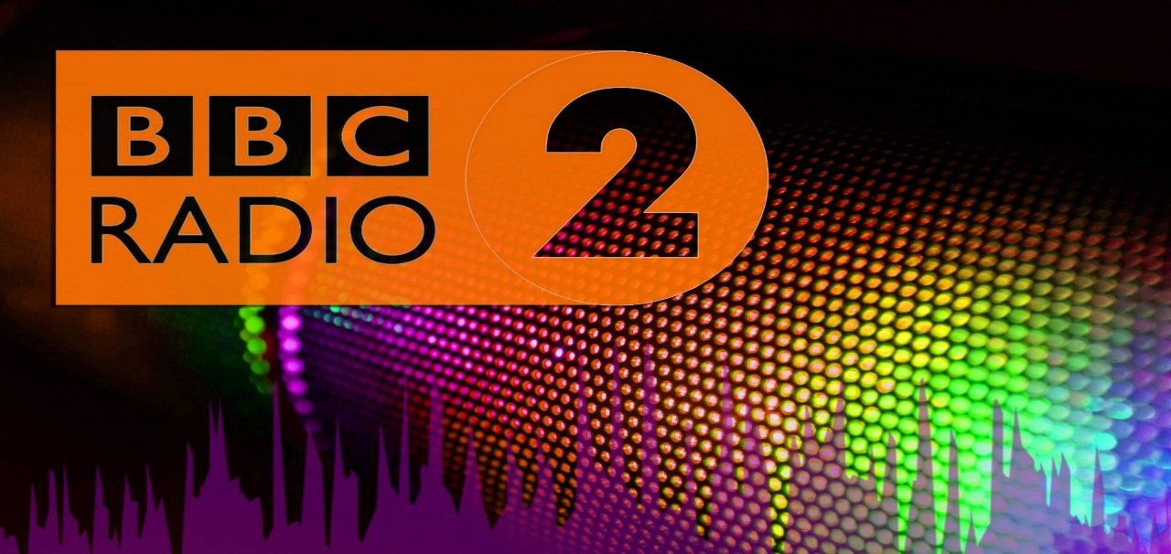
As well as I will take the development of 4 episodes where it will be explained in which areas the menopause affects women, such as the physical, social, economic, and psychological. At the same time, testimonies of people who are going through the period of the menopause their experiences and how they have managed to overcome or manage this difficult period. (Soares & Warren, 2009)
There are different government organizations that help overcome menopause by providing emotional or psychological support, such as the NHS, NICE National Institute for Health and Care Excellence according to (British Menopause Society,2019). Therefore, women can receive hormone therapy which can reduce some symptoms such as hot flashes. Or vaginal Strogen which consists of acquiring vaginal creams or tablets to reduce the discomfort that women have when urinating. Other treatment includes medications to control other symptoms such as insomnia, headache, etc.

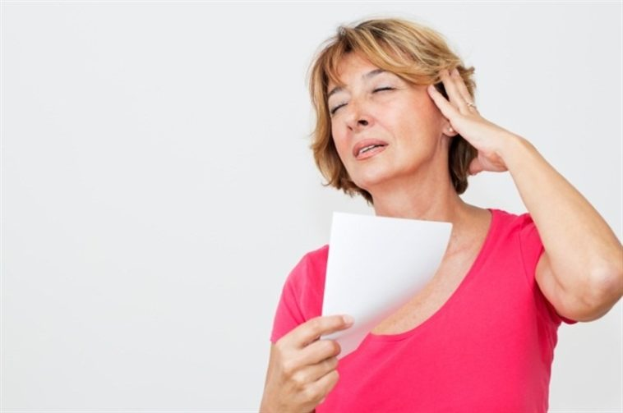

18 October
World Menopause
Day.

Effect of menopause symptoms on women.

(British Menopause Society, 2022)

STAGE 1  SOCIAL  Menopause can affect the social activity of many women. Therefore, the physical factors which can lead many women to lock themselves in the house because they feel ashamed of them, as well as the fatigue it produces. But you can also prevent menopause from affecting social relationships, despite aged women can stay healthy, become more beautiful than ever and much happier than ever, the most important thing is not to neglect yourself in any aspect and not allow This affects the social life of women, as well as the physical and intellectual. It is important for women to lead an active life in terms of exercise, healthy eating, etc. This will also help her feel better about herself. (Leef, 2015) | STAGE 2  PSYCHOLOGICAL  In the psychological factor, menopause also affects women since, as I mentioned earlier, it can affect the state of mind or mood in women and often lead to depression, which is where many women turn to a psychologist to be able to cope. menopause and obtain more knowledge about it, since some women do not seek information or psychological help, since in some cases they may have erroneous information about the situation. (Smith, 2013)
STAGE 3  ECONOMIC  In the economic factor, menopause can also affect women, since the performance of women is not the same in some women, it can cause fatigue, memory loss, mood swings, etc. and this can affect them in their work environment, it can cause lack of consent and some Sometimes even depression and the person can miss work because of this so they can even lose or leave their job, and this can also lead to economic loss. (Frankenhaeuser et al., 2012). | STAGE 4  PHYSICAL  Symptoms are classified as physical, such as hot flashes, psychological, such as mood swings, or mixed. such as cardiovascular disorders; have also been They are classified into typical and atypical.  the first group includes vasomotor symptoms (hot flashes, night sweats, and sleep disturbances) and the second to symptoms associated with both menopause and changes in age such as headaches, back and joint pain, dry skin, and decreased concentration. (Hunter & & Smith, 2014).

There are different government organizations that help overcome menopause by providing emotional or psychological support, such as the NHS, NICE National Institute for Health and Care Excellence, British Menopause Society. Therefore, women can receive hormone therapy which can reduce some symptoms such as hot flashes. Or vaginal Strogen which consists of acquiring vaginal creams or tablets to reduce the discomfort that women have when urinating. Other treatment includes medications to control other symptoms such as insomnia, headache, etc. The symptoms that are reported in various groups of women are due to the ethnic difference and socio-cultural environment.
user profile
Age range - 45-55
Gender - female
Content types –real life documentaries, radio program, channel 4
Preferred channels: Facebook, Instagram, BBC radio 2.

Main Characters
Dr. Jeannette Raymond
Gynaecologist specialized in menopause and treatments.
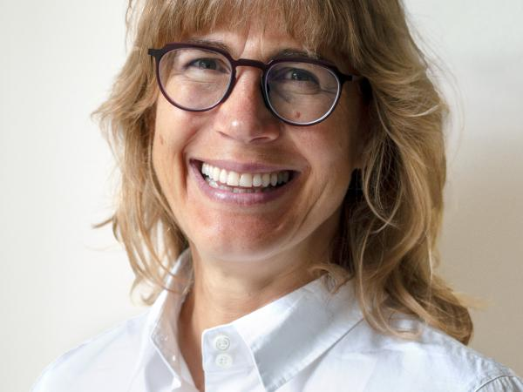
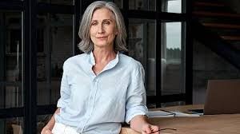
Mrs. Sarah Moore: Speaker who shares his experiences and how he has controlled the symptoms of menopause.
Presenter: Jennifer Marin.
She decided to take Hormone Replacement Therapy because she says it helped her a lot with her extreme menopausal symptoms as well as talking about her experiences with menopause and how she can help other people who are going through the same problem. (Muir, 2022)

 CONTACT US

07861487285

Sfloresdehyland@yahoo.com

References

British Menopause society (2019) British Menopause society, Women's Health Concern. Available at: https://www.womens-health-concern.org/about-the-charity/british-menopause-society/ (Accessed: October 28, 2022).
British Menopause Society (2022) World menopause day 2022, British Menopause Society. Available at: https://thebms.org.uk/publications/world-menopause-day-2022/ (Accessed: October 28, 2022).
Frankenhaeuser, M., Lundberg, U. and Chesney, M. (2012) Women, Work and Health: Stress and Opportunities. New York: Springer Science & Business Media. (Page.228-231).

Geraghty, P. (2022) Each woman's menopause: An evidence based resource, Google Books. Google. Available at: https://books.google.co.uk/books?id=dtNSEAAAQBAJ (Accessed: October 28, 2022).
Hunter &, M. and Smith, M. (2014) Managing hot flushes and night sweats, Google Books. Google. Available at: https://books.google.co.uk/books?id=pbtEAQAAQBAJ&printsec=frontcover&dq=menopause%2Bsymptoms&hl=en&newbks=1&newbks_redir=0&sa=X&ved=2ahUKEwjexdjp-IL7AhWdTEEAHbngByY4ChDoAXoECAYQAg#v=onepage&q=menopause%20symptoms&f=false (Accessed: October 28, 2022).
Leef, R. (2015) Menopause symptoms and conquering menopause weight gain, Google Books. Google. Available at: https://books.google.co.uk/books?id=qFfzCQAAQBAJ&pg=PT33&dq=menopause%2Bsymptoms&hl=en&newbks=1&newbks_redir=0&sa=X&ved=2ahUKEwjexdjp-IL7AhWdTEEAHbngByY4ChDoAXoECAgQAg#v=onepage&q=menopause%20symptoms&f=false (Accessed: October 28, 2022).

Muir, K. (2022) Everything you need to know about the menopause (but were too afraid to ask), Google Books. Google. Available at: https://books.google.co.uk/books?id=iZs5EAAAQBAJ&printsec=frontcover&dq=depression%2Bin%2Bmenopause%2Buk&hl=en&newbks=1&newbks_redir=0&sa=X&ved=2ahUKEwilqfuV_YL7AhUKTcAKHTmlBGgQ6AF6BAgIEAI#v=onepage&q=depression%20in%20menopause%20uk&f=false (Accessed: October 28, 2022).

Panay, N., Briggs, P. and Kovacs, G.T. (2015) Managing the Menopause, Google Books. Google. Available at: https://books.google.co.uk/books?id=0cfsDwAAQBAJ&printsec=frontcover&dq=menopause%2Bsymptoms&hl=en&newbks=1&newbks_redir=0&sa=X&ved=2ahUKEwj0kYaa5oL7AhWLh1wKHbt2BbYQ6AF6BAgIEAI#v=onepage&q=menopause%20symptoms&f=false (Accessed: October 28, 2022).
Smith, M. (2013) Managing hot flushes and night sweats - a cognitive behavioural self-help G. Taylor & Francis Ltd.(pag.44-45).

Soares, C. and Warren, M. (2009) The menopausal transition, Google Books. Google. Available at: https://books.google.co.uk/books?id=jIhqCaJokjIC&printsec=frontcover&dq=menopause%2Bsymptoms&hl=en&newbks=1&newbks_redir=0&sa=X&ved=2ahUKEwj0kYaa5oL7AhWLh1wKHbt2BbYQ6AF6BAgBEAI#v=onepage&q=menopause%20symptoms&f=false (Accessed: October 28, 2022).

