Cloud Computing Administration

Student number: 2022635
Mihail Dimitrov Milchov

Table of Contents
Introduction 2
Azure Total Cost of Ownership (TCO) 3
Azure File Storage for GLI 5
Azure File Storage options 5
Azure Storage cloud options 10
Configuring back-up schedules 14
References 19

Introduction
In the current era of digital transformation, it is important for educational institutions to be at the forefront in providing online certifications and courses to the overall global audience. As the GLI expands its operations and as grows its user base, the current on-premises infrastructure becomes increasingly apparent. To address this the institution needs to address its cost efficiency, resilience, scalability, and cost-efficiency, the institution needs to shift its on premise infrastructure.
GLI on premise servers pose several issues; first is the cost of upgrades and maintenance. The current on premise is costly and it usually require a regular maintenance and hardware upgrades. Second is that the on-premises servers are susceptible to power outages, natural disasters like operational continuity, and hardware failures. Third, the current infrastructure has a limited scalability to accommodate the increasing demand of the online certifications and courses. In lieu to this the recommended solution to alleviate the situation is to leverage cloud infrastructure such as Azure cloud platform.
Aims of Azure migration
The transition to Azure cloud platform aims at achieving the following aims:
- Reliability and resilience; This provides disaster recovery capabilities and an in-built redundancy, this ensures data durability and availability.
- Scalability: This ensures GLI is dynamically adjusted to meet the current fluctuating demand. This in turn ensures that the institution accommodates future growth and a seamless user experience is met
- Cost optimization: By taking advantage of Azure pay-as-you-go model the organization will reduce the infrastructure, it will enhance the operational efficiency.

Azure Total Cost of Ownership (TCO)
According to Microsoft (2023), the current Azure TCO is effective and measurable process as it assesses the current state of infrastructure and translates that to Azure economics and architecture. It is important to note a TCO assessment considers hardware costs such as software licenses, data centers, physical machines, storage, and servers.
The following assumptions were made for the this TCO assessment.
On-Premises infrastructure assumptions
Current the organization in this case operates a medium sized on premise infrastructure which consists of networking equipment, storage, and servers. Their premise hardware is moderately aged but with a lifespan of five years. The support and maintenance costs for the on premise infrastructure is factored in.
Network Usage
The company network bandwidth requirements for the company is moderate with administrative tasks, file downloads and uploads, and data transfer volumes for all user transactions.
Storage requirements
The organization in this case requires a scalable solution which hosts all the administrative files, course materials and user profiles. Also, the Azure cloud storage services are to be utilized for storing the various types of data.
Database Usage
The organization utilizes a relational database which currently store student’s course materials and the various administrative data. Also the database performance and size requirements are moderate and suitable Azure service tiers and standard
Using the current Azure TCO calculate and the above assumptions and parameters to estimate cost savings will include details like storage capacity, network bandwidth, number of servers, and storage capacity.
GLI TCO assessment
The TCO model in this case first underwent a cost structure and identification of the various cost types. First was the cost related to strategic decision of selecting the best cloud service provider, cost related to evaluation and selection of service provider, cost related to the implementation and configuration of Azure, initial training, modification, system failure, and back sourcing. Table one is highlights TCO for the all the related costs
Cost type | Costs
Costs related to the selection of a cloud provider | Expenditure of the time cost  16 hours by $112 which culminates to $1792  (The average wage is $112 each hour)
Selection and evaluation of a service provider | Expenditure of time is approximately to be 2000 dollars
Azure cloud services costs  Service charge | Computing power  10 months by 0.14$ by 727 hours = 1412 dollars  Storage capacity  1TB by $1.14 by 12 months = $1680 ($0.12 per 1 GB)  Outbound data transfer  200GB by $1.12 by 12 months 290 dollars
Implementation costs including the integration, migration, and configuration | Expenditure of the time required  50 hours by $112 which results to $5600
Modification and maintenance | The expenditure of time which is  2hours by $112 by 12 months which results to $2700
System failures | Loss of per period (loss)  Fifty dollars by 12 months which results to 600 dollars
TCO per year | 16, 530 dollars

In this case, the strategic decision required about sixteen hours of work which is the average wages per hour for the IT personnel and the decision maker. The consultation services in this case are not included as there are kept down

Azure File Storage for GLI

Azure File Storage options
Microsoft Azure offers various benefits and features which can be used to enhance GLI’s data storage and management capabilities. These capabilities are’ first scalability, Azure provides a highly scalable storage services. This usually seamlessly grow with the GLI’s needs. Also using the Azure storage services, the institution is able to easily scale down or up based on their demand without worrying about managing or provisioning hardware.
Second, Azure storage are cost effectiveness. With the Azure storage pay as you go, the organization can optimize on costs by paying only for the storage capacity it is consuming. Also, as indicated in the TCO model organization are able to pay for data transfer which it consumers. This in turn eliminates the needs for upfront costs related to operational expenses and hardware investments.
Third feature related to hardware services offered by Azure is that there are highly redundant and high available. This replicates data from various storage nodes with a certain region. Also, this redundancy minimizes the risk of data loss which is as a result of disasters and hardware failures. Other two Azure storage features are related to accessibility, Azure supports what is known as access protocols which includes the SMB and the NFS. This makes it compatible with a wide range of operating systems and applications. This in turn ensures a seamless integration with the GLI existing applications and infrastructure. Lastly, is the security measure, Azure File storage offers a robust security feature including data in transit and on rest. The current security mechanism utilized by Azure is the Role Based Access Control commonly known as RBAC and what is known as the Azure Storage Service Encryption. Azure does so by using the Active Directory commonly known as the Azure AD integration.

Proof of concept
Azure dashboard
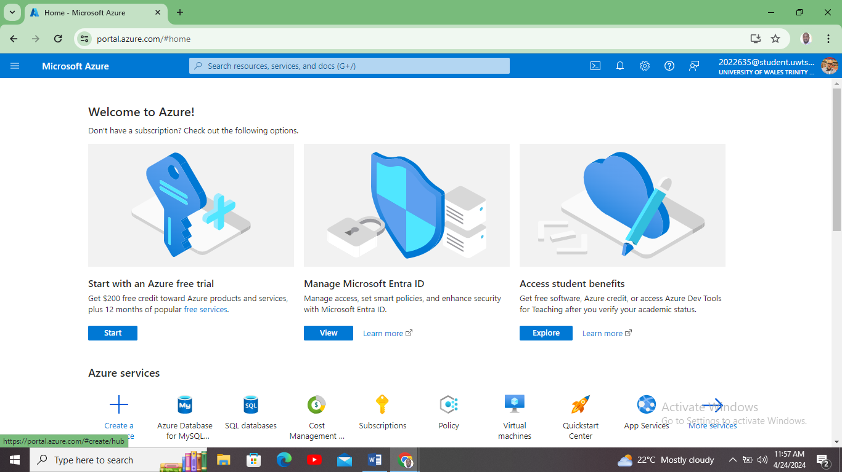

Creating Azure storage
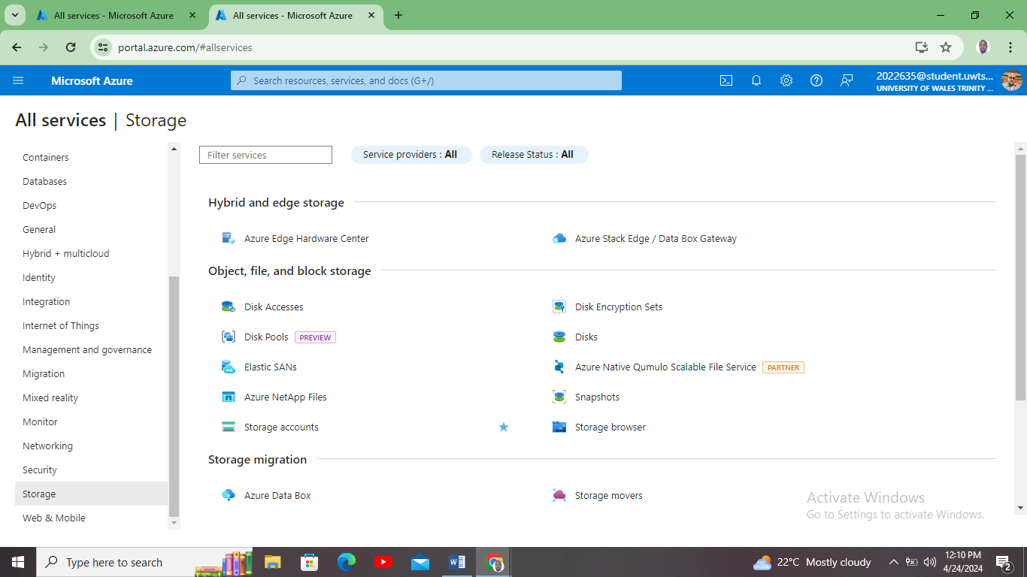
Creating Azure storage account
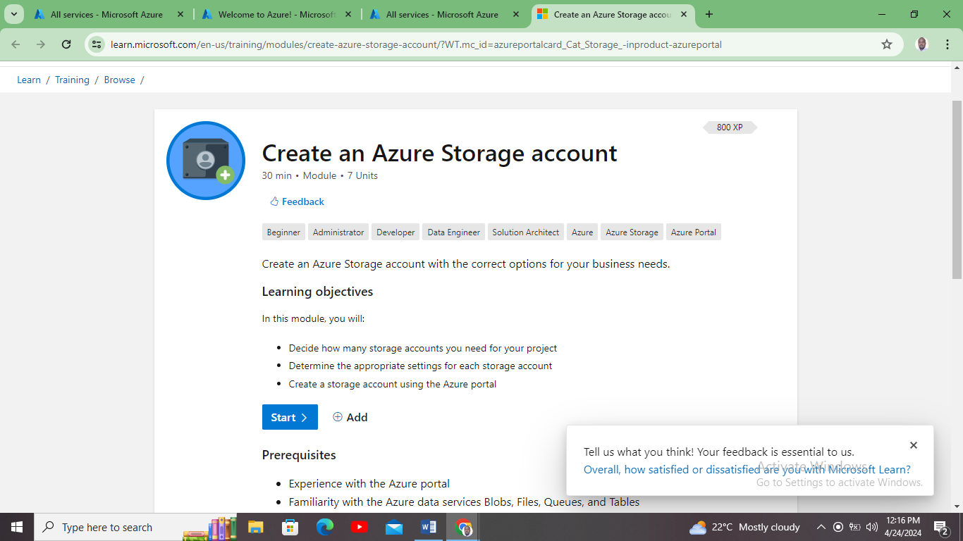

Available Azure accounts
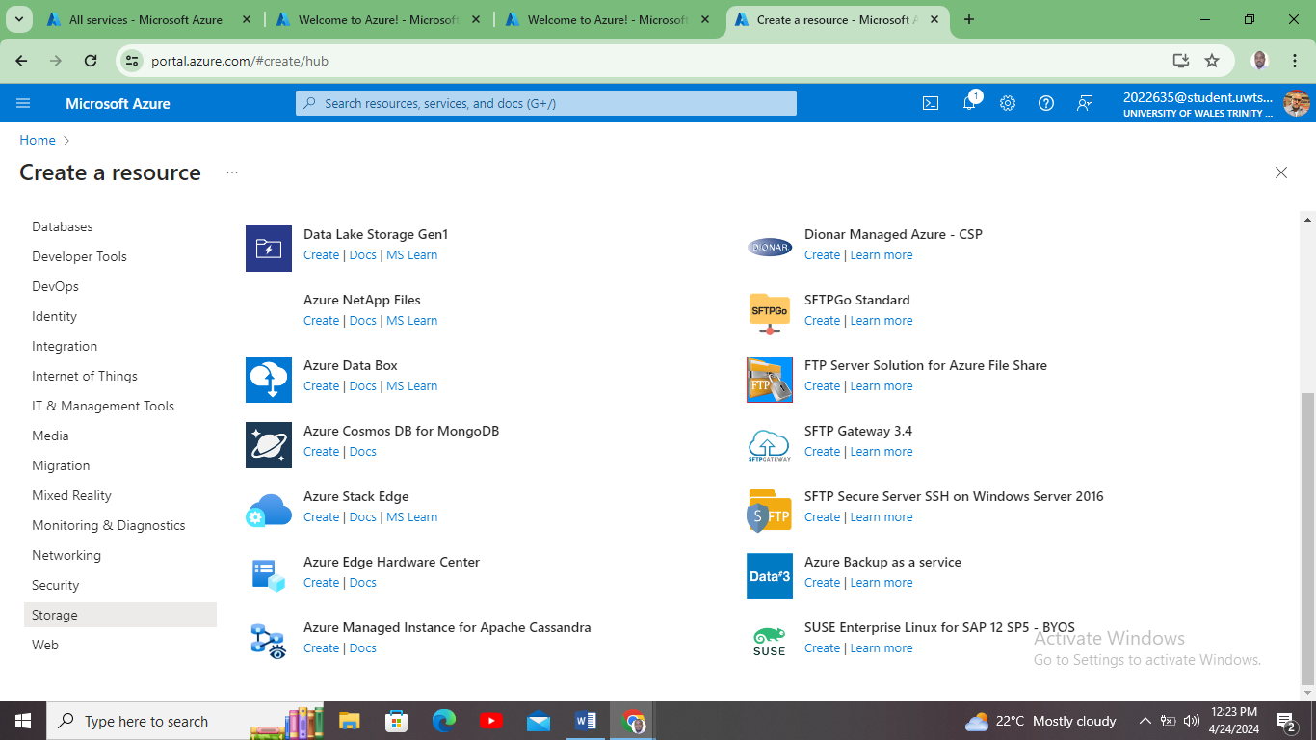
Creating Azure Blob storage
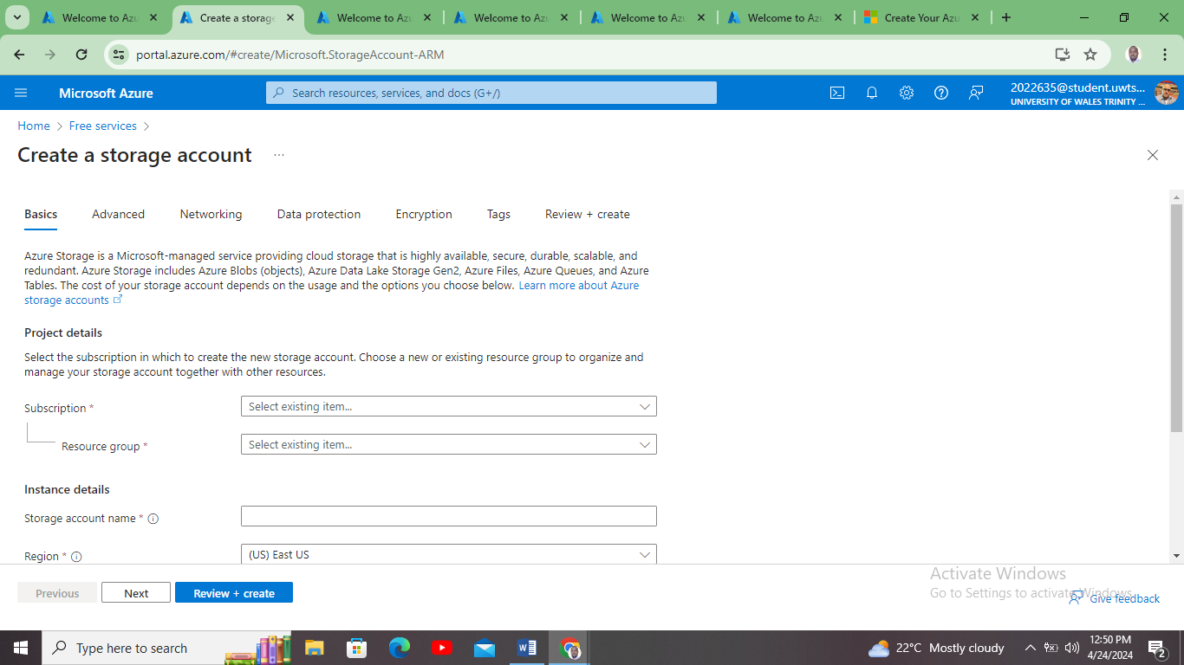

Created Azure blob storage
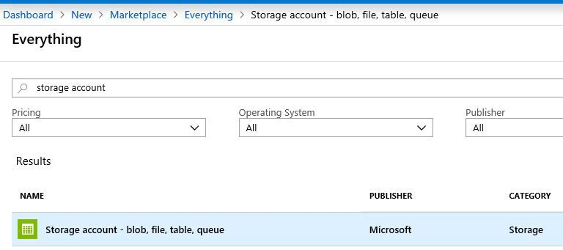
Showcasing Implementation for Azure Storage for GLI’

Azure Storage cloud options
Azure offers diverse array of database options which suits various needs. When considering the best Azure database option for storing let say profile options, GLI needs to evaluate the factors like ease of management, security, performance, compatibility, and scalability. Each of the Azure database service has its own weaknesses, considerations, and strengthens. This makes it important for one to conduct and evaluation to have the best Azure database option.
Azure SQL database is one of the fully managed relational database which is based in Microsoft SQL server. This type provides high scalability, availability, and the in built-in technologies which can be used of optimizing the performance of the database. With this type of database, Microsoft SQL server, the organization in this case can take advantage of the various technologies and tools. Some of the features of the Azure SQL server are database management tasks simplifications. Other features are threat detection, automatic tuning, and the transparent enhance security. Nevertheless, if GLI institution was to implement this database, they would require computability with the other database platforms
Second option is the Azure database for MYSQL. This is a database which is tailored for the MYSQL workloads. The database provides security features, scalability, and high availability but specific to the MYSQL database. GLI might opt for this in case they find that their applications are all developed using MYSQL. Also, they can use in preference for the open-source database solutions. Nevertheless, compatibility with the current GLI tools and applications can be an issue. It requires high level of expertise with the Azure migrating team.
Third option is the Azure database for the PostgreSQL. This is a type of database which is suitable for the storage of profile needs. This type of database provides scalability, advanced features, and high availability. In this case, this type of database aligns well with the GLI’s requirements. It offers a seamless integration with the Azure services thereby ensuring efficient and cohesive GLI cloud ecosystem for all the institution operations.
Criteria | Azure PostgreSQL | Azure SQL database | Azure MYSQL database
Management | A fully managed service with various automated service management routines | A fully managed service, software updates, and handling of routine maintenance | Managed with a simplified management and what are known as administrative tasks s
Compatibility | Requires applications to be compatible with PostgreSQL features and applications | High compatible with the current SQL server, technologies and tools | Highly compatible with most applications
Scalability | Offers scalability options to scale one resources | It provides scalability based features | Offers an elastic scalability
Security | Security features are tailored only for PostgreSQL databases including access control and data encryption | Security features are specifically for MYSQL databases | Advanced security features including threat detection, dynamic data masking, and transparent data encryption

Creating a sample Azure database
Azure Database storage dashboard
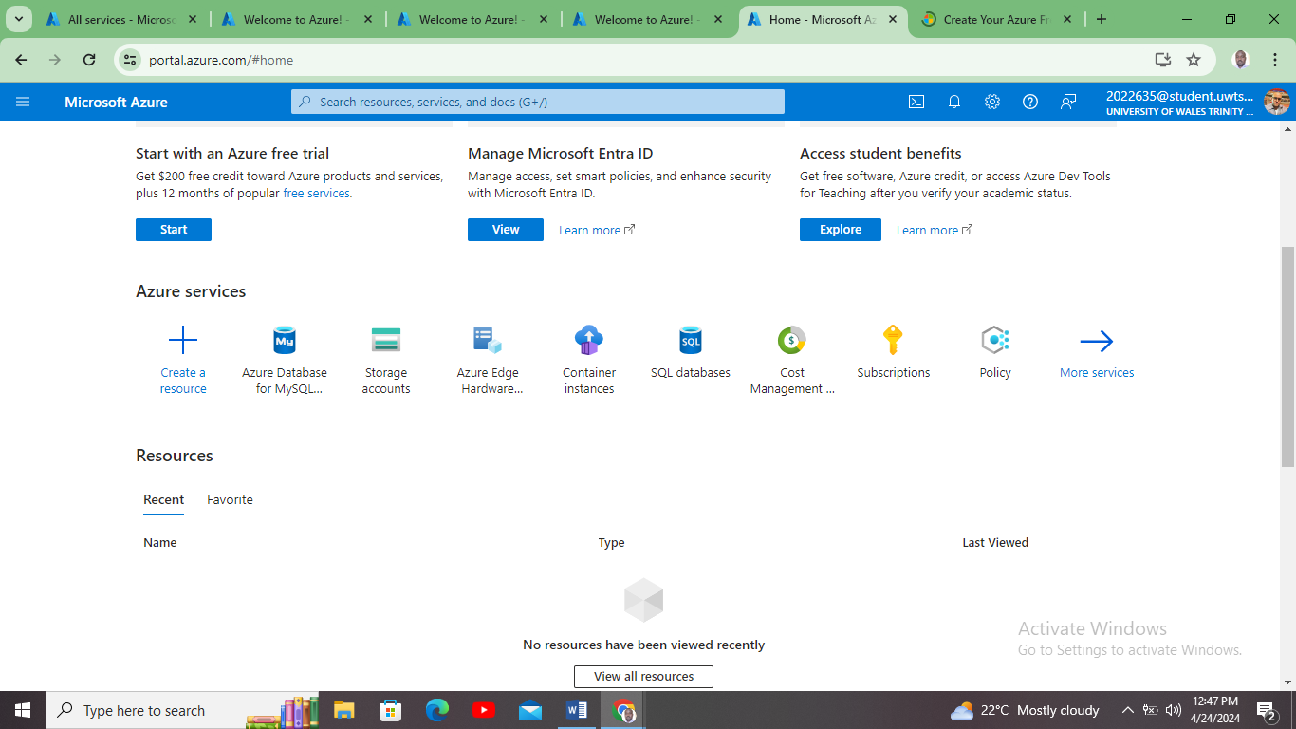
Azure SQL database

Created Azure SQL database
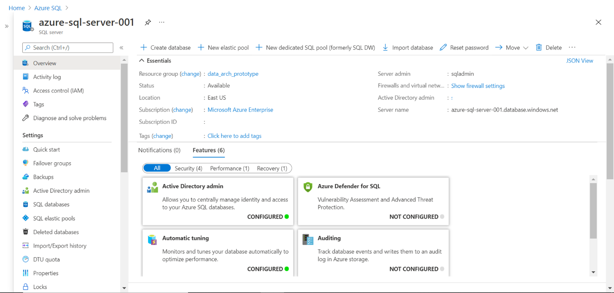

Configuring back-up schedules
For GLI to fully leverage Azure cloud advantages, the organization needs to configure back-up schedules and the retention policies. This in turn ensures compliance, disaster recovery, compliance, and data protection. To configure back-up schedules and retention policies for both databases and file shares can use the following options.
First is the Azure File Sync, in here the organization synchronizes the on premise file shares with what is known as the Azure shares. This option provides a seamless extension of the existing infrastructure to the cloud. The second option is the configuring the back-up schedules using the Azure file shares. In this case the organization needs to use the Azure back-up feature. This involves the act of creating a back-up policy which specifies the back-ups frequency for weekly and daily.
Third, the company needs to set the retention policies. In here GLI needs to define how long a certain back-up data can be retained. This in turn allows the customization of the retention periods which are based on compliance standards and the GLI requirements. For example, the organization in this case, GLI, can opt to retain the daily back-ups for about thirty days, monthly back-ups for one year, and the weekly back-ups for 12 weeks (Edwards, 2020).
Forth is the long-term retention. Microsoft Azure back-up offers a long term retention options. This allows GLI organization to retain the back-up data for an extended period of time like several years. This is specifically useful in meeting the compliance or what are known as regulatory requirements which mandates for data retention for a certain period.
Lastly is monitoring the backup jobs. This is usually done by setting alerts to be notified for any back-up issues or failures. Microsoft Azure usually provides a comprehensive monitoring capabilities. This allows GLI to track the storage utilization capabilities, and compliance.
Proof of concept
Azure back-up center
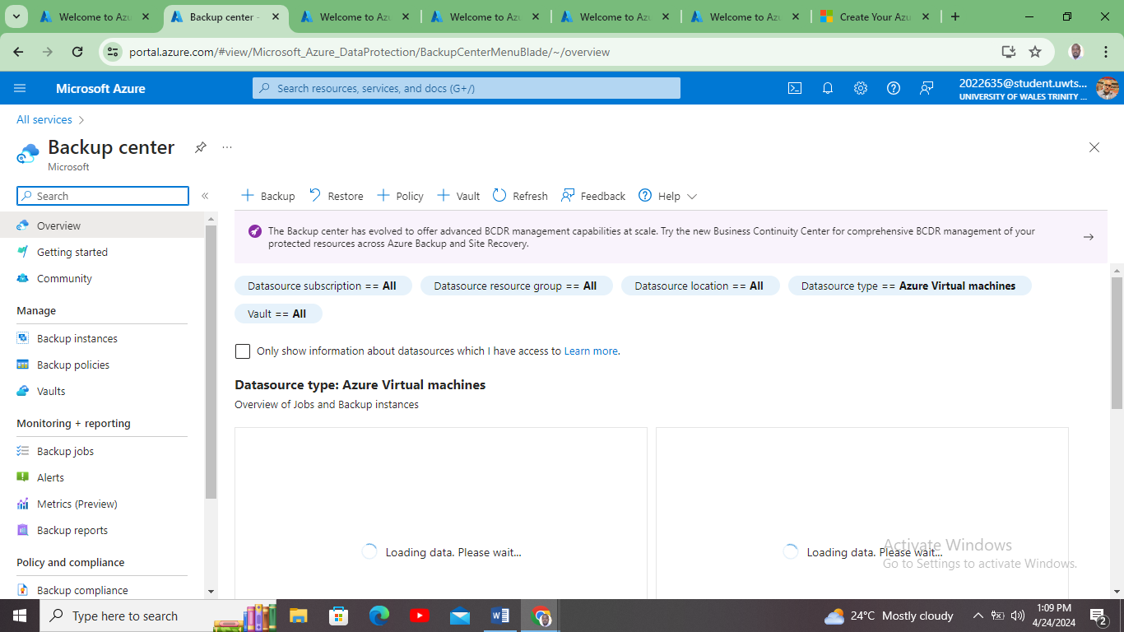
Azure Back-up for a sample created Azure VM
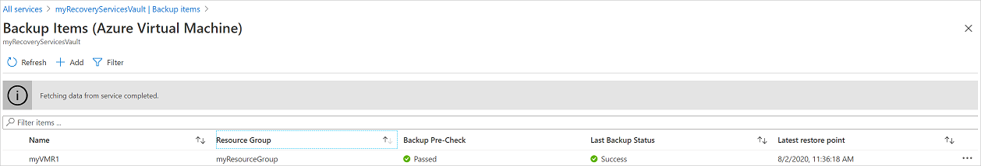
Back-up Azure cloud
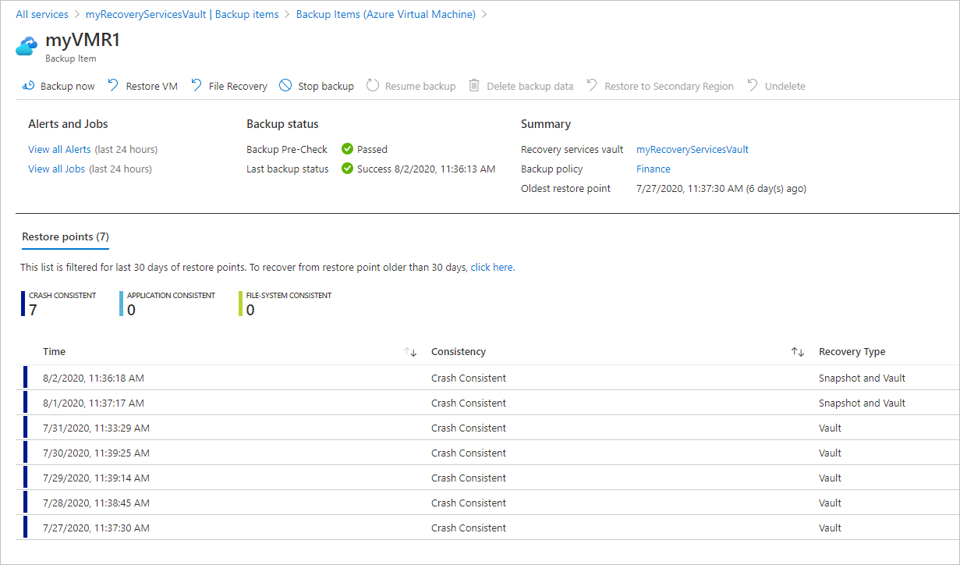
GLI Business continuity plan
Azure Site Recovery or what is known as ASR plays an important role in ensuring business continuity specifically, disaster recovery. This ensures business continuity and at the same minimizes the downtime in the event of disasters or outages. Here is how the organization in this can utilize ASR to protect its databases and storage
First is using the automated replication. In here the organization needs to automates the replication of all its VMs. This includes both databases and shares. In here the organization can replicate the database and storage resources. Second is opting for a continuous data protection; the ASR feature automates the failover process. Also, GLI can define its recovery plans which specifies the sequence steps which are to be executed during an failover.
Other options are cross-platform support. In here the GLI can recover storage and database across the various resources and OS. Also the organization can define the RPOs commonly known as the Recovery Point Objectives.
This by taking advantage of the ASR GLI organization can have a robust disaster recovery procedure for all their databases and storage. This in turn ensures data protection, business continuity, and high availability.

In the contemporary landscape of education, digital transformation has emerged as a critical driver of progress, fundamentally reshaping the way institutions deliver knowledge and interact with learners. The Global Learning Institute (GLI), like many educational entities worldwide, is navigating this paradigm shift, recognizing the imperative to embrace online certifications and courses to cater to a global audience hungry for knowledge. However, with growth comes the realization of the limitations inherent in traditional on-premises infrastructure. The GLI finds itself at a crossroads, where the constraints of cost, scalability, resilience, and efficiency demand a strategic shift towards cloud computing solutions.
The significance of this transition cannot be overstated. Beyond mere operational convenience, migrating to cloud infrastructure represents a strategic imperative for educational institutions like GLI. By harnessing the power of cloud computing, GLI can unlock a myriad of opportunities, from enhanced scalability and reliability to cost optimization and seamless user experiences. This essay will delve into the multifaceted benefits of cloud computing administration, with a particular focus on Azure, Microsoft's cloud platform, as a transformative solution for GLI.
Azure Total Cost of Ownership (TCO):
The concept of Total Cost of Ownership (TCO) serves as a cornerstone in evaluating the economic feasibility of cloud adoption. At its essence, TCO encapsulates the holistic assessment of all direct and indirect costs associated with deploying and operating IT infrastructure, both on-premises and in the cloud. For GLI, embarking on a migration journey to Azure necessitates a meticulous examination of various cost factors, ranging from hardware procurement and maintenance to network bandwidth utilization and storage requirements.
In conducting a TCO analysis, it is imperative to adopt a comprehensive approach that encompasses not only the immediate costs of infrastructure deployment but also the long-term implications of scalability, reliability, and performance. By transitioning from traditional on-premises servers to Azure's cloud platform, GLI stands to benefit from a paradigm shift in cost dynamics. The pay-as-you-go model inherent in Azure enables GLI to optimize expenditure by aligning costs with actual usage, mitigating the need for substantial upfront investments in hardware and software licenses.
Furthermore, Azure's TCO assessment facilitates informed decision-making by providing insights into cost drivers and potential areas for optimization. By leveraging Azure's economies of scale and flexible pricing structures, GLI can achieve significant cost savings over time, channeling resources towards innovation and strategic initiatives rather than infrastructure maintenance.
Azure File Storage for GLI:
One of the cornerstone features of Azure is its robust file storage capabilities, which offer unparalleled scalability, cost-effectiveness, and resilience. For GLI, harnessing Azure File Storage presents a transformative opportunity to streamline data management, enhance collaboration, and ensure seamless access to educational resources for students and faculty alike.
At the heart of Azure's file storage offerings lies the principle of scalability. Unlike traditional on-premises storage solutions, which often necessitate cumbersome upgrades and provisioning to accommodate growing data volumes, Azure File Storage provides a virtually limitless repository that can scale on-demand. This elasticity enables GLI to adapt to evolving storage requirements without incurring the overhead of hardware procurement or capacity planning.
Moreover, Azure File Storage's pay-as-you-go model aligns cost with consumption, enabling GLI to optimize expenditure by only paying for the storage capacity and data transfer it utilizes. This eliminates the need for costly upfront investments in storage infrastructure, freeing up resources for strategic initiatives and educational endeavors.
In addition to scalability and cost-effectiveness, Azure File Storage boasts robust security features, including data encryption at rest and in transit, role-based access control, and integrated compliance certifications. These measures ensure that sensitive educational materials and student data remain protected against unauthorized access or breaches, instilling trust and confidence in GLI's digital infrastructure.
By embracing Azure File Storage, GLI can unlock a wealth of opportunities for collaboration, innovation, and educational excellence. From seamless access to course materials and assignments to enhanced data security and compliance, Azure File Storage serves as a cornerstone in GLI's journey towards digital transformation.
Azure Storage Cloud Options:
Azure offers a diverse array of database options tailored to suit the unique needs and requirements of educational institutions like GLI. Whether it's managing student profiles, course materials, or administrative data, Azure's database services provide a scalable, reliable, and cost-effective solution for storing and accessing critical information.
Among the myriad options available, Azure SQL Database stands out as a fully managed relational database service, based on Microsoft SQL Server technology. With its built-in scalability, availability, and performance optimization features, Azure SQL Database empowers GLI to streamline database management tasks, enhance security, and ensure high availability for mission-critical applications and services.
Similarly, Azure Database for MySQL and Azure Database for PostgreSQL cater to specific workload requirements, offering compatibility with open-source technologies and seamless integration with Azure's ecosystem of services. Whether it's leveraging MySQL for legacy applications or harnessing PostgreSQL's advanced features for modern data workloads, GLI can choose the database option that best aligns with its strategic objectives and technical requirements.
To optimize database performance and cost-effectiveness, GLI must carefully evaluate factors such as management complexity, compatibility with existing systems, scalability requirements, and security considerations. By leveraging Azure's diverse array of database options, GLI can future-proof its digital infrastructure, drive innovation, and deliver a seamless learning experience for students and faculty alike.
Configuring Backup Schedules:
Data protection and disaster recovery are paramount considerations for educational institutions like GLI, where the integrity and availability of critical information are essential for academic success. Azure offers a suite of backup and recovery solutions designed to safeguard against data loss, mitigate downtime, and ensure compliance with regulatory requirements.
Configuring backup schedules and retention policies is a critical component of GLI's data protection strategy. By defining backup frequencies, retention periods, and disaster recovery objectives, GLI can mitigate the risk of data loss and ensure business continuity in the event of unforeseen disruptions.
Azure Backup Center provides a centralized platform for managing backup operations across Azure services, offering insights into storage utilization, compliance status, and backup health. By monitoring backup jobs and setting up alerts for potential issues or failures, GLI can proactively identify and address backup-related challenges, minimizing the impact on academic operations.
In addition to traditional backup methods, Azure offers advanced features such as long-term retention and application-consistent backups, enabling GLI to meet stringent compliance requirements and regulatory standards. By leveraging Azure's robust backup and recovery capabilities, GLI can instill confidence in students, faculty, and stakeholders, ensuring the integrity and availability of educational resources and sensitive data.
GLI Business Continuity Plan:
Ensuring business continuity and resilience in the face of disasters or outages is a core responsibility for educational institutions like GLI. Azure Site Recovery (ASR) offers a comprehensive solution for disaster recovery, enabling GLI to replicate and failover critical workloads and data to Azure's cloud infrastructure.
Automated replication and failover processes play a pivotal role in ASR, allowing GLI to maintain continuous availability of databases, file shares, and virtual machines in the event of disruptions. By defining recovery objectives, recovery point objectives (RPOs), and recovery time objectives (RTOs), GLI can tailor its disaster recovery strategy to meet specific business requirements and regulatory obligations.
Cross-platform support and compatibility ensure seamless recovery of workloads across diverse environments and operating systems, enhancing flexibility and agility in disaster recovery scenarios. By leveraging ASR's capabilities, GLI can minimize downtime, mitigate data

=Strategic Benefits of Azure Implementation
Adopting Azure enables GLI to harness the power of cloud computing to meet its immediate operational needs and future-proof its technological base. This strategic decision brings numerous benefits, including enhanced flexibility, scalability, and a significant reduction in IT overhead. These advantages ensure that GLI can respond more agilely to changes in educational demand and technology advancements without the constraints of physical infrastructure.
Economic Impact
The economic benefits of migrating to Azure extend beyond simple cost savings. They catalyze a transformation in how financial resources are allocated within the institution. Freed from the substantial capital expenditures associated with maintaining and upgrading physical servers, GLI can redirect funds towards enriching student services, expanding course offerings, and investing in research and development. This reallocation supports a broader strategic objective of enhancing educational quality and accessibility on a global scale.
Technical Advancements and Operational Resilience
With Azure, GLI gains access to state-of-the-art technologies that are continually updated and improved upon, ensuring the institution remains on the cutting edge of educational technology. This access not only supports a high level of operational resilience but also introduces opportunities for innovation in pedagogical methods and student engagement. For instance, Azure’s advanced analytics and machine learning tools enable GLI to develop predictive models that can tailor educational content to individual student needs, potentially transforming the educational experience into a more personalized journey.
Challenges and Mitigation
The migration process, while beneficial, has its set of challenges, including the need for comprehensive training and change management to ensure a smooth transition. GLI has proactively addressed these challenges by implementing a detailed change management plan and continuous learning programs for its staff. These initiatives are crucial for maximizing the benefits of Azure’s capabilities and ensuring that the transition enhances, rather than disrupts, the institution’s operations.
Future Prospects and Vision
Looking forward, GLI's integration with Azure opens up new avenues for collaboration and innovation. The cloud environment facilitates easier collaboration across geographic boundaries, enabling GLI to form global partnerships with other educational institutions. This collaborative potential can lead to the development of new, co-created course materials and shared educational resources, thereby enriching the learning experience for students worldwide.
Furthermore, GLI’s adoption of cloud technology signals a shift towards more sustainable educational practices. By reducing physical infrastructure and leveraging cloud-based solutions, GLI contributes to a reduction in energy consumption and a smaller carbon footprint, aligning with broader environmental sustainability goals within the global education sector.
Concluding Reflections
In conclusion, GLI’s migration to Microsoft Azure is a transformative step that redefines its operational framework and strategic outlook. This move not only addresses the current logistical and economic challenges but also sets the stage for a future where education is more adaptive, innovative, and globally interconnected. Through Azure, GLI is not just keeping pace with technological progress; it is actively shaping the future of education, making it more inclusive, effective, and aligned with the evolving needs of a global student body.

References
Edwards, R. (2020, September 30th). Cloud adoption saved half of UK businesses from COVID-19 collapse. Retrieved from Enterprise Times: https://www.enterprisetimes.co.uk/2020/09/30/cloud-adoption-saved-half-of-uk-businesses-from-covid-19-collapse/

