THE IMPACT OF TEAM WORKING AND EFFECTIVE COMMUNICATION

EFFECTIVE TEAM WORKING AND COMMUNICATION
01/5/2020

CONTENTS
ABSTRACTS
INTRODUCTION
METHODOLOGY
RESULT FINDINGS
CONCLUSION
REFERENCES

APPENDICES

Table of contents

Effective Team Work

Communication Verbal and Non-verbal communication
Means of communication
Types of communication
Barriers of communication
Case study 1
Case study 2
Case study 3

[Introduction]
[Effective team working and communication is essential in our work places . It is required from every professional worker to be able to understand the need and apply these skills effectively at your work place. The importance effective communication is now more important due to diversity of people, culture, religion, age and beliefs. Health care and social healthcare workers should have the adequate understanding of how they may use to express themselves at their working environment. The ability communication effectively within your work place, with your team member and with the service users and their relatives .The modern cultural differences and the global village has change the way we interact with people . Diversity of people and diversity of acts, body language like gestures like the facial expressions and tone of your voice may have different interpretation to other cultures . Effective team working can bring achievement and success to the organisation in which you work and as a community as whole . Ineffective team work and wrong communication can lead to many conflicts , barriers and poor management even at the risk of peoples life.(Gritfinns .BA , Dunham EB,)(2015)

Communication can be interpreted and understood in different ways. The Schramm’s model of communication and Berlo’s Model of communication relates to how people receives messages and interprate them .Encoding and Decoding. There are other Models such as the Shannons and the SMR which also explains how messages are receive and understood due to emotional state, attitudes, tone , generational language and sickness.
Barriers like psychological barriers , problems with structured design, cultural noise, assumption about others, lack of common experience, information overload, jumping into conclusion, making assumption before conclusion can hinder the progress of every organisation

EFFECTIVE TEAM WORK/COMMUNICATION

[EFFECTIVE TEAM WORKING AND COMMUNICATION]

Nothing happens without collaborating effort (refer) (Steinhofel Greg Dishman 2012). A target CEO. A multibillion-dollar company occurred as a target’s success in attribute of a teamwork within the company. The company began as a single discount general store in 1962 and has since become a 1772-store-strong multibillion-dollar company due to effective teamwork. A team is a group of two or more who are interacting with one another in such a manner that each person influences and is influenced by each other person; stated concepts a relationship, interaction and influence (Marvin Shaw 1981). Effective teamwork enables people to work effectively, perminete and enjoyable. It eases tension create happy environment. Lack of commitment, poor communication, ignoring individual contribution, poor leadership, interpersonal conflict can lead to productivity losses (Griffiths B.A. and Dunham E.B.)
Stability in teamwork can bring success while members whiles members become frustrated and ineffective when teams are run strictly with tension. It is more effective for team members to be told what to do instead of the right set of rules (Molleman, Nuata an Jehu 2004) Page 22.

Members become frustrated with the mutual structure question its effectiveness
Groups begin with an initial structureOrder Ambiguity and tension create instability which generates a new structure

Effective Teamwork and communication
Effective teamwork and good communication enable people to solve problems and achieve collective goals. Ineffective communication can promote good team work.

Task Role | Function
Information Selection | Ask facts, opinions and ideas from the group and for clarification and elaboration about existing concepts
Information given | Contributes facts, opinions and novels ideas to the group.
Discussion Facilitator | Facilitates the discussion by engaging the group
Task manager | Keeps the group on task and focuses on practical details
Sceptic | Challenges ideas and evaluates potential solutions
Record | Takes notes and records the decisions of the group
Task 2 Relationship roles | fictions
Encourager | Validates, affirms and support others
Harmonizer | Mediates conflict among group members
Process observer | Observes and periodically comments on the groups progress
Advocate | Helps quieter members to speak up and be heard in the group

Task 3
Individual Functions
Resister | Operates the group by being negative passive aggressive
Dominator | Dominates discussion and intimidates others
Avoider | Tries to do as little work as possible
Avoider | Tries to do as little work as possible
Attention Seeker | Calls attention to self to meet personal needs

Looking at the chart, you can see how individuals operate (Griffiths BA and Dunham EB)

Communication Specified

Communication is an Italian word which means to share. It is the sharing of information between individuals. It includes sharing ideas, behaviours, imaginations, written and recording contents. Communication as defined is simply transfer of information from one place to another. Communication can be concluded in many ways.
Communication is transferable because it involves exchange. It is continuous process. It is also contagious. Communicator can be learned because it can be improved.
Communication is a word which means to share .It is the sharing of information between people . It includes sharing of ideas , behaviours , imaginations, written and recoding contents. Communication as defined is simply the transfer of information from one place to another. Communication can be conducted in many ways.It can be conducted through writing ,text messages, recording, electronic scans and pictures, emails. It can also be conducted vocally orthrough gestures. Shannon and Weaver’s cycle of communication explains how communication loose it potential due to the sender ,encoding ,the noise or abstraction that can affect the channel that decode it to the recipient

The Therapeutic Communication
The therapeutic communication helps you to address clients or service users’ needs through communication. https:www.scie.org.uk
Effective Communication
Multi professional communication for children
- Making system work for children –(Glenny Georgina)(Roaf, Caroline) McGraw-Hill Education 2008.
- Meeting the needs of young people and vulnerable children has much to do with collaboration. It is essential and needs to be regarded (Huxham and Vaugen’s)
(The Childrens Act 1989 Laming Report (2003
[NTERPERSONAL COMMUNICATION and VERBAL and NON – VERBAL COMMUNICAITION. Thesetypesof communication can affect the quality of work at the work places in a positive or in a negative way. It is estimated 44% of employers have difficult in conversation. 18 .4 % have difficulty speaking as a leader, 13.3% experience difficulty in giving presentation.10.6% with coaching motivation, 7.85% communicating with customers and 5.25% with engaging in meetings. The assessment was done within a period of five months from February to June 2012 (Dekay.SH ). (Business and Communication) .The influence of body language also known as Kinesics is mainly about postures and how we demonstrate unconsciously .(https:wwwstarmedical.co.uk).]

Verbal and Non-verbal communication

NONE- VERBAL COMMUNICATION .
None-verbal communication reveals TRUST, LISTENNING, CLARITY, TENSION and CONFUSION. (www.helpguide.org.2020) THE POSTURE. Gestures and movement eye contact and facial expressions and dress can be improved

PICTURE OF NON-VERBAL

Practicing can improve one’s ability to express themselves well without nerves and it is most rewarding. Good habits are the practice of good eye contact, clear speaking. The better way is to assess the quality of your own voice. Assessing yourself, the tone of your voice, the motions of your voice, slowly or quickly, muttering or clearer. The pronunciation and ascent also matter a lot. Always be at ease so you do not gasp for air as you speak.
You can always make it work if you naturally speak loudly you can practice decreasing the volume of your speech in order not to scare children, vulnerable or people at your care. Some people speak at such volume and authority that people get scared or frightened around them. If your voice can not be heard, at times it can be irritating. A service user may ask a question or may need something your response may let them think you do not want to answer them, and they may not have the boldness to ask again. Speaking when you are at ease will also ease tension on your listeners both old and young, vulnerable or capable.

Barriers of Communication
Environmental issues like noise, tension and emotions can affect communication, concept, and bring disagreement. Cultures, isolations, dementia which is memory loss, vulnerability, rapid death of brain cells or lost of words can be barriers to communication. Tone, voice and gestures and facial expressions can be barriers to communication. Lack of experience, overuse of abstractions, jumping into conclusion physiological barriers attitudes can be barriers (Collins 2009). Barriers of communication can be between professionals and individuals. The act of breaking down information in communication can have a good side and a negative side. Lack of proper recording information given, mistakes in writing or re-writing, transforming report into digital or data and shortage of words.

CommunicationBarriers
Barriers of communication can be between professionals and individuals. The act of breaking down information in communication can have a good side and a negative side. Lack of proper recording information given,mistakes in writing or re-writing or simply transforming written information or report into digital data. Lack of words shortage.
Stress can also be a barrier for someone to misunderstand other people, send confusing nonverbal signals and use funny patterns of behaviour.
Emotions- Feelings can affect your decisions and behaviour and even how people may perceive you. Also, sickness controlling your motions can help you to understand others.
Successful communication can deepen relations in personal life or professional life. In personal life, they can help us understand better people and situations that happen on a daily basis. Developing communication skills can help us to avoid conflicts, compromise and help in better decision making.
Speak like a leader.

Contents
Service Users Scenarios. This scenario was about a service user in a mental home who refused to have his dinner. He got up from the dinning table and went to bed. Most times, this service user will go to bed without food. For that very night a bank staff came for a shift from other units, proper feedback was given forgetting to mention the service user not having food. He did not come for the food before the night staff. At around 11pm, he woke from his sleep and headed to the kitchen without anyone seeing him. Coming down the stairs, he fell of the stairs and the ambulance was called. A course for concern. Poor communication, inability to deliver effective communication. Improper way of delivering appropriate information.
www.skillsyouneed.com.

General Communication

Expect to be heard
Understand
Respond – means decoded
Feedback

Barriers
Language – not decoded
Attitude –Pretending not hear
Power struggle

The different module of communication
The Shannan-Weaver Mathematical Model 1949.
A message that was sent to a parent to pick a child but as the practitioner replied to the mum that her child is fine, relaxed and refused to pick the child to see the doctors so a staff have to take her.

SMCR Model Berlo’s Model of Communication

Types of models

Messages undergoes to process that involves more than one person. This process of encoding and decoding the sender and the receiver. The model of Berlo, Shannon, Schrams are examples of and decoding.

The Various Ways of Communication
- Listening
- Interpersonal

Legislation
Code of Conduct
Code Practice

Implementing the code of conduct
Scramm’s Model of Communication 1955

Berlo’s Model of Communication
Ref
- Definition
- Code of conduct

)

The Arvon

Communication as a Transmission

Means of Communication
Means of Communication are verbal, by telephone, voicemail, emails, online, letters and media. Other means are television, and all goes through the channels of transitions and transmission. The Shannon-Weaver Mathematical Model 1949

Information

Sign Language (BFL/Maketon). Maketon is a form of sign language. If non verbal for survival language program that uses symbols sign and speech to enable people to communicate with each other.

Here are ten means of communication: talking, writing, books, newspaper, magazines, radio, television, telephone, word of mouth and the internet (SkillsYouNeed.com). The modern communication devices are radio, mobile phone, Bluetooth, computer, intercom, paper, fax.

Presentation Skills

]

[ THE TYPES OF COMMUNICATION.]
Picture of Berlo’s transmission

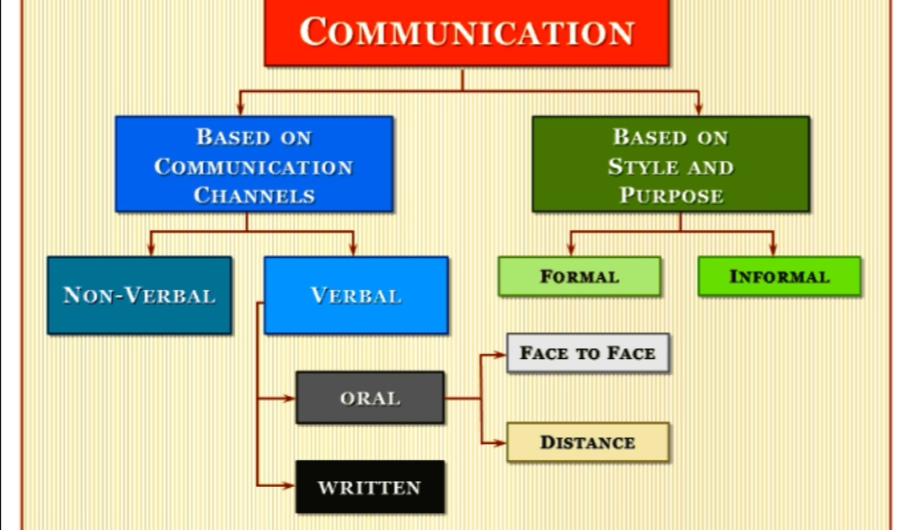

BARRIERS TOEFFECTIVE COMMUNICATION.

Language /different generation, attitudes, emotions , noise, psychological barriers ,structure designs ,cultural noise and assumption of others. Lack of common experience, information overload , jump into conclusion and making assumption.

Successful communication helps us better to understand people and situations .It helps us overcome diversity, build trust and respect and create conditions for sharing creative ideas and problem solving. (https://study.sagepub.com/morgan)

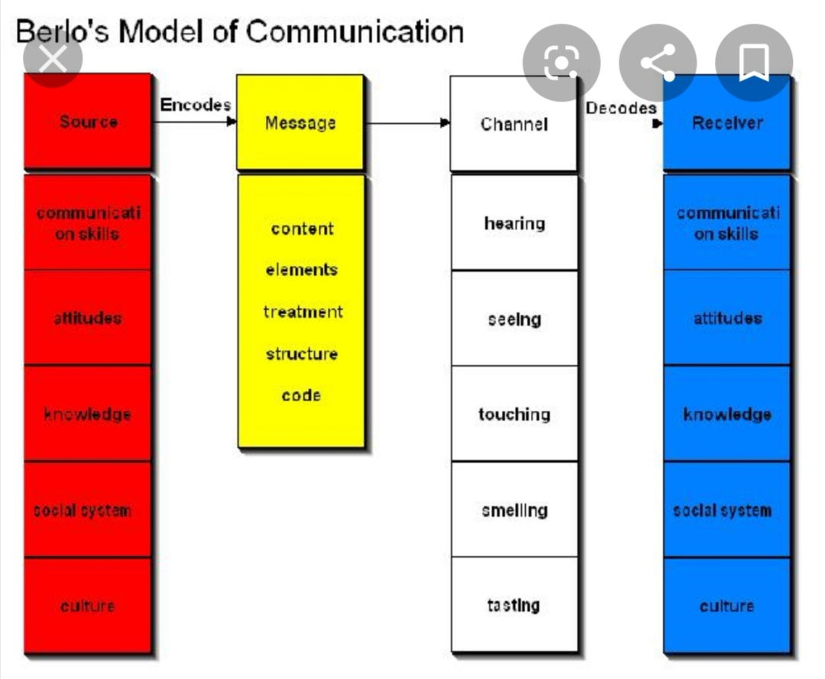
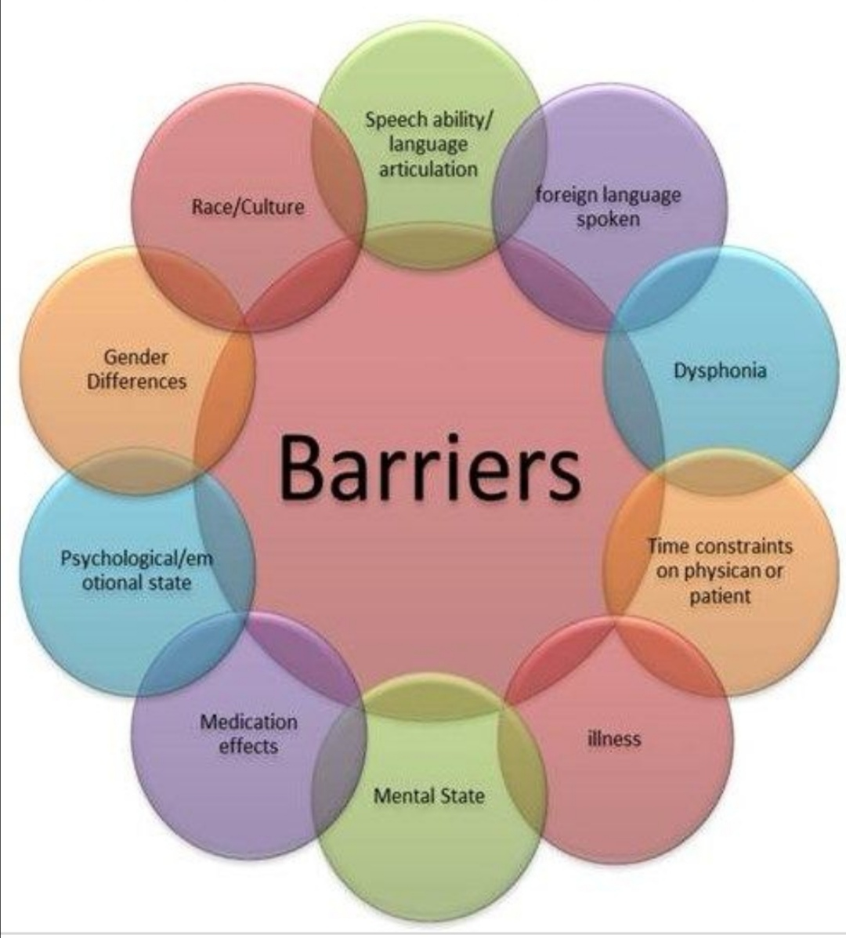

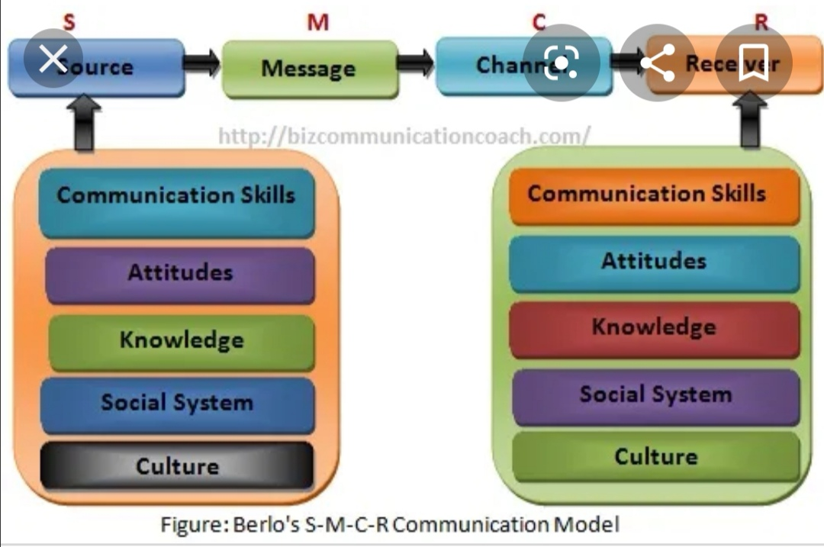

Aa

Case study 1

Case study 2

Case study 3

Case study 4

Case study 4

ABSTRACTS / SUMMARY

. be changed.communication skill can be learned because it can be improved.(www.skillsyouneed.co Communication is transferable because it involves exchange. It is a continuous process. Communication as encoding and decoding.( The shannons weaver mathematical model )(1949) ( TheBerlo’s Model of Communication) (The Schramms Model of Communication1954) The content is about how professional workers and Health care workers can improved themselves in following the procedures at the work places , the code of conduct and the code of practices in their work place. The ability to communicate effectively at their work settings.

TO BE DONE. . be changed.communication skill can be learned because it can be improved.(www.skillsyouneed.co Communication is transferable because it involves exchange. It is a continuous process. Communication as encoding and decoding.( The shannons weaver mathematical model )(1949) ( TheBerlo’s Model of Communication) (The Schramms Model of Communication1954) The content is about how professional workers and Health care workers can improved themselves in following the procedures at the work places , the code of conduct and the code of practices in their work place. The ability to communicate effectively at their work settings.

RESULT FINDINGS

CONCLUSION

REFERENCES

APPENDICES

