Effective Teamworking and Communication

Dragos Cristian Sorica
1906082
Lecturer:
06.01.2020

Content of the assignement:
- Aknowledgments………………………………………………………………………………page 3
- Summarising……………………………………………………………………………………..page 3
- Introduction………………………………………………………………………………..…….page 3
- Methodology ……………….………………………………………………………………..…page 4
  - Shannon and Weaver Model………………………………………………….page 4
  - Schramm Model……..……………………………………………………………..page 5
  - Berlo’s Model…………………………………………………………………………page 5
- Types of communication……………………………………………………………………page 6
- Practical exercise about effective communication at the workplace…page 7
- Discussion………………………………………………………………………………………….page 7
- Conclusion…………………………………………………………………………….…………..page 8
- Refferences……………………………………………………………………..…………...…..page 9
- Appendices ……………………………………………………………………………..………..page 10

Aknowledgments
I want to give many thanks and appreciation to my lecturer Lloyd Beharry because he gave me precious time and all the constructive opinions and suggestions for this assignment during this term. I appreciate very much his patient quidance.
Summarising
In my work for this assignement I have included a briefly introduction about communication, I have mention in methodology which models of communication I have learned during this first term at this moduse, I have a practical exercise about communication at the workplace and which methods shall I use to make it more effective, a small discussion about this practical exercise and conclusions about my work. I have aswell the references attached in-text and a list at the end in which I want to show my appreciation to the other author’s work because I made researches in various books and academic articles about communication. At the very end I have appendices section in which I have included all the practical in-class exercises which I have made along with my colleagues and lectuer during this first term and the exercises helped me to improve my communication and team-work skills and how to understand in a better way what means an effective communication and teamwork and all the things that I have learned at this module.
Introduction
Communication represents the main way that helps to achieve the purpose of any business organisation because during this century it exists extremely competitive businesses which bring a balance to the areas of an entity and the main goal of a business is to focuse on creating various methods of effective communication (Black, 2009). The aim of this assignment is to discuss the concerns over different communication models and theories, what is the importance of them, which are the strategies of an effective communication and therefore the ways in which it works inside the business to achieve the main goals with the help of an effective communication and teamwork.
Methodology
Here I have mentioned all the methods that helped me in my research for this assignment. I have learned about three models of communication during this term which are presented bellow:

Shannon and Weaver Model of Communication
This model was designed in the purpose of increasing the effectiveness of communication. The process deals with different stages and factors to achieve the main purpose of the model. Fist stage represents a person named sender that will transmit an information to another person which represent the receiver. The message is transmited through a channel and then the other person decode that information. Some issues may appear in transmiting and decoding of the message which are mentioned as the noise (Meijer and Kleinnijenhuis, 2006). The elements are presented in the figure bellow:
Sender: The original source of information which prepares the message and transmits it to the destination which is the other person named receiver.
Encoder: Represents the way in which the message is transformed and the language which is used to make it eligible to transfer through the process of communication (Nagel, 2013).
Channel: This is the pathway via the message is transferred to the destination which represent the ultimate user of the information (receiver).
Decoder: Represents the way in which the message is transformed by the receiver as well as signals are transformed into the message to make it understandable for him.
Receiver: Represents the ultimate destination of the message .
Noise: The disturbance to the transformation of the message which can be caused by technical or social issues and those affect the message. That stops the receiver to get the correct message which is intended and despatched by the original source which transmited the information.

Schramm model of communication

The Schramm’s model of communication represents a two-way system of communication that consists a sender of a message and as well a receiver of the message. This model of communication expects to have two people that have the same goal in order to send or receive messages. The principal composing factors of this model are: sender, receiver, a message and limitations of the communication process.
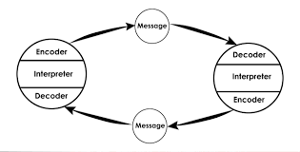
This model of communication includes both parts(the sender and the receiver) to be involved in the identical experience field and to deliver and receive the correct message.

Model of Berlo
The Berlo’s model of communication is viewed similar to the Shannon and Weaver model. The differences between this two models of communication are represented in a few stages. The factors involved in Berlo’s model of communication represents the soure which is the sender, the original content which is sent at it represents the message, the channel which is used to transmit the message and is decoded by the other persons which represents the receiver. The feedback from the receiver is not included in the process of the Berlo’s model and that is the main reason why this model is not considered as effective as compared to the other models (Turaga, 2016).
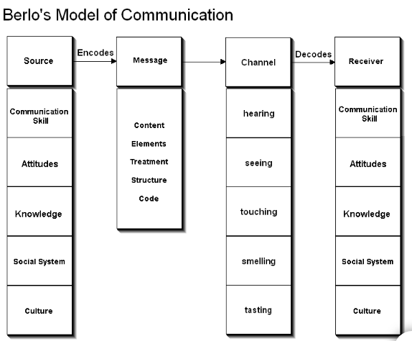

Sender
The person that create a message in which he wants to transmit a information to the receiver. The way the receiver reveice the message include a few components related with the sender that consists of the communication skills, the attitude, the technollogy used, the lifestyle and culture and as well the level of understanding, knowledge and intellect of both.

Message
Represents the information transmited by the original source to the destination. It can be sent and received in different ways wich might be either a text (email, telephone, letter and many more), visuals (videocall, picture), voice (direct communication or recorder message) as well as audio (telephone, radio).

Channel
The way via which the message is despatched from the original source represented by the sender to the final destination which is the receiver.

Receiver
The finals destination which represents the person who receives the message.
Types of communication:
I have discovered four types of communication during this term, They are: verbal, non-verbal, written and visual communication.
Verbal communication reffers to directly talk between the sender and the receiver using the mouth and the receiver is providing a feedback through the same way. This is the most used type of communcation and as well one of the most effective method in which individuals can perform the process of communication. All the issues and confusions can be explained and resolved through discussion( Havaldar and Dash, 2009).
Non-verbal communication means to analyse how the movements of the body of the individuals involved in the communication process are used and what express because they may vary because of different cultures, lifestyle or just knowledge of it’s meaning. For example, shaking the hand has different meanings in different cultures. Facial expessions, the body movements, the tone of the voice, the attitude or the way that the people dress are different aspect of non-verbal communication.
Written communication express the fact that the information is written either over a piece of paper and send as a letter or note, online through emails or via chat and online platforms. This type of communication is in continuously developing especially in the business area because all the important informations are kept as documents(Johnson and Bayless, 2005).
Visual communication is another type of communication which is used usually to transmit a message to a larger group of people but it can be present between only two people as well. It uses videos, presentations, pictures or a scenario in front of others for understanding the message.
Practical exercise:
I have experienced in the restaurant which I am working at all the effects and advantages and what exactly means an effective communication in a business. I worked in that restaurant for more than 2 years and I have observed some beneficial facts which can be follow as strategies for an effective communication at the workplace. This business has an process of developing an effective communication because if the workers receive an innapropiate feedback from the customers about their communication skills then they transmit the feedback to the management of the business. For example I was really busy in a day and I didn’t heard when a customer was calling me to ask me some details about an order because of the noise which was represented by my co-workers which disturbed my work in that day. Even if I apologize to that customer, he gave me a negative feedback and transmit it to the management team. Afer that, the management of the restaurant plans to remedy the problem depending on the comments and the feedback given by customers and that expand their good intentions of developing an advanced and effective communication and teamwork. At the restaurant which I worked for, the main purpose is to deliver overall exeptional services, quality food and a raised productivity and the teamwork is getting increased daily. The restaurant uses multiple channels of communication such as business email, whatsapp to communicate with all the staff of the restaurant and telephone but mostly in case of emergency or to contact other persons which are involved in the business(LLP, 2019). The considerable facts are saved to be accesible to the staff in order to follow the main objectives of the business. As an example, if the restaurant discover a large group of customers, they informe all the workers of the restaurant about it with the purpose than all the employees to be able to keep this in mind this information and to provide good services to that group of customers. Assertiveness is ensured in time of giving quidelines or any kind of instructionsto the staff because they need to understand the message in details and then can make sure they provide overall performance for the business. After every year the workers got their performance recorded and reported to the management teanm and then they identify any kind of issues regarding their performange. After that, they manage to solve their issues with the help of management via a discussion with the experts. In time of taking any significant business decision, the administration of the restaurant contact the workers and requires them to furnish their feedback and opinions. Using this method for an effective teamwork and communication, the staffs feels very bonded with the restaurant and because they make part of a team and provide a effective teamwork and they provide their best performance to optimize the aims and goals of the business.
Discussion
Along with all these theories and methods about the process of communication and how can I perform to have effective teamwork and communication skills I have applied them in my personal, academic and professional life. The fact that I learned about different types of communication and models helped me in better understanding which are the causes of an problematic cause of communication. I have improved my body-language when I express myself and I have analysed and developed the way that I am transmiting messages and I am more concerned now about the channels and ways of transmiting it to another person.
Conclusion
The following study describes the importance of communication and its varied models that would be enforced in an organisation. it had been determined that effective communication may facilitate any organisation to accomplish its goals or objectives in an economical manner. Effective communication may persuade be useful in decisive the needs of people and guides them to their destinations. Likewise, it had been discovered that effective communication may persuade be useful in enhancing the productivity of a business. moreover, it permits the division relations to grow that's thought-about to be a crucial half for the longer run. Through cooperation and effective communication, staff square measure closely associated with one another additionally as their leader and square measure extremely motivated to realize their common goals. varied styles of communication may well be used, like verbal additionally as nonverbal communication.

References
- Huang, C., 2003. Transitional media vs. normative theories: Schramm, Altschull, and China. Journal of communication, 53(3), pp.444-459.
- Turaga, R., 2016. Organisational models of effective communication. IUP Journal of Soft Skills, 10(2), p.56.
- Gillespie, D.J. and Schiffman, R., 2018. A Critique of the Shannon-Weaver Theory of Communication and Its Implications for Nursing. Research and theory for nursing practice, 32(2), pp.216-225.
- Ruesch, J., Bateson, G., Pinsker, E.C. and Combs, G., 2017. Communication: The social matrix of psychiatry. Routledge.
- Gallois, C. and Giles, H., 2015. Communication accommodation theory. The international encyclopedia of language and social interaction, pp.1-18.
- Markovic, M.R. and Salamzadeh, A., 2018. THE IMPORTANCE OF COMMUNICATION IN BUSINESS MANAGEMENT. BUSINESS MANAGEMENT, ENTREPRENEURSHIP AND ENTREPRENEURIAL TENDENCIES, p.11.
- Ladewig, J., 2019. Body language: Its importance for communication with horses. Journal of Veterinary Behavior, 29, pp.108-110.
- Fidalgo-Blanco, Á., Sein-Echaluce, M.L., García-Peñalvo, F.J. and Conde, M.Á., 2015. Using Learning Analytics to improve teamwork assessment. Computers in Human Behavior, 47, pp.149-156.
- ` examining social skills in drama class(Doctoral dissertation, Bilkent University).
- Petersons, A. and Khalimzoda, I., 2016, May. Communication Models and Common Basis for Multicultural Communication in Latvia. In Proceedings of the International Scientific Conference. Volume IV (Vol. 423, p. 433).
- Covey, Stephen R. (1989) The 7 Habits of Highly Effective People: Powerful Lessons in Personal Change. 5th edn. New York: Simon and Schuster.

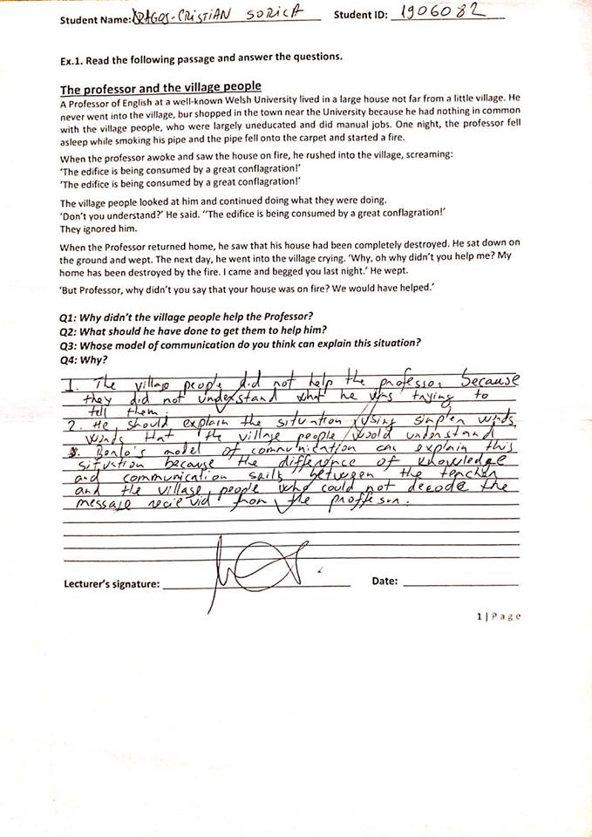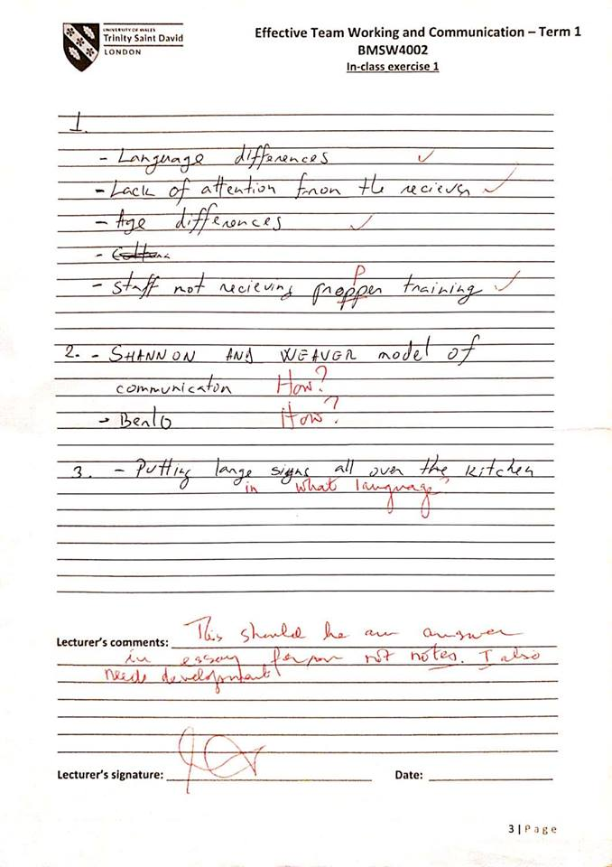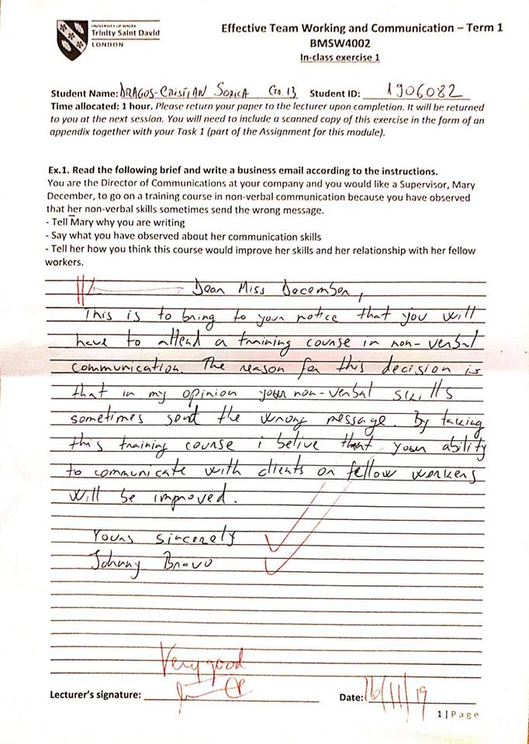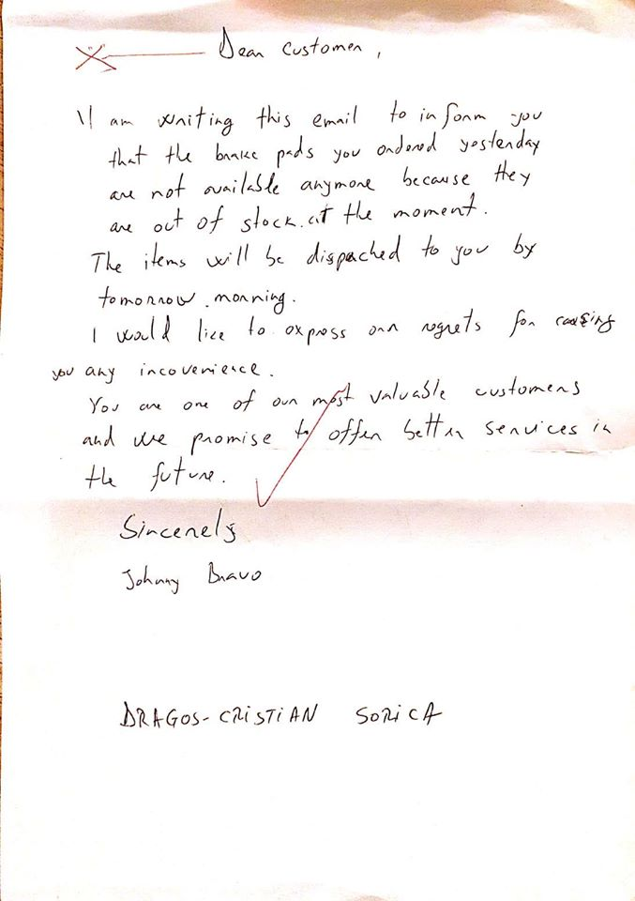
Appendices

