
University of Wales Trinity Saint David
School of Engineering

Engineering Design
ACMA4008
Cad Report – Dry Sump Design Project

Steffan Rhys Lloyd
2220589
05/02/2024

Table of Contents
1 Introduction 3
2 Quality Function Deployment 3
3 Design Specification Targets 6
4 Design Development and Presentation 8
5 Concept Design Solution 10
6 Final Design 11
7 Evaluation Framework 14
8 Reference 16

Introduction
This report looks into the design a dry sump pan and oil pickup for a motorsport company. In the realm of motorsport, especially in high-performance racing environments the demands on engine lubrication systems are intense. The need for reliable oil management becomes paramount to ensure engine longevity, consistent performance, and ultimately success on the track. Designing a new dry sump pan and oil pickup components are hugely important in the makeup of the entire engine system.

Quality Function Deployment
A Quality Function Deployment (QFD) analysis aids in systematically understanding and translating customer needs into engineering characteristics. Key factors to consider include (Lucidchart, 2018).

- Lightweight Design
In the pursuit of performance and excellence in motorsport weight optimization is paramount. The dry sump pan and oil pickup pump must be crafted from lightweight yet durable materials such as aluminium, titanium or Carbon fibre. Every gram saved contributes to improved acceleration, handling, and fuel efficiency giving the vehicle a competitive edge on the track.

- Easy Installation
Seamless installation is essential to minimize downtime and ensure rapid deployment of the dry sump system. Clear and concise installation instructions along with flexible design features should enable quick and hassle-free assembly. Compatibility with various engine configurations further enhances the installation process allowing race teams to focus on fine-tuning their vehicles for optimal performance.

- Engine Protection in Crash or Roll-Over Situations
Safety is the number one key factor in motorsport and the dry sump system must provide reliable engine protection in the event of a crash or roll-over. In the design of the dry sump system this was implemented wherever possible ensuring the optimal performance of the engine as well as safeguarding against damage and ensuring the driver’s safety on the track.

- Cost Effectiveness
While uncompromising performance is the goal cost considerations are equally important. Designing the dry sump system with cost effective materials and manufacturing processes helps to minimize production expenses without sacrificing quality or reliability. By keeping costs in check, the system remains accessible to a wide range of racing teams promoting equal competitiveness within the sport.

- Easy Access and Maintenance
Efficient servicing and maintenance are an essential part for maximizing track time and ensuring peak performance. The dry sump system should feature easy access design with removable panels and tool-less maintenance features allowing for quick and hassle-free servicing between races. This ensures that the vehicle spends more time on the track and less time in the pits contributing to its optimum competitive potential.
By prioritizing these key design features, the dry sump system can be tailored to meet the specific needs of motorsport teams delivering exceptional performance, reliability, and value to racing teams and drivers alike.


Image 1: QFD For The Dry Sump Assembly

Design Specification Targets

The creation of design targets outlines the requirements for the development of a comprehensive dry sump system. These specifications serve as a roadmap for the designing and ensuring that the final product meets the needs and expectations of the customer while adhering to industry standards and best practices.

- Oil Capacity is a key factor and Target in the design. The dry sump pan should have a minimum oil capacity to ensure sufficient lubrication during extended track sessions.
This should Adequate oil capacity as it is essential to prevent oil starvation and maintain consistent lubrication levels therefore safeguarding engine performance and longevity during high-speed driving manoeuvres (Bill Holland, 2019).

- Material Selection will be a key factor as using lightweight yet durable materials such as aluminium alloy castings for both the dry sump pan and oil pickup adaptor are ideal in the design and application. Lightweight materials contribute to overall vehicle weight reduction leading to enhancing acceleration, handling, and fuel efficiency while ensuring structural integrity and component longevity under demanding racing conditions.

- Cost Optimization where Striving for cost-effective design solutions without compromising performance, reliability, or safety. Cost optimization is crucial to making the dry sump system accessible to a wide range of racing teams, maximizing affordability without sacrificing quality or functionality will be possible the most challenging part of the design.

- Efficiency of oil removal from the engine where keeping the amount to as minimum as possible to prevent oil starvation of the engine. This is paramount in motorsport as optimal oil pressure and engine power is vital for performance and reliability.

- Accessibility and Serviceability where statically placing panels or holes ensuring easy access for removal of fasteners and the component itself is a key factor, this will help in minimizing downtime during race events therefore creating a quicker response time for mechanics when working on the vehicle.

The detailed design specification provides a comprehensive framework for the development of a high-performance dry sump system. By adhering to these specifications, the design team can ensure that the final product meets the needs and expectations of customers delivering superior performance, reliability, and value on the racetrack.

Design Development and Presentation

As can be seen in image2 below a dry sump was designed using SolidWorks where In the design a pipe is positioned at the bottom of the tank extending to the sump pan within the engine.

The aim being for a separate oil pump to be connected the bottom of the pan for increased oil capacity and better oil control, as it can be strategically positioned to optimize oil flow and cooling. This has a big benefit because a dry sump system only needs a cover for the engine's bottom with fittings for the oil lines. This allows the engine to sit lower in the chassis, which lowers the centre of gravity. Considering the weight of most engines, this is not a small advantage (Bill Holland, 2019).

Additionally, the separation of the oil reservoir from the engine reduces the risk of oil starvation during high-speed cornering or acceleration ensuring consistent lubrication and preventing engine damage.

Overall a dry sump system offers improved performance, reliability, and durability compared to traditional wet sump setups making it a popular choice in demanding automotive applications (Bill Holland, 2019).

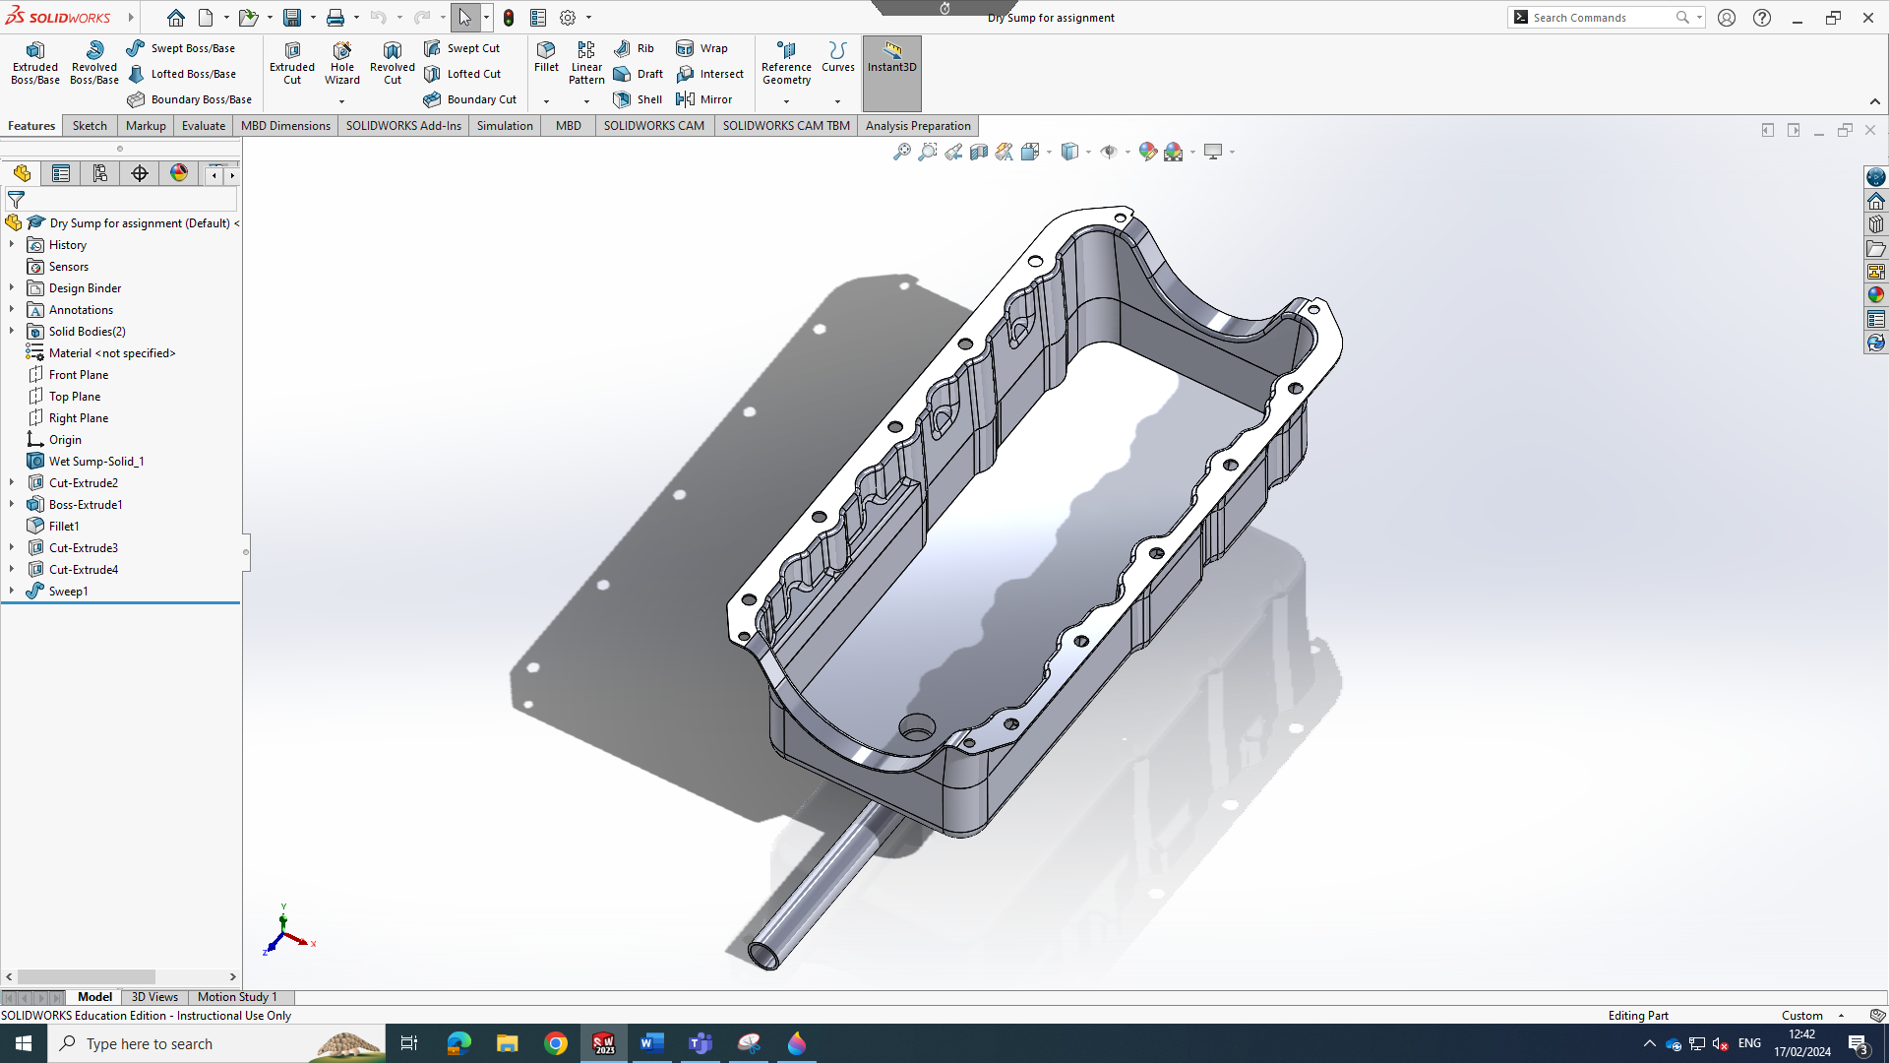
Image 2: Dry Sump Tank Design.

Below is image 3 which is the separate oil pump that has also been designed to work hand in hand with the dry sump. The oil pump is connected to the pipe tasked with scavenging oil from the sump pan and delivering it to a remote oil reservoir or tank located elsewhere in the vehicle. Combining these two components together will give a far better results and performance for the customer compared to the current system they will be using.

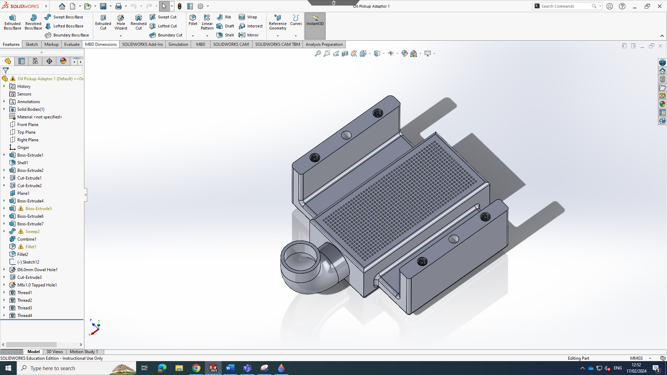
Image 3: Oil Pickup Pump Design.

Concept Design Solution

After the design process was conducted an evaluation was done for the concept idea generated for the dry sump pan and oil pickup pump to determine the most optimal or preferable solution. This process aims to identify the concept that best aligns with the established design parameters and specifications while maximizing performance, efficiency, and reliability.

Firstly, the concept idea is assessed based on predefined criteria such as Lightweight design, Ease of installation, Engine safety, Cost effective and easy fast access for servicing or parts change.
Next the strengths and weaknesses of each principle are analysed to understand their respective advantages and limitations. This involves identifying potential design flaws, areas for improvement, and opportunities for innovation.

Through using a QFD the concept idea principles are ranked and prioritized based on their overall performance and suitability for the intended application as well as compared to other competitors on the market. The goal is to establish the best balance of features, functionality, and practicality while meeting the specific needs and preferences of the customer (Ted Hessing, 2016).

By conducting the design isolation exercise identifying the best or preferable solution for the dry sump pan and oil pickup pump ensuring that the final design meets or exceeds the expectations of the customer and delivers exceptional performance on and off the track.

Final Design

Here in the image 4 below you can see an assembly Drawing for both dry sump and the oil pump, where the oil pump has been put in place to line up with the escape pipe on the dry sump allowing it to scavenge oil from the dry sump and deliver it to the oil reservoir tank.

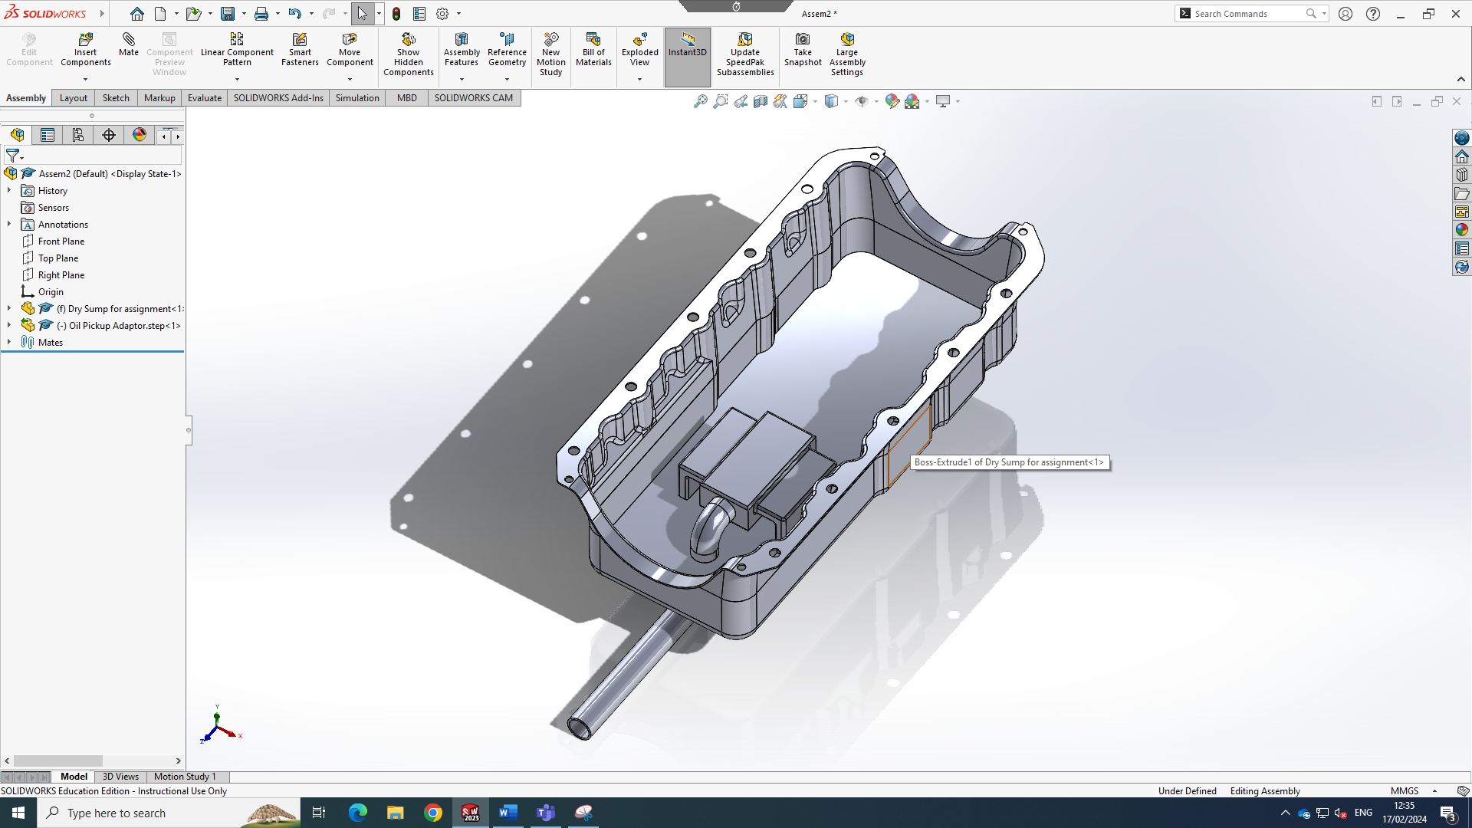
Image 4: Assembly Drawing of Dry Sump and Oil Pump.

The final design of the dry sump system for motorsport customers embodies a comprehensive approach to address key design factors. Through using the QFD system and design process the system offers significant improvements in lightweight design, ease of installation, engine protection, cost-effectiveness, and ease of access for maintenance.
Choosing aerospace-grade aluminium as the main source of material the dry sump pan and oil pickup pump prioritize lightweight construction without compromising durability or performance. This reduction in overall vehicle weight enhances acceleration, handling, and fuel efficiency on the track providing racing teams with a competitive edge.
The modular design of the dry sump system will have clear and concise installation instructions. Engineered to fit within the tight confines of a race car's engine bay the custom-designed dry sump pan facilitates hassle-free installation and compatibility with existing components therefore minimizing downtime and maximizing track time.
Advanced anti-slosh baffle design reinforces engine protection in crash or roll-over scenarios. These features prevent oil spillage and engine flooding safeguarding against damage and enhancing driver safety during high-speed racing conditions.
Cost-effectiveness is achieved using efficient manufacturing processes to create the components such as die casting, although initially this will be an expensive procedure manufacturing each component after the die has been made becomes a much more efficient and cost-effective way to mass produce the parts. As well as using cost-effective material such as aluminium ensuring accessibility to a wide range of racing teams without compromising quality or reliability. By optimizing production expenses, the dry sump system remains affordable while delivering exceptional performance and value.
Easy access design features including removable panels and tool-less maintenance components will lead to optimal servicing between races maximizing track time and minimizing downtime in the pits. With simplified maintenance procedures the system ensures peak performance and reliability throughout the racing season.

As seen in images 5&6 the scale and size of the components can be roughly seen where size, weight and strength was paramount in the decision for the final designs.

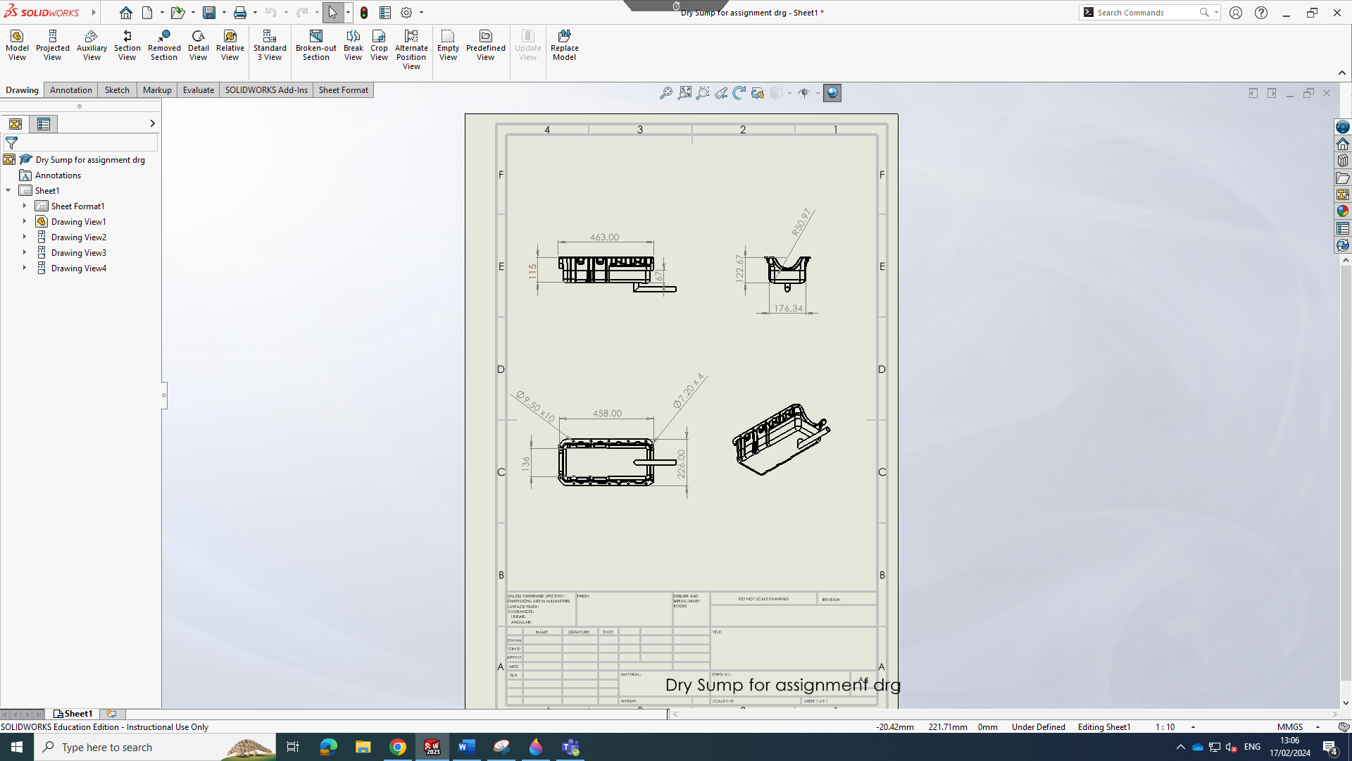
Image 5: Technical Drawing of The Dry Sump.

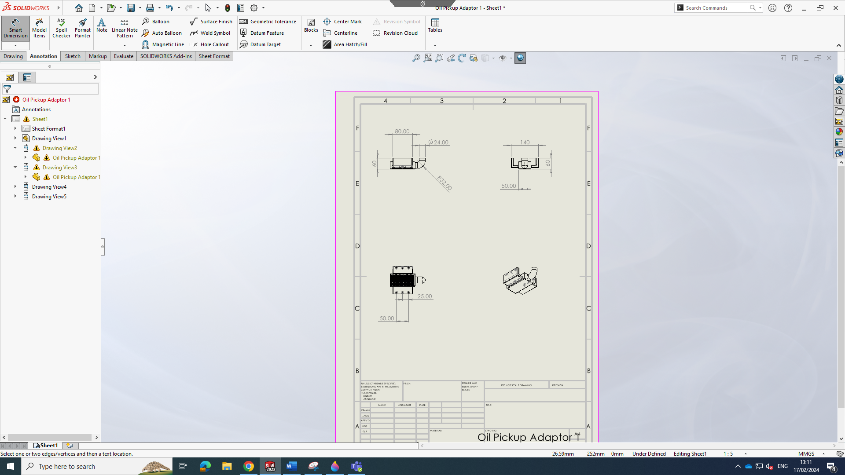
Image 5: Technical Drawing of The Oil Pickup Pump.

Evaluation Framework
A simple evaluating framework can be followed to ensure the performance, reliability, safety, cost-effectiveness, and ease of use for the customers. Ensuring the requirements of motorsport competition are met while delivering value to racing teams and drivers.

1. Performance Testing:
- Perform bench testing trials to evaluate oil scavenging efficiency, oil pressure stability, and heat dissipation capabilities under simulated racing conditions.
- Perform on-vehicle testing to assess system performance during actual track sessions including high-speed cornering and acceleration.

2. Reliability Testing:
- Subject the dry sump system to endurance testing to simulate prolonged racing conditions and assess long-term durability.
- Conduct vibration testing to ensure components remain secure and functional under high G-forces and mechanical stress.

3. Fitment and Compatibility:
- Verify compatibility with a range of engine configurations and aftermarket components through testing and compatibility examination.
- Ensure easy combination with existing oil pump and reservoir/tank setups commonly used in motorsport applications.

4. Safety Evaluation:
- Assess the effectiveness of engine protection features, such as anti-slosh baffles design in preventing oil spillage and engine flooding during crash or roll-over scenarios.
- Conduct structural reliability testing to verify the strength of the dry sump pan and oil pickup pump under impact and mechanical loads.

5. Cost-Benefit Analysis:
- Perform a cost-benefit analysis to evaluate the economic feasibility of the enhanced dry sump system compared to alternative solutions.
- Consider factors such as initial investment, maintenance costs, and potential savings in engine maintenance and repair expenses over the system's lifespan.

6. Regulatory Compliance:
- Ensure compliance with relevant industry standards and regulations governing motorsport equipment including safety and performance requirements.
- Conduct certification testing as necessary to demonstrate compliance with applicable standards and regulations.

Incorporating the evaluation framework will ensure the dry sump assembly’s performance, reliability, safety, cost efficient methods and ease of use will all have the greatest chance of being optimized. By Systematically testing each of these frameworks we can validate its effectiveness in meeting requirements demanded in motor sport completion by the drivers and their teams.

Reference
Lucidchart. (2018). How to build a House of Quality (QFD). [Online]. Lucidchart. Last Updated: (Unknown). Available at: https://www.lucidchart.com/blog/qfd-house-of-quality [Accessed 16 February 2024].

Ted Hessing. (2016). Quality Function Deployment (QFD) and House of Quality (HOQ). [Online]. Six Sigma Study Guide. Last Updated: (Unknown). Available at: https://sixsigmastudyguide.com/house-of-quality-hoq/ [Accessed 9 February 2024].

BILL HOLLAND. (2019). Pros and Cons Of Installing A Dry Sump Engine Oiling System. [Online]. Engine Labs. Last Updated: APRIL 18, 2019. Available at: https://www.enginelabs.com/engine-tech/pros-and-cons-of-installing-a-dry-sump-engine-oiling-system/ [Accessed 16 February 2024].

