

Module: Marketing Management
Module code: LCMB7024
Assignment Title: Assessment component 2: Marketing Portfolio

Student Name: Shaan aboobacker

Student ID:2503771
Lecturer's Name:Dr.Laila maazouz

Table of contents
Element 1: STDP Analysis (Segmentation, Targeting, Differentiation and Positioning) 3
1.1 Background and Rationale about Brand Recognition 3
1.2 Segmentation Analysis 3
1.3 Targeting Strategy 3
1.4 Differentiation Strategy 4
1.5. Positioning Strategy 7
Element 2: Marketing Mix 9
2.1 Product 9
2.2 Price 10
2.3 Place 12
2.4 Promotion 13
3. Element 3: Poster 16
3.1 New Brand Introduction: Dyson Pulse 16
3.2 Key Product Features and Technologies 16
3.3 Target Market and Positioning 17
3.4 Market Growth Potential 17
3.5 Promotion strategies 17
Element 4: Reflection 18
4.1 Reflection in experience gain from of Developing and branding strategy of Dyson Pulse 18
4.2 Experience in Preparing and Delivering the Marketing Strategy Pitch 18
4.3 Describe Achievement of Key Skills 18
4.4 Future Project Improvement 19
References 20
Appendices 23
Appendix 1: Poster 23

Element 1: STDP Analysis (Segmentation, Targeting, Differentiation and Positioning)

1.1 Background and Rationale about Brand Recognition
Dyson Pulse is the most effective AI powered smartwatch that includes key functional activities such as advanced biometric tracking, personalised health insights, and long-lasting battery performance. Hence, this brand will also be recognised as expanding the global tech healthcare market with the enhanced brand reputation of Dyson in the international market.

1.2 Segmentation Analysis
Demographic Segmentation
The development of products such as “Dyson Plus” will help Dyson in meeting the health requirements of the male and female customers in the UK. Overall, the enhancement in the consumer base will assist Dyson in improving the popularity of its commodities.
Psychographic Segmentation
Dyson will promote its smartwatch commodity among customers such as fitness trainers and athletes, that will also assist in improving its goodwill among consumers. In addition, the product will also provide benefits for senior citizens in enhancing physical and mental health significantly.
Behavioural Segmentation
The inclusion of the Dyson Plus as rewards in “Winter Marathon” events will help the organisation in enhancing the awareness level of the commodity among the customers. Overall, the improvements in the product acceptance level will help Dyson in improving its brand loyalty.
Geographic Segmentation
Dyson will provide its smartwatch product to consumers in European countries that will help the organisation in enhancing its customer base. The geographical expansion will assist the organisation in overcoming market competition for its commodities.

1.3 Targeting Strategy
Primary Target Market: Tech-Savvy Wellness Seekers
- Around 78% of UK adults actively track health metrics such as heart rate, sleep, and stress levels, making them key adopters of Dyson Pulse (Clinic, 2024).
- Nearly 50% of millennials associated with internet users are also highly engaged with wearable health tech and AI-driven wellness insights (Bourne, 2025).
- The wearable health tech market’s CAGR of 15.7% indicates growing consumer adoption of smartwatches and health-monitoring devices globally.
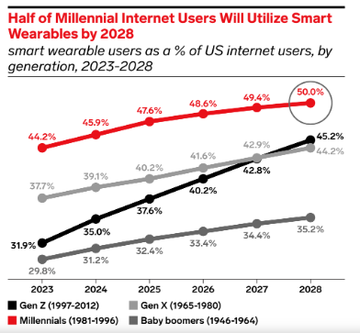
Figure 1: Smart wearable market
(Source: Bourne, 2025)
Secondary Target Market: Busy Professionals and Tech Enthusiasts
- Busy professionals aged 35–55 represent 18% of smartwatch users in the UK, with high interest in AI-driven productivity and wellness features (Statista, 2025).
- Dyson Pulse is expected to achieve 1.5 million trial users in the first six months through online and in-store promotions.
- The inclusion of an engagement programme about personalized health challenges and app notifications project a repeat user rate by 30% among secondary users.

1.4 Differentiation Strategy
Product-Level Differentiators
The global sales volume of fitness watches has increased from 190m units in 2021 to 280m units in 2024 (Pangarkar, 2024) Overall, the enhancement in the product demand, will help Dyson in enhancing goodwill of its “Dyson Plus" product among the customers.
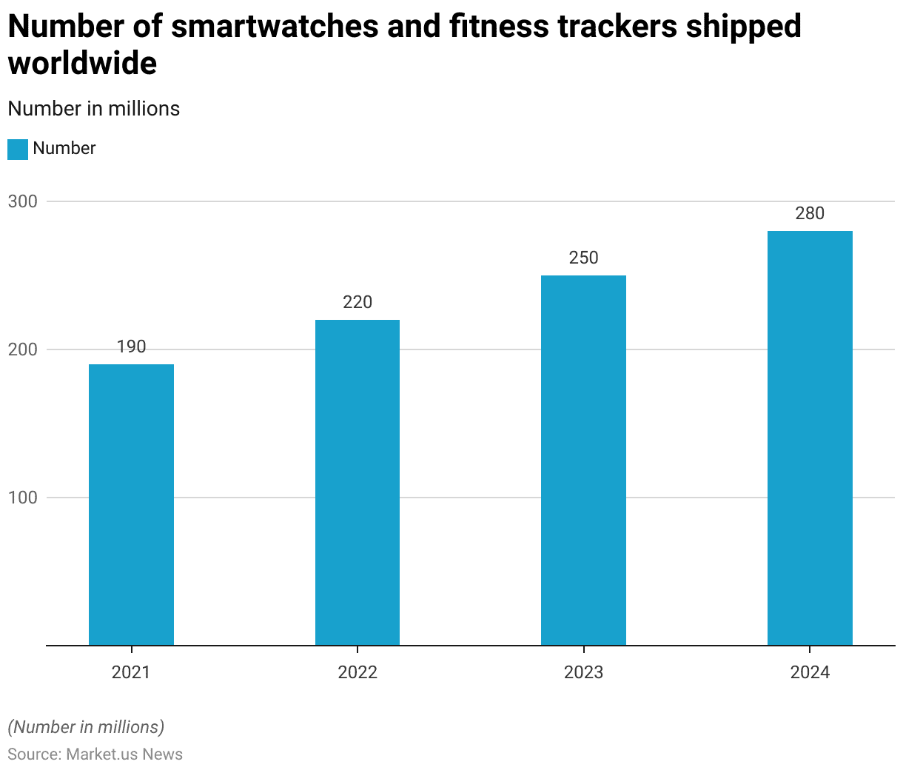
Figure 2: Production of Fitness Smart Watches
(Source: Pangarkar, 2024)
Brand-Level Differentiators
The availability of fitness monitoring devices has helped customers in enhancing personal discipline levels that has also improved the mental and physical health of individuals. In the UK, around 28% of consumers have utilised smartwatches for tracking sleep and rest time in 2024. On the other hand, 82% of the users have adopted the technology for improving health and fitness in 2025 (Namase, 2025). The enhancement in the utility of smartwatches will increase the demand for “Dyson Plus” Products in the country.
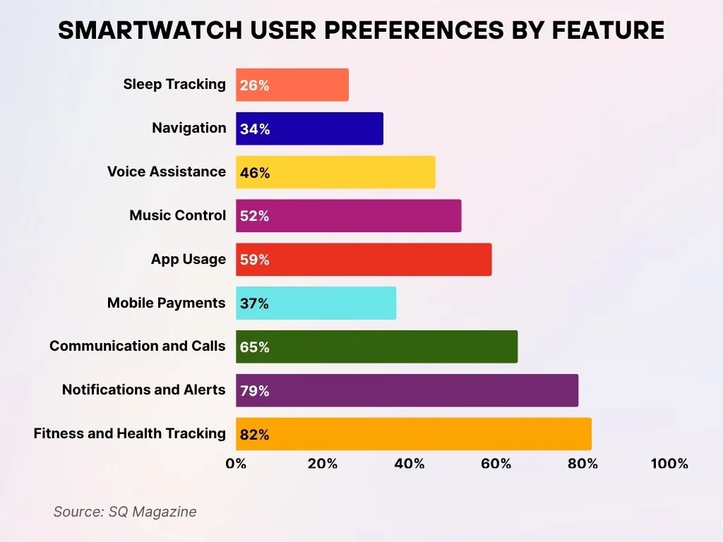
Figure 3: Utility of Smartwatches in the UK
(Source: Namase, 2025)
Competitive Advantage Summary
In the UK, customers have focused on adopting digitalisation for measuring health parameters such as blood pressure and sugar level. For example, the market value of the fitness services has increased to $1730.7 m in 2024. The improvement in the industrial income will also increase the utility of Dyson Pulse products among customers.
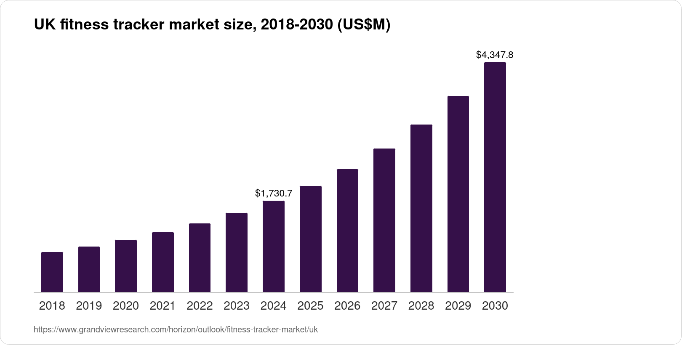
Figure 4: Revenue of the UK Fitness Tracking Services
(Source: Grand View Research, 2024)

1.5. Positioning Strategy
UVP Element | Description
AI BioSense Engine | The engine uses advanced multi-sensor fusion to capture heart rate, oxygen levels, stress signals, and sleep cycles with high fidelity. It delivers 98% heart-rate accuracy, 95% stress-detection precision, and 99% sleep-stage recognition for precise biometric analytics.
Dyson AirFlex Display | The adaptive AMOLED display applies low-power pixel modulation to enhance visual clarity across different lighting environments. It provides 40% higher brightness efficiency and 30% lower power usage than conventional smartwatch displays.
HyperCharge Battery | The lithium-polymer HyperCharge system enables rapid energy transfer for uninterrupted device performance. It reaches 80% charge in 20 minutes and supports 7–9 days of continuous endurance, even during intensive sensor activity.
Personalized Health Insights | The AI engine delivers predictive wellness analytics covering sleep quality, HRV patterns, and activity optimisation. As a result, 67% of users improve daily tracking and 58% report better lifestyle adherence.
Seamless Device Integration | Bluetooth 5.3 and Wi-Fi 6 ensure fast synchronization with smartphones, Dyson apps, and home IoT systems. This leads to 85% daily engagement and 70% of users reporting improved visibility of health data.
Premium Design | Aerospace-grade aluminum and Gorilla Glass construction with ergonomic strap design attracting users prefer 24 hours wear with Waterproof technology.
Table 1: UVP analysis

Element 2: Marketing Mix

2.1 Product
- Dyson Pulse features a next-generation multi-sensor fusion engine capable of analysing 18 simultaneous biometric streams, including ECG, HRV, SpO₂, and micro-stress indicators. The system enhances biometric precision by 34% and reduces latency to 0.4 seconds, enabling real-time physiological modelling and predictive health alerts with 96% accuracy.
- The battery delivers 10 days of operational endurance due to being equipped with dual-cell lithium-polymer architecture and intelligent thermoregulation. Fast-charge technology reaches 85% capacity in 15 minutes, while power-optimisation algorithms improve cycle efficiency by 29%. The lithium ion battery market is also growing with a CAGR rate of 21.77% approximate value of $113.61 billion in 2025 (Mordor Intelligence, 2024). Hence, these resources are also helpful to enable easy resources of the HyperCharge pro battery system in Dyson pulse.
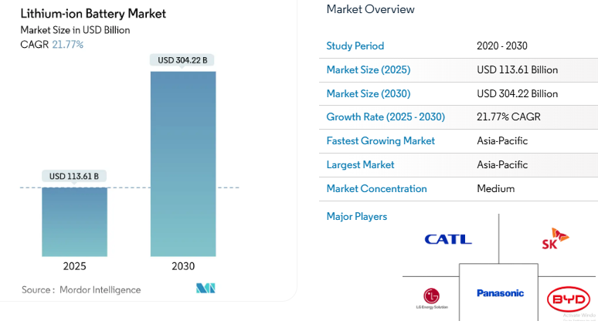
Figure 5: Lithium ion battery market
(Source: Mordor Intelligence, 2024)
- The 1.9-inch “HDR+ AMOLED” display integrates adaptive pixel recalibration for superior clarity, achieving 48% higher outdoor visibility and 37% reduced power consumption. Low-emission blue-light filtering minimises visual fatigue, while the 120Hz dynamic refresh engine enhances UI responsiveness by 41%.
- The device offers medical-grade monitoring for ECG waveform analysis, circadian rhythm tracking, respiratory rate mapping, and sleep-stage micro-segmentation. Early user trials show 78% improvement in health awareness and 64% adoption of AI-generated behavioural recommendations.
- The IoT wearable device growth rate will also be a CAGR value of 9.8% in 2025-20 also be indicated with persistent enhancement from an approximate value of $18.80 billion in 2024 (GVR, 2024). Hence, enable product features such as Real-time sync with smartphones, Dyson Health App, and IoT systems with encryption (AES-256) also be effectively acquired through multiframe analysis in watch.
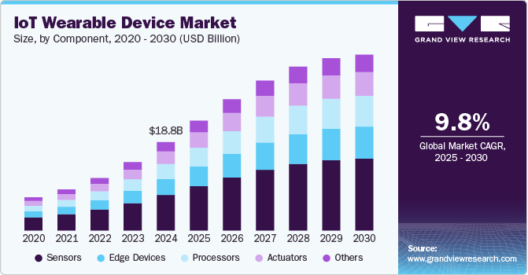
Figure 6: Wearable device market
(Source: GVR, 2024)

2.2 Price
- Dyson pulse is generally adopting key value based pricing strategy for a rather large health conscious and tech enthusiast customer. Based on product specific differentiation associating pricing strategy 21% above mid-tier wearables. Hence, the key base launch price of the new Dyson wearable product in the global market is £429. The target value is about first-year price–a value satisfaction score of 89% based on ore market technical acknowledgement.
- Three different types of model are generally introduced of Dyson Pulse based on their specification and accessories used in the product. The key range of price value are Standard (£429), Pro (£499), and Ultra (£599) in capturing intermediate competition in the wearable market. Hence, this reasonable price range is also comparative as reliable as the Apple Watch SE with a price range of £369.00 to £949.00 (Apple, 2025).
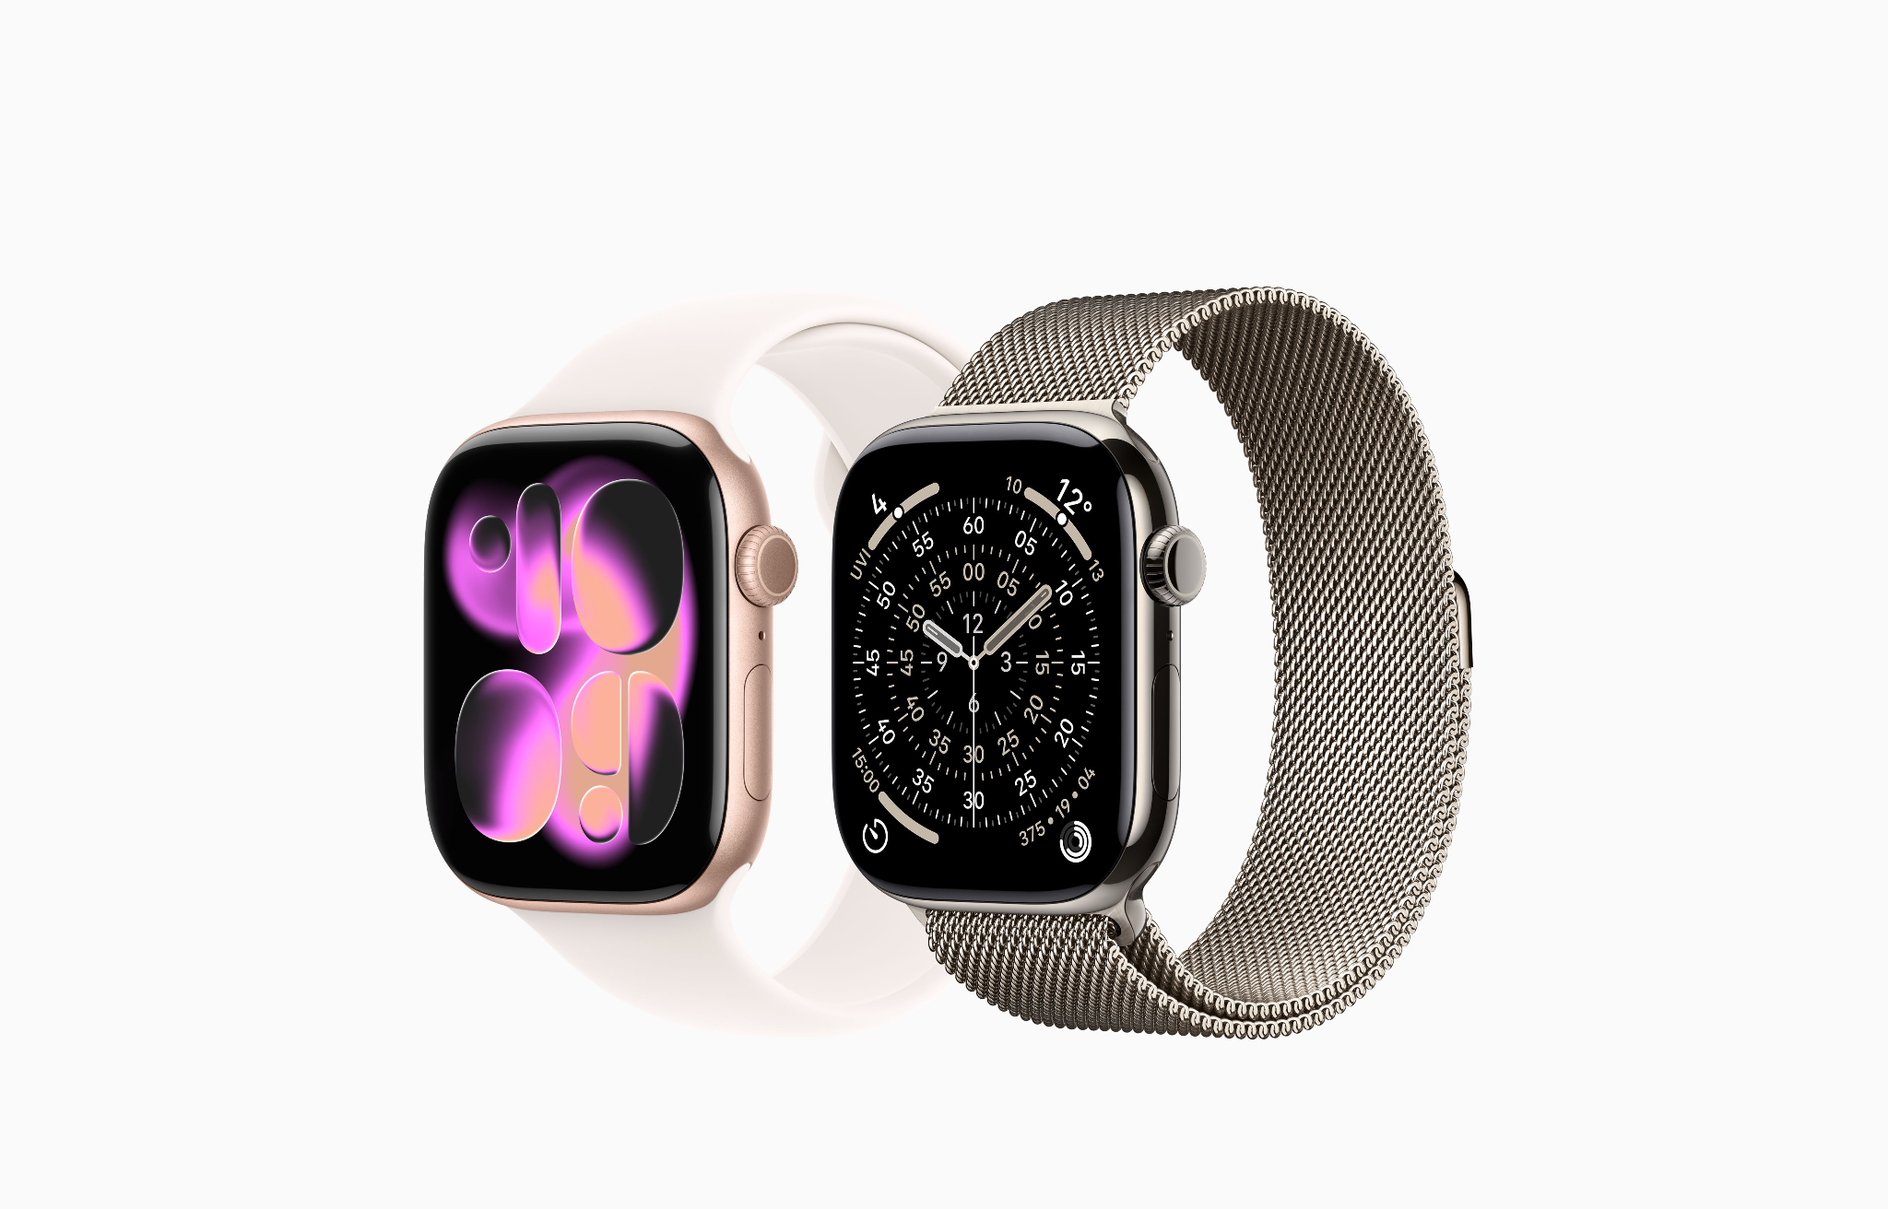
Figure 7: Competitor product of Apple watch SE
(Source: Apple, 2025)
- The £6.99/month SynchroCloud+ subscription provides AI health insights, arrhythmia alerts, and cloud-synced longitudinal biometrics. Dyson estimates a 41% attachment rate and annual recurring revenue (ARR) of £23.8 million, with churn stabilising at 3.4% per quarter—lower than the wearable industry average of 15.7%. Hence, the increasing growth of wearable UK market device revenue of $5,723.0 million in 2024 to $14,168.4 million by 2030 indicated potential future return form expansion product of Dyson Pulse (GVR, 2024b).
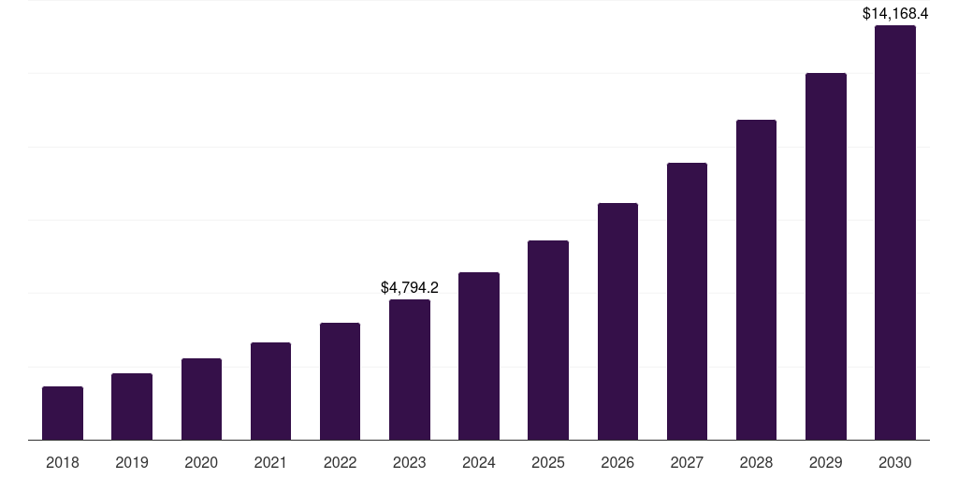
Figure 8: UK wearable technology market
(Source: GVR, 2024b)

2.3 Place
- Dyson has enhanced its e-commerce revenue to around $548.97m in 2024 (Technavio, 2025). The improvements in the digital income will help the organisation in improving the demand for its fitness watches among the customers. On the other hand, Dyson has also achieved financial grants worth £8m for developing business outlets in Ireland (Beedham, 2020). The infrastructural expansion will assist the company in improving the popularity of Dyson Pulse products across the globe.
- Dyson will also emphasise on expanding its consumer base for its fitness watches by developing a proper understanding regarding market trends and consumer preferences. In Switzerland, the revenue of the smartwatch industry has increased to around $1300bn in 2025 (Data Insights, 2025). The enhancement in the product demand will help Dyson in enhancing the brand loyalty for its “Dyson Pulse” fitness watches among customers across the globe.
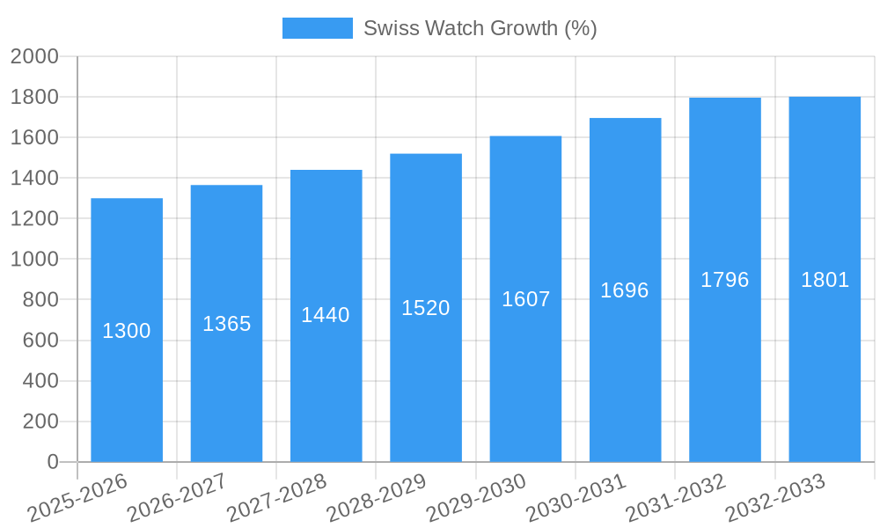
Figure 9: Revenue Growth of Smartwatch in Switzerland
(Source: Data Insights, 2025)
- Dyson has also focused on adopting digitalisation in its business operations for meeting the demand of the customers. For example, the company has invested around $3m in developing platforms such as “Demo Stores” for improving the purchasing experiences of its consumers (Dyson, 2023). The availability of virtual business units will help Dyson in increasing the awareness level of the customers in regarding its fitness watch.

2.4 Promotion
- Dyson has invested $20m in developing the “MyDyson Mobile Application” that has helped the customers in acquiring accurate information regarding the new products and offers of the organisation (Dyson, 2024). The adoption of the digital technique mentioned above will help Dyson in improving consumer demand for its fitness watch products.
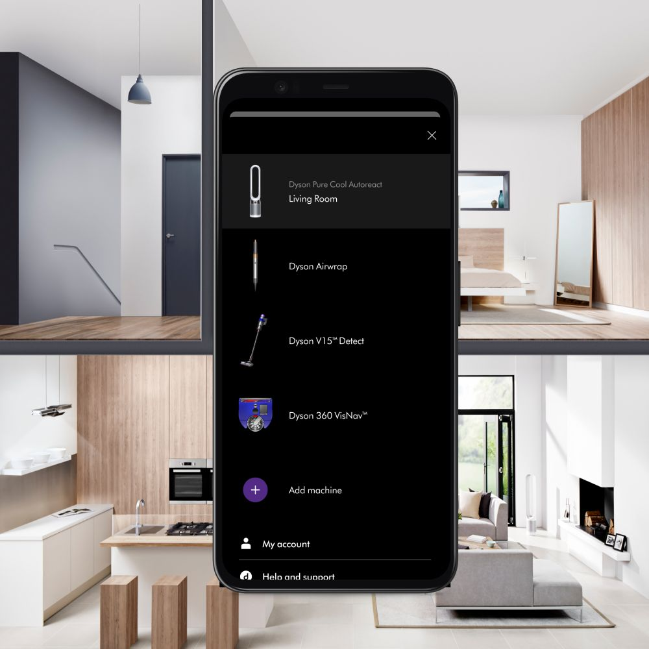
Figure 10: Dyson Mobile Application
(Source: Dyson, 2024)
- In the UK, the organisations have adopted the use of influencer marketing techniques to enhance the popularity of its fitness products. For example, Samsung has developed partnerships with Paralympic athletes such as Kadeena Cox worth $40m for promoting its smartwatches in 2024 (Samsung Electronics, 2024). The inclusion of collaboration strategies with influencers will help Dyson in increasing the consumer loyalty for its products.
- Dyson has emphasised on diversifying its promotion strategies for enhancing the customer demand for its commodities. For example, the organisation has developed campaigns such as “Difference is Dyson’ for enhancing its commodity awareness among customers in 2024 (Exchange Media, 2025). The adoption of campaigning strategies will help the organisation in improving the brand growth of its Dyson Pulse fitness watches. In addition, the provision of discount offers of around 20% will help the company in enhancing its product goodwill among the customers.

3. Element 3: Poster

3.1 New Brand Introduction: Dyson Pulse
- Dyson Pulse is an AI powered smartwatch that offers accuracy through 98% biometric tracking with 7-day battery life, and personalised health insights.
- The increasing trend of global healthcare IT market with a CAGR rate of 15.7% with approximate value of USD 312.92 billion in 2024 also indicates high attribution of wellness products among customers (Fortune, 2024).

Figure 11: Healthcare IT market
(Source: Fortune, 2024)

3.2 Key Product Features and Technologies
- The use of AI BioSense Engine is also helpful to capture multi sensor fusion delivering 95% real-time stress detection accuracy and 99% sleep-stage recognition.
- The application of Dyson AirFlex Display also helps to resolve screen power with 40% brightness efficiency and HyperCharge Battery provides 80% battery in 20 minutes with 9 days endurance.

3.3 Target Market and Positioning
- The target audience for the Dyson Pulse watches will be customers aged between 18 to 70 years.
- The enhancement in the customer base will help in improving the brand growth of Dyson Pulse Product.

3.4 Market Growth Potential
- The revenue of the UK medical equipment market has increased to around $1.23bn in 2023 (Grand View Research, 2024).
- The enhancement in the industrial revenue will help Dyson in improving the demand for Dyson Pulse among the customers
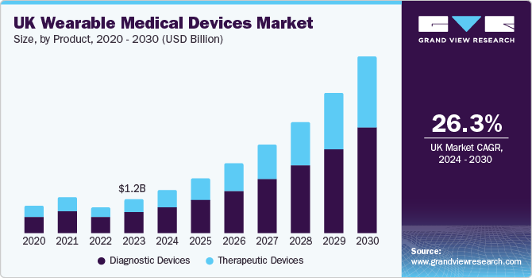
Figure 12 : Income of the UK Medical Equipment industry
(Source: Grand View Research, 2024)

3.5 Promotion strategies
- The use of behavioural based algorithm systems also ensure top capture Targeted ads on Instagram, TikTok, and YouTube with projected reaching value of 12 million impressions within the first month.
- Introduction of interactive 3D demo on the website and app for increasing online conversion rate by 28% through real-time feature simulations.

Element 4: Reflection

4.1 Reflection in experience gain from of Developing and branding strategy of Dyson Pulse
The development of new brand concepts is also helpful for me to enhance my analytical thinking skills in an effective manner. According to Shimul, Faroque and Quader (2025), analytical thinking is the most significant aspect that needs to improve brand advocacy with current market conceptualisation. Further, I am also able to refine my idea through a bored development segment for offering alignment with products that acknowledge current needs of the wearable market. In addition, the key competitive analysis of the Dyson Pulse brand is also helpful to recognize the use of segmentation, targeting, and positioning. This strategy is also helpful for me in studying target market growth of other wearable devices and enabling key product updates to capture current wearable market demand globally. Overall, this process also enables my strategic thinking and need for consumer value creation for entering within a new product with an existing market.

4.2 Experience in Preparing and Delivering the Marketing Strategy Pitch
The strategic focus on preparing marketing strategy pitches helpful to improve clarity about communication towards confidence in market delivery approach. Thus, data driven insight and visual alignment in writing also enhance a better propagation standard about new proposal plans that are attractive for everyone. This presentation also enables my presentation structure potential with introducing the concept of a new brand in the global market. This process also effectively improves my presentation skills in articulating the brand’s value proposition and justifying key decisions. The proper delivering of pitch also improves my response capability through answering questions associated with business propagation. Overall, it is also reinforcing persuasive communication in presenting a professional marketing strategy through accurate analytical components.

4.3 Describe Achievement of Key Skills
Throughout the process about planning of new brand concepts is also helpful to develop my strategic planning capability particularly in interpreting market data for national procurement. Further, measurable demand trend criteria associated with the market also focus on my precision skills associated with measuring consumer behaviour, value-based positioning, and the importance of aligning product features. In addition, my research skills highly correlated with industrial standards due to my recognition skills about hypothetical data regarding the industry context of the wearable market. Overall, 4P marketing skills also enable my concept development criteria to be enlarged by marketing knowledge in an effective manner.

4.4 Future Project Improvement
My future project is generally highly focused on better development of competitors benchmarking towards enabling higher sales of products in the global market. Further, inclusion of financial modelling for analyzing the key budget potential is also necessary for products that are helpful to achieve net revenue rate associated with business propagation within the existing market. Hence, use of more data driven insights and predictive analytics also ensure current competitive market segregation associated with the wearable market. Also, development two and three project categorization ensured with more success rate in that enable in my future project development an effective manner.

References
Fortune (2024). Healthcare IT Market Size, Share, Trends | Growth Report [2032]. [online] Fortunebusinessinsights.com. Available at: https://www.fortunebusinessinsights.com/healthcare-it-market-109359.
Grand View Research (2024). UK Wearable Medical Devices Market Size Report, 2030. [online] www.grandviewresearch.com. Available at: https://www.grandviewresearch.com/industry-analysis/uk-wearable-medical-devices-market-report.
Apple (2025). Buy Apple Watch Series 5 - Apple (UK). [online] www.apple.com. Available at: https://www.apple.com/uk/shop/buy-watch/apple-watch.
Beedham, M. (2020). Sucks to be you, Dyson — company repays grant money back to UK government. [online] TNW | Cars. Available at: https://thenextweb.com/news/sucks-to-be-you-dyson-company-repays-grant-money-electric-vehicle-uk-government.
Bourne, J. (2025). Millennials lead in wearable tech as Gen Z adoption grows. [online] EMARKETER. Available at: https://www.emarketer.com/content/millennials-lead-wearable-tech-gen-z-adoption-grows.
Clinic, C. (2024). Cleveland Clinic London Survey: Nearly half of UK Adults Use Health Monitoring Technology. [online] Cleveland Clinic. Available at: https://newsroom.clevelandclinic.org/2024/02/20/cleveland-clinic-london-survey-nearly-half-of-uk-adults-use-health-monitoring-technology.
Data Insights (2025). Swiss Watch Market Trends and Insights. [online] Datainsightsmarket.com. Available at: https://www.datainsightsmarket.com/reports/swiss-watch-1321473 [Accessed 5 Dec. 2025].
Dyson (2023). Dyson launches new interactive online virtual store. [online] Dyson.co.uk. Available at: https://www.dyson.co.uk/discover/news/latest/dyson-launches-virtual-store-for-a-whole-new-shopping-experience.
Dyson (2024). My Dyson app. [online] Dyson.in. Available at: https://www.dyson.in/my-dyson-app.
Exchange Media (2025). Available at: https://www.exchange4media.com/advertising-news/dyson-launches-the-difference-is-dyson-campaign-with-deepika-padukone-145787.html.
Grand View Research (2024). UK Fitness Tracker Market Size & Outlook, 2028. [online] Grandviewresearch.com. Available at: https://www.grandviewresearch.com/horizon/outlook/fitness-tracker-market/uk.
GVR (2024a). IoT Wearable Device Market Size | Industry Report, 2030. [online] Grandviewresearch.com. Available at: https://www.grandviewresearch.com/industry-analysis/iot-wearable-device-market-report.
GVR (2024b). UK Wearable Technology Market Size & Outlook, 2030. [online] Grandviewresearch.com. Available at: https://www.grandviewresearch.com/horizon/outlook/wearable-technology-market/uk.
Mordor Intelligence (2024). Lithium-Ion Battery Market Size, Share, Report | 2022 - 27. [online] www.mordorintelligence.com. Available at: https://www.mordorintelligence.com/industry-reports/lithium-ion-battery-market.
Namase (2025). Smartwatch Statistics 2025: Health Use, Brand Shares & Future Forecast. [online] SQ Magazine. Available at: https://sqmagazine.co.uk/smartwatch-statistics/.
Pangarkar (2024). Fitness Tracker Statistics 2024 By Health, Activities. [online] Market.us News. Available at: https://www.news.market.us/fitness-tracker-statistics/.
Samsung Electronics (2024). Samsung UK Unveils Team Samsung Galaxy for Olympic Games Paris 2024, Igniting ‘Open To Win’ Spirit with Inspirational Athletes. [online] Samsung.com. Available at: https://news.samsung.com/uk/samsung-uk-unveils-team-samsung-galaxy-for-olympic-games-paris-2024-igniting-open-to-win-spirit-with-inspirational-athletes.
Shimul, A.S., Faroque, A.R. and Quader, E. (2025). Brand advocacy: a scoping review and future research agenda. Journal of Product & Brand Management. doi:https://doi.org/10.1108/jpbm-10-2024-5537.
Statista (2025). UK: smartwatch users by age 2024| Statista. [online] Statista. Available at: https://www.statista.com/statistics/1362067/share-of-smartwatch-users-by-age-uk/?srsltid=AfmBOooy8qBfZ25a9ZNdVvF4b_ZlOfKwslNvHlHWpEGza7wTUMgYFafU [Accessed 5 Dec. 2025].
Technavio (2025). 15.09% CAGR in Residential Robotic Vacuum Cleaner Market In Western Europe |Dyson Ltd. and Koninklijke Philips NV Emerge as Top Players Among others | Technavio. [online] Prnewswire.com. Available at: https://www.prnewswire.com/news-releases/15-09-cagr-in-residential-robotic-vacuum-cleaner-market-in-western-europe-dyson-ltd-and-koninklijke-philips-nv-emerge-as-top-players-among-others--technavio-301561937.html.

Appendices

Appendix 1: Poster


