EXAMINATION SOLUTIONS
(to accompany the examination paper sent to the external examiner
but NOT to be seen by students)

Programme: | HN/BSc Computer Networks | Level: | 4
Module: | ACCA4001 COMPUTER ARCHITECTURE and NETWORKS
Author: | Dr Kapilan Radhakrishnan  Mr Gareth Jones | Sem: | 2  May 2018

Q 1 | Question | Marks
a | a) Convert the following decimal numbers to Binary (3 marks each)  - 56 111000  - 163 10100011  b) Convert the following binary numbers to base 10 (3 marks each)  - 11100110 = 230  - 01010011 = 83  c) Convert the following hex numbers to binary (2 marks each)  - 8B 10001011  - A7 10100111  d) Convert the following Hex numbers to decimal (3 marks each)  - 23 35  - EF 239  e) How many different/unique values can be represented by a 4 bit number? (2 marks)  2^4=16  f) You are designing a full colour header graphic of dimensions 200*800 pixels where each pixel can be one of 16 million colours. Calculate how much memory storage it would occupy if you saved it in an uncompressed .BMP format (3 marks)  800*200=160000 pixels. 16million col=3 bytes/pixel. Total storage = 480KB  g) Give an approximate figure for how much memory storage one typical page of A4, 12 point text might take up. Explain your reasoning’s and show all your calculations (3 marks)  e.g. 80 chars per line, 30 lines per page = 2400 chars max. Simple 8bit ASCII=1byte per char (double for Unicode), so 2.4KB max storage, but taking white space into account, typically more like 2KB per page.

Q 2 | Question | Marks
- Produce a labelled diagram showing the construction of a typical rotating hard disk (5 marks)
By referring to this diagram, explain its basic method of operation (5marks)
Similarly, explain what the specifications ‘Average access time’, ‘sustained transfer speed’ and ‘burst transfer speed’ refer to. (3 marks)
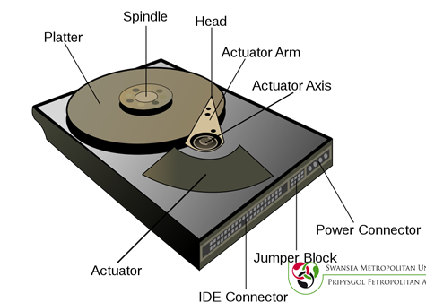

5 marks for diagram
5 marks for accurately describing the constituent parts and operation.

Seek Time - Time to position Head.
Rotational Latency - Time to reach start of a sector.
Access Time therefore = Sum of Seek time and Rotational Latency (1 mark)

Sustained data transfer – the speed at which data can be continuously read off the disk (1 mark)
Burst transfer – the max speed at which data can be read directly from the drives cache down the IDE/SATA lead. (1 mark)

How does a Solid State Drive (SSD) differ from a conventional rotating hard disk? State two advantages and one disadvantage of SSDs over conventional Hard Disks. (7 marks)

SSD comprises solid state flash memory, much like a USB pen drive. ( 1 mark)

Advantages:
No moving parts so more robust
Can be designed to give higher data transfer speeds
Much lower latency
Can be smaller
(2 to be provided – 2 marks each = 4 marks total)

Disadvantage:
Currently more expensive per unit storage.
(2 marks)

Q 3 | Question | Marks
 |  | Each 1 mark
  Q no | Question | Answer
  1 | An advantage of the peer-to-peer network model is | Ease of setup
  2 | Which term is used to refer to a Layer 2 PDU?​ | Frame
  3 | Which type of Ethernet cable should be used to directly connect two devices that both use the same pins for transmitting and receiving data? | Crossover twisted-pair
  4 | How many binary bits exist within an IPv6 address? | 128
  5 | An example for global routable IP address | 200.165.200.215
  6 | A _______ centre is a facility used to house computer systems in an enterprise network. | data
  7 | At which layer of the TCP/IP model does TCP operate? | Transport
  8 | What role does a router play on a network? | selecting the path to destination networks
  9 | What type of program installs and gathers personal information, including password and account information, from a computer without permission or knowledge of the user? | spyware
  10 | What type of device is commonly connected to the Ethernet ports on a home wireless router? | LAN devices
  11 | Records where each host is located and how it is connected to the network | Physical network topology
  12 | What terms represent the maximum and actual speed that can be utilized by a device to transfer data? | bandwidth; throughput
  13 | Which type of attack involves an attacker using a powerful computer to try a large number of possible passwords in rapid succession to gain access to a system​? | Brute force
  14 | ________ protocol operate at the application layer of the OSI model? | SMTP
  15 | Transfer a photo to another phone by touching the two devices to each other | NFC
  16 | ________is a private IP address | 10.1.1.1
  17 | _____ provide secured virtual terminal access to remote servers. | SSH
  18 | Uses acknowledgements to guarantee delivery | TCP
  19 | Which IP configuration parameter provides the IP address of a network device that a computer would use to access the Internet? | default gateway
  20 | What type of attack is the ping of death? | DoS
  21 | What is a "best effort" protocol well suited for streaming audio and VoIP? | UDP
  22 | The process of adding additional information to the pieces of data that make up the message in order to ensure that it is delivered to the correct application on the correct destination host | Encapsulation
  23 | What type of message is sent to a specific group of hosts? | multicast
  24 | _________ is a broadcast Ethernet frame | FF:FF:FF:FF:FF:FF
  25 | Hardware that enables the device to connect to the network medium, either wired or wireless | Network Interface Card (NIC)
  26 | Which type of network model describes the functions that must be completed at a particular layer, but does not specify exactly how each protocol should work? | reference model
  27 | Port 80 is well known port for the _________ server application | HTTP server
  28 | Term used to describe the global IP network that results from the interconnection of many independently owned networks | Internet
  29 | What type of server would use IMAP? | email
  30 | Which destination IPv4 address does a DHCPv4 client use to send the initial DHCP Discover packet when the client is looking for a DHCP server? | 255.255.255.255
Q 4 | Question
a  b  c  d  e | A computer network is defined as two or more computers connected together to share information and resources.  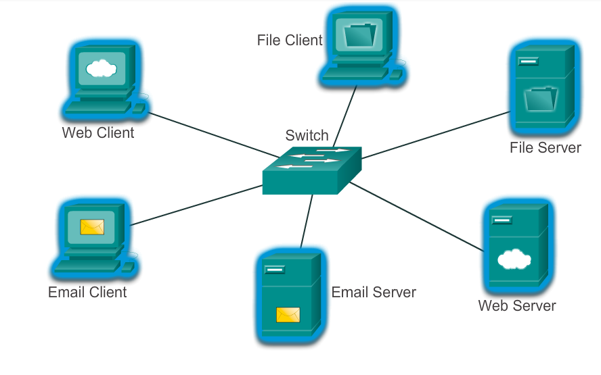  Advantages:  Easy to set up  Less complexity  Lower cost since network devices and dedicated servers may not ne required  Can be used for simple tasks such as transferring files and sharing printers  Disadvantages:  No centralised administration  Not as secure  Not scalable  All devices may act as both clients and servers which can slow their performance  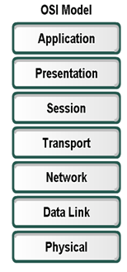  Access Layer – This layer provides connections to hosts in a local Ethernet network.  Distribution Layer – This layer interconnects the smaller local networks.  Core Layer – This layer provides a high-speed connection between distribution layer devices.  - 11000000.10101000.00011010.00100110  - 10101100.11001000.01001110.11111110  - 11111111.11111111.11111111.11110000 | 3  3 marks  3 marks  7 marks  2 marks each  1 mark each
 |  | 100

