Student Name:
Lachezar Georgiev Dimitrov

Student Number:
1915922

Proposed research title:
Challenges and opportunities for reducing the carbon footprint in the UK construction industry

Name of the University:
University of Wales Trinity Saint David

Submission date:
23.08.2024 – 15.09.2024

Table of Contents
CHAPTERT 1: INTRODUCTION 2
Talk about the topic 2
Significance of the topic 3
Purpose of the research 3
CHAPTER 2: LITERATURE REVIEW 4
Importance of Reducing Carbon Footprint in the Construction Industry 5
Challenges of Reducing Carbon Footprint in the Construction Industry 6
CHAPTER 3: RESEARCH METHODS AND METHODOLOGY 8
REFERENCES 8

CHAPTERT 1: INTRODUCTION

Talk about the topic

The construction industry is one of the biggest contributors to global GHG emissions, particularly carbon dioxide. The contribution to GHG emissions is mainly CO2, in terms of a percentage, at about 76.4% of the total GHG emissions. Its main sources include burning fossil fuels, land-use changes, predominantly deforestation, and industrial processes (Chai et al., 2022). A huge part of its carbon footprint comes from the production and transportation of raw materials like steel, cement, and asphalt, which are very energy-consuming with large amounts of CO2 emissions. Construction in the UK accounts for a significant proportion of the nation's total carbon emissions, which already creates one of the most severe barriers to attaining climate objectives.

The urgency in cutting CO2 is for mitigating global warming, with the earth having already heated up 1.2 degrees Celsius in the last decade. The environmental impact of construction's carbon footprint goes beyond borders; for instance, countries like Brazil and China are large contributors through steel and cement production, respectively. Increasing pressure is being put on the UK construction industry for low-carbon material adoption, energy efficiency, and reuse and recycling.

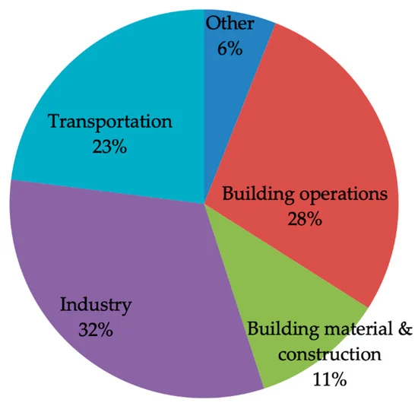
Figure: World carbon emission

Significance of the topic

The reduction of the UK's carbon footprint in its construction industry is immense, relating both to environmental sustainability and economic resilience. It is expected that construction will represent about 39% of global carbon dioxide emissions (Misopoulos et al., 2019). Therefore, with the UK having set its target for net-zero emissions by 2050, the carbon footprint of this sector becomes very critical to reduce. There are so many advantages associated with reducing CO2:. It will reduce, to a great extent, greenhouse gases at a global level, hence slowing down the likely effects of climate change such as adverse weather conditions and loss of biodiversity. Besides, it will enhance air quality and public health by developing construction sustainably. Economically, low-carbon construction can foster innovation and open up new business opportunities. Such investments in green technologies can lead to long-term savings and make the UK construction industry comparative and competitive, leaders in best practice, and stand out in the international markets. However, such has not been the case in this process of transition to low-carbon construction: high technology costs, workforce retraining needs, likely supply chain disruptions. Only after having faced such challenges it has been possible to address them and come up with effective strategies that facilitate the transition to low-carbon construction.
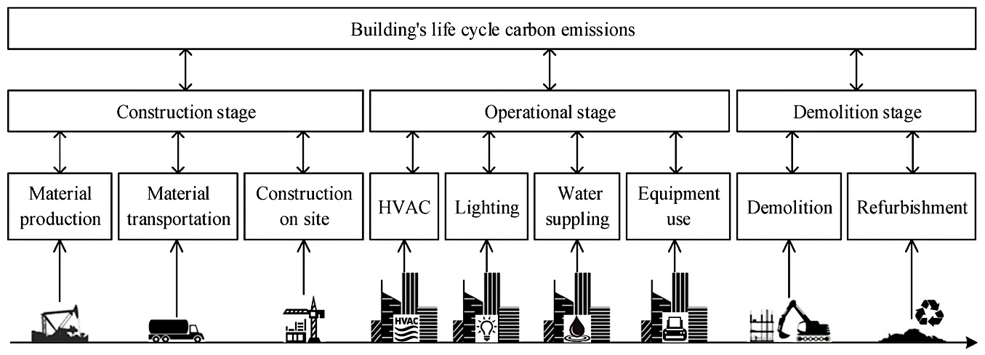

Purpose of the research

The present paper thus researches and analyzes the drivers and challenges affecting the reduction of carbon emissions in the UK's construction industry. The aim is to develop an in-depth understanding of the environmental, economic, and operational consequences of adopting low-carbon practices within the construction sector. Specifically, it is about how changing over to sustainable processes—of which use of alternative raw materials, increasing energy efficiency, and enhancing recycling processes will decrease the carbon footprint of the industry.
Aim

This paper seeks to identify the motivators and challenges in the reduction of CO2 footprint within the UK Construction Industry.

Objectives

- Identify the motivators for reducing CO2 emissions in the construction sector.
- Analyze the challenges associated with reducing CO2 emissions in the industry.
- Provide recommendations for reducing the CO2 footprint in the UK construction industry.

Research Question

“What are the challenges and opportunities for reducing carbon footprint in the UK construction industry, and how could they be addressed to achieve sustainable development?”

CHAPTER 2: LITERATURE REVIEW

The carbon footprint in the construction industry is the total amount of greenhouse gases that are related to a building or infrastructure project over its entire lifecycle. It represents all the emissions from raw material extraction and processing, manufacture of construction products, transport of materials, on-site construction activities, and buildings' operational energy use during their lifetime. It is usually expressed in terms of carbon dioxide equivalents, which capture the differential global warming potential of various GHGs, including methane and nitrous oxide.

The construction industry in the UK has a share of approximately 25% in the nation's total emissions of GHG. This represents the whole life cycle of the building: from material production to construction, use phase, and eventual demolition. Consider this: the carbon emissions embodied in materials used in construction run at about 40 to 50 million tonnes of CO2 annually (Hanifa et al., 2023). This is equivalent to more than the combined emissions from aviation and shipping. The imperative to act in respect of these emissions is furthered by the sixth Carbon Budget, mandating that the UK reduce its emissions by 78% by 2035 and committing it to net-zero emissions no later than 2050.

Most of the carbon emissions from the construction industry result from energy-intensive construction materials like cement, steel, and asphalt, among others. For example, the production of cement is responsible for about 8% of CO2 emissions worldwide (Andrew, 2018). The materials, especially if transported over long distances, will also contribute to their carbon footprint.

Importance of Reducing Carbon Footprint in the Construction Industry

- Environmental Impact

Construction is the principal liquidator of the greenhouses that result, responsible for nearly 39% of all GHG emissions across the globe, including those involved in erecting as well as the logistic support for running the structures. Now, buildings are the consumers of 40% of the materials and approximately 40% of primary energy sources. During their management, they emit 40% of the produced waste within the European Union. Furthermore, buildings account for 33 percent of global energy use, with likely emissions from the construction sector on the rise from 8.6 billion tons of CO2 equivalent in 2004 to 15.6 billion tons by 2030, a rise of 26 percent (Sizirici et al., 2021).

- Economic Considerations

Economic implications of reduced carbon emissions in construction still remain very high. The construction industry is one of the key sources, and carbon from construction rates at almost 11% globally; therefore, big reductions in the emission rates would automatically translate into high economic impacts. Buildings that use sustainable practices such as energy-efficient designs and low-carbon materials translate into operational cost savings. For example, it would reduce the amount of money that is paid as energy bills for many building owners and contribute to good financial performance. Construction can also leverage the increasing ESG-investment trend, where companies having a high record of sustainability are favored for investment.

- Regulatory Framework

There are strong economic implications for low-carbon construction. Construction accounts for almost 11% of worldwide carbon emissions (Davda, 2024), therefore big cuts in these areas may lead to very significant economic benefits. Among the sustainable practices which lower operation costs for buildings are energy-efficient designs and application of low-carbon materials. For example, an increasing share of energy-efficient systems implies reduced energy use, lower utility bills, and an improved bottom line for building owners. Another avenue to tap into is the rising trend in ESG investing, where firms with sound sustainability practices have tended to be favored by investors.

- Technological Innovations

Reduction of the carbon footprint in construction depends mainly on technological innovation. This includes a number of steps that would go a long way in optimizing the usage of resources and reducing waste, such as BIM and use of energy-efficient equipment. According to one study, in Xiamen, China, the carbon footprint of urban buildings rose from 8.95 million tons in 2005 to 13.57 million tons in 2009; of these, building material production accounted for about 45% of CO2 (Li et al., 2022), while energy consumption by buildings accounted for about 40%. Transitioning to electrically powered construction equipment can reduce emissions by a huge extent, especially if coupled with renewable energy sources .

Challenges of Reducing Carbon Footprint in the Construction Industry

- High Initial Costs

Some of the low-carbon technologies involve huge upfront costs that usually scare most employed contractors and building owners away. For example, RICS (Royal Institution of Chartered Surveyors) estimates it to be 10% to 20%, while installing low-carbon technologies. Many of the corporate businesses bank on realizing quick financial returns, and it is next to impossible to make an investment appeal in favor of a long time money-saving approach at a point when the initial investment requirement is quite high.

- Lack of Awareness and Expertise

There is little awareness or capability relating to carbon reduction strategies in construction. In a survey by McKinsey & Company, 70% of the construction community responded that it did not have adequate knowledge about the tools and techniques of sustainability. This gap fuels the inertia and results in very slow diffusion of innovation.

- Fragmented Industry Structure

By its very nature, the construction industry is fragmented. Parties involved—from architects through engineers to contractors and suppliers—often have different priorities in their quest toward sustainability. With more than 300,000 businesses making up the UK construction sector, collaboration will prove hard to achieve, suggests the Construction Industry Training Board.

- Regulatory Barriers

Current UK regulation has focused on operational emissions; very little has been paid to the embodied carbon associated with material production, construction, and demolition. The embodied emissions account for approximately 40-50 million tonnes of CO2 annually, yet there is no mandatory requirement for them to be assessed or controlled. According to the Committee on Climate Change, if not dealt with, the share of embodied carbon could represent 50% of the total from new buildings by 2030.

CHAPTER 3: RESEARCH METHODS AND METHODOLOGY

REFERENCES

- Andrew, R. M. (2018). Global CO2 emissions from cement production. Earth System Science Data, 10(1), 195–217. https://doi.org/10.5194/essd-10-195-2018
- Chen, L., Huang, L., Hua, J., Chen, Z., Wei, L., Osman, A. I., Fawzy, S., Rooney, D. W., Dong, L., & Yap, P.-S. (2023). Green construction for low-carbon cities: a review. Environmental Chemistry Letters. https://doi.org/10.1007/s10311-022-01544-4
- Chai, S. Y. W., Ngu, L. H., How, B. S., Chin, M. Y., Abdouka, K., Adini, Mohd. J. B. A., & Kassim, A. M. (2022). Review of CO2 capture in construction-related industry and their utilization. International Journal of Greenhouse Gas Control, 119, 103727. https://doi.org/10.1016/j.ijggc.2022.103727
- Davda, K. (2024). oizom. Oizom. https://oizom.com/how-to-reduce-greenhouse-gas-emissions-in-construction-industry/#:~:text=To%20avoid%20a%202
- Hanifa, M., Agarwal, R., Sharma, U., Thapliyal, P. C., & Singh, L. P. (2023). A review on CO2 capture and sequestration in the construction industry: Emerging approaches and commercialised technologies. Journal of CO2 Utilization, 67, 102292. https://doi.org/10.1016/j.jcou.2022.102292
- Li, N., Mo, L., & Unluer, C. (2022). Emerging CO2 utilization technologies for construction materials: A review. Journal of CO2 Utilization, 65, 102237. https://doi.org/10.1016/j.jcou.2022.102237
- Misopoulos, F., Manthou, V., & Michaelides, Z. (2019). Environmental and Social Sustainability in UK Construction Industry: a Systematic Literature Review. European Journal of Economics and Business Studies, 5(1), 100. https://doi.org/10.26417/ejes.v5i1.p100-115
- Sizirici, B., Fseha, Y., Cho, C.-S., Yildiz, I., & Byon, Y.-J. (2021). A Review of Carbon Footprint Reduction in Construction Industry, from Design to Operation. Materials, 14(20), 6094. NCBI. https://doi.org/10.3390/ma14206094

