Planning and Delivering an International Meeting/Event

Student Name: Bianca Beatrice Matal
Student ID: 2244785
Module title and Code: International Meetings Management BMIH6007
Lecturer’s Name: Kathryn Flynn
Wordcount: 2562 words

AI DECLARATION
I acknowledge the use of Grammarly (https://www.grammarly.com) on 11 June 2025 to check my whole work.
I confirm that I have not presented any AI generated text as my own work. I confirm I have copies of my draft, notes, and other resources I use before, and after the use of AI tools which I may be asked to provide in evidence.

Executive Summary
In South Wales, the events sector is grappling with major shifts, including sustainability, use of hybrid formats and community inclusion, offering opportunities but also challenges. Also, by stressing on eco-friendly practices along with virtual elements, organisers are able to reach out to larger audiences as well as minimise environmental impact and ensure that the region is seen as a pioneer in the art of hosting innovative events. These trends thus echo larger cultural aims that align with Visit Wales’ “Year of Croeso”, that is, increased Welsh heritage and community involvement. But the post COVID economic pressures such as increasing cost and workforce shortage are significant challenges. Venue and supply expenses have been raised by inflation and skilled event professionals are short so quality and deliverability is threatened.
Specifically in South Wales, economic disparity has to be tackled because events have to be kept accessible and inclusive in rural or disadvantaged areas. While all these challenges fill the region with obstacles, the region can leverage upon its strong cultural identity and local talent by incorporating community participation into the design of events. This approach is good for social cohesion and for local tourism and local economic development. Effective event feasibility is also about sound financial planning, as it includes contingency budgeting and diversification of funding sources. In its position to balance innovation with practical risk management and community focus, South Wales has a chance to deliver successful and sustainable events that celebrate its own unique culture whilst adding to regional growth.

Table of Contents
Introduction 4
The Event Cycle 4
Event Concept 5
Aim and Objectives 7
SWOT Analysis 9
Event Management 10
Planning 11
Operational Management 11
Marketing and Promotion 11
Human Resources 11
Event Budget 11
Income Projections Table 12
Expenditure Breakdown 12
Feasibility and Financial Analysis 13
Industry Trends, Issues & Impacts 13
Emerging Trends in the Events Industry 13
Current Issues Affecting Event Planning 14
Impacts on South Wales 14
Situation and Cultural Considerations 14
Recommendations 16
Conclusion 16
Reference List 17

Introduction
The “Year of Croeso” event by Visit Wales is an annual initiative to promote and celebrate the diverse culture, heritage and hospitality Wales has to offer. The term “Croeso,” which translates to “welcome” in Welsh, captures the spirit of the nation in terms of accessibility and value for visitors (Allen, 2022). The campaign is intended to drive tourism and economic development by promoting unique and distinct regional identities, talents, heritage sites and community events. The intention is to have themed experiences throughout the country that drive both domestic and international visitors, while showcasing and celebrating places, people and culture in Wales, particularly during the peak summer period. In parallel with the campaign, the potential event “Art and Culture in South Wales Swansea” is envisioned as a two-day summer event in July, dedicated to celebrating the artistic and cultural scene of Swansea, drawing together local artists, musicians, dancers, and storytellers (Arcos-Pumarola, Paquin and Sitges, 2023).

The Event Cycle
From inception to conclusion, the Event Cycle assists event administrators in the organisation and evaluation of events. Kaunisto et al. (2021) propose that the event cycle consists of five interconnected periods. This encompasses the event's inception, planning, execution, and evaluation. This approach guarantees a coordinated effort, seamless delivery, and reduced risk.
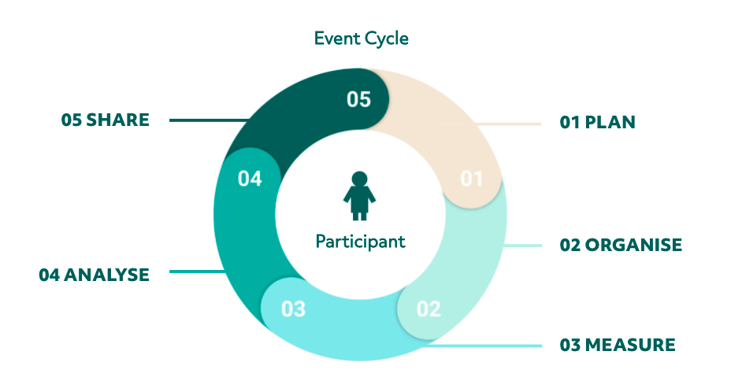
Figure: The Event Cycle
Source: (Kaunisto, 2021)
Successful event planning consists of five stages namely, initiation, planning, execution, monitoring, and closure. This structured approach was then followed in the “Art and Culture in South Wales Swansea” event. In the initiation phase, the purpose of the event was determined with relation to the ʻYear of Croesoʼ, community interested and capabilities were considered, feasibility was assessed, and the resources required were identified. The stakeholder theory referred to the importance of inviting for participation local artists, cultural organisations and infrastructure of community (Barakat and Wada, 2021). The strategic alignment theory served to establish the objectives of the project as clear, define the target audience, and the event was specifically characterised by the region identity.

Event Concept
The planned activity, “Art and Culture in South Wales Swansea”, will be held over the course of two afternoons on the 20th and 21st of July, during the height of summer tourism, and coinciding with Visit Wales’ “Year of Croeso.” The event will immerse visitors in the creative and cultural ecology of Swansea, showcasing both contemporary creativity and the strong Welsh culture and heritage.
- Day 1: Saturday, 20 July
Morning (10:00–12:30):
Art exhibitions at the Swansea Waterfront Museum with artwork from local painters, photographers, and sculptors (Ferdinand and Kitchin, 2022). There will be live demonstrations, and artist talks designed to stimulate interaction.
Afternoon (13:30–17:00):
Cultural performances in National Waterfront Museum, including traditional Welsh folk music, contemporary dance acts and community storytelling circle (Griffiths, 2021). Workshops on Celtic crafts and Welsh language basics will also be offered.
Evening (18:30–21:00):
An open-air gala dinner in National Waterfront Museum featuring local Welsh food, live acoustic music and a keynote speech from a local cultural ambassador.
- Day 2: Sunday, 21st July
Morning (10:30–13:00):
Family-focused activities, such as youth art competitions, face painting, and cultural games.
Afternoon (14:00–17:00):
Closing concert featuring emerging Welsh musicians and community choir performances.
The inclusive, fun, educational, and interactive event allows visitors to learn about Welsh heritage by talking to visiting Welsh artists and doing special activities and research about Swansea's past, present, and future, whatever makes its cultural landscape remarkable.

Aim and Objectives
Aim:
As part of Visit Wales' “Year of Croeso” project, hold two fun-filled days of events in Swansea to celebrate Welsh art and cultural identity. This will help bring more tourists to the area.
SMART Objectives:
SMART Objective 1
S - Specific: Attract at least 3,500 event attendees.
M - Measurable: Track via ticket purchases and registrations on-site.
A - Achievable: Feasible based on the venue, promotional reach, and cultural interest.
R - Realistic: Past events show similar turnout is possible.
T - Time-bound: A multi-day event on July 20–21, 2025.
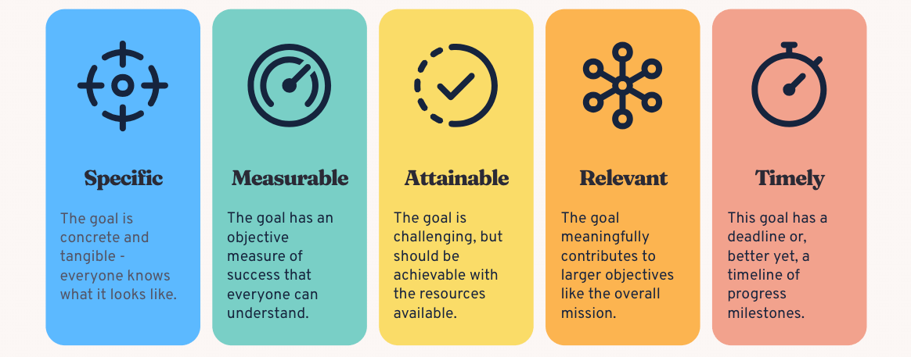
Figure: SMART Objectives
Source: (Bitesize Learning, 2023)
SMART Objective 2
S – Specific:
• Ticket sales, vendor fees, and sponsorships identified as revenue sources.
• Ensure targeted income generation through multiple streams.
M – Measurable:
• Revenue target: £40,000.
• Allows comparison between actual and projected income.
A – Achievable:
• Based on expected attendees, vendor participation and confirmed sponsorships.
• Target aligns with event scope and pricing strategies.
R – Realistic:
• Competitive ticket pricing and local sponsor interest make the goal attainable.
• Similar events in the area have met/exceeded such revenue goals.
T – Timely:
• Revenue goal to be reached by July 20 – 21, 2025.
• Enables real-time financial tracking and post-event evaluation.
SMART Objective 3
S – Specific:
• Conduct attendee satisfaction questionnaires.
• Clear action to collect structured feedback on event experience.
M – Measurable:
• Achieve a 90% satisfaction rate.
• Measured using Likert- scale responses and calculated percentages.
A – Achievable:
• Possible through quality event design, hospitality, and responsive staff.
• Focus on guest comfort and smooth delivery increases the likelihood of success. .
R – Realistic:
• Based on strong cultural programming, accessibility, and visitor engagement.
• Aligns with outcomes from similar well-managed events.
T – Time-bound:
• Feedback to be collected within one week after the post-event via digital and on-site tools.
• Ensures timely responses while attendee memories are fresh.

SWOT Analysis
Strengths | Weaknesses | Opportunities | Threats
Strong alignment with the national “ Year of Croeso” event (Allen, 2022).  Celebrates and promotes local culture, heritage, and identity. | Limited funding or sponsorship may restrict event scale and quality.  Lack of experience in managing large-scale cultural events locally. | Opportunity to create strategic partnerships with cultural institutions and tourism bodies.  Potential to become an annual signature event for Swansea. | Competing summer events across the UK may reduce attendance.  Economic uncertainty or travel restrictions could reduce visitor numbers.
Attracts both domestic and international tourists during peak season. | Dependence on good weather, especially if held outdoors. | Digital and social media promotion can increase reach and visibility. | Risk of underrepresentation or lack of inclusivity in cultural programming.

Event Management
Art and Culture in South Wales Swansea event administration requires careful planning, solid organisational structures, focused marketing, and savvy HR utilisation. The Event Management Body of Knowledge (EMBOK) will lead the event's integrated strategy to balance logistics and visitor satisfaction (EMBOK, n.d.).
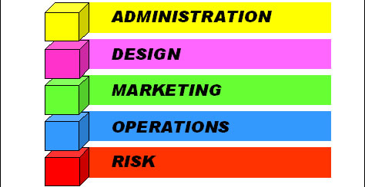
Figure: Event Management Body of Knowledge (EMBOK)
Source: (EMBOK, n.d.)

Planning
Strategic planning is crucial to the success of Art and Culture in South Wales. The itinerary will contain significant dates nine to twelve months before the event (Groom, 2022). These include locating locations, verifying engagement, obtaining licenses, and contacting potential partners. Stakeholder meetings should begin nine months in advance. Swansea City Council, Visit Wales, local companies, and artists should attend these seminars.

Operational Management
During operation, we focus on event execution. Hire a core crew to manage transportation, provide professional advice, and monitor on-site operations (Ifans, 2022). A complete risk assessment must include how to manage huge crowds, adverse weather, and emergency procedures. There will be clean-up areas, first-aid trained workers, secure gates for outdoor events, and other health and safety precautions.

Marketing and Promotion
A great integrated marketing technique may increase attendance and participation. Visit Wales will promote using social media, email, and its website. Local marketing will include signs, handouts, and radio ads (Kaunisto, 2021). Collaboration with Swansea cultural bloggers, leaders, and creatives will expand the campaign's reach.

Human Resources
To operate the event, paid personnel and volunteers are needed. Volunteers will assist with welcoming, ticketing, information desks, and artist work (Mair and Smith, 2022). To ensure the event is secure and culturally acceptable, security, cultural, and event planners must be hired. People will get training and introductory sessions to ensure services are always available and visitors are delighted.

Event Budget
A successful financial budget is the foundation of strategic event management. A properly balanced budget for the “Art and Culture in South Wales” planned for 20th-21st July 2025, will ensure the event is financially viable and sustainable, and achieve opportunities to maximise return on investment and benefit to the community.

Income Projections Table
Source | Details | Estimated Income
Ticket Sales | (3,500 attendees × £20) | £70,000
Sponsorship | Local business support | £10,000
Government/Tourism Grants | Funding from councils/Visit Wales | £15,000
Total Income | Combined revenue sources | £95,000

Expenditure Breakdown
Category | Details | Estimated Cost
Venue Hire | Waterfront Museum, setup, cleaning | £15,000
Talent & Performances | Artists, musicians, speakers | £12,000
Marketing | Print, digital, social media ads | £13,000
Staff & Security | Event staff, security, first aid | £14,000
Logistics & Equipment | AV, staging, signage, accessibility | £17,000
Contingency (10%) | Reserve for unexpected costs | £9,000
Total Expenditure | Combined planned expenses | £80,000

Feasibility and Financial Analysis
A basic cost-benefit analysis indicates a surplus of £15,000. The event would be financially viable and its future income reinvestment placed into community based cultural initiatives (Price, 2020). It is in line with the tenets of sustainable event management, wherein the surplus funds are invested back to create long term social and cultural values. Lastly, the budget is a good value for money given it maximises local talent and venues to decrease such expenses as travel, accommodation, and logistics. As marked out by Bowdin et al. (2023), local sourcing does not only enhance efficiency, but strengthens community involvement too. Further, the event draws on diversified event funding model raising funds through ticket sales, sponsorships and government grants and complements Getz’s Event Evaluation Framework of event feasibility and long-term resilience as the latter espouses the event financial diversity theme. In a sense, the inclusion of a 10% contingency fund into the budget comes in line with best practices for risk-aware budgeting from a project risk management perspective. It reduces unforeseen costs and strengthens the confidence of stakeholders.

Industry Trends, Issues & Impacts

Emerging Trends in the Events Industry
In 2024, changes are being thrust upon the events sector, from a focus on sustainability and hybrid event formats, to a greater inclusion of community. For years, sustainability has been taking center stage, and event organisers have been working to play a smaller role environmentally in terms of waste reduction, using eco-friendly materials and carbon offsetting (Raimo et al. 2021). As per a published 2023 industry report, 68% of the event professionals aimed at the planning process have sustainability as the goal while over 52% have already adopted green procurement policies. This conveys new expectations that not only should an event be entertaining, but that it should also promote social and environmental responsibility and help on a broader level to achieve wider global sustainability goals.

Current Issues Affecting Event Planning
Despite positive emerging trends, events industry in 2024 is still faced with huge challenges due to post COVID economic pressure. Venue hire, staffing and logistics are being hit by rising inflation and disrupted supply chains as costs have gone up on the materials used. Citing a survey published by Salesbury (2023), average event delivery costs have risen by 25% and costs higher than pre pandemic levels have put even more pressure on budgets as they eat into budgets and limit the ability of organisers to be flexible. For small community focused initiatives as much as larger commercial events, these economic pressures restrict the creative possibilities and scale and frequency of events.

Impacts on South Wales
The current trend and challenges facing event organising in the industry in South Wales provide both a promising opportunity to event organisers as well as an area of concerns. In adopting sustainability practices and hybrid event formats, South Wales is already strategically ahead, being able to present itself as forward-looking event hub where events are not only managed differently but are also managed in a responsible manner (Stanton, 2023). Digital platforms can be leveraged for the region to reach out further culturally, and eco conscious planning is in line with the global aims to address the menace of environmental challenges. On top of this these approaches do so much more than raise the reputation of South Wales; they attract a range of audiences and stakeholders who want to see and be a part of experiences that are inclusive and modern.

Situation and Cultural Considerations
The Swansea “Art and Culture in South Wales” event’s environs can be comprehended through a PESTLE analysis (Freepik, 2023).
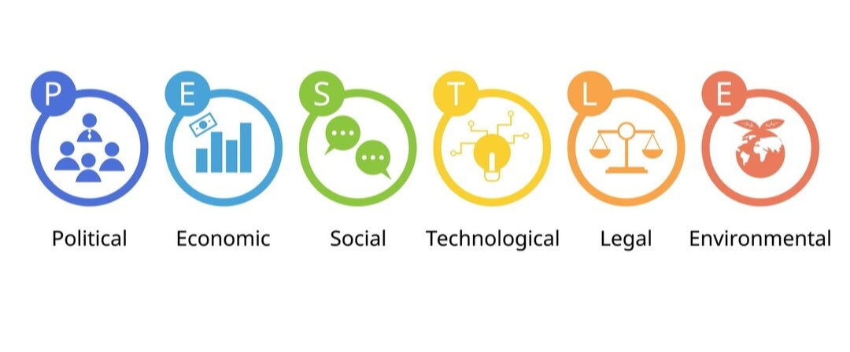
Figure: PESTLE Analysis
Source: (Freepik, 2023)

Political: In politics, the Wales government promote cultural tourism through initiatives such as the “Year of Croeso,” which heighten national pride and drawn in tourists (Vittle, 2023). Local governments and Visit Wales provide funding, guidance and coordination for cultural initiatives such as this.
Economic: Swansea residents believe that the festival will simulate the local economy by encouraging visitors to purchase local art, cuisine, and residences (Yaroslav Martynyshyn, 2023). Nevertheless, financing may be challenging, particularly in the context of professional skills and construction, due to economic uncertainty and inflation.
Social: It is essential to engage in social events. Couples, seniors, and individuals with disabilities will be invited by event planners (Allen, 2022). The use of English and Wales in bilingual signage, advertisements, and statements is required to preserve the linguistic identity.
Technological: The use of QR-coded event booklets, phone scheduling applications, and electronic ticketing will streamline the visitor experience and reduce paper pollution (Arcos-Pumarola, Paquin and Sitges, 2023). Online venue will also facilitate mixed-activity participation.
Environmental: A zero-waste event will promote the use of recyclables, provide local food merchants that use minimal packaging, and provide recycling stations (Bladen et al. 2022). Sustainability has emerged as a prominent theme in contemporary event administration.
Legal: Event coordinators are required to adhere to the law (Bowdin et al. 2023). Crowd management, health and safety, and municipal liability insurance and license regulations are all addressed.
Cultural: Welsh culture ought to be honoured Traditional arts, multilingual presentations, and local tales will be incorporated into the activities to foster cultural awareness, acceptance, and community identification.

Recommendations
Several strategic recommendations are advised to ensure successful and sustainable event delivery in South Wales. To start with, the organisers should not relinquish the promotion of a sustainable event by incorporating eco-friendly activities like digital ticketing, waste reduction, and sourcing locally. Second, by spreading hybrid event formats the accessibility of these events will be broadened, and the reach of the audience will also be widened especially for those based internationally or at remote locations (Bernhardt, 2023). Local training programmes and spares being formed with Education institutions can bolster workforce capacity by addressing staff shortages (Beattie et al. 2024). Additionally, financial incentives or subsidies are worth considering as incentives for inclusion and participation of community at large, especially in economically disadvantaged areas. Culture relevance and local pride will thus be secured by working in close collaboration with local businesses, artists and local tourism boards.

Conclusion
This report has carefully examined some of the strategic planning and delivery considerations for the proposed “Art and Culture in South Wales” summer event in Swansea. This event has a clear synergy and alignment with Visit Wales’ “Year of Croeso” strategy for Welsh culture as it celebrates, promotes, and shares Welsh cultural identity, engages and supports local artists, and encourages regional tourism. The analysis of the event cycle, management, budget, and external environment indicates both operational viability and cultural grounds for the project. Strategic planning is required in all phases of the event cycle, from idea generation to post-event evaluation to ensure operational efficiency, stakeholder engagement, and participant satisfaction. Considerations like accessibility, environmental friendliness, and digital approaches are current market trends and help the event reach more people.

Reference List
Allen, J., Harris, R. and Jago, L. (2022). Festival & Special Event Management Interactive Wiley E-Text. S.L.: John Wiley. Available at: https://books.google.com/books?hl=en&lr=&id=fbIxEAAAQBAJ&oi=fnd&pg=PR3&dq=International+Meetings+Management+Report+Event+Art+and+Culture+&ots=yU9-2Sdm1m&sig=Kvy9NxZOBCU9CAeSDYzEOsV7Uwk (Accessed: 28 May 2025)
Arcos-Pumarola, J., Paquin, A.G. and Sitges, M.H. (2023). The use of intangible heritage and creative industries as a tourism asset in the UNESCO creative cities network. Heliyon, 9(1), p.e13106. Available at: https://doi.org/10.1016/j.heliyon.2023.e13106 (Accessed: 28 May 2025)
Barakat, S.R. and Wada, E.K., (2021). Stakeholder theory in the hospitality field: insights drawn from a systematic literature review. Hospitality & Society, 11(2), pp.183-207. Available at: https://intellectdiscover.com/content/journals/10.1386/hosp_00031_1 (Accessed: 29 May 2025)
Beattie, J., Fuller, L., Binder, M.J., Gray, L., Versace, V.L. and Rogers, G.D., (2024). Do Medical Graduates from a Rural Longitudinal Integrated Clerkship Work in Similar Rural Communities?. International Journal of Environmental Research and Public Health, 21(12), p.1688. Available at: https://pmc.ncbi.nlm.nih.gov/articles/PMC11675845/ (Accessed: 11 June 2025)
Bernhardt, F. 2023. ‘In Wales … we do things differently’. The politics of asylum dispersal in the UK and emerging national (self-) imaginaries of hospitality in Wales. Political Geography, 103, p.102886. Available at: https://doi.org/10.1016/j.polgeo.2023.102886 (Accessed: 11 June 2025)
Bitesize Learning (2023). SMART goals: the meaning of this goal-setting framework, with examples. BiteSize Learning. Available at: https://www.bitesizelearning.co.uk/resources/smart-goals-meaning-examples (Accessed: 28 May 2025)
Bladen, C., Wilde, N., Kennell, J. And Abson, E. (2022). Events Management. Events Management, 1(1). Available at: https://doi.org/10.4324/9781003102878 (Accessed: 31 May 2025)
Bowdin, G., McDonnell, I., Harris, R., O’Toole, W., Allen, J. And Leo Kenneth Jago (2023). Events Management. Routledge. Available at: https://doi.org/10.4324/9781003044963 (Accessed: 31 May 2025)
Byrnes, W.J. (2022). Management and the Arts. Available at: https://doi.org/10.4324/9781003030287 (Accessed: 28 May 2025)
EMBOK (n.d.). EMBOK – Event Management Body of Knowledge – Domains. www.embok.org. Available at: https://www.embok.org/index.php/domains-page (Accessed: 29 May 2025)
Ferdinand, N. And Kitchin, P. (2022). Events management : an international approach. Thousand Oaks: SAGE Publications Ltd. Available at: https://www.torrossa.com/it/resources/an/5282204 (Accessed: 28 May 2025)
Freepik. (2023). Premium Vector | PESTEL analysis is used to identify threats and weaknesses to examines the Political Economic. Available at: https://www.freepik.com/premium-vector/pestel-analysis-is-used-identify-threats-weaknesses-examines-political-economic_85196559.htm (Accessed: 31 May 2025)
Griffiths (2021). Speak Not. Bloomsbury Publishing. Available at: https://books.google.com/books?hl=en&lr=&id=PwA1EAAAQBAJ&oi=fnd&pg=PP1&dq=International+Meetings+Management+Report+Event+Art+and+Culture+in+South+Wales+(Swansea)+Year+of+Croeso&ots=rw4ew6XAiN&sig=e0CTNzKj8Sug2cOIzZY17g_h8qE (Accessed: 28 May 2025)
Groom, D. (2022). Research Framework for the Archaeology of Wales 2021-2026: Maritime Chapter. Bangor University. Available at: https://research.bangor.ac.uk/portal/en/researchoutputs/research-framework-for-the-archaeology-of-wales-20212026(b275b9b1-73b6-48bc-be4f-c4df8e025228).html (Accessed: 29 May 2025)
Ifans (2022). Stars and Ribbons. Available at: https://books.google.com/books?hl=en&lr=&id=jr1dEAAAQBAJ&oi=fnd&pg=PP1&dq=International+Meetings+Management+Report+Event+Art+and+Culture+in+South+Wales+(Swansea)+Year+of+Croeso&ots=0v29hc73mb&sig=eJibMpK4A-9P0NtDlA241MReQ7w (Accessed: 29 May 2025)
Kaunisto, A. (2021). Introducing the Event Cycle – The core of Event Success Management. www.lyyti.com. Available at: https://www.lyyti.com/en/blog/introducing-the-event-cycle-the-core-of-event-success-management (Accessed: 29 May 2025)
Mair, J. And Smith, A. (2022). Events and sustainability: why making events more sustainable is not enough. Events and sustainability: why making events more sustainable is not enough, pp.1–17. Available at: https://doi.org/10.4324/9781003314295-1 (Accessed 29 May 2025)
Price, W.R. (2020). Mining for Tourists: An Analysis of Industrial Tourism and Government Policy in Wales. Tourism Planning & Development, pp.1–22. Available at: https://doi.org/10.1080/21568316.2020.1829695 (Accessed: 30 May 2025)
Raimo, N., De Turi, I., Ricciardelli, A. And Vitolla, F. (2021). Digitalization in the cultural industry: evidence from Italian museums. International Journal of Entrepreneurial Behavior & Research, ahead-of-print(ahead-of-print). Available at: https://doi.org/10.1108/ijebr-01-2021-0082 (Accessed: 30 May 2025)
Salesbury (2023). Cymru and I. Available at: https://books.google.com/books?hl=en&lr=&id=ayflEAAAQBAJ&oi=fnd&pg=PT76&dq=International+Meetings+Management+Report+Event+Art+and+Culture+in+South+Wales+(Swansea)+Year+of+Croeso&ots=q91pjOth-f&sig=vsPBXj4uIMJV4WAxNIGnC7yLnOE (Accessed: 30 May 2025)
Stanton (2023). Cydymdreiddiad: The Interpenetration of Land and Language as Illustrated by Welsh Language Great War Memorials – ProQuest. Proquest.com. Available at: https://search.proquest.com/openview/5d133a2c0525d3a4a1ff3e8ad89ba3d6/1?pq-origsite=gscholar&cbl=2026366&diss=y (Accessed: 30 May 2025)
Vittle (2023). Charles and the Welsh Revolt. Google Books. Available at: https://books.google.com/books?hl=en&lr=&id=1xvEEAAAQBAJ&oi=fnd&pg=PT2&dq=International+Meetings+Management+Report+Event+Art+and+Culture+in+South+Wales+(Swansea)+Year+of+Croeso&ots=3-cf3Ok_L6&sig=nPL1ZoatNVyJeVgKaqSWCQi0E1s (Accessed: 31 May 2025)
Yaroslav Martynyshyn (2023). EXHIBITION AS A SOCIO-CULTURAL PHENOMENON AND OBJECT OF EVENT MANAGEMENT. Культура і сучасність, (2), pp.131–136. Available at: https://www.ceeol.com/search/article-detail?id=1279268 (Accessed: 31 May 2025)

