Mania
In my exhibition I will be exploring the effect of mania on the minds of artists. “Mania can hit anyone, since it can be induced by street drugs and by other causes as well as by the dynamics of one’s own racing, needy brain.” (Maisel, 2012) I will be exploring different artists who experienced mania in diverse ways, including street drugs, depression and a parasitic infection called Toxoplasmosis. All the artists in my exhibition were affected differently and this is clear in their artwork. This is an important subject to explore as it teaches us more about creative minds and how they develop with the influence of environmental and emotional states. It is also an indication of how much drugs can influence our brain and creativity, how we can so easily be manipulated, and we should all be aware of the impact of depression, anxiety and medication. “studies underline the linkage between creativity and mania and we have thousands of years of anecdotal evidence in support of the view that smart and creative people are often manic.”(Maisel, 2012) I will be analysing work from Eduard Munch who developed depression and anxiety, Louis Wain who was infected with Toxoplasmosis and Bryan Lewis Saunders who explored the affect of drugs on the mind.
My aim in this exhibition is to influence the viewers mind by changing the atmosphere within the space, there will be walls within the exhibition to separate the areas. For example, Munch’s space I will darken the room and put an ambient sound to create an eerie and lonely atmosphere. Within Louis Wain’s space I would like to put Kaleidoscopic lighting along with crazed music, signifying the insanity and change which Wain’s brain went through with the parasite he contracted. Bryan Lewis Saunders’ space will be lit as if it was in a hospital, as his experimental drug use lead him there. His space will be sterile and sanitised apart from the artwork on the wall which will describe his moments of mania.
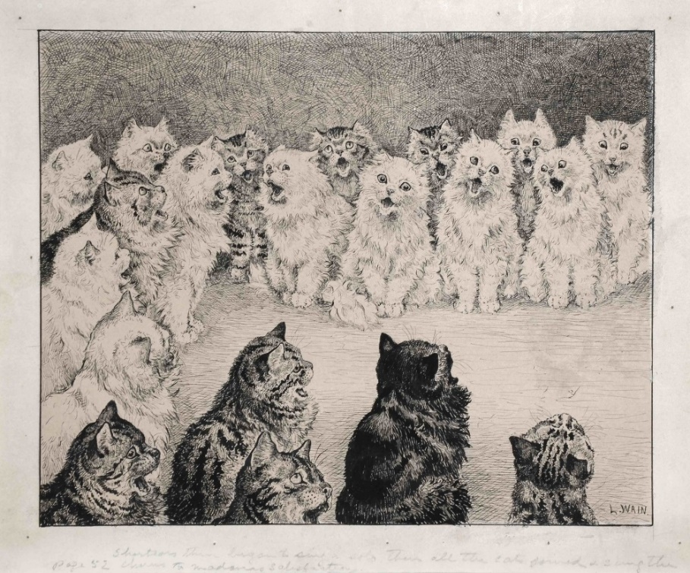
Louis Wain, 1886
Louis Wain loved his many cats, and throughout his creative years that is what he would draw. As time went on, Wain’s art changed and so did his mind. Wain contracted a parasite infection called Toxoplasmosis which originates from cat faeces. This changed his art so much you are not able to create any similarities between his early and late years of artwork. His art turned psychedelic, and Kaleidoscopic, the forms started to change yet he kept the iconic cat figure. Most of his early years his work was black and white, and towards the end it was very colourful and was created of patterns. This development of work clearly depicts his mania as his creative mind changed completely from his early work.
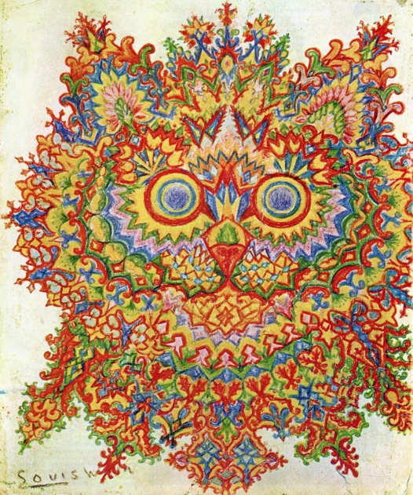
Louis Wain, 1920
It is said that Toxoplasma can change the carriers long-term personality. “Carriers tend to show long-term personality changes that are small but statistically significant. “ (Yong, 2008) and that it “could be influencing human culture across the globe.” (Yong, 2008) To think that a parasitic infection could be shaping the human culture is a very daunting thing, and it is good to be aware of this within our culture.
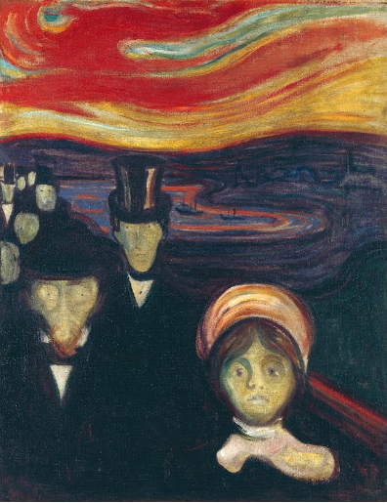
Edvard Munch, 1894
Edvard Munch was a Norwegian expressionist painter who mainly focused on expressing his dark-toned emotions through his art. When Munch was young, his mother had died to Tuberculosis and shortly after his father had suffered from a mental illness which strongly influenced Eduard’s childhood. “Their father raised them with the fears of deep seated issues, which is a part of the reason why the work of Edvard Munch took a deeper tone, and why the artist was known to have so many repressed emotions as he grew up.” (EdvardMunch.org, 2011) Munch’s work clearly depicts many deep issues within his life, the death of his mother and sister and also being very ill at most points of his life. “A majority of the works which Edvard Munch created, were referred to as the style known as symbolism. This is mainly because of the fact that the paintings he made focused on the internal view of the objects.” (EdvardMunch.org, 2011) The symbolism throughout his work is very unique to Munch, he was able to examine and connect our minds with his through his deep tones.
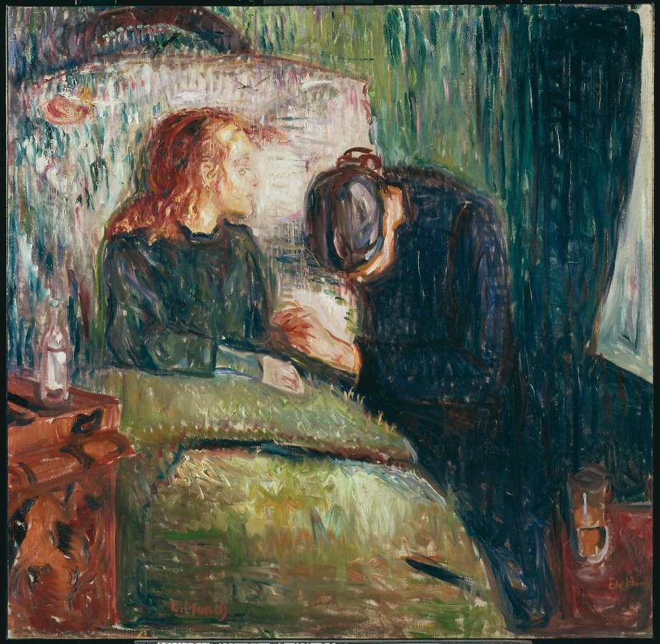
Edvard Munch, The Sick Child, 1885-1886
The Sick Child was one of Munch’s most famous pieces about the death of his sister. It is clear to see the emotion which he underwent through his brushstrokes. Everything is angling downwards, it gives the impression of rain, or depression. It is hard not to feel emotional when looking at this as it is like the figure on the right is apologising to the child on the bed, she is bowing her head and, in my opinion, hoping for forgiveness.
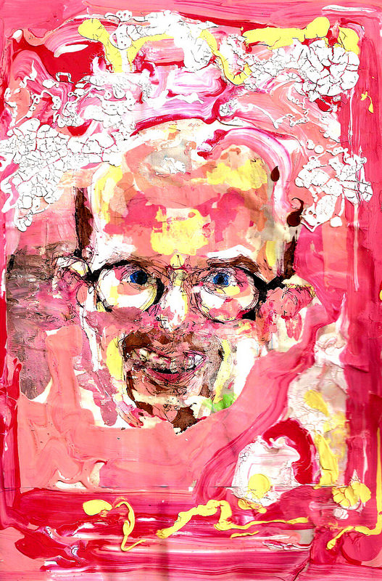
Bryan Lewis Saunders, Crystal Meth
My final artist is Bryan Lewis Saunders who experimented with drug use to see what it would do to his creative ability. “ After experiencing drastic changes in my environment, I looked for other experiences that might profoundly affect my perception of self.” (Saunders, 2008) Saunders experienced many different drugs which he eventually “became lethargic and suffered mild brain damage that wasn't irreparable.” (Saunders, 2008) Even though Saunders inflicted damage on himself he continues to explore this theme but “I am still conducting this experiment but over greater lapses of time and presently only take drugs that are prescribed to me by a doctor.”(Saunders, 2008) With his experience he created a Self-portrait video of his works in lapse, with a monologue being cited. His self-portrait video is very powerful and I will have this soundtrack playing within his space. His video makes me very uncomfortable and I believe it is perfect to display his mania. It is very busy with heavy drums in the background which contrasts with his setting at the time of taking the various drugs, as he was hospitalised when doing this work. His work is very strong and it plays with the danger of drugs and insanity. The monologue on his video is strong with no breaks, it reminds me of a trail of thought how he expresses the emotions and visuals he saw whilst under the influence, which is also accompanied by the art which he produced.
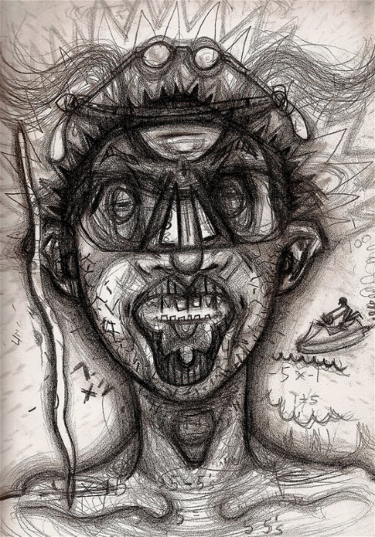
Bryan Lewis Saunders, Cocaine

Seeing his Cocaine addition, you can visualise the crazy thoughts running through his mind, but also the random thoughts he is also thinking, with a man on a jet ski and the maths behind the head. His manic thoughts were still being seen through his art.

Bibliography
Eric R. Maisel (2012) Psychology Today: Intelligence, Creativity and Mania Available at: https://www.psychologytoday.com/us/blog/rethinking-mental-health/201206/intelligence-creativity-and-mania (Accessed: 19 April 2018)
Bryan Lewis Saunders (2011) “Near Death Experience” by Bryan Lewis Saunders & Spastic Dementia Available at: https://vimeo.com/19566969 (Accessed: 20 April 2018)
Bryan Lewis Saunders (2008) Bryan Lewis Saunders Under the Influence Available at: http://bryanlewissaunders.org/drugs/ (Accessed: 20 April 2018)
Ed Yong (2008) Toxoplasma – The brain parasite that influences human culture Available at: http://blogs.discovermagazine.com/notrocketscience/2008/10/05/toxoplasma-the-brain-parasite-that-influences-human-culture/#.WtmbrojwbIU (Accessed: 20 April 2018)
Unkown Author (2008) Edvard Munch, Painting, Biography and Quotes Available at: https://www.edvardmunch.org/ (Accessed: 20 April 2018)

