
An Investigation into Surface Oil and How to Prevent it Entering the Marine Environment
Emma Bergson P148476
Bachelor of Engineering in Energy and Environmental Engineering

Contents
Acknowledgements vi
Abstract vii
1 Introduction 1
1.1 The Pandemic Effect 1
2 Aims and Objectives of the Project 3
3 Timing Plans 4
4 The Surface Water System at Pembroke Power Station 6
5 To investigate where the oil is potentially coming from 8
5.1 Previous Investigation 8
5.1.1 DMAGIC Summary 8
5.2 Transformers and Their Role at PPS 10
5.2.1 Transformer components 11
5.2.2 Phases 12
5.2.3 TX bund, sump pump & skimmers 12
5.2.4 TX Maintenance 12
5.3 Oil Leak Investigation 13
5.3.1 C Inspections 2019/2020 13
6 To consider the environmental and financial impacts 14
6.1 Environmental Impact 14
6.1.1 Special Area of Conservation (SAC) 14
6.1.2 A Local case of oil sheen 15
6.2 Financial Impact 15
6.2.1 Labour 15
6.2.2 Fixing leaks & oil processing 15
6.2.3 NRW Actions 16
7 To research potential solutions to prevent the oil entering the Surface Water System 17
7.1 FMEA Report 17
8 To investigate methods that can be used to contain and remove any oil to prevent it entering the marine environment 20
8.1 Pollution Pathway 20
8.1.1 Source 20
8.1.2 Pathway 20
8.1.3 Receptor 26
9 Work done 27
10 Experiments and Analysis 29
10.1.1 Commercial solidifier product 29
10.1.2 Testing the Effectiveness of PetroGuard-D® (Block Copolymer) Absorbing Transformer Oil (Gemini-X) 29
11 Discussions and Conclusion 33
12 Recommendations for Further Work 35
12.1 Short Term 35
12.2 Medium Term 35
12.3 Long Term 35
13 References 36
14 Appendices 40
14.1 Appendix 1 40
14.2 Appendix 2 41
14.3 Appendix 3 42
14.4 Appendix 4 43
14.5 Appendix 5 44
14.6 Appendix 6 45

Table 1. Nomenclature iv
Table 2. Original Timing Plan 4
Table 3. Adjusted Gannt chart 5
Table 4. Payback vs Effort table 9
Table 5. Original budget to fix and process the oil 16
Table 6. Actual cost to fix and process oil 16
Table 7. FMEA on Oil Sheen Forming on SWT 19

Figure 1. Basic Schematic of the SWS at PPS 6
Figure 2. Floating sensors for the automatic pump system in the SWT 7
Figure 3. SWT pump control panel 7
Figure 4.DMAGIC tool used by RWE 8
Figure 5. Visible Oil Sheen at SWT 10
Figure 6. An example of a transformer with main components labelled (Canada Border Services Agency, 2012) 11
Figure 7. Details of where leaks have been occurring on the TX 13
Figure 8. Boundary of the Pembrokeshire Marine SAC (Bergson, 2019) 14
Figure 9. Refurbished CT box 17
Figure 10. Pressure testing device 18
Figure 11.Cavalli oil containment system (Cavalli, 1999). In figure (a) the barrier is deployed and contains the entire oil spill with a very thin layer of oil. In figures (b) & (c) an increase in barriers helps to increase the thickness of the oil, making the recovery much easier. 21
Figure 12. Wong and Barin's flexible ramp boom system (Wong & Barin, 2003) 22
Figure 13. Graphic depiction of a SheenGuard blanket being used to remove oil from inland water and tidal areas 23
Figure 14. MycoBoom™ floating in saltwater in Totten Inlet, southern Puget Sound near Kamilche Point, Washington. (Picture courtesy of Fungi Perfecti) 25
Figure 15. Oyster mushroom fruiting from the end of a MycoBoom™ (Picture courtesy of Fungi Perfecti) 26
Figure 16. W2, where the receiving water enters the Pennar Gut 26
Figure 17. A reed bed joining the Pennar Gut to the Milford Haven Estuary 27
Figure 18. Equipment and apparatus used 30
Figure 19. 1 minute intervals for 5 minutes using sample water 31
Figure 20. After five minutes of PDG using sample water 32
Figure 21. SWS Plan 40
Figure 22. PPS Environmental Permit pp 37 41
Figure 23. Recommendations for using SheenGuard Pillows 42
Figure 24. SWI P1521 43
Figure 25. PRAD-PEM-RA-614-A 44
Figure 26. COSHH for Nytro Gemini X & PetroGuard 45
Figure 27. COSHH cont. 46
Figure 28. COSHH cont. 47
Figure 29. COSHH cont. 48
Figure 30. COSHH cont. 49

Table 1. Nomenclature
Nomenclature
Abbreviation | Definition
CCGT | Combined-Cycle Gas Turbine
SAC | Special Area of Conservation
NRW | National Resources Wales
SWT | Surface Water Tank
DMAGIC | Define the problem, Measure, Analysis, Generate solutions, Implement solutions, Check & sustain
FMEA | Failure Mode & Effects Analysis
TX | Generator Step-up Transformers
SWS | Surface Water System
PPS | Pembroke Power Station
W2 | Outfall into Pennar Gut
DCS | Direct Control System
CT | Current Transformer
PGD | PetroGuard-D®
MWCNT | Surface functionalized multiwall carbon nanotube
ICS | tris[3-(trimethoxysilyl)propyl]isocyanurate
SWI | Standard Work Instruction
COSHH | Control of Substances Hazardous to Health Regulations
MSDS | Material Safety Data Sheet
POWRA | Point of Work Risk Assessment
WTP | Water Treatment Plant

Declaration of Authority
This thesis is the result of the author’s original research. It has been composed by the author and has not been previously submitted for examination which has led to the award of a degree.


Signed
Date 02 May 2020

Acknowledgements
I’d like to start with thanking my course tutor, Andrew Thorn, for the help and advice he gave.
I also need to thank my ex-colleagues at RWE who were a great help whilst working there and with their continued support, in particular Ben Williams, Ben Jones, Dafydd Williams, and Amy Rhodes.
I couldn’t have done any of this without my family and friends who have shown me such kindness and given me courage when I’ve been full of doubt. Their support and understanding gave me the strength to keep going, especially my sister Ave, who always made me laugh at adversity and gave great advice. Also, my friend, Jess, who gave me the skills to deal with the emotional roller coaster the final year of a degree can be. Without the patience and love from my husband Paco and the ‘take me for a walk’ nudges from my dog Tony, to give me a break, none of this would’ve happened, thank you.

Abstract
Pembroke Power Station (PPS) is one of the most efficient power stations in Europe using five Combined-Cycle Gas Turbines (CCGT) (RWE, n.d.), with individual Generator Step-up Transformers (TX).
Situated in a Special Area of Conservation (SAC) their environmental permit, set by National Resources Wales (NRW), states no visible oil should be seen on the surface of the receiving waters, a slow flowing outfall area entering the Pennar Gut (W2). They have a large retention tank (SWT) where all surface water drains to combining with rainfall effluent, this eventually gets pumps through the surface water system (SWS) to W2. In 2016 oil sheen was seen at W2 and they breached their permit, since then efforts have been made to ensure this hasn’t happened since, however, oil sheen still appears in the SWT.
This investigation began by looking into where the oil is coming from and discovered that after PPS had fixed most of the problems, the remaining difficulties were leaking TX and the separators, hence these were the areas that were looked into in more depth.
The environmental and financial impacts were considered, going into detail about the location being situated within a SAC and surrounded by Pembrokeshire National Park. It looked at the labour involved, actual costs to fix the TX leaks and possible NRW repercussions.
Research into potential solutions to prevent the oil sheen entering W2 again used Future Modes & Effects Analysis (FMEA), this realised the separators are insufficient for TX oil and the TX can only be fixed during a certain period which commenced in September 2019.
The pollution pathway – Source, Pathway, Receptor – is used to evaluate methods for containment and removal of any sheen. Focusing on the pathway, SWT, containment looked at solid and flexible booms along with solidifiers. For removal, more experimental options were researched.
An experiment was done with a commercial product, PetroGuard-D®, with good results for a potential product to install, SheenGuardTM and has been recommended for use. Mycoremediation has also been advised and cleaning flushing through the TX bunds and pipework.

Introduction
Pembroke Power Station (PPS) is one of the most efficient power stations in Europe producing power at 60% efficiency using Combined-Cycle Gas Turbines (CCGT) which produce up to 440MW per stack of electricity (RWE, n.d.). The CCGTs are put through regular 2-shift cycles, being turned off overnight when less energy is required and turned back on again in the morning.
The station is situated in a Special Area of Conservation (SAC) and surrounded by the Pembrokeshire National Park. They are held accountable to their Environmental Permit, EPR/DP3333TA - Environmental Permitting (England & Wales) Regulations 2010, set by the Government’s environmental authority, National Resources Wales (NRW), (National Resources Wales, 2010).
One of the Station’s permit requirements is for no visible oil to be seen on the surface of the receiving waters (National Resources Wales, 2010, p. 37), known onsite as W2 (Appendix 1), this is a slow flowing outfall area which enters the Pennar Gut. All surface water including rainfall, road drainage and drainage from general plant areas drain to a large retention tank known as the Surface Water Tank (SWT) where it combines with rainfall effluent, it then passes through a couple of bypass separators before entering the Pennar Gut (Harrison & Smith, 2010).
The first area for sheen to become visible is on the surface of the SWT and has been reported there on several occasions. Any sheen found on the SWT has the potential to be pumped into the Haven and pollute the water, this would then have to be reported to NRW and would put the station in breach of their permit (National Resources Wales, 2010, p. 22) (Appendix 2). This occurred in 2016, therefore all efforts for prevention is vital. Any further environmental incidents at the Station would impact the reputation with local stakeholders and NRW and as a result NRW could introduce sanctions to ensure it doesn’t recur and could issue fines.
This project will investigate where the oil is potentially coming from and research the environmental and financial impacts. It will generate potential solutions to prevent the oil entering the surface water system and methods to contain and remove any oil sheen.
A lot of investigation has already been undertaken at the station using their DMAGIC analysis tool. The results have been revised and included in the report. Their efforts have so far have prevented another breach of permit, however, a new solution needs to be investigated. A FMEA report will be used to continue the investigation and create potential solutions.

The Pandemic Effect
Due to the pandemic some work was unachievable. A second experiment testing booms with a TX oil sample couldn’t happen due the labs being closed, testing a Cavalli boom system was planned and some other basic booms using different materials. This has resulted in minimal data analysis and results.
With a lot of uncertainty, the author experienced high levels of anxiety and extreme fatigue, making it extremely hard to complete the literature review to the standard they wanted.

Aims and Objectives of the Project
The main aim of the project is to prevent surface oil entering the marine environment, this will be done by undergoing the following objectives:
- To investigate where the oil is potentially coming from
- To consider the environmental and financial impacts
- To research potential solutions to prevent the oil entering the Surface Water System
- To investigate methods that can be used to contain and remove any oil to prevent it entering the marine environment

Timing Plans
Original timing plan
Table 2. Original Timing Plan
Month | Work Plan
May | Look into DMAGIC – RWE’s analysis tool  Start proposal
June | Research – Permit; What is the actual wording around oil sheen?  Research – TX; What does is do? Why does it need oil? Why do they leak?  Have a close look at leaks on U31 Transformer  Get detailed information from Ben Jones regarding leaks i.e. costs and photos of leaks  Meet with AT  Continue with proposal – Complete as much as possible before first week of Uni
July | Research – DMAGIC; how does it work?  Do experiment with PGD, write up results  Make sure enough info has been gleaned from the correct people before leaving RWE  Last day at the Station 31 July
August | Set up dissertation on word
September | 1st Viva - Start putting info on PowerPoint
October | Begin Literary review – use library and online journals to research oil sheen  1st proposal due – Hand in first week  Meet with AT, review proposal
November | Project week – Complete lit review on oil sheen  Meet with AT, discuss progression, where to go next  Look at oil containment and removal
December | Finish presentation  1st Viva  Contact RWE, need more info re TX
January | Continual of writing up first draft  Look into environmental and financial impacts - Contact NRW, research SAC, contact BJ re costs of fixing TX
February | First draft complete and sent for proofread
March | Finish poster – start to think about what to say in Viva
April | 20/4/19 Hand in dissertation  Make any adjustments to poster and Practice, Practice, Practice!!  Final Viva - Invite BW, DW

Adjusted Gantt chart due to pandemic | April |  |  |  | May
First Draft
Final Draft
Poster
Complete questions
Gantt chart from commencement of course | October |  |  |  | November |  |  |  | December |  |  |  | January |  |  |  | February |  |  |  | March |  |  |  | April |  |  |  | May
Tutor Meetings
Proposal
Introduction
Aims and objectives
1st Viva
SWS
Aim 1. DMAGIC
Aim 1. TX info
Aim 2. Environmental Impact
Aim 2. Financial Impact
Aim 3. FMEA Report
Aim 4. Pollution Pathway
Work carried out - work done post project
Results
Discussions and Conclusion
Recommendations for further work
Abstract
First draft
Final Draft
Final Viva
Table 3. Adjusted Gannt chart

The Surface Water System at Pembroke Power Station
The Surface Water System (SWS) at PPS plays a vital role in ensuring any clean water such as rainwater or oily water created on site goes through a system of filters and separators before finally draining into the marine environment at W2 (Figure 1). A more detailed plan can be found at .
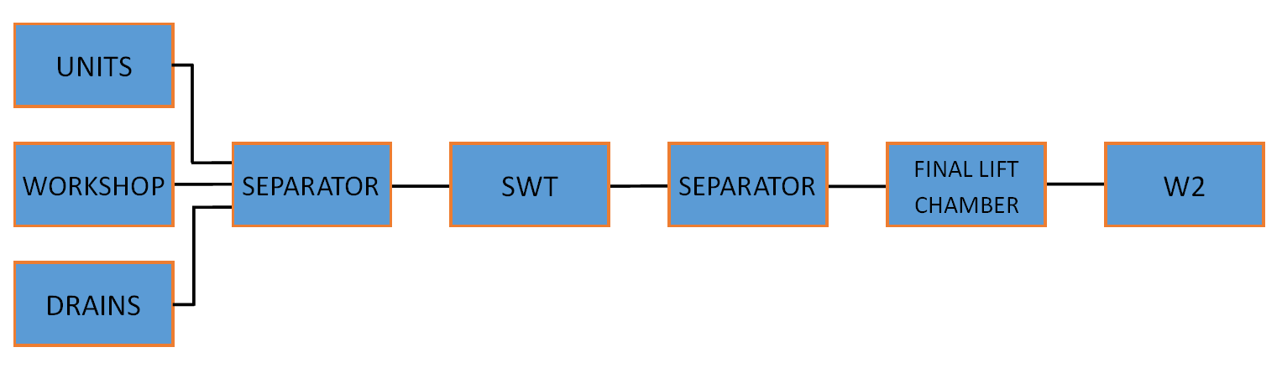
Figure 1. Basic Schematic of the SWS at PPS
The surface water drains consist of a below ground network of gravity drains which collect treated process liquid effluents and rainwater from building roofs, building surrounding areas, roads etc, and finally discharges to Pennar Gut. There is a constant flow and to reduce the depth of the site drains, the intermediate lift chamber, SWT and a final effluent lift chamber are all employed with floating sensors for pumps (Figure 2). Most begin to pump automatically when the sensors reach a certain level in the tank with the exception of the Generator Step-up Transformers (TX) sump pumps which are controlled manually. All pumps can be turned into manual, this is the current state of the SWT pump (Figure 3). When the SWT pumps are on automatic the pumps run for short periods of time keeping the levels of water low because the lower sensors are activated. When oil sheen is present the pumps are switched to manual, allowing the tank to reach a much higher level thus helping with emulsion degradation. The pumps are then used for longer periods of time to empty the tank ( RWE Didcot, n.d.).
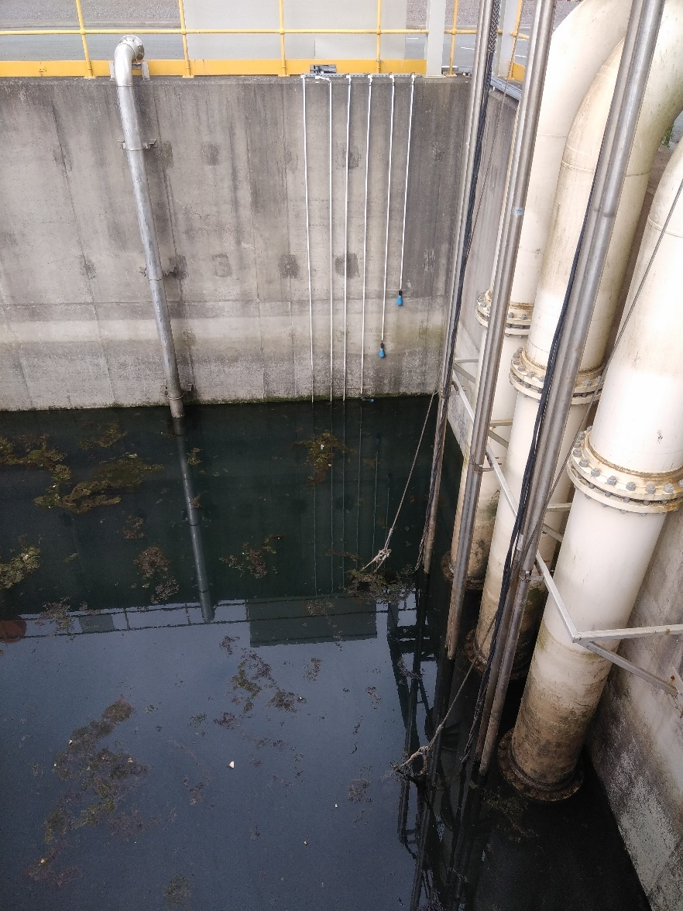
Figure 2. Floating sensors for the automatic pump system in the SWT
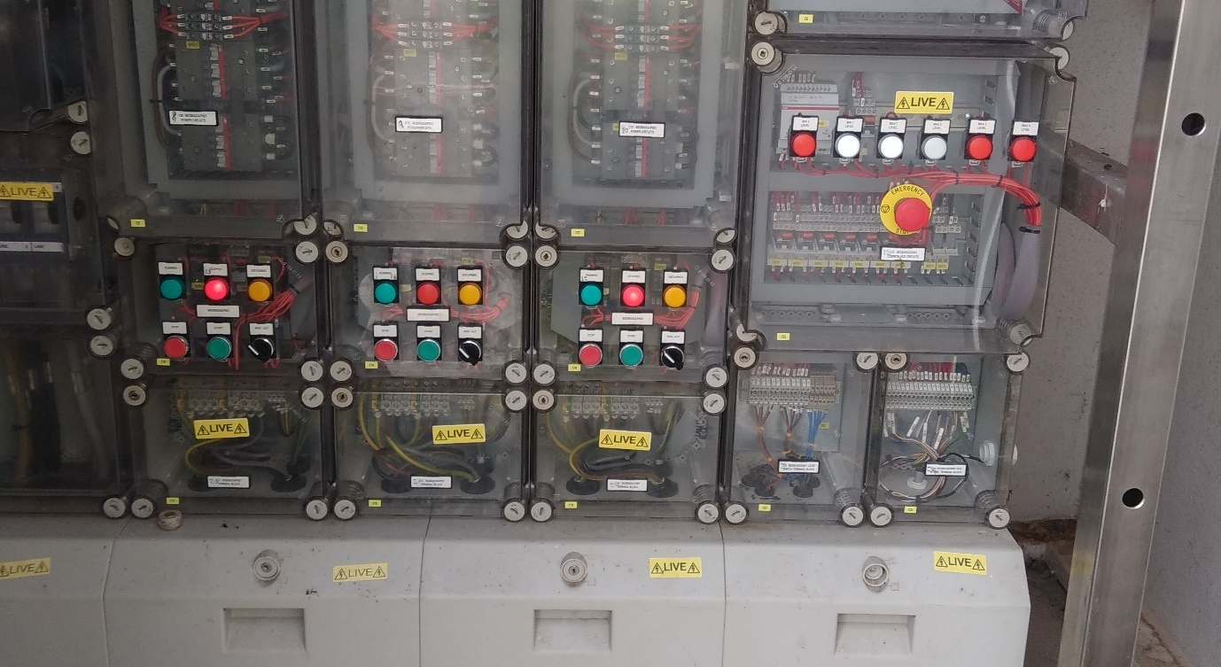
Figure 3. SWT pump control panel

To investigate where the oil is potentially coming from
Included in this section are a summary of the previous investigation into the problem, TX and their role in the station and an oil leak investigation.

Previous Investigation
PPS have been monitoring the problem of visible oil sheen for some time. A multidepartment team came together to assess this situation and using DMAGIC – RWE’s analysis tool as seen in Figure 4 – they began to generate and implement some solutions; a summary of their analysis follows.
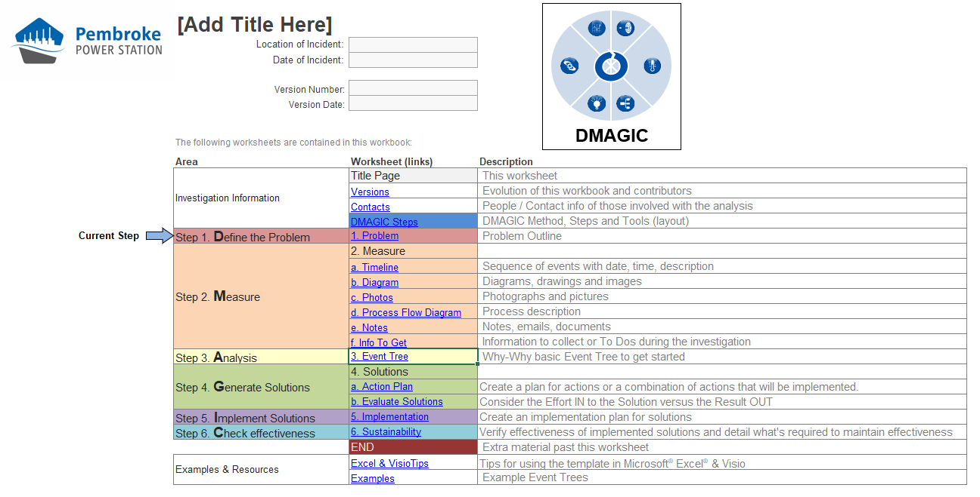
Figure 4.DMAGIC tool used by RWE

DMAGIC Summary

Define the problem
Oil sheen is present within the sites surface water system, it has been visible on the surface of the SWT and in December 2016 was visible at W2, breaching their Environmental Permit.

Measure
The previous DMAGIC investigation found multiple issues with the surface water system. These included:
- Final bypass separator going into bypass during normal operation.
- Sub-optimal conditions of surface water separators.
- Standing alarms on separators.
- Large amounts of oil in TX bunds.

Analysis
There are environmental concerns for the potential of sheen to reach the surface water adjacent to W2, if this reaches the Pennar Gut it could have an environmental impact depending on the severity.
Commercially, the cost for new measures to be put in place are unknown, a financial analysis needs to be completed.
Compliance is one of the main concerns; if the permit is breached again the reputation of the site with local stakeholders and NRW would be marred, NRW could want the permit adjusted to bring in tougher measures and fines could be issued, prosecution through the courts could occur.
The main resource concern is time. Mitigation measures are in place around the TX and an ongoing investigation could stretch on for a while (RWE, 2016).

Generate Solutions
Generating solutions created some easy fix ideas such as a review of the TX bund level and adjusting the max alarm. Not so suitable for the SWT was the chemical treatment of sheen due to its position on the coast, this is further reviewed in section 6.1.1 and 8.1.3.
Table 4. Payback vs Effort table
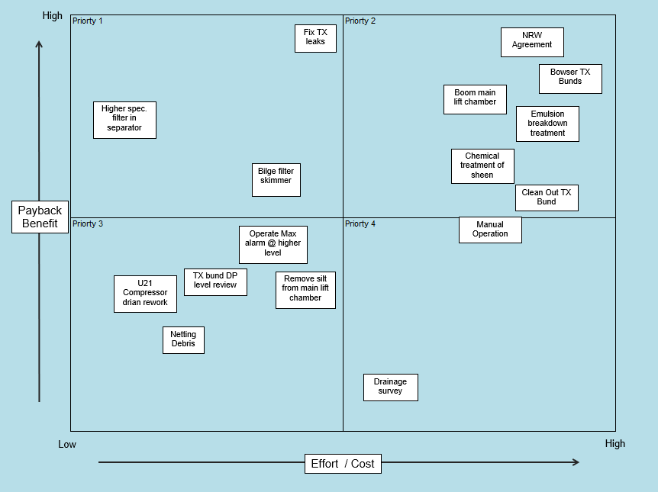

Implement Solutions
Some action has been taken to alleviate the problem (see Work done for details) however oil sheen still appears in the SWT as seen in the following photo (Figure 5). From reviewing their DMAGIC Analysis, further investigation into the separators and the TXs is needed.
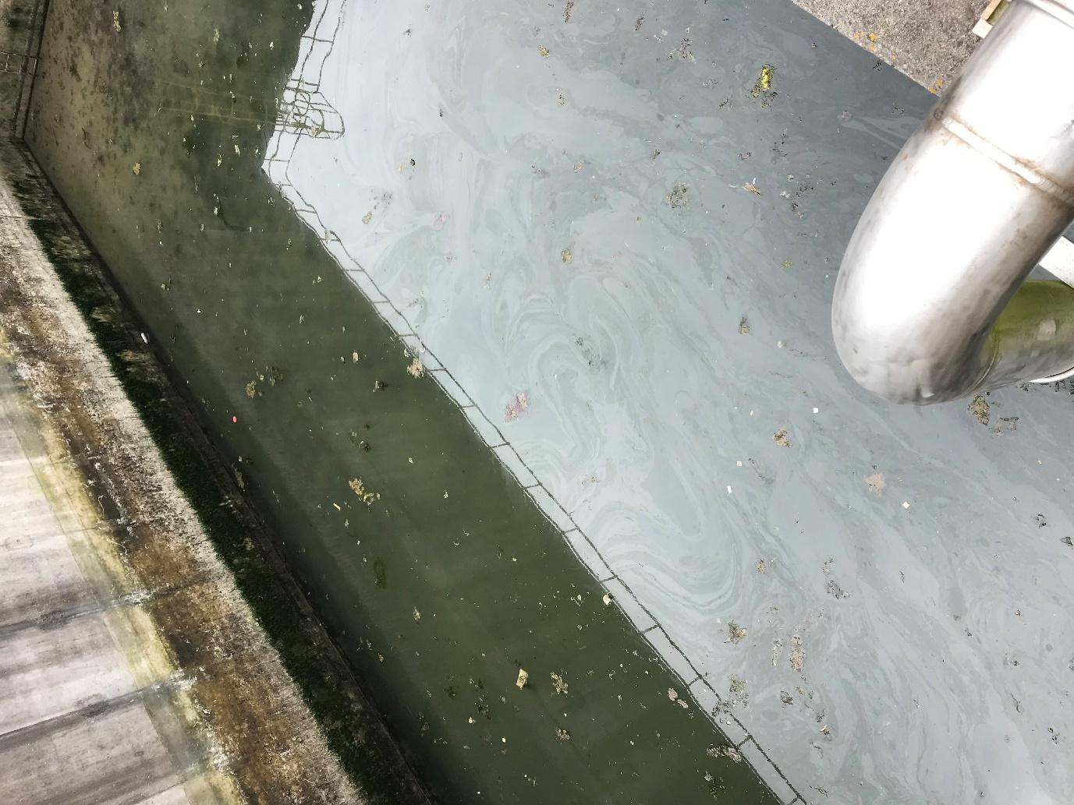
Figure 5. Visible Oil Sheen at SWT

Transformers and Their Role at PPS
A transformer interconnects and transfers power between systems at different voltages. It is a very efficient way of transferring energy between circuits of different voltages. There are different types of transformers; Generator Step-up Transformers (TX) found on power stations step up from up to 19000A and 25kV to 1200A and 400kV, the lower current saves energy along the line. Then there are the numerous distribution centres for domestic purposes, they step down to a more manageable 110 – 250V. For other more power consuming machines, as you might find on an industrial factory site, they could use 10kV-30kV (Heathcote, 2011) (Evans, 2019).
PPS has five industrial TX, stepping up from the generator voltage of 21kV to match the grid network of 400kV. Due to the running regime of the site, 2-shifting, (when a generator is switched off due to lower demand for electricity and back on when demand resumes, putting components through a certain amount of stress) the TX are regularly cycled thermally (Jones, 2020).

Transformer components
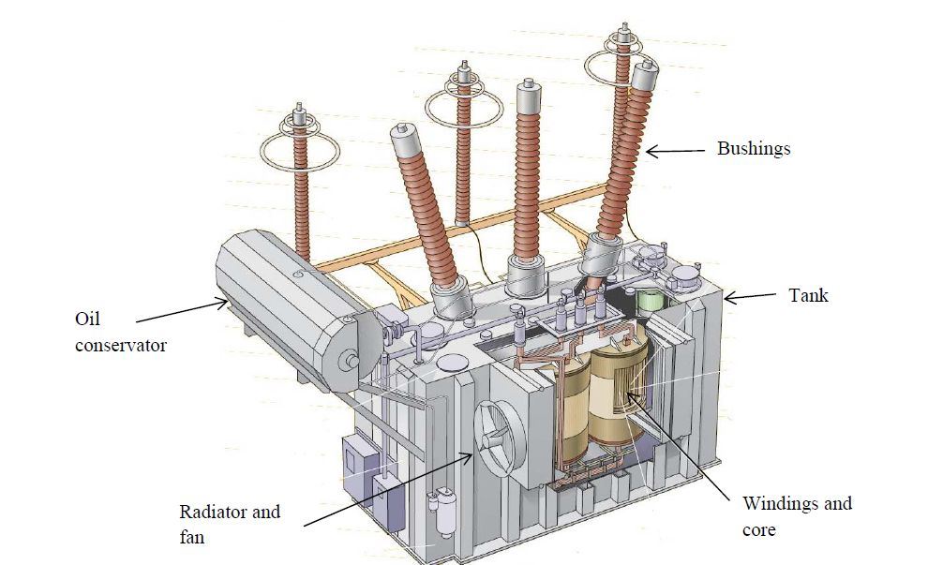
Figure 6. An example of a transformer with main components labelled (Canada Border Services Agency, 2012)
Figure 6 shows an example of a transformer with labels of the main components, please note, this is not the TX found at PPS which is protected under Industrial Property. The PPS TX consist of two-windings, primary and secondary, on a laminated iron core electrically separated with tappings. Due to the high voltages created they use an oil-immersed cooling system.

Core
From a mechanical and electrical perspective, the core is the mainstay of the TX. Passing through the core, the primary and secondary windings are interconnected with the magnetic flux. The windings are mechanically supported by the core frame. The core material properties, ‘…specific losses and permeability…the methods of holding the core laminations together, patterns for interleaving joints and core cross-sections’, signal TX performance.

Windings
All power TX have windings concentrically arranged around a core which is cylindrical. Two-winding consists of a Primary and Secondary insulated winding with the primary connected to the supply - the generator, and the secondary winding to the load – the grid (RWE, n.d.).

Cooling system
A cooling system needs to be in place due to the heat created during the energy transference. The TX are oil-immersed forced-cooled which consist of 44 oil radiators and 16 ventilators with 1 fan and 1 pump redundancy per cooler. The coolant, a pure hydrocarbon oil, is pumped around the windings and out to the heat exchanger. There are three types of cooling methods used;
- ONAN – Oil Natural Air Natural, used at low temperatures up to 55°c
- OFAN – Oil Forced Air Natural, this comes on at 55°c
- OFAF – Oil Forced Air Forced, this comes on at 70°c (Jones, 2019).
The oil used in the transformer cooling system is ‘Nitro Gemini X’, an industrial insulating oil created to withstand high temperatures and meets B.S.148. It is a hazardous substance, harmful to aquatic life with long lasting effects (Nynas, 2017).The cooling control system is contained within a tank-mounted marshalling kiosk. This kiosk also provides marshalling for all the protection device signals, controls and indications (Jones, 2019).

Phases
The AC supply is 3-phase, this is the most efficient way to generate constant energy. The constant power generation leads to a more effective use of the wires keeping costs down.

TX bund, sump pump & skimmers
The TX are positioned above gravel on concrete, gently sloping into a bund which contains a sump pump. This collects rainwater and any oil leaks. A local control panel controls the pump and when the high water level alarm is repeated in the Direct Control System (DCS) an operator is required to start the pump. If the bund is pure oil the pump can’t be started, it must be disposed of externally. Skimmers have been put in place to collect oil off the surface ( RWE Didcot, n.d.).

TX Maintenance
Visual inspections and oil sampling take place at 3 monthly intervals. Oil levels are monitored as part of the 3 monthly visuals, the last time they were topped up was 2015. Due to the hazardous nature of TX, gaining entry to do more intrusive maintenance can only be achieved during a full shutdown of the unit known as a C Inspection. This occurs every 4/5 years (Jones, 2020).

Oil Leak Investigation

C Inspections 2019/2020
Starting 11 May 2019 all Units have/will undergo a full shutdown. This is the only opportunity to investigate the TX leaks and make any repairs. Units 11-31 completed their inspections by the end of November 2020. Figure 7 shows the areas found to have leaks. The causes have been attributed to the following:
- Build quality – Poor installation and probable lack of Quality Assurance. Poorly fitted flange connections were discovered that have since been rectified.
- Poor design – As an example, the bushes within the CT boxes were of a very poor design that led to them cracking and gaskets splitting. This appears to have been a common issue as the OEM had redesigned them when replacements were purchased.
- Thermal cycling – Due to the running regime of the site (2-shifting) the TXs are regularly cycled thermally. This has led to everything expanding and contracting at regular intervals which has had an impact on all the bolted connections and flanges and with the salty environment have tarnished leading to leaks (Jones, 2020).
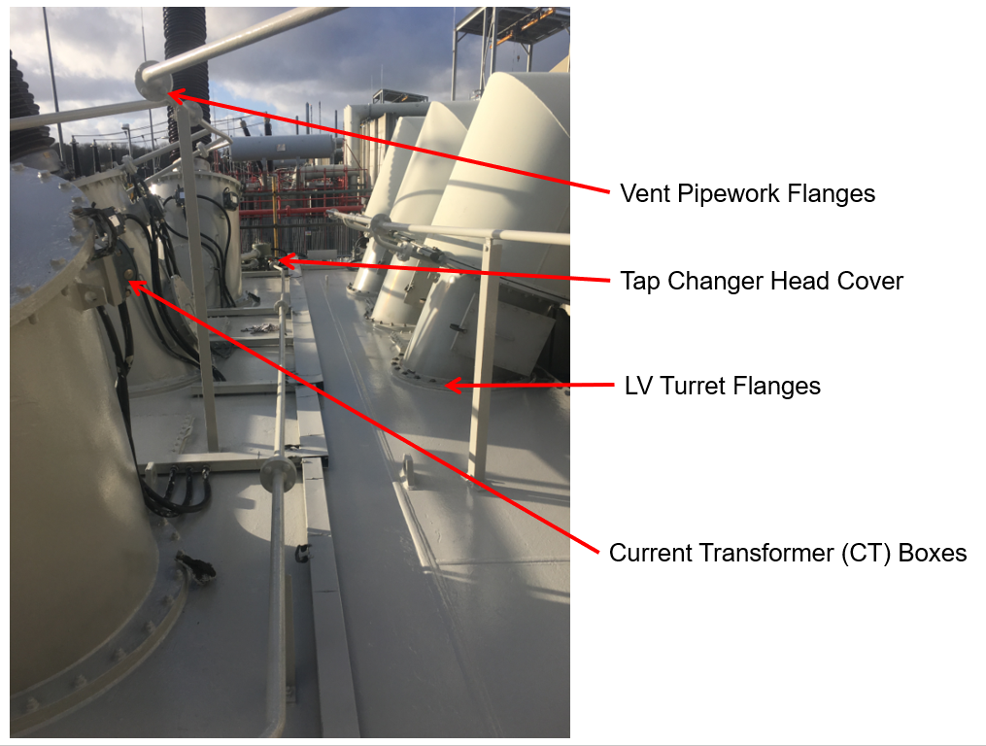
Figure 7. Details of where leaks have been occurring on the TX

To consider the environmental and financial impacts
This section explains what a Special Area of Conservation is and its important role in maintaining healthy marine life. It goes on to give an example of a local oil leak causing an oil sheen and the effects it may have if it reaches the Haven.
Financially, it estimates the labour costs, gives details on the cost for fixing all five TX and goes into detail about the fines NRW could impose.

Environmental Impact

Special Area of Conservation (SAC)
‘Special Areas of Conservation (SACs) are strictly protected sites designated under the EC Habitats Directive‘ (Joint Nature Conservation Committee, n.d.).
According to Milford Haven Port Authority, the marine species and habitats contained in the Pembrokeshire Marine SAC are of great European importance. To ensure their longevity laws are in place to protect them (Milford Haven Port Authority, n.d.).
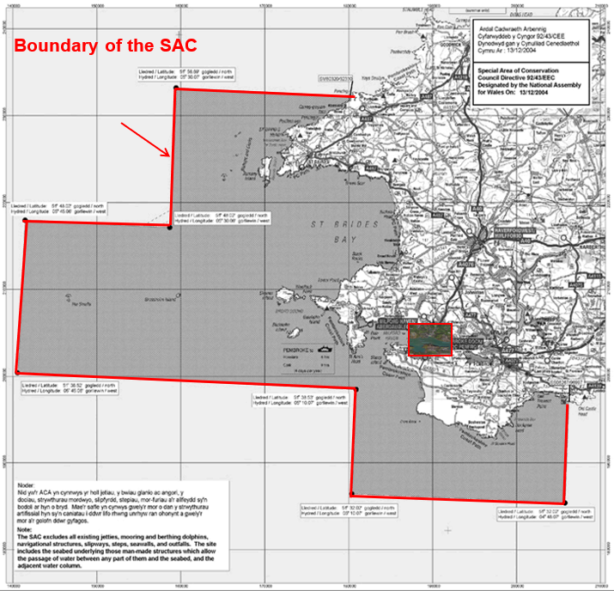
Figure 8. Boundary of the Pembrokeshire Marine SAC (Bergson, 2019)
As seen in Figure 8, PPS is situated in the Pembrokeshire Marine SAC, an example of a ria (a coastal formation that was once a river valley (Pariona, 2017)), one of the best in the UK. The environmental conditions of such an extensive range leads to a richness and diversity of species and supports extensive beds of narrow-leaved eelgrass, Zostera angustifolia (JNCC, n.d.) which is a perfect habitat for small marine biota, many of which are protected.
According to Horst, (1999), it is almost inevitable that oil will be spilled, accidentally or purposely, into a marine environment. The harmful effects that will occur if left to disperse and disappear into pelagic and demersal space after a relatively short period (Horst, 1999) could be irreversible. Any oil released into the Haven could cause untold damage to marine flora and fauna. Details on how to prevent this are in To investigate methods that can be used to contain and remove any oil to prevent it entering the marine environment

A Local case of oil sheen
Oil sheen is a tragic yet inevitable anthropic pollution. As recently as January 2019, the local oil refinery leaked an unknown quantity of petroleum into the Haven causing on oil sheen. Shipping ceased during the primary investigation and booms were deployed to protect the salt marshes. NRW worked closely with the Milford Haven Port Authority and local organisations to minimise any effects of the oil spill (Malloy, 2019). This is evident that local organisations work quickly and effectively to reduce anything harmful entering the marine environment and to reduce a negative public opinion.

Financial Impact

Labour
When the SWT pump is in a manual state someone has to physically check the tank for visible oil sheen before it can be pumped out. If all is clear one or two pumps will be switched on to pump the water up to the final lift chamber. Whilst the pump is on that person remains there to watch for any further oil entering the tank and to switch back to manual when enough water has been pumped out or they see oil sheen entering from the entrance tunnel. The level of water in the tank is normally quite high because it has been left to help with evaporation and degradation of oil sheen, thus it can take up to 60 minutes of observation (depending on the weather). Add this to on average 15 minutes either side for changing into and out of PPE it can take about 90 minutes out of an employee’s day. The cost to the company will vary with which level of employee has to undertake this but the man hours saved with prevention would be put to more productive tasks.

Fixing leaks & oil processing
In the first instance the leaks needed to be found to be able to create a plan for fixing them and to create a budget. The C inspections will give an opportunity for this. The original budget to fix the leaks and process the oil can be seen in Table 5. This was based on having to retrofit the CT boxes in house. Money was saved on the materials and labour when they found a company to produce the boxes at a fifth of the cost reflected in Table 6. Having fixed the problems with higher grade materials the next C Inspection should cost less.
Table 5. Original budget to fix and process the oil
Item | Cost (£)
Materials | 11,000
Labour | 10,000
Oil processing | 9,000
Contractor costs | 23,000
Total | 53,000

Table 6. Actual cost to fix and process oil
Item | Cost (£)
Materials | 6,000
Labour | 4,000
Oil processing | 9,000
Contractor costs | 23,000
Total | 42,000

NRW Actions
Unfortunately, information on NRW fines was unavailable, however, they could issue prohibition notices, enforcement notices, improvement notices, improvement conditions or just address it in a compliance assessment report. If there’s environmental damage from the breach then there would be fines/recovery mechanisms under environmental damage regulations (Williams, 2020), this would only happen after a criminal prosecution. Fortunately, PPS has a good rapport with NRW and if a breach would occur again they would most likely have an improvement condition set into their permit.

To research potential solutions to prevent the oil entering the Surface Water System

FMEA Report
Table 7 shows a Failure Mode & Effects Analysis (FMEA) report for the separators and leaking TXs. The results reveal that after a thorough inspection of the separators they are working to their design. They were not designed for TX oil which has a lower viscosity than the fiters can deal with.
After a close investigation during the recent C Inspections, where the leaks were found on the TX, higher quality parts have been used to fixed them (Figure 9). One of the main sources of leakage were the Current Transformer (CT) boxes. Following a retrofit of the seals, the device shown in Figure 9, was fabricated for pressure testing the CT boxes. The head of oil in the conservator (a space specifically designed for the expansion of the oil with temperature) was estimated to be 4m above the position of the CT boxes on the High Voltage turret, hence 400mbar, the boxes were pressure tested at 800mbar for 1 hour. The test box was filled with oil and more oil added via a bucket pump through the hose seen in the image. A bucket pump was used to raise the pressure to achieve test pressure via a local gauge and the pressure locked in. The pressure gauge was checked after 1 hour to ensure no pressure drop and an inspection carried out inside the CT box for any sign of oil revealed there was none (Jones, 2020).
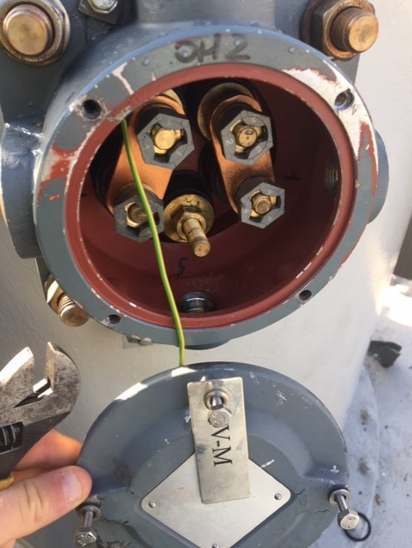
Figure 9. Refurbished CT box
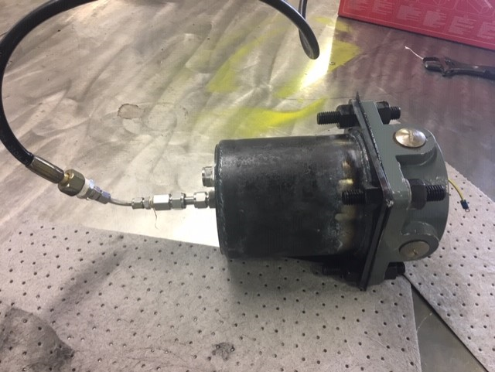
Figure 10. Pressure testing device

The retrofit CT box was only used on one Unit, an alternative supplier of the redesigned boxes was able to produce them for a fifth of the cost and they were able to meet delivery requirements for U21 outage in September (Jones, 2020).

Table 7. FMEA on Oil Sheen Forming on SWT

To investigate methods that can be used to contain and remove any oil to prevent it entering the marine environment

Pollution Pathway
Oils are hydrophobic and if allowed to enter a body of water will cause a sheen of rainbow colours to appear on the surface, usually around 0.01mm. It is known as slick and if left can cause serious damage to the environment. The grade of oil will define the rate of degradation (Muttin, 2014). If dealt with quickly, the hydrophobic buoyant qualities of oil can be contained and response crews can remove it (Zdrazil, 2019).
The pollution pathway consists of Source, Pathway and Receptor. Controls can be put in place at any point to control or reduce the risk of pollution (Thorn, 2018).

Source
From the investigation the main source is from leaking TX. Although the leaks have been fixed, due to the thermal cycling, leaks will occur again, therefore, although the source has been reduced it cannot be stopped (Jones, 2020).

Pathway
The pathway will be the easiest most cost effective way to reduce the risk of pollution, in particular at the SWT. In 2016, oil sheen was visible at W2 and caused PPS to breach their environmental permit. To prevent this from recurring, ways to contain and remove any visible oil sheen from the SWT have been researched. The following investigation includes examples of open sea oil spill recovery systems, all of which could be scaled down for use in the SWT.

Containment
Before any thought of removing oil is considered, containment must be achieved. One of the most effective ways of containing oil is to set up an oil containment boom surrounding the area of sheen. A boom is a large, piece of equipment that floats on water and is navigable, used for containing oil spill on water. Not only do they minimise the likelihood for polluting the environment they also support recovery operations (Zdrazil, 2019). They come in a wide variety of configurations, mostly consisting of floatation, skirt and ballast. A lot of research has been undertaken to realise the most effective configuration (Wong & Barin, 2003). There are over 100 types of boom available for coastal and estuarine waters, all having pros and cons for different situations (Muttin, 2008), due to the fairly predictable nature of the nature of the SWT, realising the best option shouldn’t be difficult.
Cavalli (1999), developed a new anti-pollution system trapping the oil in a single reservoir then gradually introducing more smaller ones, this increased the thickness of the oil which assisted with skimming and pumping it (Figure 11). Although designed for an open sea environment a similar system could be introduced to the SWT on a smaller scale (Cavalli, 1999).
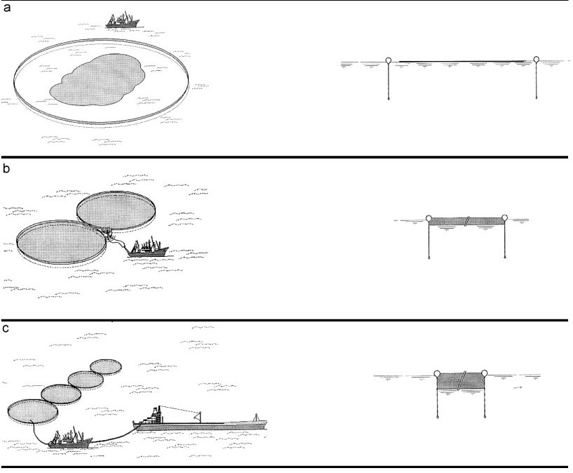
Figure 11.Cavalli oil containment system (Cavalli, 1999). In figure (a) the barrier is deployed and contains the entire oil spill with a very thin layer of oil. In figures (b) & (c) an increase in barriers helps to increase the thickness of the oil, making the recovery much easier.

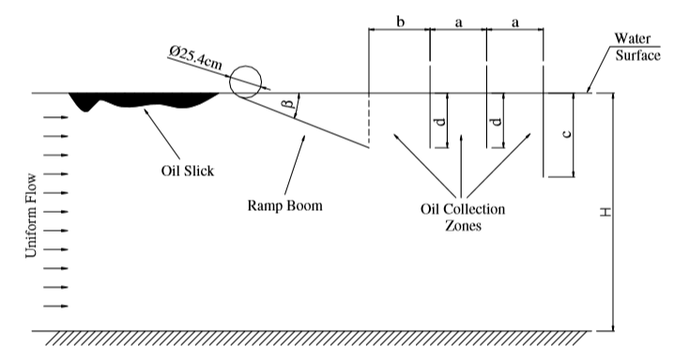Figure 12. Wong and Barin's flexible ramp boom system (Wong & Barin, 2003)
Wong and Barin studied a scale model of a flexible ramp boom system, concluding the system seen in Figure 12 would have 100% efficiency at 30.5 cm/s maximum flow speed and could be scaled up using Froude number scaling.
‘When the Fr numbers of the model and the prototype are made equal, the square root of the ratio of the length scale multiplied by the model flow speed gives the prototype flow speed. For the optimum setting, the ramp boom length was found to be 20 cm. Therefore, for a prototype with a ramp boom skirt length of 2 m, the corresponding flow speed would be U=√(200/20) ∗ (0.305 m/s) ≅ 1 m/s ≅ 2 knots. In other words, 100% collection efficiency could be obtained by the use of a large-scale ramp boom system, with a ramp boom skirt length of 2 m and a total span 14.6 times the draft of the ramp boom.’ Oil is trapped by the ramp boom in two ways: in the first instance the direction of flow is guided by the ramp. Due to a lower downward velocity, the fluid entering the collection zones should not overshoot these zones. Secondly, because of the ramp, a sizable amount of latent oil will collect in the zone, an ideal situation for oily water to stratify into layers due to gravity (Wong & Barin, 2003).
Another form of containment is to use solidifiers. Solidifiers are agents transforming the liquid form of the oil into a mass which can then be more easily collected and are becoming state of the art for oil spill response (Motta, et al., 2018). There are many commercial products available for absorbing oil from water, some specifically with sheen in mind. One of these products is called PetroGuard-D® and comes in an absorbent pillow, SheenGuardTM. The highly absorbent pillows clip together to create a custom sized blanket creating a boom which can absorb four times their weight in oil, when full they can easily be replaced (Figure 13) (Appendix 3) (Guardian Environmental Technologies, n.d.).
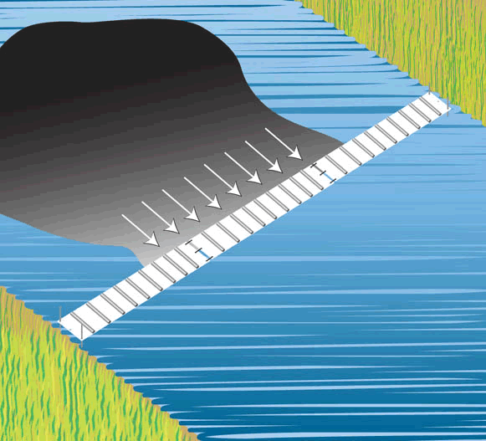
Figure 13. Graphic depiction of a SheenGuard blanket being used to remove oil from inland water and tidal areas
Not all boom designs will be affective. According to Delvigne (Delvigne, 2017), the following failure modes regarding oil sheen containment are found in literature:
- Drainage failure – failure occurs if an increase in the velocity of the relative current combined with increase in slick (caused by the evenness of spreading forces and friction) exceeds the barrier draft
- Droplet entrainment – when the velocity of the oily water is high, droplets may be entrained and flow underneath the barrier
Researching barrier failure, Delvigne investigated a third type of failure, critical accumulation. This appears to occur for oil viscosities $v_{○}≳3,000cs$ and relative current velocities $U≳0.15m/s$. Under these conditions equilibrium between the friction and spreading forces is no longer possible if U exceeds a critical relative velocity U_{ca}, the slick length reduces to zero, and the complete oil slick passes under the barrier independently of the barrier draft (Delvigne, 2017).

Oil removal
Once the oil has been contained either by booms or solidification, removal needs to occur. There are several methods used to remove spilled oil in the environment, some in the experimental phase and some tried and tested .
Fabrics are made into pads or sweeps to collect oil. Polypropylene is often used for its low cost but can lose integrity after deployment. Commercially available pads are made of melt blown fabrics and able to absorb several times their weight. Without the strength of a spunbond fabric they can be heavy and dense (Cerex Advanced Fabrics, 2016).
Surface functionalized multiwall carbon nanotube (MWCNT) reinforced Teflon fibrils (MWCNT@Teflon) have had successful testing as an oil absorbent. An investigation by Padmajan Sasikala, et al., (2018), discovered a potential for large amounts of oil removal from the surface of water. After squeezing the oil out of the MWCNT it also benefits from being a sustainable product with regeneration post oil sorption. The leftover substance can also be recycled as a dye absorbent after undergoing pyrolysis (Padmajan Sasikala, et al., 2018).
Kizil & Bulbul Sonmez, (2017), have experimented with oleophilic hydrophobic gels. They were prepared, ‘via bulk polymerization of the ICS (tris[3-(trimethoxysilyl)propyl]isocyanurate) monomer with different molecular weights of propoxylate macromonomer and different monomer ratios.’ The advantages are numerous; their extreme capacity for absorption, excellent hydrophobicity, quick to swell and de-swell, they are reusable, and chemically and thermally stable. They retain their capability for sorption even after 10 cycles of testing which makes them a good sustainable material for oil recovery (Kizil & Bulbul Sonmez, 2017).
Sorour et al., (2016), developed and investigated the use of hydrophobic silica aerogels. The synthesized samples used the process of ambient pressure drying. Along with creating a fast efficient product for oily-water decontamination their aims included reducing the production time, cost and effort for the process. They were successful in producing synthesized silica aerogel samples with a hydrophobic quality with up to 96% oil removal and realised their aim of low cost production creating an effective sustainable product for cleaning up oil spill. (Sorour, et al., 2016).
Oribayo, et al., (2017), fabricated a superoleophilic and superhydrophobic foam sorbent. This sorbent showed remarkable qualities featuring, ‘high selectivity to oil/organic pollutant sorption relative to water’ and is reusable over many ‘sorption-squeezing’ cycles, retaining its original sorbent rate. The reusability makes it a sustainable option. The materials for the foam are low cost and easily fabricated making it a good economical option (Oribayo, et al., 2017).
According to Cha, et al., (2010) good results can be achieved when removing oil from produced water using a technique of coupling sand filtration and pressure-assisted ozonation. The rapid process involves, ‘…chemical conversions that alter interfacial properties of the oil droplets rendering them abatable by conventional sand filtration.’ (Cha, et al., 2010).
Mycoremediation (using fungi to reduce toxic compounds into less harmful ones) has been investigated as a strong possibility for the removal of oil from water for many years. Mycologist Paul Stamets, has developed a strain of oyster mushrooms which can withstand the salinity of the sea and has created a straw ‘MycoBoom™’(Figure 14); oil on the surface of the water is metabolised by the packed burlap of straw and mycelia, the mycelium feeds on the hydrocarbons of the oil and grows edible mushrooms (Figure 15) (Trimarco, 2010) (Stamets, 2010). This has been tested on a large scale helping in the clean-up of the BP Gulf oil spill (Stamets, n.d.). In the Amazon Rainforest, they have been used in cleaning up abandoned open air waste sites left there by Chevron Texaco drilling for oil.
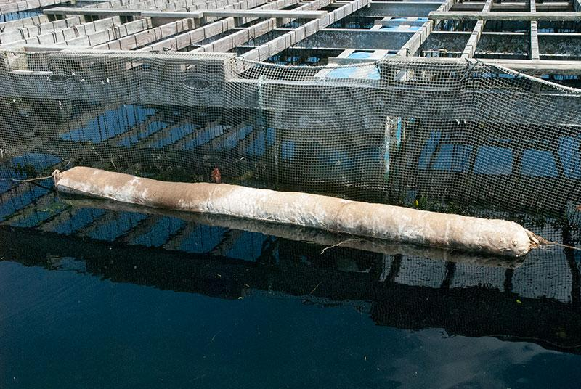
Figure 14. MycoBoom™ floating in saltwater in Totten Inlet, southern Puget Sound near Kamilche Point, Washington. (Picture courtesy of Fungi Perfecti)
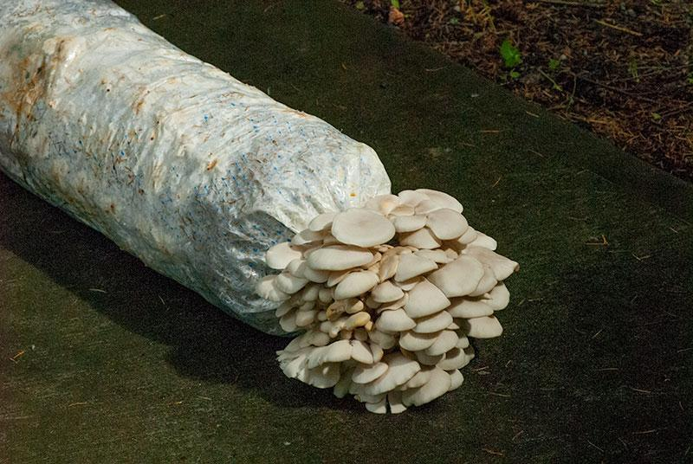
Figure 15. Oyster mushroom fruiting from the end of a MycoBoom™ (Picture courtesy of Fungi Perfecti)

Receptor
The Receptor is the Pennar Gut which flows into the ria of Milford Haven. As can be seen in Figure 16 and Figure 17, the water goes through a reed before entering the Haven, this is the last protective element from any oil sheen passing through the SWS and can’t be diverted thus all measures have been put in place already for this part of the pollution pathway .
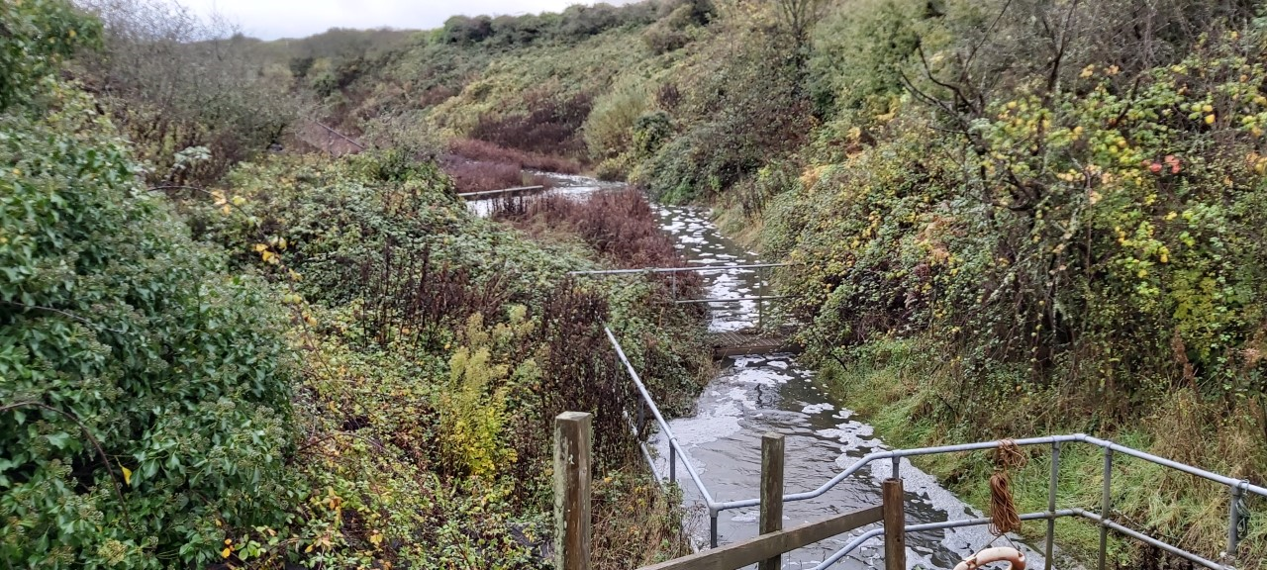
Figure 16. W2, where the receiving water enters the Pennar Gut
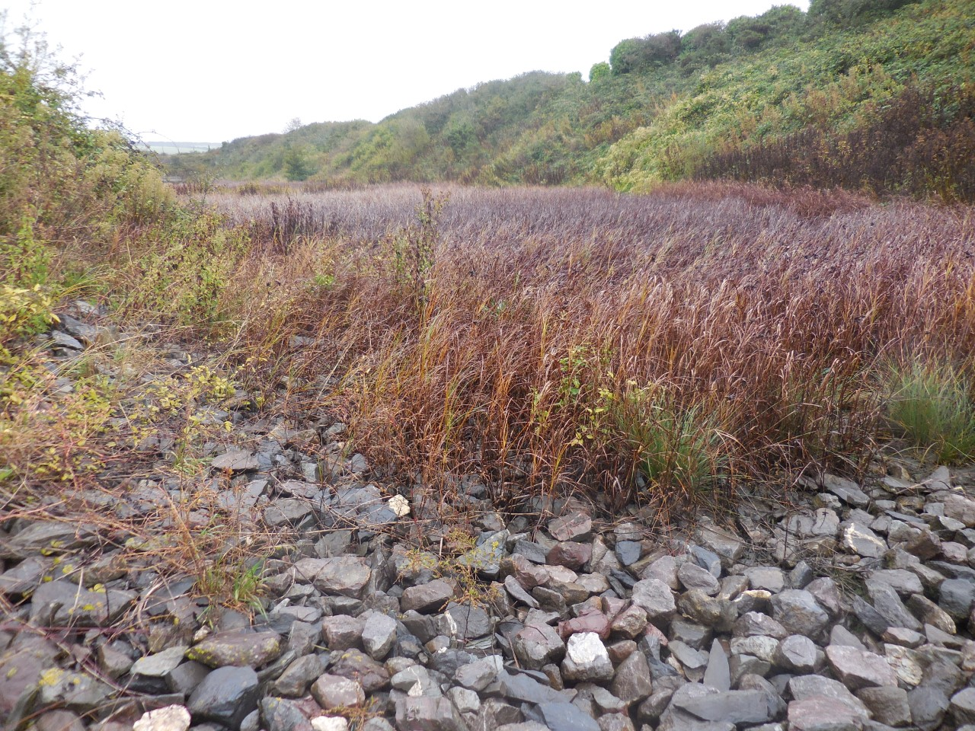
Figure 17. A reed bed joining the Pennar Gut to the Milford Haven Estuary

Work done
Oil dropped anywhere on site needs to be contained and not allowed to be discharged. With oil sheen visible at W2 an investigation took place.
There are a number of separators on site, the TX separator was found to contain a lot of oil and sludge. The separator filters were also blocked. The filters were changed, and the separator cleaned out, however small amounts of oil still passed through. A test was conducted to reduce the flow through the separator. The test hoped the increased residence time in the separator would prevent the oil passing through, but the test failed. Different grade filters and other modifications were discussed to alleviate the issue.
The final interceptor performance was also inspected and found that it was not working as per design. When the final lift chamber was running with one pump the interceptor went into by-pass operation. The design is for the interceptor to only go into by-pass during two pump operation. When the interceptor goes in to bypass any oil in the final lift chamber would have free passage to W2. The interceptor has now been modified and under one pump operation will not go into by-pass.
There were a number of alarm issues which have been resolved. The interceptor coalesces were also found to be partially blocked with silt and were changed for new.
All TX bunds now have skimmers, skimming off oil on the surface of the oily water contained in the bund and directing them into an IBC. When the IBC is full of oil it gets taken off site by a waste management company.

Experiments and Analysis

Commercial solidifier product
A sample of the PetroGuard-D® (PGD) solidifying absorbent was made available from Guardian Environment and an experiment was undertaken to discover its effectiveness.

Testing the Effectiveness of PetroGuard-D® (Block Copolymer) Absorbing Transformer Oil (Gemini-X)

Introduction
The following experiments took place to analyse the effectiveness of PGD at absorbing oily-water, in particular the TX oil found on site which is in the SWS. A Standard Work Instruction (SWI) (Figure 24), risk assessment (Appendix 5) and COSHH (Appendix 6) were created for the experiment.

Materials
- PGD sample
- TX oil sample
- Water sample
n.b. as advised by Guardian Environmental, the ratio used in this experiment was 1:2 in weight PGD:TX oil; the amount of water does not need to be quantified

Equipment/Apparatus
- Sampling equipment (in this instance a sampling bucket attached to 1m chain and 10m rope wrapped around a reel)
- Bottle for water sample
- Scales ± 0.005
- Fume hood
- Impermeable gloves
- Plastic container
- Spoon
- 2 x Petri dish
- Pipette ±
- Note pad with pen/pencil
- Stopwatch ± 0.05s
- Oil absorbent pads
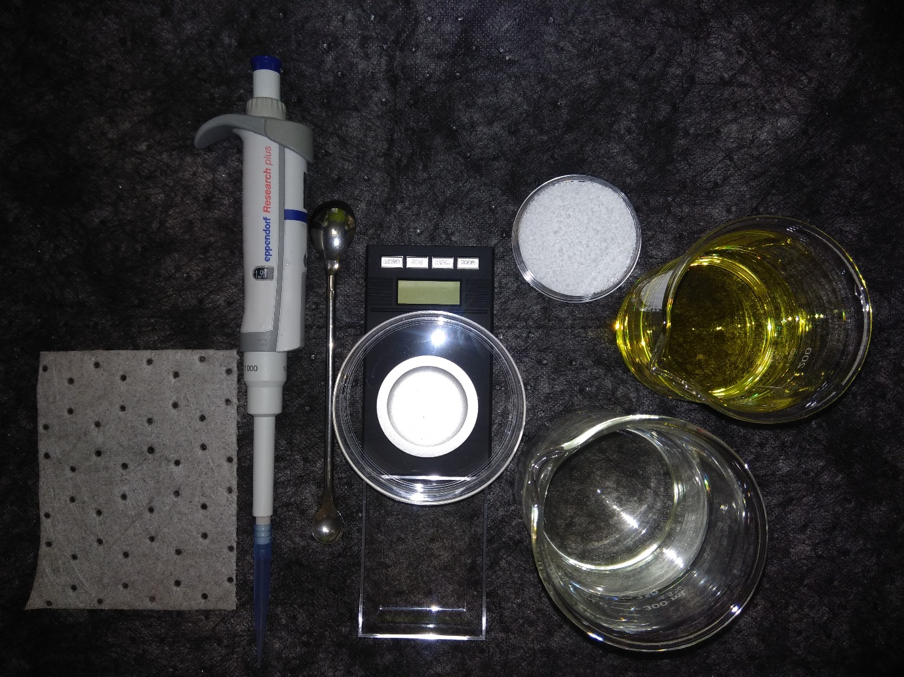
Figure 18. Equipment and apparatus used

Method
- Read the risk assessment PEM/RA/614/A (Appendix 5) and COSHH 3848505 (Appendix 6) and the MSDS for both chemicals which are available on request
- Use PRISM to schedule a Work Order and get this approved by a safety operator
- After completing a Point of Work Risk Assessment (POWRA) obtain a water sample from the Main Plant Downstream chamber following the instructions on SWI 1521 (Appendix 4) ensuring impermeable gloves are worn at all times
- Transport it to the Water Treatment Plant (WTP)
- In the WTP complete POWRA
- Place the water sample in the fume hood
- Place the plastic container in the fume hood and pour some sample water into it
- Place an oil absorbent rag next to the plastic container
- Place one petri dish on the scales, tare the scales and weigh 1mg of TX oil using the pipet and put to one side
- Place the other petri dish on the scales, tare the scales and weigh 0.5 mg of PGD using the spoon and put to one side
- Bring both dishes to the fume hood
- Using the pipet drop the TX oil on the surface of the water
- Drop the PGD onto the water and start the stopwatch
- After 1 minute take photo and make notes of appearance and repeat for each minute until 5 minutes are completed
- If the PGD and TX oil combines the substance should be removed and placed on an oil absorbent rag
- The water should be emptied into the sink and the container rinsed
- To mimic an open water situation this can be repeated and stirred vigorously
- This can be repeated with increasing weights ensuring the water is replaced each time and the 1:2 ratio is maintained
- Make sure all waste is disposed of in the correct areas i.e. oily rags put in an oily rag bin

Result/Analysis
An initial trial was done using petri dishes, with photos rather than notes taken, as can be seen in Figure 19. Minute to minute not much occurs until the fifth minute. At this time the compound appears to be solidifying.
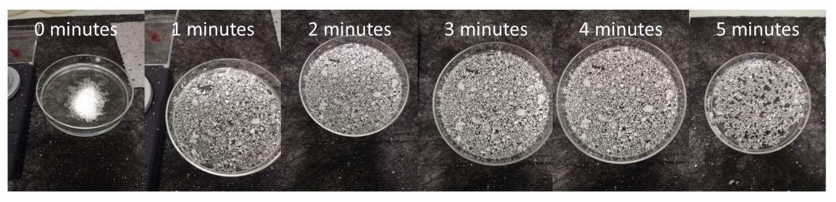
Figure 19. 1 minute intervals for 5 minutes using sample water
The second test used a 3l plastic container with 2l of sample water and maintained the 1:2 ratio for the PGD and TX oil. This time the oily-water was mixed to mimic an open water situation. Learning from the previous experiment a photo was only taken after five minutes. Figure 20 shows more evidence that the product absorbs the oil and would be beneficial for use in the SWT.
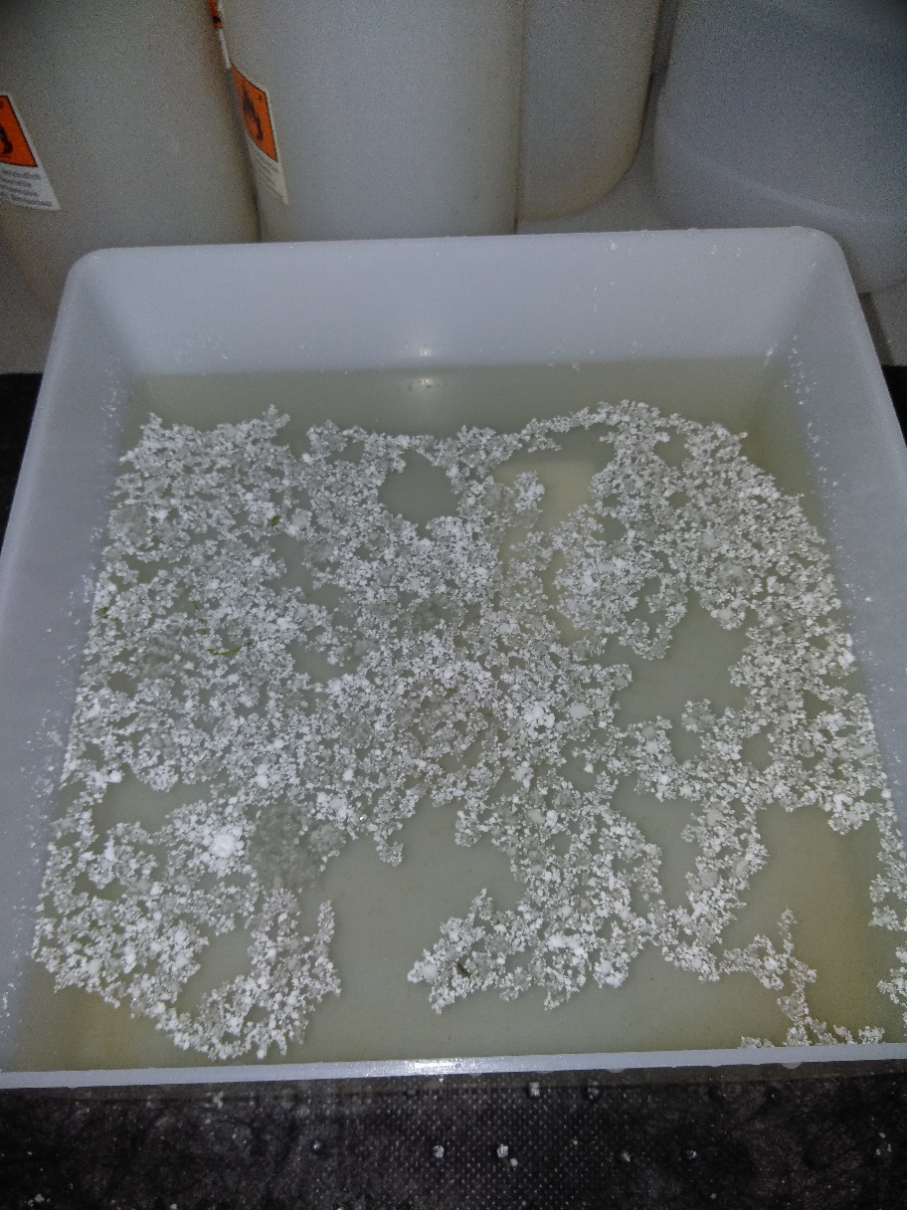
Figure 20. After five minutes of PDG using sample water

Remarks
The experiment used PGD, the commercial product, SheenGuardTM, uses the solidifying product in an ‘absorbent pillow’. To install this product a bespoke version would be made.

Discussions and Conclusion
The first aim, to investigate where the oil is potentially coming from, was aided by a previous investigation on site using their analysis tool, DMAGIC. It uncovered several issues with the SWS and had already dealt with most, leaving the separators and leaking TXs to investigate further. Maintenance strategies are in place to inspect the TX at 3 monthly intervals and any intrusive work has to be done every 4/5 years during a C Inspection.
Considering the environmental impacts revealed the site to be within a SAC, supporting a diverse range of protected species. Ensuring the continued protection is paramount.
Financially, three areas were covered; labour (having to manually control the pump), fixing the TX leaks and oil processing, and NRW fines. Looking at labour, if the pumps could remain on automatic it could save up to 90 minutes in a day, time spent on more productive activities. It would also prevent the risk of oil going through the SWS and entering W2. The cost of fixing the leaks and oil processing had an original budget of £53,000, due to finding a company to produce the CT boxes, one of the main areas of leakage, this cost was reduced by about a fifth. The information from NRW regarding fines was unavailable but RWE’s Environmental Engineer suggested they would only give out a fine for a repeat offender and if the permit breach caused any serious environmental damage.
An FMEA report was used to assist the research into potential solutions to prevent the oil entering the SWS. It revealed the separators were working to their specifications however they were not designed for transformer oil which is a lower viscosity than the filters could deal with. After the C inspections, all the leaks were repaired and with better quality parts were used, special attention was given to the CT boxes, one of the main areas to be found leaking. They were all pressure tested with a custom made device before being fitted to ensure there were no leaks.
Finally, the investigation into methods that can be used to contain and remove any oil to prevent it entering the marine environment looked at the Pollution Pathway. Concluding that the pathway, i.e. the SWT, would be the best most effective way for prevention it began investigating containing the oil, researching barriers and solidifiers. Then ways to remove the oil looked into different methods, most in the experimental phase. Mycoremediation was the only method that had been used on a large scale for the remediation of the BP Gulf disaster and on a smaller scale in the Amazon Forest. This could be a possible remedy if a company in the UK could be found to undertake it.
An experiment on a commercially available product, PetroGuard-D®, brought up good results for a prospective solution. If this product is used the pumps could be returned to automatic which would free up the time of manual pumping for a more efficient use of skills and the concern over breaching the environmental permit would be alleviated.

Recommendations for Further Work
Due to the investigations concerning the separators revealing they are working to capacity and the various filter combinations are able to filter and separate other types of oil on site, no further action will be taken regarding this.

Short Term
The continuation of fixing the leaks should have an immediate effect on the amount of oil transferred to the SWT. To ensure this occurs continuing with the regular maintenance checks is paramount.

Medium Term
Containment and removal of the oil in the SWT is a safe way to solve the problem. After the research into different techniques some of the experimental options look capable, however, a tried and tested commercial product would be a better choice. The experiments with PetroGuard-D® displayed promising results. Used with an absorbent pillow, SheenGuardTM, it is used as a containment boom combined with a removal material. Contact with a UK rep has been established and a site visit should be arranged where a bespoke boom would be developed. Specifically designed for sheen removal, they are long lasting, reducing man-hours, and when at full capacity easily removed and replaced. PPS would follow its strict waste rules regarding the removal of the blankets.
The only other tried and tested method was mycoremediation. This technique would remove the sheen however the ability to take out the by-product could pose problems. Also finding a company in the UK offering the technique might prove time consuming.

Long Term
Residual oil will still be in the TX bunds and pipes. These should be emptied, cleaned and flushed through. Due to the hazardous nature of the TX, this would involve one unit at a time being shut down, reducing the generating capacity by 440MW, or happening during the next C Inspection, 4/5 years.

References
RWE Didcot, n.d. Introduction to CCGT Power Plant. Didcot: Didcot Technical Support Centre.
BBC, 2019. www.bbc.co.uk/news. [Online]
Available at: https://www.bbc.co.uk/news/uk-wales-46801619
[Accessed 8 12 2019].
Bergson, E., 2019. Environmental Awareness Training, Pembroke Power Station. s.l.:RWE.
Canada Border Services Agency, 2012. Concerning the preliminary determination with respect to the dumping of CERTAIN LIQUID DIELECTRIC TRANSFORMERS ORIGINATING IN OR EXPORTED FROM THE REPUBLIC OF KOREA. [Online]
Available at: https://www.cbsa-asfc.gc.ca/sima-lmsi/i-e/ad1395/ad1395-i12-pd-eng.html
[Accessed 29 April 2020].
Cavalli, U., 1999. Réservoir flottant souple et contractile: Dimensionnement théorique préalable, s.l.: Electrical Engineering.
Cerex Advanced Fabrics, I., 2016. Fabrics for Oil Sheen Removal and Items Made Therefrom. United States of America, Patent No. 14/857,448.
Cha, Z., Lin, C.-F., Cheng, C.-J. & Hong, P. K. A., 2010. Removal of oil and oil sheen from produced water by pressure-assisted ozonation and sand filtration. Chemosphere, 78(5), pp. 583-590.
Delvigne, G. A. L., 2017. Barrier Failure by Critical Accumulation of Viscous Oil. International Oil Spill Conference Proceedings, 2017(1), pp. 143-148.
Evans, P., 2019. How Transformers Work. [Online]
Available at: https://theengineeringmindset.com/how-transformers-work/
[Accessed 28 April 2020].
Guardian Environmental Technologies, n.d. SHEENGUARD OIL SHEEN REMOVAL PILLOWS AND BLANKETS. [Online]
Available at: https://guardianenvironmental.com/spill-absorbents/oil-absorbent-sheen-removal-pillows-and-blankets/
[Accessed 12 June 2019].
Harrison, Z. & Smith, R., 2010. Pembroke Power Station - Environmental Permit Application Volume 1. Swindon: RWE Environmental Department.
Heathcote, J. M., 2011. Transformers. In: R. P. M & J. H. E, eds. Modern Power Station Practice. 13th ed. Oxford: Pergamon Press.
Horst, U. O., 1999. Physical properties and processes that influence the clean up of oil spills in the marine environment. Spill Science & Technology Bulletin, 5(3/4), pp. 177-289.
JNCC, n.d. Pembrokeshire Marine/ Sir Benfro Forol. [Online]
Available at: https://sac.jncc.gov.uk/site/UK0013116
[Accessed 10 February 2020].
Joint Nature Conservation Committee, n.d. Special Areas of Conservation. [Online]
Available at: https://sac.jncc.gov.uk/
[Accessed 4 February 2020].
Jones, B., 2019. Lead Electrical Engineer [Interview] (10 June 2019).
Jones, B., 2019. TX Costs. Pembroke: s.n.
Jones, B., 2020. [Interview] (17 January 2020).
Kizil, S. & Bulbul Sonmez, H., 2017. Oil loving hydrophobic gels made from glycerol propoxylate: Efficient and reusable sorbents for oil spill clean-up. Journal of Environmental Management, Volume 196, pp. 330-339.
Malloy, A., 2019. Updated Statement 13:00: Oil Pollution Incident. [Online]
Available at: https://www.mhpa.co.uk/news/2019/01/03/updated-statement-1300-oil-pollution-incident/
[Accessed 12 January 2020].
Malloy, A., 2019. www.mhpa.co.uk. [Online]
Available at: https://www.mhpa.co.uk/news/2019/01/03/updated-statement-1300-oil-pollution-incident/
[Accessed 8 12 2019].
Milford Haven Port Authority, n.d. The Waterway Habitat. [Online]
Available at: https://www.mhpa.co.uk/the-milford-haven-waterway/
[Accessed 4 February 2020].
Motta, F. L., Stoyanov, S. R. & Soares, J. B. P., 2018. Application of solidifiers for oil spill containment: A review. Chemosphere, Volume 194, pp. 837-846.
Muttin, F., 2008. Structural analysis of oil-spill containment booms in coastal and estuary waters. Applied Ocean Research, 30(2), pp. 107-112.
Muttin, F., 2014. Marine Coastal and Water Pollutions, Oil Spill Studies. 1st ed. London: ISTE Ltd.
National Resources Wales, 2010. Pembroke Power Station Permit. s.l.:National Resources Wales.
Nynas, 2017. NITRO GEMINI X SAFETY DATA SHEET. Stockholm: Nynas.
Oribayo, O., Feng, X., Rempel, G. L. & Pan, Q., 2017. Synthesis of lignin-based polyurethane/graphene oxide foam and its application as an absorbent for oil spill clean-ups and recovery. Chemical Engineering Journal, Volume 323, pp. 191-202.
Padmajan Sasikala, S. et al., 2018. Multiwall carbon nanotube reinforced teflon fibrils for oil spill clean up and its effective recycling as textile dye sorbent. Journal of Environmental Management, Volume 211, pp. 198-205.
Pariona, A., 2017. Coastal Features: What Is A Ria? What Is A Ria Coast?. [Online]
Available at: https://www.worldatlas.com/articles/coastal-features-what-is-a-ria-what-is-a-ria-coast.html
[Accessed 29 February 2020].
Rinkesh, n.d. www.conserve-energy-future.com. [Online]
Available at: https://www.conserve-energy-future.com/effects-of-oil-spills.php
[Accessed 8 12 2019].
RWE, 2016. DMAGIC Analysis of Visible Oil Sheen. Pembroke: RWE Pembroke Power Station.
RWE, n.d. Everything you ever wanted to know about Pembroke Power Station. s.l.:RWE.
Sorour, M. H., Hani, H. A. & Al-Bazedi, G. A. e. a., 2016. Hydrophobic silica aerogels for oil spills clean-up, synthesis, characterization and preliminary performance evaluation. Journal of Porous Matter, Volume 23, pp. 1401-1409.
Stamets, P., 2010. The Petroleum Problem. [Online]
Available at: https://fungi.com/blogs/articles/the-petroleum-problem
[Accessed 3 May 2020].
Stamets, P., n.d. Paul Stamets Discusses Bioredmediation and the BP Spill [Interview] n.d.
Thorn, A., 2018. Pollution Pathway. s.l.:UWTSD.
Trimarco, J., 2010. Can Oil-Eating Mushrooms Clean Up After a Spill?. [Online]
Available at: https://www.alternet.org/2010/10/can_oil-eating_mushrooms_clean_up_after_a_spill/
[Accessed 19 April 2020].
Williams, D., 2020. RWE Environmental Engineer. s.l.:s.n.
Wong, K.-F. V. & Barin, E., 2003. Oil Spill Containment by a Flexible Boom System. Spill Science & Technology Bulletin, 8(5-6), pp. 509-520.
Zdrazil, T., 2019. How Does an Oil Containment Boom Work?. [Online]
Available at: https://www.absorbentsonline.com/spill-containment-blog/how-does-an-oil-containment-boom-work/
[Accessed 19 April 2020].

Appendices

Appendix 1
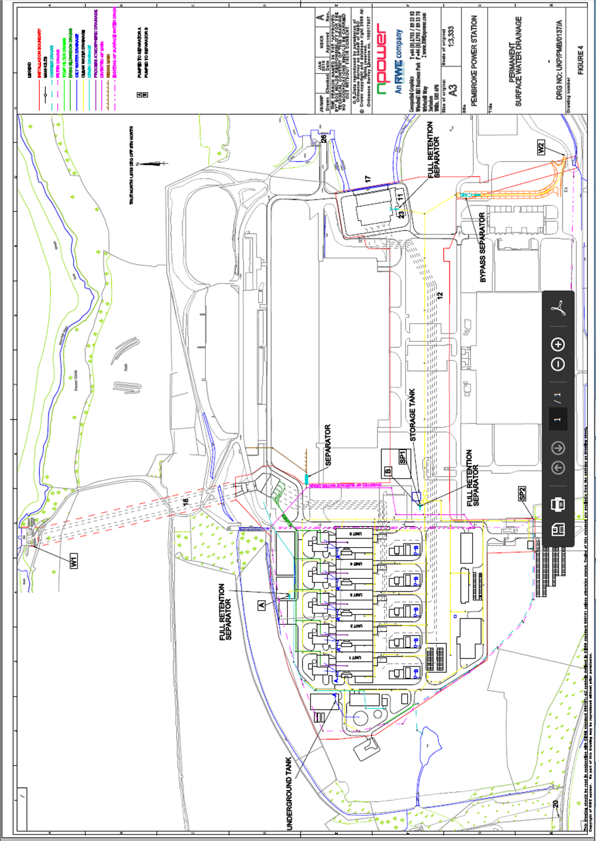
Figure 21. SWS Plan

Appendix 2
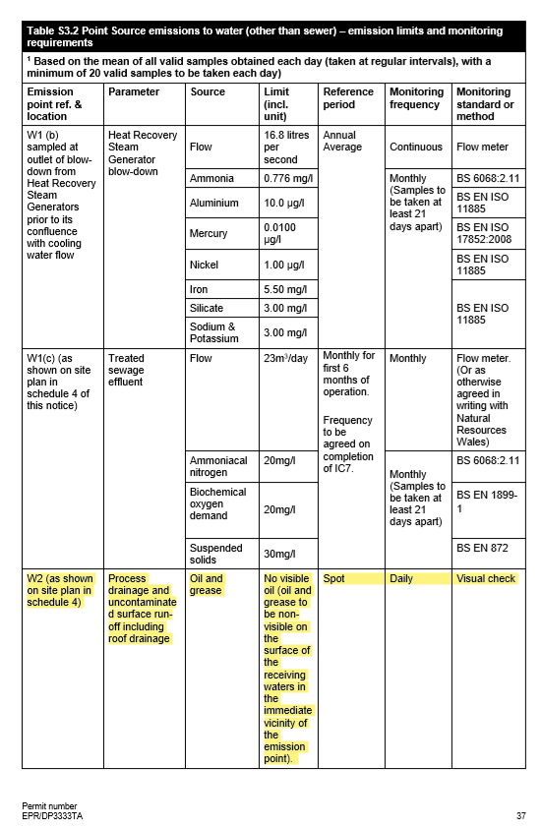
Figure 22. PPS Environmental Permit pp 37

Appendix 3
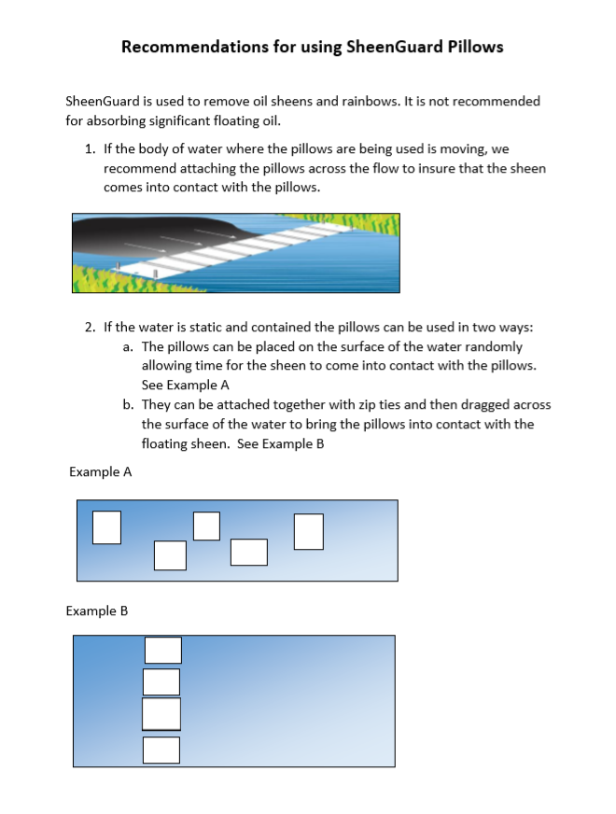
Figure 23. Recommendations for using SheenGuard Pillows

Appendix 4
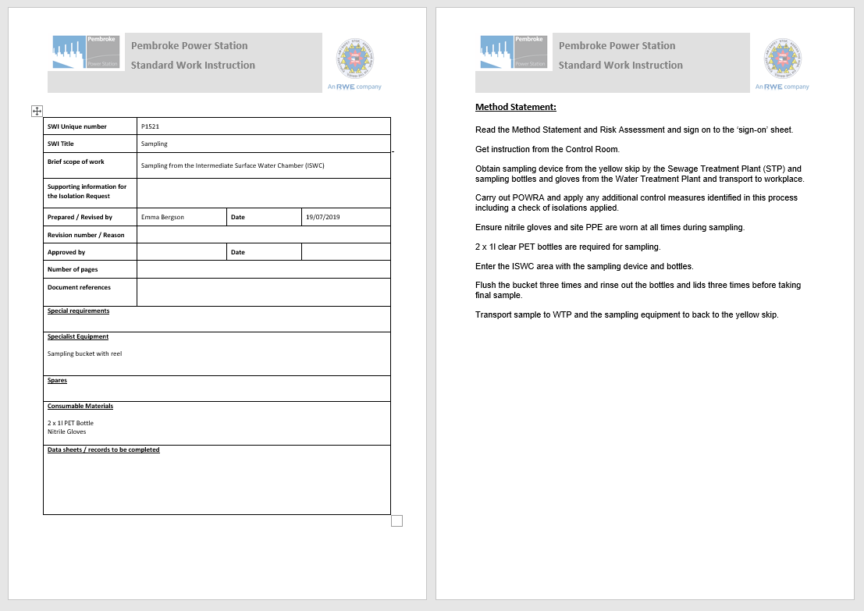
Figure 24. SWI P1521

Appendix 5
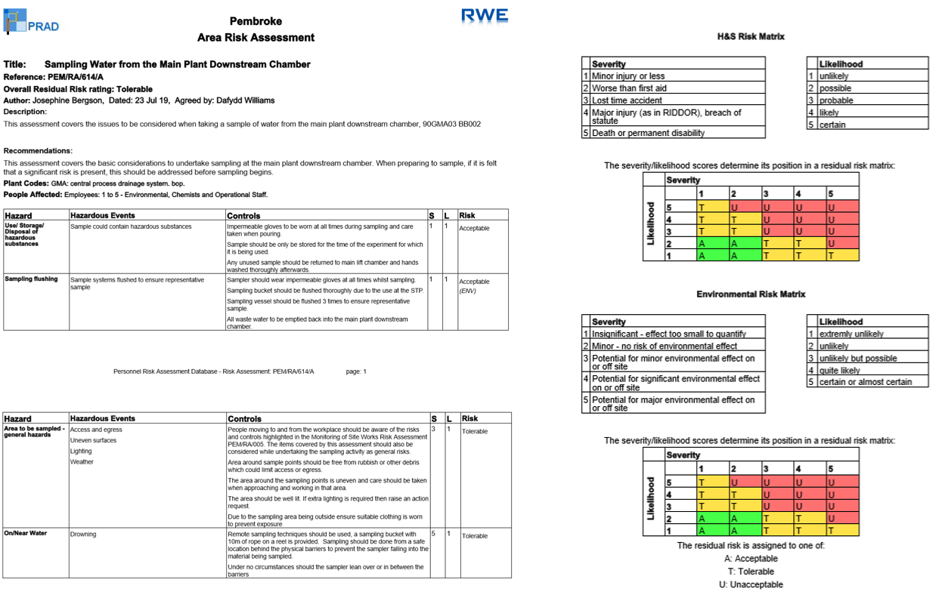
Figure 25. PRAD-PEM-RA-614-A

Appendix 6
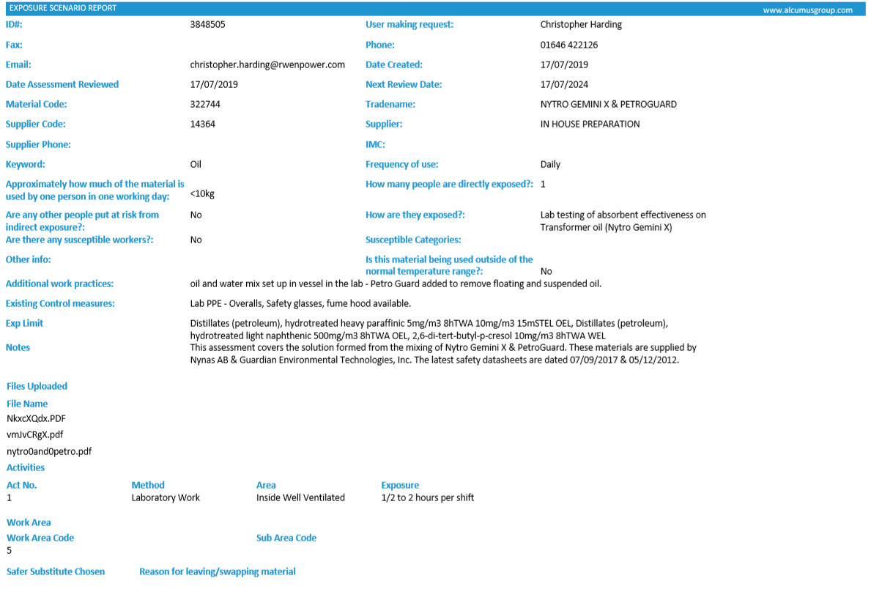
Figure 26. COSHH for Nytro Gemini X & PetroGuard

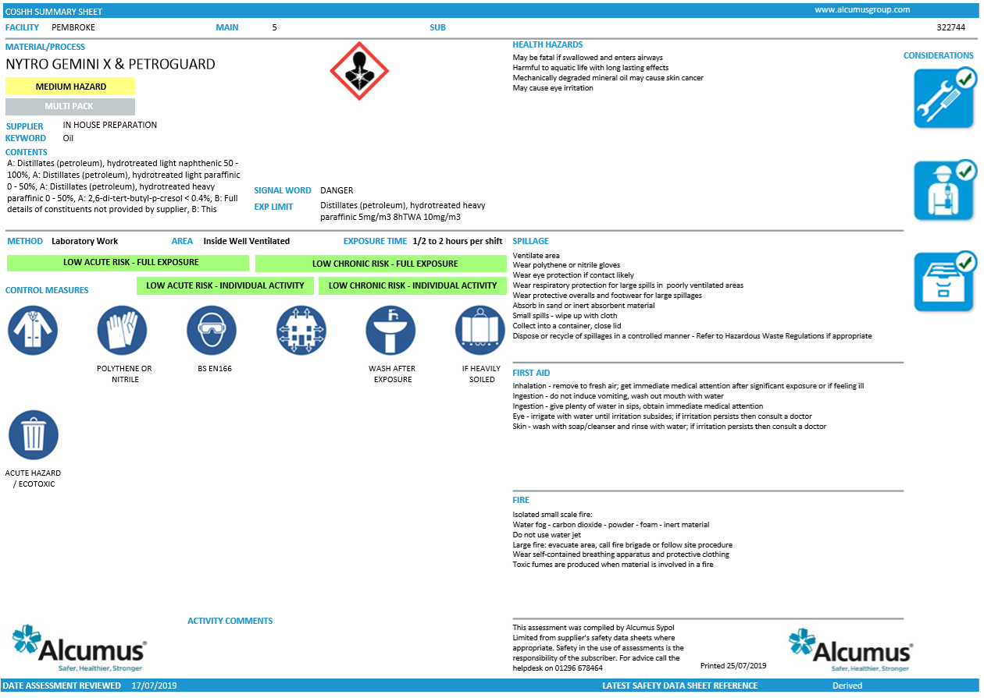
Figure 27. COSHH cont.
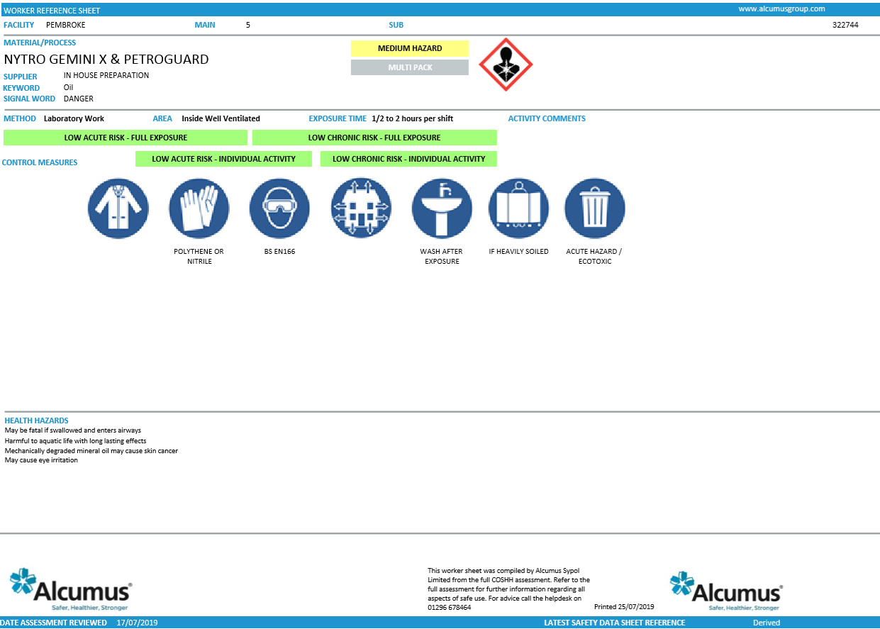
Figure 28. COSHH cont.

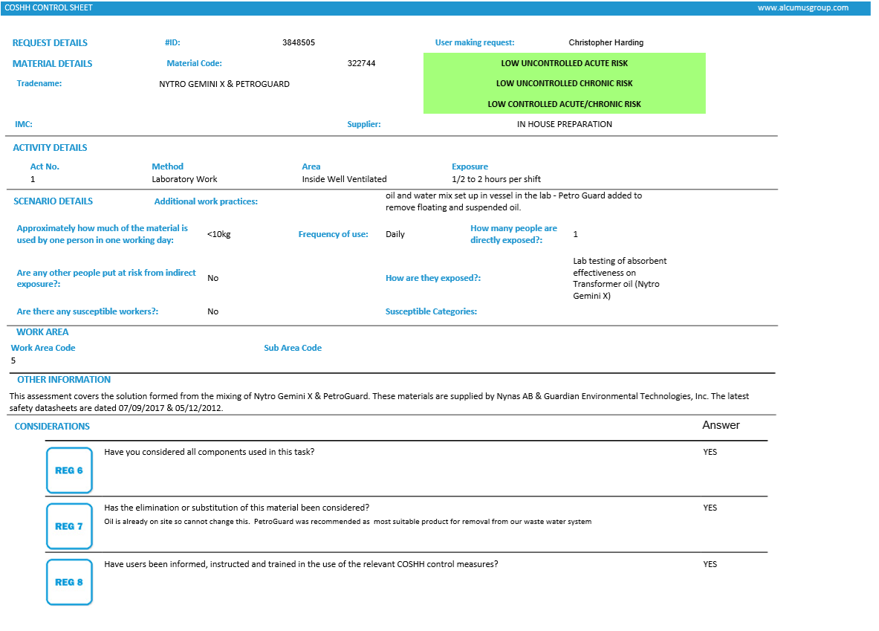
Figure 29. COSHH cont.

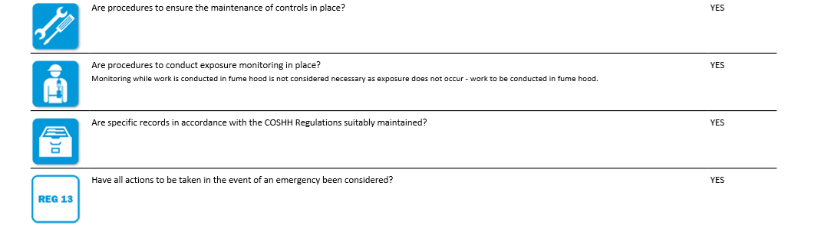
Figure 30. COSHH cont.

