ACADEMIC AND EMPLOYABILITY SKILLS

Lecturer: Adesewa Ajayi
Module Code: BMSW4001
Student Name: Ramona Georgeta Marza
Student Id: 1919636
Table of contents

Introduction 3
Gibbs Reflective cycle 4
Kolb theory of learning style 5
Reflective writing 6
Summarising 7
Paraphrasing 8
Conclusion 9
Reference List 10

Introduction

The current academic report is about the academic and employability skills. In this assignment I will be choosing four to five topics which has made a good for me in the field of academics and employability. I will discuss by learnings on these topics and how it can be beneficial for me in future. I will also mention my past learnings about these topics and activities I was engaged in the classroom while staying these topics. Mostly in this assignment I will focus on the ways by which these concepts will help me in growth of my employment area and academic area.

Gibbs Reflective cycle
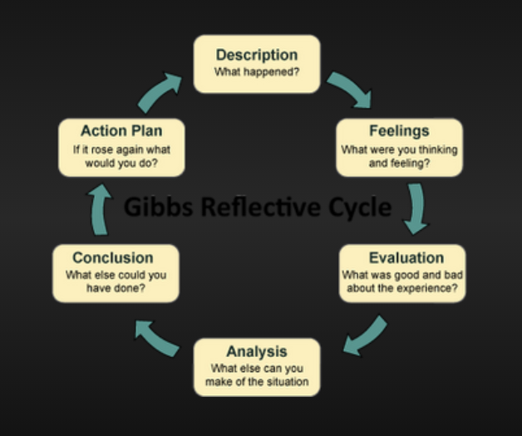
Figure 1: Gibbs Reflective Cycle
Gibbs reflective model is one of the significant models that helps in encouraging the people to recall their experiences in a systematic way regarding a specific situation. Before completion of this topic I was not aware about all the steps of the Gibbs reflective cycle. In classroom my professor gave some assignments of 1000 words to describe a situation from past by the help of Gibbs reflective cycle. These assignments helped in making me know regarding how I can divide my experience in each of the step. The concept regarding this topic was very light before completion, however, it improved my concept and now I am good at writing any of the situation with Gibbs reflective cycle. In step one I described the overall situation for which I will be writing y experience, in step 2 feelings are written, in step 3 evaluation is done regarding the situation based on the feelings (influenced by Adeani et al. 2018). This is first three stage of the cycle which is followed by more their steps that are analysis, conclusion and action plan. Previously I was confused with stage 3 and stage 4 as it is about evaluation and analysing the situation. Both the terms sound like me. However, after completion of this course I understood that in evaluation part good things and bad things in the situation needs to be discussed and in the analysis part, alternatives one can make in that specific situation are written in analysis part. As per my opinion, I think action plan is the most critical and important part. Through the overall reflective cycle when I can know my issues then in last stage, I must make action plan on it regarding the improvement required. This reflective cycle is the important topic in the field of employability (influenced by Sekarwinahyu et al. 2019). I can rectify my issues by using this model of reflection.

Kolb theory of learning style
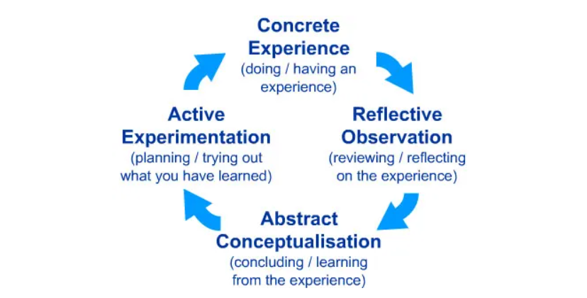
Figure 2: Kolb’s reflective cycle
According to the viewpoint of Fewster-Thuente and Batteson (2018), Kolb’s learning style is known as one of the best and widely used learning style theories. As per Koln individual learning style emerges due to life experiences and demands of the current environment. This theory is linked with the employability field as through job requirements and person’s skills can be assessed. Thus, it is important to know about this theory so that my future career can be secured, and I can use them wisely. This is being done in four stages that is concrete experience, reflective observation, abstract conceptualisation and active experimentation. In first stage, concrete experience that is feelings for the specific situation, in the second stage reflective observation will be developed such as the experience regarding relation to the learning. In third stage I can be able to understand the learning outcome and the way by which the thoughts can be easily conceptualised. In the last stage I will be discussing what the learning from the situation has impact on the future. In order to make this topic understand in the class, we have been provided with some hypothetical situation with which I have deal with and write reflection based on Kolb’s learning model.
This will help me in gaining employability in future. This model will help me in processing what happened during situation, in the third stage I can both evaluate their experience as well as recount. Learning though the experience is important so that I can develop some skills and knowledge which was lacking in that situation. Learning process can be gained through this cycle. As per the Kolb’s learning theory, it is believed that individual cannot perform both the variables on single axis at same time. The type pf Kolb’s learning style is the product f the two-choice decision. There are four types of learning cycles taught by teacher that is diverging, assimilating, converging and accommodating. By understanding these types of learning style, I understood that I fall in the assimilating section., as I generally prefer concise logical approach. Ideas and concepts are more important fir me than the people. I always require good clear explanation rather than any type of practical community. I like science subject may this is the reason I follow this learning style.

Reflective writing
Examining an event or an observation help the person to know about the situation. It will include all types of good things, challenges and faults, changes that can be made and other aspects. As mentioned by Gibson et al. (2017), reflective writing gives the writer an insight regarding situation and it also led to further learning. I think this topic is remarkably interesting as through reflective writing I can know what differently I would have done in that situation to make it better. Reflection should be done always in first person as the person is writing own reflection. Previously I have written some reflective writing, however I was not clear about the steps I should follow. The classroom activities made my concept clearer. I understood that firstly I need to describe the situation and then interpret the situation. In this stag I need to write my feelings and reactions. It will also include the good and bad aspects and what really is going on at that time. The last step is the outcome in which I ned to make a conclusion and the various ways which I could have used in that situation to handle it in effective way. In classroom teacher has shown examples of various reflective writing for making our concept clear. Some of those examples include “How well did you do in school last year?” and “school excursion”. There are some models by which reflective writing can be made more systematic and it also enhance my academic skills. Gibbs reflective cycle is one of those models which also have been taught by teachers in the term. I have decided that now on words I will be writing each of the important observation or any situation which is beneficial for me, by writing the reflective writing I can know my problems and accordingly I can plan for their improvement. Recently I have written in reflective writing and after writing I came to know that I have weakness in the time management skills, so I am planning to improve time management. Thus, I think reflective writing is particularly important for me.

Summarising
As mentioned by Audritoand Bergamini (2018), summarising is the important academic concept which is being taught to student to discern most important ideas in the text. In addition, this, the summarising concept also make student know how to ignore irrelevant information and integrate the most significant one in meaningful way. almost in every content areas summarisation strategy is used. This is helpful in both employability field and academic field. The principle of abstract summarisation has been taught. The models and thoughts of summarising important text has been made understood through providing us various assignment. A study of one page has been provided in classroom and teacher told us to summarise it in 300 words. First of all, I felt difficult as How can I include is much information within 200 words, after that I tried and made it. After doing 3 to 4 such assignments now I am confident enough to do such type of assignments. Previously I only know about the summarisation, however now I know there are two different approaches which can be used for summarisation that is abstraction and extraction.
In this case deep learning methods are not state of the art compared to extraction method of summarisation. However, impressive results are achieved on some of the constrained issues such as developing headlines, news articles and other abstractive methods. Importance of summarisation is clear to me after I completed in topic in my term. With the help of summarisation student can easily focus on the phrases and can assign text that worth nothing and remembering (Bataineh et al., 2018). Along with this, summary writing teaches most of the students to write large section into concise form. This is important in the field of academics as well as in employability. Using summarising strategy also required some ideas regarding main points if the text, which is information is relevant and which is not. In future in case when must summarise ant report to my senior can do it with this strategy so I think this topic will be helpful for me in future.

Paraphrasing
It can be said that paraphrasing is alternative to quoting. In this method idea or someone else is being copied and given a new form. In case direct quotes of any author is being given then inverted commas are used. In case I develop my career in the field of academics I will require this concept. In the field of academics, it is been told that copying anyone text is unethical. However, I can take idea from an author and give it my own words. In this case also I need to acknowledge the author from whom I took the idea from. These are the basic necessities in the field of academics. I understood from this topic that paraphrasing can serve as popular form of note taking and it also allows to retain the writers exact learning. The importance of paraphrase is also clear to me after I completed in course.
Many of us confuse with two terms that is paraphrasing and summarisation., however both are different. Both the topics has been taught in the course which made easier for me to know the exact difference usage of both the concept in the field of academics. Tips of doing paraphrase has also made clear by the teachers, I must paraphrase only the passages or the parts that are key to the purpose. Putting the idea of the source into the own words in own word order and own type is significant in nature (Kettel and DeFauw, 2018). I must use some of tags to keep reminding the reader that the content is being paraphrased. In addition to this, it is significant to keep revise the certain things so that it can be ensured that the sentence is not copy exactly. I also learn from this study that I should never paraphrase more than a paragraph. In most of the cases few sentences should be given as a background or something specific can be quoted. Paraphrasing strategy can be used while writing any kind of research paper in future.

Conclusion
Based on the overall discussion on the learnings regarding these concepts and models, I think I have gained enough knowledge regarding the skills which are required in improving in the area of employability as well as academics. I think that the Gibbs reflective cycle and Kolb’s learning theory will be most effective while I will be trying for any employment. This will help me to plan an action plan such as communication, time management and others. While writing reflection I will be able to know my shortcomings and I can thus manage those accordingly. I can also conclude that summarisation and paraphrasing have different purpose and utilisation. Thus, I must use these tools when it is required. When I need to concise in large text then I need to use summarisation, however when idea of one author is required to present in own word paraphrasing is used.

Reference List
Adeani, I.S., Febriani, R.B., Syafryadin, S., Mangana, A.V., Kurniawan, E., Ananda, J. and Maryam, 2018, S., Using GIBBS reflective cycle in making reflections of literary analysis. Indonesian EFL Journal (IEFLJ), 6(2), pp.139-148.
Sekarwinahyu, M., Rustaman, N.Y., Widodo, A. and Riandi, R., 2019, February. Development of problem-based learning for online tutorial program in plant development using Gibbs’ reflective cycle and e-portfolio to enhance reflective thinking skills. In Journal of Physics: Conference Series (Vol. 1157, No. 2, p. 022099). IOP Publishing.
Fewster-Thuente, L. and Batteson, T.J., 2018. Kolb's Experiential Learning Theory as a theoretical underpinning for interprofessional education. Journal of allied health, 47(1), pp.3-8.
Gibson, A., Aitken, A., Sándor, Á., Buckingham Shum, S., Tsingos-Lucas, C. and Knight, S., 2017, March. Reflective writing analytics for actionable feedback. In Proceedings of the seventh international learning analytics & knowledge conference (pp. 153-162).
Audrito, G. and Bergamini, S., 2018. Resilient blocks for summarising distributed data. Ar Xiv preprint arXiv:1802.01789.
Bataineh, R., Khalaf, K.B. and Baniabdelrahman, A., 2018. The effect of e-mail and WhatsApp on Jordanian EFL learners' paraphrasing and summarizing skills. International Journal of Education and Development using ICT, 14(3).
Kettel, R.P. and DeFauw, D.L., 2018. Paraphrase without plagiarism: Use RRLC (read, reread, list, compose). The Reading Teacher, 72(2), pp.245-255.

