

Continental Hotel

Budget Planner & Zero-Based Budget Report

Student Name Nazir Ahmed
Student Number
2022590
Lecturer Name
Dale Clarke
Module code
BMIH5007
04/07/2022

Task 1
Answer:
To prepare the budget planner or the cash flow forecast, we need to categorize the entries of expected cash inflows and the actualspendings. In Table 1, detailed entries are categorized and recorded for a decisive analysis for the hotel’s forcasting year.
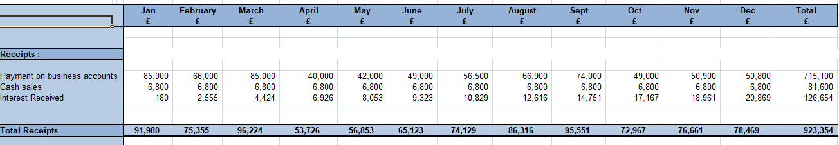
Table 1
Entries:
First section of Table 1 shows the total receipts the hotel is expected to receive in the up-coming year. However, these are recorded on the monthly basis. The section includes expected payments from room reservation, cash sales and the interest received through bank.
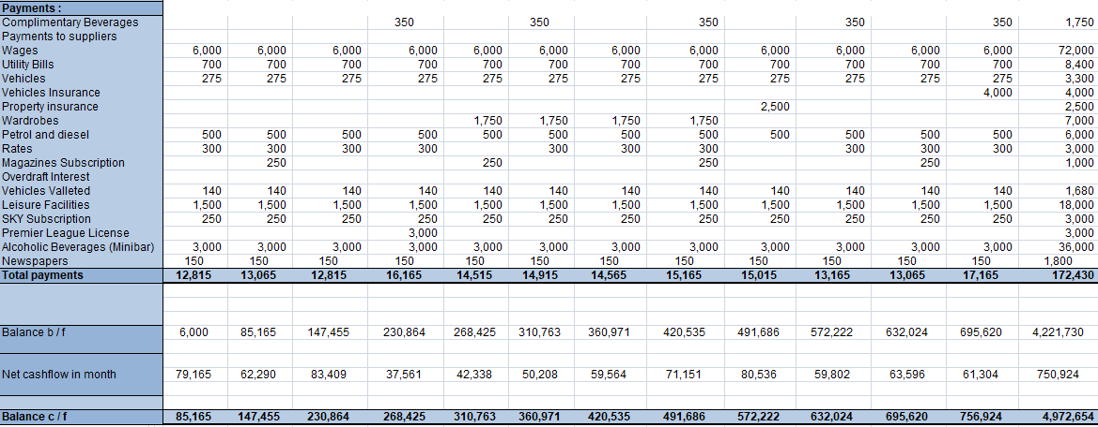
Table 2
Second section of the Table 2 shows the recorded entries of the total expected expenditures. These expenditures are recorded according to the previous year’s record. The entries include the fixed and variable costs. (detailed entries are made in the second section of the Table 2)
Total Values (Overview):
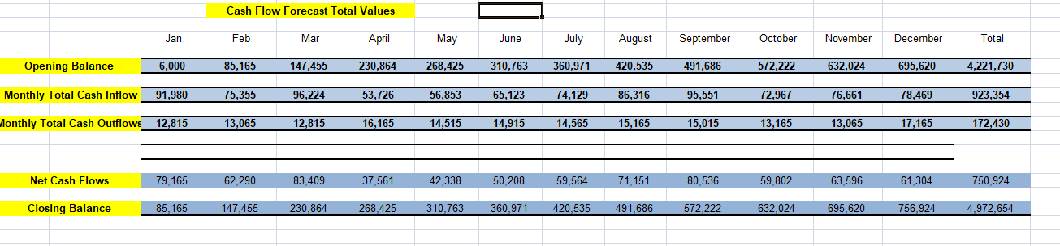
Table 3
Table 3 shows the total values that include the opening balance for each month. We can see the starting balance of the January is £6000 which is forecasted to increase every month due to increased economic activity. After that, total predicted cash inflows for each month are recorded. That starts from 91,980 to 78,469 with fluctuations. After that, total expected cash outflows are recorded that remains same with slight fluctuations.
Net Cash Flows for each month come next which I is calculated after taking the difference of cash inflows and outflows. At the last, we calculated the closing cash balance for each month.
Analysis:
Overall scenario for the hotel looks satisfactory and the hotel needs no external funds to finance its expenditures. That is due to the consistency in the net cash flows. We can see in Table 4 hotel’s monthly expenditures are less from its potential revenue and the hotel will generate more than its financial needs.
Wages:
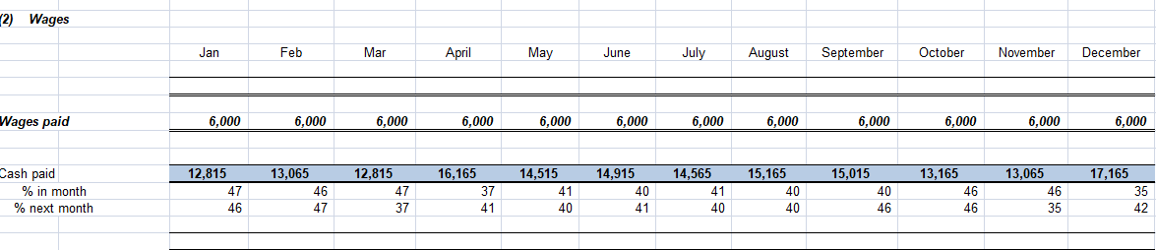
Table 5
Table 5 shows the flat expense of £6000 per month is expected to be recorded for the next month, which varies from 35% to 47% of month’s total expenses.
Credit Sales:
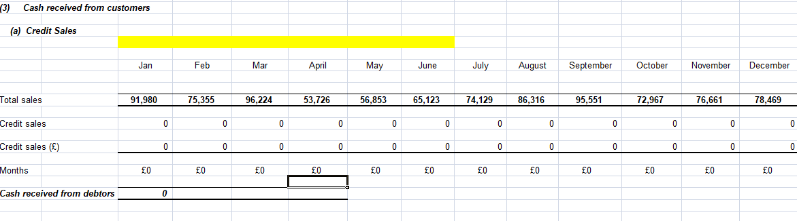
Table 6
Table 6 Shows the data of credit sales, which indicates zero credit sales as the hotel doesn’t deal the customers on credit basis.
Cash Sales:
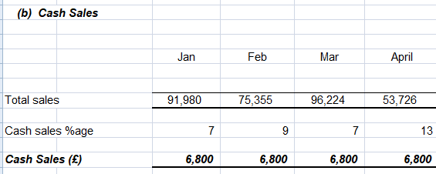
Table 7
Table 7 Shows the cash sales data for the months of January to April, Which is expected to be £6800 per month.
Financial Management for April:
April is the month where the hotel will potentially generate less amount of all time with an expected net cash flow amount of £37,561. That is because of the additional Premier League License of £3000 and £350 to the complementary beverages supplier payments. If the hotel makes an advance payment for April in the March to the Alcoholic Beverages Suppliers for mini bar, the Net cash flow will cross the £40000 for the month of April. Similarly, when we see the Month of March, Expected Net Cash Flow is £83,409, which is the best among the coming months. So, compensating £3000 in terms of advance payment for beverages will not affect so much. So, if the hotel targets for the £40000 Net Cash Flow mark for every month, managing £3000 odd from March instead of April will be the best strategy.

Task 2

Zero-Based Budgeting Technique

Table of Contents
Executive Summery 4
Introduction 4
Traditional & Zero-Based Budget 5
Traditional Budgeting: 5
Zero-Based Budgeting (ZBB): 5
Comparative Table between Traditional & Zero-Based Budget 5
Zero-Based Budget Process 6
Decision Unit Identification: 6
Decision Package Creation: 7
Ranking the Decision Packages: 7
Resource Allocation: 8
Monitoring: 8
Implementation 8
Can budgeting control support sustainability? 9
Conclusion 10

Executive Summery
Following report contains a detailed overview of Zero-based budgeting. First, the report will depict the two budgeting techniques i.e., traditional budgeting and the Zero-based budgeting. A short comparative analysis of both techniques will be presented, and points will be discussed on which both techniques differ.
After the comparison, I’ll present the detailed process of Zero-based technique, which includes the identification of decision units, decision package making, ranking decision package, allocation of available resources and the controlling and monitoring the resources. After the detailed process discussion, I’ll try to discuss how we can implement the technique in our organization.
After the process and implementation, an analysis will be presented that can budgeting control or support the sustainability. I’ll try to find the answer with the help of budgeting objectives. After a suitable analysis, a short conclusion and point of view will be discussed.

Introduction
The budget planning process is carried out each year. Budgeting becomes a habitual practice for managers and be prone to repeating the same budget and then adjusting the numbers a little to reflect inflation. However, budget play’s crucial role in financial planning which includes the systematic study and analysis of forecasts for financial benefits in relation to market trends, products and use of resources. (Cheong, 2021) It requires financial and operational information to make decisions.

Traditional & Zero-Based Budget

Traditional Budgeting:
Budgeting traditionally is a technique that relies on the previous year's budget to make planning for budgeting in the next year. (Thakur & Vaidya, 2020) This method adopts the incremental method of calculating things that starts with budget of previous year. After that, managers adjust the numbers upward and downward and set the assumptions for the next year. The traditional method of budgeting is widely used because it is timesaving and if you are incremental with your approach, you'll be able to quickly calculate the amount you'll have to budget for your business or as an individual.

Zero-Based Budgeting (ZBB):
ZBB is a zero-based is a budgeting technique where every expenditure is justified each time a new timeframe begins. (Kagan, Brock, & Rathburn, 2022) Zero-based budgeting starts with the point of a "zero base," and each function in an organization is examined to determine its requirements and expenses. The budgets are then constructed based on what is required to cover the next period regardless of whether the budget is greater or less than the prior one. (Anaplan, 2021)
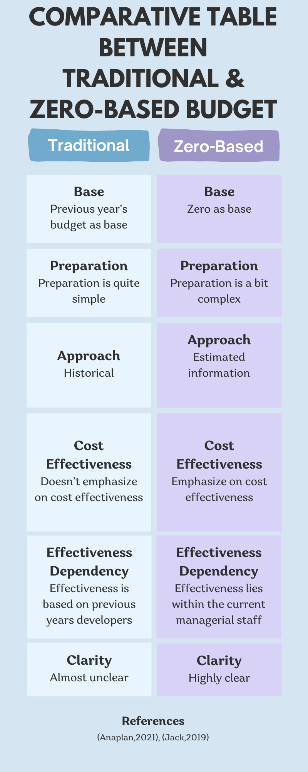

Comparative Table between Traditional & Zero-Based Budget

Zero-Based Budget Process

Decision Unit Identification:
The initial and most important stage in the zero-based budgeting process identifying what the decision-making unit is. A decision unit could be a single task or a set of activities that are clearly and effectively determined. When we say independent, it means an activity that is performed independently and does not overlap with other activities. Thus, each decision unit will be distinct from the others. A company has numerous decision units. Each cost center, for instance, the production department, the marketing department and human resource department research and development department etc. is an individual decision-making unit.
Head of decision unit is required to justify his expenses and the budget allocation required for the unit. The reasons provided by the manager must not be based on the previous period's budget or on the expenditure of his decision unit in the prior year. Since zero-based budgeting requires making the budget completely from initial stage, reasoning for their plan should reflect a fresh note. (Borad, 2022)

Decision Package Creation:
In this phase, the decision units that were identified in the previous step are separated to smaller units of decision-making. The decision packages must be consistent with the goals of the company. Each decision package functions as an individual proposal that appeals to the allocation of funds.
Each decision package outlines the purpose, actions and operation that the proposition will perform, the necessity of the idea, the economic and non-tangible benefits resulting from the application of the proposal, the risk of losing opportunities in the event that funds are not allotted to the proposal, etc.

Ranking the Decision Packages:
In this stage, the order of all decision-making packages within a unit of decision and between various decision units is done according to their prioritization. The reason for prioritizing these decision-making packages is the need to use the scarce resources effectively.
Decision packages are ranked on analysis of the costs and benefits. It is essential that all options are analyzed to choose the most effective and cost-effective choices while ranking the package. The top management has the power to either decide whether to approve any decision-making package. Only those decisions are approved, which aids the company to reach its objectives.

Resource Allocation:
The next step in the process depicts the allocation of resources which are available within the organization. Resource allocation is the extension of previous step and managers allocate the funds to the decision packages which ranked in the previous step. This step is totally based on decision funding. Managers allocate the funds and resources according to the ranking of decision packages. Thus, the most promising packages are rewarded with higher funding. This will ensure optimal utilization of resources that are scarce.

Monitoring:
In the final step of this type of budgeting, decisions are monitored and controlled to determine their effectiveness and results. Decision-making packages monitoring aids the stakeholders to determine the efficiency and accuracy of the allocated resources. The monitoring also provides a base to enhance the performance check and balance.

Implementation
Although the implementation and process look same however, approach may be different for it. Zero-based budgeting is a method of justifying the allocation of resources within an individual budget regardless of previous period budgets. It does not take into account previous data and starts each budget cycle from scratch. (Fong & Kumar, 2002) The budget is assigned as a zero amount unless the person in charge justifies the need for the allocation of resources. I would indicate following three steps in implementation.
- Managers begin by establishing various decision-making frameworks for the various work tasks like forecasting the cost and benefits of undertaking a project, outsourcing it, or decentralizing versus centralizing operations. (Hilton & Platt, 2005)
- The decision packages must be ranked by importance. The tradeoffs between the various packages must be taken into consideration. They allow managers to sort prioritization and blend decision packages for both new and old projects into one.
- Furthermore, managers decide on different levels to be used for each option for the proposed action. The setting of various levels allows managers to look at and assess the amount of spending that is lower than the operational level. The decision makers have the option of removing the activity or allocating resources to the level they choose, incorporating changes in the expenditure level as well as the tradeoffs between departments. (Ross & Hanson, 2005)

Can budgeting control support sustainability?
Corporations are profit-oriented companies. Sustainability in organizational development is one of their primary objectives. If they don't make enough profits, they will not be able to survive. Forecasts and expectations play an important role to play in the process of making decisions. (Yılmaz, 2018) Based on these expectations and forecasts, it is possible to create a scenario. If the scenario includes financial matters, it means the budget has been created that helps to stimulate the business sustainability.
Budgeting is also a way to maintain the efficiency of resources and capital of the business. There are many variations in budgets for each industry or sector. Logistics, manufacturing, and construction, as well as airlines hospitality, and other industries are all different in their budgeting. (OECD, 2019)
For larger companies, sustainability data is gathered into several different buckets like production buying, HR, purchasing etc. Then, a different IT system will extract the information and transfer it into a new system which will perform the calculations. All the system is based or processed through budgeting. (Insights, 2022)

Conclusion
The report discussed two types of the budgeting that are the traditional budgeting and the zero-based budgeting. Traditional budgeting is based on the previous records of the company and managers prepare budget from the previous attributes and numbers. Whereas the zero-based budget technique based on zero and managers have to justify their financial needs and starts the process from zero point. However, the zero-based technique is a bit difficult to adopt but the detailed coverage and cost effectiveness abilities makes it one of the best choice for our company.

References
Anaplan. (2021, February 15). The ultimate guide to zero-based budgeting (ZBB). Retrieved June 27, 2022, from anaplan.com: https://www.anaplan.com/blog/zbb-zero-based-budgeting-guide/
Borad, S. B. (2022, May 07). Steps in Zero Based Budgeting. Retrieved June 27, 2022, from efinancemanagement: https://efinancemanagement.com/budgeting/zero-based/zero-based-budgeting-steps#Zero_Based_Budgeting_Steps_Process
Cheong, D. F. (2021). From traditional budget planning to zero-based budgeting. Macao: Macao Polytechnic Institute.
Fong, & Kumar. (2002). Cost Accounting. Hong Kong: Hong Kong Association of Accounting Technicians.
Hilton, R., & Platt, D. (2005). Managerial Accounting: Creating Value in a Dynamic Business Environment. New York: McGraw-Hill.
Insights, I. (2022, January 11). Budgeting for sustainability. Retrieved June 27, 2022, from icaew.com: https://www.icaew.com/insights/viewpoints-on-the-news/2022/jan-2022/budgeting-for-sustainability
Kagan, J., Brock, T., & Rathburn, P. (2022, march 14). Zero-Based Budgeting (ZBB). Retrieved June 27, 2022, from Investopedia: https://www.investopedia.com/terms/z/zbb.asp
OECD. (2019). Budgeting for environmental and sustainable development. In OECD, Government at a Glance 2019 (pp. 114-115). Paris: OECD Publishing, Paris.
Ross, G., & Hanson, L. (2005). SOUTH-WESTERN CENTURY 21 ACCOUNTING. London: International Thomson Publishing.
Thakur, M., & Vaidya, D. (2020, may 16). Traditional Budgeting. Retrieved june 27, 2022, from Wallstreetmojo: https://www.wallstreetmojo.com/traditional-budgeting/
Yılmaz, F. (2018). Budgeting as a Tool for Sustainable Development. Istanbul: Istanbul University, Turkey.

