A Quantitative Study on the Factors Influencing Lawyers' Engagement in Pro Bono

Kenuo Chen
2106008

Abstract
The legal profession, as an ancient industry, has existed in human society, radiating its brilliance throughout the course of history. After entering the 21st century, the rise of global public welfare activities gradually entered the public's view and gained attention from different countries, social organisations, and individuals. Pro bono service is a common practice in the majority of legal jurisdictions. However, why lawyers provide services for free is a long-standing puzzle in current research (Cummings et al., 2022). There is evidence that English-speaking countries have established a legal pro bono culture and practice, such as the United States, the United Kingdom, Canada, Australia, and China, Israel, and others are getting involved in public welfare work and formulating pro bono plans (Fiona & Mcleay, 2009). Many people's impressions of pro bono work by lawyers start with this understanding, namely, the tradition of providing free services is as old as the profession itself (Ferguson, 2005). Other scholars (Rhode, 2009) propose that in practice, legal pro bono work is not only about benefiting the public. It also involves what benefits the lawyers, such as how it can enhance the lawyers' reputation, experience, networks, and relationships. This is extended to the notion that legal pro bono activities can be considered a part of cultural capital (Hilary,2007). Furthermore, in large law firms, pro bono activities have shifted from individual lawyers' personal responsibility to the collective responsibility of the firm (Kay& Granfield,2023), increasingly used to promote the interests and policies of law firms (Granfield and Mather, 2009). Lastly, differences in institutionalization, such as the minimum requirements for lawyers to fulfill mandatory legal pro bono service obligations in different countries, can lead to varying outcomes (Fu, 2020).

Significance and Potential Value of the Study

This is an attempt at quantitative research on the topic of lawyers' pro bono service, which is rare, and even rarer are studies using SPSS data analysis methods. Existing quantitative literature is limited, with only a few studies related to law students' involvement in pro bono. Many literature works related to legal pro bono adopt mixed methods or qualitative research. Additionally, this study enriches a new research path for lawyers' pro bono .
It primarily focuses on the participation of Chinese lawyers in public service, analysing the current status of legal pro bono services in China. It helps lawyers better understand the challenges they face, and it has practical value for the development of lawyers and law firms.

Research Objectives:

- To construct a model that includes personal self-drive, historical tradition, cultural capital (reputation and money), workplace, and mandatory institutional requirements and test their impact on lawyers' pro bono services.

- Based on empirical research results, to evaluate the degree and paths through which the five factors mentioned above affect lawyers' participation in pro bono services.

- To provide new knowledge and discoveries in the field of Chinese lawyers' participation in pro bono services.

Research Questions:
RQ1: Do all five categories of factors impact lawyers' participation in pro bono services?
RQ2: Which factor is most likely to influence lawyers' participation in pro bono services?
RQ3: Which factor is least likely to influence lawyers' participation in pro bono services？

- Literature review, conceptual framework and hypothesis

Pro bono

While there is no universally accepted definition for "pro bono," it can be broadly characterised as actions that lawyers should take in the service of the public good. Typically, lawyers are expected to offer free legal services or significantly reduce their fees to assist the general public in need. Pro bono service is now a widely recognised duty among lawyers worldwide. As Chinese legal professionals venture into the global legal arena, the significance of pro bono work is deeply ingrained in their values. In the Chinese context, pro bono is widely perceived as a type of public interest service. The pro bono activities in China mirror the trends of institutionalisation in the globalized era. This suggests that pro bono work is being carried out in a centralised and efficient manner within well-structured frameworks that involve various sectors, such as professional associations, law firms, government, and non-profit public interest organisations. Previous research has demonstrated that the combined efforts of the legal profession, government bodies, society, and the legal services market have accelerated this profound transformation (Dong, 2022)
In the United Kingdom, pro bono work is an integral part of many lawyers' professional lives. It helps people in the UK and abroad access justice when they cannot afford legal assistance. Pro bono work refers to the provision of legal advice or representation that legal professionals offer for free in the interest of the public good. This may apply to individuals, charities, or community groups who cannot afford legal assistance and have no other means of funding or legal aid (UK Law Society, 2019).

Self-Determination Theory

People have an innate sense of belonging, feeling themselves to be a part of a social group (Deci & Ryan 2000). They seek to connect with others, to "love and be loved, to care and be cared for" (Baumeister & Leary 1995; cited by Bidee et al.,2013). When people interact with their social environment, they desire to feel effective. By seeking out challenging activities, they create a sense of mastery over their world. Since people are likely to engage freely in activities that satisfy these needs, background factors that enhance autonomy, competence, and relatedness cognitions will strengthen autonomous motivation (Grouzet et al., 2004). For example, volunteering, as it allows an individual to fulfill other important life values. While the behavior performed aligns with an individual's values and self-awareness, thus being integrated and internalised, the behavior itself is not inherently enjoyable, which sets it apart from intrinsic motivation. When driven by intrinsic motivation, people volunteer out of their own free will because they enjoy the feeling of being a volunteer (Bidee, J., Vantilborgh, T., Pepermans, R, 2013). Additionally, external regulation exists. Experiences of self-determination are strongly associated with a wide range of emotional, behavioral, and cognitive outcomes. In the context of work and organizations, self-determination is positively correlated with several favorable job-related outcomes. Specifically, self-determined motivation is related to variables associated with role identity concepts, such as professional or organizational commitment(Güntert & Wehner,2015)

Institutional Logic Theory

Friedland and Alford (1991) were the first to introduce the concept of "institutional logic" into the analysis of organizational and management theory. They categorised the core institutional orders of contemporary Western society into five major categories: family, government, Christianity, capitalism, and democracy. Thornton et al. (2005) expanded this classification to seven major categories, building upon Weberian theory: family, government, religion, market, community, profession, and enterprise. Friedland and Alford (1991) argued that individuals, organisations, and society operate on different levels, and organizational logic and societal logic determine the opportunities and constraints on individual actions. Since these logics cannot always be achieved simultaneously, the interaction of multiple logics often leads to conflicts (Friedland and Alford, 1991). This perspective has been commonly observed in studies of nonprofit organizations, which often must balance economic sustainability and societal expectations (McMullin & Skelcher, 2018).

In the context of professional public service, individuals are expected to align their actions with what their organizations require (organisational logic), such as generating revenue, and with the social roles (societal logic), which includes conforming to social norms and value systems. Simultaneously, they strive to do what they personally believe they should do for the nonprofit sector, such as engaging in public service. Professionals may experience tension when dealing with these different institutional logics. For instance, there may be tension between the time required by the organisation and the personal beliefs and requirements related to helping society. Recognising the potential interplay of conflicting institutional logics, professionals within their organisations and their expected recipients can better harmonize these logics for mutual benefit (Patterson, et al., 2020). Certain researchers have noted that organizations respond to institutional requirements by formulating "definitions of tasks and methods for their execution." This institutional framework encompasses elements of social significance, unspoken anticipations, and various aspects of everyday life that are frequently accepted as standard rules in social exchanges. These frameworks influence individual conduct in a manner that results in substantial reactions to institutional stories and the related significance (Granfield, 2007)

By combining these two theories, it becomes evident that Self-Determination Theory (SDT) can be employed to explain individual internal motivation and behavior, while Institutional Logic Theory can be used to explore the influence of external environments and institutions on organisational internal motivation and behavior. For instance, an organisation may choose to support employee autonomy and a sense of competence because it aligns with societal institutions and norms. In such cases, these two theories can complement each other. Institutional Logic Theory can also be used to explain an organisation's behavior within specific societal systems and how it adapts and operates within these institutions. SDT emphasises the role of intrinsic motivation within employees or individuals within the organization, which is crucial for understanding how employees interact with the organisation.

Intrinsic Motivation

Individual-level intrinsic motivation represents a consistent inclination to behave in a specific manner, irrespective of the situation. As some scholars suggest, people may demonstrate a concern for the well-being of others in social distress, even when their choices do not revolve around tangible or social rewards. (Kay & Granfield, 2023) Some researchers argue for the presence of a pro-social personality (Allen and Rushton, 1983) or an altruistic personality tendency (Wang et al., 2019). Additionally, Penner's (2002) pro-social personality model emphasizes the relevance of other-oriented empathy and a willingness to help as precursors to volunteer service. Research consistently indicates a close association between self-reported pro-social motives and volunteer service (Aydinli et al., 2015). Furthermore, some scholars have observed that certain individuals have a strong desire for meaningful work (Dwyer et al., 2013). The sense of meaning generated by volunteer service serves as an intrinsic motivator guiding subsequent behavior. Some researchers even mention a "philanthropic personality," whereby individuals act on personal morals and passions when presented with compelling cases by clients (Bartlett & Taylor, 2016). Consequently, seemingly dissatisfying work can stimulate employees to increase their engagement in volunteer service, seeking a more meaningful sense of life. In this way, volunteer service compensates for deficiencies in the workplace (Rodell, 2013).

Historical and Traditional Cultural Factors

Lawyers have made continuous efforts to ensure that the poor have access to the legal system, with the origins of such efforts dating back to the medieval period (M. Cappelliti et al., 2001). In 1495, King Henry VII enacted the "Statute of Poor," which required judges to appoint lawyers to represent the poor in court, including preparing the necessary pleadings, without requiring the lawyers to be compensated for their work (P. R. Cavill, 2009). While the intent for such practices can be found in legislation and the words and deeds of some lawyers, there seems to be no strong tradition of lawyers providing pro bono services to the poor in the legal history of England and America. Pro bono work is something that lawyers in the common law world have always been doing – hence, it appears to be a less conspicuous aspect of the pro bono tradition. In and of itself, the legitimacy of contemporary pro bono efforts based on historical evidence of the legal profession may not be sufficient. (Ryan,2021) In contrast, even though pro bono service by Chinese lawyers has become increasingly institutionalised, it is surprising that the concept of pro bono service by lawyers did not exist in China just 20 years ago (Dong, 2022).

Encouragement in the Workplace

In large law firms, pro bono activities have shifted from the personal responsibility of individual lawyers to the collective responsibility of the firm. This is reflected in the following facts: there is an increasing trend in managing pro bono services by promoting policies that benefit the firm Law firm leaders commend pro bono as a crucial mechanism for training young lawyers and diversifying their skillsand for increasing the retention of new staff.(Kay & Granfield, 2023) For lawyers working in small law firms and practicing solo, pro bono work is a routine practice (Anderson, &Gordon,2003 ) and a client recruitment strategy. Large law firms have a "pro bono practice community" in which they share ideas and define, structure methods, and allocate resources. In contrast, small companies and solo practitioners lack the time and opportunity to access the same practice community, as well as the same resources or motivation to engage in it. (Bartlett & Taylor 2016) other scholar also argue that the workplace environment creates positive conditions for increasing engagement in legal pro bono activities. (Granfield,2007).

Economic and Reputation

Pro bono, through training and trial experiences that offer various practical benefits, can enable newly-minted young lawyers to gain some economic advantages (McColl-Kennedy et al., 2015). In contrast to paid services, the pro bono work of lawyers can bring recognition, connections, and professional knowledge to the domains of paid work (Granfield, 2007). Given that lawyers function as social actors, they require extensive social connections, which is why some lawyers actively seek opportunities for pro bono service in order to enhance their professional reputation and promote career development (Granfield & Koenig, 2003). For junior attorneys in large law firms, pro bono cases can often extend beyond their primary job responsibilities, presenting challenges in terms of case experience and intellectual demands (Cummings, 2004). However, Granfield (2007) suggests that despite the challenges, pro bono work is highly attractive to young lawyers in large law firms because it enables them to collaborate directly with potential or existing clients. In the context of senior lawyers such as partner-level attorneys, pro bono work may represent a form of cultural capital used to elevate their status rather than reflecting lawyers' altruism and selflessness (Dinovitzer & Garth, 2009). Therefore, pro bono work is pursued in exchange for enhanced professional status, skills, and earning potential (Bartlett & Taylor, 2016). Pro bono service helps companies gain the trust and respect of client groups, especially large corporations, which stand to benefit from it. Large law firms possess significant resources and teams of lawyers capable of handling a variety of cases. Some conclusions drawn from my own (2023) qualitative research pilot study suggest that lawyers often engage in legal pro bono services to gain more potential reputation and financial benefits.

Mandatory system
The institutionalisation of pro bono work in China is closely linked to mandatory regulations. In other words, policy and legislative changes have driven the institutionalisation of pro bono work in China. The Chinese government has been making continuous efforts to support pro bono work, considering it a means to maintain social and community stability.
Chinese lawyers have a mandatory statutory duty to provide legal pro bono, which means that they are required to take a certain number of pro bono per year as determined by the jurisdiction – for which they will be paid. According to Article 42 of the Lawyers Law (Lawyers Law of the People's Republic of China, 2001), lawyers should provide legal services according to state regulations and should do so diligently and dutifully. An amendment in 2007 expanded this duty to law firms. The Legal Aid Regulations also reiterate the duty for mandatory legal pro bono services on the part of lawyers.
In 2019, the Ministry of Justice (MOJ) in China issued the "Opinions on Promoting Lawyers' Public Interest Legal Services," which stipulated that each lawyer should set a minimum of 50 hours or handle at least two state legal aid cases as their annual duty. To ensure the full implementation of this policy, it requires law firms to carefully assess the pro bono performance of each lawyer based on the "Law Firm Annual Evaluation Method" formulated by MOJ in 2010 (Fu, 2020).

Conceptual framework

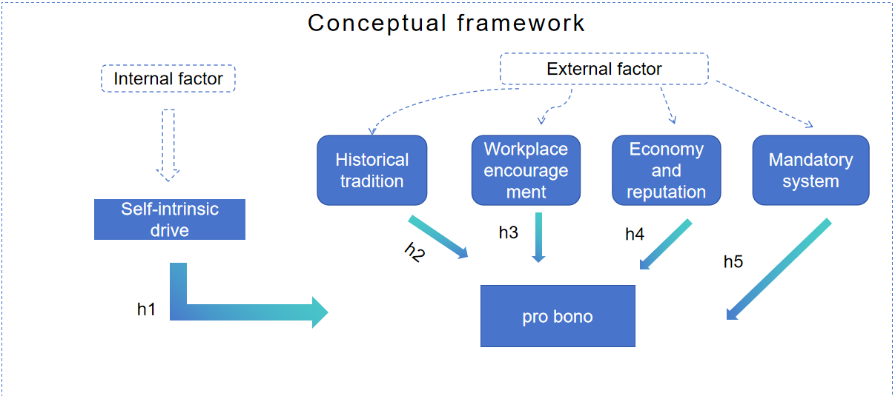

Hypothesis

H1: Lawyers' personal traits and intrinsic motivation influence their participation in pro bono services.
H2: Historical tradition influences lawyers' participation in pro bono services.
H3: Large law firms have a greater ability to influence lawyers' participation in pro bono services compared to small and medium-sized law firms.
H4: Economic and reputation benefits influence lawyers' participation in pro bono services.
H5: Mandatory institutional requirements influence lawyers' participation in pro bono services.

Research Design and Methods

This research survey consists of two parts: basic information and measurements of variables. A questionnaire was conducted among a group of key figures in the legal profession in China. The variable scale was developed based on the perspectives of scholars from Western countries and China, combined with our own understanding of the field.

The survey in this study employed a Likert five-point scale, where the Likert items are statements. Respondents were asked to indicate the extent to which they agree with the statement or provide any form of subjective or objective assessment (David et al., 2005). Typically, five response levels are used. An empirical study (Dawes, 2008) indicated that data from 5-level, 7-level, and 10-level options have similar means, variances, skewness, and kurtosis after simple data transformation. For example, in the Likert five-level option:

1 - Strongly Disagree
2 - Disagree
3 - Neutral
4 - Agree
5 - Strongly Agree

Sampling in Quantitative Research

Overall, the study would benefit from a more robust sampling strategy. Our research tool will focus on lawyers in the central province capital city of Xi'an, Shaanxi Province, China. Therefore, a more extensive survey is needed to gain insights into the attitudes of a broader population of legal professionals towards pro bono services.

Purposive Sampling (Another Non-Probability Sampling):

Here, researchers select the sample group based on their judgment of who would be most relevant to the study. This sampling method is primarily used in situations where the population is limited and background knowledge related to the ongoing research is crucial. Researchers filter out irrelevant responses that do not fit the research background. It also reduces the margin of error in data collection as the data source is closely aligned with the research context (Obilor, 2023).

Constructs and Measurement items derived from previous studies.

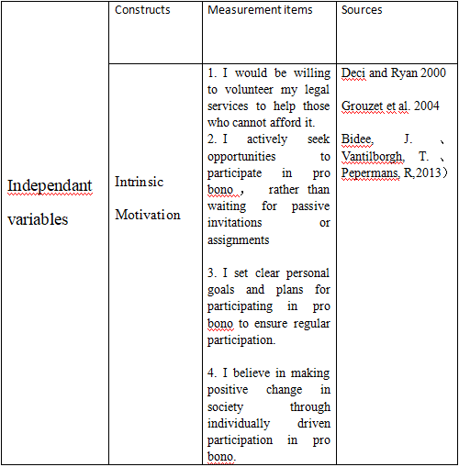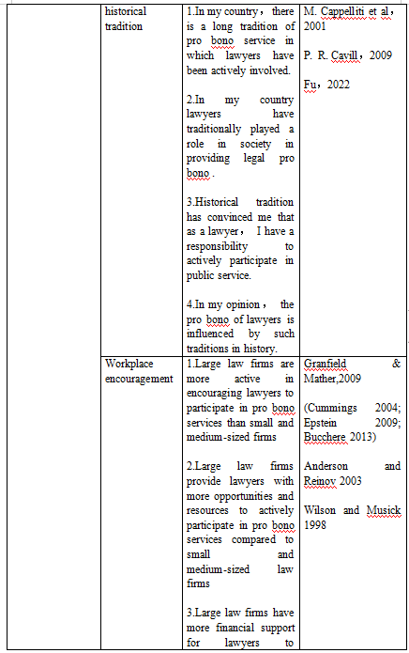
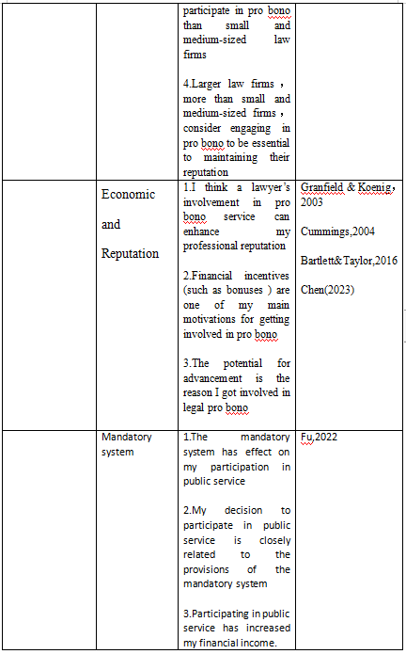

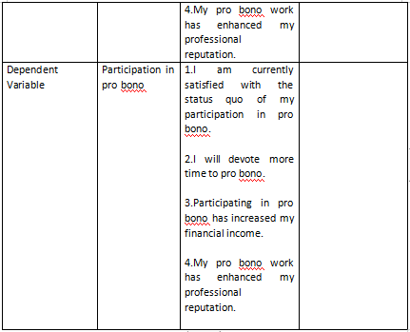

Data analysis

Frequency

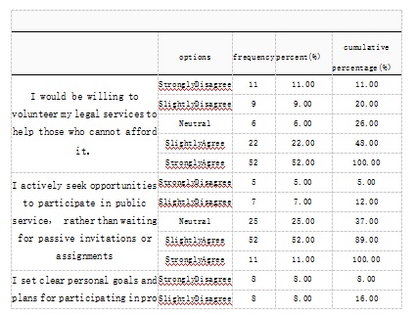
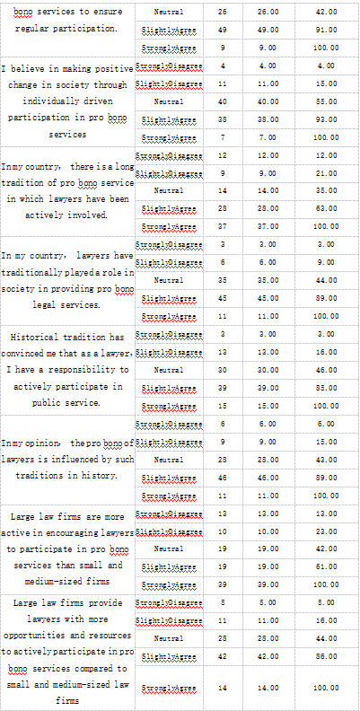

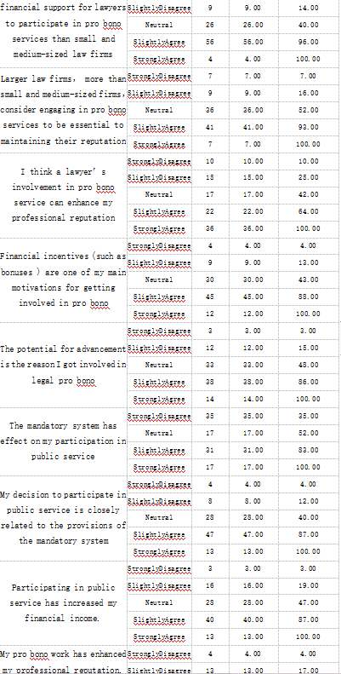
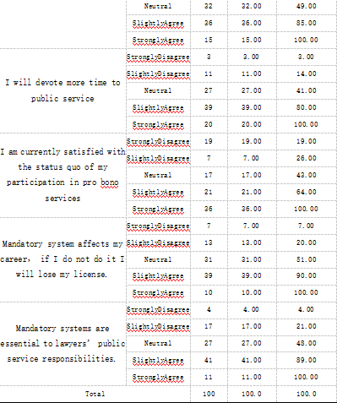

Looking at 'I would be willing to volunteer my legal services to help those who cannot afford it,' more than 50% of the samples in the survey 'Strongly Agree.' The proportion of samples choosing 'Slightly Agree' is 52.00%, and 'Slightly Agree' accounts for 49.00%. Regarding 'I believe in making positive change in society through individually driven participation in pro bono services,' distribution-wise, the majority of samples are 'Neutral,' making up 40.00%. The proportion of 'Slightly Agree' samples is 38.00%, and 'Strongly Agree' is 37.00%.

For 'In my country, lawyers have traditionally played a role in society in providing pro bono legal services,' 'Slightly Agree' accounts for the highest proportion at 45.00%. Additionally, 35.00% of the samples are 'Neutral.' Concerning 'Historical tradition has convinced me that as a lawyer, I have a responsibility to actively participate in public service,' it appears that more than 30% of the samples 'Slightly Agree.' 'Slightly Agree' is at 46.00%, and 39.00% of the samples choose 'Strongly Agree.' 'Slightly Agree' is 42.00%.

Examining 'Large law firms have more financial support for lawyers to participate in pro bono services than small and medium-sized law firms,' 'Slightly Agree' is relatively high in the sample, at 56.00%. For 'Larger law firms, more than small and medium-sized firms, consider engaging in pro bono services to be essential to maintaining their reputation,' distribution-wise, the majority of samples are 'Slightly Agree' at 41.00%. Additionally, 36.00% of the samples are 'Neutral,' and 36.00% of the samples 'Strongly Agree.'

As for 'Financial incentives (such as bonuses) are one of my main motivations for getting involved in pro bono,' 'Slightly Agree' accounts for the highest proportion at 45.00%. 'Slightly Agree' is 38.00%, and the proportion of 'Neutral' samples is 33.00%.

In terms of 'The mandatory system has effect on my participation in public service,' distribution-wise, the majority of samples are 'Strongly Disagree,' totaling 35.0 samples and making up 35.00%. Additionally, 'Slightly Agree' samples are at 31.00%. Considering 'My decision to participate in public service is closely related to the provisions of the mandatory system,' in the sample, 'Slightly Agree' is relatively high at 47.00%.

Examining 'Participating in public service has increased my financial income,' 'Slightly Agree' is relatively high in the sample, at 40.00%. For 'My pro bono work has enhanced my professional reputation,' 'Slightly Agree' accounts for the highest proportion at 36.00%. Additionally, 32.00% of the samples are 'Neutral,' and 'Slightly Agree' is 39.00%, with 36.00% of the samples choosing 'Strongly Agree.' Finally, looking at 'Mandatory system affects my career, if I do not do it I will lose my license,' distribution-wise, the majority of samples are 'Slightly Agree' at 39.00%. Furthermore, 31.00% of the samples are 'Neutral,' and 41.00% of the samples 'Slightly Agree.'"

Descriptive statistical analysis

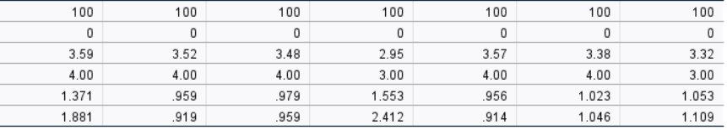

To assess the significance level of each variable, the mean and standard deviation are commonly used in descriptive statistical analysis. A measure of dispersion is employed to characterise the spread of data within a distribution; for example, the standard deviation indicates the extent of variation among different samples of the same variable. A higher mean implies a higher average for that specific variable. The survey design in this instance employs a five-point Likert scale for dimensional observations, with higher scores indicating a higher level of agreement. Furthermore, most values in the table are above 3, from which it can be inferred that the majority of respondents are more likely to express agreement. Likewise, higher overall scores indicate a greater likelihood of participants holding more consistent views

Reliability analysis

Intrinsic Motivation

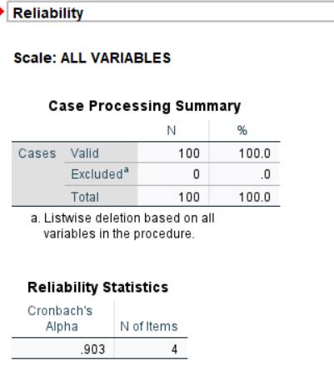

Historical and Traditional Cultural Factors

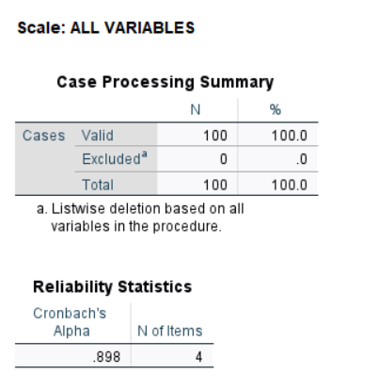

Workplace encouragement

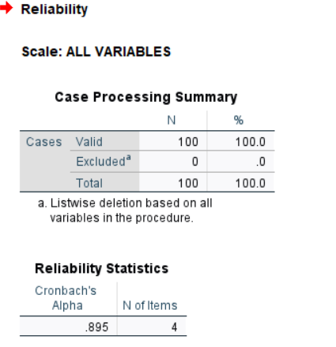

Economy and reputation

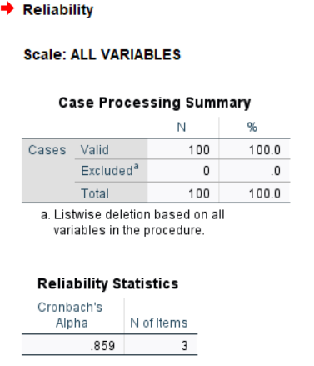

Mandatory system

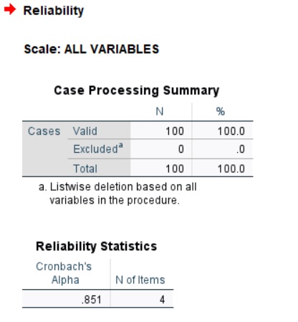

To ensure the reliability and validity of the questionnaire and enhance the scientific rigor and validity of this study, a preliminary data collection and analysis were conducted for reliability testing of the survey instrument. The reliability assessment used Cronbach's alpha coefficient. Alpha, developed by Lee Cronbach in 1951, is employed to measure the internal consistency of a test or scale, and it is expressed as a number between 0 and 1. Internal consistency reflects the extent to which all items in a test measure the same concept or construct, hence it is related to the interrelatedness of items in the test(Bisher,2015). When the value is closer to 1, it indicates higher internal consistency of the scale, and greater reliability. Different reports suggest varying acceptable alpha values, ranging from 0.70 to 0.95 (Tavakol & Dennick, 2011). If alpha is too high, it may indicate that some items are redundant as they are testing the same issues in different forms. The maximum recommended alpha value is 0.90 (Streiner, 2003). Therefore, a high reliability coefficient for the questionnaire items suggests that the survey data can be considered relatively reliable. Based on the four charts above, an alpha value approaching 0.9 indicates that the survey data is relatively reliable.

Exploratory factor analysis

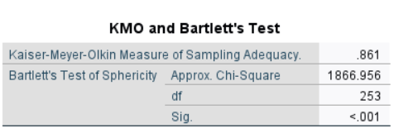

The KMO and Bartlett's test can determine whether this dataset is suitable for factor analysis. The KMO is 0.861, and the Bartlett's sphericity test is significant with p < 0.001, indicating a good sample adequacy, making it suitable for factor analysis. Typically, KMO values between 0.7 and 0.79 are considered to have moderate adequacy, while values above 0.8 are classified as good adequacy (Kaiser, 1974).

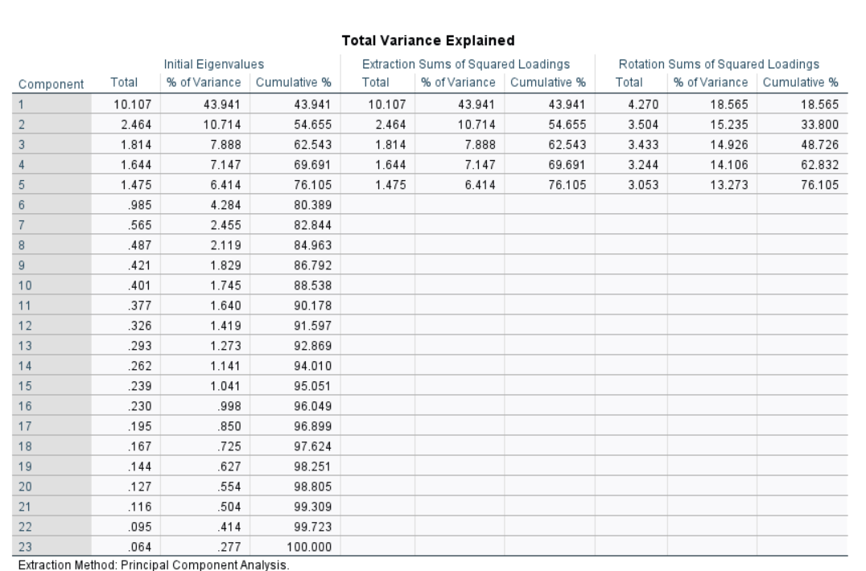

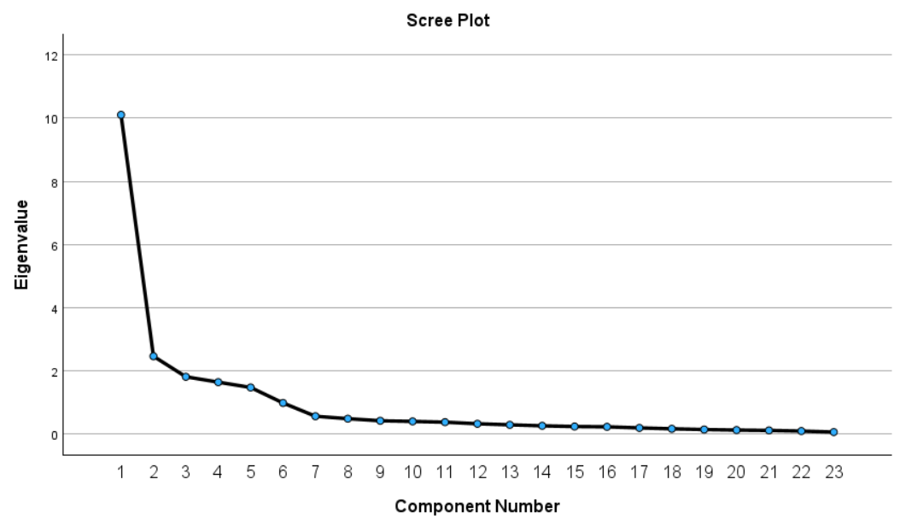

Based on the table above, there are 5 components with eigenvalues exceeding 1. Additionally, when considering the Scree plot, it is suggested by the SPSS system that my questionnaire should be divided into 5 sections. Therefore, this aligns with the division of my scale into 5 sections as well.

Correlations 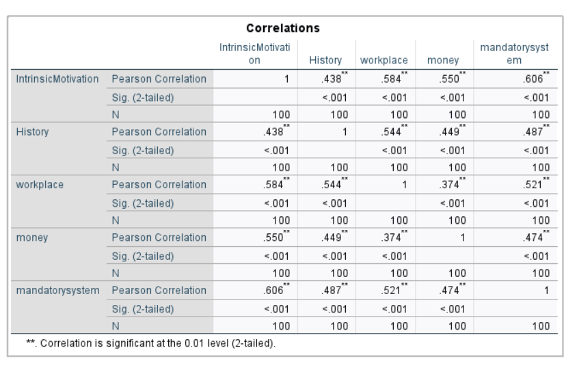

To study the strength of the relationship between two or more variables, correlation is used. Correlation is a statistical tool that measures how strong the relationship is between variables. The values of correlation range from -1 to +1. Values closer to zero indicate weak correlations between variables, while values closer to 1 signify a stronger relationship between variables. Therefore, correlation is a value that attempts to explain the degree of association between variables (Kafle, 2019). From the figure above, it can be observed that individual drive, historical tradition, workplace encouragement, money and reputation, and mandatory systems all exhibit a positive correlation with lawyers' engagement in pro bono.

The correlation between independent and dependent variables

Personal self-drive will promote lawyers to participate in legal public service

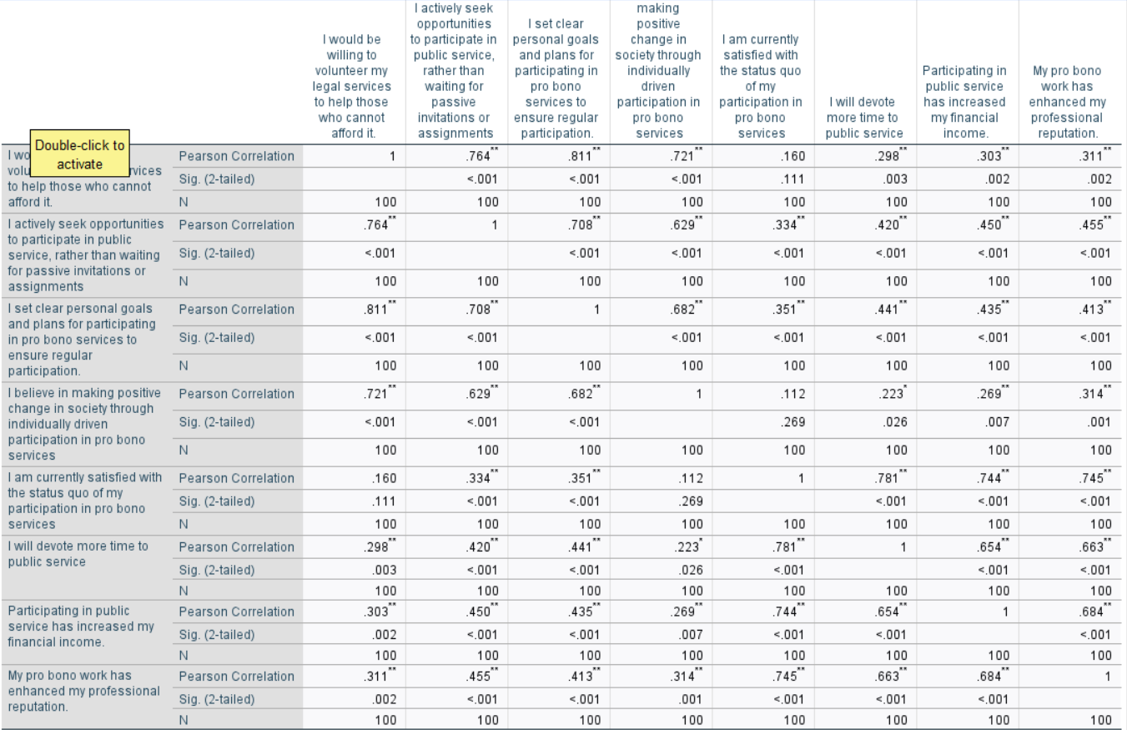

The data reveals significant positive correlations among several variables, indicating that lawyers who are willing to volunteer their legal services, actively seek opportunities for public service, set clear goals for their involvement in pro bono work, and believe in making positive changes are more likely to devote more time to public service, experience increased financial income, and enhance their professional reputation. However, there are no significant correlations between certain variables, suggesting that the strength of these relationships may be weaker in this context.

Historical and Traditional Cultural

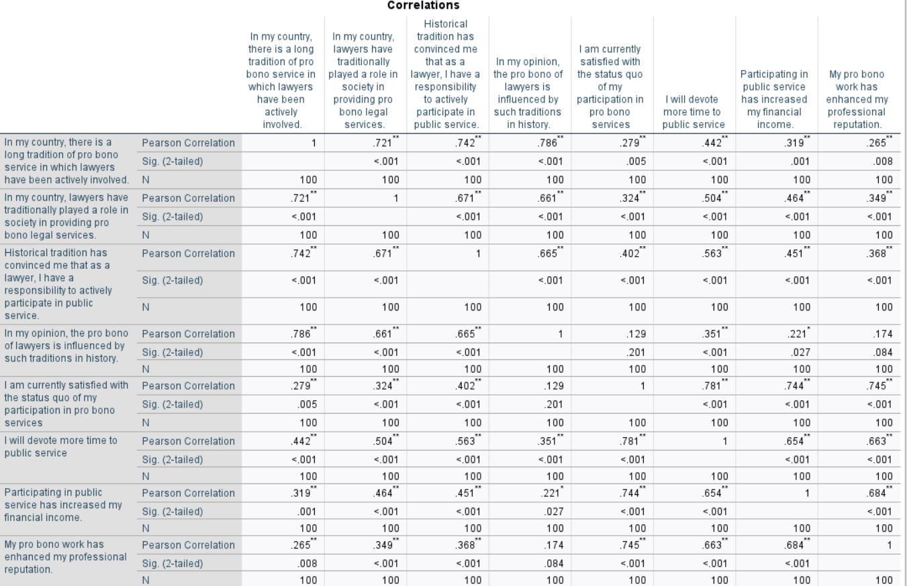

The data suggests that individuals who acknowledge and appreciate these historical traditions are often more involved in public service. However, the variables related to perceptions of how lawyers are influenced by historical pro bono traditions are only significantly correlated with two out of the four factors, indicating a weaker correlation in this case.

Workplace encouragement

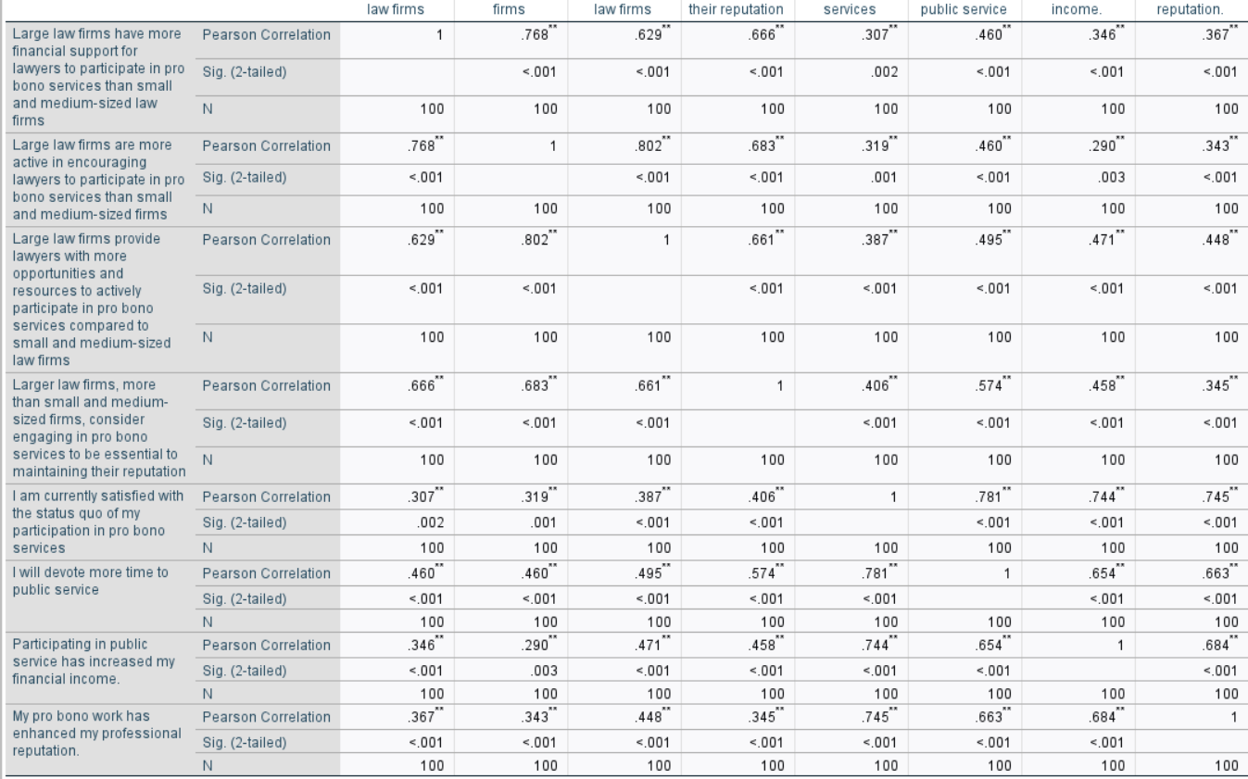
Large law firms are more active in encouraging lawyers to participate in pro bono services than small and medium-sized firms, and they provide lawyers with more opportunities, resources, and financial support for pro bono work. Additionally, larger law firms, more than small and medium-sized firms, consider engaging in pro bono services to be essential for maintaining their reputation.

All of these factors are significantly positively correlated with the following variables:

"I am currently satisfied with the status quo of my participation in pro bono services."
"I will devote more time to public service."
"Participating in public service has increased my financial income."
"My pro bono work has enhanced my professional reputation."
This suggests that lawyers in larger law firms who are encouraged to engage in pro bono work and have access to more resources are more likely to be satisfied with their participation, dedicate more time to public service, experience increased income, and enhance their professional reputation.

In summary, there are significant positive correlations between the size and support of law firms and lawyers' attitudes and activities related to pro bono work and public service. Larger law firms tend to have a more significant impact on these variables compared to small and medium-sized firms

Economy and reputation

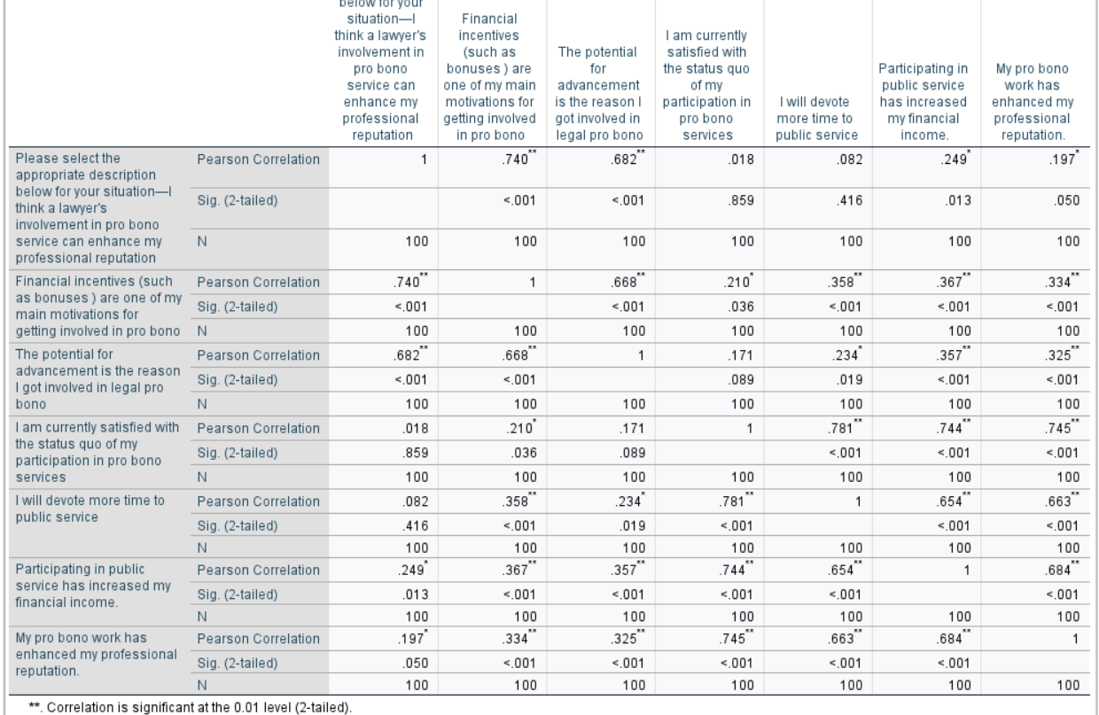

The data indicates that certain motivations and beliefs related to pro bono service are significantly positively correlated with lawyers' engagement in public service and its outcomes, such as increased income and professional reputation. However, "I believe a lawyer's involvement in pro bono service can enhance my professional reputation" is not significantly correlated with "I am currently satisfied with the status quo of my participation in pro bono services." Additionally, "The potential for career advancement is the reason I got involved in legal pro bono" does not exhibit a significant correlation with "I am currently satisfied with the status quo of my participation in pro bono services."

Mandatory system

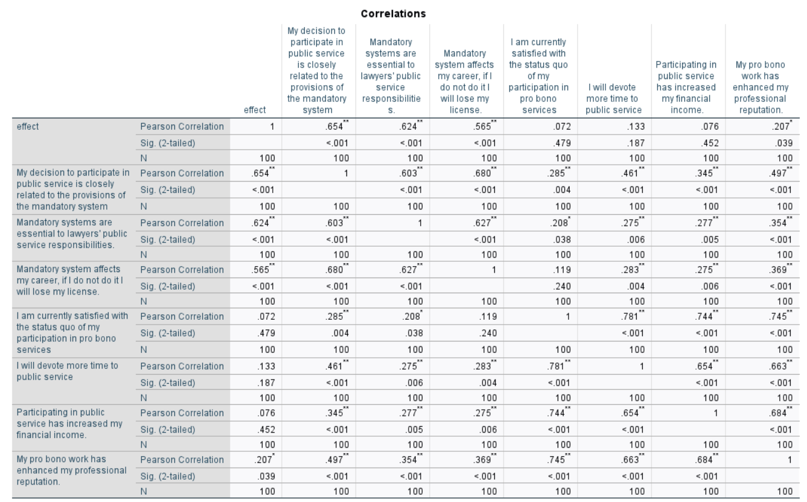

There is a positive correlation between participation in pro bono and the regulations of the mandatory system. This means that a lawyer's decision to engage in pro bono is closely related to the regulations imposed by the mandatory system.

linear regression

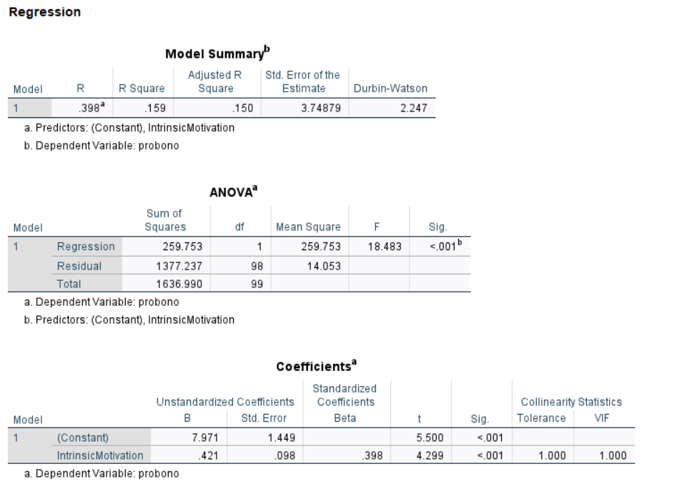

The adjusted R-squared value of 0.15 indicates that the independent variables (explanatory variables) in the model can explain 15% of the variance in the dependent variable (the variable being explained). This suggests that the independent variables do not fully account for the variability in the dependent variable, implying a relatively weak association between the independent and dependent variables. In this scenario, the model may not predict changes in the dependent variable effectively.

The D-W (Durbin-Watson) statistic value of 2.247, close to 2, indicates the absence of autocorrelation in the model. The D-W statistic typically falls in the range of 0 to 4, and a value close to 2 suggests that there is no autocorrelation among the residuals of the independent variables.
A VIF (Variance Inflation Factor) of 1 suggests there are no issues with multicollinearity. VIF measures the multicollinearity among independent variables, with a higher value indicating more severe multicollinearity. However, a VIF less than 5 is generally considered as an absence of significant multicollinearity issues.
Sig<0.05 implies that the p-values of certain independent variables in the model are less than 0.05. This typically indicates that these independent variables have a statistically significant influence on the dependent variable, as their p-values are lower than the usual significance level.
In summary, these results indicate that there is no substantial multicollinearity among the independent variables, no autocorrelation in the model, The hypothesis of H1 is verified.However the model's explanatory power is relatively weak, explaining only a small portion of the dependent variable's variance. Further model improvement or the addition of more independent variables may be needed to enhance the model's fit.

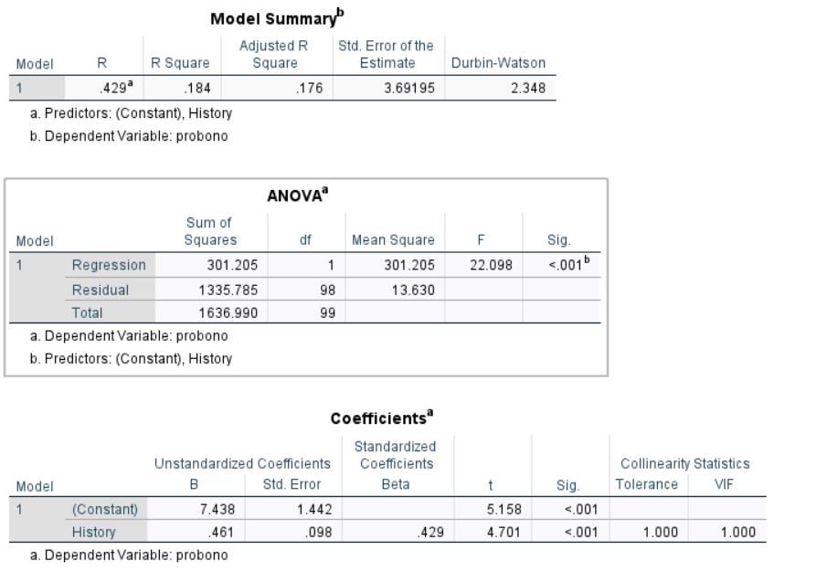
The adjusted R-squared value of 0.176 indicates that the independent variables (explanatory variables) in the model can explain 17.6% of the variance in the dependent variable (the variable being explained). This suggests that the independent variables do not fully account for the variability in the dependent variable, indicating a relatively weak association between the independent and dependent variables. In this context, the model's ability to predict changes in the dependent variable may be limited.

The D-W (Durbin-Watson) statistic value of 2.348 is acceptable and suggests that there is no significant autocorrelation in the model. The D-W statistic typically ranges from 0 to 4, and a value close to 2 indicates that there is no autocorrelation among the residuals of the independent variables.

A VIF (Variance Inflation Factor) of 1 indicates an absence of multicollinearity issues among the independent variables. VIF measures the degree of multicollinearity among independent variables, with a higher value indicating more severe multicollinearity. However, a VIF less than 5 is generally considered as an absence of significant multicollinearity issues.

"sig<0.05" implies that the p-value associated with the model is less than 0.05. This indicates that the model as a whole is statistically significant.

The F-statistic of 22.098 suggests that the overall model is statistically significant, and at least one of the independent variables in the model has a significant impact on the dependent variable. The hypothesis of H2 is verified, and the corresponding model also needs to be improved, which cannot predict the change of dependent variable very effectively.

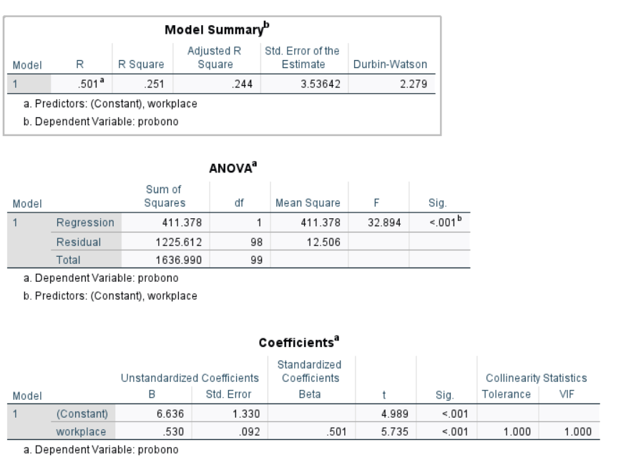

In summary,the hypothesis of H3 is verified these results indicate that there is no substantial multicollinearity among the independent variables, no significant autocorrelation in the model, and the model as a whole is statistically significant.

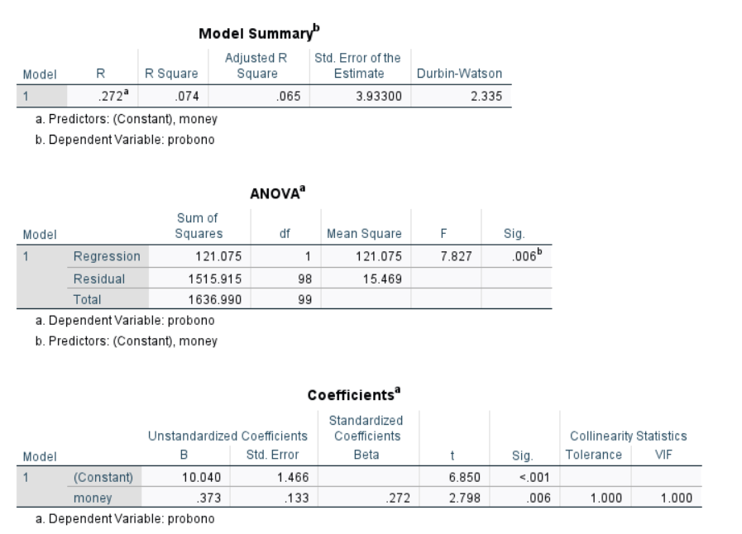

The adjusted R-squared value of 0.65 indicates that the model's independent variables (explanatory variables) can explain 65% of the variance in the dependent variable (response variable). This can be interpreted as a relatively weak relationship between the independent variables and the dependent variable. With D-W value of 2.335, which is acceptable, there is no significant autocorrelation. A VIF of 1 suggests that there are no issues with multicollinearity. A significance level (sig) of 0.06, with a p-value greater than 0.05, implies that data has not provided enough evidence to support my research hypothesis or effects, typically interpreted as a lack of statistical significance. Hypothesis H4 has not been verified.

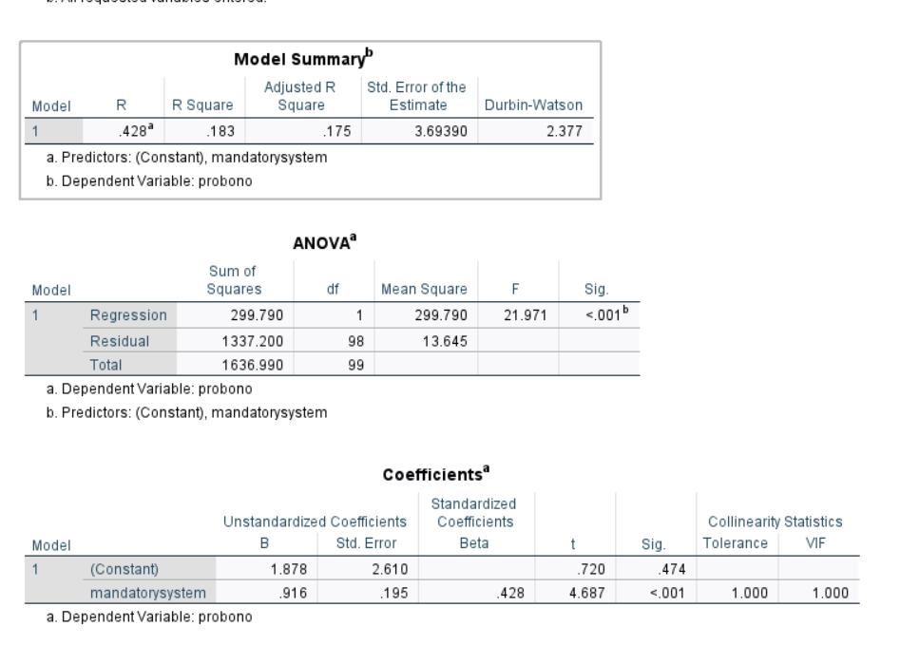

The adjusted R-squared value of 0.175 suggests that the model's independent variables can explain 17.5% of the variance in the dependent variable. This indicates a relatively weak relationship between the independent variables and the dependent variable. A D-W (Durbin-Watson) value of 2.377, which is acceptable, indicates no significant autocorrelation. A VIF of 1 implies the absence of multicollinearity issues. A significance level (sig) smaller than 0.01 indicates that the data provides strong evidence to support H5 hypothesis or effects. An F-value of 21.971 is a statistic used in hypothesis testing, and its interpretation depends on the context of your analysis.

Discussion and findings

This study conducted a comprehensive analysis and evaluation through SPSS statistical analysis. It explored the factors influencing lawyers' participation in public service. Factors such as personal intrinsic motivation, the influence of historical cultural traditions, workplace encouragement, and mandatory regulations all impact the extent of lawyers' engagement in public service. Among these, workplace encouragement has the most significant impact on lawyers' participation in pro bono services, while personal intrinsic drive has the least influence. It's worth noting that money and reputation have the most influence on lawyers' participation in pro bono services, but their SIG values exceed 0.05. I will further discuss this aspect. Although these hypotheses have been validated, the model I designed still has some issues. For instance, the independent variables cannot fully explain the variance of the dependent variable, indicating a relatively weak relationship between the independent and dependent variables. This suggests that the model may not effectively predict changes in the dependent variable. Furthermore, although pro bono service is literally understood as work done without compensation, some scholars argue that engaging in pro bono work may represent a form of cultural capital lawyers use to enhance their professional status, rather than reflecting lawyers' altruism and selflessness (Dinovitzer & Garth, 2009). Therefore, pro bono work might be for the sake of gaining exceptional professional status, skills, and earning potential (Bartlett & Taylor, 2016). However, there are cases where the p-value exceeds 0.05 in the relationship between the independent variable (money) and the public service variable. Despite an R-squared value greater than 0.65, this hypothesis cannot be validated. Perhaps increasing the sample size is necessary, or the analysis may not have found enough evidence to support the considered effects or relationships. In this case, the authenticity of the results cannot be confirmed, and no statistically significant conclusions can be drawn. In the context of this issue, this will also be a focal point of my future research. This can also be integrated with my qualitative research to explore whether quantitative research can empirically substantiate my findings.

Research Limitations

This quantitative study is an exploratory one, and all hypotheses are based on very limited literature, which is not highly correlated with quantitative research. There is relatively little literature on the factors influencing lawyers' participation in pro bono, which also led to some of my hypotheses being unverified conclusions. At the same time, there was no expert or professor's review during this process, and the effectiveness and reliability are in question. Due to time constraints, there was no specific focus group to provide background information for this quantitative study. Furthermore, in this quantitative research, I did not perform analysis of variance, and the rotated component matrix was not analysed in exploratory analysis. Additionally, Bryman (2004) suggests that quantitative research has inherent limitations, such as the research process being linear and therefore rigid and homogeneous, and it is difficult to delve into the reasons behind the phenomenon without direct interviews with participants. In topics involving personal intrinsic motivation's influence on lawyers' participation in public service and exploring human thoughts and emotions, qualitative research is still necessary for assistance. Furthermore, I employed purposive sampling, and researchers make subjective or generalized assumptions when selecting online survey participants, making researcher bias likely. Moreover, my study sample size is only 100, which is insufficient and statistically not highly representative.

Reflexivity

Engaging in my very first independent SPSS quantitative research has been a challenging and entirely new experience in my life. Despite facing some difficulties and obtaining results that were not entirely satisfying, it has proven to be a valuable journey of learning and personal growth.

In the course of my academic journey, this research marked my initial encounter with SPSS, a statistical analysis tool, and the world of quantitative research. I had never been introduced to many of the theories and concepts involved in this process, making the entire experience an entirely new challenge for me. Through participating in relevant courses led by professors, I gradually grasped these theories and concepts, while also acquiring the skills required for data analysis with SPSS. This furnished me with a crucial academic tool, in addition to enhancing my capabilities and skills.

However, I encountered several challenges throughout the research process. To begin, I realized that my sample size was relatively small, potentially affecting the reliability of the study. The research hypotheses might have needed more detailed design. During the initial stages of the study, I failed to consider various factors comprehensively, which resulted in research outcomes that fell short of expectations. This experience has reminded me of the importance of careful and comprehensive formulation of research hypotheses in my future studies.

Although I may not be entirely content with the results of this research, it does not imply that it lacks value. On the contrary, this experience has highlighted the significance and challenges associated with academic research. Success is often accompanied by failures and unsatisfactory outcomes. I have learned how to confront challenges, persevere in the face of setbacks, and continuously enhance the quality of research through this experience.

I believe that this research experience will become a crucial lesson in my future academic career. I will persist in learning and improvement to enhance my research skills and analytical capabilities. The less-than-ideal results of this research will motivate me to work even harder and aspire to achieve greater academic accomplishments.

In summary, embarking on my very first SPSS quantitative research was a challenging experience. Despite facing difficulties and achieving results that were less than satisfying, it provided me with an opportunity for learning and growth. I eagerly anticipate future research endeavors, considering this experience as a valuable lesson and striving for greater academic achievements

Appendix 1 Dataset

Instructions: Please, use a 5-point likert-scale as described below:

1 – Strongly Disagree
2 – Slightly Disagree
3 – Neutral
4 – Slightly Agree
5 – Strongly Agree

No | Statements | Scale
Construct A: Personal intrinsic drive
A1 | I would be willing to volunteer my legal services to help those who cannot afford it. | 1 | 2 | 3 | 4 | 5
A2 | I actively seek opportunities to participate in public service, rather than waiting for passive invitations or assignments
A3 | I set clear personal goals and plans for participating in pro bono services to ensure regular participation.
A4 | I believe in making positive change in society through individually driven participation in pro bono services

Construct B: Historical tradition

B1 | In my country, there is a long tradition of pro bono service in which lawyers have been actively involved. | 1 | 2 | 3 | 4 | 5
B2 | In my country, lawyers have traditionally played a role in society in providing pro bono legal services.
B3 | Historical tradition has convinced me that as a lawyer, I have a responsibility to actively participate in public service.
B4 | In my opinion, the pro bono of lawyers is influenced by such traditions in history.

Construct C: Workplace encouragement
C1 | Large law firms are more active in encouraging lawyers to participate in pro bono services than small and medium-sized firms | 1 | 2 | 3 | 4 | 5
C2 | Large law firms provide lawyers with more opportunities and resources to actively participate in pro bono services compared to small and medium-sized law firms
C3 | Large law firms have more financial support for lawyers to participate in pro bono services than small and medium-sized law firms
C4 | Larger law firms, more than small and medium-sized firms, consider engaging in pro bono services to be essential to maintaining their reputation

Construct D: Economy and reputation

D1 | I think a lawyer's involvement in pro bono service can enhance my professional reputation | 1 | 2 | 3 | 4 | 5
D2 | Financial incentives (such as bonuses ) are one of my main motivations for getting involved in pro bono
D3 | The potential for advancement is the reason I got involved in legal pro bono

E1 | The mandatory system will make me passively participate in public service | 1 | 2 | 3 | 4 | 5
E2 | My decision to participate in public service is closely related to the provisions of the mandatory system
E3 | Mandatory systems are essential to lawyers' public service responsibilities.
E4 | Mandatory system affects my career, if I do not do it I will lose my license.
Construct E: Mandatory system

F1 | I am currently satisfied with the status quo of my participation in pro bono services | 1 | 2 | 3 | 4 | 5
F2 | I will devote more time to public service
F3 | Participating in pro bono has increased my financial income.
F4 | My pro bono work has enhanced my professional reputation.

References:

Anderson, J, and Gordon R.(2003) . “Legal Services ‘for the Public Good.’” Alternative Law Journal 28, no. 1: 13–17

Aydinli, A., Bender, M., Chasiotis, A., van De Vijver, F. J., Cemalcilar, Z., Chong, A., & Yue, X. (2016). A cross-cultural study of explicit and implicit motivation for long-term volunteering. Nonprofit and Voluntary Sector Quarterly, 45(2), 375-396.

Bartlett, F., & Taylor, M. (2016). Pro bono lawyering: Personal motives and institutionalised practice. Legal Ethics, 19(2), 260-280.

Baumeister, R. F., & Leary, M. R. (1995). The need to belong: Desire for interpersonal attachments as a fundamental human motivation. Psychological Bulletin, 117(3), 497–529

Bidee, J., Vantilborgh, T., Pepermans, R. et al. Autonomous Motivation Stimulates Volunteers’ Work Effort: A Self-Determination Theory Approach to Volunteerism. Voluntas 24, 32–47 (2013)

Bisher,M,T,M (2015).Patient Experiences of Undesirable Safety Events during
Hospital Care: A Study in the Palestinian Medical Complex. https://dspace.alquds.edu/server/api/core/bitstreams/8ce56b1d-65e3-40c4-a8e9-a865ab9fae3a/content

Bryman, A. (2004) Social research methods. 2nd Edition, Oxford University Press, New York, 592.

Cappelliti.M (2001), Pro bono as a professional legacy (2001) 19(2) Law In Context 97;

Cavill, P. R., 'Justice', The English Parliaments of Henry VII 1485-1504, Oxford Historical Monographs (Oxford, 2009; online edn, Oxford Academic）

Cummings. “The politics of pro bono”. UCLA Law Review,52,2004, pp.1-149.

Cummings, Scott L., Silva, Fabio de Sa e, and Trubek, Louise G., eds.(2022) Global Pro Bono: Causes, Context, and Contestation. Cambridge, UK: Cambridge University Press.

David R. Hodge, David F. Gillespie.(2005).Phrase Completion Scales, Encyclopedia of Social Measurement,P 53-62,

Dawes,J (2008), "Do Data Characteristics Change According to the number of scale points used? An experiment using 5-point, 7-point and 10-point scales," International Journal of Market Research, 50 (1), 61-77.

Dinovitzer, R., & Garth, B. (2008). Pro bono as an elite strategy in early lawyer careers. Available at SSRN 1291998.

Dong, J. (2022,). The Institutionalization of Pro Bono in China. In 2022 8th International Conference on Humanities and Social Science Research (ICHSSR 2022) (pp. 983-987). Atlantis Press.

Dwyer, P.C., Bono, J.E., Snyder, M., Nov, O. and Berson, Y. (2013), Sources of Volunteer Motivation: Transformational Leadership and Personal Motives Influence Volunteer Outcomes. Nonprofit Management and Leadership, 24: 181-205

Ferguson,(2005).Perspectives on a great tradition: proudly pro bono Proctor Journal of the Queensland Law Society 2.

Friedland R. & R. R. Alford,（1991） Bringing society back in: symbols, practices, and institutional contradictions, in W. W. Powell & P. J. DiMaggio (eds.), The New Institutionalism in Organizational Analysis, pp.232-263, Chicago: The University of Chicago Press.

Fu, H,L（2020） Pro Bono, Legal Aid, and the Struggle for Justice in China ( 2020). University of Hong Kong Faculty of Law Research Paper No. 2020/073, Available at SSRN: https://ssrn.com/abstract=3743658

Granfield, R., & Koenig, T. (2003). HARVARD LAW SCHOOL AND THE SOCIAL PRODUCTION OF ELITE LAWYERS. Social Problems Across the Life Course, 73.

Granfield, R. (2007), The Meaning of Pro Bono: Institutional Variations in Professional Obligations among Lawyers. Law & Society Review, 41: 113-146

Granfield.R and Mather,L.（2009）."Pro bono, the public good, and the legal profession: An introduction.” Oxford University Press, 2009, pp.1-22.

Grouzet, F. M., Vallerand, R. J., Thill, E. E., & Provencher, P. J. (2004). From environmental factors to outcomes: A test of an integrated motivational sequence. Motivation and Emotion, 28, 331-346.

Güntert, S. T., & Wehner, T. (2015). The impact of self-determined motivation on volunteer role identities: A cross-lagged panel study. Personality and Individual Differences, 78, 14-18.

Hilary S,(2007) ‘Researching and Theorizing the Processes of Professional Identity Formation’ 34(2) Journal of Law & Society 190.

Kafle, S. C. (2019). Correlation and Regression Analysis Using SPSS. Management, Technology & Social Sciences.

Kaiser, H. F. (1974). An index of factorial simplicity. psychometrika, 39(1), 31-36.

Kay, F. M., & Granfield, R. (2023). Altruism at Work: An Integrated Approach to Voluntary Service among Private Practice Lawyers. Law & Social Inquiry, 48(2), 593-631.

Kenuo,C.(2023) A phenomenological pilot study on Chinese lawyers' participation in pro bono.UWTSD DBA 7012 moodle.

Lawyers Law of the People's Republic of China, 2001

McColl-Kennedy, Janet R., Paul G. Patterson, Michael K. Brady, Lilliemay Cheung, and Doan Nguyen. (2015). “To Give or Not to Give Professional Services to Non-paying Clients.” Journal of Service Management 26(3): 426–59

McMullin, C., Skelcher, C. (2018)The Impact of Societal-Level Institutional Logics on Hybridity: Evidence from Nonprofit Organizations in England and France. Voluntas 29, 911–924

Obilor, E. I. (2023). Convenience and purposive sampling techniques: Are they the same. International Journal of Innovative Social & Science Education Research, 11(1), 1-7.

Patterson, Paul， McColl-Kennedy, Janet Lee, Jenny Jiyeon Brady, Michael
（2020） Gaining insights into why professionals continue or abandon pro bono service European Journal of Marketing

Penner, L.A. (2002) Dispositional and Organizational Influences on Sustained Volunteerism: An Interactionist Perspective. Journal of Social Issues, 58, 447-467

Rhode,D, L (2009) ‘Rethinking the Public in Lawyers’ Public Service’ (2009) 77(3) Fordham Law Review 1435, 1435

Ryan.F (2021) Voices from the front line: exploring what pro bono means to lawyers in England and Wales?. International Journal of the Legal Profession 28:3, pages 265-278.

Ratner, B. The correlation coefficient: Its values range between +1/−1, or do they?. J Target Meas Anal Mark 17, 139–142 (2009)

Rodell, J. B. (2013). Finding meaning through volunteering: Why do employees volunteer and what does it mean for their jobs?. Academy of Management Journal, 56(5), 1274-1294.

Ryan, R. M., & Deci, E. L. (2000). Self-determination theory and the facilitation of intrinsic motivation, social development, and well-being. American Psychologist, 55(1), 68–78

Rice, W. R. (1989). Analyzing tables of statistical tests. Evolution, 43(1), 223-225.

Streiner D.(2003)Starting at the beginning: an introduction to coefficient alpha and internal consistency. Journal of personality assessment. 2003;80:99-103

Tavakol M, Dennick R. Making sense of Cronbach's alpha. Int J Med Educ. 2011 Jun 27;2:53-55.

Thornton, P. H., Jones, C., & Kury, K. (2005). Institutional logics and institutional change in organizations: Transformation in accounting, architecture, and publishing. In Transformation in cultural industries (pp. 125-170). Emerald Group Publishing Limited.

UK LAW SOCIETY PRO BONO 2019 https://www.lawsociety.org.uk/topics/pro-bono/introduction-to-pro-bono

Wang, Y., Zhang, X., Li, J., & Xie, X. (2019). Light in darkness: Low self-control promotes altruism in crises. Basic and Applied Social Psychology, 41(3), 201-213.

