European field studies
Blog assignment
BMTH 5000
Steffan Treharne
1705128

Switzerland Travel Blog
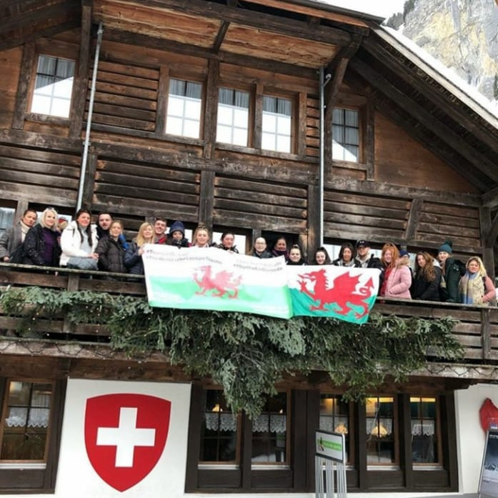

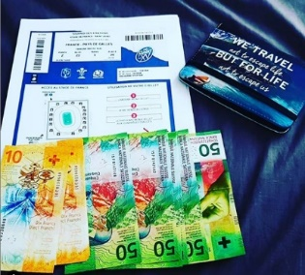
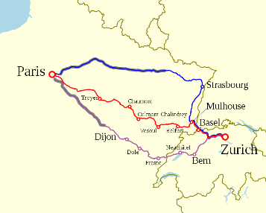
So, my journey began on the 1st of February 2019 where I set off from Swansea train station with passport and interrail pass traveling via London to Paris. After staying in Paris for two nights I moved on to Switzerland, traveling by train is one of the most cost-effective ways to travel across Europe even at a cost of roughly £160 for a five day pass it is well worth the money.

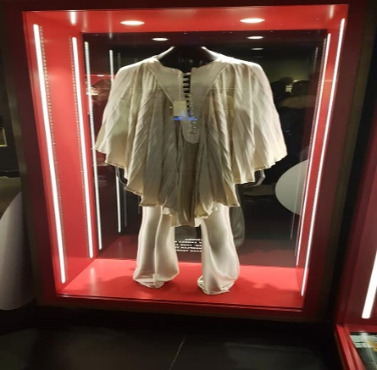
When arriving in Switzerland the culture, climate and atmosphere was completely different to what I have ever experienced which was made even greater with that feeling of excitement. Everything was very clean and very simple, when I arrived and Montreux with my suit case there was several locker facilities for suit cases which could hold up to 3 suitcases for 9 swiss francs. Whilst in Montreux you notice that Switzerland is very traditional with the traditional swiss shops and the red and white flags and colour scheme dotted around the area. Whilst in Montreux I visited the Freddie Mercury museum which was outstanding, amazing I have never experienced truly wonderful as this. it is also here where Freddie wrote many songs and a lot of his written work and instruments and costumes are held for display, to be able to have a slight insight to the legend’s work and life was fantastic and worth seeing as it was free. This is very much culture for Switzerland with the whole red and white colour scheme to Freddie Mercury exhibit with a statue of the man himself outside on the lake back drop to the wonderful country that Switzerland is famous for such as, snow, ski cabins made from wood, traditional villages and trains running through the mountains and the higher I went up the more scenic with beautiful snowfall and then the swiss photo perfect became a reality.
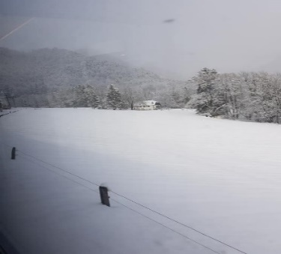
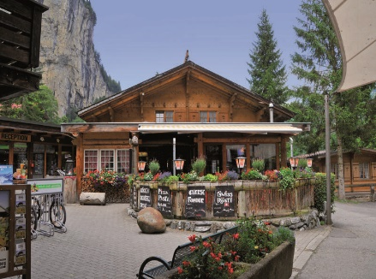
Arrived at Lauterbrunnen in the evening, Lauterbrunnen is a village in the German region of Switzerland and is a valley situated between two mountains, this is the area I stayed in a chalet which was situated in Camping Jungfrau which is a camping site with caravan pitches and chalets. This location could not be better for a culture experience. Traditional swiss village with local shops, pubs and traditional resorts, everybody that I met were very welcoming with open arms easy to speak to, but you also have a sense of tradition and if you respect, they tradition then they are very nice people. they are people who believe in keeping the back drop and scenery traditional with laws in place where you cannot build on the land unless you knock a building down, culturally this is something I was not use to, but it works as it pulls more and more tourists back to the location.
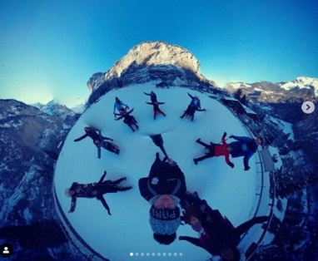
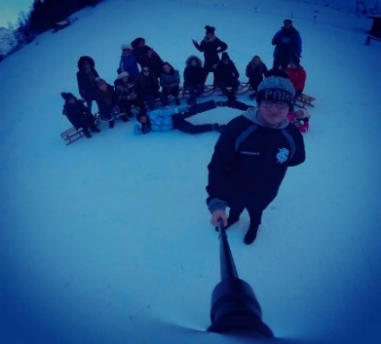
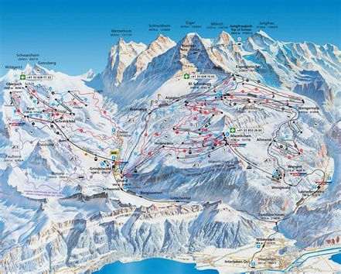
One of many things I had experienced whilst staying In Switzerland on two occasions was traditional sledging. This is something I had never experienced before, and it is something I will only ever do once in my lifetime and is worth every second, feeling the cold swiss air hitting your face whilst travelling at speed down a snowy mountain, embracing the scenery of the sledging path between Kleine Schneidegg and Wengen. The scenery was outstanding natural beauty of fresh snow on top of the 3000m high mountains with amazing drops on each side. yet this is a cultural activity that has been done in Switzerland for hundreds of years also skiing is very much part of the culture and is just as much as the log cabins and the traditional pubs and buildings, it is an activity / sport that is learnt from a very young age in the surrounding community.

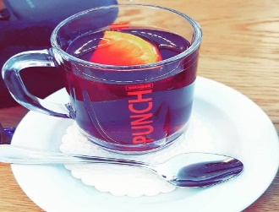
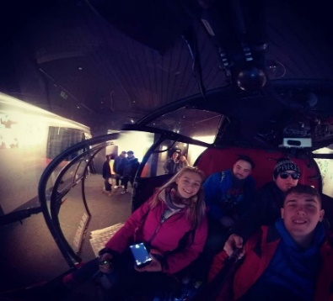
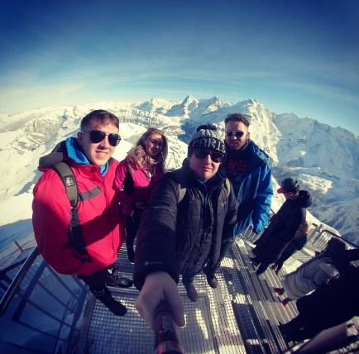
On my travels in Switzerland I also managed to visit the James Bond 007 experience on top of the Schilthorn mountains which is also a big culture destination for film enthusiasts. This has been brought in to the swiss culture as one of many James Bond’s was produced on top of the mountain. Once again amazing, life changing views that will put life and the world into prospective, there is so many things to do whilst visiting this location. There are props and movie takes from the film which is outstanding such as a helicopter in a room and even the sledge from the actual film which is truly amazing and exciting to see the visual items such as props, they use in the film. One amazing idea that the location had is when signing into the Wi-Fi they automatically put a clear backdrop of the scenery, luckily, I was one of many lucky ones to visit on a clear day. there is also a café that serves traditional food and beverage which is local for the area such as the glupfein. Whilst experiencing the 007 it was stunning with backdrops of 3000m high surroundings with fresh snow and to be able to experience this with people who I didn’t know that well. The whole surrounds were just amazing, breath taking as there is less oxygen 3000m high.

Switzerland cannot be compared to any other destination even the likes of Austria, there is something that as a tourist you can see that Switzerland is in a league of its own. Nothing compares it when you want snow, excitement, culture and winter sports, Switzerland with its whole diversity of tradition will always stick to this and when people mention about of expensive everything in the country is, you’re not buying a holiday to me your buying into an experience a tradition a culture that is like no other to compare, if you had asked me two years ago would I visit Switzerland I would of probably of said “no” but after visiting I would say “get my passport and lets go”. Switzerland to me is by far one of the best destinations and experiences I have ever had and would not change it for the world. #loveswitzerland #getswissed #theworldisourlecturetheatre

