7a Using loops (1) – While

1. Ask the user to enter their age, which must be 18 or more. If they enter something out of range, keep prompting them to enter a number. Don't forget to test on the boundary (exactly 18)

Sample output:

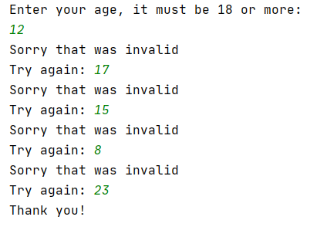

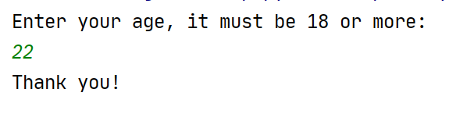

2. Ask the user to choose a number – this time, it must be between 1 and 10. Any numbers outside that range should trigger a "Try again" message.

Sample output:



